3D-printed aberration-free terahertz metalens for ultra-broadband achromatic super-resolution wide-angle imaging with high numerical aperture

Supplementary Note 1 Theoretical analysis of our proposed metalens
According to Equation 2, the original RI profile is given in Fig. S1 b, and the corresponding ray traces and electric field distributions are calculated and depicted in Fig. S1 a and c, respectively.
Fig. S1 Achromatic property of the metalens with the original RI profile. a Calculated ray traces of metalens with the original RI profile. b. Original RI distribution. c Calculated electric field distributions from 0.2 to 0.9 THz.
For the modified RI profile, calculated electric field distributions in the x-y plane under the normal incidence from 0.2 to 0.9 THz are illustrated in Fig. S2 a. The focal spots are rather symmetrical from the center to the periphery, which is very useful for imaging. The relevant FWHM and focusing efficiency are extracted and shown in Fig. 2e. Under the oblique incidence, the corresponding electric field distributions in the x-z plane are displayed in Fig. S2 b, with the incident angle ranging from 15º to 45º. To quantifiably analyze the focal shift in the x-axis with increasing incident angle, the electric field distributions in the x-y plane are also shown in Fig. S2 c-d. The relationship between the focal shift in the x-axis and the incident angle is presented in Fig. 2f. The corresponding FWHMs are given in Fig. S2 d. It can be seen that super-resolution focusing is effective in a wide FOV of 90º.
Fig. S2 Calculated electric field distributions of our proposed metalens a. The electric field profiles in the x-y plane with normal incidence. b-c. The electric field profiles in the x-z plane and x-y plane with increasing incident angles from 15º to 45º. d. The FWHMs for oblique incidences.
Supplementary Note 2 Corresponding metamaterial design and simulated results
Fig. S3 gives the relationship between structural parameters and the effective refractive index from 0.2 to 0.9 THz.
Fig. S3 Effective refractive index with varying hole radius (a) and varying width of the inversed Y-shaped structure (b).
The designed metamaterial structure is simulated in CST Studio 2023 to validate the feasibility of our designed metalens. Fig. S4 a depicts that the focusing position remains unchanged from 0.2 to 0.9 THz with linearly polarized waves. The corresponding focusing efficiency and FWHM are extracted and illustrated in Fig. S4 d. The simulated results agree well with the measured results.
Fig. S4 Simulated electric field profiles of the designed metalens from 0.2 to 0.9 THz. Simulated results of electric field profile in the x-z plane a and x-y plane b. c. The extracted electric field distribution at the focusing line. d. The derived focusing efficiency and FWHM.
Furthermore, to prove the polarization-insensitive property of the designed metamaterial structure. Fig. S5 presents the simulated electric field distribution under L/R-handed circularly polarized illumination in the x-z plane and x-y plane. From the electric field distributions in the x-y plane, it can be seen that the phase difference between the electric x-component and y-component is ±90º, which fully demonstrates that our designed metalens is polarization-insensitive.
Fig. S5 Simulated electric field profiles of the designed metalens from 0.2 to 0.9THz under circularly polarized illumination. a. Simulated electric field profiles in the x-z plane under left circularly polarized illumination. b. Simulated x- and y-component of the electric field profiles in the x-y plane. c. Simulated electric field profiles in the x-z plane under right circularly polarized illumination. d. Simulated x- and y-component of the electric field profiles in the x-y plane.
To demonstrate the focusing performance of designed metamaterial structures under the oblique incident, Fig. S6 a-b presents the simulated electric field distribution under oblique illumination in the x-z plane and x-y plane from 15º to 45º. The corresponding FWHM and focal shift in the x-axis are given in Fig. S6 c-d. Simulated results agree well with the theoretically predicted ones. It is confirmed that the FOV of our designed metalens is 90º.
Fig. S6 Simulated electric field profiles of the designed metalens from 0.2 to 0.9THz under oblique illumination. a-b Simulated electric field profiles in the x-z plane and x-y plane under oblique illumination. c. The extracted FWHM under oblique illumination. d. The extracted focal shift in the x-axis with increasing incident angles from 15º to 45º.
Supplementary Note 3 Details of the experimental setup and measured results
Fig. S7 and Fig. S8 illustrate the experiment setup for focusing measurement under normal and oblique incidences, respectively.
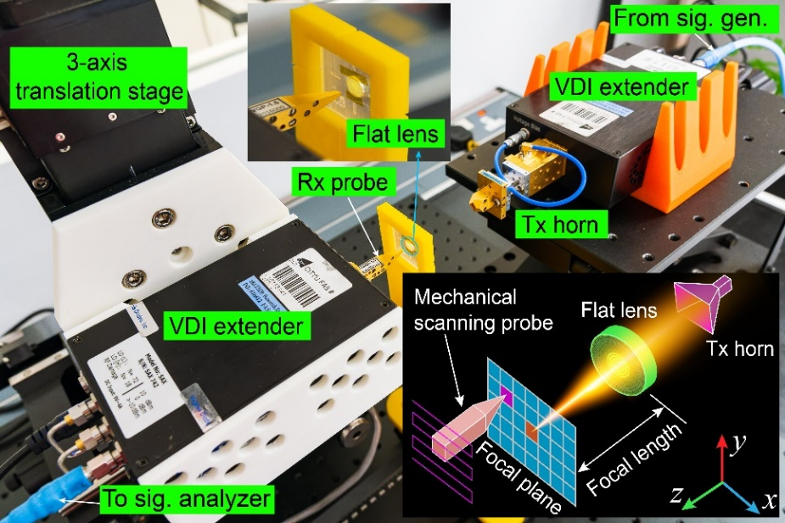
Fig. S7 Experimental setup for focusing under normal incidence.

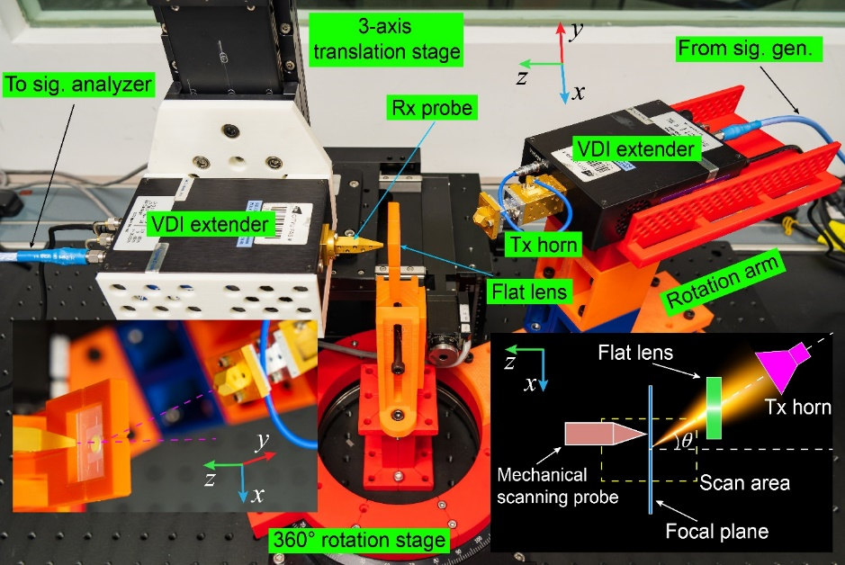
Fig. S8 Experimental setup for focusing under oblique incidence.
Fig. S9 and Fig. S10 display the measured electric field distributions under normal incidence in the x-y plane and under oblique incidence from 15º to 45º in the x-z plane, respectively. For Fig. S10, the focusing position only varies with the incident angle. It can be concluded that the achromatic property is effective in both normal and oblique incidences. Measured FWHMs under oblique incidences are illustrated in Fig. S11. Except for FWHM under the incident angle of 45º, measured FWHMs are all below the diffraction limit. Super-resolution imaging in a wide FOV is highly anticipated.
Fig. S9 Measured electric field distributions under normal incidence in the x-y plane.

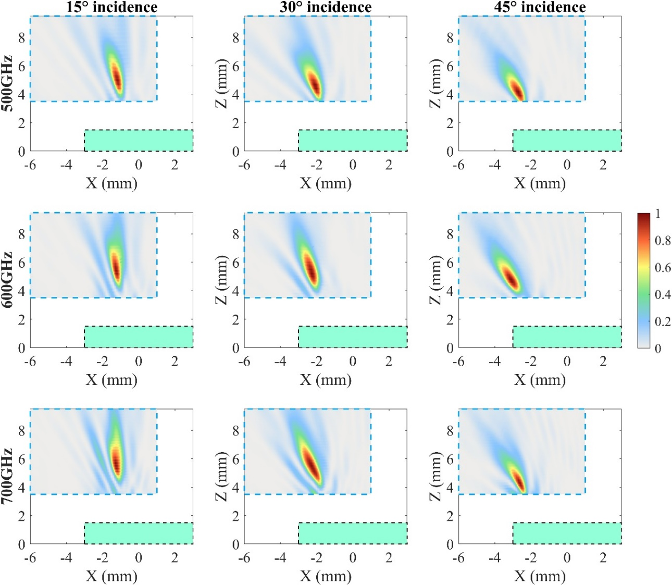
Fig. S10 Measured electric field distributions under oblique incidence from 15º to 45º in the x-z plane. The green zone represents the metalens.
Fig. S11 Measured and theoretical FWHMs under oblique incidence from 15º to 45º at the frequency of 0.5, 0.6, and 0.7THz, respectively.
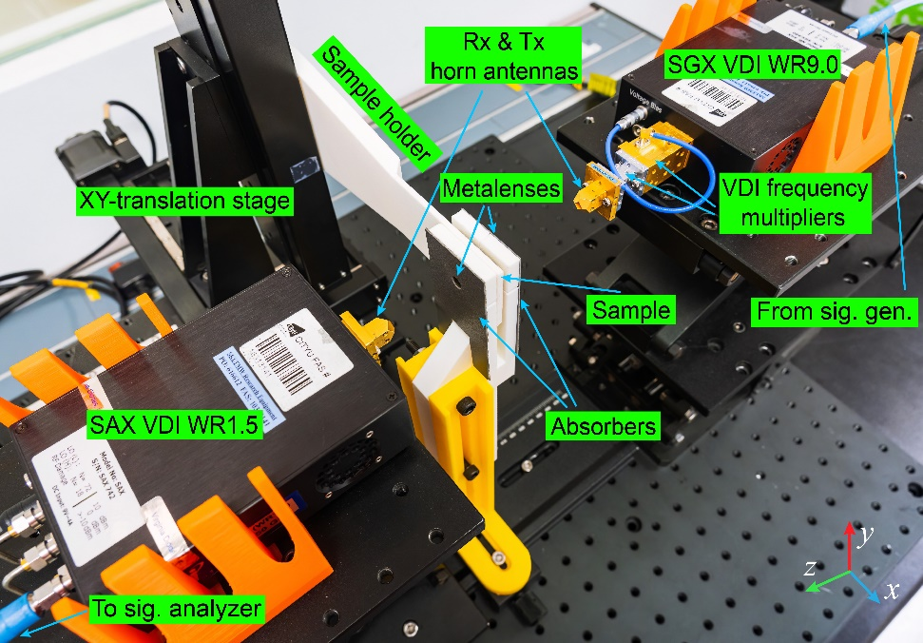
Fig. S12 Photograph of the imaging system described in Fig. 4a.
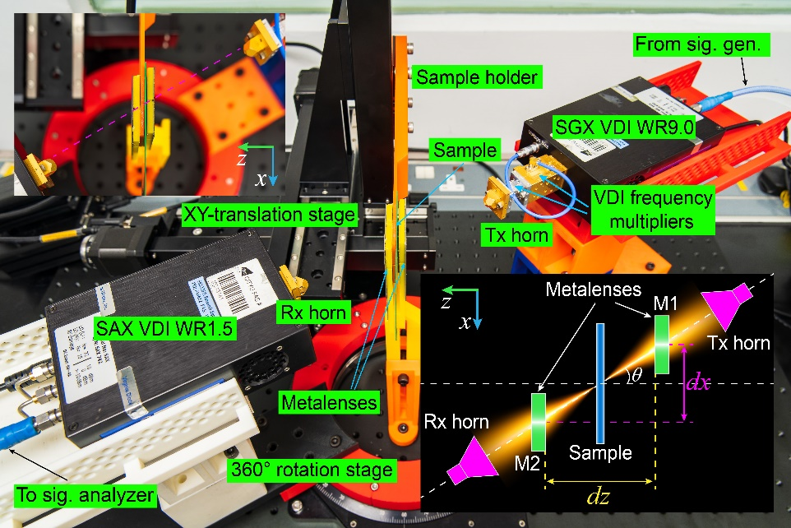
Fig. S13 Photograph of the imaging system under the oblique incidence.

