Ferrocyanide Surface Ligands to Quantum Dots for Prussian Blue Composites Showing Efficient and Reversible Electrochemical Response
Taeyong Haª, Yunmo Sungª, Yongju Kwon^{a,b}, Sukyung Choi*^{,c}, Ho Jin*^{,d} and Sungjee Kim*^{,a}
ªDepartment of Chemistry, Pohang University of Science and Technology, Pohang 37673, South Korea.
^{b}Institut für Physikalische und Theoretische Chemie, Universität Tübingen, Tübingen 72076, Germany
^{c}Reality Display Research Section, Electronics and Telecommunications Research Institute (ETRI), Daejeon 34129, South Korea.
^{d}Department of Chemistry, Ulsan National Institute of Science and Technology, Ulsan 44919, South Korea.
*Corresponding authors. Email: skchoi915@etri.re.kr (Sukyung Choi), hojin@unist.ac.kr (Ho Jin), sungjee@postech.ac.kr (Sungjee Kim)

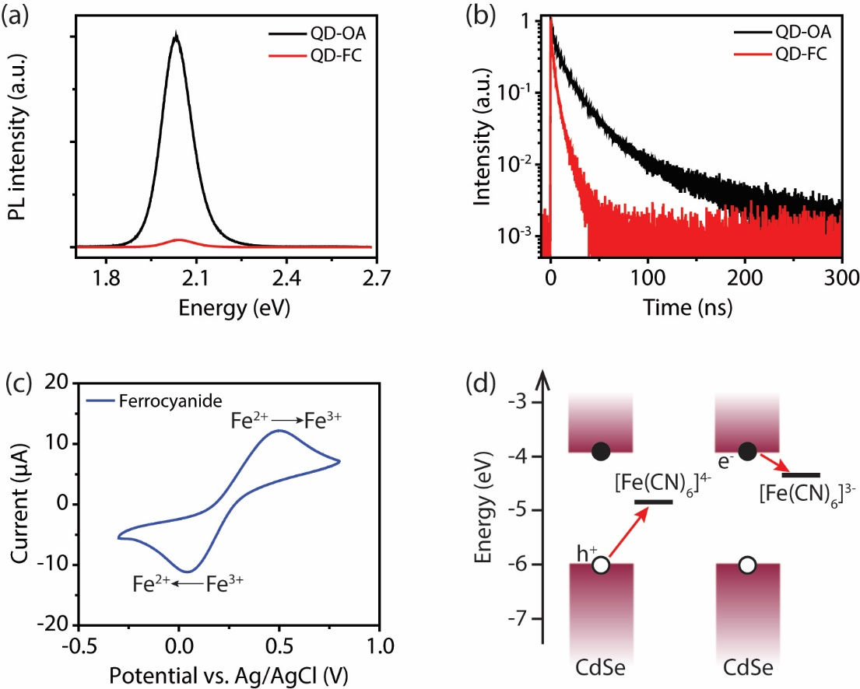
Figure S1. (a) PL spectra of QDs before the ligand exchange covered with OA (QD-OA, black) and after the exchange covered with ferrocyanide (QD-FC, red). (b) Time-resolved PL decay of QDs with OA (QD-OA, black) and ferrocyanide (QD-FC, red) surface ligands. (c) Cyclic voltammetry measurement of ferrocyanide. The oxidation reaction from Fe²⁺ to Fe³⁺ occurs at 0.498 V (vs. Ag/AgCl reference electrode), which corresponds to the conversion of ferrocyanide ([Fe(CN)₆]⁴⁻) to ferricyanide ([Fe(CN)₆]³⁻). The reduction reaction from Fe³⁺ to Fe²⁺ occurs at 0.043 V (vs. Ag/AgCl), which corresponds to the conversion of ferricyanide to ferrocyanide. (d) The redox potentials of ferrocyanide and ferricyanide are compared with the energy of conduction and valence band edge of CdSe QDs. Ferrocyanide can accept a hole from valence band of QDs, whereas ferricyanide can accept an electron from conduction band of QDs.

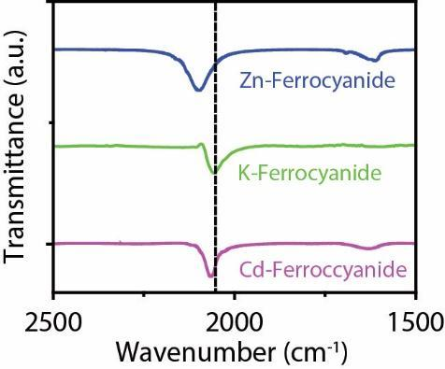
Figure S2. Fourier-transform infrared (FT-IR) spectra of ferrocyanide molecules with various counter cations. The ferrocyanide molecules with K⁺ ions have a peak near 2057 cm⁻¹ due to the vibration of C-N triple bonds. When the counter cations are switched to Zn²⁺ or Cd²⁺, the peak moves to higher energy to 2098 cm⁻¹ for Zn²⁺ or 2064 cm⁻¹ for Cd²⁺ by the increased binding interaction of cyanide ligands with the counter cations.

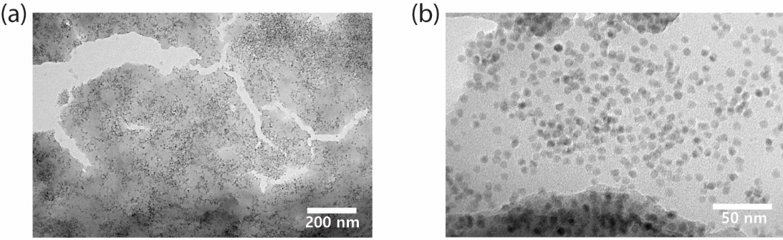
Figure S3. Transmission electron microscopy (TEM) images of QD-in-PBA composites. Images are at a magnification of (a) x40,000, and (b) x200,000. It displays homogeneously distributed QDs within the PBA matrix.

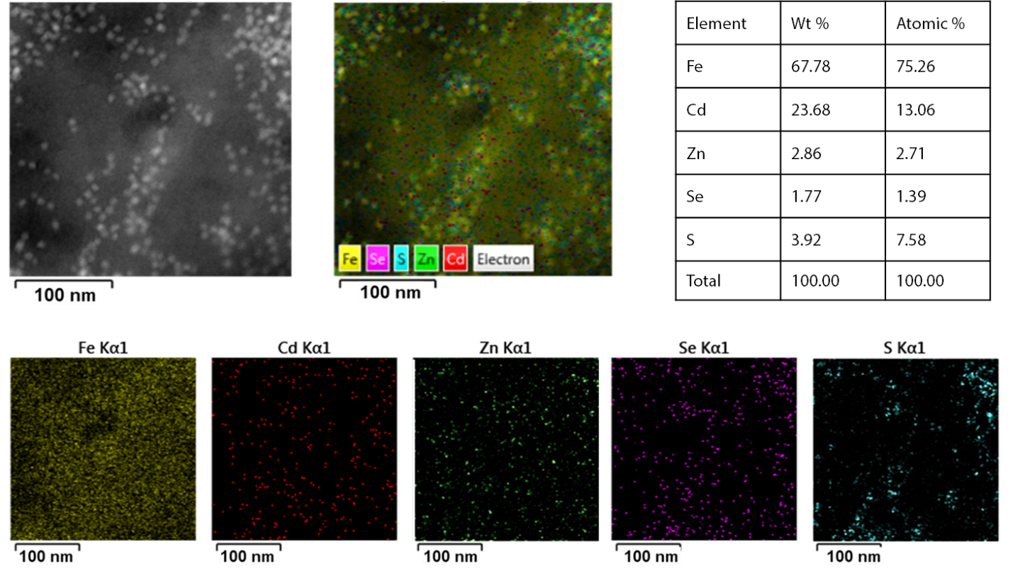
Figure S4. (a) High resolution scanning transmission electron microscopy (STEM) image of QD-in-PBA composites. (b) The five atomic signals of Fe (yellow), Cd (Red), Zn (Green), Se (Magenta), and S (Sky-blue) atoms are overlapped on the STEM image and (c) relative molar compositions of QD-in-PBA composites are confirmed by energy dispersive X-ray spectroscopy (EDS) analysis. (d) Elemental mapping images of individual Fe, Cd, Zn, Se and S elements of QD-in-PBA composites overlapped in (b).

