SUPPLEMENTARY INFORMATION
Sequential Extraction Procedure & ICP-MS Analysis quality control.
The figures below compare measured (ICP-MS analysis; this study) and published metal concentrations for the leachates obtained from the BCR-701 standard. The different replicate samples (three in total) are indicated by different colours. Published concentrations of the metals Cr, Ni, Cu, Zn, Cd and Pb (Sutherland, 2010) are indicated by the horizontal black lines. Detection limits for the concentrations are indicated by the smaller horizontal lines (colour-coded by replicate).

Figure S1: Step 1 (exchangeable fraction)
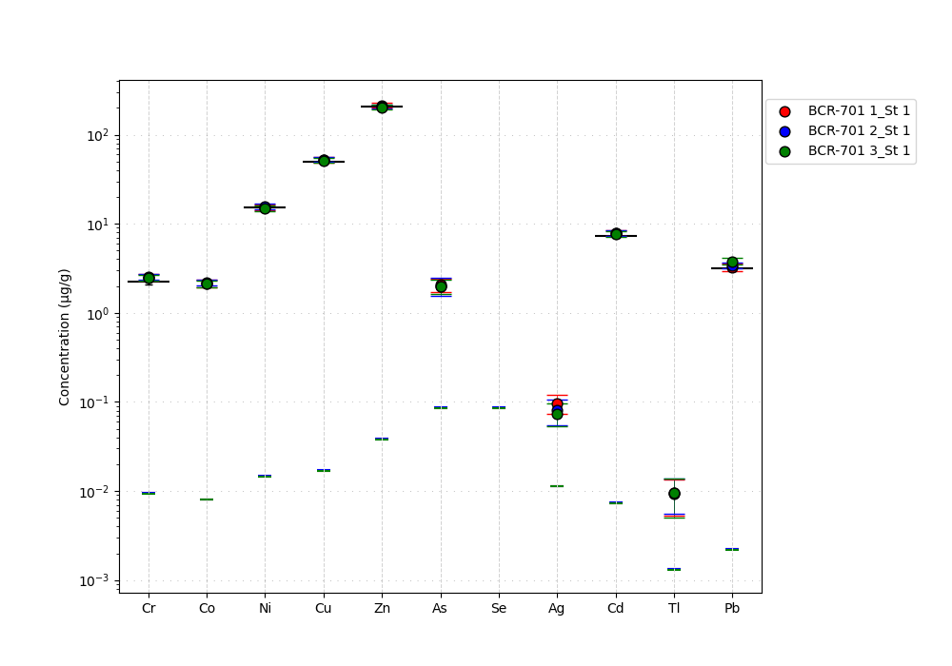

Figure S2: Step 2 (reducible fraction)

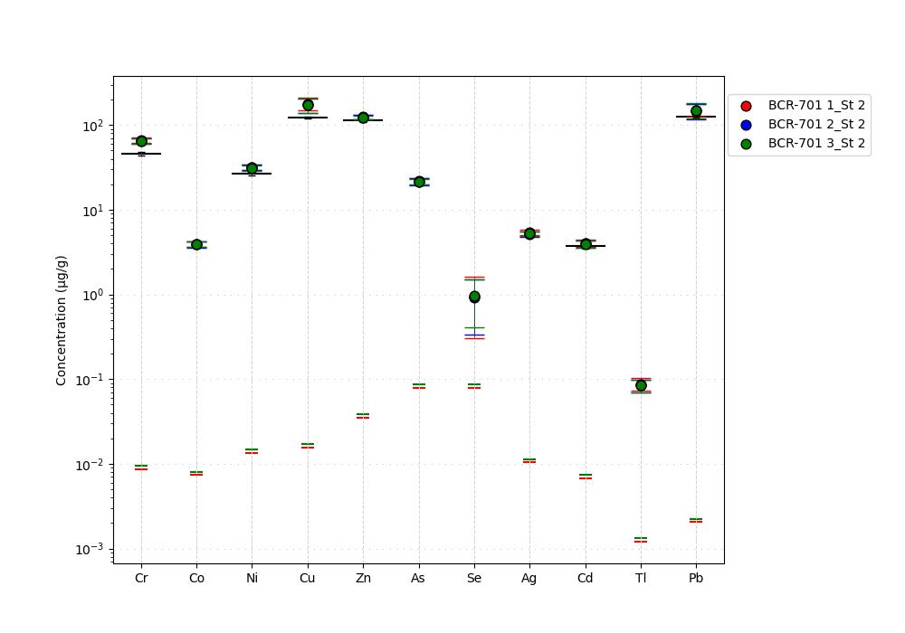

Figure S3: Step 3 (oxidizable fraction)
