 | 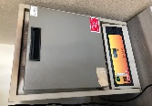 | 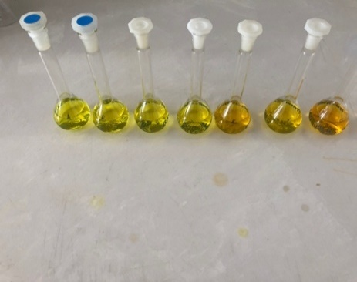 | 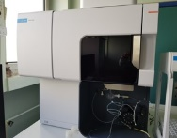 | Macroelements:  *P  *K  *Ca  *Mg
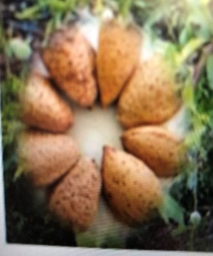 | 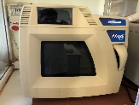 |  |  | Microelements:  *Fe  *Cu  *Mn  *Zn
 | 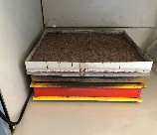 |  |  | Toxic elements:  *As  *Al  *Ba  *Ni  *Pb
 | 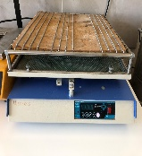 |  |  | Toxic elements:  *As  *Al  *Ba  *Ni  *Pb

Graphical Abstract: In this study, the macro, micro- and toxicelement levels of the almond kernels burned with four different digestion methods were revealed.

