Supplement of

Improved global estimation of seasonal variations in C3 photosynthetic capacity based on eco-evolutionary optimality hypotheses and remote sensing
Yihong Liu ª, Jing M. Chen ^{a, b} *, Mingzhu Xu ^{b}, Rong Wang ^{b}, Weiliang Fan ^{c}, Wenyu Li ª, Lucas Kammer ª, Colin Prentice ^{d}, Trevor F. Keenan ^{e, f}, Nicholas G. Smith ^{g}

ª Department of Geography and Planning, University of Toronto, Toronto, Canada
^{b} School of Geographical Sciences, Fujian Normal University, Fuzhou, China
^{c} School of Environmental and Resources Science, Zhejiang A&F University, Hangzhou, 311300, China
^{d} Department of Life Sciences, Imperial College London, London, UK
^{e} Climate and Ecosystem Sciences Division, Lawrence Berkeley National Laboratory, Berkeley, CA, USA
^{f} Department of Environmental Science, Policy and Management, UC Berkeley, Berkeley, CA, USA
^{g} Department of Biological Sciences, Texas Tech University, Lubbock, TX, USA

⁎ Corresponding author at: Department of Geography and Program in Planning, University of Toronto, Toronto, Canada, and School of Geographical Sciences, Fujian Normal University, Fuzhou, China.
E-mail address: jing.chen@utoronto.ca (JM. Chen)

Table S1 Leaf parameters used in the PROSPECT model for each PFT. N refers to structure parameter, Car refers to carotenoid content with its amount considered as one seventh of the LCC, Cb refers to brown pigment, Cm refers to dry matter, and Cw refers to equivalent water thickness. ENF = Evergreen needleleaf forest, EBF = Evergreen broadleaf forest, DBF = Deciduous broadleaf forest, MF = Mixed broadleaf forest, SHR = Shrubland, SAV = savanna; GRS = Grassland, CRO = Cropland.
PFT | N | Car (μg·cm⁻²) | Cb | Cm (g·cm⁻²) | Cw (g·cm⁻²) | Reference
ENF | 2.8 | LCC/7 | 0 | 0.05 | 0.01 | De Santis et al. (2009) & Kötz et al. (2004)
EBF | 1.8 | LCC/7 | 0 | 0.005 | 0.01 | Arellano et al., 2017a, 2017b
DBF | 1.2 | LCC/7 | 0 | 0.005 | 0.01 | Féret et al. (2011)
MF | 1.2 | LCC/7 | 0 | 0.005 | 0.01 | Féret et al. (2011)
SHR | 1.8 | LCC/7 | 0 | 0.005 | 0.01 | Enrique et al. (2016) & Sow et al. (2013)
SAV | 1.2 | LCC/7 | 0 | 0.005 | 0.01 | Féret et al. (2011)
GRA | 1.2 | LCC/7 | 0 | 0.005 | 0.01 | Darvishzadeh et al. (2008)
CRO | 1.4 | LCC/7 | 0 | 0.015 | 0.01 | Jacquemoud et al. (2000)

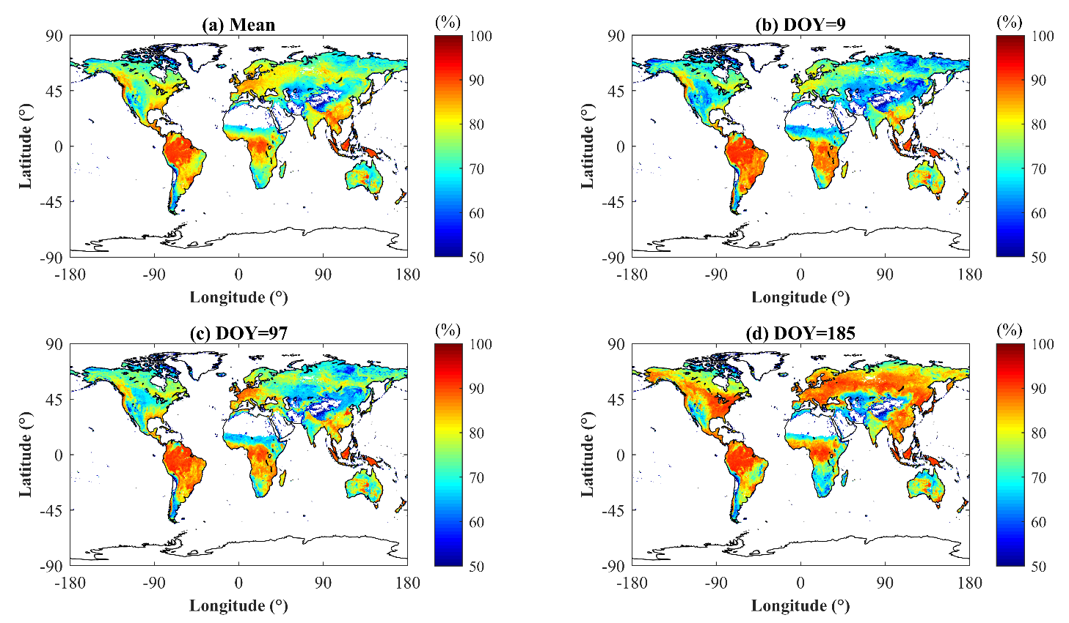
Fig. S1. Global distribution of (a) the seasonal mean leaf absorptance $α$, (b) $α$ at DOY 9, (c) $α$ at DOY 97, and (d) $α$ at DOY 185.

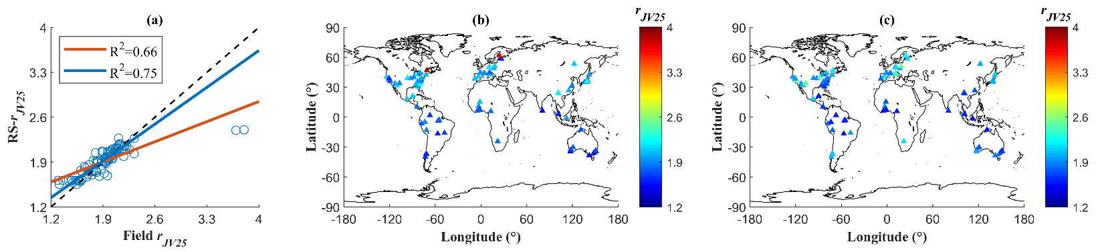
Fig. S2. (a) Comparison between RS-r_{JV25} and Field r_{JV25} from the global observational dataset. The red line is the regression line, the blue line is the regression line after excluding Field r_{JV25} higher than 3, and the black dashed line is the 1:1 line; (b) Field r_{JV25} at each pixel covering the sites in the global observation dataset; (c) RS-r_{JV25} at each pixel covering the sites in the global observation dataset.

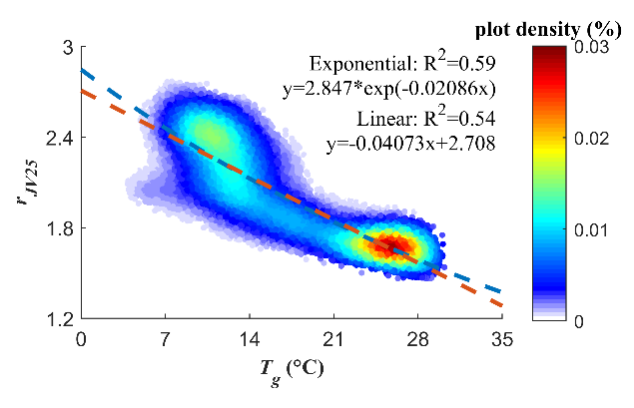
Fig. S3. Relationship between RS-r_{JV25} and T_{g} on the global scale. The blue dashed line is the exponential empirical relationship, and the red dashed line is the linear one.

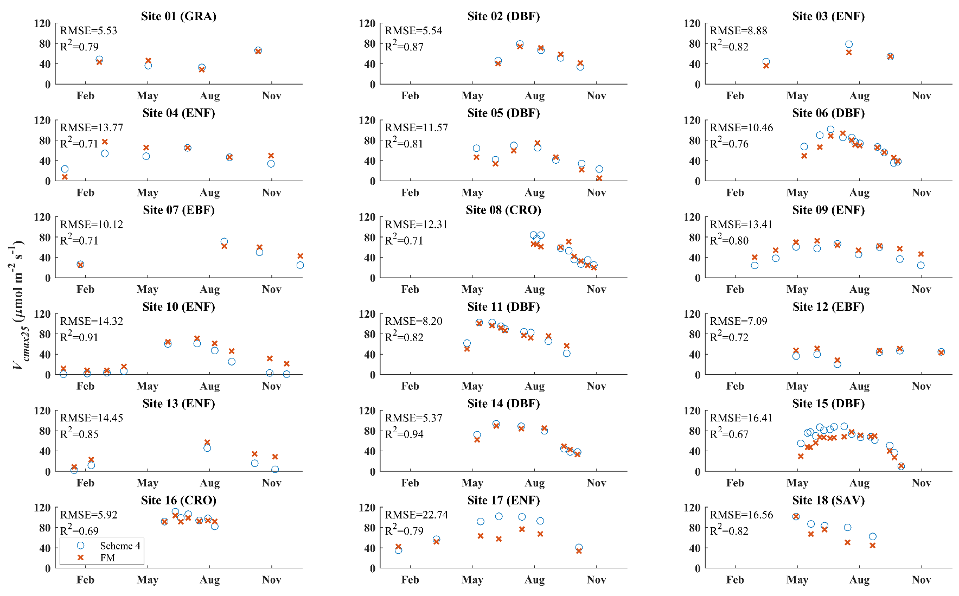
Fig. S4. Comparison between the simulated V_{cmax25} (μmol·m⁻²·s⁻¹) of Scheme 4 (LCC-based $α$ and RS-r_{JV25}) and field measurements over the growing season at 18 sites. FM indicates field-measured V_{cmax25}.

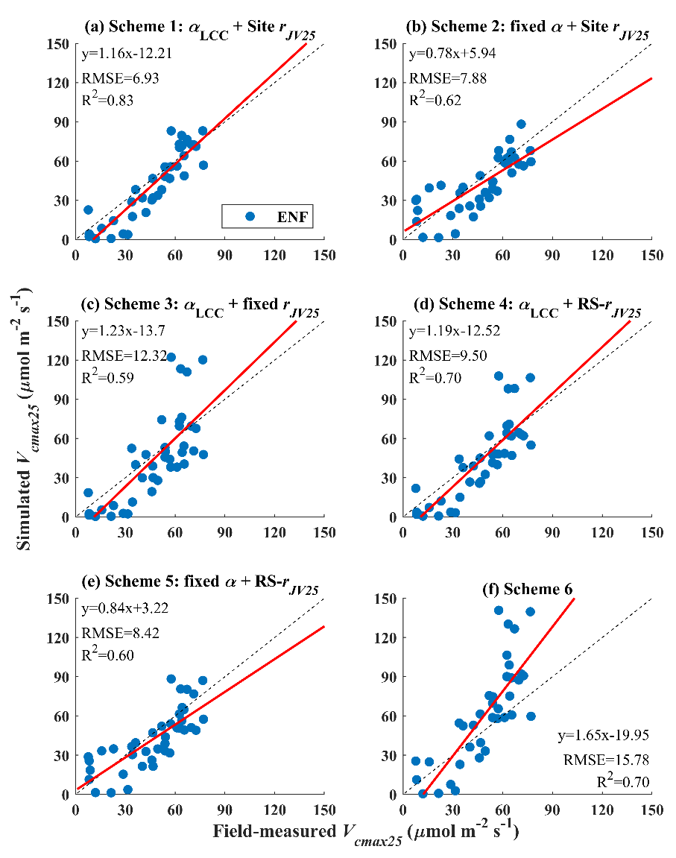
Fig. S5. Comparisons between all field measurements and simulated V_{cmax25} for ENF in (a) Scheme 1 (LCC-based $α$ and Site r_{JV25}), (b) Scheme 2 (fixed $α$ and Site r_{JV25}), (c) Scheme 3 (LCC-based $α$ and fixed r_{JV25}), (d) Scheme 4 (LCC-based $α$ and RS-r_{JV25}), (e) Scheme 5 (fixed leaf $α$ and RS-r_{JV25}), and (f) Scheme 6 (variations in $α$ and r_{JV25} were not incorporated to constrain the model) over the growing season at 18 sites. The red lines are the regression lines, and the black dashed lines are the 1:1 lines.

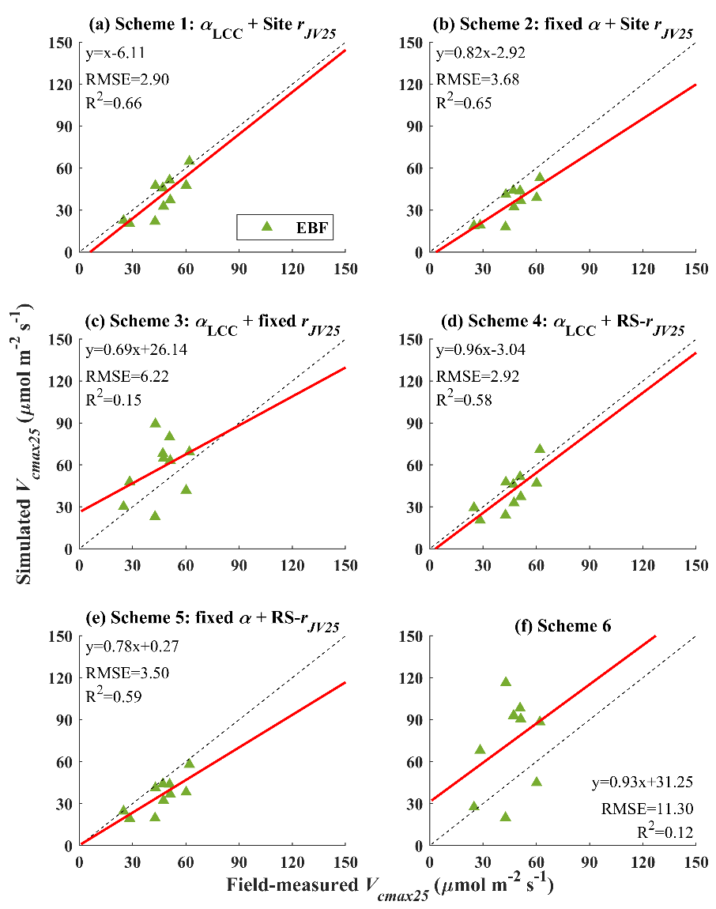
Fig. S6. Comparisons between all field measurements and simulated V_{cmax25} for EBF in (a) Scheme 1 (LCC-based $α$ and Site r_{JV25}), (b) Scheme 2 (fixed $α$ and Site r_{JV25}), (c) Scheme 3 (LCC-based $α$ and fixed r_{JV25}), (d) Scheme 4 (LCC-based $α$ and RS-r_{JV25}), (e) Scheme 5 (fixed leaf $α$ and RS-r_{JV25}), and (f) Scheme 6 (variations in $α$ and r_{JV25} were not incorporated to constrain the model) over the growing season at 18 sites. The red lines are the regression lines, and the black dashed lines are the 1:1 lines.

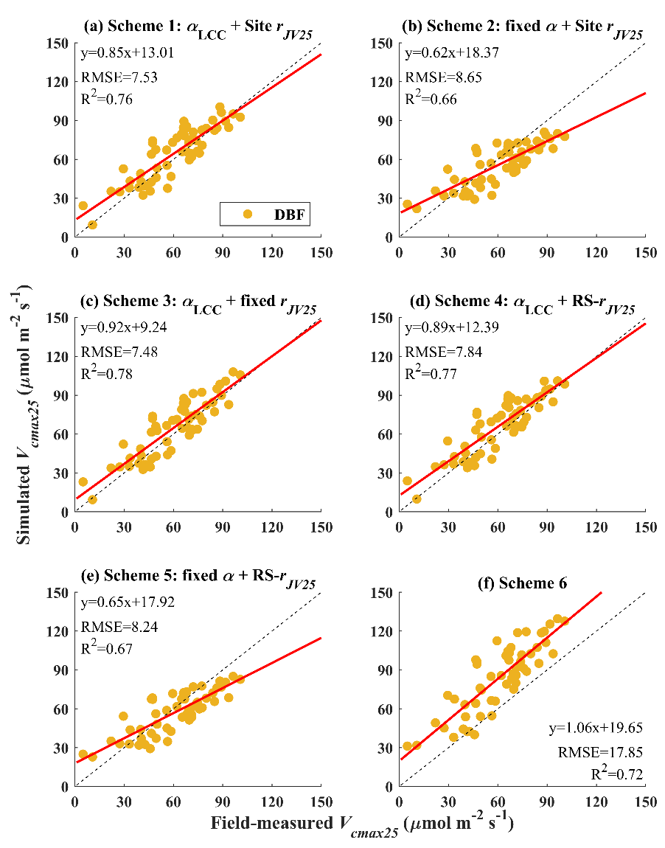
Fig. S7. Comparisons between all field measurements and simulated V_{cmax25} for DBF in (a) Scheme 1 (LCC-based $α$ and Site r_{JV25}), (b) Scheme 2 (fixed $α$ and Site r_{JV25}), (c) Scheme 3 (LCC-based $α$ and fixed r_{JV25}), (d) Scheme 4 (LCC-based $α$ and RS-r_{JV25}), (e) Scheme 5 (fixed leaf $α$ and RS-r_{JV25}), and (f) Scheme 6 (variations in $α$ and r_{JV25} were not incorporated to constrain the model) over the growing season at 18 sites. The red lines are the regression lines, and the black dashed lines are the 1:1 lines.

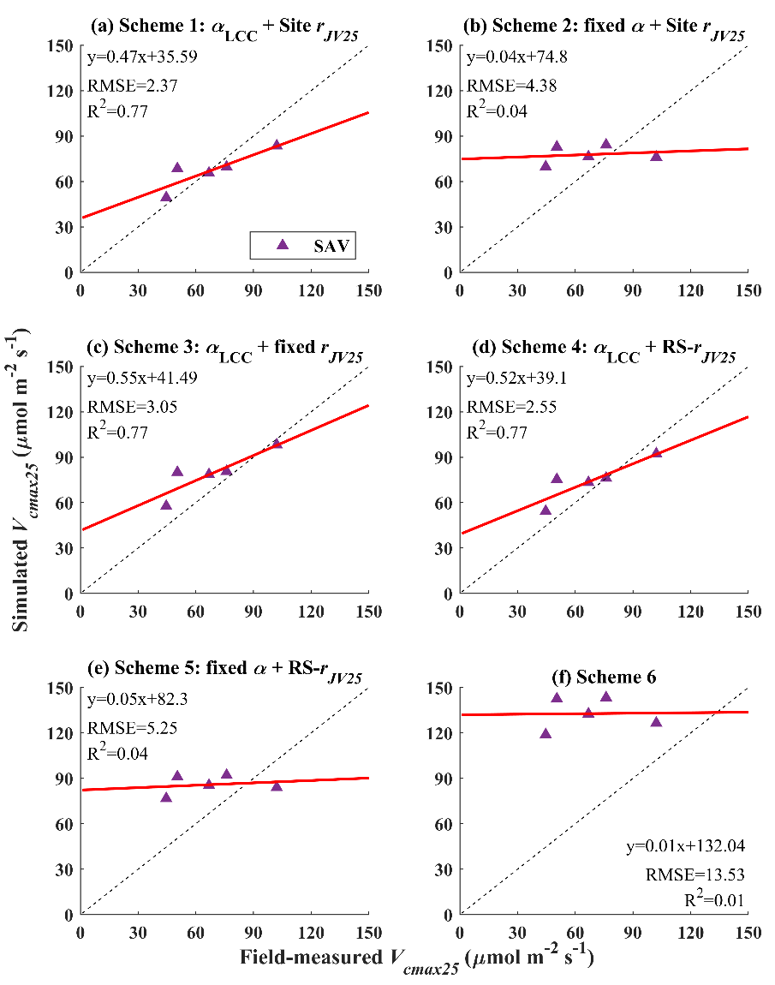
Fig. S8. Comparisons between all field measurements and simulated V_{cmax25} for SAV in (a) Scheme 1 (LCC-based $α$ and Site r_{JV25}), (b) Scheme 2 (fixed $α$ and Site r_{JV25}), (c) Scheme 3 (LCC-based $α$ and fixed r_{JV25}), (d) Scheme 4 (LCC-based $α$ and RS-r_{JV25}), (e) Scheme 5 (fixed leaf $α$ and RS-r_{JV25}), and (f) Scheme 6 (variations in $α$ and r_{JV25} were not incorporated to constrain the model) over the growing season at 18 sites. The red lines are the regression lines, and the black dashed lines are the 1:1 lines.

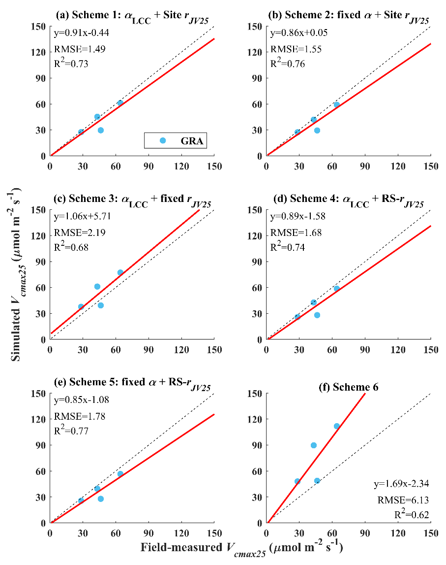
Fig. S19. Comparisons between all field measurements and simulated V_{cmax25} for GRA in (a) Scheme 1 (LCC-based $α$ and Site r_{JV25}), (b) Scheme 2 (fixed $α$ and Site r_{JV25}), (c) Scheme 3 (LCC-based $α$ and fixed r_{JV25}), (d) Scheme 4 (LCC-based $α$ and RS-r_{JV25}), (e) Scheme 5 (fixed leaf $α$ and RS-r_{JV25}), and (f) Scheme 6 (variations in $α$ and r_{JV25} were not incorporated to constrain the model) over the growing season at 18 sites. The red lines are the regression lines, and the black dashed lines are the 1:1 lines.

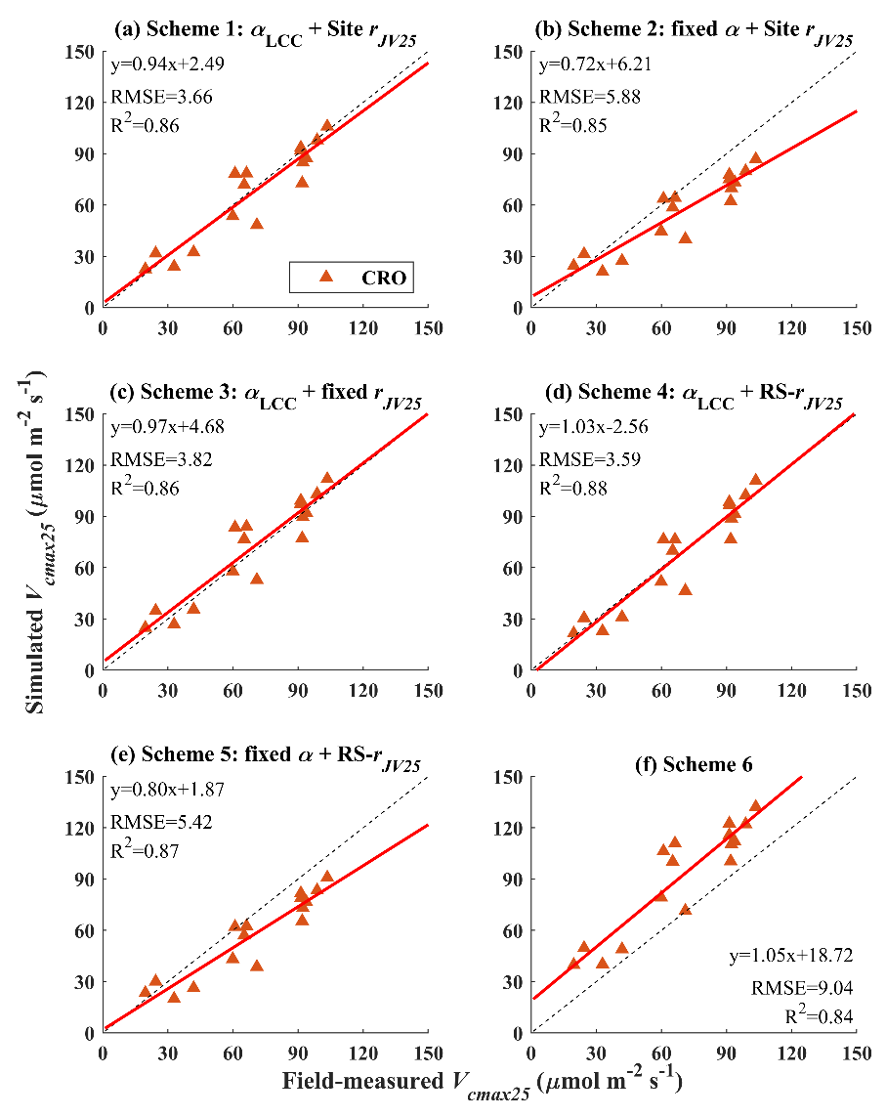
Fig. S10. Comparisons between all field measurements and simulated V_{cmax25} for CRO in (a) Scheme 1 (LCC-based $α$ and Site r_{JV25}), (b) Scheme 2 (fixed $α$ and Site r_{JV25}), (c) Scheme 3 (LCC-based $α$ and fixed r_{JV25}), (d) Scheme 4 (LCC-based $α$ and RS-r_{JV25}), (e) Scheme 5 (fixed leaf $α$ and RS-r_{JV25}), and (f) Scheme 6 (variations in $α$ and r_{JV25} were not incorporated to constrain the model) over the growing season at 18 sites. The red lines are the regression lines, and the black dashed lines are the 1:1 lines.

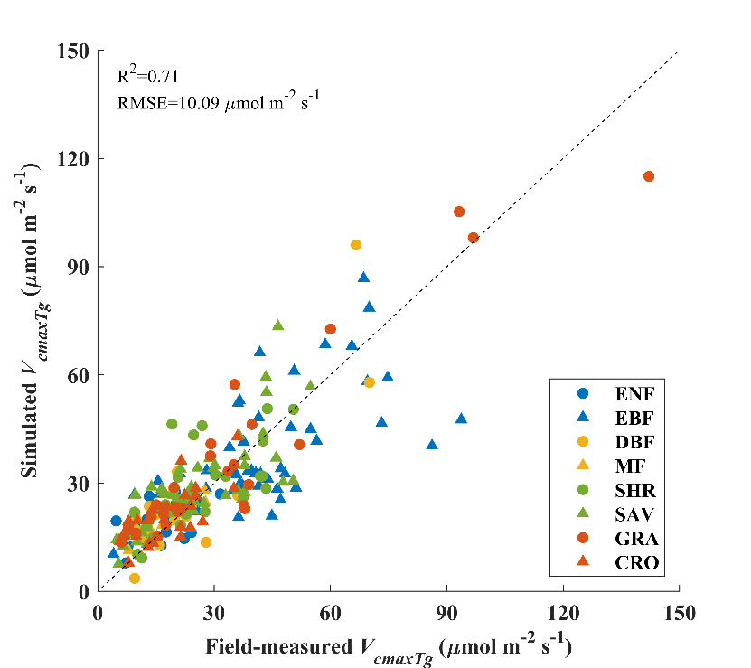
Fig. S11. Comparison between the simulated V_{cmaxTg} (μmol·m⁻²·s⁻¹) of Scheme 4 (LCC-based $α$ and RS-r_{JV25}) and field measurements in the global observation dataset. The black dash line is the 1:1 line.

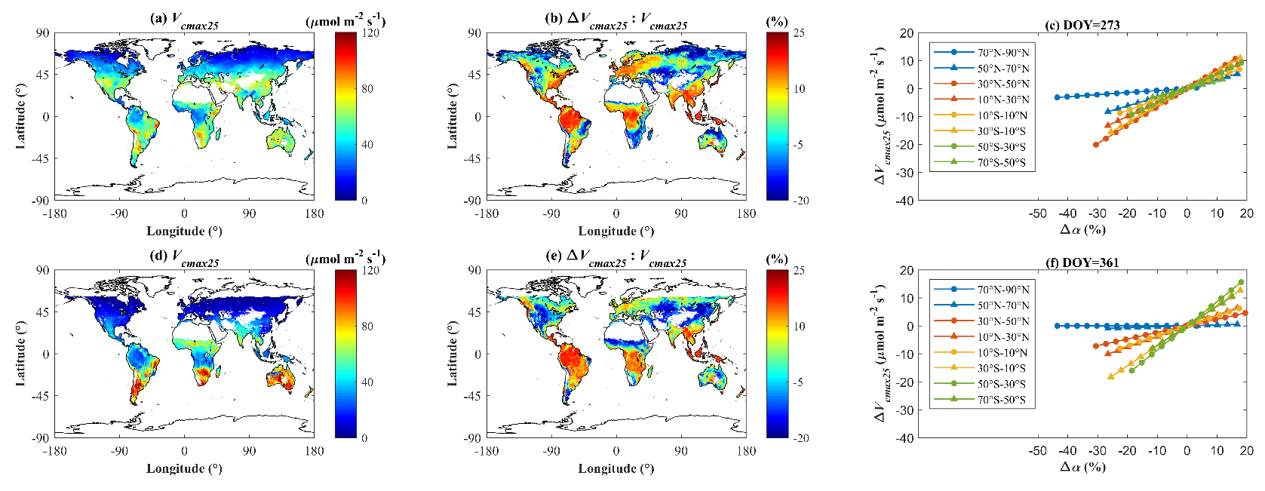
Fig. S12. (a) and (d) Global distributions of simulated V_{cmax25} of Scheme 4 (LCC-based $α$ and RS-r_{JV25}) at DOY 273 and 361, respectively; (b) and (e) Global distributions of ΔV_{cmax25} relative to Scheme 4 at DOY 273 and 361, respectively; (c) and (f) Sensitivity of ΔV_{cmax25} to variations in $α$ in different regions at DOY 273 and 361, respectively.

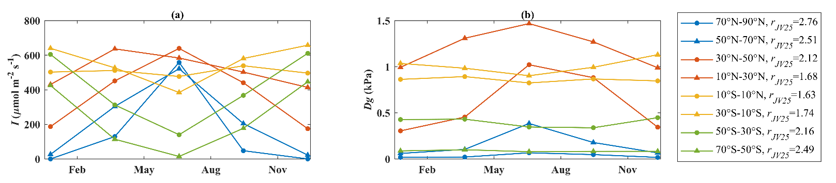
Fig. S13. Averaged (a) I and (b) D for different latitudinal regions used in the sensitivity test in Figs. 7 and S12.

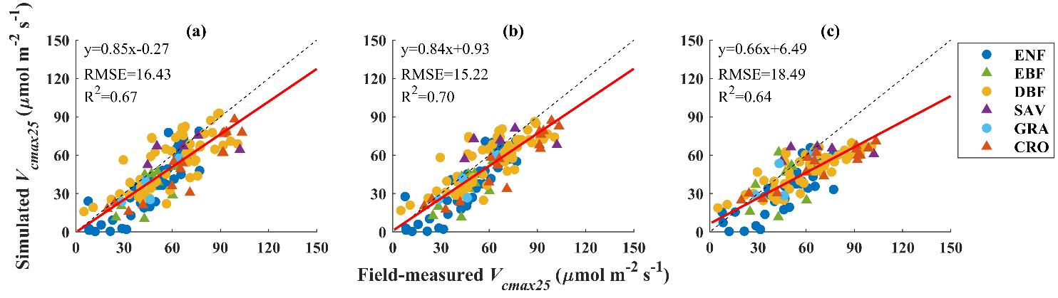
Fig. S14. Comparisons between all field measurements at 18 sites and (a) the canopy-average V_{cmax25} simulated using Eq. 15 with canopy-averaged APAR, (b) the top-leaf V_{cmax25} converted from (a) based on the empirical nitrogen vertical distribution coefficient, and (c) the top-leaf V_{cmax25} simulated using the model version in Jiang et al. (2020) with canopy-averaged APAR and the empirical nitrogen vertical distribution coefficient. The empirical nitrogen vertical distribution coefficient was estimated using the method in Jiang et al. (2020). Site r_{JV25} was adopted in (a) and (b). The red lines are the regression lines, and the black dashed lines are the 1:1 lines.

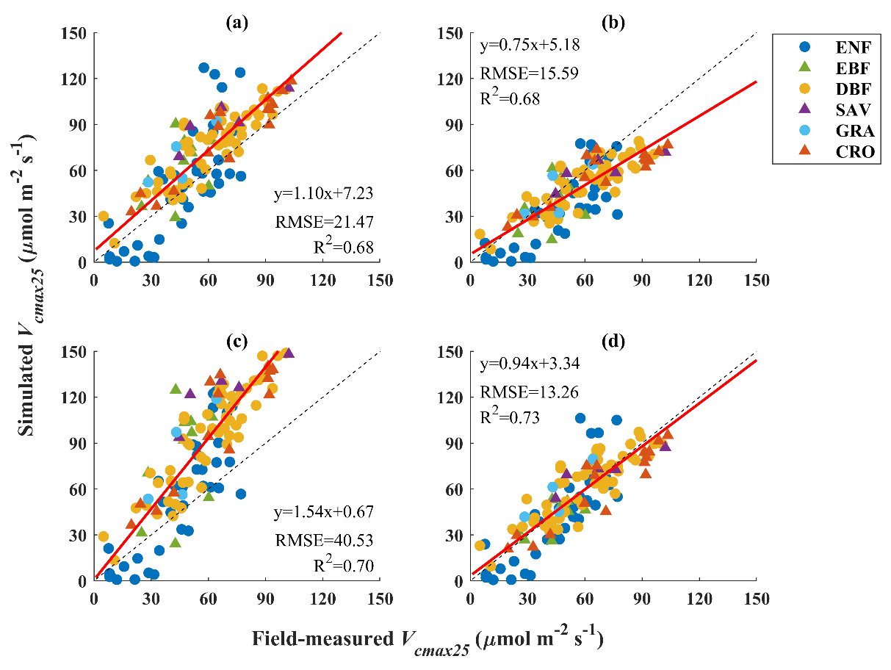
Fig. S15. Comparisons between all field measurements at 18 sites and (a) V_{cmax25} simulated using the model version in Smith et al. (2019), (b) V_{cmax25} simulated using the model version in Jiang et al. (2020), (c) V_{cmax25} simulated using the model version in Peng et al. (2021), and (d) V_{cmax25} simulated using Eq. 15 with r_{JV25} estimated empirically from T_{g}. All inputs for the four simulations were the same as Scheme 1 except for r_{JV25}. The red lines are the regression lines, and the black dashed lines are the 1:1 lines.

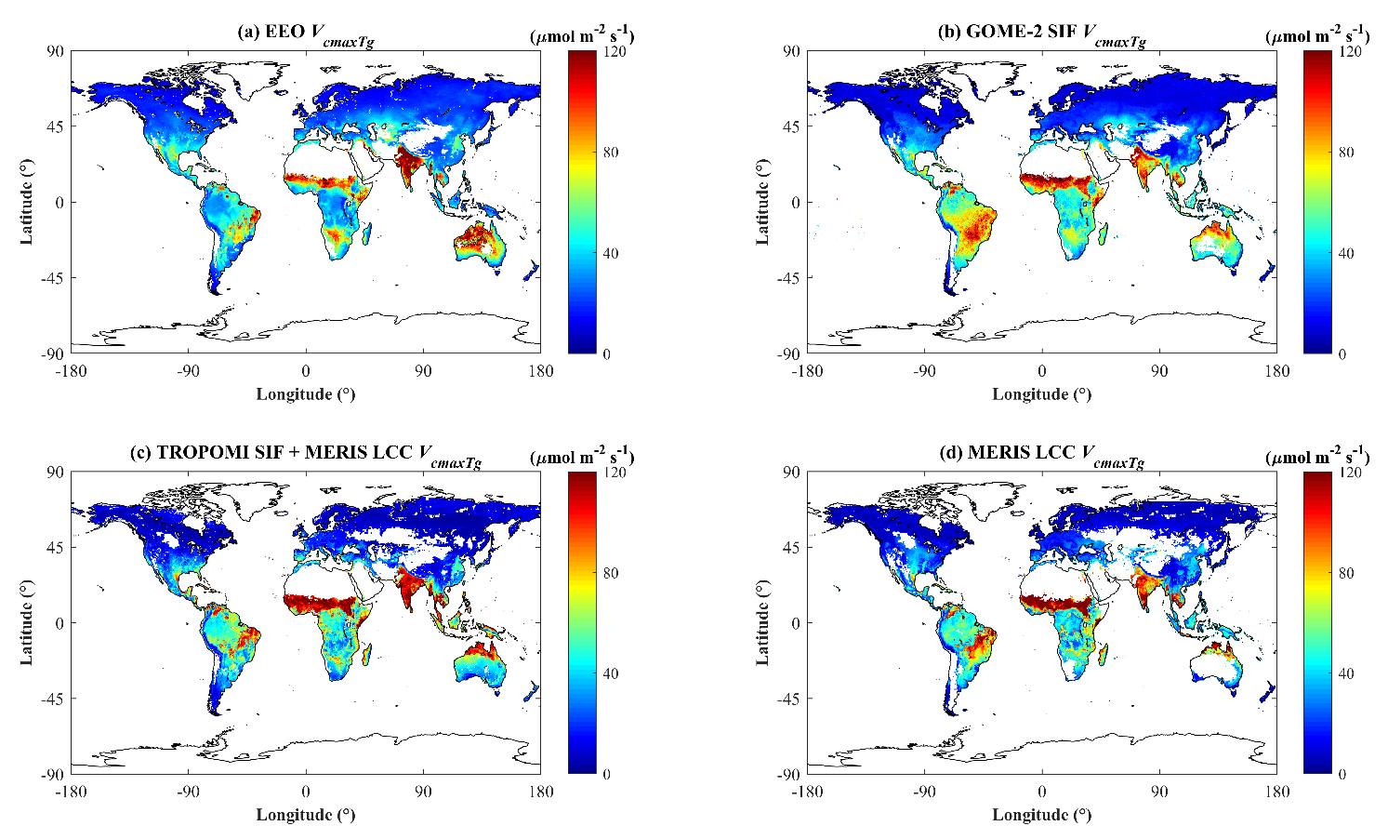
Fig. S16. Global distributions of V_{cmax} at the growth temperature (V_{cmaxTg}) derived using (a) the EEO model in this study, (b) GOME-2 SIF, (c) TROPOMI SIF and MERIS LCC, and (d) MERIS LCC. The remote-sensing-based V_{cmaxTg} datasets in (b)-(d) are from Chen et al. (2022).

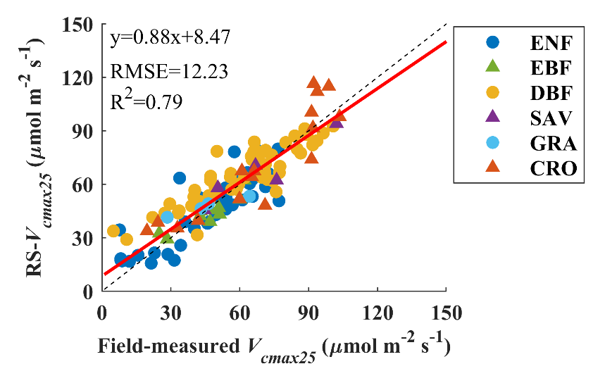
Fig. S17. Comparisons between all field measurements at 18 sites and V_{cmax25} derived in a data assimilation system from MODIS LCC and TROPOMI SIF. The red lines are the regression lines, and the black dashed lines are the 1:1 lines.

References
Arellano, P., Tansey, K., Balzter, H., & Boyd, D. S. (2017a). Field spectroscopy and radiative transfer modelling to assess impacts of petroleum pollution on biophysical and biochemical parameters of the Amazon rainforest. Environmental Earth Sciences, 76, 1-14.
Arellano, P., Tansey, K., Balzter, H., & Tellkamp, M. (2017b). Plant family-specific impacts of petroleum pollution on biodiversity and leaf chlorophyll content in the Amazon rainforest of Ecuador. PloS one, 12(1), e0169867.
Chen, J. M., Wang, R., Liu, Y., He, L., Croft, H., Luo, X., ... & Dong, N. (2022). Global datasets of leaf photosynthetic capacity for ecological and earth system research. Earth System Science Data, 14(9), 4077-4093.
Darvishzadeh, R., Skidmore, A., Schlerf, M., & Atzberger, C. (2008). Inversion of a radiative transfer model for estimating vegetation LAI and chlorophyll in a heterogeneous grassland. Remote sensing of environment, 112(5), 2592-2604.
De Santis, A., Chuvieco, E., & Vaughan, P. J. (2009). Short-term assessment of burn severity using the inversion of PROSPECT and GeoSail models. Remote Sensing of Environment, 113(1), 126-136.
Enrique, G., Olmo, Manuel, Poorter, Hendrik, Ubera, Jose Luis, Villar, Rafael, 2016. Leaf mass per area (LMA) and its relationship with leaf structure and anatomy in 34 Mediterranean woody species along a water availability gradient. PLoS One, 11(2), e0148788.
Feret, J. B., François, C., Gitelson, A., Asner, G. P., Barry, K. M., Panigada, C., ... & Jacquemoud, S. (2011). Optimizing spectral indices and chemometric analysis of leaf chemical properties using radiative transfer modeling. Remote sensing of environment, 115(10), 2742-2750.
Jacquemoud, S., Bacour, C., Poilve, H., & Frangi, J. P. (2000). Comparison of four radiative transfer models to simulate plant canopies reflectance: Direct and inverse mode. Remote Sensing of Environment, 74(3), 471-481.
Jiang, C., Ryu, Y., Wang, H., & Keenan, T. F. (2020). An optimality‐based model explains seasonal variation in C3 plant photosynthetic capacity. Global Change Biology, 26(11), 6493-6510.
Kötz, B., Schaepman, M., Morsdorf, F., Bowyer, P., Itten, K., & Allgöwer, B. (2004). Radiative transfer modeling within a heterogeneous canopy for estimation of forest fire fuel properties. Remote Sensing of Environment, 92(3), 332-344.
Peng, Y., Bloomfield, K. J., Cernusak, L. A., Domingues, T. F., & Colin Prentice, I. (2021). Global climate and nutrient controls of photosynthetic capacity. Communications Biology, 4(1), 462.
Smith, N. G., Keenan, T. F., Colin Prentice, I., Wang, H., Wright, I. J., Niinemets, Ü., ... & Zhou, S. X. (2019). Global photosynthetic capacity is optimized to the environment. Ecology letters, 22(3), 506-517.
Sow, M., Mbow, C., Hély, C., Fensholt, R., & Sambou, B. (2013). Estimation of herbaceous fuel moisture content using vegetation indices and land surface temperature from MODIS data. Remote Sensing, 5(6), 2617-2638.

