Supplementary information
Figure S1-20 and Figure S legends:
Fig. S1 MCM5 expression in cancer and cell lines.
a. 1.Alveolar Rhabdomyosarcoma; 2.Anaplastic Ependymoma; 3.Anaplastic Renal Wilms Tumor; 4. Atypical Teratoid/Rhabdomyoid tumor; 5.B-cell lymphoblastic Acute leukemia (deep red box);Glioblastoma; 6.Brain Glioblastoma; 7.Desmoplastic medulloblastoma; 8.Embryonial Rhabdomyosarcoma; 9.Ependymoma; 10.Ewing's Sarcoma of Bone; 11.Extraosseous Ewing's Sarcoma; 12.Giant Cell Glioblastoma; 13.Glioblastoma; 14.Medulloblastoma; 15.Neuroblastoma; 16.Osteosarcoma; 17.Pleomorphic Xanthoastrocytoma; 18.Renal Wilms Tumor; 19. Rhabdooid Tumor of the Kidney; 20. T-cell Acute lymphoblastic leukemia (red box). b: The protein level of MCM5 in cell lines was detected by WB assay. Renal fibroblasts (COS-7), human acute T lymphocytic leukemia cell line (CEM, Jurkat, Molt4); c: Use ImageJ software to analyze the protein level of MCM5. For b, the data were presented as means ± SD; The P values (t-test; two-tailed) “*” P＜0.05; “**” P＜0.01.

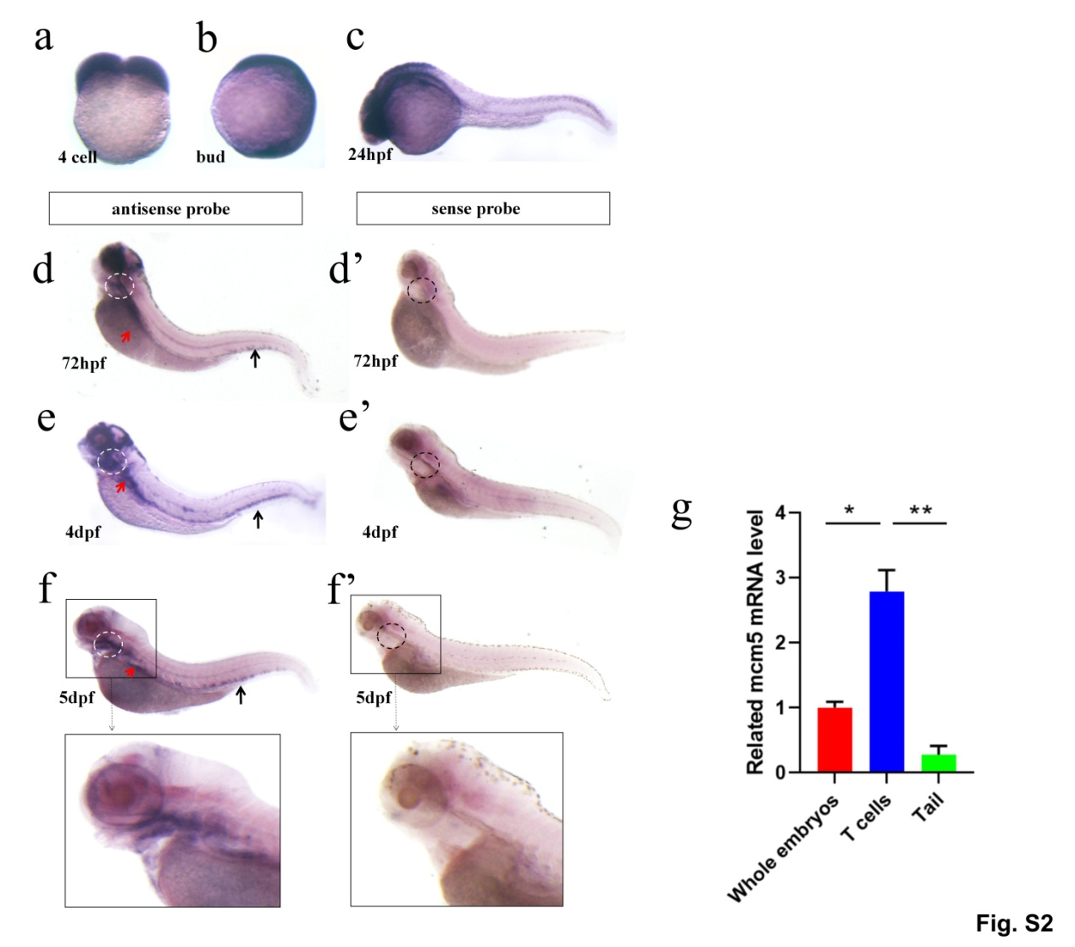
Fig. S2 Expression of mcm5 at different developmental stage and in different tissues
(a) Expression of mcm5 indicated mcm5 was a maternal expressed gene. (b) mcm5 was expressed ubiquitously at bud stage. (c) At 24 hours post fertilization (hpf), mcm5 was restricted in head eyes and endoderm. (d-f) The expression of mcm5 was restricted in eyes, the boundary of hindbrain and midbrain, gills and thymus area (white/black circles showed), endoderm organ (red arrow showed) and caudal hematopoietic tissue (CHT) (black arrow showed). (g) Immature T cells was sorted on 5 dpf, then the whole embryos, the T cells and the tails were used to examine the relative level of mcm5 expression using RT-qPCR. The level of mcm5 expression in T cells was higher than that in tails and whole embryos. For g, the data was presented as means ± SD; The P values (t-test; two-tailed), “*” P＜0.05; “**” P＜0.01.

Fig. S3 The related information about mcm5 mutants
(a) In the exon3 of mcm5 gene, 23bp nucleotides was exchanged with another 65 bp nucleotide (a1, showed on the left, blue box), which results in pre-stop codon in the CDs region (a2) and a truncated MCM5 protein (a3). (b) PCR amplification of the genomic DNA in wild type embryos (a single and short band), heterozygotes (a longer band and a short band) and homozygotes embryos (a single longer band). (c) Living embryos of sibling and mcm5^{-/-} embryos on 3dpf, 4dpf and 5dpf. The eye and the head in mcm5^{-/-} embryos was smaller (red box showed), and the swimming bladder was disappeared in mcm5^{-/-} embryos. (d) The expression of mcm5 mRNA was greatly downregulated in mcm5^{-/-} embryos at bud stage and 24hpf, even disappeared in eyes, boundary of hindbrain and midbrain, thymus area and CHT region on 3dpf. (e) RT-qPCR was used to examine the level of mcm5 mRNA in controls and mcm5^{-/-} embryos, the control siblings are wild type embryos. (f) RT-qPCR was used to examine the level of mcm5 mRNA in thymus region in controls and mcm5^{-/-} embryos. For e and f, the data were presented as means ± SD; The P values (t-test; two-tailed), “*” P＜0.05; “**” P＜0.01; “***” P＜0.001.

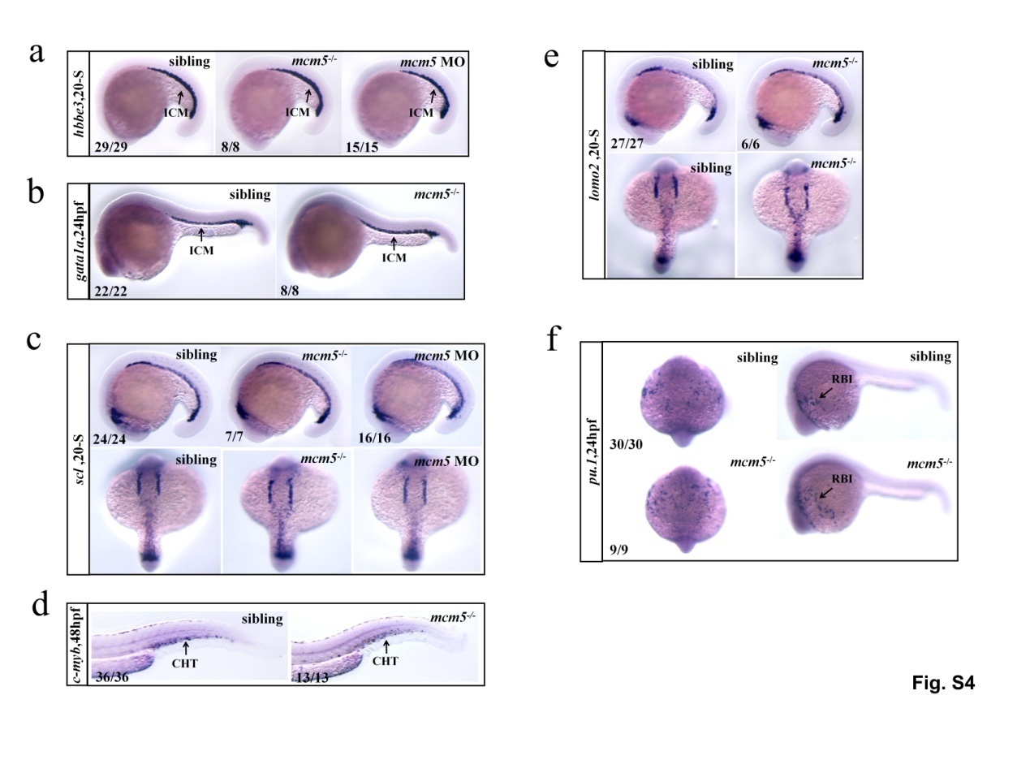
Fig. S4 Mcm5 loss of function does not influence the primary hematopoiesis at early stage
(a-b) The expression of the erythrocyte markers hbbe3 and gata1a were examined. No different was observed for the expression of hbbe3 in controls (n=29), mcm5^{-/-} embryos (n=8) and mcm5 morphants (n=15) at 20 Somite stage (SS) (a). Expression of gata1a in siblings (n=22) and mcm5^{-/-} embryos (n=8) was examined at 24 hpf (b), there is no difference between these two groups of embryos. (c-d) The expression of the HSCs markers scl and c-myb were examined. Expression of scl in siblings (n=24), mcm5^{-/-} (n=7) and mcm5 morphants (n=16) was similar at 20 SS(c). Expression of c-myb in siblings (n=36) and mcm5^{-/-} embryos (n=13) was same at 48hpf (d). (e) Expression of lmo2, the primitive hematopoietic regulator, was checked in siblings (n=27) and mcm5^{-/-}embryos (n=6) at 20 SS, there is no difference between them. (f) Myelopoiesis regulator pu.1 was examined and the expression of pu.1 in siblings (n=30) and mcm5^{-/-} embryos (n=9) was similar at 24hpf.
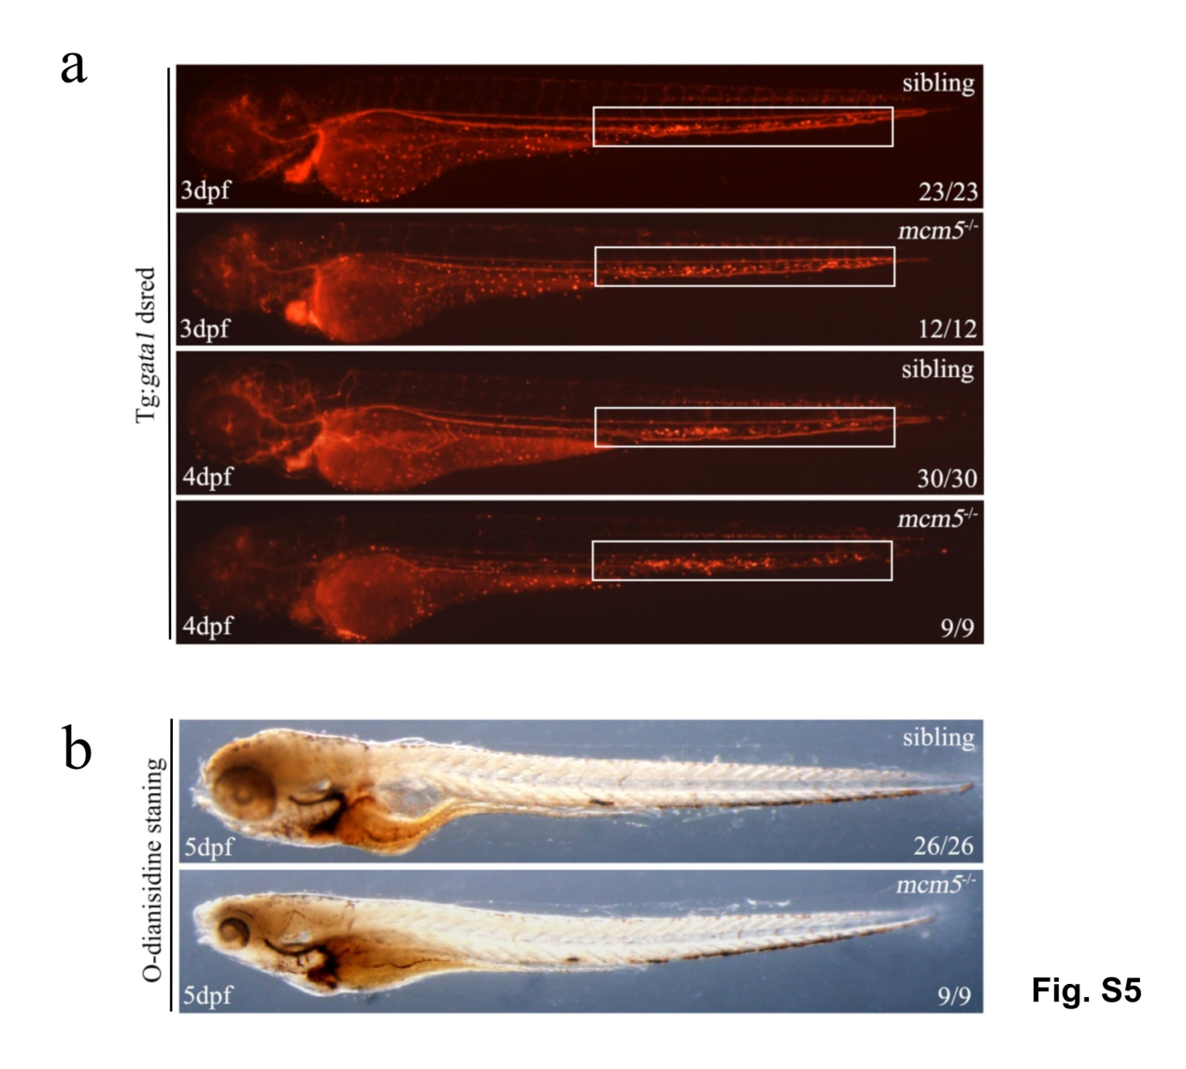
Fig. S5 The role of mcm5 was not observed in erythropoiesis
(a) Erythrocyte development was evaluated on 3dpf and 4dpf for siblings and mcm5^{-/-} embryos in Tg(gata1a: desRed) transgenic line background. (b) Erythrocyte staining with o-dianisidine showed no different in siblings and mcm5^{-/-} embryos on 5dpf. 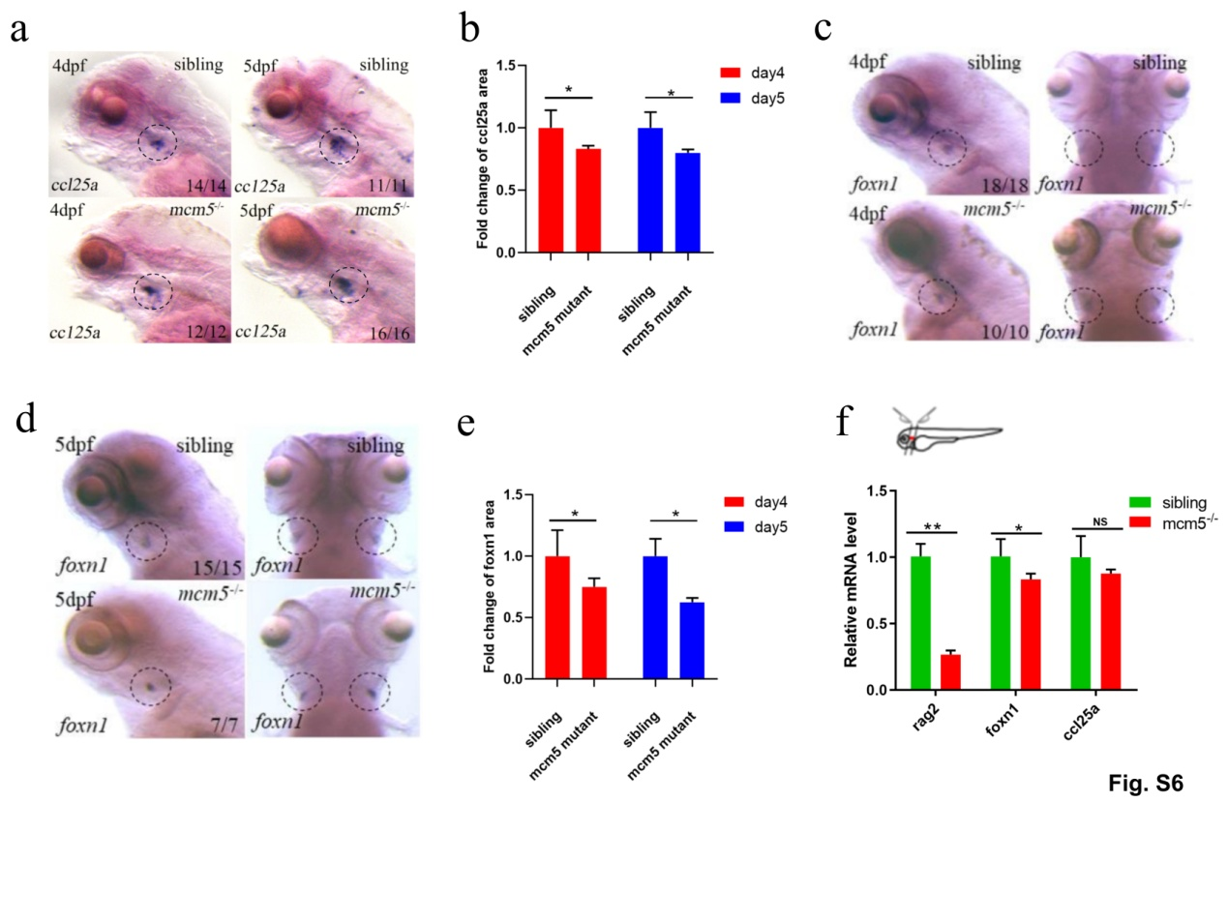 Fig. S6 The expression of thymus marker ccl25a and foxn1
(a) Expression of ccl25a in siblings and mcm5^{-/-} embryos on 4dpf and 5dpf. The quantification analysis showed that the area of ccl25a expression was decreased in mcm5 mutants (b).(C-D)The area of foxn1 expression was decreased on 4dpf (c) and 5dpf (d). (e) The quantification analysis showed that the area of foxn1 expression was decreased in mcm5 mutants. (f) The thymus and the around region was cut and collected, which was used to examine the expression level of rag2, foxn1 and ccl25a. The level of rag2 expression was greatly decreased, the level of foxn1 expression was mild decreased. For b, e and f, the data were presented as means ± SD; The P values (t-test; two-tailed); “*” P＜0.05; “**” P＜0.01.

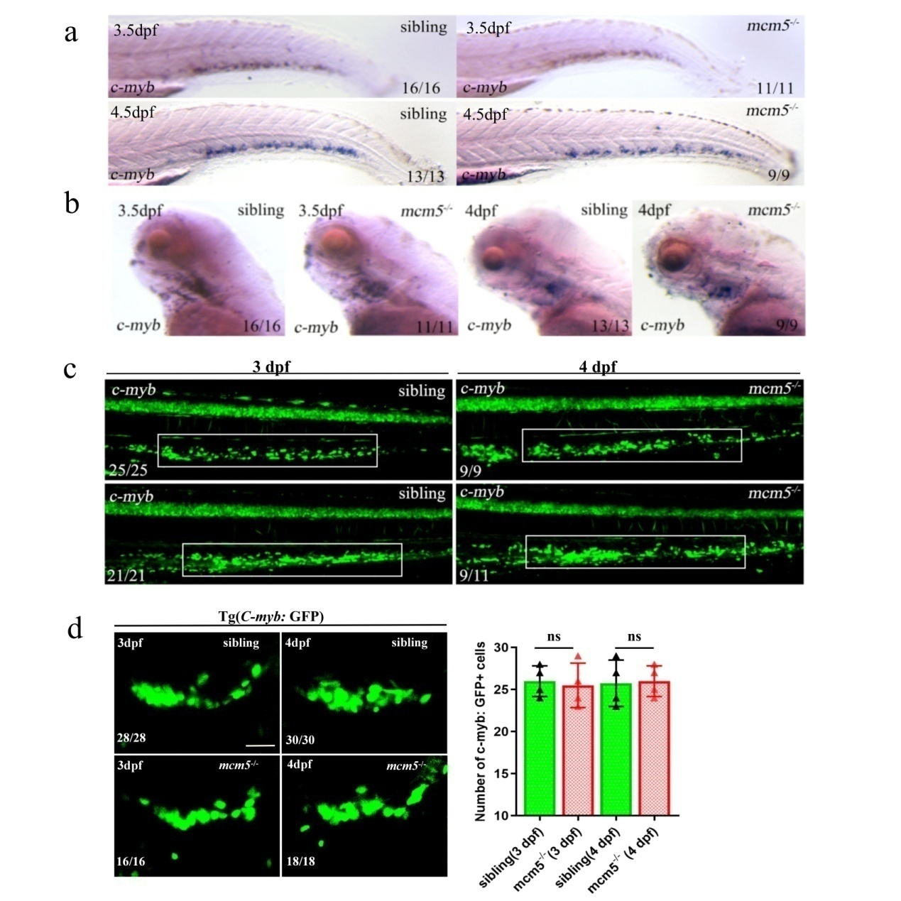
Fig. S7 HSCs development was not disturbed greatly in mcm5^{-/-}embryos.
(a-b) HSCs were analyzed in siblings and mcm5^{-/-} embryo using in situ experiments on 3.5dpf and 4.5dpf. No big difference was observed for the expression of c-myb in the CHT (a) and thymus area (b) in siblings and mcm5^{-/-} embryos on 3.5dpf and 4.5dpf. (c-d) The HSCs in the CHT (c) and thymus area (d) were examined using Tg (c-myb:GFP) transgenic line, no distinct difference was observed in siblings and mcm5^{-/-} embryos on 3dpf and 4dpf. Scale bars, 40μm. For d, the data was presented as means ± SD; The P values (t-test; two-tailed), NS, not significant.

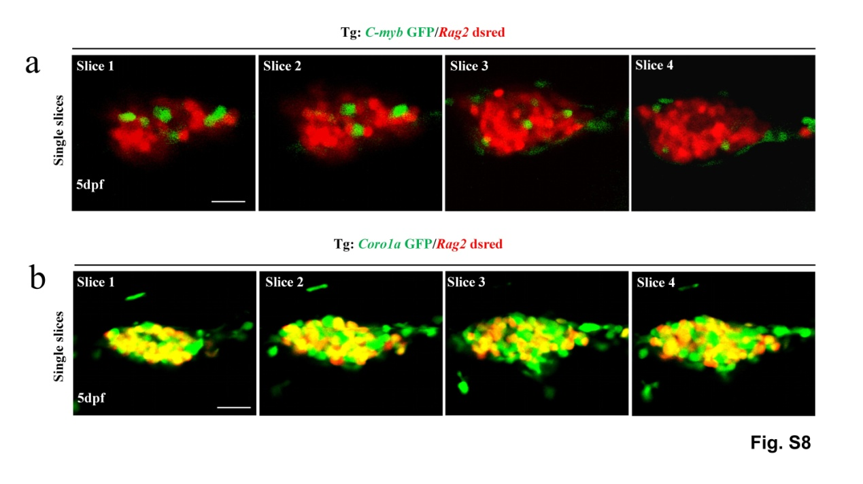
Fig. S8 Most of immature T cells was labeled with Coro1a:GFP positive cells
(a) Live image of rag2:desRed positive immature T cells (Red cells) and c-myb:GFP positive HSCs in different single slices in Fig. 2b. Only small part of immature T cells was labeled with GFP (yellow column, 3%). (b) Live image of rag2:desRed positive immature T cells and coro1a:GFP positive cells in single slices in Fig. 2c. 82.4% of desRed positive cells were overlapped with GFP labeled cells (yellow column). Scale bars, 30μm.

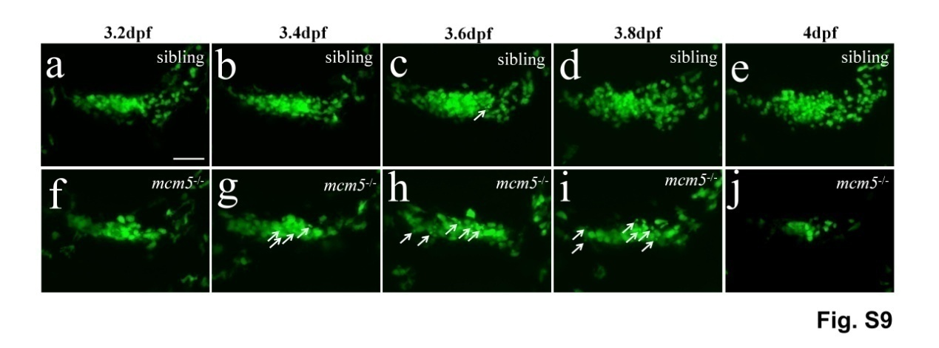
Fig. S9 Live image of coro1a:GFP labeled cells in Tg(coro1a:GFP) embryo.
(a-e) Live image of coro1a:GFP cells in siblings. From 3.2dpf to 4dpf, the coro1a:GFP labeled cells increased (a-e), only occasional apoptosis like cell appeared (c, d, arrow showed). (f-j) Live image of coro1a:GFP cells in mcm5^{-/-} embryos. Comparing with the siblings, the coro1a:GFP cell number was not significant different before 3.4dpf (g), but from this stage and later, more coro1a:GFP cells displayed apoptosis-like phenotype (g-i, arrow showed), and the coro1a:GFP cell number decreased (h-j). Scale bars, 40μm.

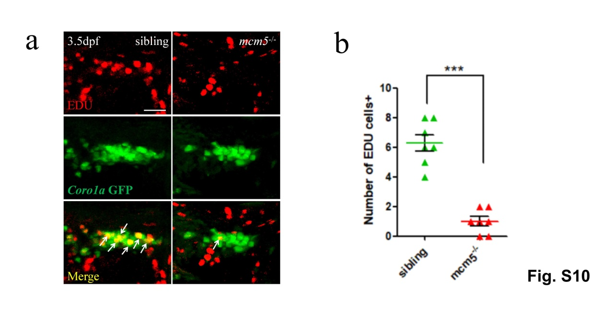
Fig. S10 The Edu incorporation assay.
(a) EdU incorporation was assessed in siblings (left showed) and mcm5^{-/-}embryos (right showed) on 3.5dpf. (b) Statistic analysis showed that the coro1a:GFP cell labeled with EdU was significantly decreased in mcm5^{-/-} embryos (n=7 for siblings and mutants). For b, the data was presented as means ± SD; The P values (t-test; two-tailed); “***” P＜0.001. Scale bars, 40μm.

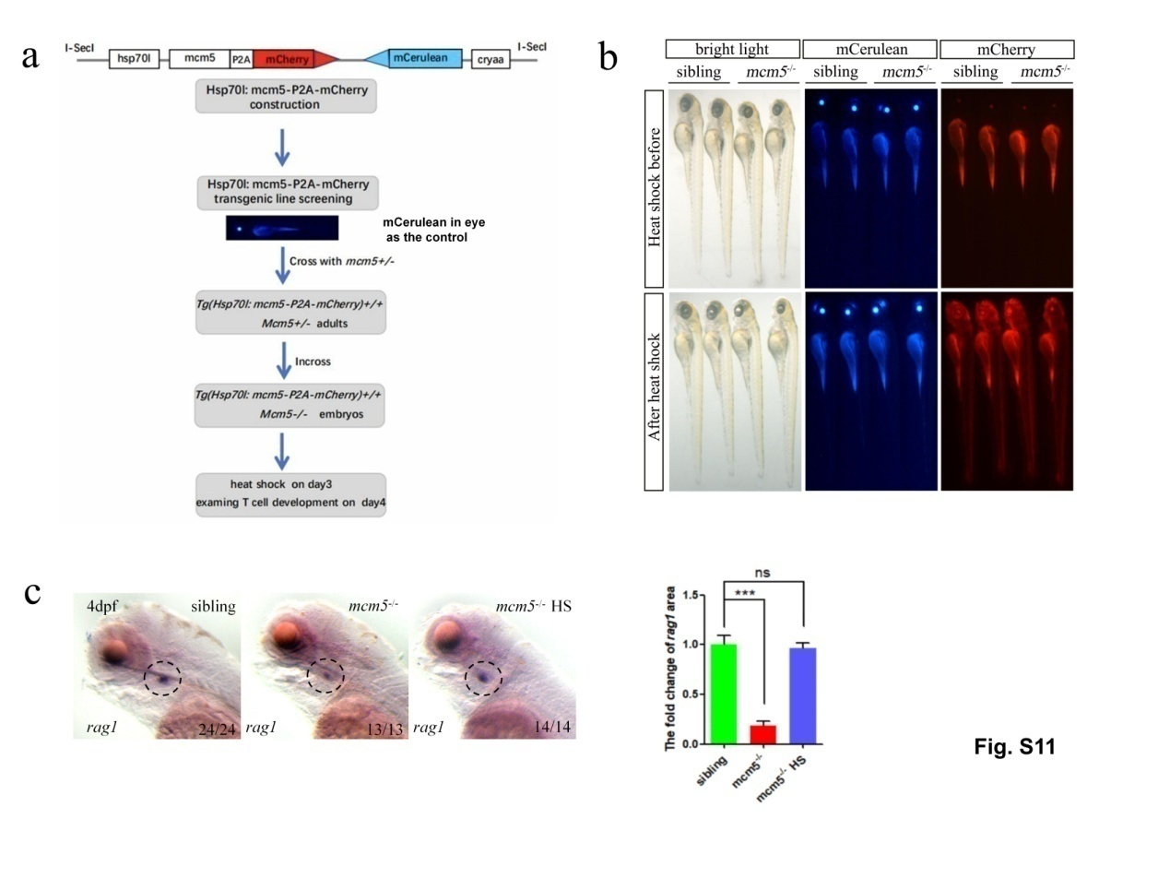
Fig. S11 Induced expression of mcm5 on 3dpf rescued the T lymphocyte developmental defect in mcm5^{-/-} embryos.
(a) Schematic for the construction of the transgenic line Tg(Hsp70l:mcm5-T2A-mCherry), and how to use it to carry out rescue experiment in specific stage. The mCerulean in eyes is used as a control, the embryos with mCerulean in eyes are Tg(Hsp70l:mcm5-T2A-mCherry) transgenic embryos. (b) MCM5-T2A-mCherry was extensively induced to express using heat-shock on 3dpf. Before heat shock, the autofluorescence (red) exists in the yolk of embryos. After heat shock, MCM5-P2A-mcherry was induced to express in the whole body, including head, thymus region and truck region. (c) The expression of rag1 was rescued on 4dpf by overexpression of mcm5. For c, the data was presented as means ± SD; The P values (t-test; two-tailed); “NS”, not significant; “***” P < 0.001.
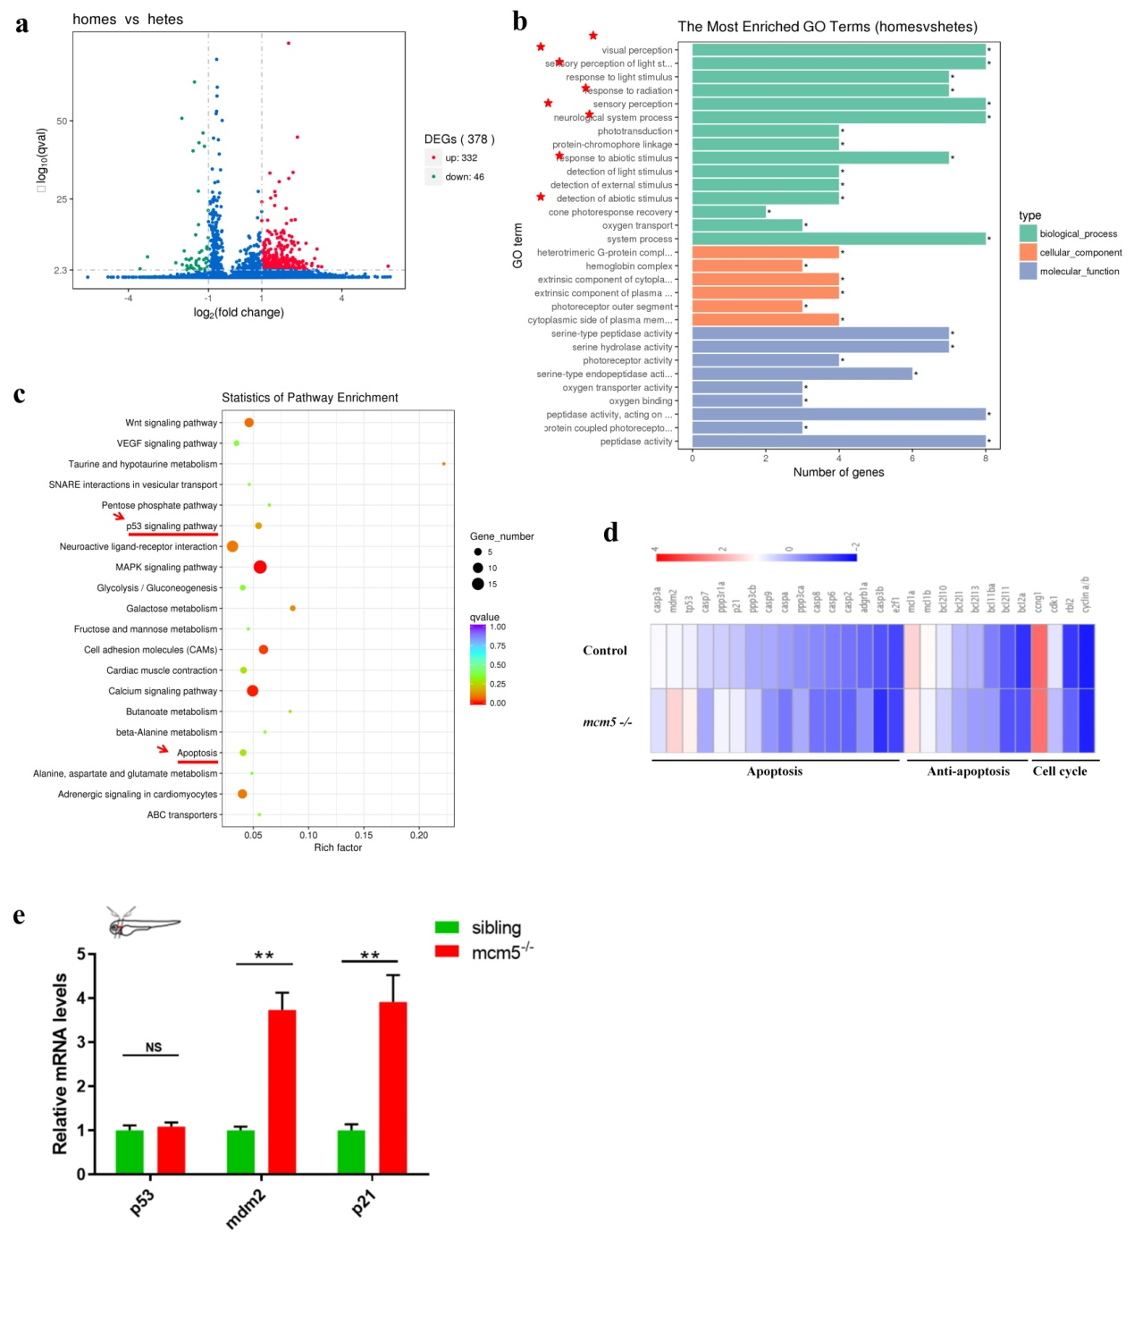
Fig. S12 The transcription analysis in mcm5 mutants and control embryos
(a) In comparing with the controls, 332 genes and 46 genes were up/down regulated significantly in mcm5 mutant embryos. (b) In the down-regulated genes, many of them were neural related genes, especial the genes being related to eye development and function (8/15 of the clusters in biological process). (c) Pathway enrichment analysis showed that the p53 signal and cell apoptosis signal were both up-regulated (red arrows and red lines showed). (d) Detailed analysis of some genes in p53 signal and cell cycle regulation, the apoptosis and the anti-apoptosis related genes were both up-regulated, as well the cell cycle related genes were also changed. (e) The thymus region and the region around thymus were cut from mcm5 mutants and siblings, which were used to evaluate the expression difference of tp21 and mdm2 between mcm5 mutant and siblings using RT-qPCR. The data showed that tp53 signaling downstream gene tp21 and mdm2 was also upregulated in thymus region of mcm5 mutants. For e, the data was presented as means ± SD; The P values (t-test; two-tailed); “NS”, not significant; “**” P < 0.01.

Fig. S13 Treatment with different chemicals resulted in mild T cell development defect.
(a) The transcription level was examined using RT-qPCR for p53, mdm2, p21 and bcl2a. Expression of mdm2 and p21 were upregulated in mcm5^{-/-} embryos and chemical treatment embryos; Expression of bcl2a was upregulated in chemical treatment embryos, but decreased in mcm5^{-/-} embryos. (b) Comparing with controls (b1), after treating with chemicals from 1.5 dpf to 4 dpf the coro:GFP labeled T cells was decreased in embryos treated with aphidicolin (b3), but not as strong as in that of mcm5^{-/-} embryos (b2). (c) c-myb:GFP labeled HSCs was examined in embryos treated with different chemicals from 1.5 dpf to 2.5 dpf (red arrow heads showed). The data showed that in CHT region the member of HSCs was mild decreased (b2-b5). (d) Expression of bcl2a in different kind of embryos at 2.5 dpf after treating with chemicals from 1.5 dpf to 2.5 dpf. Comparing with controls (d1), the expression of bcl2a was decreased in mcm5^{-/-}embryos (d2), the expression of bcl2a was increased in embryos treated with aphidicolin or camptothecin, including in the CHT region (d3, d4, red arrow showed). The data was presented as means ± SD; The P values (t-test; two-tailed); NS, not significant. “*” P < 0.05, “**” P < 0.01, “***” P < 0.001.

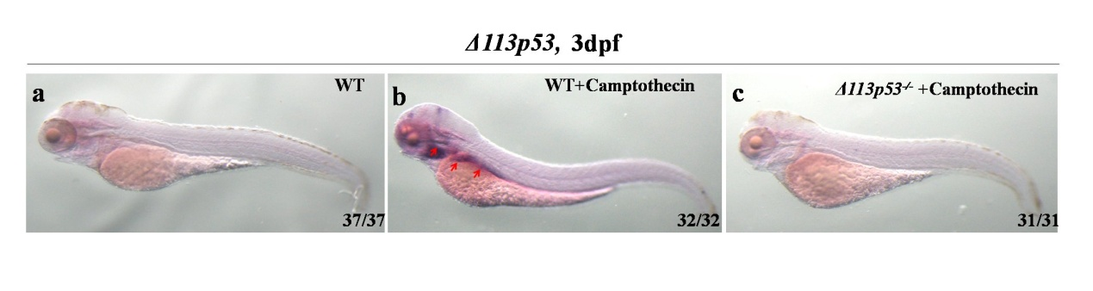
Fig. S14 Expression of Δ113p53 could not be increased in Δ113p53^{-/-} embryos when campothecin treatment was applied
(a) In wild type embryos, no expression of Δ113p53 was observed in thymus, endodermal organs and the boundary of midbrain and hindbrain. (b) While its expression in these regions was upregulated in embryos treated with campothecin (red arrows showed). (c) Δ113p53 expression was not observed in Δ113p53^{-/-} embryos.
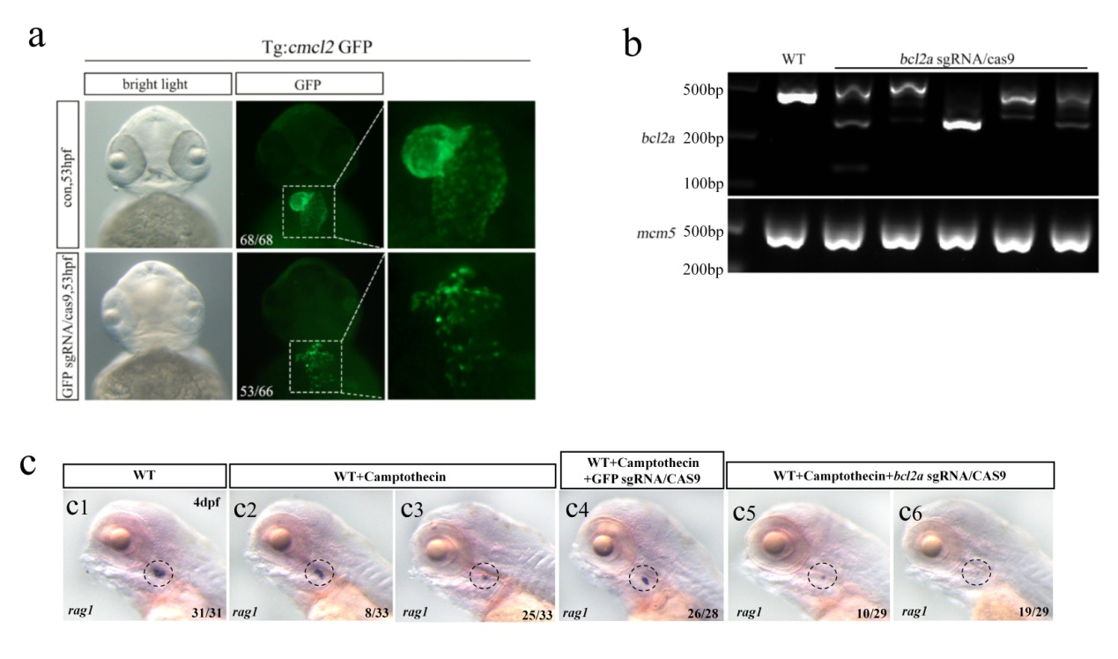
Fig. S15 bcl2a loss of function enhanced T lymphocytes phenotype in embryos treated with camptothecin
(a, b) 3 sgRNAs targeting GFP were synthesized and co-injected with Cas9 protein into the Tg(cmlc2:GFP) embryos at one-cell stage, the genome was edited and the GFP expression was greatly down-regulated in the heart (a), indicating the gene editing system works well; and 4 sgRNAs targeting bcl2a were co-injected with Cas9 protein into the embryos, most of genome was edited (b). (c) On 4dpf, comparing with that of controls, the expression of rag1 was decreased in embryos treated with camptothecin (c1-c3). When the embryos were treated with camptothecin, comparing to injection with GFP sgRNAs/Cas9 complex (c4), injection with bcl2a sgRNAs/Cas9 enhanced the T lymphocytes developmental defect (c5-6).

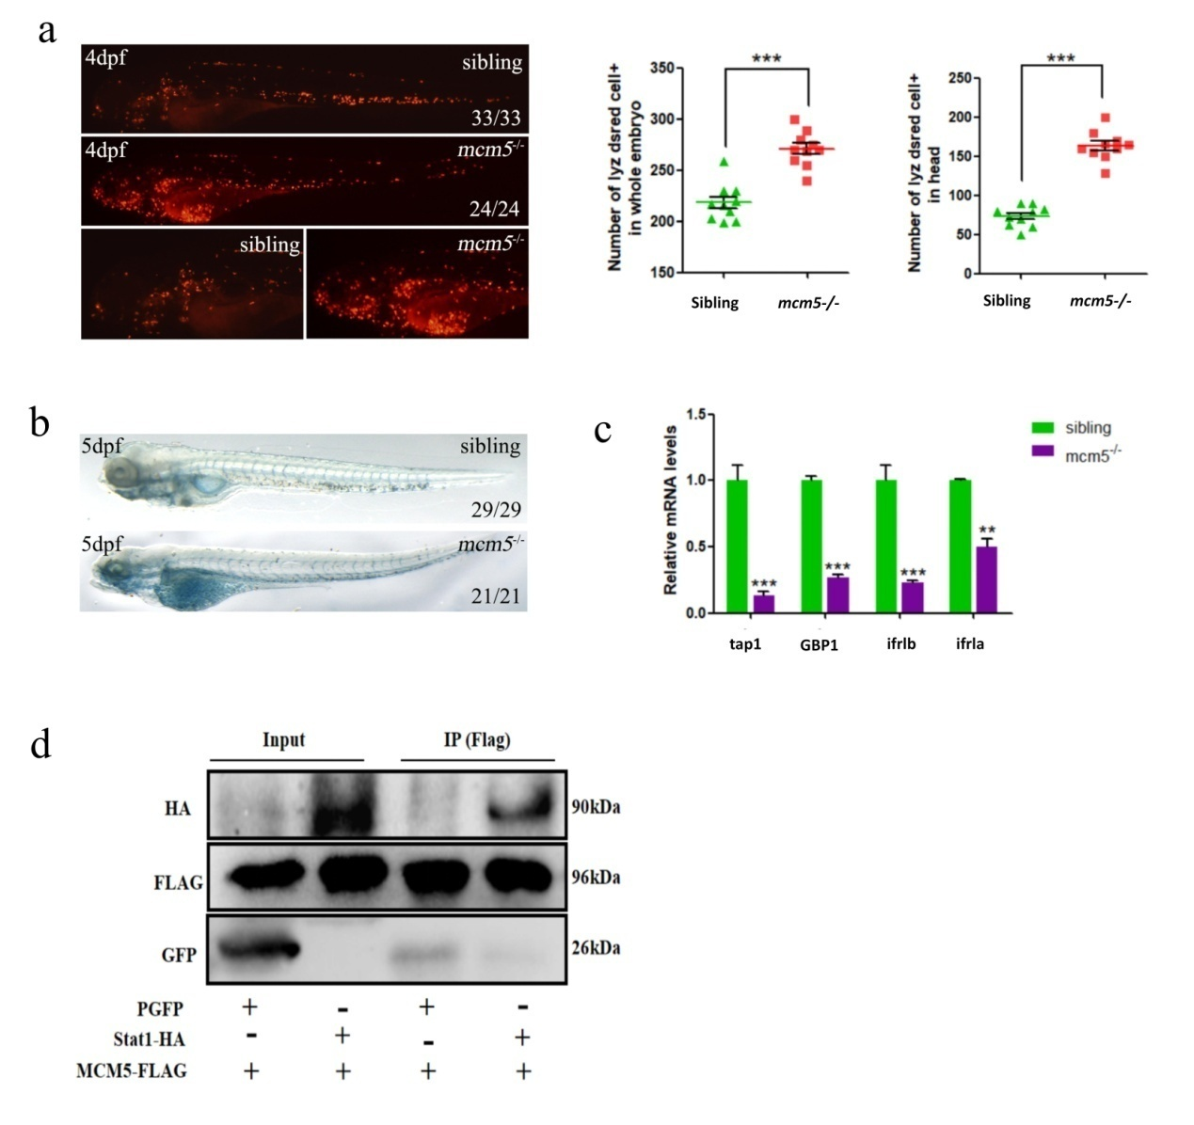
Fig. S16 The activity of Stat1a signaling was downregulated in mcm5^{-/-} embryos.
(a) The neutrophil in siblings and mcm5^{-/-} embryos was showed in Tg(lyz:desRed) transgenic line. Comparing to siblings (n=9), the number of total neutrophil in mcm5^{-/-} embryos was increased (n=10), especially in head region of mcm5^{-/-} embryos (A, n=9). (b) Sudan black staining showed the number of neutrophils was increased in mcm5^{-/-} embryos. (c) The four downstream gene of Stat1, the expression of tap1, GBP1, irf1b and irf1a was downregulated in mcm5^{-/-} embryos. (d) The interaction between Mcm5 and Stat1a was examined using CoIP experiment. The GFP was used as negative control. For a and c, the data were presented as means ± SD; The P values (t-test; two-tailed); “**” P < 0.01, “***” P < 0.001.
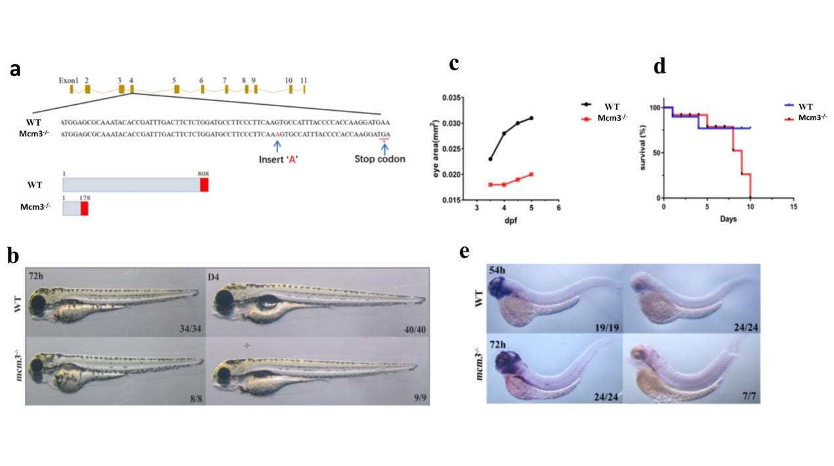
Fig. S17 Generation of mcm3 mutant
(a) In the exon4 of mcm3 gene, additional ‘A’ was inserted, which result the stop codon ‘TGA’. As result, in the mutant mcm3 gene, the premature protein (only 177 AA) was produced. (b) Comparing with the wild type embryos, mcm3 homozygotes displayed mild shorter and smaller eyes from 3dpf. (c) The size difference of the eyes in wild type embryos and mutant embryos. (d) The survival ratio of wild type embryos and mutants in early development. (e) At 54hpf and 72hpf, the expression of mcm3 was greatly down-regulated.
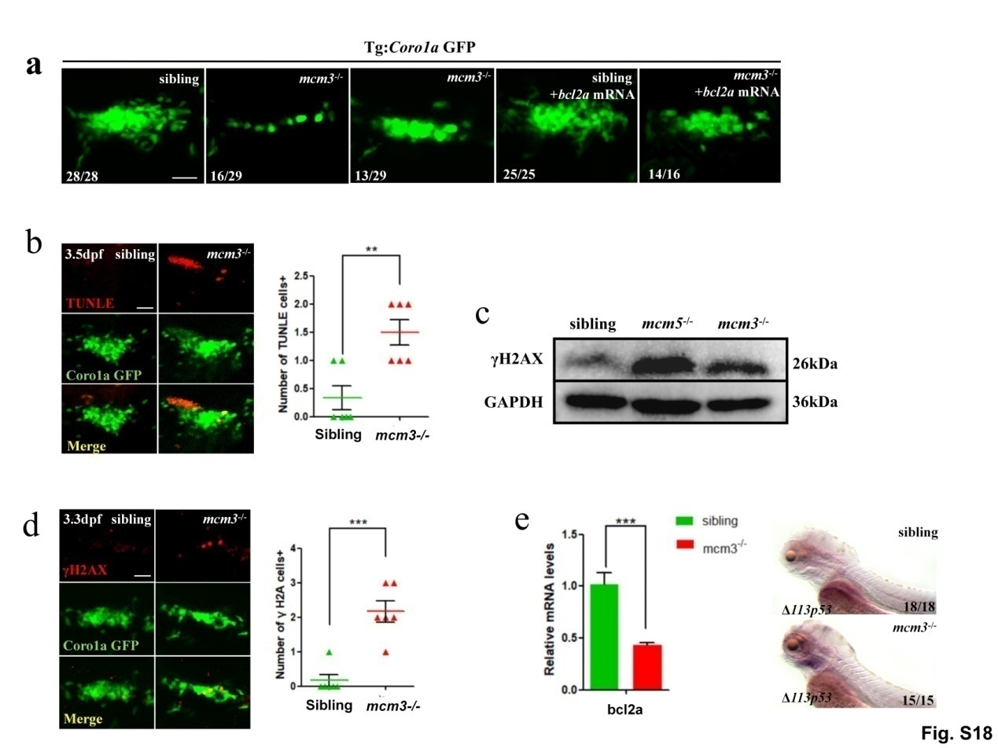
Fig. S18 T lymphocytes development in mcm3^{-/-} embryos
(a) In mcm3^{-/-} embryos, coro1a:GFP cells was decreased (a2, a3), but was not as strong as that in mcm5^{-/-} embryos. Injection of bcl2a mRNA partially recued T cell developmental defect (a5). (b) On 3.5dpf, Tunel labeled coro1a:GFP cells increased in mcm3^{-/-} embryos (n=6). (c) Protein level of γH2A was increased in mcm3^{-/-} embryos. (d) In thymus region, γH2AX labeled coro1a:GFP cells was increased (n=6). (e) The transcription of Δ113p53 mRNA was upregulated in mcm3^{-/-} embryos. Δ113p53 was upregulated in thymus and the around region. Scare bars, 40μm. For b and d, the data were presented as means ± SD; The P values (t-test; two-tailed); “*” P < 0.05,“**” P < 0.01, “***” P < 0.001.
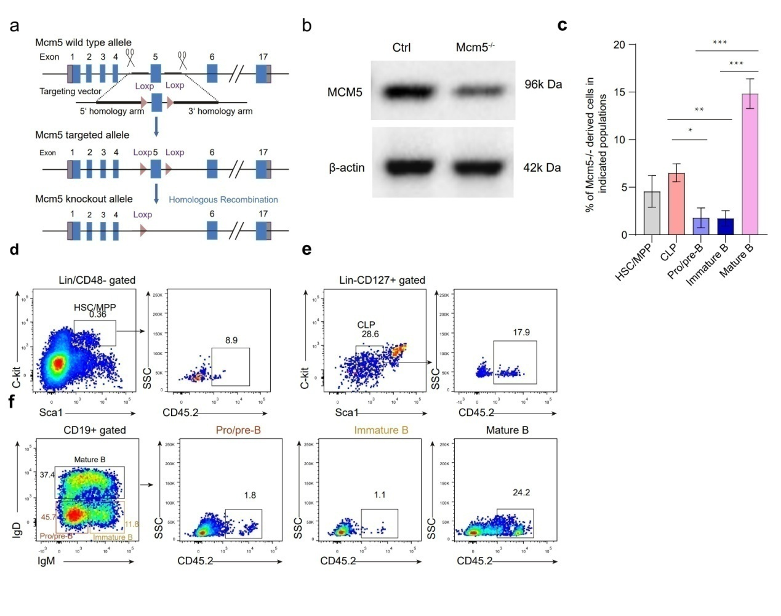
Fig. S19 Pro/pre-B and immature B cells are sensitive to Mcm5 knockout.
(a) The method to generate Mcm5 knockout using Cre/loxp system. (b) Comparing the protein level between control mouse bone marrow and experimental mouse bone marrow using western blot. To the control mouse, WT (CD45.1) mouse bone marrow was used to perform western blot (left lane). To the experimental mouse, the Mcm5f/f;Mx1-Cre (CD45.2) and WT (CD45.1) mouse bone marrow were transplanted, 4 weeks after transplantation, 200 µg of pI-pC was injected intraperitoneally into recipients every other day for 3 doses. At 1.5 weeks after treatment with pI-pC, the bone marrow was used to perform western blot. Because in the transplanted bone marrow, the WT cell still express MCM5 after poly:IC treatment, the total MCM5 level was just downregulated (right lane). (c) Statistical analysis of Mcm5^{-/-} derived cells in HSCs/MPPs, CLPs, Pro/pre-B, Immature B and mature B cells in bone marrow. N=4, Data in (c) are represented as means ± SEM. * p<0.05, ** p<0.001, *** p<0.0001. (d-f) Flow cytometry analysis of Mcm5 knockout cells in hematopoietic stem cells/multi-potential progenitors (HSCs/MPPs), common lymphocyte progenitors (CLPs), Pro/pre-B, Immature B and mature B cells.
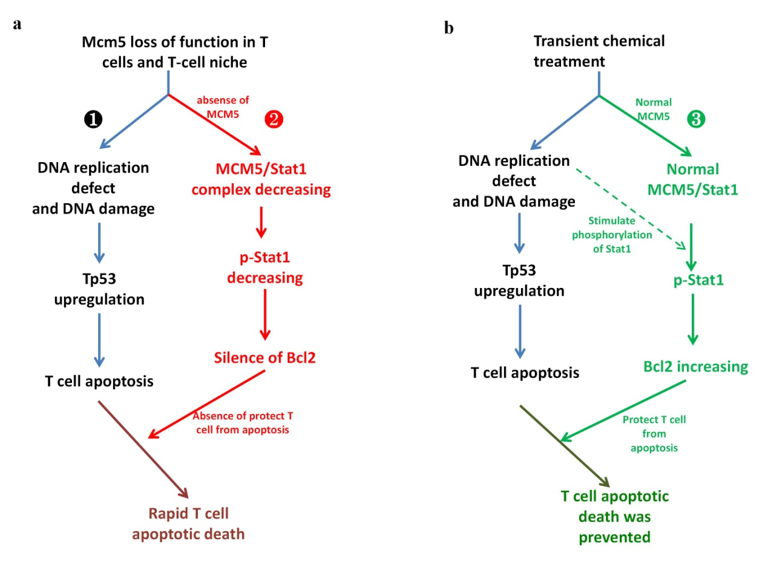
Fig. S20 Model of how mcm5 loss of function facilitates p53-dependent apoptosis in immature T cells
(a) In mcm5 mutants, mcm5 loss of function leads to DNA damage and the sequentialupregulation of Tp53 signaling, which results in T-cell apoptosis (a, pathway 1).In addition, mcm5 loss of function decreases the level of p-Stat without increasing the transcription of bcl2, which accelerates T-cell apoptosis (b, pathway 2). In contrast, under transient DNA replication stress, the normal levels of MCM5 and the MCM5/Stat1 complex increase the level of bcl2ato protect T cells from apoptosis (b, pathway 3).

Table S1.
Primers for RT-qPCR
gene name | Forward | Reverse
beta actin | 5′-CCCAGACATCAGGGAGTG-3′ | 5′-TCTCTGTTGGCTTTGGGATT-3′
P53 | 5′-GAGTTCGCGGAGCTCTGG-3′ | 5′-CCTAAATCCATGATCGCCGGG-3′
Δ113p53 | 5′-GAAGTCCGAGCATGTGGCTG-3′ | 5′-CCCCATGCAGCTGCTATTGC-3′
p21 | 5′-CGCAAACAGACCAACATCAC-3′ | 5′-CGGAATAAACGGTGTCGTCT-3′
mdm2 | 5′-CTCGCAGTGAGGGCAGTGAAG-3′ | 5′-TCTAGGCACGTAGCGGGAAGG-3′
ccng1 | 5′-GACCAGGTGACCGAAACGGG-3′ | 5′-CAGCCAGGAATCGATCTAGGAG-3′
puma | 5′-CAGGACAGTCTACTCAGGGACA-3′ | 5′-CTAGCAGATCTGGCAGAGGAA-3′
bax | 5′-GTTTGCAGCAGATCGGAGAT-3′ | 5′-GGCCACTCTGATGAAGACG-3′
bik | 5′-CTAGAAAGTGGGCAGCTTGG-3′ | 5′-TGCCAGGGTGTATGTAGTGC-3′
bcl2a | 5′-TGGCGTCCCAGGTAGATAAT-3′ | 5′-ACCGTACATCTCCACGAAGG-3′
GBP1 | 5′-CCAACATGTCTAAACCCACAATG-3′ | 5′-GGACACACCACATCCAGATACC-3′
tap1 | 5′-GTGCTGGAGATGAAGGATAAGATG-3′ | 5′-GACTGGATAGAGAAGACCGTGG-3′
irf1a | 5′-GACATGCATCAGGGGCGTC-3′ | 5′-GAGAGCGCATCTGAAGTTCG-3′
irf1b | 5′-CATGCCCGTGTCCAGAATG-3′ | 5′-GCGAGTTCATTGCACAGCG-3′
mcl1a | 5′-CTCGGCAGCTCTTATTGG-3′ | 5′-GATGAAGTCCAGAGAGGCC-3′
mcl1b | 5′-CGGGTTGTGGACAATCTCG-3′ | 5′-GGTATTTGCACAGCATTGCCC-3′

Table S2.
Primers for Plasmids construction
Primer name | sequence
PCS²⁺_F | 5′-CTCGAGCCTCTAGAACTATAGTG-3′
PCS²⁺_R | 5′-TGGTGTTTTCAAAGCAACGATATCG-3′
Δ113p53_F | 5′-CATCGATATCGTTGCTTTGAAAACACCAGTTCAAATGGTGGTGGACGTTG-3′
Δ113p53_R | 5′-CGACTCACTATAGTTCTAGAGGCTCGAGCCCATCACCTTAATCAGAGTCGC-3′
bcl2a_F | 5′-GCTTTGAAAACACCACGTGATTTAAAACCATGGCTAACG-3
bcl2a_R | 5′-TTCTAGAGGCTCGAGGAGGCTGTCACTTCTGAGC-3′
pcDNA3.1_F | 5′-CCAGTGTGGTGGAATTCTGC-3′
pcDNA3.1⁺_R | 5′-GGATCCGAGCTCGGTACC-3′
mcm5_F | 5′-ACCGAGCTCGGATCCATGTCGGGATTTGATGATCCAGG-3′
mcm5_R | 5′-ATTCCACCACACTGGCTATTTGACCCTGTAAAGCACCTTC-3′
stat1a_F | 5′-ACCGAGCTCGGATCCGTCGCAGCAATGACTCAGTGG-3′
stat1a_R | 5′-ATTCCACCACACTGGCGAGTCACTCGCGTTTTCTATGTC-3′

Table S3.
MO sequence
MO name | sequence
mcm5MO | 5′-ATAGTTTCGATAAGTGCTGTC GATG-3′
p53 MO | 5′-GCGCCATTGCTTTGCAAGAATTG-3′
stat1a MO | 5′-GCTGAAGCTCCAACCACTGAGTCAT-3′
control MO | 5′-CCTCTTACCTCAGTTACAATTTATA-3′

