Supplemental Material
1. Supplemental methods
1.1 Study design
1.2 Data sources
1.3 Instrumental variable selection
1.4 Mendelian randomization and sensitivity analysis
1.5 Statistical analysis
2. Supplemental Figure
Figure S1. MR leave-one-out sensitivity analyses for lichen planus on autoimmune diseases
Figure S2. Scatter plot of the MR analysis of the effect of lichen planus on autoimmune diseases.
3. Supplemental Table
Table S1. Detail information of traits involved in this study.
Table S2. The results of MR analysis of the effect of LP on autoimmune diseases.
1. Supplemental methods
1.1 Study design
The MR analyses were performed to explore the associations between lichen planus (LP) and autoimmune diseases. We conducted the MR study based on publicly accessible summary-level data from genome-wide association studies (GWAS) of non-overlapping samples of the same underlying population. One provided measures of the associations between IVs and LP and the others on the associations between IVs and each autoimmune diseases.
1.2 Data sources
Based on the GWAS of European ancestry, GWAS data for LP was sourced from the FinnGen (https://www.finngen.fi/en), including 1865 LP cases and 212242 controls. We collected genetic associations for 15 autoimmune diseases from the summary-level data came from the IEU Open GWAS database (https://gwas.mrcieu.ac.uk/), which comprises mainly publicly available GWAS summary data. These 15 autoimmune diseases include vitiligo, psoriasis vulgaris, systemic lupus erythematosus, alopecia areata, atopic dermatitis, rheumatoid arthritis, type 1 diabetes, Crohn's disease, ulcerative colitis, hypothyroidism, Graves' disease, systemic sclerosis, localized scleroderma, Sjogren's syndrome, ankylosing spondylitis, which were summarized in Table S1.
1.3 Instrumental variable selection
To investigate potential associations between LP and autoimmune diseases, it is essential to select valid IVs that satisfy three key assumptions: (1) the relevance assumption, the genetic instrument variables (GIVs) must be significantly associated with the exposure; (2) the exclusion restriction assumption, the GIVs must not be related to any confounders of exposure–outcome association and (3) the independence assumption, the GIVs should only affect the risk of outcome via the exposure^{[1]}. At a threshold of p<5x10⁻⁸, less than 10 single nucleotide polymorphisms (SNPs) were screened for LP and therefore failed to meet the minimum criteria for MR analysis. of p<5x10⁻⁶, 14 SNPs associated with LP were screened. Less than 10 SNPs were tested for LP at a level of p<5x10⁻⁸, which did not match the minimal requirements for MR analysis^{[2]}. We selected SNPs that met a more relaxed threshold of p<5 × 10⁻⁶ for LP. Thereafter, to remove the effect of linkage disequilibrium (LD), we applied a LD factor (r²) of 0.001 and a clumping window width of 10000kb.
1.4 Mendelian randomization and sensitivity analysis
Prior to the MR analysis, exposure and outcome data were subjected to standardization of aligning the effect alleles to the forward strands, and palindromic genetic variants were excluded. Inverse variance-weighted (IVW) method was conducted as the primary method to conduct the MR analysis and estimate the causal effect of LP on autoimmune diseases, which is regarded as the most reliable approach and could offer strong causal analyses when directional pleiotropy is absent^{[3]}. To assess the stability of the result, MR-Egger, weighted median and weighted mode methods were employed to infer potential causality^{[4,5]}. To decrease the effects of horizontal pleiotropy effect, MR-PRESSO was utilized to detect potential outlier SNPs (p < 0.05) with the MRPRESSO package^{[6]}. For sensitivity analyses, Cochran’s Q statistics were calculated to assess the heterogeneity, with a P>0.05 indicating heterogeneity. If heterogeneity exists, the random-effects model was performed as the main method^{[7]}. Furthermore, by sequentially excluding the SNPs, the leave-one-out analysis was performed to evaluate whether the casual impact was driven by specific variants and stabilized the MR results. Besides, we present the effect estimates using odds ratios (ORs) with 95% confidence intervals (CIs).
1.5 Statistical analysis
The MR analysis was conducted using the R software (http://www.r-project.org) with the TwoSampleMR and MR-PRESSO packages. The forestploter package was utilized to produce certain figures. With a p value threshold of less than 0.05, the association was determined statistically significant.
2. Supplemental Figure
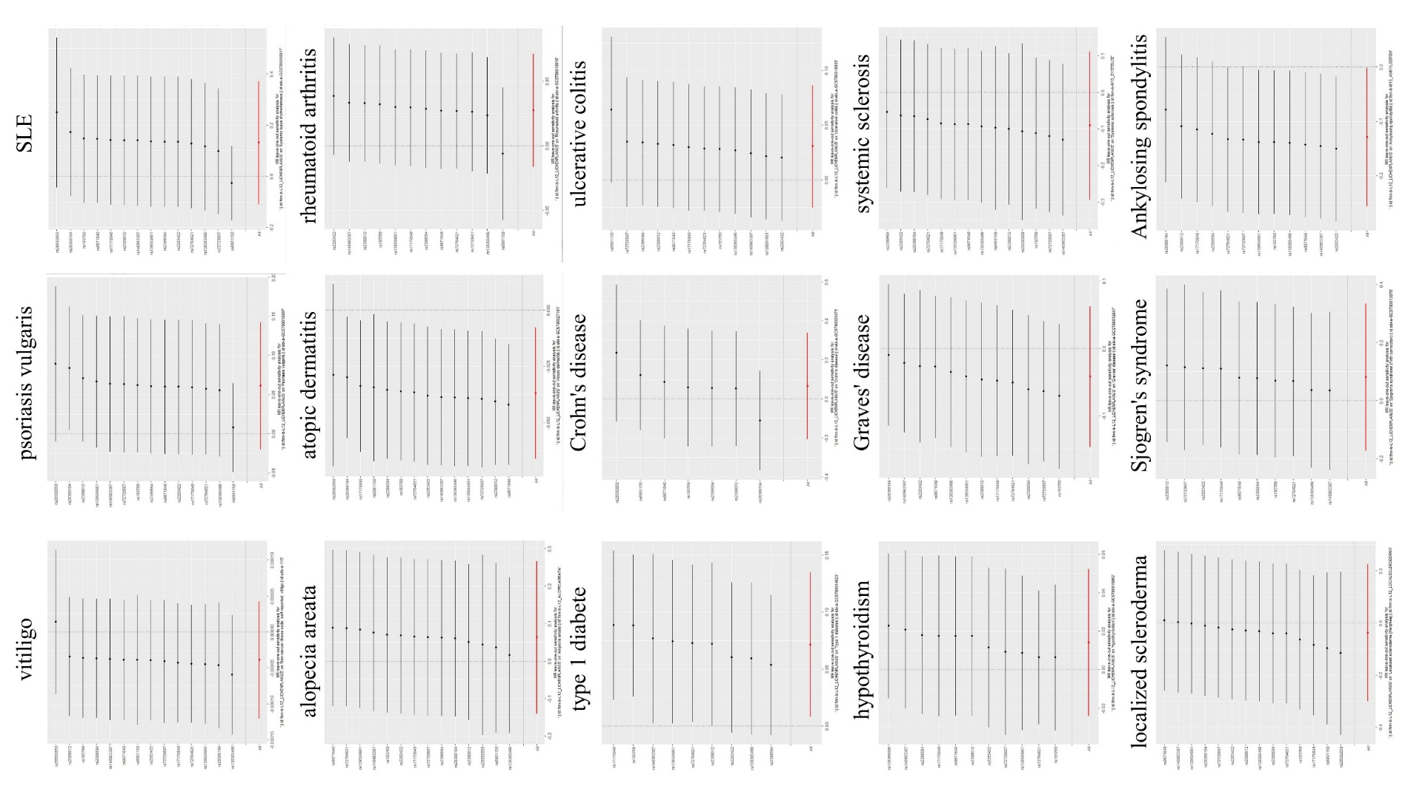
Figure S1. MR leave-one-out sensitivity analyses for lichen planus on autoimmune diseases
Abbreviations: LP, lichen planus; SNP, single nucleotide polymorphism; IVW, inverse-variance weighted; MR, Mendelian randomization, SLE, systemic lupus erythematosus.
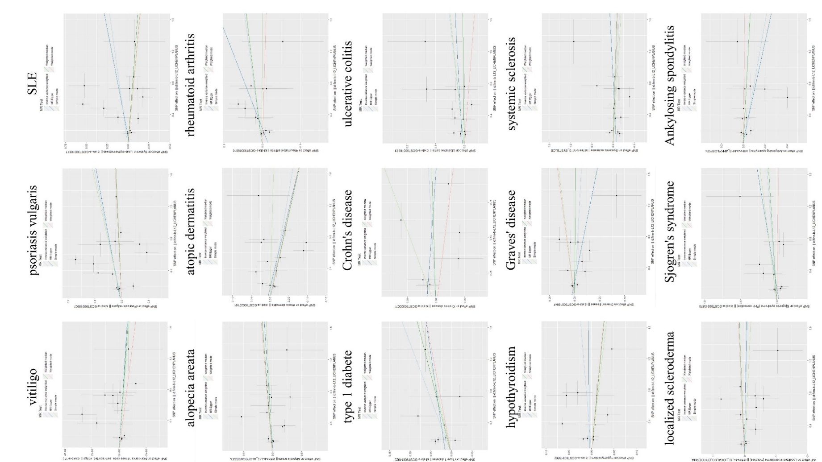
Figure S2. Scatter plot of the MR analysis of the effect of lichen planus on autoimmune diseases.
Abbreviations: LP, lichen planus; MR, Mendelian randomization; SNP, single nucleotide polymorphism; SLE, systemic lupus erythematosus.

3. Supplemental Table section
Table S1. Detail information of traits involved in this study.
exposure or outcomes | IEU-ID | Data Source | Sample Size | Cases/Controls | Year | Population | NSNP
 | finn-b-L12_LICHENPLANUS | FinnGen | 214,107 | 1,865/ 212,242 | 2021 | European | 16,380,458
  Lichen planus
Vitiligo | ukb-a-115 | Neale Lab | 337,159 | 95/337,064 | 2017 | European | 10,894,596
Psoriasis vulgaris | ebi-a-GCST90018907 | Sakaue S et al.^{[8]} | 483,174 | 5,072/478,102 | 2021 | European | 24,191,364
systemic Lupus erythematosus | ebi-a-GCST90018917 | Sakaue S et al.^{[8]} | 482,911 | 647/482,264 | 2021 | European | 24,198,877
Alopecia areata | finn-b-L12_ALOPECAREATA | FinnGen | 211,428 | 289/211,139 | 2021 | European | 16,380,450
Atopic dermatitis | ebi-a-GCST90027161 | Sliz E.^{[9]} | 796,661 | 22,474/ 774,187 | 2021 | European | 16,121,213
Rheumatoid arthritis | ebi-a-GCST90018910 | Sakaue S et al.^{[8]} | 417,256 | 8,255/409,001 | 2021 | European | 24,175,266
Type 1 diabetes | ebi-a-GCST90014023 | Chiou J.^{[10]} | 520,580 | 18,942/ 501,638 | 2021 | European | 59,999,551
Crohn's disease | ebi-a-GCST90020071 | Garcia-Etxebarria K.^{[11]} | 1,219 | 284/ 935 | 2022 | European | 5,394,739
Ulcerative colitis | ebi-a-GCST90018933 | Sakaue S et al.^{[8]} | 417,932 | 5,371/ 412,561 | 2021 | European | 24,187,301
Hypothyroidism | ebi-a-GCST90018862 | Sakaue S et al.^{[8]} | 410,141 | 30,155/ 379,986 | 2021 | European | 24,138,872
Graves' disease | ebi-a-GCST90018847 | Sakaue S et al.^{[8]} | 458,620 | 1,678/456,942 | 2021 | European | 24,189,816
Systemic sclerosis | finn-b-M13_SYSTSLCE | FinnGen | 213,358 | 302/ 213,145 | 2021 | European | 16,380,454
Localized scleroderma | finn-b-L12_LOCALSCLERODERMA | FinnGen | 207,662 | 180 / 207,482 | 2021 | European | 16,380,444
Sjogren's syndrome | ebi-a-GCST90013879 | Mbatchou J.^{[12]} | 407,746 | NA | 2021 | European | 11,039,117
Ankylosing spondylitis | finn-b-M13_ANKYLOSPON | FinnGen | 166,144 | 1,462/ 164,682 | 2021 | European | 16,380,022

Table S2. The results of MR analysis of the effect of LP on autoimmune diseases.
Exposure | Outcome | Method | nSNP | SE | OR | OR_L CI95 | OR_U CI95 | p-value
Lichen planus | vitiligo | Inverse variance  weighted | 14 | 4.159399e-05 | 0.9999614 | 0.9998798 | 1.000043 | 0.3529689
Lichen planus | vitiligo | Weighted  median | 14 | 5.431462e-05 | 0.9999590 | 0.9998526 | 1.000065 | 0.4504856
Lichen planus | vitiligo | MR Egger | 14 | 7.229971e-05 | 0.9999649 | 0.9998233 | 1.000107 | 0.6365046
Lichen planus | vitiligo | MR-Egger pleiotropy | Intercept = -1.878521e-06; P_{ple} = 0.9524987
Lichen planus | Psoriasis vulgaris | Inverse variance  weighted | 14 | 0.04138434 | 1.063277 | 0.9804366 | 1.153118 | 0.1381832
Lichen planus | Psoriasis vulgaris | Weighted  median | 14 | 0.03617447 | 1.013029 | 0.9436901 | 1.087462 | 0.7204652
Lichen planus | Psoriasis vulgaris | MR Egger | 14 | 0.07318891 | 1.056625 | 0.9154213 | 1.219608 | 0.4662182
Lichen planus | Psoriasis vulgaris | MR-Egger pleiotropy | Intercept =0.003086274; P_{ple} = 0.9172957
Lichen planus | Systemic lupus erythematosus | Inverse variance  weighted | 14 | 0.12256959 | 1.1408022 | 0.8971747 | 1.450587 | 0.2824866
Lichen planus | Systemic lupus erythematosus | Weighted  median | 14 | 0.08347296 | 0.9310208 | 0.7905071 | 1.096511 | 0.3918601
Lichen planus | Systemic lupus erythematosus | MR Egger | 14 | 0.21112248 | 1.2018862 | 0.7946068 | 1.817919 | 0.4008326
Lichen planus | Systemic lupus erythematosus | MR-Egger pleiotropy | Intercept = -0.02483654; P_{ple} = 0.7623442
Lichen planus | Alopecia areata | Inverse variance  weighted | 14 | 0.1036821 | 1.064982 | 0.8691334 | 1.304963 | 0.5437029
Lichen planus | Alopecia areata | Weighted  median | 14 | 0.1414863 | 1.109852 | 0.8410648 | 1.464538 | 0.4613320
Lichen planus | Alopecia areata | MR Egger | 14 | 0.1778294 | 1.094545 | 0.7724351 | 1.550975 | 0.6206579
Lichen planus | Alopecia areata | MR-Egger pleiotropy | Intercept = -0.01227323; P_{ple} = 0.8528579
Lichen planus | Atopic dermatitis | Inverse variance  weighted | 14 | 0.01490371 | 0.9637782 | 0.9360322 | 0.9923466 | 0.0133051
Lichen planus | Atopic dermatitis | Weighted  median | 14 | 0.01499565 | 0.9542872 | 0.9266475 | 0.9827514 | 0.0018068
Lichen planus | Atopic dermatitis | MR Egger | 14 | 0.02567767 | 0.9513451 | 0.9046505 | 1.0004500 | 0.0759155
Lichen planus | Atopic dermatitis | MR-Egger pleiotropy | Intercept = 0.006712427; P_{ple} = 0.541262
Lichen planus | Rheumatoid arthritis | Inverse variance  weighted | 12 | 0.02234222 | 1.0280441 | 0.9839967 | 1.074063 | 0.2157427
Lichen planus | Rheumatoid arthritis | Weighted  median | 12 | 0.03308451 | 1.0252665 | 0.9608921 | 1.093953 | 0.4507257
Lichen planus | Rheumatoid arthritis | MR Egger | 12 | 0.04093748 | 1.0842156 | 1.0006195 | 1.174796 | 0.0764898
Lichen planus | Rheumatoid arthritis | MR-Egger pleiotropy | Intercept = -0.01845749; P_{ple} = 0.1519848
Lichen planus | Type 1 diabetes | Inverse variance  weighted | 9 | 0.03231494 | 1.074276 | 1.0083445 | 1.144519 | 0.0266127
Lichen planus | Type 1 diabetes | Weighted  median | 9 | 0.05818181 | 1.050477 | 0.9683713 | 1.139544 | 0.2356350
Lichen planus | Type 1 diabetes | MR Egger | 9 | 0.04152243 | 1.028712 | 0.9178430 | 1.152973 | 0.6414512
Lichen planus | Type 1 diabetes | MR-Egger pleiotropy | Intercept = 0.01369826; P_{ple} = 0.3977046
Lichen planus | Crohn's disease | Inverse variance  weighted | 7 | 0.1395948 | 1.0691423 | 0.8132237 | 1.405598 | 0.6319853
Lichen planus | Crohn's disease | Weighted  median | 7 | 0.1477996 | 1.0376868 | 0.7767062 | 1.386359 | 0.8023565
Lichen planus | Crohn's disease | MR Egger | 7 | 0.2517869 | 0.9172215 | 0.5599495 | 1.502448 | 0.7454270
Lichen planus | Crohn's disease | MR-Egger pleiotropy | Intercept = 0.0841697; P_{ple} = 0.4899139
Lichen planus | Ulcerative colitis | Inverse variance  weighted | 12 | 0.02852568 | 1.0314065 | 0.9753227 | 1.090715 | 0.2783400
Lichen planus | Ulcerative colitis | Weighted  median | 12 | 0.03952847 | 1.0029910 | 0.9282174 | 1.083788 | 0.9397743
Lichen planus | Ulcerative colitis | MR Egger | 12 | 0.05167062 | 1.0154997 | 0.9176919 | 1.123732 | 0.7720469
Lichen planus | Ulcerative colitis | MR-Egger pleiotropy | Intercept = 0.00597141; P_{ple} = 0.725783
Lichen planus | Hypothyroidism | Inverse variance  weighted | 11 | 0.01952019 | 1.0143871 | 0.9763102 | 1.053949 | 0.4642987
Lichen planus | Hypothyroidism | Weighted  median | 11 | 0.02567165 | 0.9833515 | 0.9350969 | 1.034096 | 0.5131265
Lichen planus | Hypothyroidism | MR Egger | 11 | 0.03603582 | 1.0007313 | 0.9324878 | 1.073969 | 0.9842575
Lichen planus | Hypothyroidism | MR-Egger pleiotropy | Intercept = 0.004695902; P_{ple} = 0.6594272
Lichen planus | Graves' disease | Inverse variance  weighted | 12 | 0.4326575 | 0.9590130 | 0.8638206 | 1.064696 | 0.4326575
Lichen planus | Graves' disease | Weighted  median | 12 | 0.9351246 | 0.9940729 | 0.8614939 | 1.147055 | 0.9351246
Lichen planus | Graves' disease | MR Egger | 12 | 0.1501403 | 0.8550849 | 0.7022801 | 1.041138 | 0.1501403
Lichen planus | Graves' disease | MR-Egger pleiotropy | Intercept = 0.02476525; P_{ple} = 0.2128376
Lichen planus | Systemic sclerosis | Inverse variance  weighted | 14 | 0.1034806 | 0.9136788 | 0.7459489 | 1.119124 | 0.3829919
Lichen planus | Systemic sclerosis | Weighted  median | 14 | 0.1385787 | 0.9448497 | 0.7201155 | 1.239719 | 0.6822708
Lichen planus | Systemic sclerosis | MR Egger | 14 | 0.1769049 | 1.0965181 | 0.7752313 | 1.550959 | 0.6119519
Lichen planus | Systemic sclerosis | MR-Egger pleiotropy | Intercept = -0.08169007; P_{ple} = 0.2276942
Lichen planus | Localized scleroderma | Inverse variance  weighted | 14 | 0.1337250 | 0.9645080 | 0.7421246 | 1.253530 | 0.7869797
Lichen planus | Localized scleroderma | Weighted  median | 14 | 0.1745424 | 1.1038026 | 0.7840033 | 1.554050 | 0.5715102
Lichen planus | Localized scleroderma | MR Egger | 14 | 0.2288766 | 0.9482058 | 0.6054509 | 1.484999 | 0.8201676
Lichen planus | Localized scleroderma | MR-Egger pleiotropy | Intercept = 0.007628375; P_{ple} = 0.9283917
Lichen planus | Sjogren's syndrome | Inverse variance  weighted | 10 | 0.1289667 | 1.0848956 | 0.8425763 | 1.396904 | 0.5275046
Lichen planus | Sjogren's syndrome | Weighted  median | 10 | 0.1696862 | 1.0708626 | 0.7678811 | 1.493391 | 0.6865972
Lichen planus | Sjogren's syndrome | MR Egger | 10 | 0.2263731 | 1.2022694 | 0.7714524 | 1.873676 | 0.4393355
Lichen planus | Sjogren's syndrome | MR-Egger pleiotropy | Intercept = -0.03595858; P_{ple} = 0.595919
Lichen planus | Ankylosing spondylitis | Inverse variance  weighted | 12 | 0.06479923 | 0.8794432 | 0.7745502 | 0.9985413 | 0.0474202
Lichen planus | Ankylosing spondylitis | Weighted  median | 12 | 0.08641828 | 0.9620329 | 0.8121368 | 1.1395952 | 0.6542260
Lichen planus | Ankylosing spondylitis | MR Egger | 12 | 0.11979503 | 0.8517275 | 0.6734868 | 1.0771402 | 0.2099936
Lichen planus | Ankylosing spondylitis | MR-Egger pleiotropy | Intercept = 0.01078881; P_{ple} = 0.7568279
Abbreviations: OR, odds ratio; P_{ple}, p value of MR-Egger pleiotropy.
Reference
[1] Davies NM, Holmes MV, Davey Smith G. Reading Mendelian randomisation studies: a guide, glossary, and checklist for clinicians[J]. Bmj, 2018, 362: k601.
[2] Bao B, Zhu C, Shi J, et al. Causal association between inflammatory bowel disease and hidradenitis suppurativa: A two-sample bidirectional Mendelian randomization study[J]. Front Immunol, 2023, 14: 1071616.
[3] Burgess S, Dudbridge F, Thompson SG. Combining information on multiple instrumental variables in Mendelian randomization: comparison of allele score and summarized data methods[J]. Stat Med, 2016, 35(11): 1880-1906.
[4] Bowden J, Davey Smith G, Haycock PC, et al. Consistent Estimation in Mendelian Randomization with Some Invalid Instruments Using a Weighted Median Estimator[J]. Genet Epidemiol, 2016, 40(4): 304-314.
[5] Burgess S, Thompson SG. Interpreting findings from Mendelian randomization using the MR-Egger method[J]. Eur J Epidemiol, 2017, 32(5): 377-389.
[6] Verbanck M, Chen CY, Neale B, et al. Detection of widespread horizontal pleiotropy in causal relationships inferred from Mendelian randomization between complex traits and diseases[J]. Nat Genet, 2018, 50(5): 693-698.
[7] Bowden J, Hemani G, Davey Smith G. Invited Commentary: Detecting Individual and Global Horizontal Pleiotropy in Mendelian Randomization-A Job for the Humble Heterogeneity Statistic?[J]. Am J Epidemiol, 2018, 187(12): 2681-2685.
[8] Sakaue S, Kanai M, Tanigawa Y, et al. A cross-population atlas of genetic associations for 220 human phenotypes[J]. Nat Genet, 2021, 53(10): 1415-1424.
[9] Sliz E, Huilaja L, Pasanen A, et al. Uniting biobank resources reveals novel genetic pathways modulating susceptibility for atopic dermatitis[J]. J Allergy Clin Immunol, 2022, 149(3): 1105-1112.e1109.
[10] Chiou J, Geusz RJ, Okino ML, et al. Interpreting type 1 diabetes risk with genetics and single-cell epigenomics[J]. Nature, 2021, 594(7863): 398-402.
[11] Garcia-Etxebarria K, Merino O, Gaite-Reguero A, et al. Local genetic variation of inflammatory bowel disease in Basque population and its effect in risk prediction[J]. Sci Rep, 2022, 12(1): 3386.
[12] Mbatchou J, Barnard L, Backman J, et al. Computationally efficient whole-genome regression for quantitative and binary traits[J]. Nat Genet, 2021, 53(7): 1097-1103.

