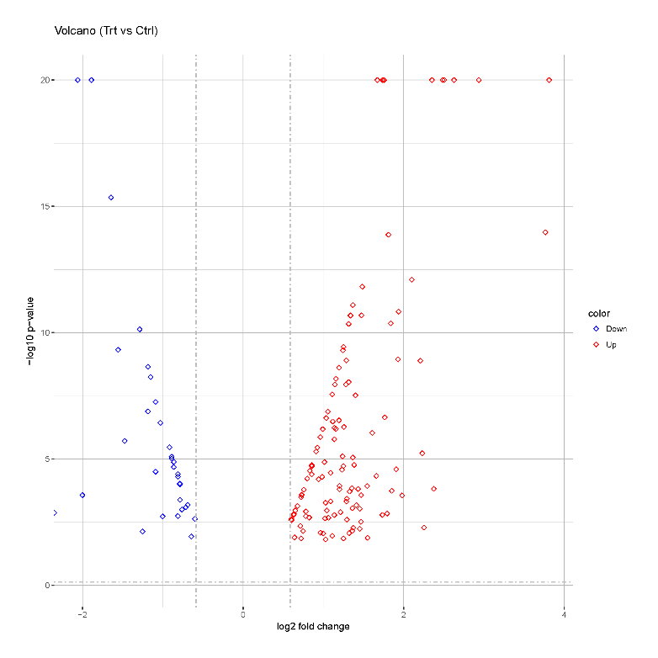
supplement 1A

supplement 1B
Description | Intensity control | Intensity ARDS patients | Ratio  control | Ratio ARDS patients
Protein S100-A12 | 461000 | 1750000 | 1 | 3.81

The blood samples used in this study were randomly collected from three patients with ARDS and three control subjects who visited Wuxi No. 2 People’s Hospital. All subjects with ARDS met the Berlin definition criteria and were studied within 24 h of admission to ICU. For comparison, healthy control subjects, matched for age and gender and body mass index, without medication, were selected for comparison. Using an iTRAQ-based quantitative proteomics approach, this study identified the DEPs from ARDS patients and control subjects. supplement 1A The volcano map of quantified serum proteins expressed in the ARDS patient group compared with those expressed in the control subject group. The blue dots represent downregulated and the red dots represent upregulated proteins. Specifically, 128 of the 162 proteins were upregulated, whereas the others were downregulated. supplement 1B Results of proteomics research. ARDS=acute respiratory distress syndrome.

