Appendix A

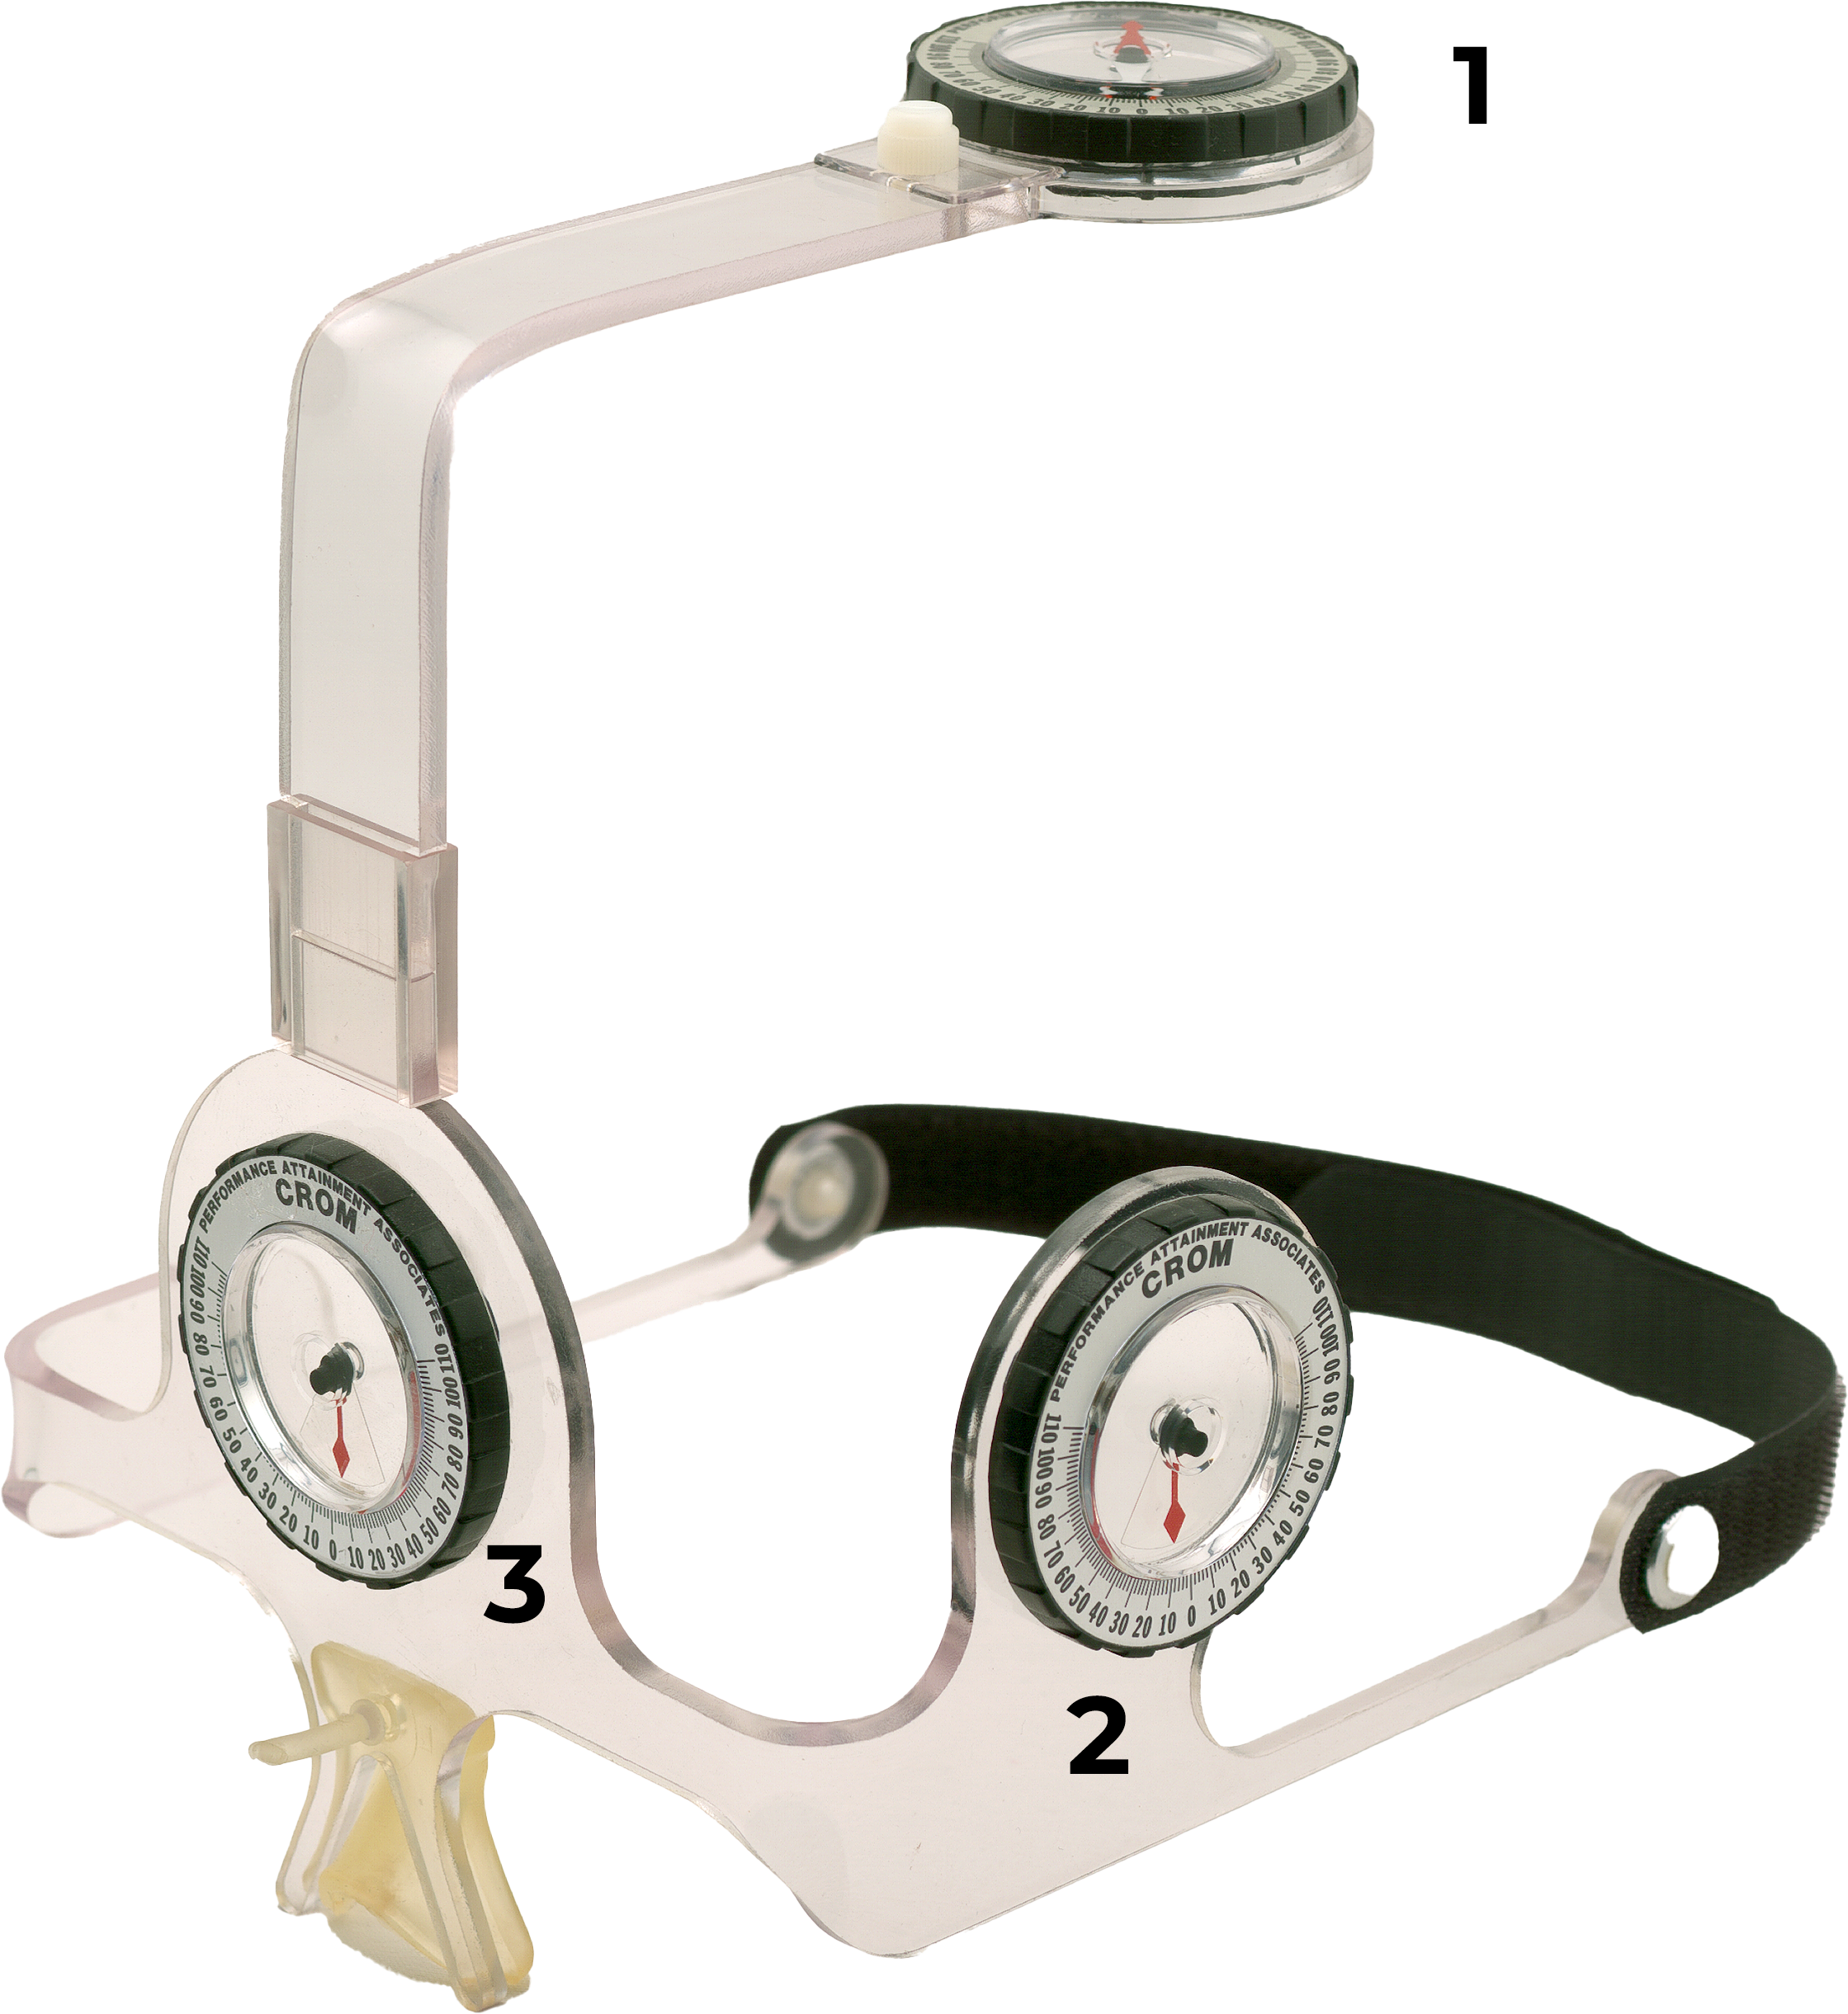
Fig. A1 Cervical Range of Motion Device (CROM) 1 Compass goniometer for rotation measure- ment, 2 Gravity goniometer for flexion and extension measurement, 3 Gravity goniometer for lateral flexion measurement

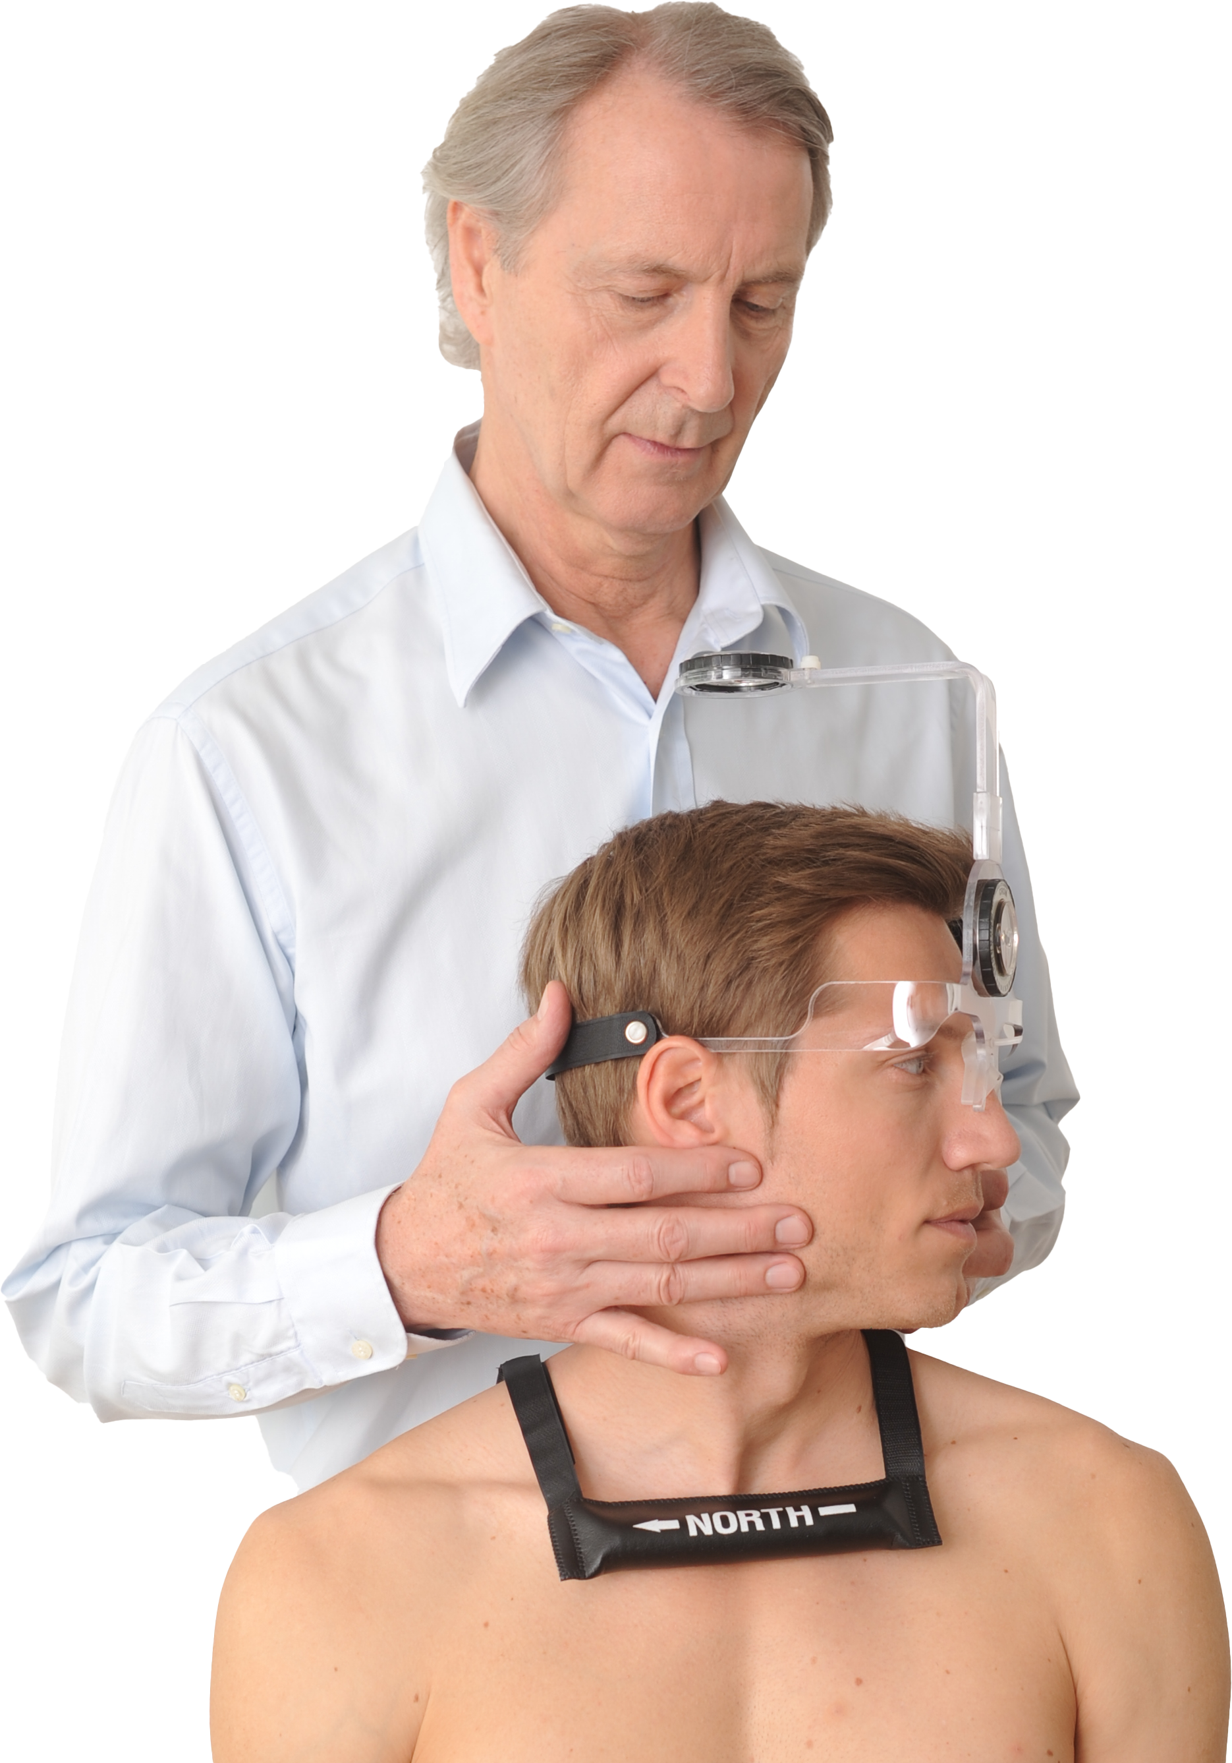

Fig. A2 Rotation measurement with the compass goniometer of the CROM device. A magnetic yoke stabilizes the compass needle, compensating for the influence of electromagnetic fields.

Observation Group | Muscle L | Muscle R | Fascia L | Fascia R | SC L | SC R
M Dist L | -0.531S | -0.369S | -0.590P | -0.419S | -0.578S | -0.478S
M Dist R | -0.634S | -0.572S | -0.338P | -0.624S | -0.661S | -0.662S
SC Dist L | 0.063S | -0.162S | 0.202S | -0.120S | -0.078S | -0.103S
SC Dist R | -0.318S | -0.183S | -0.355P | -0.105S | -0.516S | -0.225S
Skin Dist L | -0.413S | -0.394S | -0.478P | -0.429S | -0.343S | -0.291S
Skin Dist R | -0.164S | -0.064S | -0.063P | -0.065S | -0.142S | 0.052S
Table A1 Correlation of Stiffness (E) and Thickness in the Observation Group. M Dist = Thickness Muscle, SC Dist = Thickness Subcutaneous tissue, Skin Dist = Thickness Skin, L = Left, R = Right.

Control Group | Muscle L | Muscle R | Fascia L | Fascia R | SC L | SC R
M Dist L | 0.148S | -0.192P | 0.342P | -0.202P | -0.086P | -0.097P
M Dist R | -0.126S | 0.197P | -0.060P | 0.045P | -0.232P | -0.174P
SC Dist L | -0.286S | -0.013P | -0.425P | -0.189P | -0.416P | -0.358P
SC Dist R | -0.219S | -0.093P | -0.269P | -0.077P | -0.156P | -0.196P
Skin Dist L | -0.148S | -0.031P | -0.193P | -0.215P | -0.023P | -0.368P
Skin Dist R | 0.209S | 0.155P | 0.112P | -0.041P | 0.157P | -0.214P
Table A2 Correlation of Stiffness (E) and Thickness in the Control Group. M Dist = Thickness Muscle, SC Dist = Thickness Subcutaneous tissue, Skin Dist = Thickness Skin, L = Left, R = Right.

