Supplementary Materials for

C. elegans colony formation as a phase separation phenomenon
Yuping Chen¹, James E. Ferrell, Jr.^{1,2}*
Correspondence to: james.ferrell@stanford.edu

This PDF file includes:

Supplementary Text
Supplementary Figs. 1-3
Captions for Supplementary Movies 1-4

Other Supplementary Materials for this manuscript include the following:

Supplementary Movies 1-4

Supplementary Text

A rate equation model for co-existence of two or more C. elegans colonies
In Fig. 1 we observed co-existence of multiple C. elegans colonies on the same plate. Here we provide a rate equation model to describe the phenomenon. For simplicity, we first examine a three compartment system consisting of solitary worm (w), colony 1 (w¹*), and colony 2 (w²*).
Similar to the single-colony scenario described in the main text, rate equations for w¹* and w²* can be written as:

$\frac{dw^{1*}}{dt}= k_{1}{(w}_{tot}- w^{1*}- w^{2*}){{(w}^{1*})}^{\frac{1}{2}}-k_{-1}{{(w}^{1*})}^{\frac{1}{2}}$ , and [Eq. 9]
$\frac{dw^{2*}}{dt}= k_{1}{(w}_{tot}- w^{1*}- w^{2*}){{(w}^{2*})}^{\frac{1}{2}}-k_{-1}{{(w}^{2*})}^{\frac{1}{2}}$, [Eq. 10]

where we used the conservation relationship $w_{tot}= w+ w^{1*}+w^{2*}$.
At steady state, the time derivatives in both Eq. 9 and Eq. 10 must equal zero. There are two solutions:
$w_{SS}^{1*}=0$ and $w_{SS}^{2*}=0$, or [Eq 11]
$w_{SS}^{1*}+w_{SS}^{2*}=w_{tot}- {k_{-1}}/{k_{1}}$, [Eq 12]

Note that none of $w_{ss}^{1*}$ , $w_{ss}^{2*}$ or w_{tot} can be smaller than zero. Hence, when 0 ≤ w_{tot} ≤ k₋₁/k₁ there is a single steady state given by Eq 11. When w_{tot} > k₋₁/k₁, there are two steady states given by Eqs 11 and 12. Similar to Fig. 2e, f, Eq 11 is a stable steady state when w_{tot} ≤ k₋₁/k₁ but becomes an unstable steady state when w_{tot} > k₋₁/k₁. Similar to the single-colony scenario, this is a transcritical bifurcation at a threshold of k₋₁/k₁.

Therefore, the construction and the steady-state prediction of the rate equation model is insensitive to whether there is one or two colonies. One can apply a similar treatment to systems of colony number greater than two and obtain similar results.

A rate equation model for Ostwald ripening in C. elegans colony formation
To account for the Ostwald ripening phenomenon in C. elegans colony formation, we suppose that there are three compartments—a small colony (w*), a big colony (w**), and out-of-colony worms (w) (Fig. 4a)—and we assume that the rate constant for departing from a colony depends upon the colony’s size, with large colonies having smaller rate constants. We used a function of the form of the Gibbs-Thomson equation²⁷:

$\frac{k_{-1}}{k_{1}}[r]=\frac{k_{-1}}{k_{1}}\left[∞\right]e^{a/r}$, [Eq 13]

where a is a parameter that determines how steeply the vapor pressure, chemical potential, or solubility of a substance falls as r increases, in an idealized system.

For simplicity, let us first examine a two-compartment system, with w and w*, using the Gibbs-Thomson equation to account for the size dependence of colony stability. Assuming that the change in colony stability is due to a change in k₋₁, it follows that:

$\frac{dw^{*}}{dt}= k_{1}\left(w_{tot}- w^{*}\right){{(w}^{*})}^{\frac{1}{2}}-k_{-1}[∞]e^{a/{{{(w}^{*})}^{\frac{1}{2}}}}{{(w}^{*})}^{\frac{1}{2}}$. [Eq 14]

Note we made use of the conservation equation, w_{tot} = w + w* to eliminate the variable w.
We solved for and plotted the steady state value of w and w* (Supplementary Fig. 2a, b). We also performed rate balance analysis and plotted the observed rates as a function of colony size (w*) and the total density (w_{tot}) (Supplementary Fig. 2c). We found that when w_{tot} is smaller than a threshold, colonies tend to dissolve regardless of size (Supplementary Fig. 2c). When w_{tot} is larger than a threshold, colonies smaller than the corresponding unstable steady state limit tend to dissolve, whereas if the colony is larger than the unstable steady state it tend to grow and dominate. The final size of the dominant colony is also limited, defined by the limit of the stable steady state. Comparing to the previous model, the size-dependency makes the steady state a saddle-node bifurcation (Supplementary Fig. S2a-c).

Now to extend the analysis to three compartments, with a large colony (w**) as well as a small one (w*), we write two rate equations:

$\frac{dw^{*}}{dt}= k_{1}\left(w_{tot}-w^{*}- w^{**}\right){{(w}^{*})}^{\frac{1}{2}}-k_{-1}[∞]e^{a/{{{(w}^{*})}^{\frac{1}{2}}}}{{(w}^{*})}^{\frac{1}{2}}$ [Eq 10]
$\frac{dw^{**}}{dt}= k_{1}\left(w_{tot}- {w^{*}-w}^{**}\right){{(w}^{**})}^{\frac{1}{2}}-k_{-1}[∞]e^{a/{{{(w}^{**})}^{\frac{1}{2}}}}{{(w}^{**})}^{\frac{1}{2}}$. [Eq 11]

Note the conservation equation now is w_{tot} = w + w* + w**.

Ostwald ripening happens when a dominant colony shifts towards the large stable steady state, and the smaller colonies away from the large stable steady state. Eventually, the smaller colonies become so close to a size of zero and vanish (Supplementary Fig. 2d, e). Although different initial sizes of the two colonies may result in identical steady states, — the larger colony dominates and the smaller colony dissolves — the process of achieving the steady state may vary greatly. To illustrate the variation in the processes, here we show two examples with different initial conditions. In the first example, both w* and w** are small, and w** is only slightly greater than w* (Supplementary Fig. 2d). Both colonies grow initially (also reflected in our experimental observation in Fig. 1) but then diverge, with w** sustains to grow and w* starts to shrink. The system takes a longer time to arrive at the steady state. However, in the second example, where the size of the colonies differ by a greater amount, w** grows and w* dissolves, and the system quickly transits into the steady-state (Supplementary Fig. 2e).

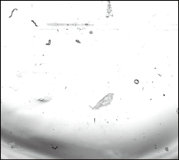

Supplementary Fig. 1: Sparsely seeded worms showed no colonies after 12 h of incubation.
Washed adult N2 C. elegans seeded at a low concentration (0.01 worms/mm²) and incubated for 12 h.

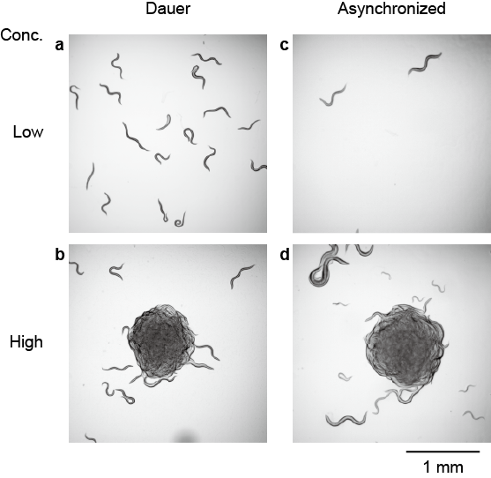

Supplementary Fig. 2: Colony formation in other developmental stages also depends on density.
a, b Example micrographs of dauer-stage worms on agarose pads, which (a) did not form colonies when the population density was low (0.26 worms/mm²) and (b) formed a colony when the population density was high (3.90 worms/mm²). c, d Example micrographs of asynchronized worms on agarose pads. They (c) did not form colonies when the population density was low (0.03 worms/mm²) and (d) formed a colony when the population density was high (1.30 worms/mm²).

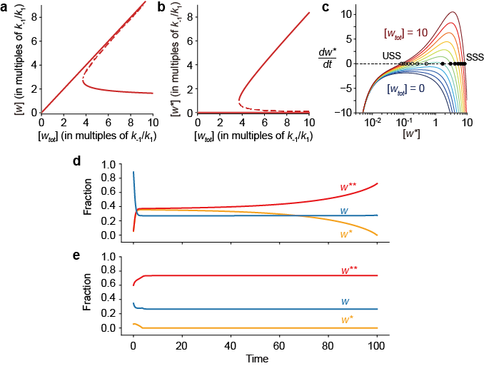

Supplementary Fig. 3: Model for Ostwald ripening in C. elegans colony formation.
a, b The modeled steady-state densities of worms out of colonies (w), and in a colony (w*), as a function of the total density of worms w_{tot}, based on numerical solutions to Eq. 10. The system has a single stable steady state until the concentration of worms reaches a critical value. Beyond the critical density, the system undergoes a saddle-node bifurcation, and has an unstable steady state (dashed) and two stable steady states (solid). One stable steady state can be regarded as a “supersaturated” system; it lies close to the unstable branch, and so small perturbations would be expected to drive the system across the unstable branch and into the stable manifold of the other steady state. c Rate analysis of cases with w_{tot} taking values of 1, 2, 3, 4, 5, 6, 7, 8, 9, and 10. When w_{tot} is smaller than the critical density, rates are always below zero, and colonies dissolve. When w_{tot} is equal to the critical density, rates are below zero except at one point.When w_{tot} is greater than the critical density, the net rate curve takes a value of zero at two points, which correspond to two steady states. The point on the left is unstable (USS), as small perturbations makes the system diverge from the steady state. The other one is stable (SSS), as small perturbations makes the system return toward the steady state. d, e Two examples of modeled time dependent processes based on Eqs. 10 and 11. The parameters for system are: w_{tot} = 4, greater than the critical density; k₁ and k-₁ are both 1; a = 0.1, showing size dependency. The initial size of the small colony is w*[0] = 0.218, a small value. We initiated the large colony colony size w**[0] to be either a very large colony (w**[0] = 2.4) (d) or one similar in size to w*[0] (w**[0] = 0.24) (e).

Supplementary Movie 1: Adult colony formation at high density.
The initial density was 0.18 worms/mm². The time stamp is in min:s and the total duration of the movie is 24 min.

Supplementary Movie 2: Adult worms at low density showing no colonies.
The initial density was 0.01 worms/mm². The time stamp is in min:s and the total duration of the movie is 24 min.

Supplementary Movie 3: Dauer worms dynamically entering and leaving a colony.
Worms in the colony are false-colored yellow, and individual worms are false-colored blue. The worms’ trajectories are initially colored blue and then progressively shift to yellow as time proceeds. Red asterisks denote events where worms entered the colony.

Supplementary Movie 4: Mixing of fluorescent and non-fluorescent worms to track single worm dynamics.
The orange line denotes the boundary of the colony, which is made up mostly of nonfluorescent worms.

