Supplementary Materials:
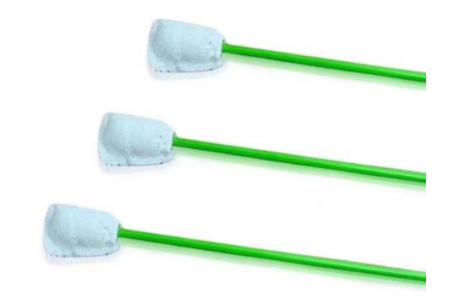
Figure s1 Picture of OPS sample collector.

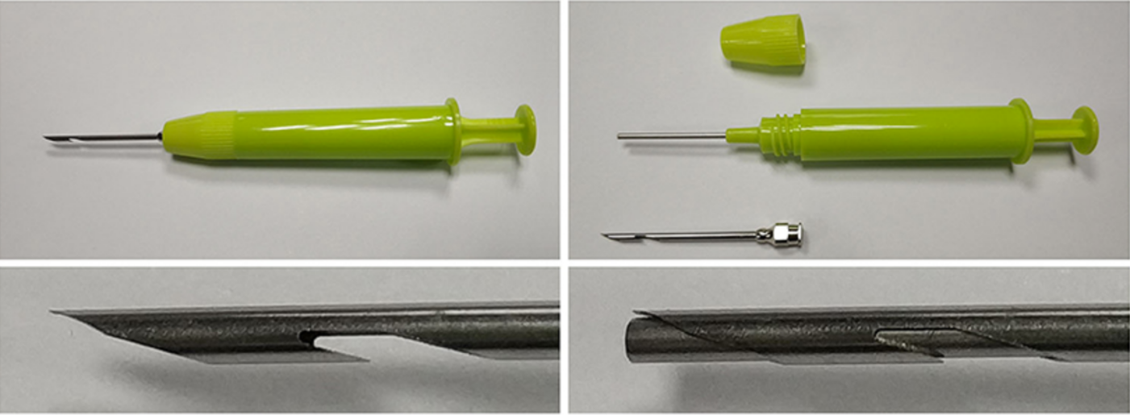
Figure s2 Picture of LN sample collector.

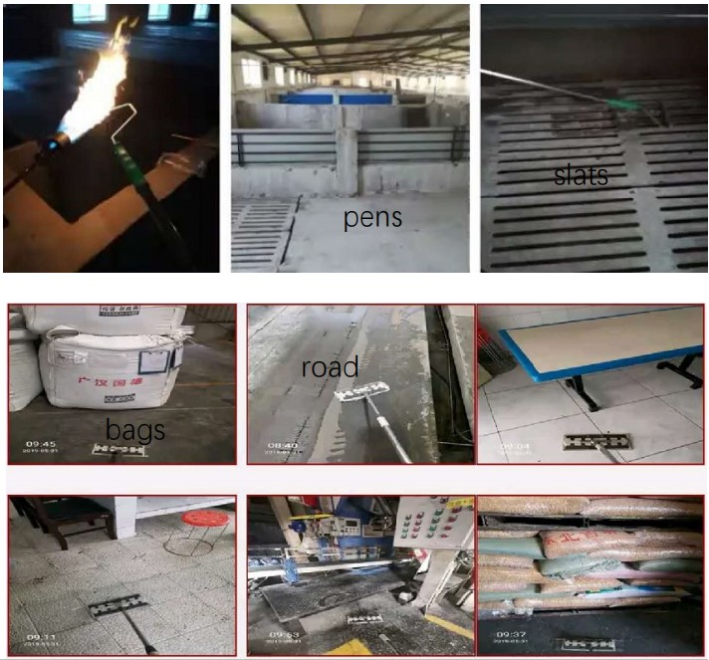
Fig. s3 Picture of Whole surface (WS) sampling.
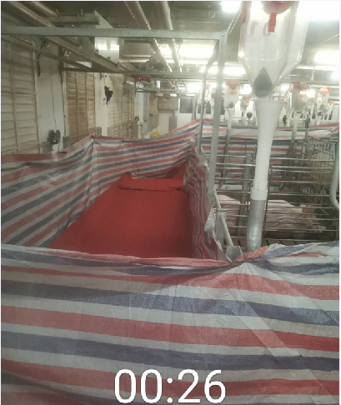
Fig. s4 Picture of a U-shape tunnel made of stripped cloth to remove pigs.

Farm 1

Farm 2

Farm 3

Farm 4
Fig. s5. Electronic maps of Farm 1, 2, 3, and 4 at day 0, respectively. The red square indicated a positive site.

