Screening and identification of Bacillus velezensis FLU-1 from the intestinal tract of largemouth bass and its use as a feed additive
Mingqi Yang, Sunan Wang, Lili Yun, Zhikun Liu, Xulu Chang*

College of Fisheries, Henan Normal University, Xinxiang, 453007, PR China

* Corresponding author: Xulu Chang
Email: changxulu@whu.edu.cn
Address: College of Fisheries, Henan Normal University, Xinxiang, 453007, PR China

Table.S1. Sequencing data.
Sample_info | Seq_num | Base_num(bp)
A1 | 64423 | 26281673
A2 | 67121 | 27432652
A3 | 68227 | 27871243
B1 | 60213 | 24646924
B2 | 62257 | 25488043
B3 | 105781 | 43283837
C1 | 62592 | 26414339
C2 | 75427 | 30803894
C3 | 67687 | 27701257
CK1 | 67217 | 28514673
CK2 | 58232 | 24606797
CK3 | 74843 | 30525296

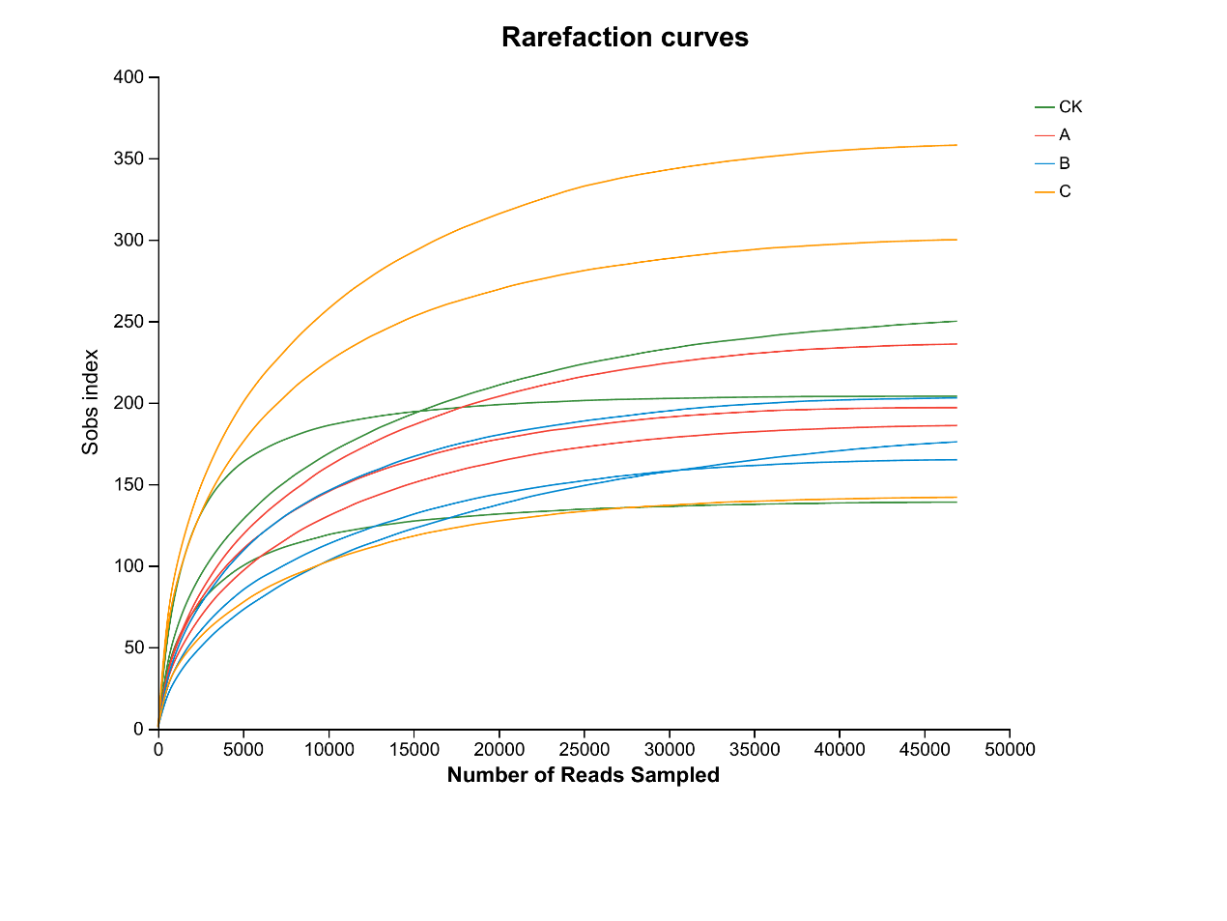
Fig.S1. Rarefaction curves of ASV clustered at a 97% phylotype similarity level. Horizontal axis: the number of valid sequences; vertical axis: the observed number of operational taxonomic units. Total sample richness estimates were calculated by the richness estimator Sobs.

