Supplementary Material for
Integrated transcriptomic analysis reveals evolutionary and developmental characteristics of tendon ossification in teleost

Fig. S1 Gene Ontology (GO) analysis of ENB- (A) or EPB- (B) specific genes in teleost. C 91 intermuscular bone-core genes were shared by both ENBs and EPBs. D Time series analysis of 91 intermuscular bone-core genes.

Fig.S2 Differential expression analysis of IB related tissues across species. A Differential expression analysis between IB tissues and muscle tissues from Wuchang bream and grass carp. 19997 one-to-one orthologs in IB-containing fish (Wuchang bream and grass carp) were identified. B Differential expression analysis between IB tissues (IB-containing fish) and muscle tissues (IB-lackinging fish). 15818 one-to-one orthologs between IB-containing fish and IB-lacking fish were identified.

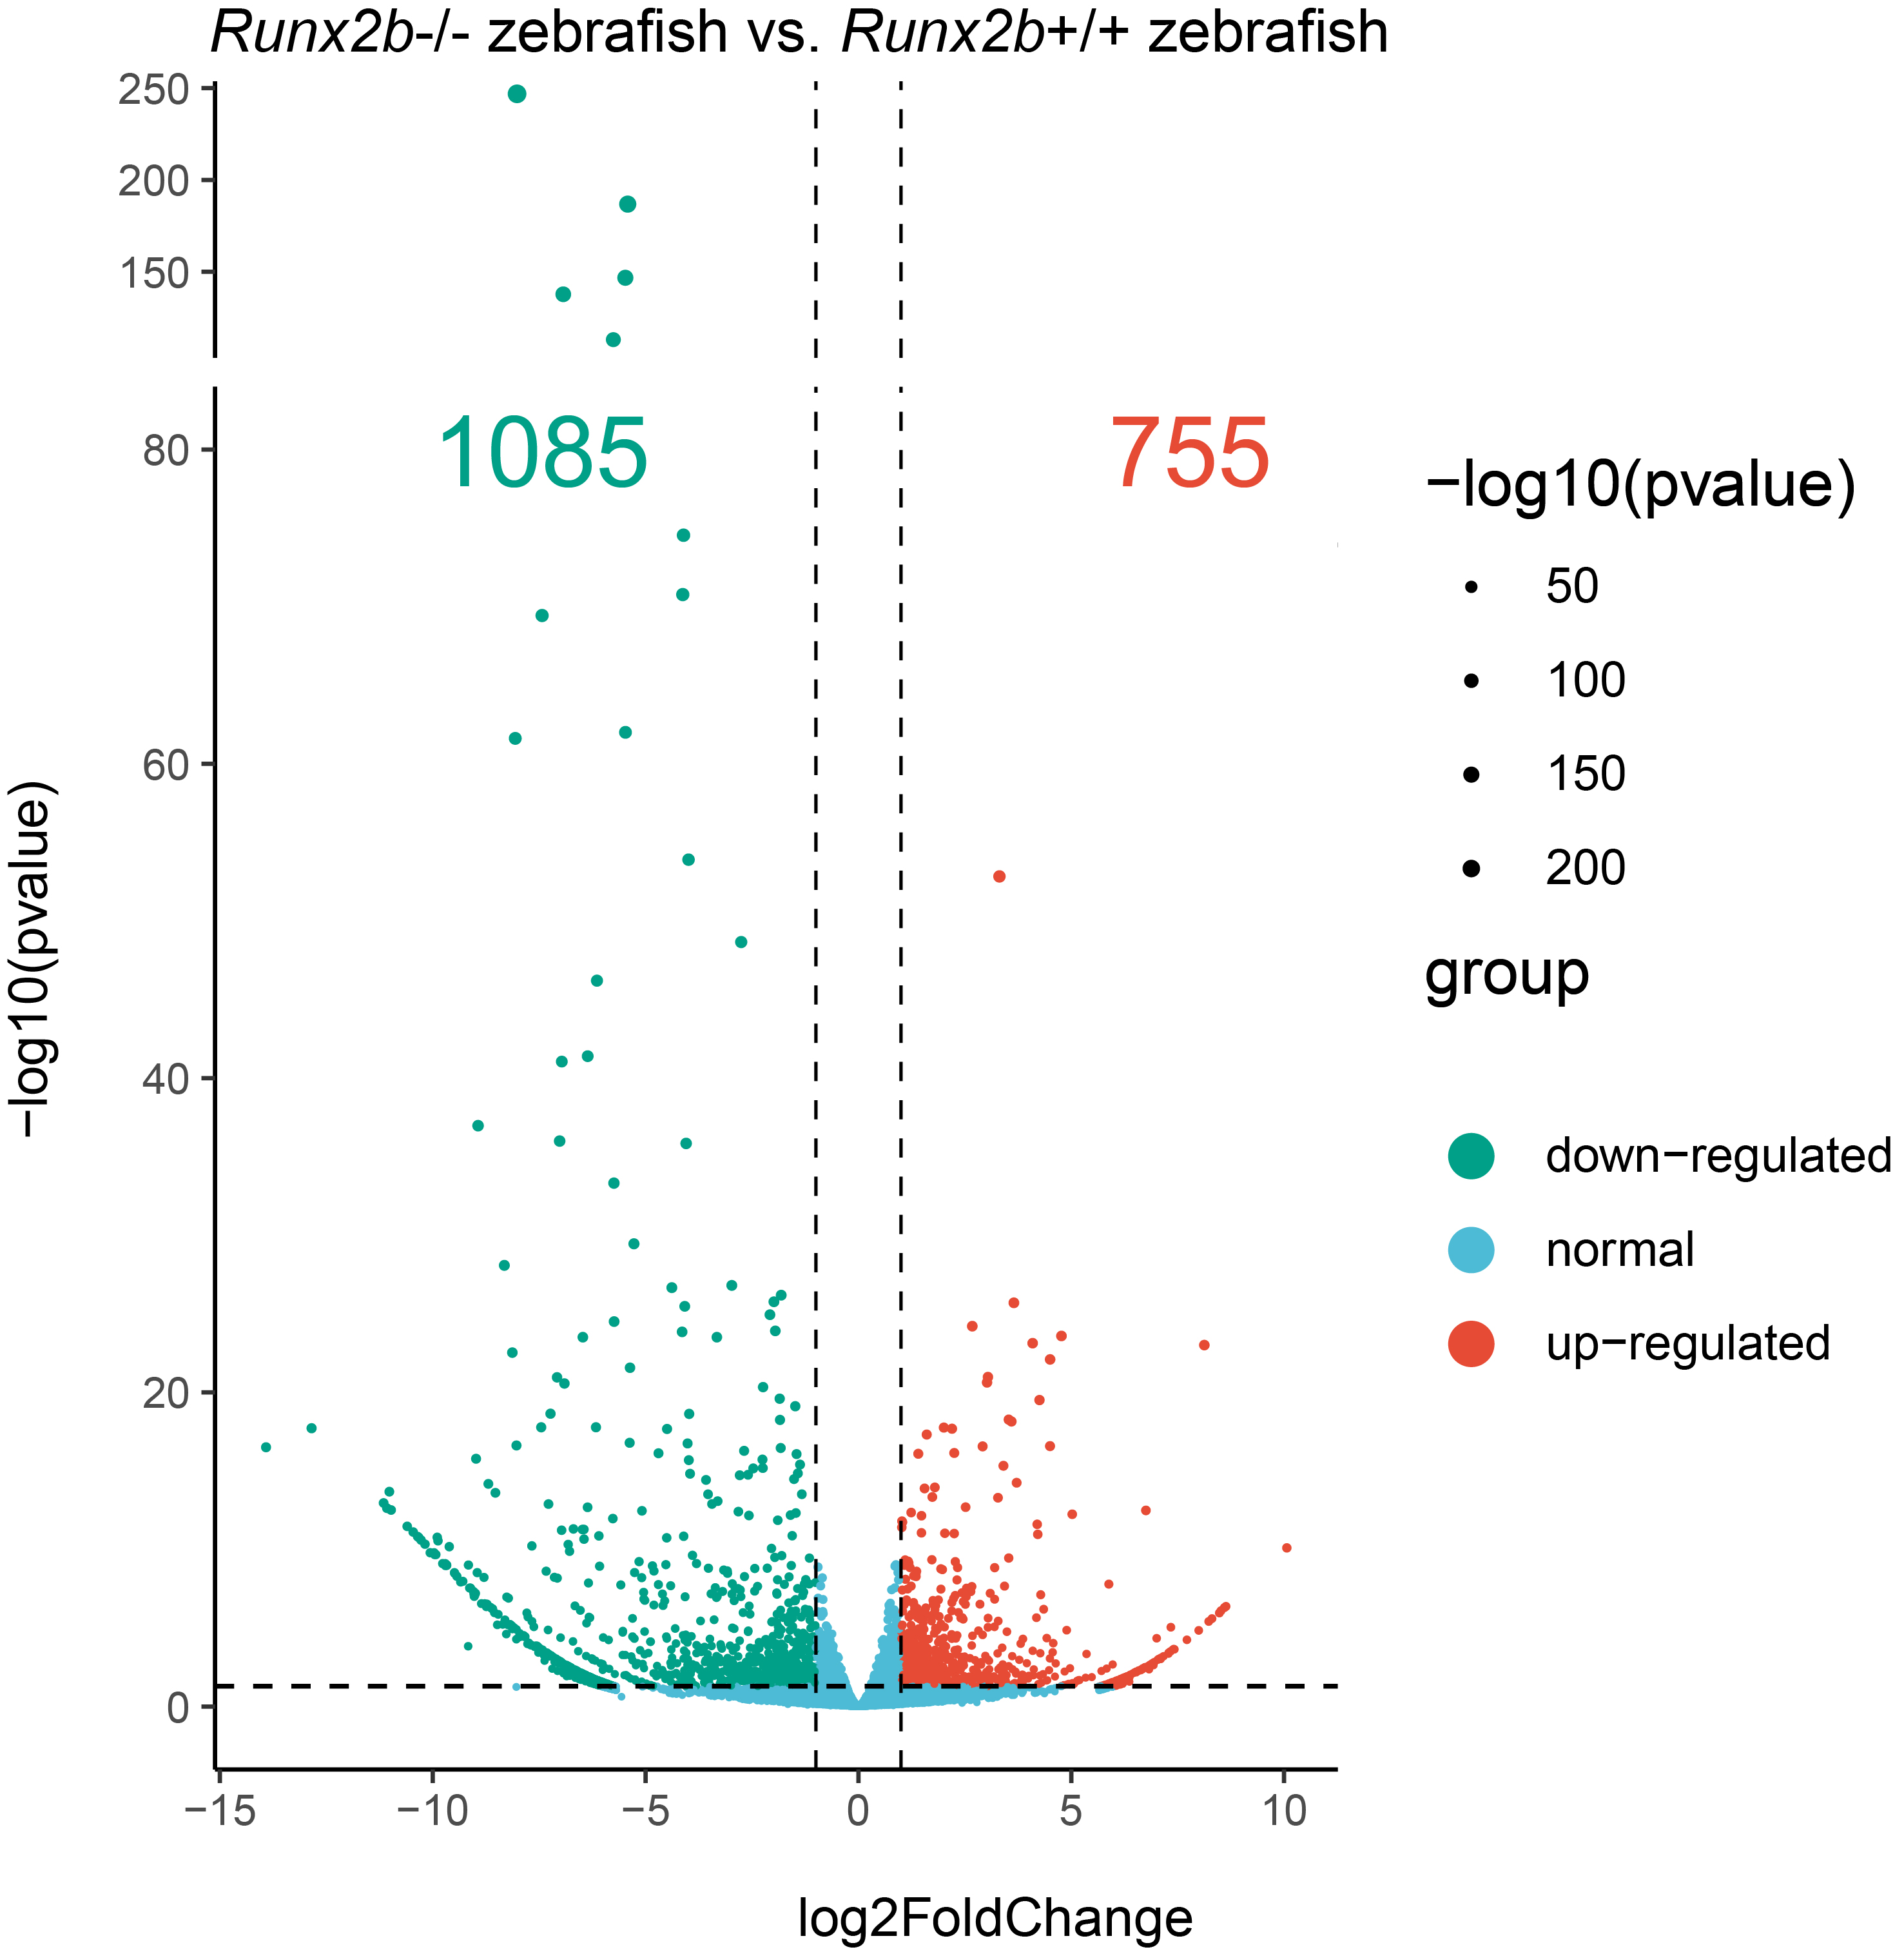
Fig.S3 Differential expression analysis between runx2b^{-/-} and runx2b^{+/+} zebrafish.

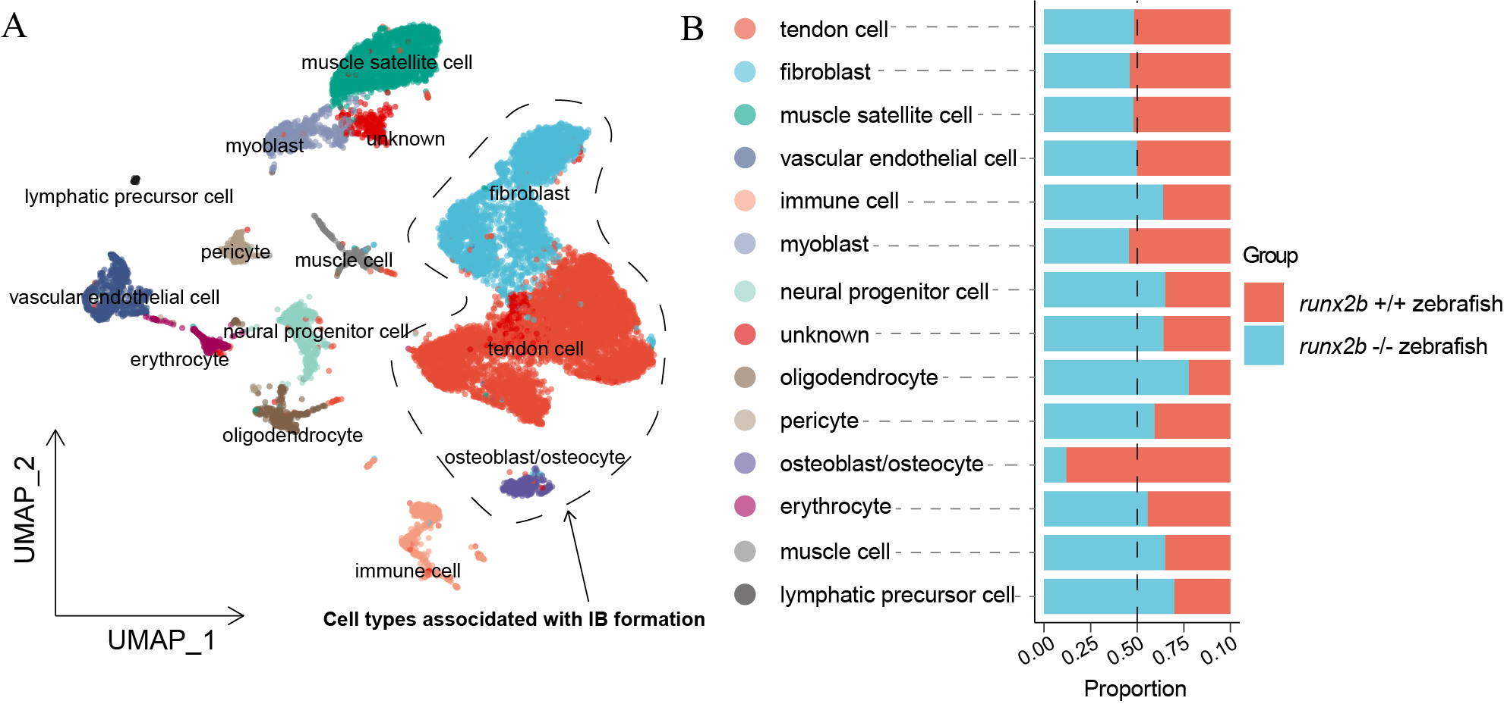
Fig.S4 Cell landscape of tail tissues from runx2b^{+/+} and runx2b^{-/-} zebrafish. A Cells are shown by Uniform Manifold Approximation and Projection and color-coded by cluster cell type. Each dot represents a cell, and different colors are associated with specific cell types. B Cell proportion analysis of runx2b^{+/+} and runx2b^{-/-} zebrafish.
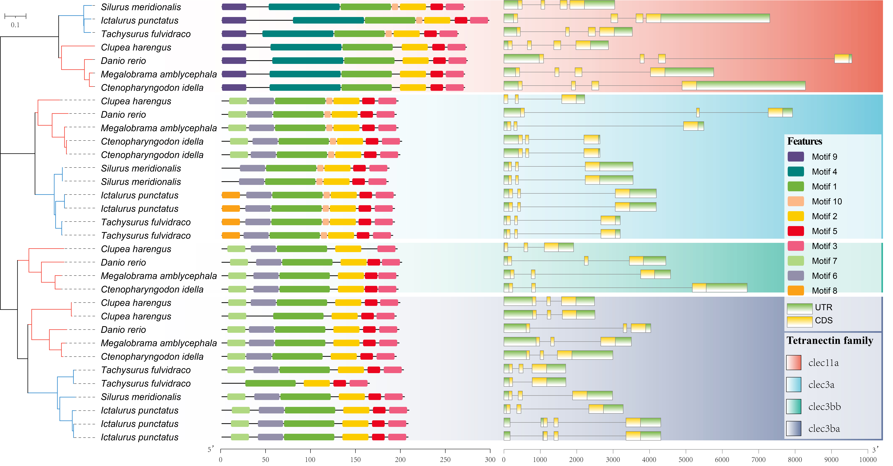Fig.S5 IB-specific genetic changes in tetranectin gene family. Comparative analysis of protein sequence between IB-containing fishes (Clupea harengus, Danio rerio, M. amblycephala, Ctenopharyngodon idella) and IB-lacking fishes (Silurus meridionalis, I. punctatus, T. fulvidraco).

