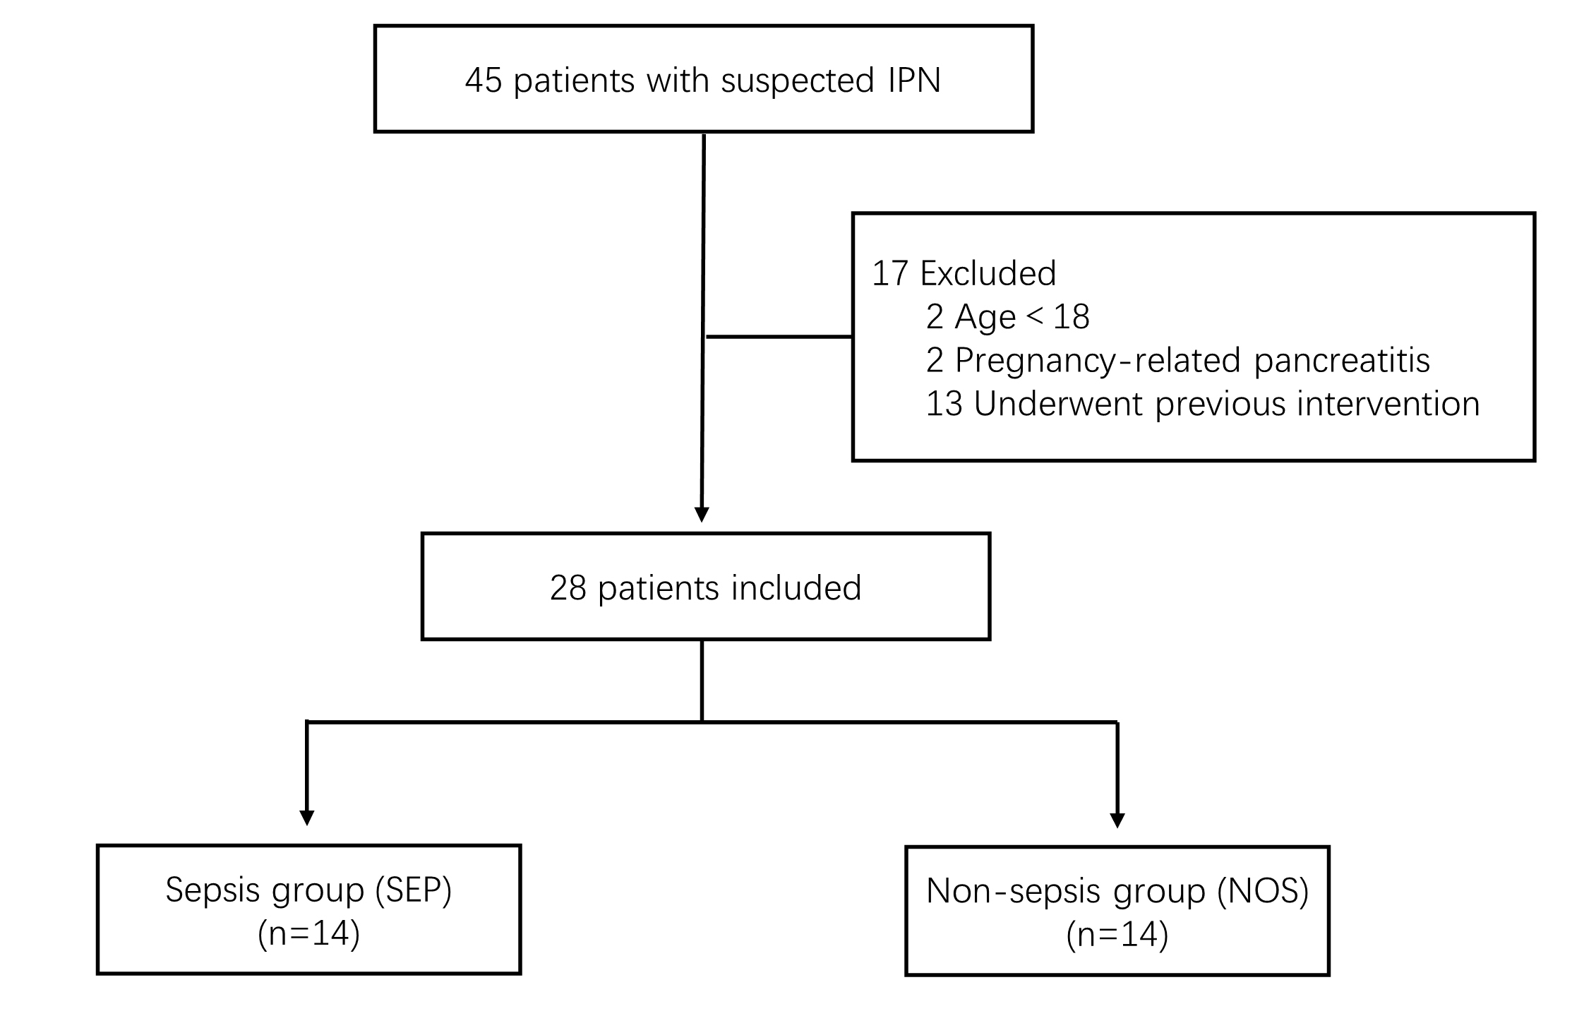
Figure S1 Flow chart of participant inclusion in the trial. Abbreviations: IPN, infected pancreatic necrosis.

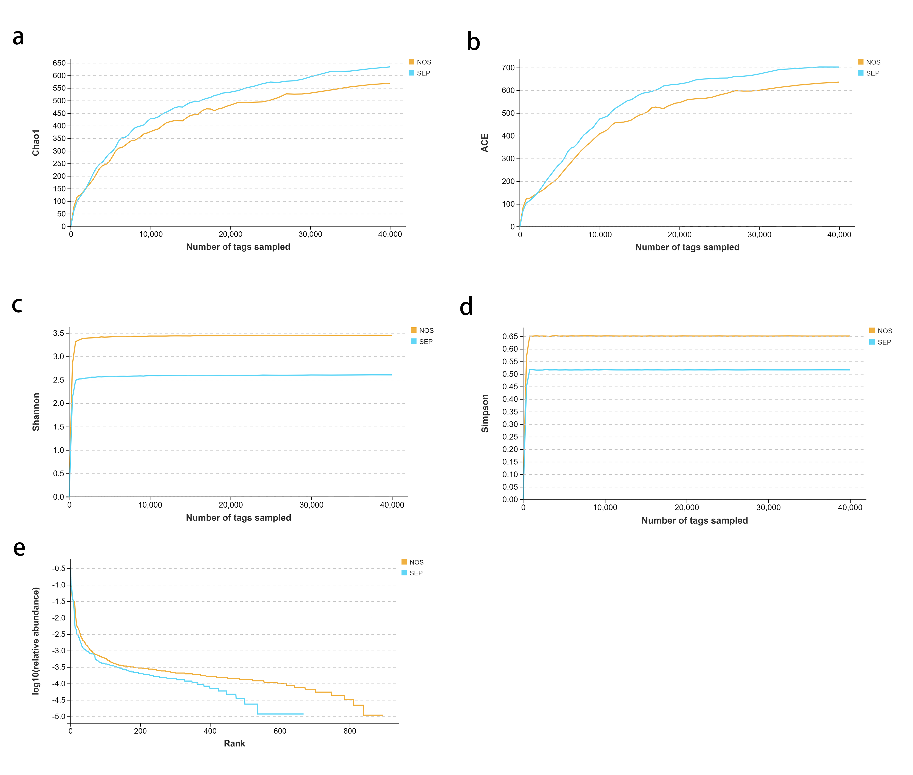
Figure S2 Alpha Diversity Rarefaction Curve and Rank Abundance Curve. a. Chao1 Index; b. Shannon Index; c. Simpson Index; d. ACE Index; e. Rank - Abundance Curve.

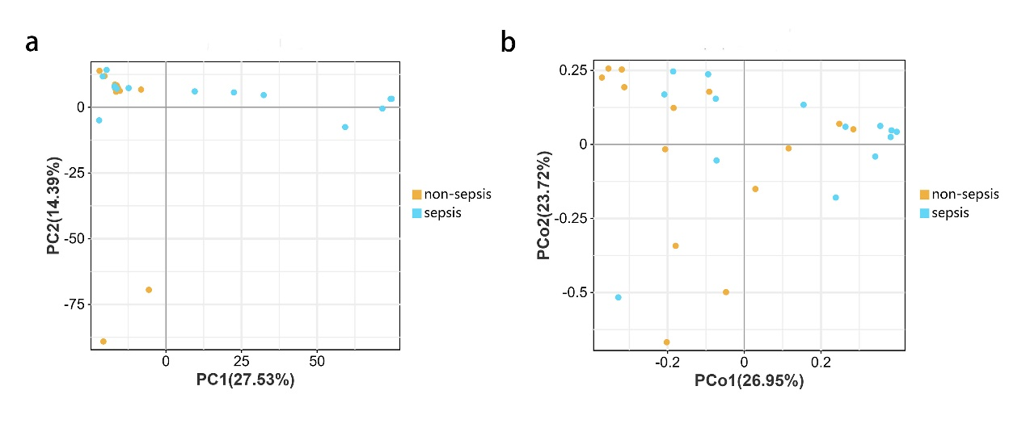
Figure S3 Comparison of Beta Diversity Indices in Two Groups . a. Principal Component Analysis (PCA); b. Principal Coordinate Analysis (PCoA);

Table S1 Microbial Culture Results
Phylum | Family | Species | Total | non-sepsis | sepsis
Proteobacteria | Enterobacteriaceae | Klebsiella pneumoniae | 4 | 1 | 3
Proteobacteria | Enterobacteriaceae | Escherichia coli | 4 | 2 | 2
Proteobacteria | Enterobacteriaceae | Enterobacter cloacae | 1 | 0 | 1
Proteobacteria | Enterobacteriaceae | Salmonella enterica | 1 | 0 | 1
Proteobacteria | Pseudomonadaceae | Pseudomonas aeruginosa | 2 | 1 | 1
Proteobacteria | Moraxellaceae | Acinetobacter baumannii | 3 | 2 | 1
Firmicutes | Staphylococcaceae | Staphylococcus aureus | 2 | 2 | 0
Firmicutes | Staphylococcaceae | Staphylococcus haemolyticus | 2 | 1 | 1
Firmicutes | Staphylococcaceae | Staphylococcus epidermidis | 1 | 0 | 1
Firmicutes | Enterococcaceae | Enterococcus faecium | 3 | 1 | 2
Firmicutes | Enterococcaceae | Enterococcus gallinarum | 2 | 1 | 1
Firmicutes | Streptococcaceae | Streptococcus pharyngitis | 1 | 1 | 0
Firmicutes | Corynebacteriaceae | Corynebacterium | 1 | 1 | 0
Fungi | Saccharomycetaceae | Candida albicans | 2 | 1 | 1
Fungi | Saccharomycetaceae | Candida tropicalis | 1 | 1 | 0
Fungi | Saccharomycetaceae | Candida glabrata | 1 | 1 | 0

Table S2 The relative abundance data at the species level
Species | non-sepsis (%) | sepsis (%)
Ectothiorhodospiraceae_bacterium_AqS1 | 7.680108 | 6.981807
Ralstonia_insidiosa | 3.843777 | 4.59232
Corynebacterium_tuberculostearicum | 8.572738 | 0.43856
Vibrio_fortis | 4.676192 | 0.235607
Bacteroides_fragilis | 4.513008 | 0.2862
Sediminibacterium_sp_Cip28 | 0.485038 | 0.261133
Lactobacillus_murinus | 0.346854 | 0.29696
Lancefieldella_rimae | 0.542462 | 0.03392
Akkermansia_muciniphila | 0.406108 | 0.046967
Dialister_pneumosintes | 0.344508 | 0.01434
Dialister_pneumosintes | 0.344508 | 0.01434

