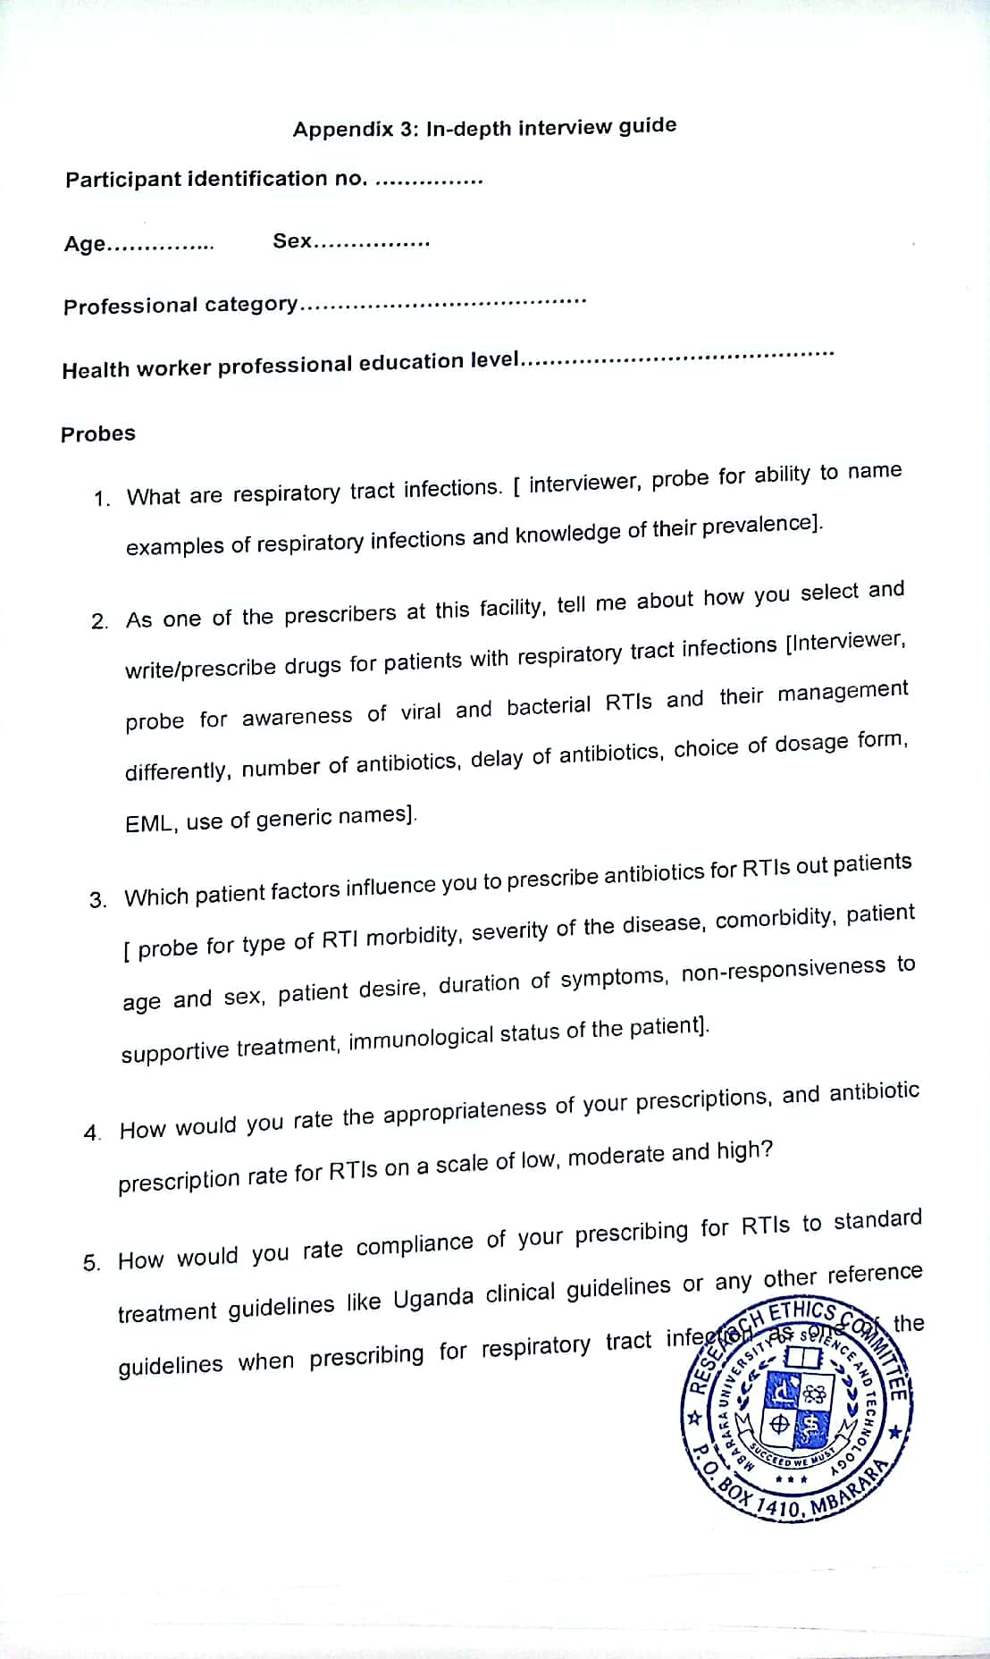

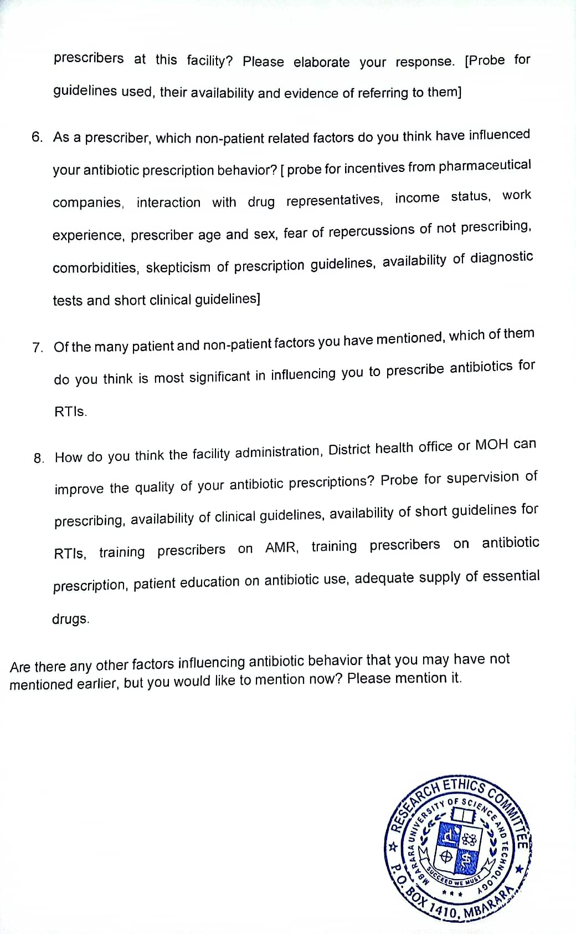

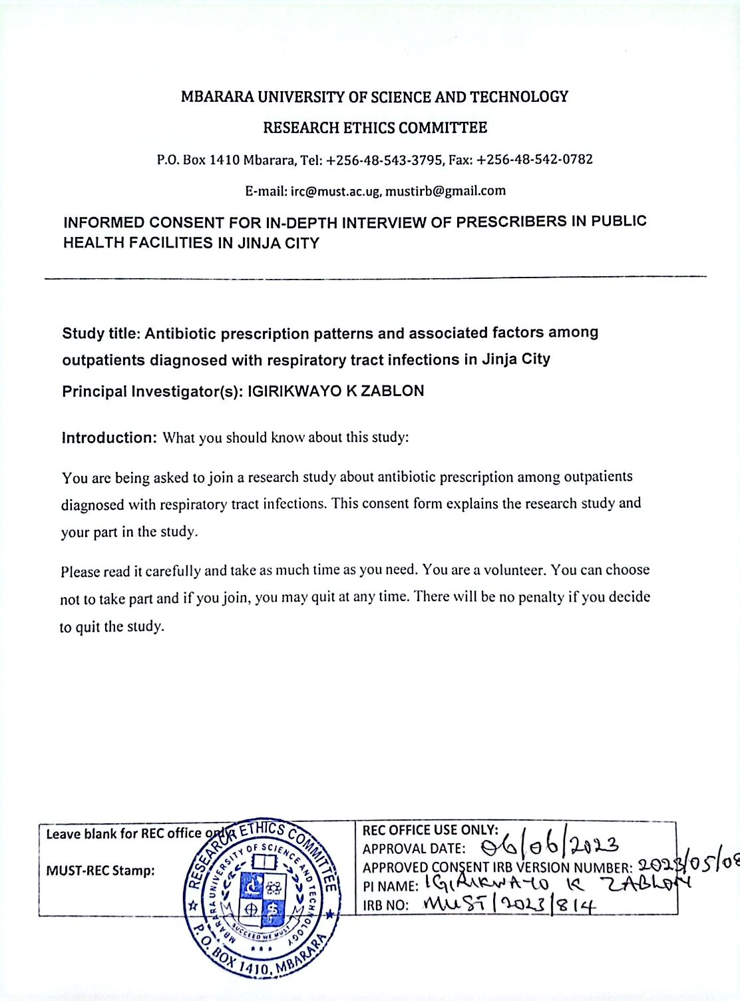

Brief background to the study
Respiratory tract infections (RTIs) are second most prevalent morbidity among outpatients in Uganda. Misuse and overuse of antibiotics in management of RTIs has been reported in some parts of Uganda and it contributes significantly to antibiotic resistance (ABR). Appropriate use of antibiotics to management RTIs can contribute a lot in controlling ABR.

