A limited performance on ASC slides
We test CALM, TransMIL and our method on test set with ASC slides as shown in Supplementary 1 figure 1. We found our model performances poor due to the addition of new categories, which significantly reduced the overall performance, compared to testing only on high-risk SIL and NEG slides. The AUC of our method decreases by 0.089, 0.118 and 0.145 for External-A, External-B and NewCohorts respectively. Basically, limited image quality, limited supervised data, and fuzzy lesion features of ASC together contribute to this result which means that our method is not robust for ASC samples. The poor binary classification results of CLAM and TransMIL, with AUC <= 0.525 for all test sets, also indicate that representations of all instances within a slide is not suitable for cervical cytology slides with sparse distribution of lesion cells.
Supplementary figure 1 | Figure illustrates the ROC curves of CLAM, TransMIL and our method on External-A, External-B and NewCohorts test set which contains ASC, LSIL, HSIL and NEG slides.

More details about our compact microscope
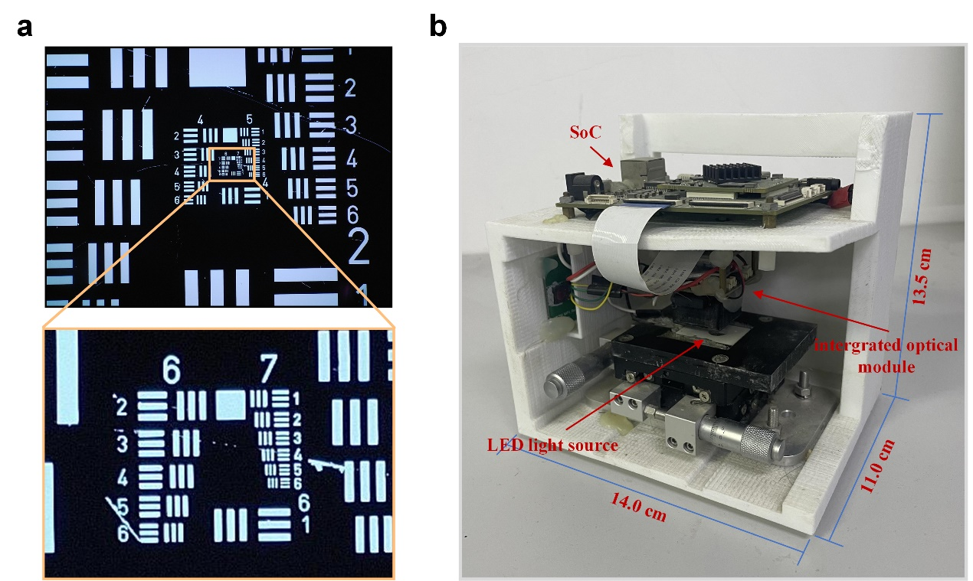
Supplementary figure 2 | a) The image acquired by our compact microscope in best focus using 1951 USAF resolution calculator as test target. b) A picture of our small microscope. The whole device is mainly composed by a 3D-printed framework, a displacement table, a SoC, a LED light source and the integrated optical module. We just put the whole system together in a rough way to make sure it works.
We test the compact microscope on 1951 USAF resolution calculator as Supplementary 1 figure 2. The result shows the resolution is better than 228.1 lp/mm (2.19 μm). We just put the whole system together as a prototype in a rough way to make sure it works. In order to simulate the real scene, we do not finetune the field of view of each shot by adjusting the displacement table, but capture the entire slide redundantly by manually and quickly moving the slide, which means that we can easily add automatic scanning module without worrying about the negative effects on robustness. Software can be easily deployed on SoC. The modular design of the entire system is also very conducive to customize the system to adapt to different work scenarios. For instance, we can add battery, add small liquid crystal display (LCD) to observe the field of view, as well as add control buttons to perform specified function.
To further demonstrate the imaging quality, we have included 100 pairs of HR and LR instances in Supplementary 2, each pair shows the images of the same region by our compact microscope and standard microscope.

