APPENDICES
Appendix 1
AGREE-II scores for 2019 NICE Guideline- NG145 Thyroid Disease: Assessment and Management
Domains and Items | Score  1= Strongly Disagree - 7=Strongly Agree
Domains and Items | Appraiser 1 | Appraiser 2 |  | Appraiser 3 |  | Appraiser 4 |  | Total
Domain 1: Scope and Purpose
Item 1: The overall objective(s) of the guideline is (are) specifically described. | 7 | 6 |  | 7 |  | 7 |  | 27
Item 2: The health question(s) covered by the guideline is (are) specifically described. | 7 | 6 |  | 7 |  | 7 |  | 27
Item 3: The population (patients, public, etc.) to whom the guideline is meant to apply is specifically described. | 7 | 7 |  | 6 |  | 6 |  | 26
Total: | 21 | 19 |  | 20 |  | 20 |  | 80
Domain Score: | 95.2%
Domain 2: Stakeholder involvement
Item 4: The guideline development group includes individuals from all relevant professional groups. | 7 | 6 |  | 6 |  | 7 |  | 26
Item 5: The views and preferences of the target population (patients, public, etc.) have been sought. | 5 | 4 |  | 5 |  | 4 |  | 18
Item 6: The target users of the guideline are clearly defined. | 6 | 6 |  | 6 |  | 5 |  | 23
Total: | 18 | 16 |  | 17 |  | 16 |  | 67
Domain Score: | 79.8%
Domain 3: Rigour of Development
Item 7: Systematic methods were used to search for evidence. | 7 | 6 |  | 7 |  | 7 |  | 27
Item 8: The criteria for selecting the evidence are clearly described. | 6 | 6 |  | 7 |  | 6 |  | 25
Item 9: The strengths and limitations of the body of evidence are clearly described. | 6 | 7 |  | 6 |  | 7 |  | 26
Item 10: The methods for formulating the recommendations are clearly described. | 5 | 6 |  | 7 |  | 6 |  | 24
Item 11: The health benefits, side effects, and risks have been considered in formulating the recommendations. | 6 | 6 |  | 6 |  | 6 |  | 24
Item 12: There is an explicit link between the recommendations and the supporting evidence. | 7 | 5 |  | 6 |  | 6 |  | 24
Item 13: The guideline has been externally reviewed by experts prior to its publication. | 5 | 4 |  | 6 |  | 5 |  | 20
Item 14: A procedure for updating the guideline is provided. | 6 | 7 |  | 7 |  | 6 |  | 26
Total: | 48 | 47 |  | 52 |  | 49 |  | 196
Domain Score: | 87.5%
Domain 4: Clarity of Presentation
Item 15: The recommendations are specific and unambiguous. | 7 | 7 |  | 7 |  | 7 |  | 28
Item 16: The different options for management of the condition or health issue are clearly presented. | 7 | 6 |  | 7 |  | 7 |  | 27
Item 17: Key recommendations are easily identifiable. | 7 | 7 |  | 7 |  | 7 |  | 28
Total: | 21 | 20 |  | 21 |  | 21 |  | 83
Domain Score: | 98.8%
Domain 5: Applicability
Item 18: The guideline describes facilitators and barriers to its application. | 4 | 2 |  | 3 |  | 3 |  | 12
Item 19: The guideline provides advice and/or tools on how the recommendations can be put into practice. | 4 | 3 |  | 3 |  | 4 |  | 14
Item 20: The potential resource implications of applying the recommendations have been considered. | 6 | 5 |  | 6 |  | 6 |  | 23
Item 21: The guideline presents monitoring and/or auditing criteria. | 5 | 5 |  | 5 |  | 6 |  | 21
Total: | 19 | 15 |  | 17 |  | 19 |  | 70
Domain Score: | 62.5%
Domain 6: Editorial Independence
Item 22: The views of the funding body have not influenced the content of the guideline. | 7 | 6 |  | 7 |  | 7 |  | 27
Item 23: Competing interests of guideline development group members have been recorded and addressed. | 7 | 6 |  | 7 |  | 7 |  | 27
Total: | 14 | 12 |  | 14 |  | 14 |  | 54
Domain Score: | 96.4%
OVERALL GUIDELINE ASSESSMENT
1. Rate the overall quality of this guideline. | 7 |  | 5 |  | 6 |  | 7
2. I would recommend this guideline for use. (Yes/Yes, with modifications/No | Yes |  | Yes, with modifications |  | Yes, with modifications |  | Yes

Appendix 2

NICE Guideline – NG145 Thyroid disease: assessment and management
Publication Time |  | November 2019 | Authors | NGC (National Guideline Centre) hosted by RCP
Review Question |  | Review I: ‘What is the clinical and cost effectiveness of using radioactive iodine vs antithyroid drugs vs surgery to treat thyrotoxicosis secondary to Graves’ disease?’  As well as single therapy reviews J, K and L
Studies included |  | 15 studies: 1 Cochrane Review (of 2 RCTs); 6 RCTs; 8 non- randomised
Summary of Recommendations | 1.6.18 | Antithyroid drugs should be offered for at least two years or more for children and young people suffering with Graves’ disease.  “Use of carbimazole is subject to MHRA advice on contraception and risk of acute pancreatitis. November 2019 – carbimazole use is off label for children under 2 years.”
Summary of Recommendations | 1.6.19 | Either continue or restart antithyroid drugs or discuss radioactive iodine and surgery (total thyroidectomy) for paediatrics with Graves' disease who have had antithyroid drugs but have relapsed back into hyperthyroidism.
 | 1.6.20 | For children and young people with hyperthyroidism secondary to a single or multiple nodules:  - Give antithyroid drugs using a dose titration regimen of carbimazole.  - Consider role of radioactive iodine and surgery with child and family, after input and advice from multidisciplinary team

Guideline Characteristics

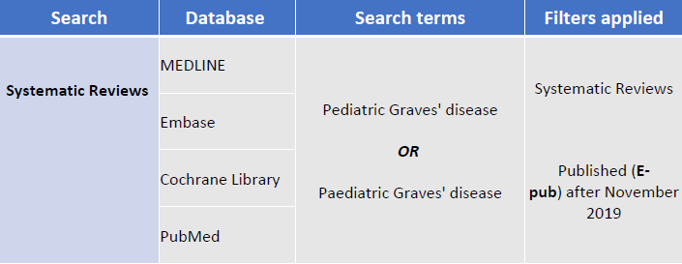
Supplementary Table 1: Search Criteria for Systematic Reviews

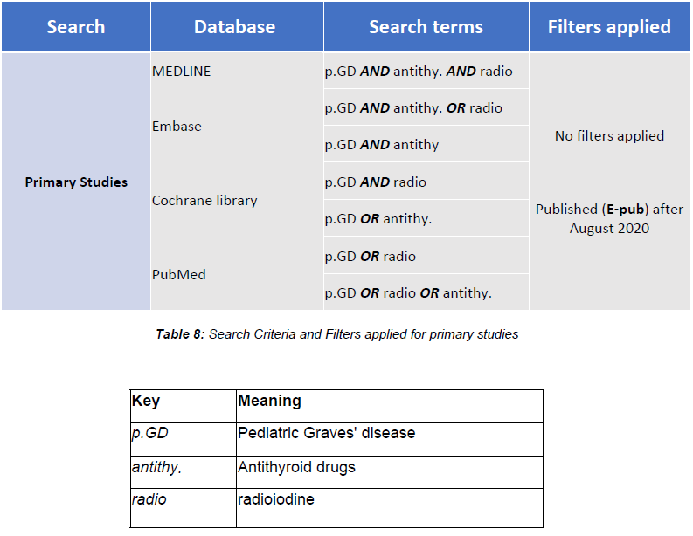
Supplementary Table 2: Search Criteria for Primary Studies

Inclusion Criteria | Exclusion Criteria
- Full text is available to read  - Participants included in studies were all up to 20 years of age and receiving therapeutic treatment for their Grave’s Disease  - Outcomes include efficacy (in terms of remission rates) or any adverse events  - Sample sizes comprised a minimum of 10 participants in each primary study included in the systematic review  - Reviews that included both adult and paediatric cohorts but carried out the analysis and reported result separately  - Published in a peer reviewed journal | - Reviews analysing both paediatric and adult Grave’s Disease patients concurrently  - Reviews with non-English language Text  - Studies taken place in least developed countries as these are less representative of the UK clinical setting

Supplementary Table 3: Selection Criteria for Systematic Review

Inclusion Criteria | Exclusion criteria
- Full electronic print version is available to read  - Participants included in study were all up to 20 years of age and receiving therapeutic treatment for their Grave’s Disease  - Outcomes include efficacy (in terms of remission rates) and any adverse events  - Study design is not limited to intervention vs control but can include varying doses of antithyroid/ radioiodine treatment.  - Bare minimum of addressing effectiveness or adverse events on their own. | - Participants comprising the study population must not be followed for a period less than 6 months  - Studies with non-English language Text  - Conference abstracts, case reports/series, reviews  - Studies taken place in the least developed countries as these are less representative of the UK clinical setting

Supplementary Table 4: Selection Criteria for Primary Studies

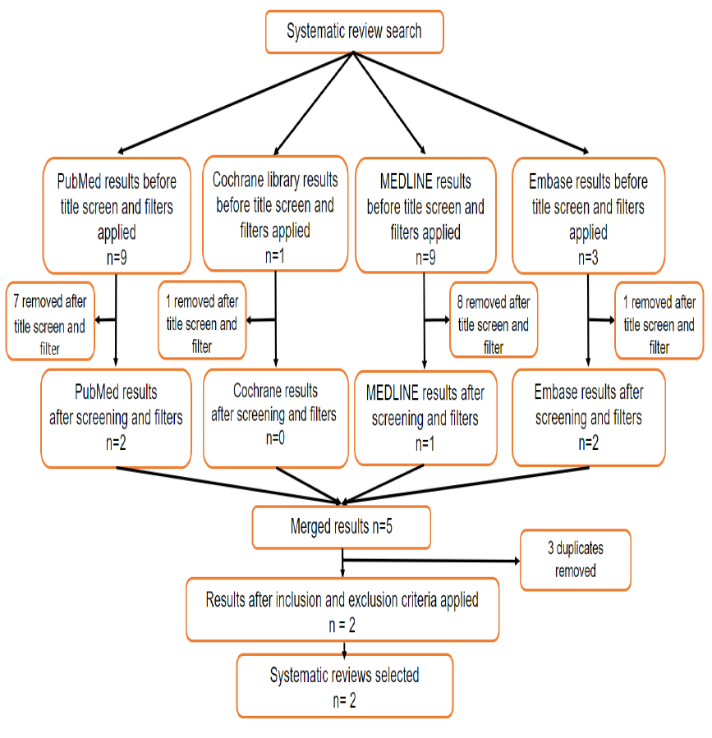

Supplementary Figure 1: PRISMA Flowchart depicting screening for systematic reviews

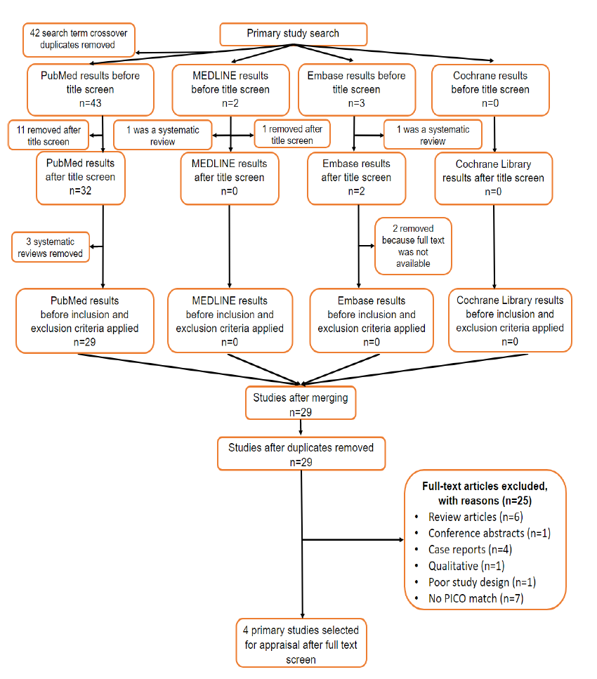

Supplementary Figure 2: PRISMA Flowchart depicting screening for primary studies

