Supplementary Information for

p-n junction induced space-charged localization of single-atom catalysts for boosting oxygen reduction reaction

Zheng Li¹, Qiyou Wang⁵, Mengran Wang¹, Hao Cheng¹, Yao Lu¹, Jian Chen¹,Wei Zhang², Jingqiang Zheng¹, Lirong Zheng⁴, Shiwei Hu^{3*}, Guanjie He^{2*} and Zhongliang Tian^{1*}

¹ School of Metallurgy and Environment, Central South University, Changsha 410083, China. ² Christopher Ingold Laboratory, Department of Chemistry, University College London, 20 Gordon Street, London WC1H 0AJ, UK. ³ Centre for Interdisciplinary Research in Fluids, Institute of Mechanics, Chinese Academy of Sciences, Beijing, China. ⁴Institute of High Energy Physics, Chinese Academy of Sciences, Beijing 100049, China. ⁵School of Physics, Central South University, Changsha 410083, Hunan, China. *email: hushiwei@mail.ustc.edu.cn; g.he@ucl.ac.uk; tianzhongliang@csu.edu.cn.

Experimental Section
Synthesis of Fe-N-C: Firstly, 6 g C₃H₆N₆, 1.5 g C₃H₇NO₂ and 0.12 g FeCl₃, were mixed homogeneously and then ball milled for 8 h. Subsequently, the sample obtained above was added to 10 mL of a mixed solution of ethanol and hydrochloric acid and stirred sufficiently (The volume ratio of ethanol to hydrochloric acid is 5:1). The above slurry is stirred continuously until the solution is completely evaporated. The resulting mixture was dried under 80°C in an oven and subsequently, ball milled again for 2h. The secondary ball-milled samples were subjected to pyrolysis and carbonization in an Ar gas atmosphere, with the rate of temperature increase controlled at 3 °C/min. Finally, the samples were immersed in a 2 M HCl solution to remove unstable substances. The sample obtained after the above steps is named Fe-NSC.
Synthesis of Fe/Zn-NC: 6 g C₃H₆N₆, 1.5 g C₃H₇NO₂, 0.1g zinc chloride and 0.1 g FeCl₃, were mixed homogeneously and then ball milled for 8 h. Subsequently, the sample obtained above was added to 10 mL of a mixed solution of ethanol and hydrochloric acid and stirred sufficiently (The volume ratio of ethanol to hydrochloric acid is 5:1). The above slurry is stirred continuously until the solution is completely evaporated. The resulting mixture was dried under 80°C in an oven and subsequently, ball milled again for 2h. The secondary ball-milled samples were subjected to pyrolysis and carbonization in an Ar gas atmosphere, with the rate of temperature increase controlled at 3 °C/min. Finally, the samples were immersed in a 2 M HCl solution to remove unstable substances. The sample obtained after the above steps is named Fe-NSC.
Synthesis of a-ZnS/Zn-NSC electrocatalyst: 6 g C₃H₆N₆ and 1.5 g C₃H₇NO₂ were first ground into a homogeneous precursor by ZrO₂ mortar ball for 2 h. Following, 10 mL mixed solution of ethanol and hydrochloric acid (volume ratio 5:1) was added. The slurry continued to be ground until the ethanol evaporated. The mixture was dried in an oven at 80 °C and ball milled again for 2 h. The fine powder mixture (6 g) and zinc powder (1.2 g) were ball milled for 2 h. Subsequently, the fine powder mixture was undergone a pyrolysis and carbonization process under the Ar atmosphere.
Materials Characterization: The surface morphology of as-prepared catalysts was studied by transmission electron microscopy (TEM, Tecnai G2 F20 S-TWIN TMP, CSU, USA) were used to investigate the microstructures of catalysts. The elementary composition of the catalysts was characterized by Oxford energy-dispersive X-ray spectrometer (EDX), which is attached to TEM equipment. The phase composition of the as-prepared catalysts was tested by X-ray diffraction (XRD, Empyrean, Malvern Panalytical., Shiyanjia Lab, Netherlands) with Cu Kα radiation (λ=1.5406 Å). The X-ray photoelectron spectroscopy (XPS, Thermo Scientific K-Alpha, Thermo Fisher Scientific, Shiyanjia Lab, USA) was analyzed on K-Alpha+ system, and calibrated by C 1s (284.8 eV). The X-ray absorption spectroscopy were recorded on 1W1B Beamline of Beijing synchrotron radiation facility (BSRF). The content of as-prepared catalysts were measured by inductively coupled plasma optical emission spectrometer (ICP-OES, Agilent 720ES, Shiyanjia Lab, USA). The gas chromatography (GC-2014C, Shimadzu, BUCT, Japan) was employed to detect H₂ quantification and the carrier gas is ultrapure argon (Ar, 99.999%). Raman (Thermo Scientific DXR2, HNU, USA) spectra were obtained using a DXR2 Raman Microscope with a wavelength of 532 nm. The surface area and meso/macropore size distributions of the as-prepared materials were determined by the Brunauer-Emmett-Teller (BET) and Barret-Joyner-Halenda (BJH) methods, respectively. N₂ adsorption-desorption isotherm tests were performed on a gas adsorption analyzer (ASAP2460, Micromeritics). The thermogravimetric experiments were conducted on TG 209 F3 Tarsus under the air atmosphere from the room temperature to 900 °C with heating rate of 10 °C min⁻¹. The electronic property was characterized by Electron paramagnetic resonance (EPR, Bruker model A300 spectrometer) in dark at room temperature. Sub-ångström-resolution HAADF-STEM characterization was conducted with a JEOL JEMARM200F STEM/TEM instrument with a resolution of 0.08 nm. XAS data, including XANES and EXAFS at Fe K-edge, were collected in total-fluorescence-yield mode using multi-element SDD detector in BL-44A at National Synchrotron Radiation Research Center (NSRRC, Hsinchu, Taiwan). The O₂-TPD of the samples was measured using AutoChem II 2920 apparatus. The catalyst (100 mg) was pretreated at 150 °C and purged with helium (He) for 2 h, and then cooled down to room temperature. And then, the catalyst was purged with 5% O₂/He at 25 °C for 2 h. Finally, the desorption profile of O₂ was recorded online under the atmosphere of He. The ⁵⁷Fe Mössbauer spectra were achieved by using an MS-500 instrument (Germany, Wissel) in transmission geometry with constant acceleration mode at room temperature. In situ electrochemical FT-IR spectroscopic studies were performed using a purged VERTEX FT-IR spectrometer equipped with the A530/P accessory and a mid-band MCT detector. A CaF₂ hemispherical window was used with the working electrode placed 1 mm above the window for the FTIR study. The in situ experimental setups is depicted in Fig. 4A The measurement parameters were 4 cm⁻¹ resolution and 100 scans. This setup enabled the detection of ORR intermediate formation and change of adsorption of various intermediates on the electrode surface and within the thin-layer electrolyte.
Electrochemical Measurements: The electrochemical measurements of catalysts were characterized using a Gamry Interface 1000 electrochemical workstation with a standard three-electrode system at room temperature. The working electrode was prepared by dropping the catalyst ink onto a glass-carbon (GC), which is a rotating disk electrode (RDE, 5 mm in diameter). The catalyst ink was prepared by dispersing 4 mg of each catalyst in 1mL of mixed solution containing 0.98 mL of ethanol/water (1:1, v/v) and 20 μL of 5 wt% Nafion solution, followed by ultra-sonication for 30 min to form a homogeneous black suspension solution. Then the as-obtained catalyst ink was drop-casted onto the surface of GC electrode followed by drying in air. The catalyst loading amount for both as-prepared catalysts and commercial Pt/C (20 wt%) was 0.2 mg cm⁻².
The ORR performance of the catalysts was measured in O₂-saturated 0.1 M KOH solution. The cyclic voltammetry (CV) curves were obtained at a scan rate of 50 mV s⁻¹. Linear sweep voltammetry (LSV) was performed using RDE at a scan rate of 5 mV s⁻¹ with various rotation speeds (400, 625, 900, 1225, 1600 and 2025 rpm). All measured potentials are provided versus the standard reversible hydrogen electrode (RHE). The onset potential was defined as the potential required for generating a current density of -0.1 mA cm⁻² in LSV curves. The electron transfer number was calculated by Koutecky-Levich (K-L) equation:
$\frac{1}{J}= \frac{1}{J_{K}}+ \frac{1}{J_{L}}= \frac{1}{J_{K}}+ \frac{1}{Bω^{1/2}}$ (1)
$B=0.62nFC_{0}D_{0} ^{2/3} υ^{-1/6}$ (2)
where 𝐽 is the measured current density, 𝐽_{𝑘} is the kinetic diffusion current density, 𝐽_{𝐿} is the kinetic limiting current density, 𝐵 is the reciprocal of the slope, ω is the angular velocity (ω=2πN, N is the rotation speed), 𝑛 is transferred electron number, 𝐹 is Faraday constant (96485 C mol⁻¹), 𝐶₀ is the saturated concentration of O₂ (1.2×10⁻⁶ mol cm⁻³), 𝐷₀ is the diffusion coefficient of O₂ (1.9×10⁻⁵ cm² s⁻¹), and ν is the kinetic viscosity (0.01 cm² s⁻¹).
The ORR stability of the electrocatalysts in the O₂-staurated 0.1 M KOH solution was examined by chronoamperometry at a potential of 0.80 V (vs. RHE) in O₂-staurated 0.1 M KOH. To test the tolerance to methanol, chronoamperometric measurements at 0.7 V (vs. RHE) in a O₂-saturated 0.1 M KOH solution along with the injection of methanol were performed. The methanol was added into the electrolyte at the time of 900 s.
The site density (SDmass) of the catalyst was evaluated by the in-situ nitrite poisoning to quantify the accessible Fe-N₄ sites on the a-ZnS/Fe-NC^{[1,2]}. The equation is as follows:
$$SDmass\left(sites·g^{-1}\right)=\frac{Q\left[A·V·cm^{-2}\right]×N_{A}[atom·mol^{-1}]}{n×W\left[V·s^{-1}\right]×F\left[s·A·mol^{-1}\right]×L[g·cm^{-2}]}$$
Q is the grey area in Fig. S23, N_{A} is Avogadro’s constant, n is the number of electrons associated with the reduction per NO stripping, W is the scan rate, and F is Faraday constant. The NO stripping charge of nitrite stripping was determined by subtracting the first negative-going voltammogram of an unpoisoned electrode from that of the poisoned electrode over the 0.4 V to -0.3 V vs. RHE potential range.
The turn over frequency (TOF) at a given potential e.g. 0.85 V RHE, we use the difference in kinetic mass current (J_{kin,mass}) at that potential between the unpoisoned and poisoned state divided by the number of sites:
$$TOF\left(e^{-}·site^{-1}·S^{-1}\right)=\frac{(i_{k}^{unpoisoned}-i_{k}^{poisoned})×N_{A}[site·mol^{-1}]}{SD_{mass}[site·g^{-1}]×F[s·A·mol^{-1}]}$$
Theoretical calculations: The theoretical analysis based on density function theory (DFT) calculations were performed by Vienna Abinitio Simulation Package (VASP).^{[3, 4]} In addition, the convergence criteria of 10⁻⁴ eV in electronic relaxation and 0.02 eV/Å in force with conjugate-gradient algorithm were adopted. The Perdew-Burke-Ernzerhof (PBE) functional within generalized gradient approximation (GGA) was employed. The plane-wave cutoff energy was set to 450 eV. The Brillouin zone of the periodic 2D slab separated with a 15 Å vacuum space along the Z-axis was sampled with 2×2×1 and 4×4×1 k-points grids for geometry optimization and electronic structure calculations, respectively. The unit cell size is set at 20×20 Å to avoid interactions between the imaging cells. Fermi-smearing of kBT = 0.1 eV was employed to speed up the convergence.
The free energy of each elementary step in the proton coupled electron transfer reactions was computed using the computational hydrogen electrode (CHE) model for oxygen reduction reaction (ORR). Considering the O₂ molecular is not broken before reduction, the associative 4e⁻ reduction pathway was evaluated to be most feasible for ORR in this work, as follows:
$O_{2}+*→ O_{2 }*$ (1)
$O_{2}*+H_{2}O+e^{-}→{OOH}^{*}$ (2)
${OOH}^{*}+e^{-}→ O^{* }+{OH}^{-}$ (3)
$O^{* }+H_{2}O+e^{-}→ {OH}^{*}+{OH}^{-}$ (4)
${OH}^{*}+e^{-}→{OH}^{-}+ *$ (5)
where * represents the active site on the corresponding surface.
All spin-polarized DFT calculations were performed using the Vienna ab initio simulation package (VASP)^{[5]}. The projector augmented wave potentials were employed with the generalized gradient approximation based on the Perdew-Burke-Ernzerhof (PBE) level^{[6-8]}. A Gaussian smearing of 0.05 eV was applied to ensure the self-consistency and convergence of the electron density. The plane wave cutoff was set to 520 eV.
Firstly, geometry optimizations were conducted for FeN₄ and ZnS with convergence thresholds of 10⁻⁵ eV for energy and 0.005 eV Å⁻¹ for force. Subsequently, static self-consistent calculations were performed for all optimized structures to obtain their electronic structures. The energy bands for each structure were then calculated using the electron distribution from the self-consistent calculations and high symmetric K-points generated from VASPKIT^{[9]}. Finally, the band gap was determined as the energy difference between the conduction band and valence band.”
Assembly of Al-air batteries: In a typical Al-air batteries, the polished aluminum plate is used as anode. The electrolyte is 6M KOH contained 0.0005 M In(OH)₃, 0.0075 M ZnO, and 0.01 M Na₂SnO₃; the gas diffusion electrode with catalyst loading amount of 2.0 mg cm⁻² is employed as cathode in a home-made cell model. As a control, the commercial Pt/C (20 wt%) was also assembled in similar mode. The measurement of batteries was performed on the LAND testing system.

Supplementary Figures
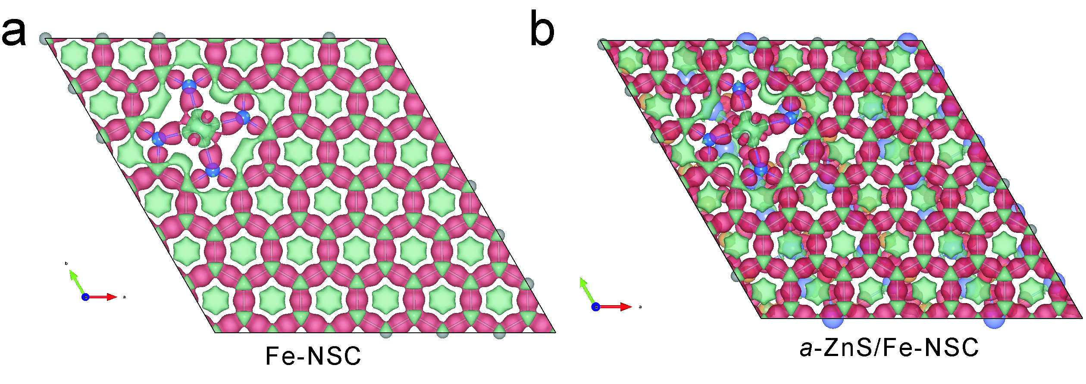
Supplementary Figure 1. Charge density mappings of Fe-NSC and a-ZnS/Fe-NSC.
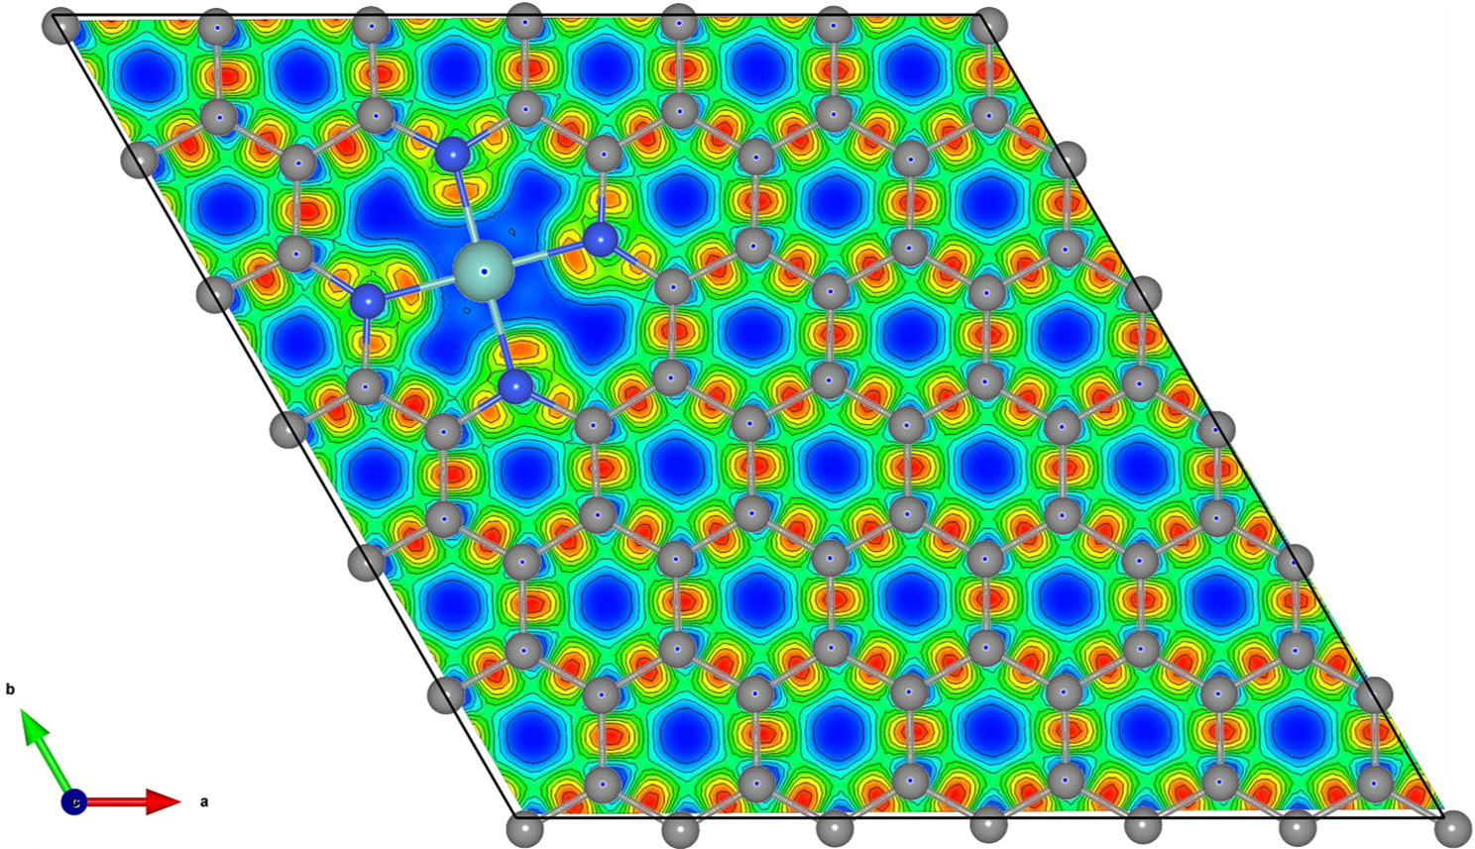
Supplementary Figure 2. Electron localization functions of a-ZnS/Fe-NSC.
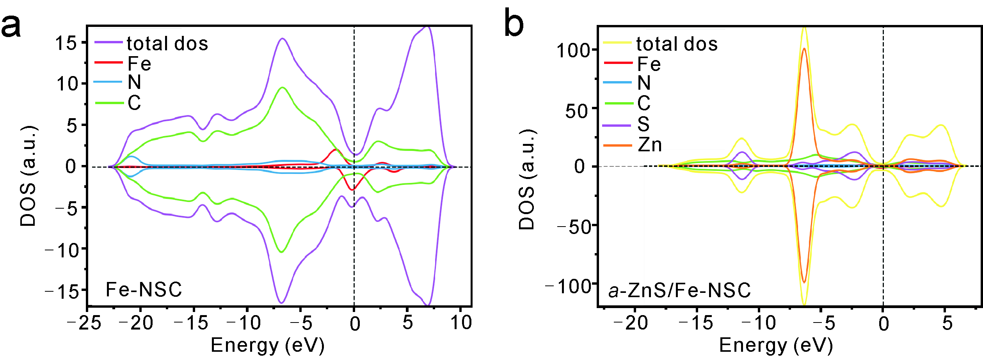
Supplementary Figure 3. The calculated DOS of (a) Fe-NSC and (b) a-ZnS/Fe-NSC.
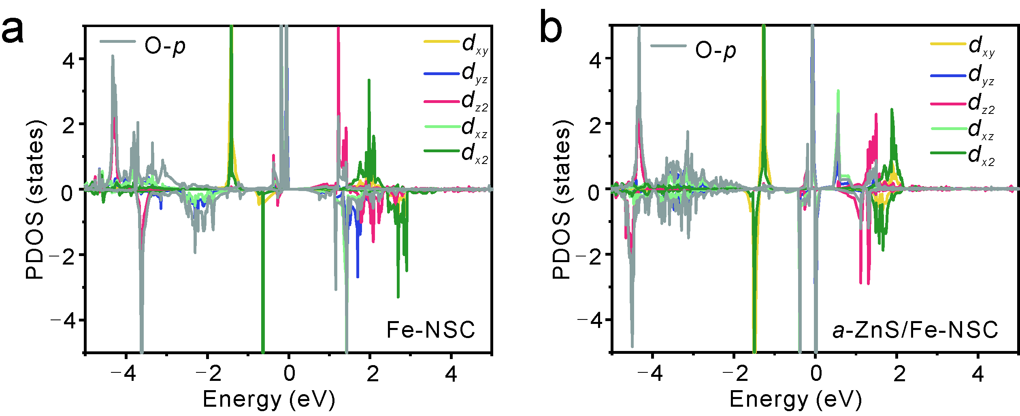
Supplementary Figure 4. The corresponding magnetic moment originated from the spin-splitting of Fe 3d atom orbitals for (a) Fe-NSC and (b) a-ZnS/Fe-NSC after O₂ adsorption.
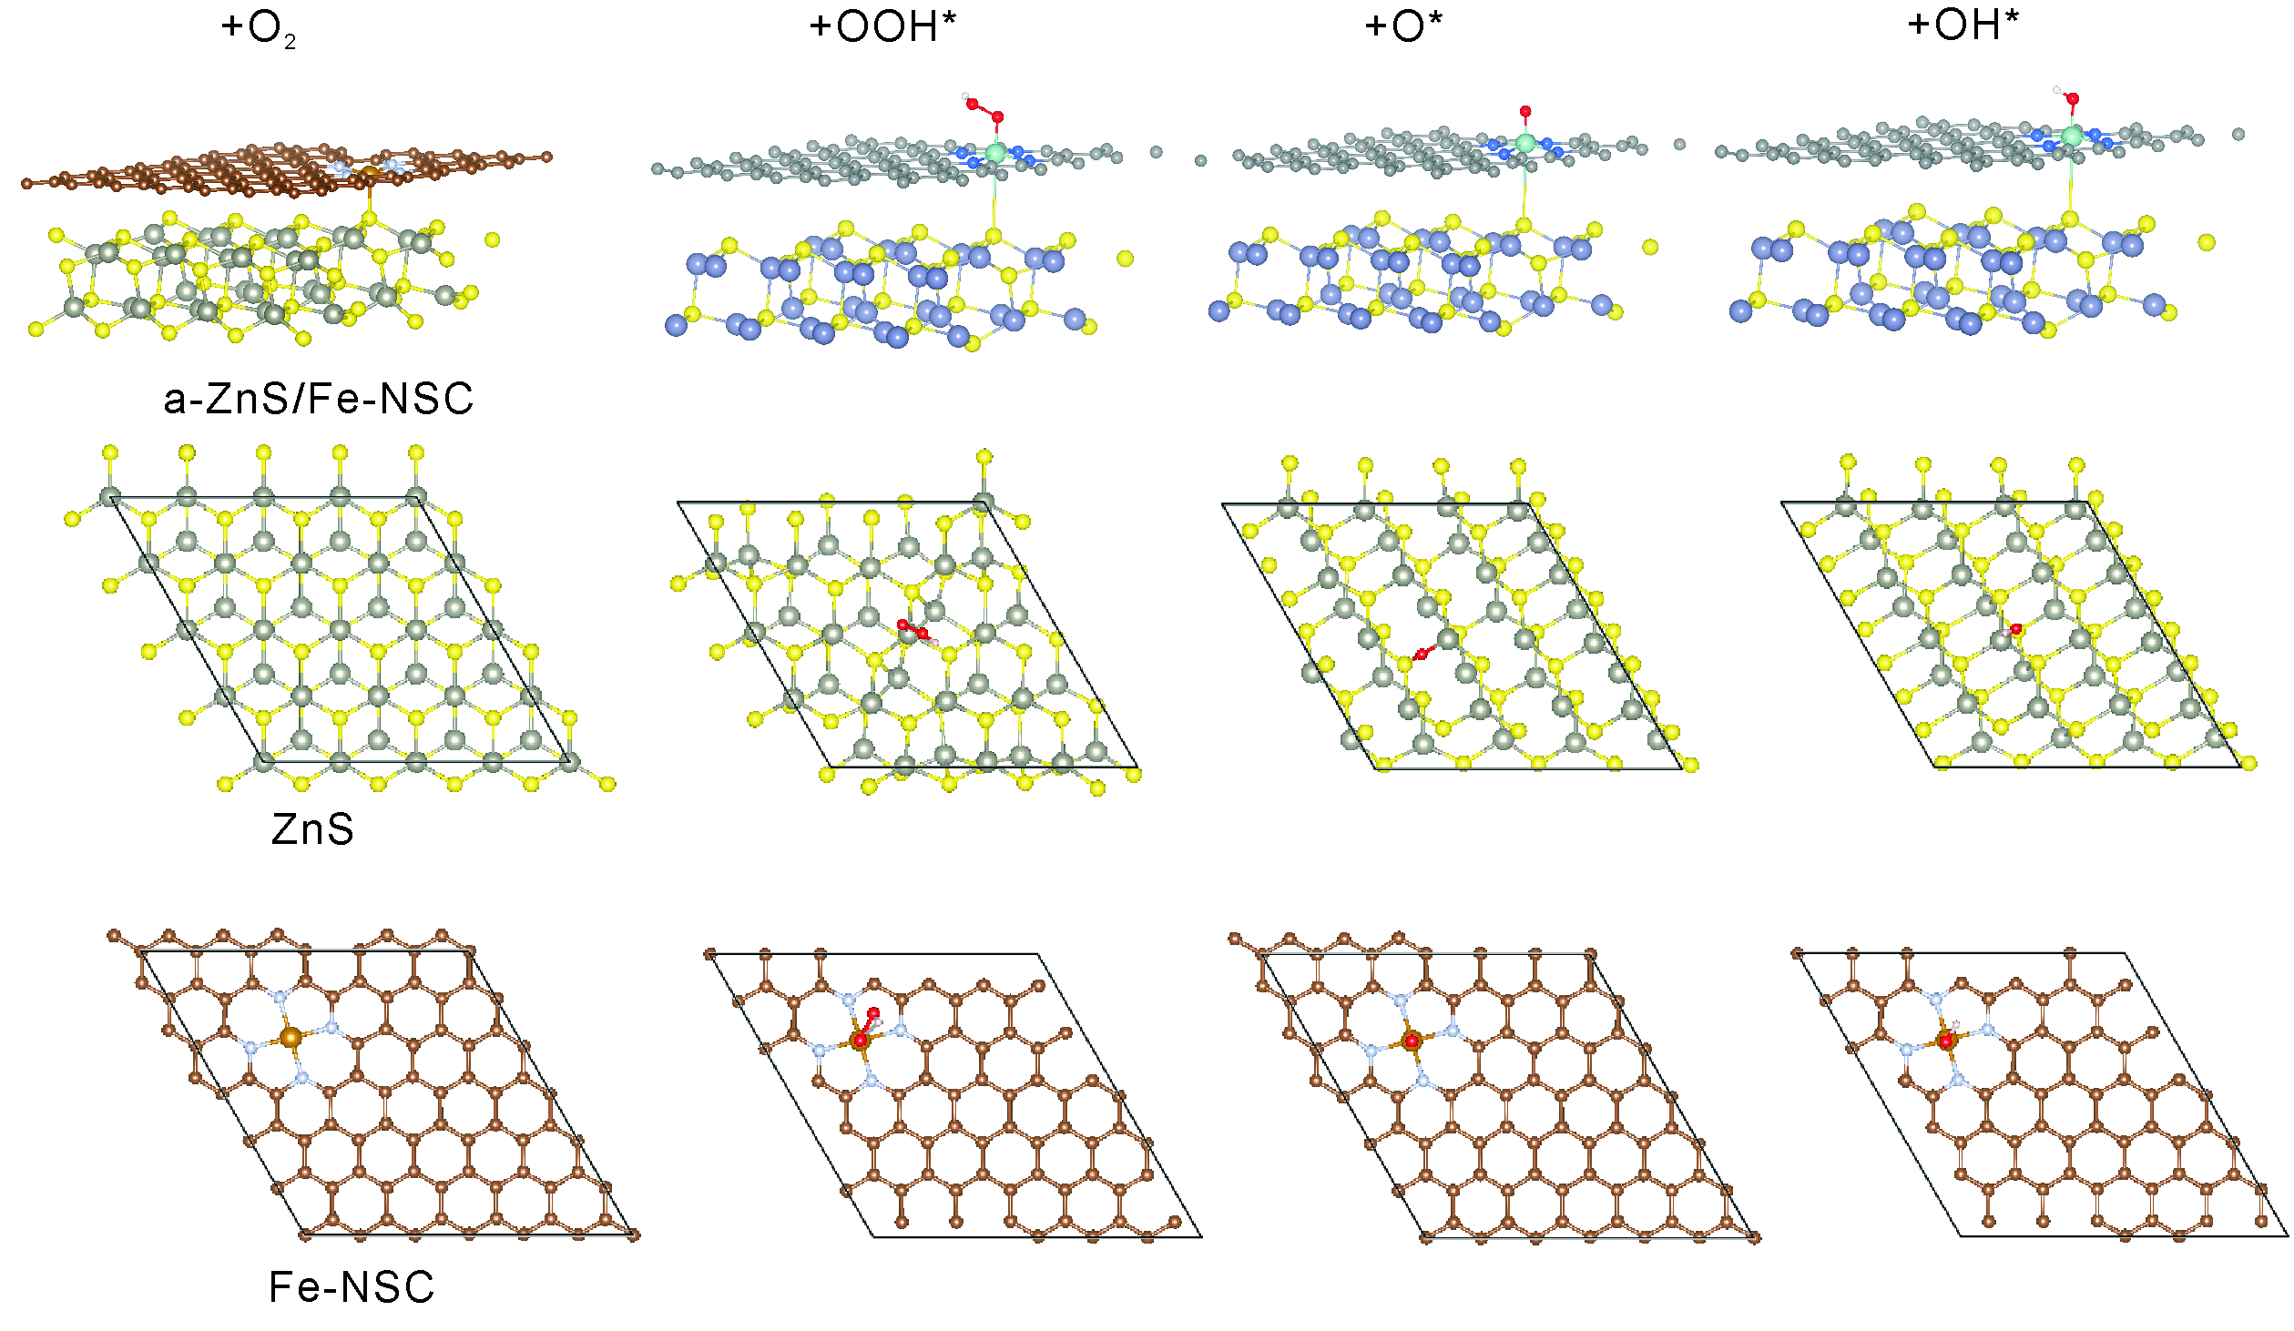
Supplementary Figure 5. The optimized adsorption configurations of the ORR intermediates of OOH*, O*, and OH*.
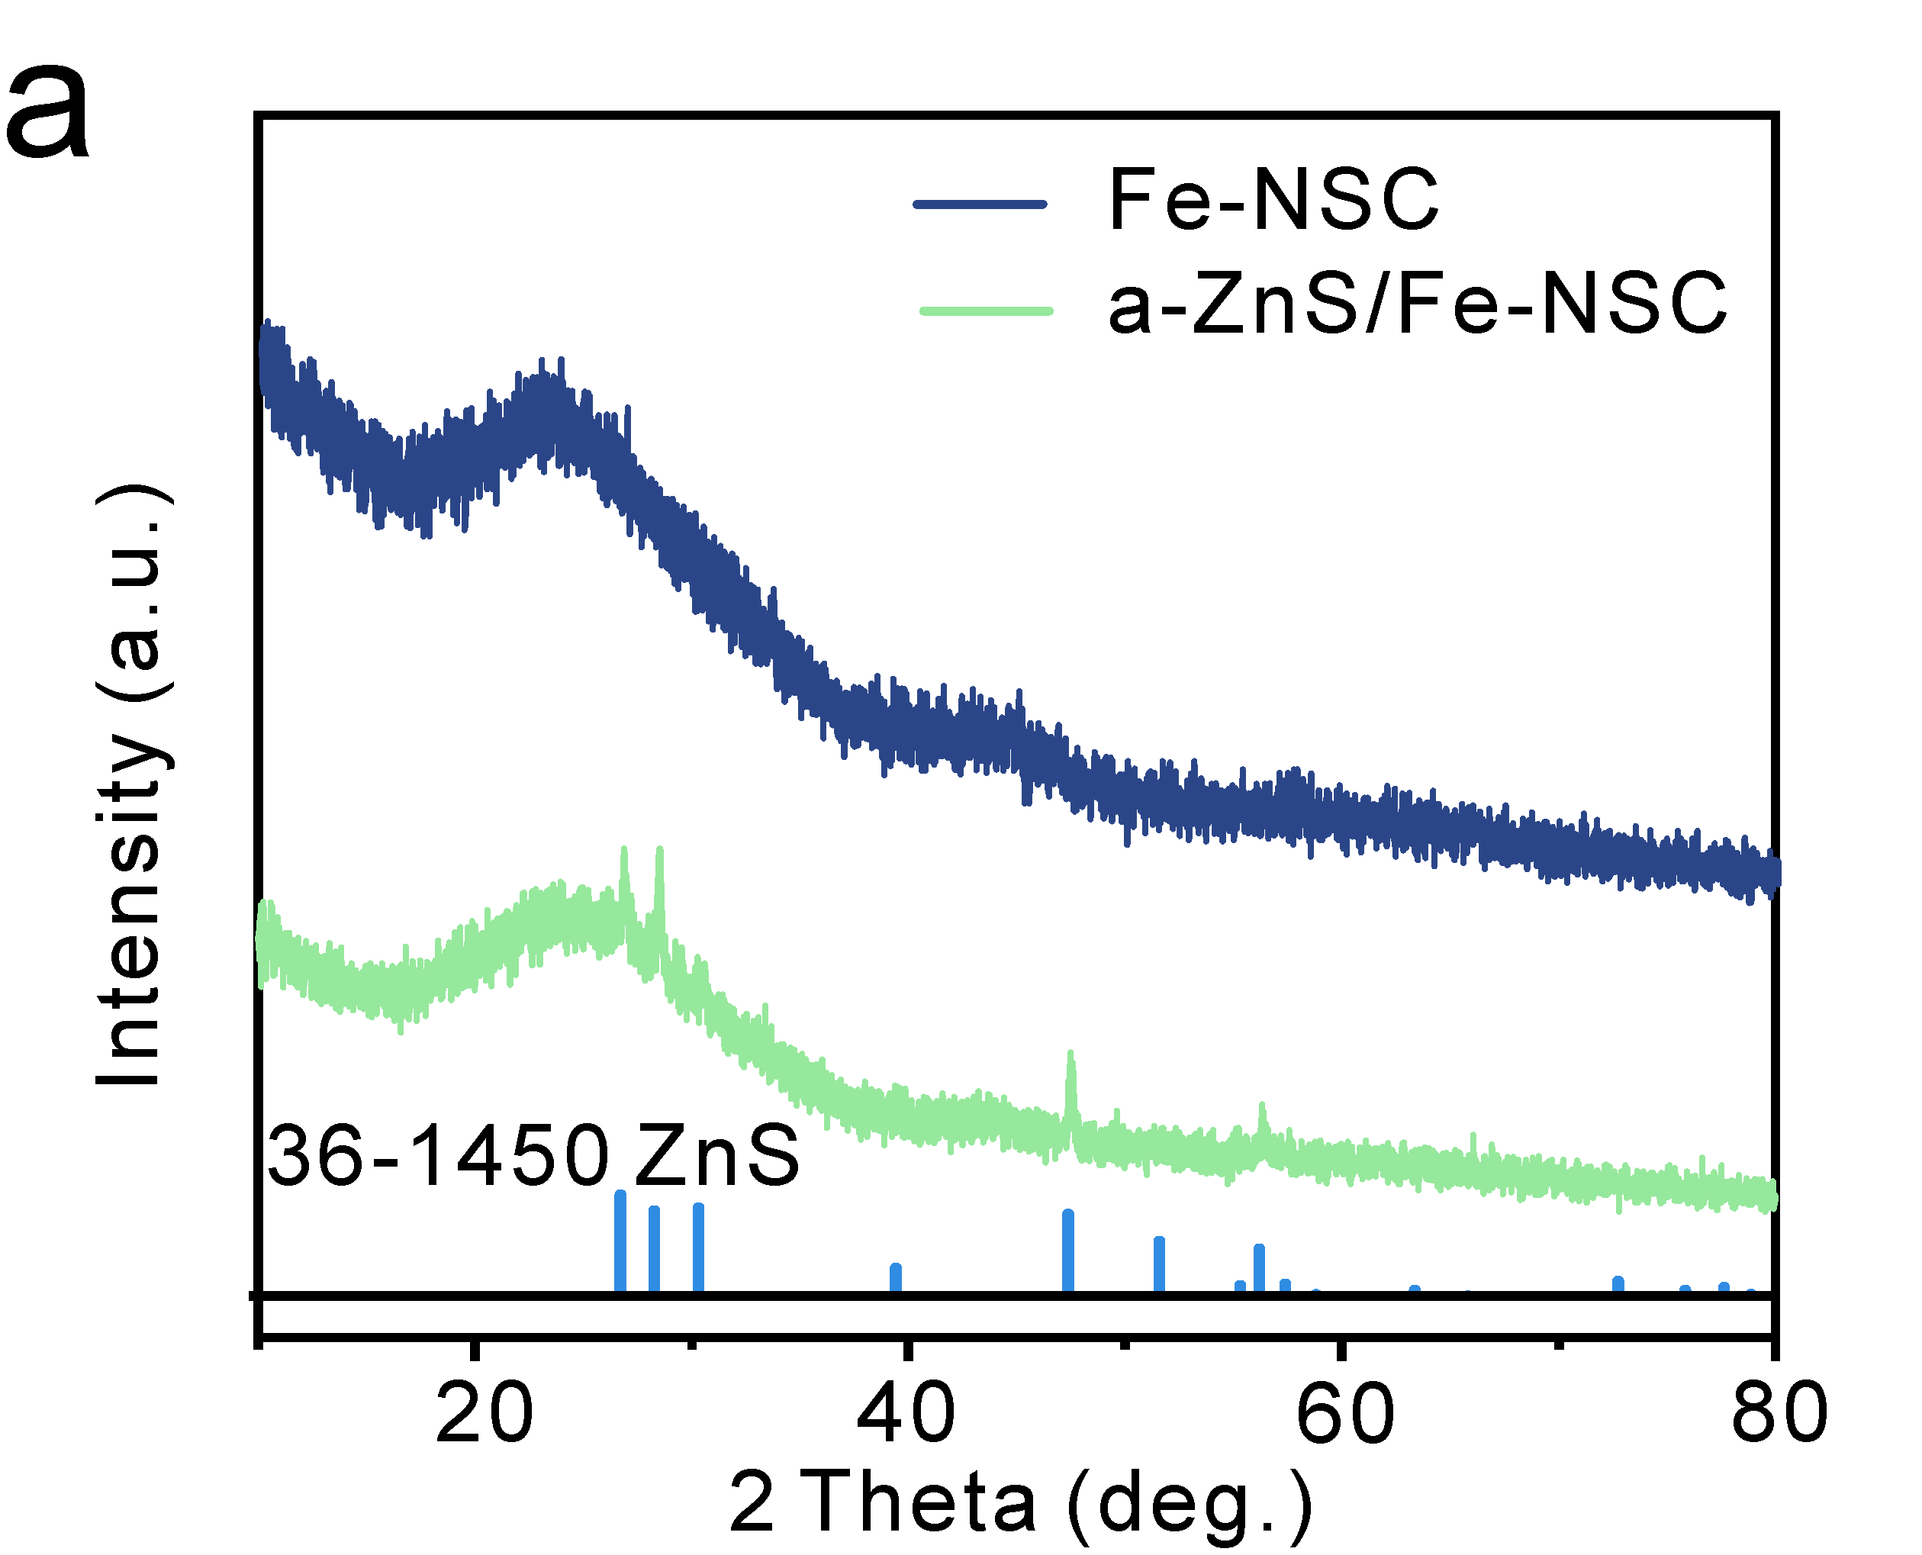
Supplementary Figure 6. XRD pattern of Fe-NSC and a-ZnS/Fe-NSC.
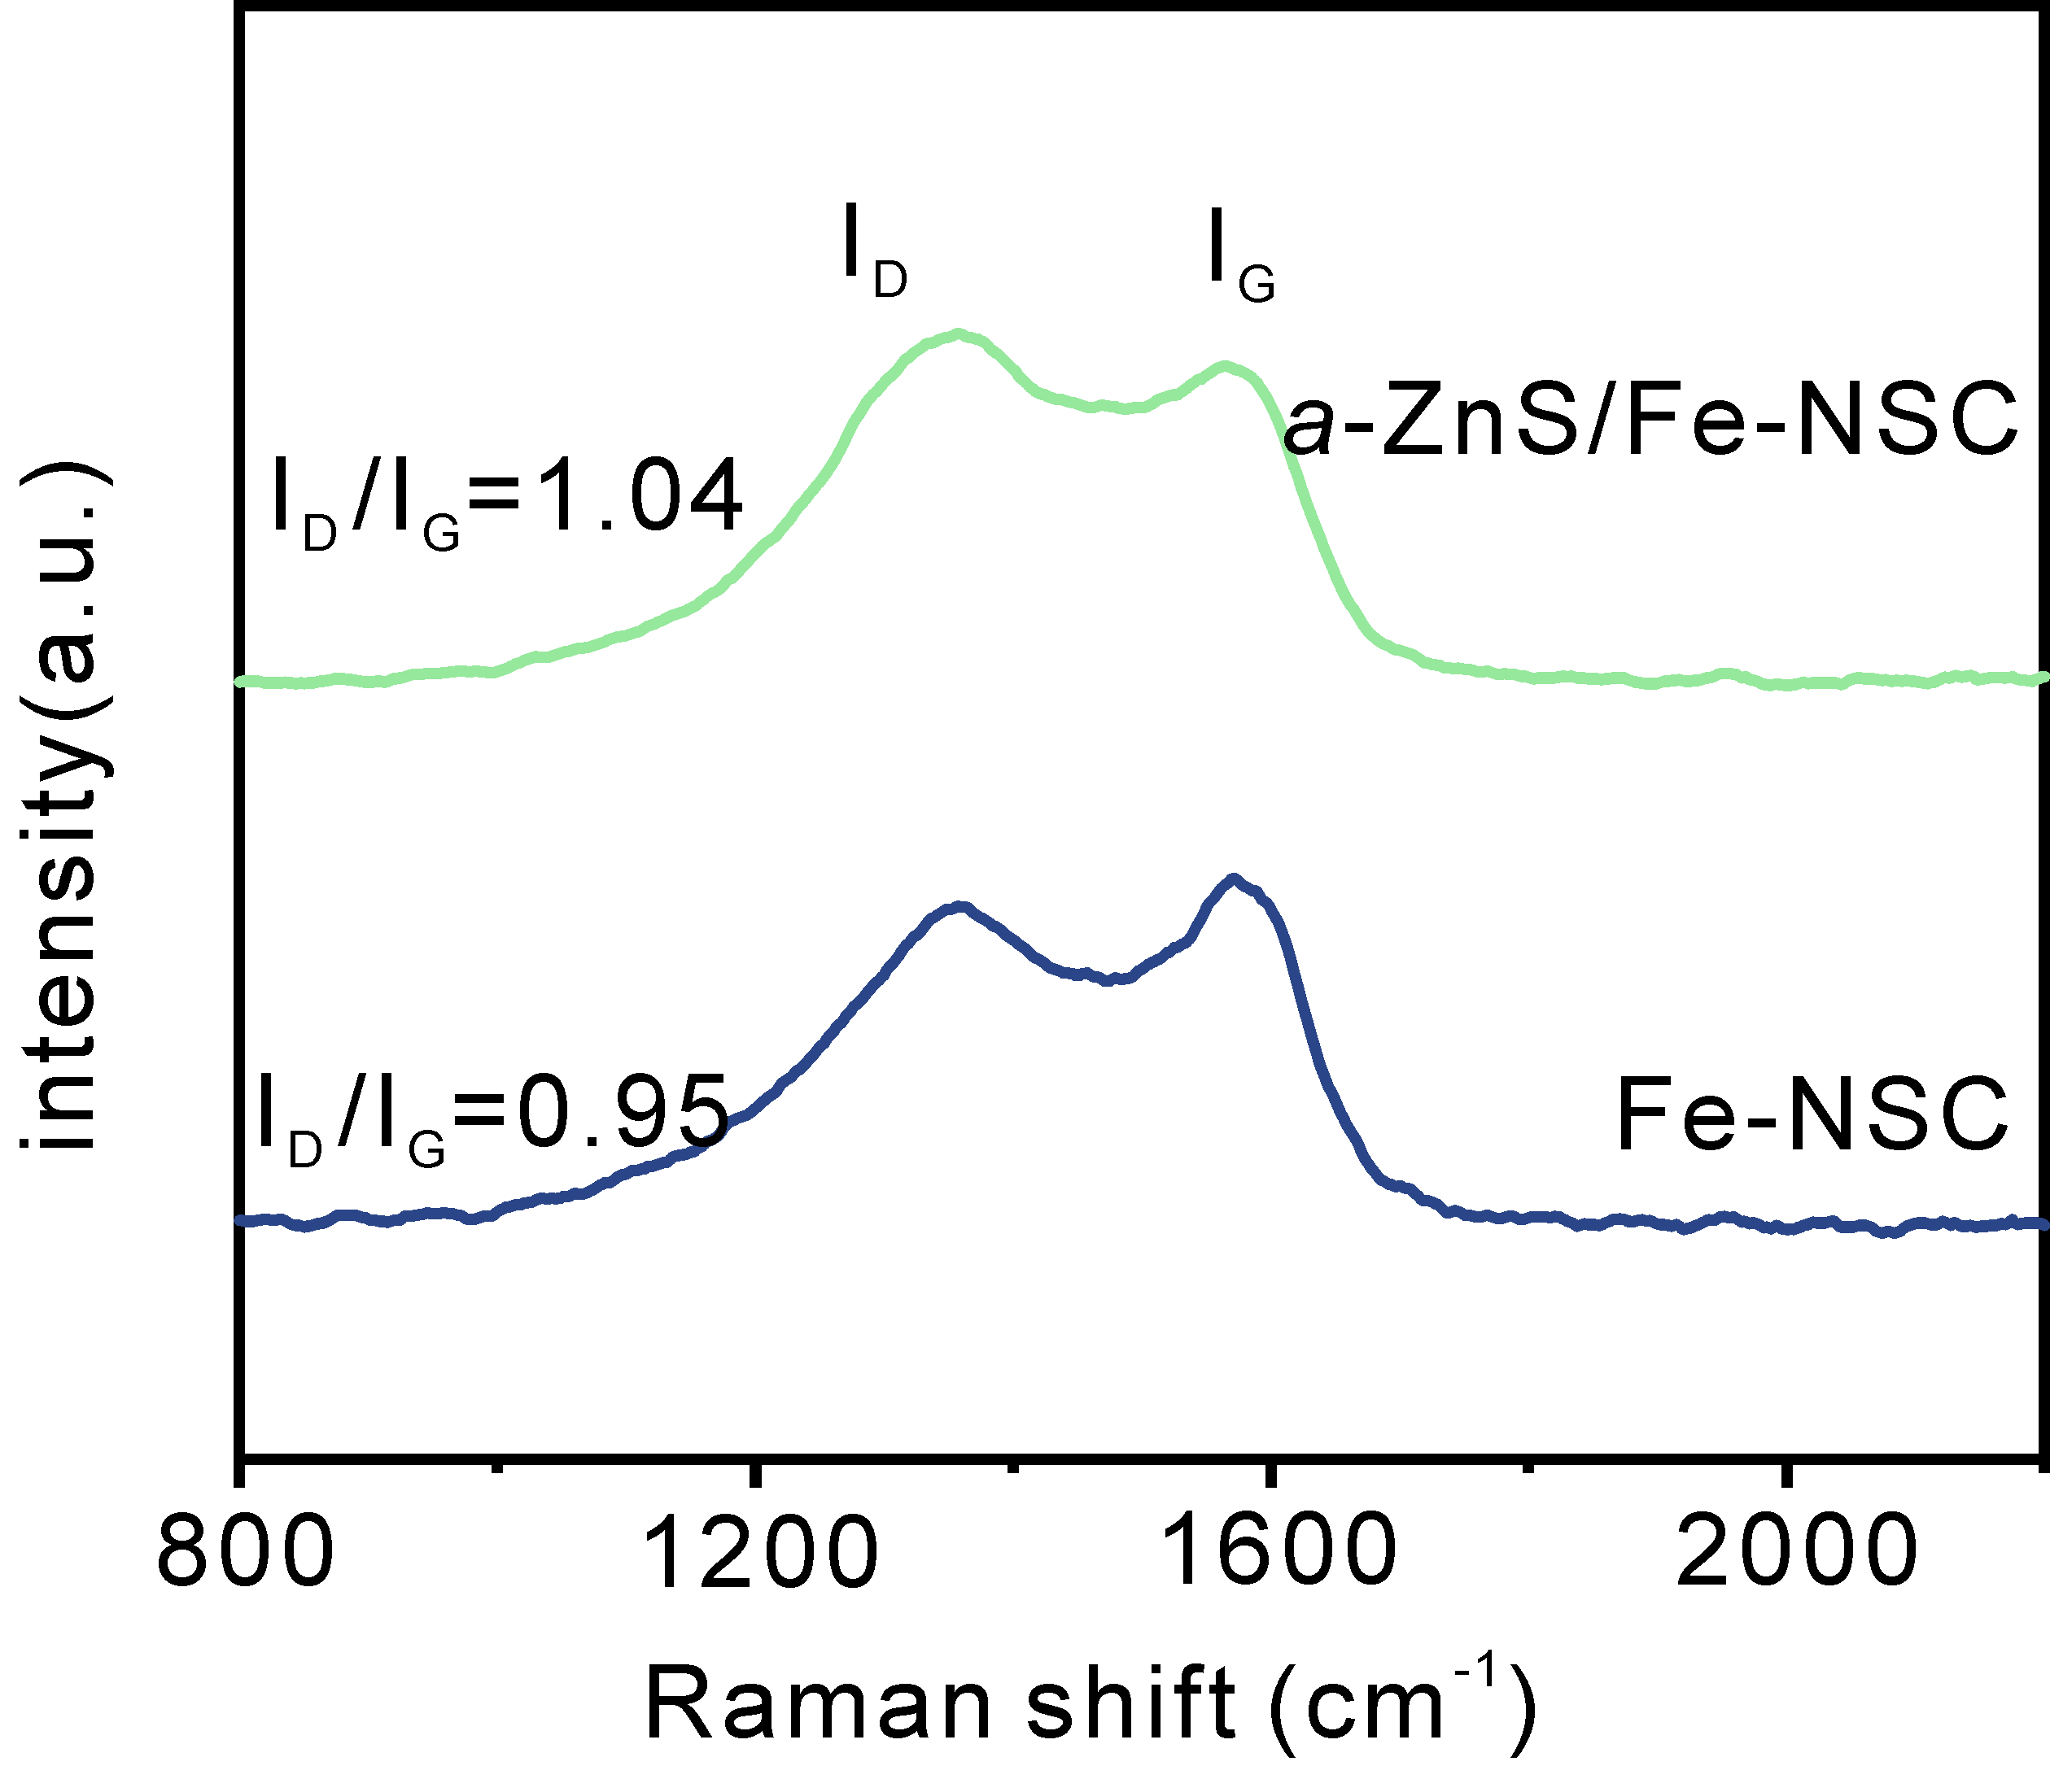
Supplementary Figure 7. Raman spectra of Fe-NSC and a-ZnS/Fe-NSC.
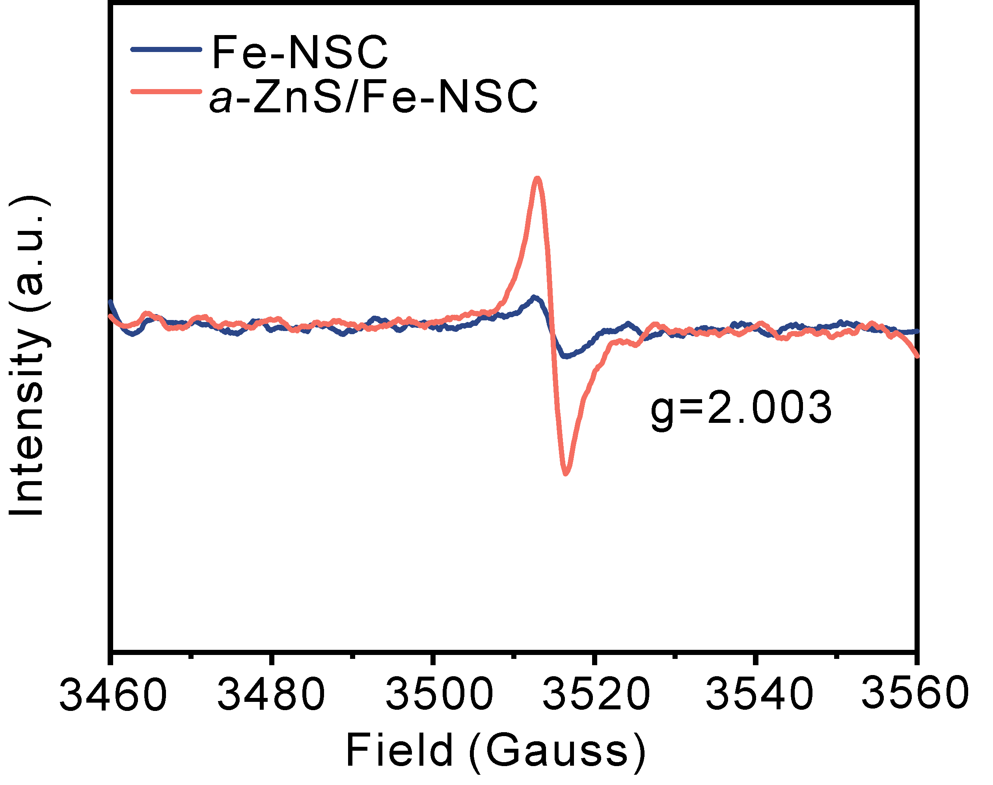
Supplementary Figure 8. EPR spectra of Fe-NSC and a-ZnS/Fe-NSC.
Supplementary Figure 9. TEM and HR-TEM images of Fe-NSC.
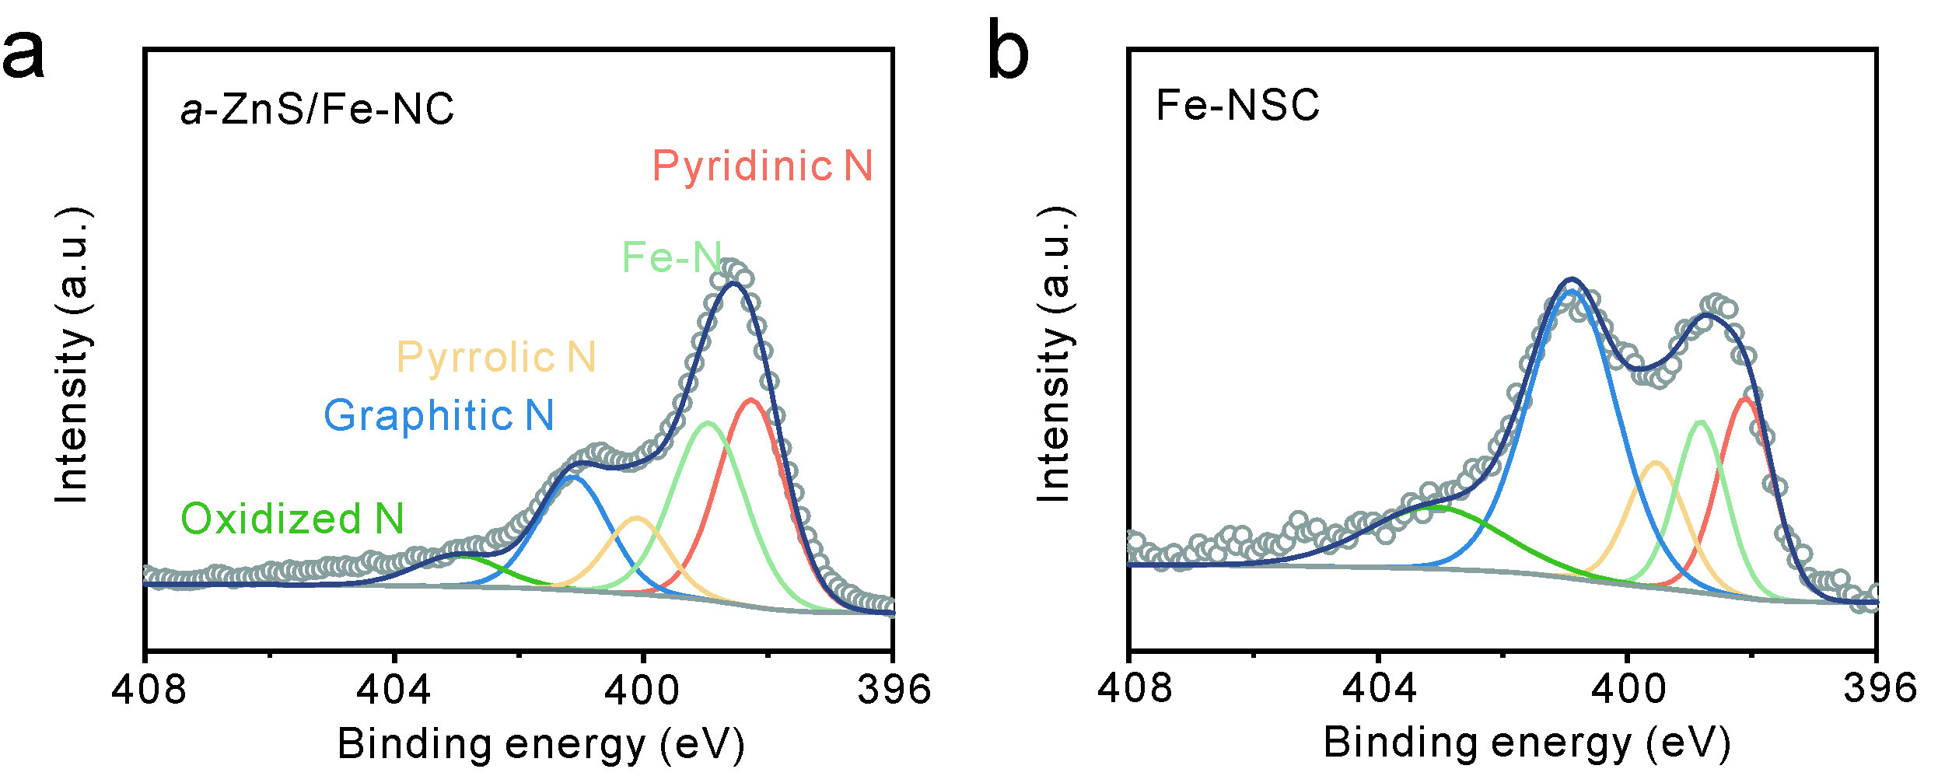
Supplementary Figure 10. High-resolution N 1s XPS spectra for (a) a-ZnS/Fe-NSC and (b) Fe-NSC.
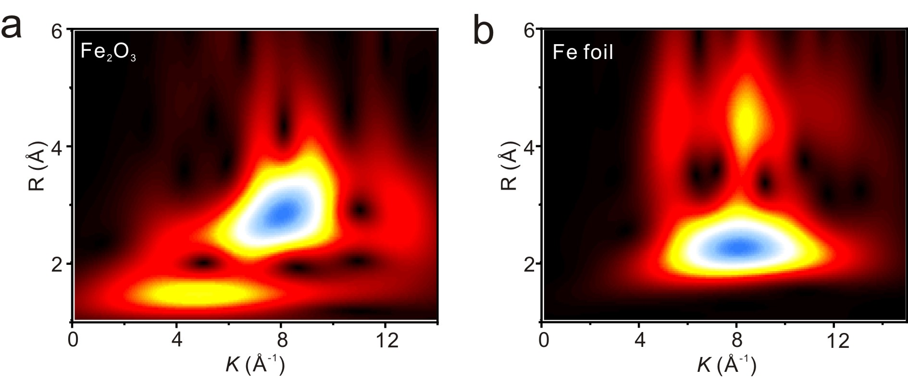
Supplementary Figure 11. WT-EXAFS spectra of (a) Fe₂O₃ and (b) Fe foil.
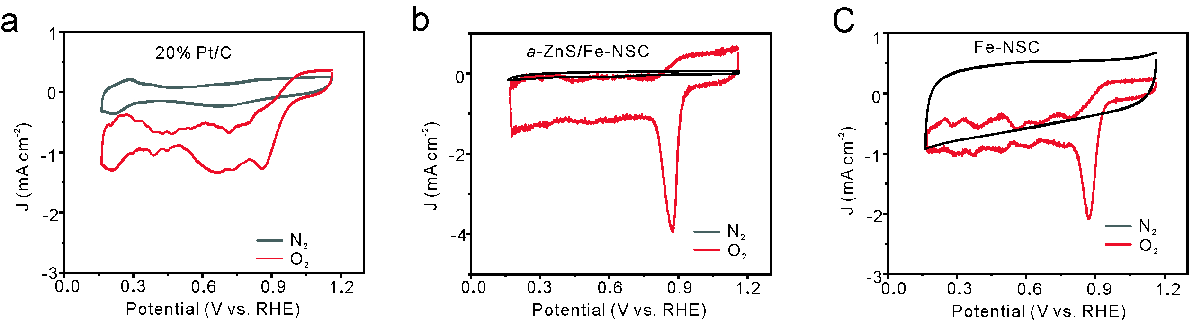
Supplementary Figure 12. CV curves of 20% Pt/C, a-ZnS/Fe-NSC and Fe-NSC in N₂- and O₂-saturated 0.1 M KOH solution with a sweep rate of 20 mV s⁻¹.
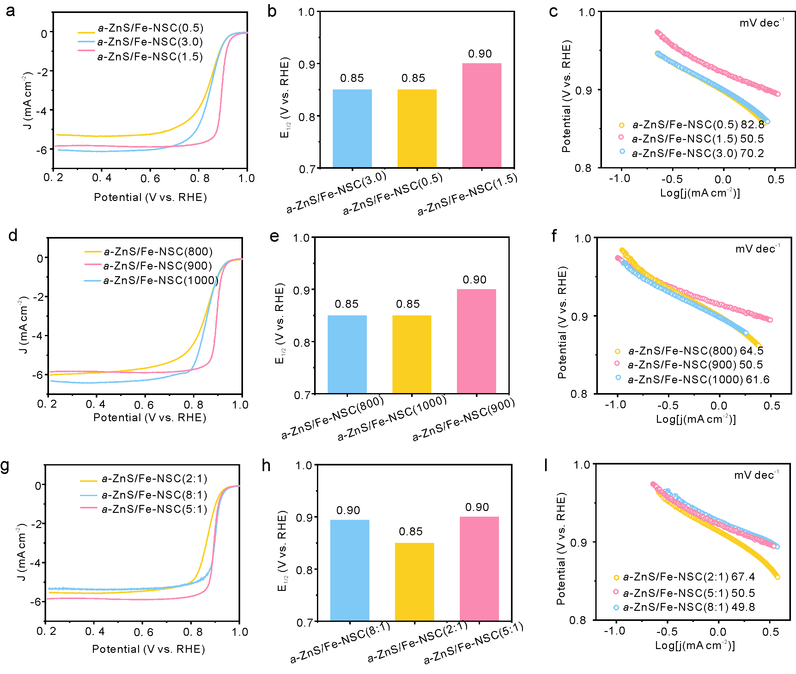
Supplementary Figure 13. LSV curves of a-ZnS/Fe-NSC.
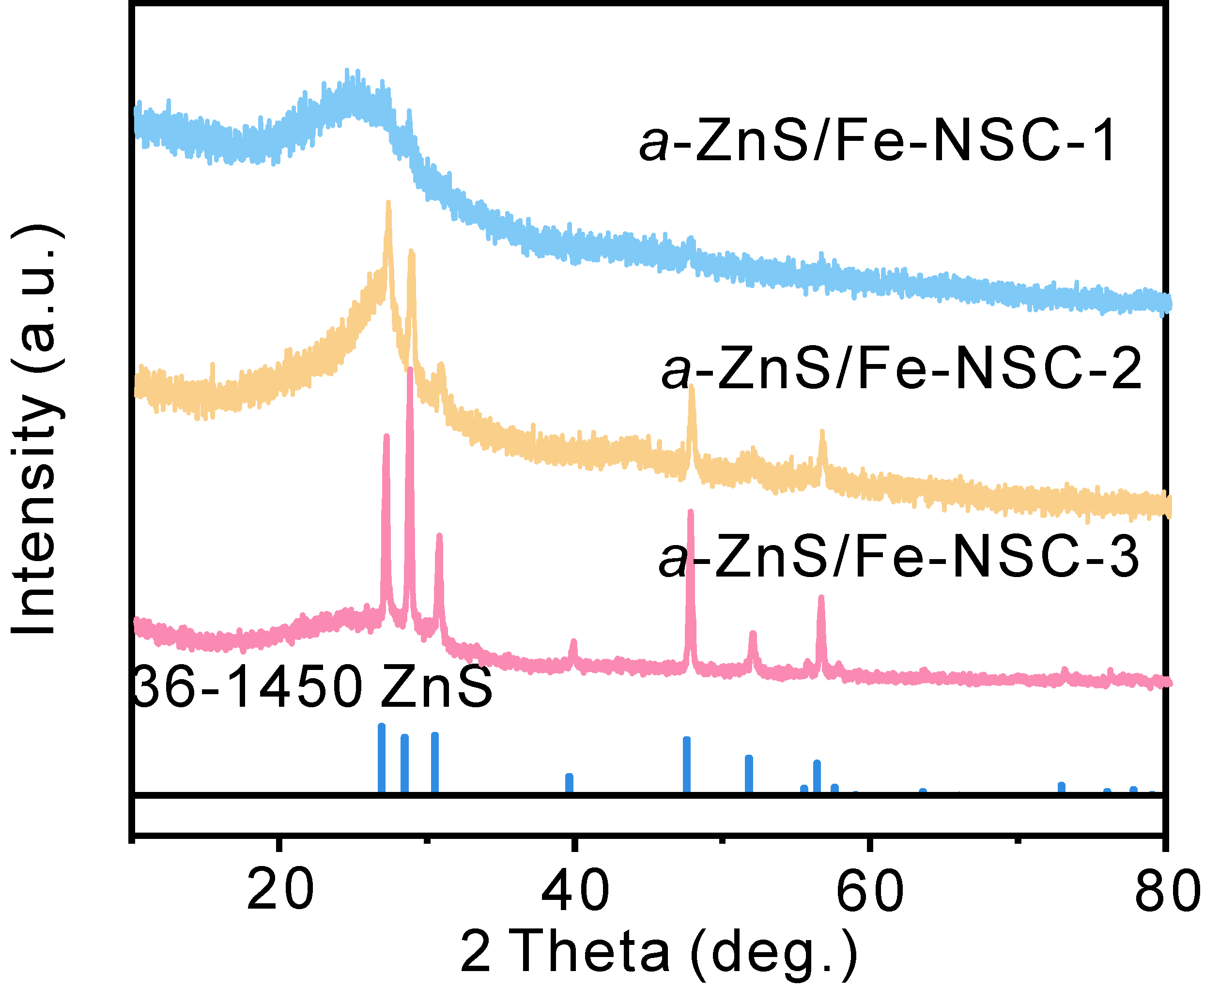
Supplementary Figure 14. The XRD of a-ZnS/Fe-NSC-1, a-ZnS/Fe-NSC-2 (namely a-ZnS/Fe-NSC), and a-ZnS/Fe-NSC-3 electrocatalysts.
When 0.3, 0.6, and 1.0 g Zinc power were utilized, the catalysts are detonated as a-ZnS/Fe-NSC-1, a-ZnS/Fe-NSC-2 (namely a-ZnS/Fe-NSC), and a-ZnS/Fe-NSC-3, respectively.
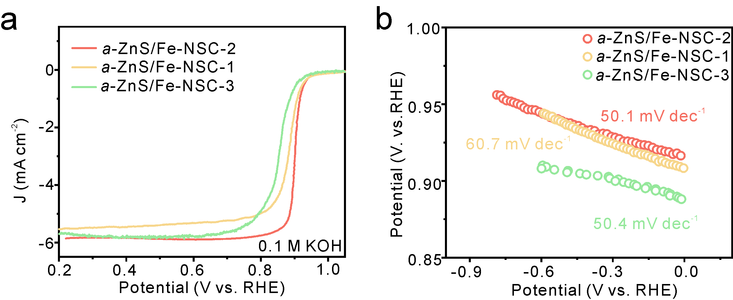
Supplementary Figure 15. LSV curves of a-ZnS/Fe-NSC-1, a-ZnS/Fe-NSC-2 (namely a-ZnS/Fe-NC), and a-ZnS/Fe-NSC-3 electrocatalysts in 0.1 M KOH.
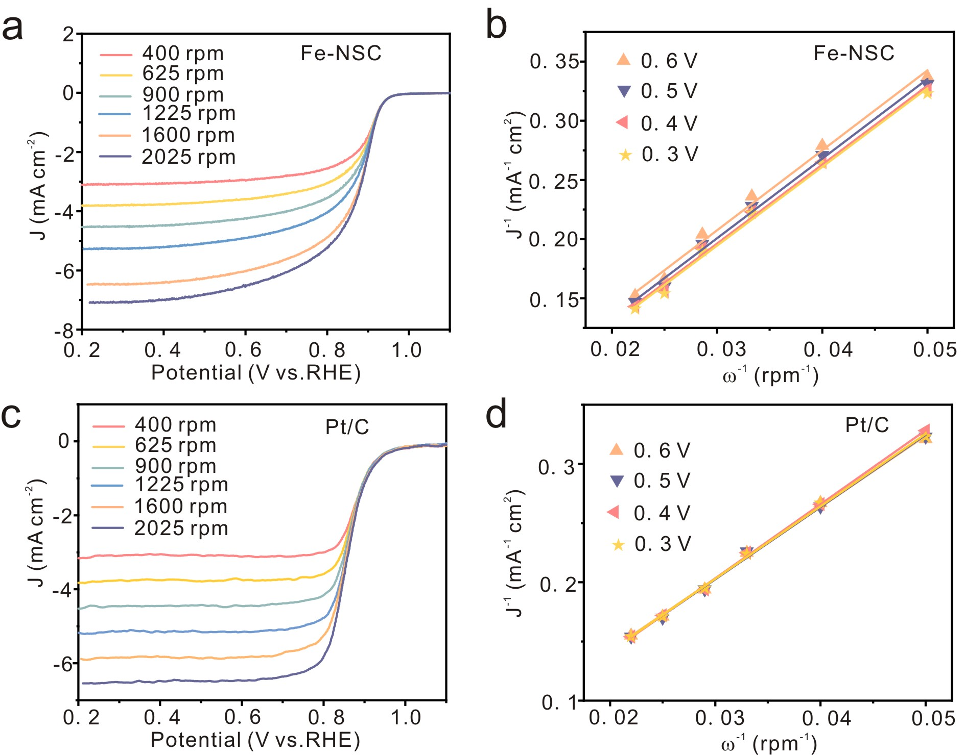
Supplementary Figure 16. LSV curves of 20% Pt/C, and Fe-NSC under different rotation speeds in O₂-saturated 0.1 M KOH solution at scan rate of 5 mV s⁻¹.
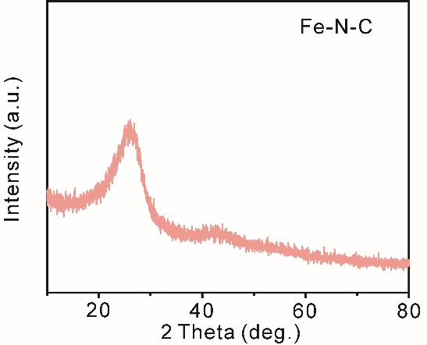
Supplementary Figure 17. Powder XRD patterns of the Fe-N-C electrocatalysts.
Two broad peaks at around 23° and 44° were observed in the patterns of all the samples, assigned to the (002) and (101) planes of partially graphitized carbon, indicating melamine was fully carbonized after pyrolysis.
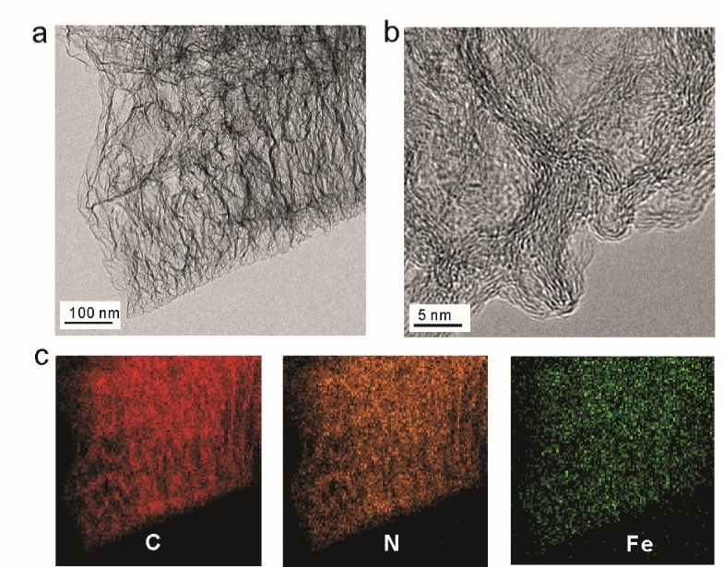
Supplementary Figure 18. a) TEM and b) HRTEM images of the Fe-N-C electrocatalyst. c) Elemental mapping images of Fe-N-C electrocatalyst.
No diffraction peaks related to crystalline Fe species were identified in XRD patterns. TEM images show carbon nanosheets and no agglomeration of Fe particles.
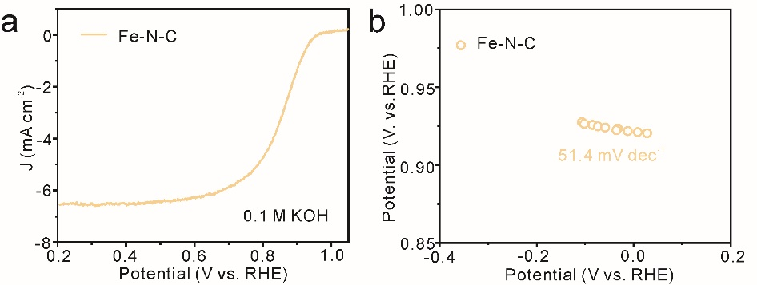
Supplementary Figure 19. LSV curves of Fe-N-C electrocatalysts in 0.1 M KOH.

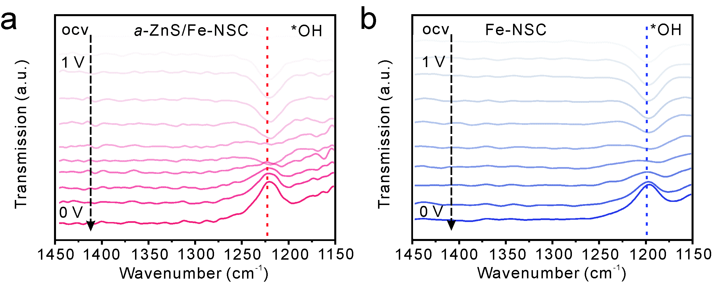
Supplementary Figure 20. in situ ATR-SEIRAS spectra on (a) a-ZnS/Fe-NSC and (b) Fe-NSC.
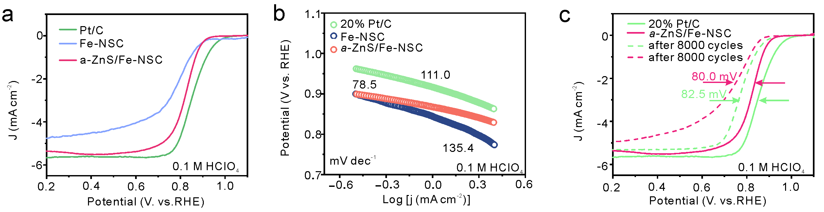
Supplementary Figure 21. ORR activity and durability evaluations: (a) LSV curves of a-ZnS/Fe-NSC, Fe-NSC, and 20% Pt/C in O₂-saturated 0.1 M HClO₄ solution. (b) Tafel slope in O₂-saturated 0.1 M HClO₄ solution. (c) LSV curves measured before and after 8,000 cycles at a rotation rate of 1600 rpm for 20% Pt/C, and a-ZnS/Fe-NSC.
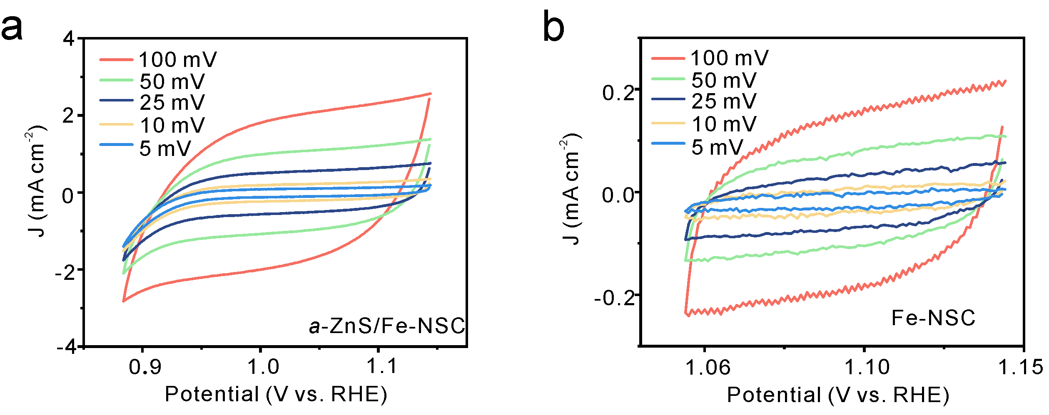
Supplementary Figure 22. CV curves of a-ZnS/Fe-NSC and Fe-NSC in non-Faradaic potential region at different sweep rates ranging from 5 to 100 mV s⁻¹.
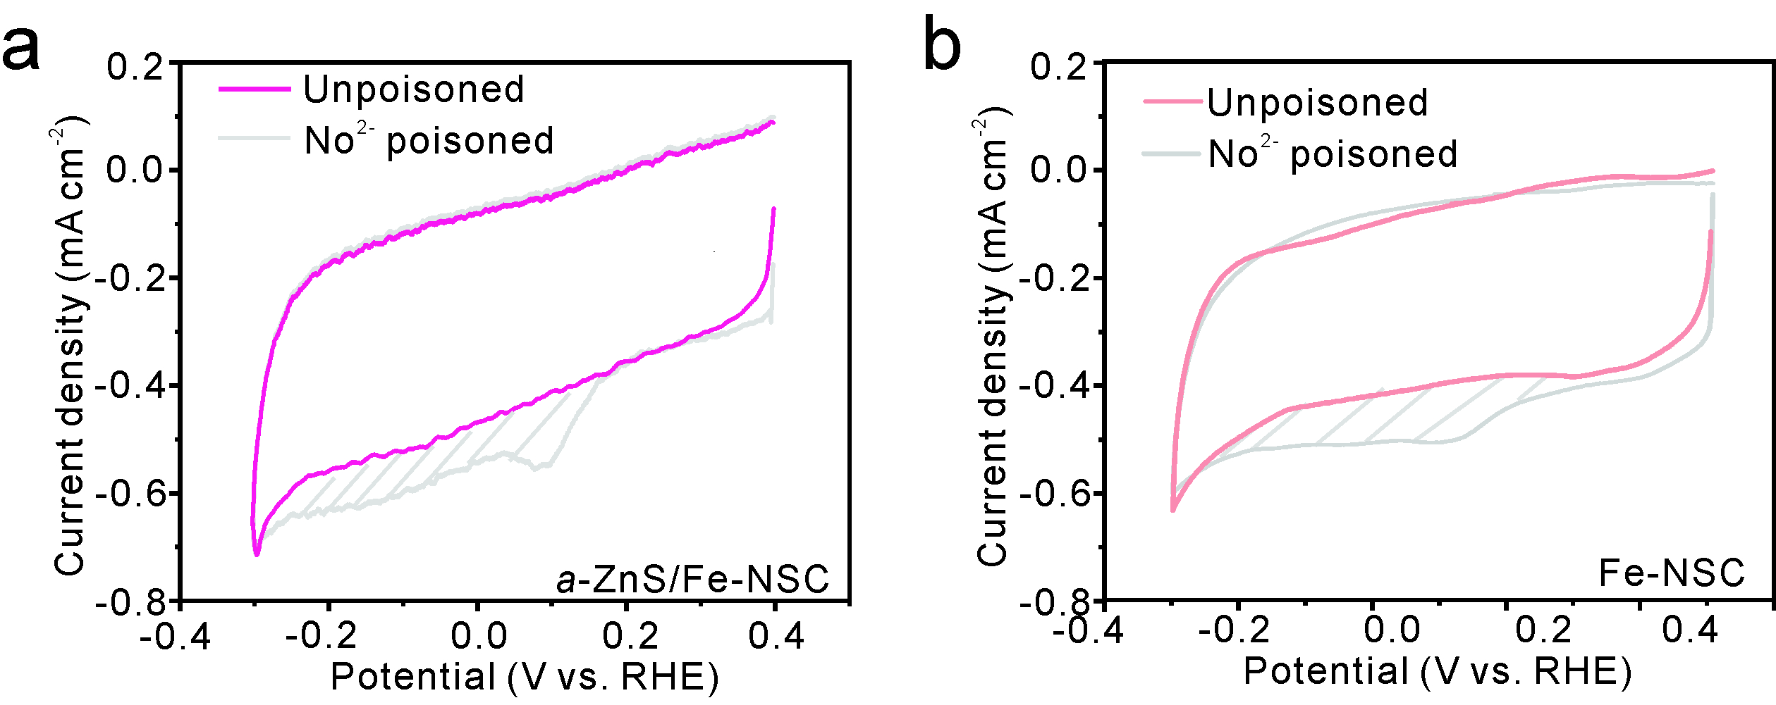
Supplementary Figure 23. Determination Fe-N₄ site density of the a-ZnS/Fe-NSC and Fe-NSC catalyst.

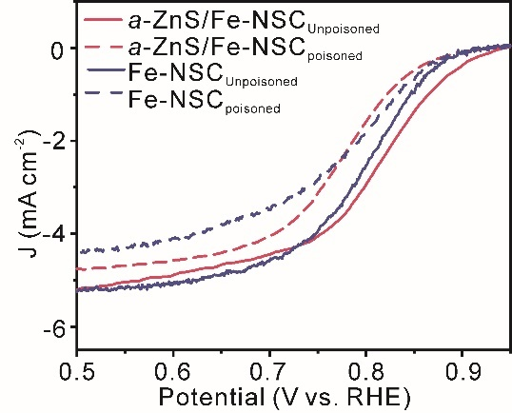
Supplementary Figure 24. RDE measurements of a-ZnS/Fe-NSC and Fe-NSC catalyst before and after nitrite poisoned. ORR polarization curves were collected in O₂-saturated 0.5 M acetate buffer at pH 5.2 with a scan rate of 10 mV·s⁻¹ and a rotating rate of 900 rpm at room temperature.

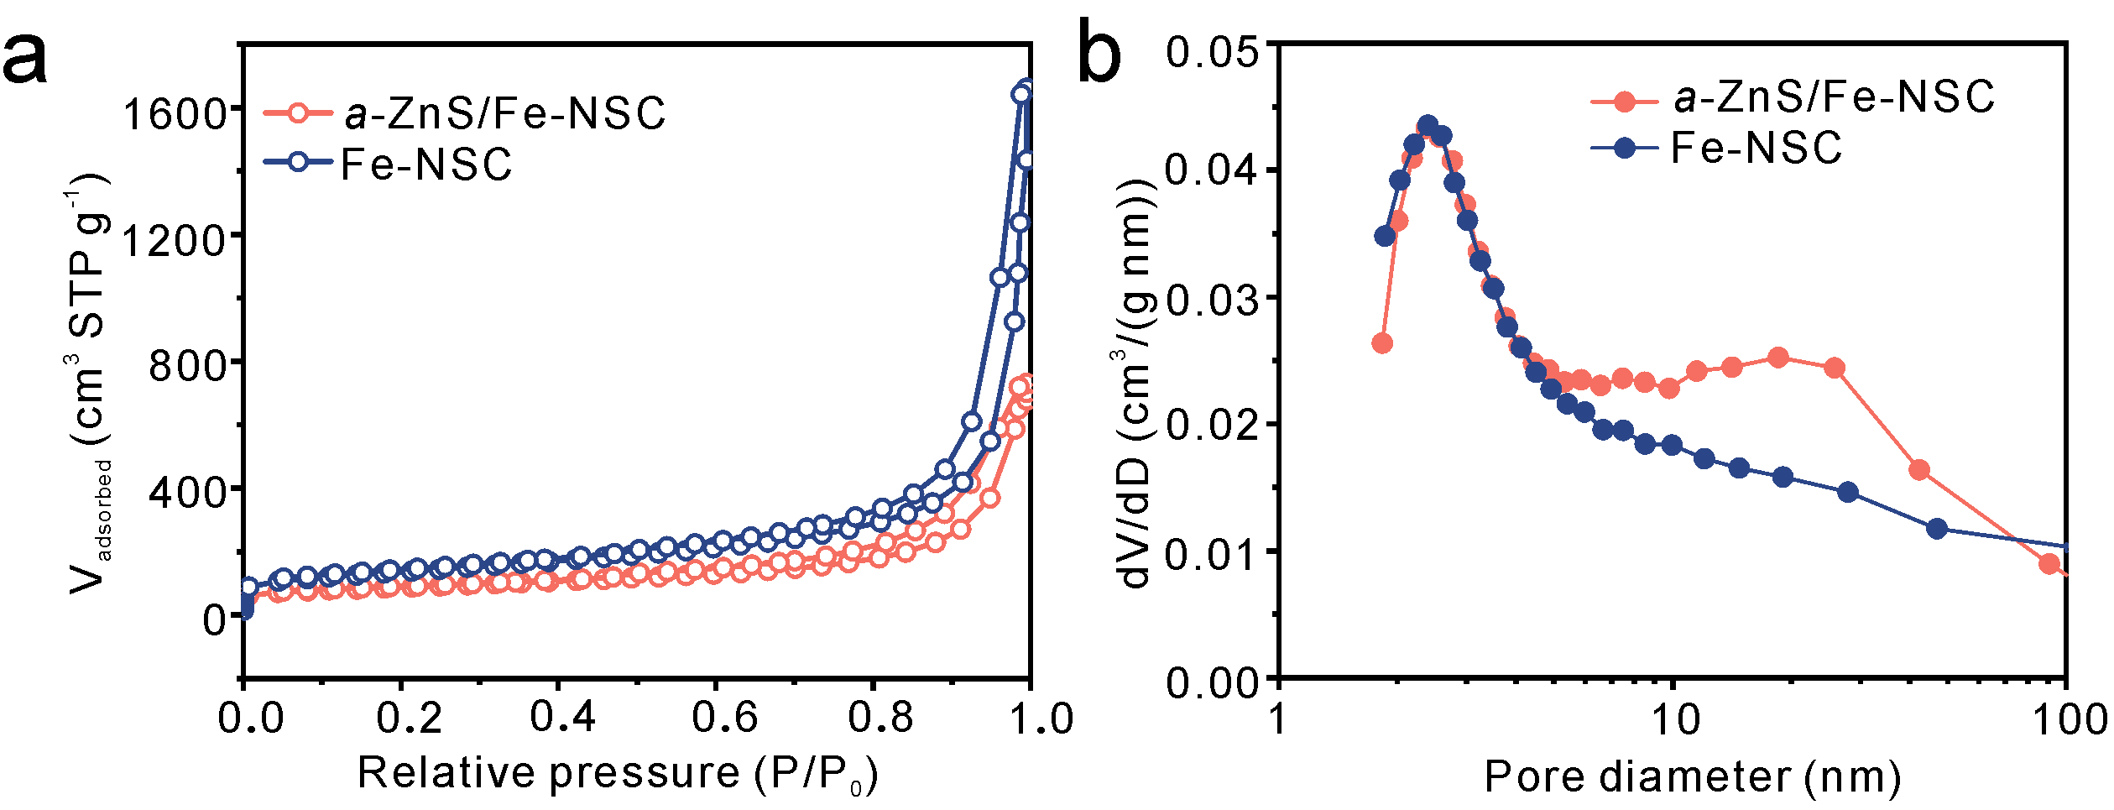
Supplementary Figure 25. (a) N₂ adsorption-desorption isotherms with the corresponding; (b) PSD curves of Fe-NSC and a-ZnS/Fe-NSC.
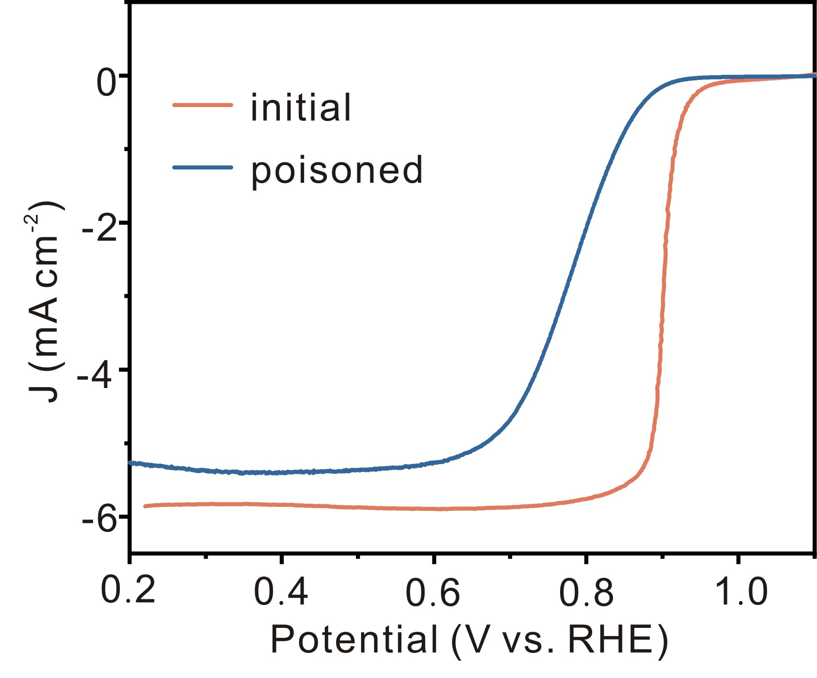
Supplementary Figure 26. LSV curves of a-ZnS/Fe-NSC in O₂ saturated 0.1 M KOH before/after poisoning by 10 mM KSCN.
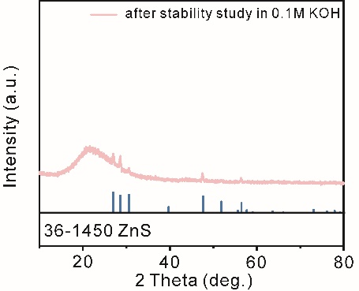
Supplementary Figure 27. XRD patterns of the a-ZnS/Fe-NSC catalyst after stability tests at 0.7 V (vs. RHE) in 0.1 M KOH.

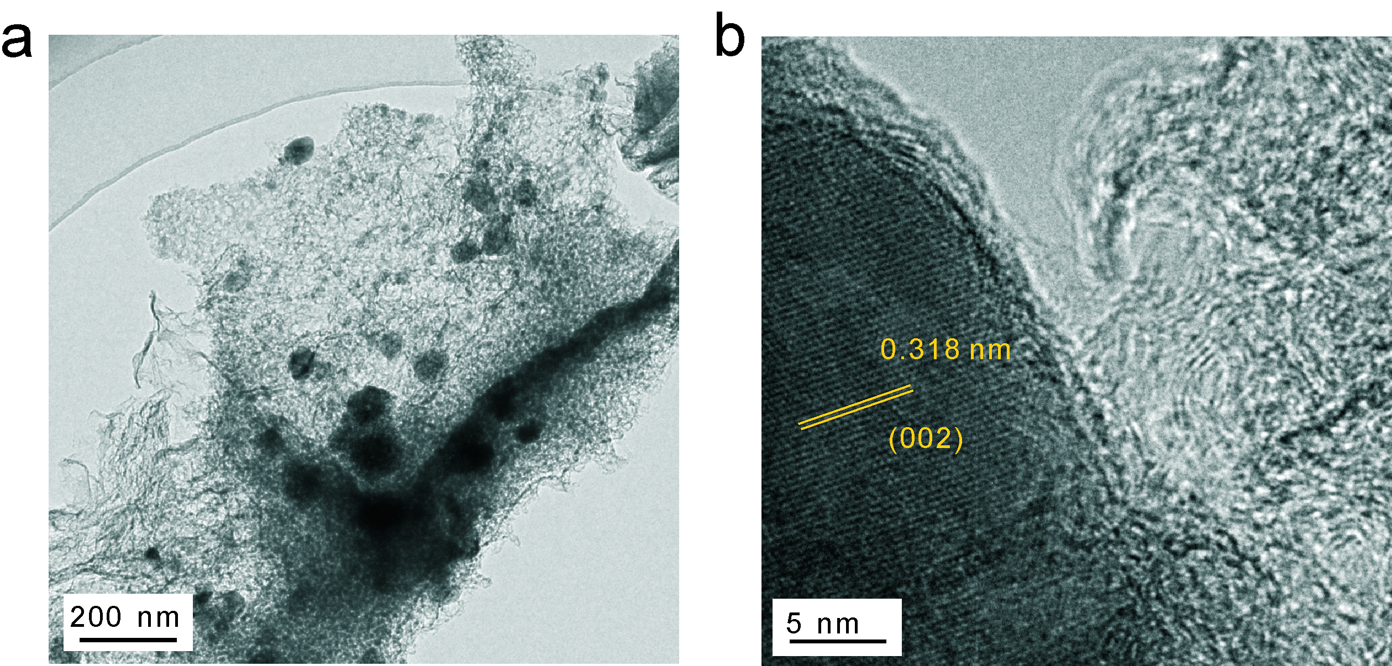
Supplementary Figure 28. (a) TEM and (b) HRTEM of the a-ZnS/Fe-NSC catalyst after the long-term durability test conducted at 0.7 V (vs. RHE) in 0.1 M KOH.

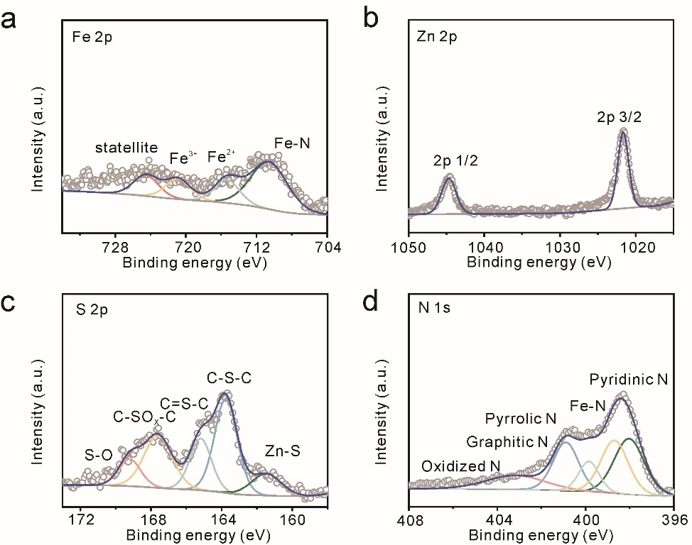
Supplementary Figure 29. XPS spectra of the a-ZnS/Fe-NSC catalyst after the long-term durability test conducted at a-d) 0.7 V (vs. RHE) in 0.1 M KOH.

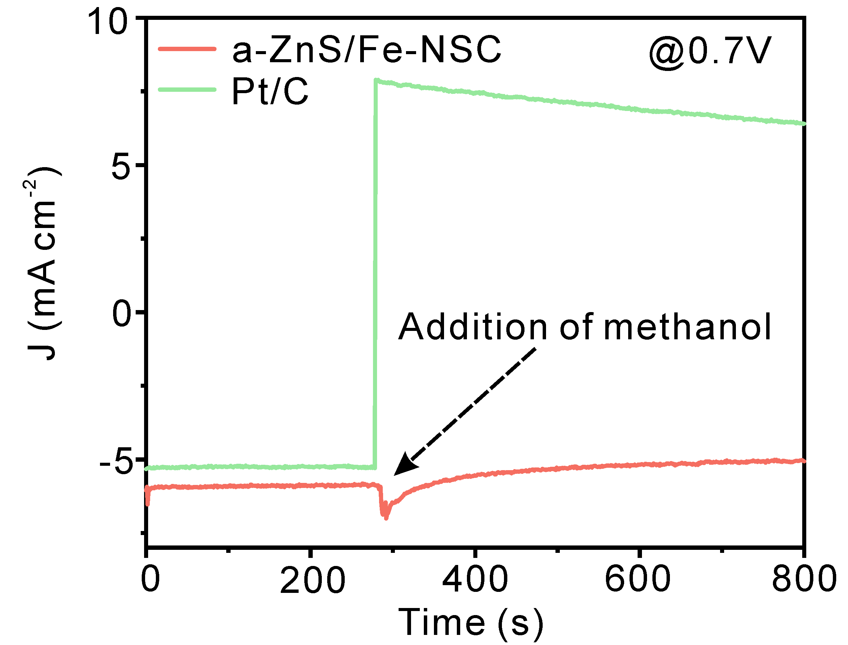
Supplementary Figure 30. The crossover effect of the a-ZnS/Fe-NSC and Pt/C electrodes at 0.7 V versus RHE, followed by introduction of methanol (3 M) in O₂-saturated 1 M KOH.
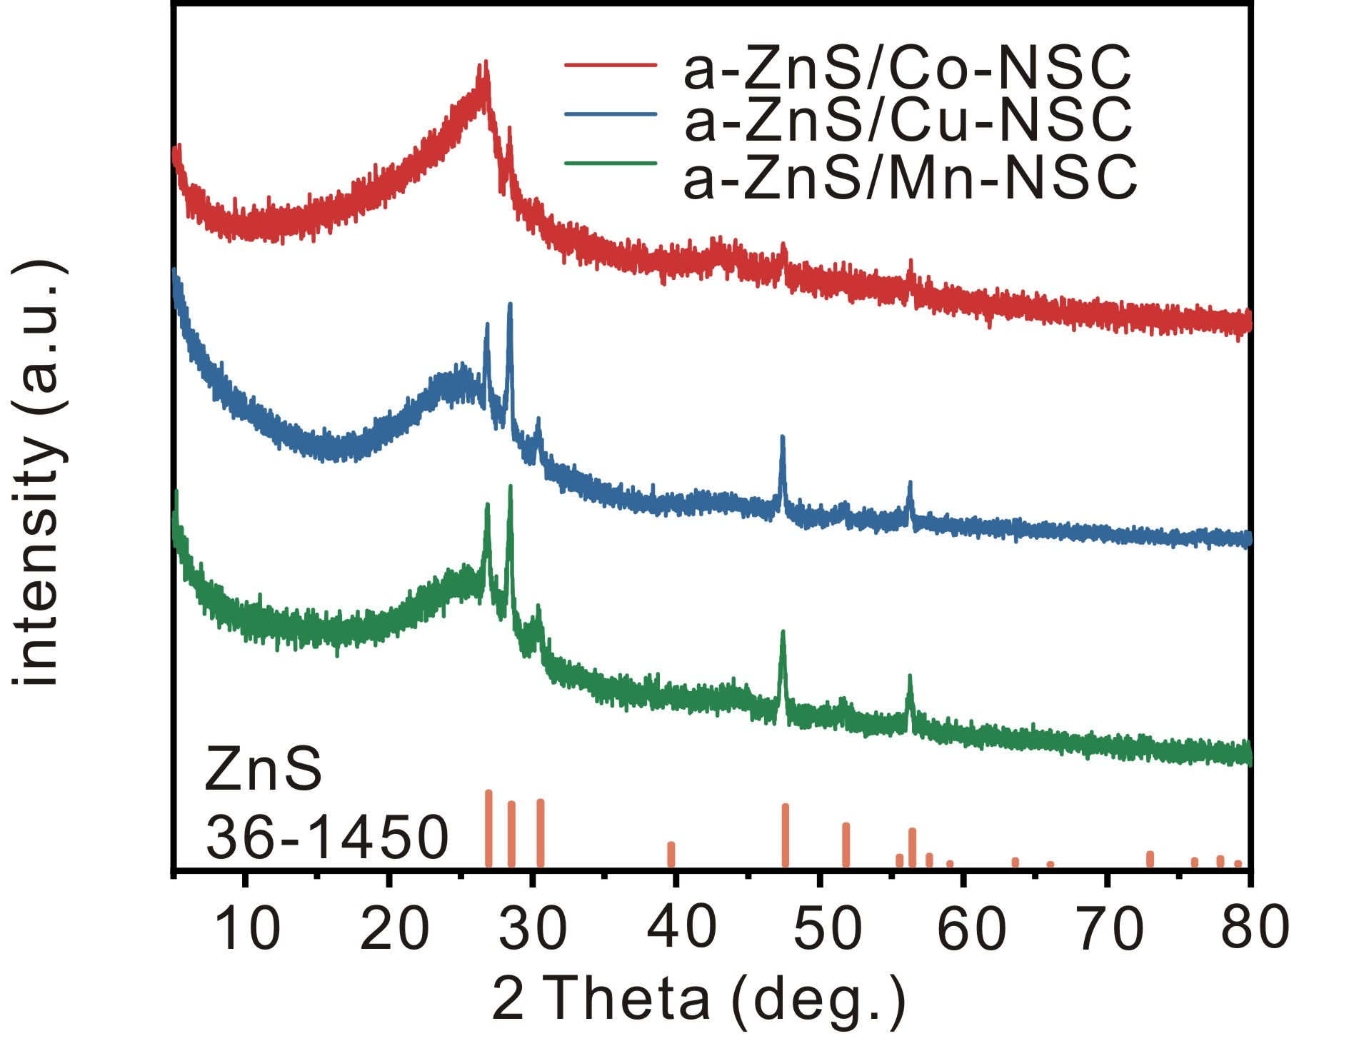
Supplementary Figure 31. XRD pattern of a-ZnS/Mn-NSC, a-ZnS/Cu-NSC and a-ZnS/Co-NSC.
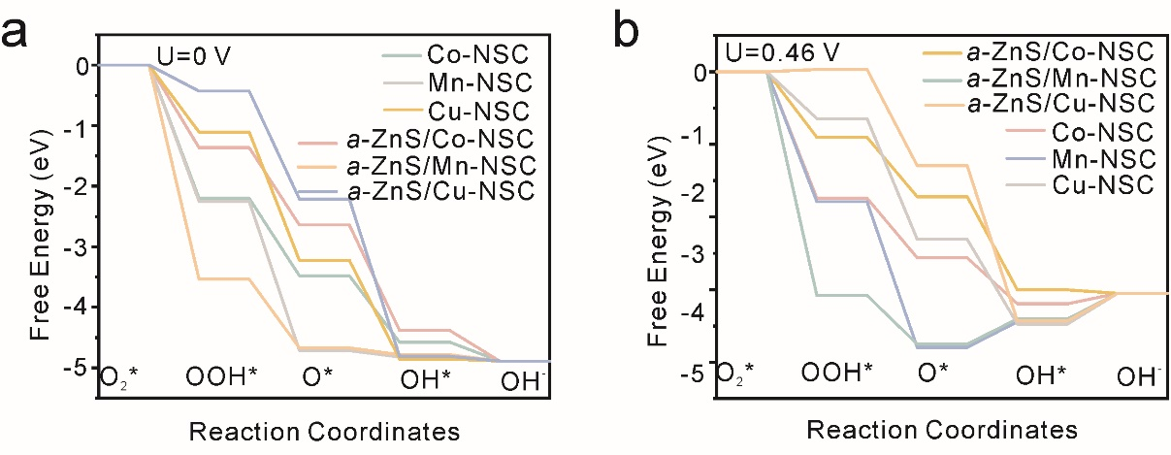
Supplementary Figure 32. Free energy diagrams of ORR pathways on Co-NSC, Mn-NSC, Cu-NSC, a-ZnS/Co-NC, a-ZnS/Mn-NSC, and a-ZnS/Cu-NSC at (a) U= 0 V and (b) U= 0.46 V.
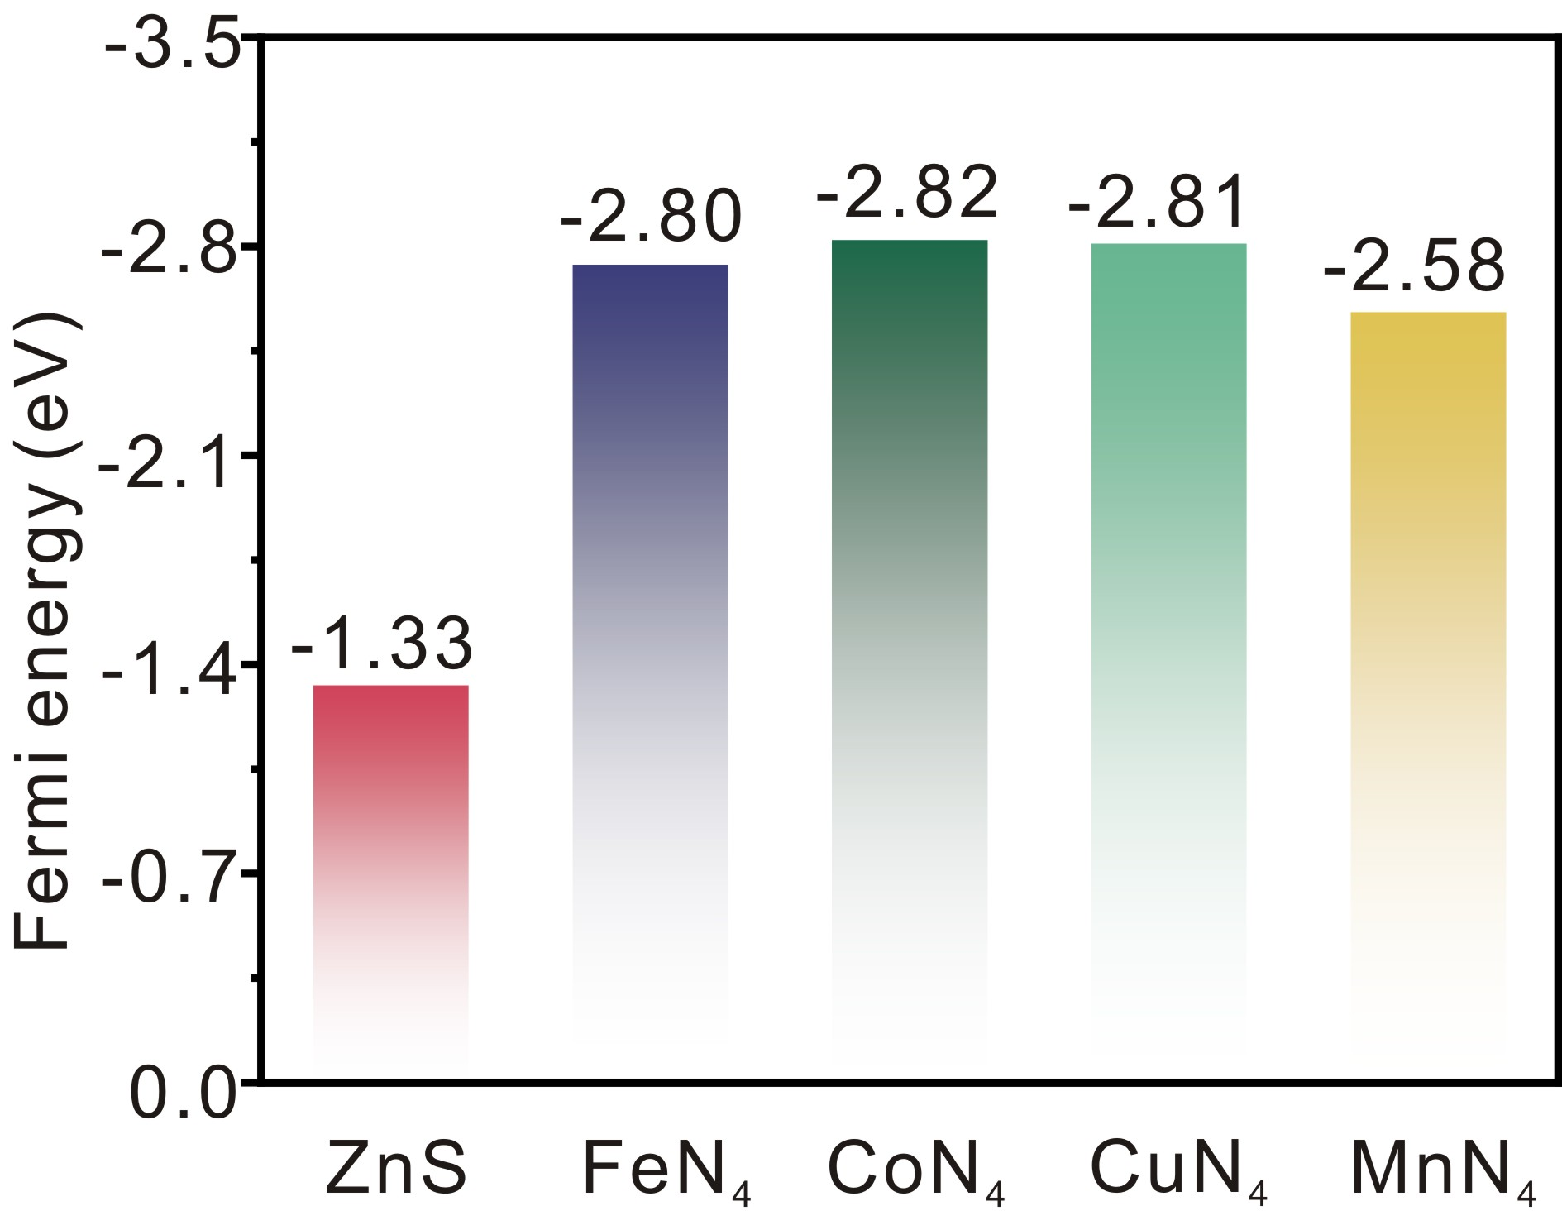
Supplementary Figure 33. Comparison of ORR performance of M-N-C catalysts.
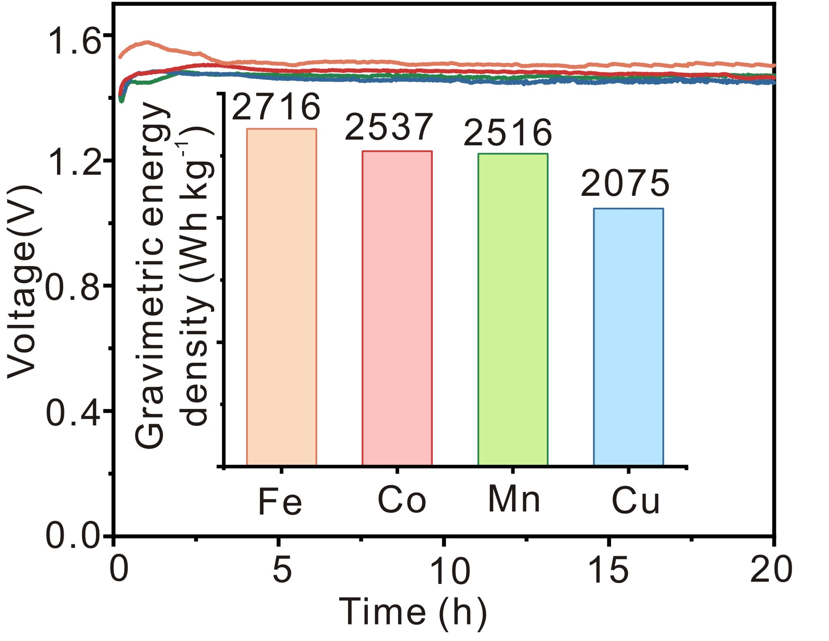
Supplementary Figure 34. Discharge curves of AABs at 50 mA cm⁻² (Inset: Comparison of the gravimetric energy density).

Supplementary Tables

Supplementary Table 1. Free energy of different reaction steps in ORR for a-ZnS/Fe-NSC, Fe-NSC and ZnS at U= 0 V.
ΔG(eV) | a-ZnS/Fe-NSC | Fe-NSC | ZnS
(1) | -1.34 | -1.76 | -2.20
(2) | -1.73 | -1.89 | -3.46
(3) | -1.37 | -1.04 | 0.05
(4) | -0.45 | -0.2 | 0.72

Supplementary Table 2. Free energy of different reaction steps in ORR for a-ZnS/Fe-NSC, Fe-NSC and ZnS at U= 0.46 V.
ΔG(eV) | a-ZnS/Fe-NC | Fe-NSC | ZnS
(1) | -0.88 | -1.30 | -1.73
(2) | -1.27 | -1.43 | -3.00
(3) | -0.91 | -0.59 | 0.51
(4) | 0.01 | 0.26 | 1.18

Supplementary Table 3. Proportion of different S configurations calculated from the fitted high-resolution XPS spectra.
Sample | Zn-S | C-S-C | C=S-C | Fe-S | S-O
a-ZnS/Fe-NSC | 0.32 | 0.28 | \ | 0.19 | 0.21
Fe-NSC | \ | 0.24 | 0.27 | 0.04 | 0.45

Supplementary Table 4. Proportion of different C and N configurations calculated from the fitted high-resolution XPS spectra.
Sample | C1 | C2 | C3 | C4
a-ZnS/Fe-NSC | 0.79 | 0.11 | 0.05 | 0.05
Fe-NSC | 0.65 | 0.22 | 0.08 | 0.05
C1 sp² C=C. C2 sp³ C−C. C3 C−N/C−O. C4 C=N/C=O.
Supplementary Table 5. C, N, O contents of carbon samples obtained from elemental analysis.
Sample | C / at% | N / at% | S / at% | Fe / at% | Zn / at%
a-ZnS/Fe-NC | 0.85 | 0.10 | 0.02 | 0.01 | 0.02
Fe-NSC | 0.89 | 0.08 | 0.02 | 0.01 | -

Supplementary Table 6. Proportion of different N configurations calculated from the fitted high-resolution XPS spectra.
Sample | N_{pyridinic} | Fe-N | N_{pyrrolic} | N_{graphitic} | N_{oxidized}
a-ZnS/Fe-NSC | 0.22 | 0.41 | 0.05 | 0.25 | 0.07
Fe-NSC | 0.09 | 0.15 | 0.20 | 0.46 | 0.03

Supplementary Table 7. EXAFS fitting structure parameters of a-ZnS/Fe-NC.
 | CN | R (Å) | σ² (Å² 10⁻³) | ΔE₀ (eV) | R factor (%)
Fe-N | 3.9 | 1.99 | 4.7 | 7.2 |  | 0.2
Fe-S | 0.7 | 2.22 | 4.5 | -5.8 |  | 0.2
CN is the coordination number; R is interatomic distance (the bond length between central atoms and surrounding coordination atoms); σ² is Debye-Waller factor (an indicator of thermal and static disorder in absorber-scatter distances); ∆E₀ is edge-energy shift (the difference between the zero kinetic energy value of the sample and that of the theoretical model). R factor is used to value the goodness of the fitting.

Supplementary Table 8. BET specific surface areas and pore volume of different catalysts.
Catalysts | S_{BET}(m² g⁻¹) | V_{micro}(cm³ g⁻¹) | V_{meso}(cm³ g⁻¹) | Proportion of mesopores
a-ZnS/Fe-NC | 309 | 0.018 | 2.511 | 0.91
Fe-NSC | 476 | 0.038 | 2.389 | 0.90

Supplementary Table 9. Contrast of ORR performances indexes of the as-obtained nanocarbons compared to other recently reported top ORR electrocatalysts tested in 0.1 M KOH solution.
Catalysts | E_{1/2}  /V | E_{one}  /V | Ref
a-ZnS/Fe-NC | 0.90 | 1.17 | This work
a-ZnS/Co-NC | 0.90 | 1.15 | This work
a-ZnS/Mn-NC | 0.90 | 1.12 | This work
a-ZnS/Cu-NC | 0.87 | 1.15 | This work
Cu/G | 0.85 | 0.92 | [12]
Fe/N-G-SAC | 0.89 | 0.97 | [13]
Mn/C-NO | 0.87 | 0.95 | [14]
FeCu-DA/NC | 0.86 | 0.96 | [15]
Co@NG-acid | 0.83 | 0.90 | [16]
Fe-N₄/NC | 0.80 | 0.92 | [17]

Supplementary Table 10. Free energy of different reaction steps in ORR for M-NSC, and a-ZnS/M-NSC at U= 0 V.
Samples | Adsorption site | (1) | (2) | (3) | (4)
Co-NSC | Co | -2.200 | -1.279 | -1.096 | -0.314
Mn-NSC | Mn | -2.250 | -2.465 | -0.106 | 0.069
Cu-NSC | Cu | -1.106 | -2.120 | -1.628 | -0.036
a-ZnS/Co-NSC | Co | -1.363 | -1.279 | -1.742 | -0.506
a-ZnS/Mn-NSC | Mn | -3.538 | -1.133 | -0.112 | -0.107
a-ZnS/Cu-NSC | Cu | -0.434 | -1.786 | -2.597 | -0.080

Supplementary Table 11. Free energy of different reaction steps in ORR for M-NSC, and a-ZnS/M-NSC at U= 0.46 V.
Samples | Adsorption site | (1) | (2) | (3) | (4)
Co-NSC | Co | -1.741 | -0.820 | -0.636 | 0.146
Mn-NSC | Mn | -1.790 | -2.005 | 0.384 | 0.391
Cu-NSC | Cu | -0.646 | -1.660 | -0.673 | 0.424
a-ZnS/Co-NSC | Co | -0.903 | -0.819 | -1.282 | -0.046
a-ZnS/Mn-NSC | Mn | -0.646 | -1.660 | -0.673 | 0.424
a-ZnS/Cu-NSC | Cu | 0.029 | -1.322 | -2.137 | 0.380

Supplementary Table 12. Performance comparison of the reported SACs-based air-cathodes.
Air-cathode | Electrolyte | Anode | OCV(V)  /P_{max}(mW/cm²) | Ref.
SA-Fe-N_{x}-MPCS | 6 M KOH/10 mM Na₂SnO₃/  7.5 mM ZnO/0.5 mM  In(OH)₃ | Al foil | 1.53/125 | [18]
Fe-SA-NC@CC | 6 M KOH/10 mM Na₂SnO₃/  7.5 mM ZnO/0.5 mM  In(OH)₃ | Al foil | 2.10/3.94 | [19]
3DP-Cu/C-film | 6 M KOH | Al foil | 1.79/119.60 | [20]
FeNi SAs/NC | Acrylic acid-8.4 M KOH-10  mM Na₂SnO₃-7.5 mM  ZnO-0.5 mM  In(OH)₃-15 mM K₂S₂O8 | Al foil | 1.87/52.12 | [21]
Ni-Mn-600 | 6 M KOH | Al foil | 1.72/100.45 | [22]
FeCoP₂-NPWC | 6 M KOH-10 mM Na₂SnO₃-  7.5 mM ZnO-0.5 mM  In(OH)₃ | Al sheet | 1.52/87.10 | [23]
a-ZnS/Fe-NC | 6 M KOH/10 mM Na₂SnO₃/  7.5 mM ZnO/0.5 mM In(OH)₃ | Al foil | 1.75/118.91 | This work
a-ZnS/Co-NC | 6 M KOH/10 mM Na₂SnO₃/  7.5 mM ZnO/0.5 mM In(OH)₃ | Al foil | 1.54/100.53 | This work
a-ZnS/Mn-NC | 6 M KOH/10 mM Na₂SnO₃/  7.5 mM ZnO/0.5 mM In(OH)₃ | Al foil | 1.73/80.67 | This work
a-ZnS/Cu-NC | 6 M KOH/10 mM Na₂SnO₃/  7.5 mM ZnO/0.5 mM In(OH)₃ | Al foil | 1.72/70.51 | This work

Supporting References
[1] H. Tian, A. Song, P. Zhang, K. Sun, J. Wang, B. Sun, Q. Fan, G. Shao, C. Chen, H. Liu, Y. Li, G. Adv. Mater. 2023, 35, 2210714.
[2] L. Jiao, J. Li, L. L. Richard, Q. Sun, T. Stracensky, E. Liu, M. T. Sougrati , Z. Zhao , Fan Yang, S. Zhong, H. Xu, S. Mukerjee, Y. Huang, D. A. Cullen , J. H. Park, M. Ferrandon, D. J. Myers, F. Jaouen, Q. Jia, C. Nat. Mater. 2021, 20, 1385-1391
[3] R. Koizumi, S. Ozden, A. Samanta, A.P.P. Alves, A. Mishra, G. Ye, G.G. Silva, R. Vajtai, A.K. Singh, C.S. Tiwary, P.M, Adv. Mater. Interf., 2018, 5.
[4] B. Liu, H. Li, B. Cao, J. Jiang, R. Gao, J. Zhang, Adv. Funct. Mater., 2018, 28.
[5] G. Kresse, J. Hafner, Phys. Rev. B. 1994, 49, 14251-14269.
[6] J. Perdew, K. Burke, M. Ernzerhof, Phys. Rev. Letters. 1996, 77, 3865-8.
[7] Kresse G, Furthmüller J. Phys. Rev. B. 1996, 54, 11169-11186.
[8] P. Blöchl. Projector augmented-wave method. Phys. Rev. B. 1994, 50, 17953-17979.
[9] V. Wang, N. Xu, J. Liu, G. Tang, W. Geng, Computer Phys. Commun. 2021, 267.
[10] L. Xue, Y. Li, X. Liu, Q. Liu, J. Shang, H. Duan, L. Dai, J. Shui, Nat. Commun., 2018, 9, 3819.
[11] Y. Jia, L. Zhang, A. Du, G. Gao, J. Chen, X. Yan, C.L. Brown, X. Yao, ACS Nano, 2016, 28, 9532-9538.
[12] R. Xing, T. Zhou, Y. Zhou, R. Ma, Q. Liu, J. Luo, J. Wang, Nanomicro. Lett., 2018, 10, 3.
[13] J. Ren, C. Weng, L. Chen, Z. Yuan, ChemCatChem, 2018, 10, 5297-5305.
[14] H. Jiang, X. Zheng, M. Liu, X. Qiu, L. Wang, W. Li, Z. Chen, X. Ji, J. Li, 2019, 12, 322.
[15] N. Jia, Y. Shi, X. Shi, X. Chen, P. Chen, Z. An, Y. Chen, Nano Res. 2018, 11, 1905-1916.
[16] H. Cui, Y. Chen,Y. Guo, L. Yang, Z. Xie, Z. Zhou, S. Guo, small Methods, 2018, 2, 1800144.
[17] M. Zhang, Z. Ma, H. Song, Nanomater. 2021, 11.
[18] X. Fu, G. Jiang, G. Wen, R. Gao, S. Li, M. Li, J. Zhu, Y. Zheng, Z. Li, Y. Hu, L. Yang, Z. Bai, A. Yu, Z. Chen, Appl. Catal. B. 2021, 293, 120176.
[19] L. Huang, W. Zang, Y. Ma, C. Zhu, D. Cai, H. Chen, J. Zhang, H. Yu, Q. Zou, L. Wu, C. Guan, Chem. Eng. J. 2021, 421, 129973.
[20] S. Sun, Z. Zhang, L. Yan, C. Li, H. Li, Z. Qiao, Z. Yu, W. Li, N. Wang, Y. Jiang, J. Porous Mater. 2022, 29:249-255.
[21] D. Yu, Y. Ma, F. Hu, C-C. Lin, L. Li, H-Y. Chen, X. Han, S. Peng, Adv. Energy Mater. 2021, 11, 2101242.
[22] J. Deng, H. Lu, B. Xu, Y. Cao, W. Yang, J. Liu, Chem. Eng. J. 2021, 413,127439.
[23] W. Chen, H. Yu, S. Chang, W. Li, R. Liu, Y. Wang, H. Zhang, Z. Zhang, Appl. Surf. Sci. 2022, 573, 151486.

