Global, regional, and national burden of HIV-negative tuberculosis, 1990–2021: Findings from the Global Burden of Disease 2021 Study

Shun-Xian Zhang^{1,2#}, Feng-Yu Miao^{3#}, Jian Yang⁴, Wen-Ting Zhou⁵, Shan Lv², Fan-Na Wei², Yu Wang¹, Xiao-Jie Hu¹, Ping Yin¹, Pei-Yong Zheng¹, Ming Yang¹, Mei-Ti Wang⁶, Xin-Yu Feng⁷, Lei Duan⁵, Guo-Bing Yang⁸, Ji-Chun Wang^{4*}, Zhen-Hui Lu^{1*}

¹ Longhua Hospital, Shanghai University of Traditional Chinese Medicine, Shanghai 200032, China.
² NHC Key Laboratory of Parasite and Vector Biology, WHO Collaborating Centre for Tropical Diseases, National Center for International Research On Tropical Diseases, National Institute of Parasitic Diseases, Shanghai 200025, China.
³ Beijing Municipal Health Big Data and Policy Research Center, Beijing Institute of Hospital Management,Beijing 101100, China.
⁴ Department of Science and Technology, Chinese Center for Disease Control and Prevention, Beijing 102206, China.
⁵ National Health Commission (NHC) Key Laboratory of Biosafety, National Institute for Viral Disease Control and Prevention, Chinese Center for Disease Control and Prevention, Beijing 102206, China. Chinese Center for Disease Control and Prevention (Chinese Center for Tropical Diseases Research).
⁶ School of Global Health, Chinese Center for Tropical Diseases Research-Shanghai Jiao Tong University School of Medicine, Shanghai 200025, China.
⁷ Shanghai Mental Health Center, Shanghai Jiao Tong University School of Medicine, Shanghai 200032, China.
⁸ Gansu Province People’s Hospital, Gansu Provincial Hospital, Lanzhou 730000, China.

# Shun-Xian Zhang and Feng-Yu Miao contributed equally to this work.
* Correspondence author: Ji-Chun Wang, wangjc@chinacdc.cn;
Zhen-Hui Lu, Dr_luzh@shutcm.edu.cn.

Emails
Shun-Xian Zhang zhangshunxian110@163.com Dr.
Feng-Yu Miao miao_feng_yu@163.com Dr.
Jian Yang yangjian@chinacdc.cn Dr.
Wen-Ting Zhou zhouwt@ivdc.chinacdc.com Dr.
Shan Lv lvshan000@126.com Dr.
Fan-Na Wei wfn17660459091@163.com Ms.
Yu Wang wangyufish18@126.com Dr.
Xiao-Jie Hu hu20211130@163.com Dr.
Ping Yin bingxue616@163.com Prof.
Pei-Yong Zheng, zpychina@sina.com Dr.
Ming Yang yangpluszhu@sina.com Dr.
Mei-Ti Wang drwangmeiti@126.com Mrs.
Xin-Yu Feng fengxinyu2013@163.com Prof.
Lei Duan duanlei@nipd.chinacdc.cn Dr.
Guo-Bing Yang gostly_1@163.com Prof.
Ji-Chun Wang wangjc@chinacdc.cn Prof.
Zhen-Hui Lu Dr_luzh@shutcm.edu.cn Prof.

Table S1: The incident cases of tuberculosis, drug-susceptible tuberculosis, multidrug-resistant tuberculosis, and extensively drug-resistant tuberculosis in HIV-negative individuals in 2021, and annualised rates of change of age-standardised incidence rate during the 1990-2021 for Global Burden of Disease regions
Region | All HIV-negative tuberculosis |  | Drug-susceptible tuberculosis |  | Multidrug-resistant tuberculosis |  | Extensively drug-resistant tuberculosis
Region | incidence number, 2021  n(95%: UI) | Percentage  change of incidence number,1990, 2021.  percentage (95%: UI) | incidence  number,2021  n(95%: UI) | Percentage  change of of incidence number,1990, 2021  percentage (95%: UI) | incidence number,2021  n(95%: UI) | Annualised rate of  change of incidence number,1990-2021  percentage (95%: UI) | incidence number,2021  n(95%: UI) | Percentage  change of incidence number,2010, 2021  percentage (95%: UI)
Global | 8407133(9393767, 7519793) | -0.02(-0.07, 0.03) | 7939417(7009965, 9018495) | -0.07(-0.12, -0.02) | 443680(259196, 766545) | 7.54(2.28, 21.55) | 24036(17144, 34587) | 0.23(-0.1, 0.75)
Gender male | 4684699(4183366, 5243434) | 0.05(0, 0.1) | 4417348(3902662, 5034961) | 7.46(2.3, 21.28) | 252065(149701, 429851) | 0(-0.06, 0.05) | 15286(10953, 21940) | 0.21(-0.13, 0.69)
Gender female | 3722434(3313147, 4158319) | -0.1(-0.15, -0.05) | 3522069(3081670, 4004716) | 7.65(2.29, 21.94) | 191614(108257, 339501) | -0.14(-0.2, -0.09) | 8751(6100, 12830) | 0.27(-0.09, 0.85)
East Asia | 707421(786489, 630578) | -0.43(-0.48, -0.38) | 675453(580945, 762720) | -0.44(-0.51, -0.38) | 29345(7477, 82540) | -0.2(-0.85, 2.58) | 2624(674, 7312) | -0.01(-0.71, 1.51)
Southeast Asia | 1264295(1395423, 1148247) | 0.08(0.03, 0.13) | 1237421(1117900, 1362517) | 0.06(0.01, 0.11) | 24442(12728, 42288) | 8.18(1.98, 24.01) | 2432(1281, 4185) | 0.3(-0.35, 1.37)
Oceania | 13738(15185, 12451) | 0.78(0.69, 0.88) | 13210(11871, 14675) | 0.71(0.59, 0.82) | 469(140, 1073) | 113.96(19.11, 599.78) | 59(17, 133) | 3.77(0.09, 14.52)
Central Asia | 50921(58501, 44323) | -0.18(-0.26, -0.09) | 38128(31898, 45461) | -0.38(-0.48, -0.29) | 10555(7086, 15013) | 99.53(28.82, 300.91) | 2238(1513, 3177) | 0.02(-0.34, 0.43)
Central Europe | 19962(23026, 17074) | -0.58(-0.61, -0.54) | 19518(16635, 22467) | -0.59(-0.62, -0.55) | 366(169, 692) | 0.41(-0.51, 2.95) | 79(37, 148) | -0.19(-0.7, 1.09)
Eastern Europe | 136684(165443, 113801) | -0.43(-0.48, -0.36) | 24136(20970, 27812) | -0.63(-0.7, -0.55) | 39543(24759, 58985) | 13.78(4.24, 37.88) | 8315(5207, 12402) | 0.03(-0.38, 0.66)
High-income Asia Pacific | 47258(54406, 40218) | -0.46(-0.51, -0.4) | 46643(39801, 53689) | -0.46(-0.51, -0.4) | 535(146, 1675) | 0.08(-0.77, 3.87) | 80(21, 246) | 0.21(-0.62, 2.52)
Australasia | 1693(1981, 1447) | -0.08(-0.15, -0.01) | 1638(1398, 1919) | -0.11(-0.18, -0.03) | 49(19, 111) | 4.41(0.41, 24.41) | 6(2, 14) | 2.05(-0.18, 9.51)
Western Europe | 24818(28634, 21587) | -0.55(-0.57, -0.53) | 24136(20970, 27812) | -0.56(-0.58, -0.54) | 592(382, 923) | 0.34(-0.27, 1.62) | 89(58, 138) | 0.24(-0.19, 1.01)
Southern Latin America | 9825(11485, 8548) | -0.27(-0.32, -0.21) | 9683(8350, 11378) | -0.27(-0.33, -0.22) | 123(35, 384) | 1.78(-0.48, 11.77) | 18(5, 55) | 0.29(-0.61, 2.29)
High-income North America | 10051(11737, 8606) | -0.23(-0.26, -0.2) | 9886(8433, 11535) | -0.22(-0.26, -0.18) | 146(60, 351) | -0.62(-0.86, 0.14) | 19(8, 46) | 0.89(-0.23, 3.63)
Caribbean | 16552(18617, 14615) | -0.04(-0.12, 0.04) | 16465(14520, 18538) | -0.04(-0.12, 0.04) | 80(28, 187) | 0.13(-0.71, 2.86) | 7(2, 17) | 1.1(-0.31, 4.72)
Andean Latin America | 40744(47864, 35282) | -0.39(-0.45, -0.33) | 37736(32547, 44811) | -0.43(-0.5, -0.37) | 2777(1369, 5504) | 4.16(0.71, 15.72) | 231(115, 455) | 0.67(-0.15, 2.08)
Central Latin America | 50152(57508, 44042) | -0.06(-0.13, 0.02) | 48557(42529, 55891) | -0.09(-0.16, -0.01) | 1471(623, 2950) | 18.28(5.36, 56.07) | 125(53, 244) | 0.88(-0.08, 2.53)
Tropical Latin America | 72891(85106, 62717) | 0(-0.08, 0.09) | 70443(59989, 82947) | -0.03(-0.14, 0.05) | 2271(516, 6514) | 64.85(7.67, 529.9) | 177(40, 507) | 1.25(-0.44, 5.23)
North Africa and Middle East | 163762(188973, 143316) | -0.18(-0.25, -0.1) | 158856(139051, 182982) | -0.2(-0.28, -0.13) | 4709(2590, 8876) | 8.28(2.56, 23.99) | 198(103, 405) | 0.11(-0.48, 1.28)
South Asia | 3569825(4088868, 3155740) | 0.02(-0.06, 0.11) | 3311451(2813452, 3884321) | -0.05(-0.17, 0.05) | 251660(78448, 566023) | 78.45(11.78, 391.64) | 6714(2182, 15024) | 0.85(-0.34, 3.17)
Central Sub-Saharan Africa | 400096(447996, 356013) | 0.72(0.62, 0.83) | 390858(345839, 439819) | 0.69(0.57, 0.79) | 9162(2772, 24002) | 11.93(1.67, 68.98) | 76(24, 199) | 0.65(-0.47, 4.1)
Eastern Sub-Saharan Africa | 860550(974844, 755465) | 0.18(0.11, 0.25) | 827721(723576, 940628) | 0.13(0.06, 0.21) | 32545(19409, 53305) | 47.3(15.44, 123.54) | 283(172, 451) | 0.94(0.16, 2.13)
Southern Sub-Saharan Africa | 344138(393275, 300917) | 0.28(0.19, 0.38) | 331566(289443, 381154) | 0.24(0.15, 0.34) | 18795(8263, 40318) | 10.61(2.2, 47.7) | 98(46, 206) | 0.41(-0.43, 2.34)
Western Sub-Saharan Africa | 601757(676842, 533192) | 0.15(0.06, 0.26) | 581222(513586, 656586) | 0.11(0.02, 0.21) | 20368(9571, 42196) | 12.23(4.19, 33.3) | 167(79, 360) | 0.26(-0.34, 1.56)
High-middle SDI | 543004(479141, 613318) | -0.37(-0.41, -0.33) | 475841(414572, 545696) | -0.44(-0.49, -0.39) | 57213(35366, 90233) | 2.64(0.36, 9.62) | 9949(6272, 14413) | -0.01(-0.37, 0.47)
High SDI | 128646(112436, 145758) | -0.39(-0.42, -0.35) | 125481(108696, 142184) | -0.39(-0.43, -0.36) | 2829(1648, 5155) | 0.13(-0.45, 1.37) | 337(213, 583) | 0.16(-0.29, 1)
Low-middle SDI | 3231462(2883990, 3665299) | -0.04(-0.1, 0.02) | 3046238(2646928, 3520100) | -0.1(-0.18, -0.03) | 179355(72252, 382932) | 50.06(13.95, 154.86) | 5869(2895, 11523) | 0.63(-0.15, 2.09)
Low SDI | 1974063(1753395, 2214868) | 0.21(0.15, 0.27) | 1888126(1654993, 2125208) | 0.16(0.09, 0.22) | 84409(49698, 144492) | 24.76(10.73, 56.27) | 1528(780, 2989) | 0.72(-0.2, 2.81)
Middle SDI | 2525796(2270799, 2798413) | 0.01(-0.05, 0.07) | 2399674(2144745, 2697854) | -0.03(-0.09, 0.03) | 119777(57287, 219650) | 3.44(0.4, 14.4) | 6345(3751, 10443) | 0.35(-0.18, 1.27)

Table S2: Age-standardized incident rate of tuberculosis, drug-susceptible tuberculosis, multidrug-resistant tuberculosis, and extensively drug-resistant tuberculosis in HIV-negative individuals in 2021, and percentage change of rates change of age-standardised incidence rate during the 1990-2021 for 204 Global Burden of Disease nations and territories for both sexes combined, the top five and the low five.
ID | sequence | feature | year | index | diseases | nations | value (percentage  (95%: UI ))
1 | 1 | low | 2021 | incidence rate | TB | San Marino | 2(1.71, 2.35)
2 | 2 | low | 2021 | incidence rate | TB | United States of America | 2.08(1.78, 2.46)
3 | 3 | low | 2021 | incidence rate | TB | Puerto Rico | 2.33(2.01, 2.74)
4 | 4 | low | 2021 | incidence rate | TB | Israel | 2.68(2.3, 3.14)
5 | 5 | low | 2021 | incidence rate | TB | Jamaica | 3.24(2.82, 3.74)
6 | 1 | high | 2021 | incidence rate | DS-TB | Somalia | 600.76(505.93, 703.81)
7 | 2 | high | 2021 | incidence rate | DS-TB | Central African Republic | 583.74(528.65, 634.31)
8 | 3 | high | 2021 | incidence rate | DS-TB | Eritrea | 514(439.86, 594.4)
9 | 4 | high | 2021 | incidence rate | DS-TB | Lesotho | 477.43(413.06, 544.95)
10 | 5 | high | 2021 | incidence rate | DS-TB | South Africa | 444.05(389.73, 503.79)
11 | 1 | low | 2021 | incidence rate | DS-TB | San Marino | 1.98(1.69, 2.31)
12 | 2 | low | 2021 | incidence rate | DS-TB | United States of America | 2.04(1.74, 2.41)
13 | 3 | low | 2021 | incidence rate | DS-TB | Puerto Rico | 2.3(1.99, 2.69)
14 | 4 | low | 2021 | incidence rate | DS-TB | Israel | 2.52(2.09, 2.97)
15 | 5 | low | 2021 | incidence rate | DS-TB | Greece | 3.13(2.61, 3.68)
16 | 1 | high | 2021 | incidence rate | MDR-TB | Somalia | 57.25(14.12, 169.56)
17 | 2 | high | 2021 | incidence rate | MDR-TB | Eswatini | 45.56(10.83, 118.38)
18 | 3 | high | 2021 | incidence rate | MDR-TB | Lesotho | 36.03(10.08, 93.29)
19 | 4 | high | 2021 | incidence rate | MDR-TB | Mozambique | 25.91(6.93, 60.75)
20 | 5 | high | 2021 | incidence rate | MDR-TB | Comoros | 25.5(3.4, 79.33)
21 | 1 | low | 2021 | incidence rate | MDR-TB | Slovenia | 0(0, 0.01)
22 | 2 | low | 2021 | incidence rate | MDR-TB | Andorra | 0.01(0, 0.04)
23 | 3 | low | 2021 | incidence rate | MDR-TB | Barbados | 0.01(0, 0.06)
24 | 4 | low | 2021 | incidence rate | MDR-TB | United States Virgin Islands | 0.02(0, 0.08)
25 | 5 | low | 2021 | incidence rate | MDR-TB | Croatia | 0.02(0.01, 0.07)
26 | 1 | high | 2021 | incidence rate | XDR-TB | Republic of Moldova | 4.43(2.62, 6.55)
27 | 2 | high | 2021 | incidence rate | XDR-TB | Kyrgyzstan | 4.25(1.41, 8.44)
28 | 3 | high | 2021 | incidence rate | XDR-TB | Ukraine | 3.83(1.7, 6.58)
29 | 4 | high | 2021 | incidence rate | XDR-TB | Russian Federation | 3.62(1.84, 5.62)
30 | 5 | high | 2021 | incidence rate | XDR-TB | Uzbekistan | 2.58(0.84, 5.13)
31 | 1 | low | 2021 | incidence rate | XDR-TB | Slovenia | 0(0, 0)
32 | 2 | low | 2021 | incidence rate | XDR-TB | Barbados | 0(0, 0)
33 | 3 | low | 2021 | incidence rate | XDR-TB | Andorra | 0(0, 0)
34 | 4 | low | 2021 | incidence rate | XDR-TB | United States Virgin Islands | 0(0, 0.01)
35 | 5 | low | 2021 | incidence rate | XDR-TB | Puerto Rico | 0(0, 0.01)
36 | 1 | high | 2021 | Death rate | TB | Central African Republic | 264.97(173.66, 356.79)
37 | 2 | high | 2021 | Death rate | TB | Somalia | 264.82(158.28, 456.76)
38 | 3 | high | 2021 | Death rate | TB | Lesotho | 213.42(143.05, 274.31)
39 | 4 | high | 2021 | Death rate | TB | Eritrea | 143.29(95.25, 220)
40 | 5 | high | 2021 | Death rate | TB | Mozambique | 138.1(96.69, 180.22)
41 | 1 | low | 2021 | Death rate | TB | Bermuda | 0.03(0.02, 0.03)
42 | 2 | low | 2021 | Death rate | TB | New Zealand | 0.07(0.06, 0.07)
43 | 3 | low | 2021 | Death rate | TB | Andorra | 0.07(0.05, 0.09)
44 | 4 | low | 2021 | Death rate | TB | Malta | 0.08(0.07, 0.09)
45 | 5 | low | 2021 | Death rate | TB | Luxembourg | 0.13(0.11, 0.14)
46 | 1 | high | 2021 | Death rate | DS-TB | Central African Republic | 256.59(168.59, 347.82)
47 | 2 | high | 2021 | Death rate | DS-TB | Somalia | 226.71(126.3, 382.94)
48 | 3 | high | 2021 | Death rate | DS-TB | Lesotho | 192.43(129.58, 252.95)
49 | 4 | high | 2021 | Death rate | DS-TB | Eritrea | 131.05(82.39, 208.69)
50 | 5 | high | 2021 | Death rate | DS-TB | Mozambique | 122.27(81.44, 166.56)
51 | 1 | low | 2021 | Death rate | DS-TB | Bermuda | 0.03(0.03, 0.03)
52 | 2 | low | 2021 | Death rate | DS-TB | New Zealand | 0.06(0.05, 0.07)
53 | 3 | low | 2021 | Death rate | DS-TB | Andorra | 0.07(0.05, 0.09)
54 | 4 | low | 2021 | Death rate | DS-TB | Malta | 0.08(0.07, 0.09)
55 | 5 | low | 2021 | Death rate | DS-TB | Luxembourg | 0.12(0.1, 0.14)
56 | 1 | high | 2021 | Death rate | MDR-TB | Somalia | 37.6(7.63, 109.59)
57 | 2 | high | 2021 | Death rate | MDR-TB | Lesotho | 20.7(4.74, 58.94)
58 | 3 | high | 2021 | Death rate | MDR-TB | Eswatini | 17.19(3.55, 44.64)
59 | 4 | high | 2021 | Death rate | MDR-TB | Mozambique | 15.61(3.55, 41.42)
60 | 5 | high | 2021 | Death rate | MDR-TB | Eritrea | 12.06(1.64, 38.94)
61 | 1 | low | 2021 | Death rate | MDR-TB | Bermuda | 0(0, 0)
62 | 2 | low | 2021 | Death rate | MDR-TB | Andorra | 0(0, 0)
63 | 3 | low | 2021 | Death rate | MDR-TB | Slovenia | 0(0, 0)
64 | 4 | low | 2021 | Death rate | MDR-TB | Malta | 0(0, 0)
65 | 5 | low | 2021 | Death rate | MDR-TB | New Zealand | 0(0, 0)
66 | 1 | high | 2021 | Death rate | XDR-TB | Mongolia | 1.01(0.22, 2.62)
67 | 2 | high | 2021 | Death rate | XDR-TB | Tajikistan | 0.88(0.3, 1.79)
68 | 3 | high | 2021 | Death rate | XDR-TB | Kyrgyzstan | 0.8(0.28, 1.44)
69 | 4 | high | 2021 | Death rate | XDR-TB | Turkmenistan | 0.79(0.25, 1.64)
70 | 5 | high | 2021 | Death rate | XDR-TB | Myanmar | 0.68(0.15, 1.85)
71 | 1 | low | 2021 | Death rate | XDR-TB | Bermuda | 0(0, 0)
72 | 2 | low | 2021 | Death rate | XDR-TB | Andorra | 0(0, 0)
73 | 3 | low | 2021 | Death rate | XDR-TB | Slovenia | 0(0, 0)
74 | 4 | low | 2021 | Death rate | XDR-TB | Malta | 0(0, 0)
75 | 5 | low | 2021 | Death rate | XDR-TB | Barbados | 0(0, 0)
76 | 1 | high | 2021 | DALY rate | TB | Central African Republic | 9243.75(6246.04, 12335.08)
77 | 2 | high | 2021 | DALY rate | TB | Lesotho | 7772.72(5196.89, 10011.22)
78 | 3 | high | 2021 | DALY rate | TB | Somalia | 7691.18(4664.62, 13131.82)
79 | 4 | high | 2021 | DALY rate | TB | Eritrea | 4645.73(3154.95, 7158.24)
80 | 5 | high | 2021 | DALY rate | TB | Zimbabwe | 4427.65(2879.56, 5875.1)
81 | 1 | low | 2021 | DALY rate | TB | Andorra | 1.78(1.27, 2.4)
82 | 2 | low | 2021 | DALY rate | TB | Malta | 3.44(2.86, 4.26)
83 | 3 | low | 2021 | DALY rate | TB | New Zealand | 3.49(2.79, 4.42)
84 | 4 | low | 2021 | DALY rate | TB | Luxembourg | 3.73(3.24, 4.37)
85 | 5 | low | 2021 | DALY rate | TB | San Marino | 3.97(2.8, 5.33)
86 | 1 | high | 2021 | DALY rate | DS-TB | Central African Republic | 8957.36(6012.69, 12141.22)
87 | 2 | high | 2021 | DALY rate | DS-TB | Lesotho | 7016.62(4703.23, 9224.74)
88 | 3 | high | 2021 | DALY rate | DS-TB | Somalia | 6609.67(3723.69, 11318.37)
89 | 4 | high | 2021 | DALY rate | DS-TB | Eritrea | 4269.24(2693.43, 6778.97)
90 | 5 | high | 2021 | DALY rate | DS-TB | Zimbabwe | 4030.88(2468.7, 5492.73)
91 | 1 | low | 2021 | DALY rate | DS-TB | Andorra | 1.77(1.27, 2.38)
92 | 2 | low | 2021 | DALY rate | DS-TB | New Zealand | 3.39(2.68, 4.3)
93 | 3 | low | 2021 | DALY rate | DS-TB | Malta | 3.39(2.83, 4.15)
94 | 4 | low | 2021 | DALY rate | DS-TB | Luxembourg | 3.57(2.98, 4.23)
95 | 5 | low | 2021 | DALY rate | DS-TB | San Marino | 3.86(2.67, 5.18)
96 | 1 | high | 2021 | DALY rate | MDR-TB | Somalia | 1066.78(219.93, 3124.42)
97 | 2 | high | 2021 | DALY rate | MDR-TB | Lesotho | 745.74(173.08, 2097.96)
98 | 3 | high | 2021 | DALY rate | MDR-TB | Eswatini | 619.2(127.73, 1575.29)
99 | 4 | high | 2021 | DALY rate | MDR-TB | Mozambique | 463.41(106.92, 1241.77)
100 | 5 | high | 2021 | DALY rate | MDR-TB | Zimbabwe | 391.37(55.07, 1266.68)
101 | 1 | low | 2021 | DALY rate | MDR-TB | Andorra | 0.01(0, 0.03)
102 | 2 | low | 2021 | DALY rate | MDR-TB | Slovenia | 0.01(0, 0.04)
103 | 3 | low | 2021 | DALY rate | MDR-TB | Malta | 0.04(0, 0.15)
104 | 4 | low | 2021 | DALY rate | MDR-TB | Bermuda | 0.04(0, 0.21)
105 | 5 | low | 2021 | DALY rate | MDR-TB | Iceland | 0.08(0.01, 0.28)
106 | 1 | high | 2021 | DALY rate | XDR-TB | Mongolia | 43.31(9.55, 109.82)
107 | 2 | high | 2021 | DALY rate | XDR-TB | Tajikistan | 38.76(13.65, 77.66)
108 | 3 | high | 2021 | DALY rate | XDR-TB | Turkmenistan | 36.73(11.87, 75.54)
109 | 4 | high | 2021 | DALY rate | XDR-TB | Kyrgyzstan | 33.48(11.73, 60.26)
110 | 5 | high | 2021 | DALY rate | XDR-TB | Ukraine | 26.54(11.65, 45.57)
111 | 1 | low | 2021 | DALY rate | XDR-TB | Andorra | 0(0, 0.01)
112 | 2 | low | 2021 | DALY rate | XDR-TB | Bermuda | 0(0, 0.02)
113 | 3 | low | 2021 | DALY rate | XDR-TB | Slovenia | 0(0, 0.02)
114 | 4 | low | 2021 | DALY rate | XDR-TB | Malta | 0.01(0, 0.03)
115 | 5 | low | 2021 | DALY rate | XDR-TB | Barbados | 0.01(0, 0.06)
116 | 1 | high | 1990-2021 | incidence rate | Tuberculosis | Philippines | 0.29(0.24, 0.34)
117 | 2 | high | 1990-2021 | incidence rate | Tuberculosis | Lesotho | -0.06(-0.17, 0.07)
118 | 3 | high | 1990-2021 | incidence rate | Tuberculosis | Sweden | -0.08(-0.18, 0.02)
119 | 4 | high | 1990-2021 | incidence rate | Tuberculosis | Georgia | -0.1(-0.18, -0.01)
120 | 5 | high | 1990-2021 | incidence rate | Tuberculosis | Ukraine | -0.15(-0.24, -0.04)
121 | 1 | low | 1990-2021 | incidence rate | Tuberculosis | Croatia | -0.77(-0.79, -0.75)
122 | 2 | low | 1990-2021 | incidence rate | Tuberculosis | Hungary | -0.76(-0.79, -0.74)
123 | 3 | low | 1990-2021 | incidence rate | Tuberculosis | Slovenia | -0.76(-0.78, -0.74)
124 | 4 | low | 1990-2021 | incidence rate | Tuberculosis | Turkey | -0.76(-0.78, -0.73)
125 | 5 | low | 1990-2021 | incidence rate | Tuberculosis | Estonia | -0.75(-0.77, -0.72)
126 | 1 | high | 1990-2021 | incidence rate | DS-TB | Philippines | 0.25(0.18, 0.32)
127 | 2 | high | 1990-2021 | incidence rate | DS-TB | Sweden | -0.11(-0.21, 0)
128 | 3 | high | 1990-2021 | incidence rate | DS-TB | Lesotho | -0.12(-0.24, 0)
129 | 4 | high | 1990-2021 | incidence rate | DS-TB | Greenland | -0.19(-0.27, -0.11)
130 | 5 | high | 1990-2021 | incidence rate | DS-TB | Botswana | -0.19(-0.29, -0.07)
131 | 1 | low | 1990-2021 | incidence rate | DS-TB | Estonia | -0.79(-0.84, -0.75)
132 | 2 | low | 1990-2021 | incidence rate | DS-TB | Croatia | -0.77(-0.79, -0.75)
133 | 3 | low | 1990-2021 | incidence rate | DS-TB | Hungary | -0.77(-0.79, -0.74)
134 | 4 | low | 1990-2021 | incidence rate | DS-TB | Turkey | -0.77(-0.79, -0.73)
135 | 5 | low | 1990-2021 | incidence rate | DS-TB | Belarus | -0.77(-0.85, -0.69)
136 | 1 | high | 1990-2021 | incidence rate | MDR-TB | Kyrgyzstan | 260.68(36.58, 2418.08)
137 | 2 | high | 1990-2021 | incidence rate | MDR-TB | Azerbaijan | 208.56(36.58, 1890.98)
138 | 3 | high | 1990-2021 | incidence rate | MDR-TB | Uzbekistan | 201.41(25.56, 2634.13)
139 | 4 | high | 1990-2021 | incidence rate | MDR-TB | Turkmenistan | 125.99(20.47, 1453.24)
140 | 5 | high | 1990-2021 | incidence rate | MDR-TB | Tajikistan | 107.7(21.09, 1059.87)
141 | 1 | low | 1990-2021 | incidence rate | MDR-TB | Slovenia | -0.94(-1, -0.55)
142 | 2 | low | 1990-2021 | incidence rate | MDR-TB | Saint Lucia | -0.84(-0.98, 1.21)
143 | 3 | low | 1990-2021 | incidence rate | MDR-TB | Barbados | -0.84(-0.99, 1.85)
144 | 4 | low | 1990-2021 | incidence rate | MDR-TB | Saint Vincent and the Grenadines | -0.83(-0.98, 1.67)
145 | 5 | low | 1990-2021 | incidence rate | MDR-TB | Croatia | -0.77(-0.96, 0.99)
146 | 1 | high | 2010-2031 | incidence rate | XDR-TB | Papua New Guinea | 2.42(-0.27, 11.04)
147 | 2 | high | 2010-2032 | incidence rate | XDR-TB | Bermuda | 1.99(-0.62, 29.55)
148 | 3 | high | 2010-2033 | incidence rate | XDR-TB | Australia | 1.8(-0.37, 10.88)
149 | 4 | high | 2010-2034 | incidence rate | XDR-TB | Germany | 1.72(-0.11, 5.44)
150 | 5 | high | 2010-2035 | incidence rate | XDR-TB | Grenada | 1.58(-0.46, 15.78)
151 | 1 | low | 2010-2036 | incidence rate | XDR-TB | Iceland | -0.79(-0.96, -0.2)
152 | 2 | low | 2010-2037 | incidence rate | XDR-TB | Slovenia | -0.75(-0.95, -0.12)
153 | 3 | low | 2010-2038 | incidence rate | XDR-TB | Cyprus | -0.73(-0.94, -0.12)
154 | 4 | low | 2010-2039 | incidence rate | XDR-TB | Hungary | -0.71(-0.94, -0.1)
155 | 5 | low | 2010-2040 | incidence rate | XDR-TB | Guam | -0.68(-0.95, 0.31)
156 | 1 | high | 1990-2021 | death rate | Tuberculosis | Lesotho | 0.39(-0.14, 1.09)
157 | 2 | high | 1990-2021 | death rate | Tuberculosis | Zimbabwe | 0.35(-0.2, 0.91)
158 | 3 | high | 1990-2021 | death rate | Tuberculosis | Somalia | -0.11(-0.32, 0.19)
159 | 4 | high | 1990-2021 | death rate | Tuberculosis | Ukraine | -0.18(-0.44, 0.14)
160 | 5 | high | 1990-2021 | death rate | Tuberculosis | Eswatini | -0.21(-0.52, 0.22)
161 | 1 | low | 1990-2021 | death rate | Tuberculosis | New Zealand | -0.93(-0.93, -0.92)
162 | 2 | low | 1990-2021 | death rate | Tuberculosis | Hungary | -0.92(-0.93, -0.91)
163 | 3 | low | 1990-2021 | death rate | Tuberculosis | Maldives | -0.91(-0.94, -0.85)
164 | 4 | low | 1990-2021 | death rate | Tuberculosis | Turkey | -0.91(-0.94, -0.85)
165 | 5 | low | 1990-2021 | death rate | Tuberculosis | Ecuador | -0.91(-0.93, -0.89)
166 | 1 | high | 1990-2021 | death number | DS-TB | Zimbabwe | 1.08(0.17, 2.04)
167 | 2 | high | 1990-2021 | death rate | DS-TB | Lesotho | 0.26(-0.24, 0.93)
168 | 3 | high | 1990-2021 | death rate | DS-TB | Zimbabwe | 0.24(-0.3, 0.79)
169 | 4 | high | 1990-2021 | death rate | DS-TB | Somalia | -0.23(-0.51, 0.04)
170 | 5 | high | 1990-2021 | death rate | DS-TB | Central African Republic | -0.26(-0.46, 0.02)
171 | 1 | low | 1990-2021 | death rate | DS-TB | New Zealand | -0.93(-0.94, -0.92)
172 | 2 | low | 1990-2021 | death rate | DS-TB | Hungary | -0.92(-0.93, -0.91)
173 | 3 | low | 1990-2021 | death rate | DS-TB | Ecuador | -0.92(-0.94, -0.9)
174 | 4 | low | 1990-2021 | death rate | DS-TB | Turkey | -0.92(-0.95, -0.86)
175 | 5 | low | 1990-2021 | death rate | DS-TB | Maldives | -0.91(-0.94, -0.86)
176 | 1 | high | 1990-2021 | death rate | MDR-TB | Somalia | 111.77(14.93, 1511.71)
177 | 2 | high | 1990-2021 | death rate | MDR-TB | Kyrgyzstan | 89.45(13.95, 858.79)
178 | 3 | high | 1990-2021 | death rate | MDR-TB | Turkmenistan | 84.75(16.35, 1030.45)
179 | 4 | high | 1990-2021 | death rate | MDR-TB | Lesotho | 82.74(9.42, 1037.16)
180 | 5 | high | 1990-2021 | death rate | MDR-TB | Djibouti | 80.04(12.17, 847.52)
181 | 1 | low | 1990-2021 | death rate | MDR-TB | Slovenia | -0.98(-1, -0.85)
182 | 2 | low | 1990-2021 | death rate | MDR-TB | Saint Vincent and the Grenadines | -0.92(-0.99, 0.12)
183 | 3 | low | 1990-2021 | death rate | MDR-TB | Saint Lucia | -0.91(-0.99, 0.31)
184 | 4 | low | 1990-2021 | death rate | MDR-TB | United States of America | -0.91(-0.97, -0.7)
185 | 5 | low | 1990-2021 | death rate | MDR-TB | Barbados | -0.91(-1, 0.59)
186 | 1 | high | 2010-2031 | death rate | XDR-TB | Papua New Guinea | 2.27(-0.29, 10.08)
187 | 2 | high | 2010-2032 | death rate | XDR-TB | Comoros | 1.36(-0.53, 9.73)
188 | 3 | high | 2010-2033 | death rate | XDR-TB | Madagascar | 1.25(-0.52, 6.09)
189 | 4 | high | 2010-2034 | death rate | XDR-TB | South Sudan | 1.09(-0.47, 7.26)
190 | 5 | high | 2010-2035 | death rate | XDR-TB | Australia | 1.07(-0.48, 7.09)
191 | 1 | low | 2010-2036 | death rate | XDR-TB | Slovenia | -0.88(-0.98, -0.58)
192 | 2 | low | 2010-2037 | death rate | XDR-TB | Iceland | -0.82(-0.97, -0.32)
193 | 3 | low | 2010-2038 | death rate | XDR-TB | Malta | -0.81(-0.97, -0.21)
194 | 4 | low | 2010-2039 | death rate | XDR-TB | Hungary | -0.8(-0.96, -0.39)
195 | 5 | low | 2010-2040 | death rate | XDR-TB | Cyprus | -0.74(-0.94, -0.18)
196 | 1 | high | 1990-2021 | DALY rate | Tuberculosis | Lesotho | 0.37(-0.14, 1.05)
197 | 2 | high | 1990-2021 | DALY rate | Tuberculosis | Zimbabwe | 0.34(-0.19, 0.89)
198 | 3 | high | 1990-2021 | DALY rate | Tuberculosis | Ukraine | -0.1(-0.35, 0.2)
199 | 4 | high | 1990-2021 | DALY rate | Tuberculosis | Somalia | -0.21(-0.41, 0.05)
200 | 5 | high | 1990-2021 | DALY rate | Tuberculosis | Eswatini | -0.25(-0.54, 0.16)
201 | 1 | low | 1990-2021 | DALY rate | Tuberculosis | Republic of Korea | -0.93(-0.94, -0.91)
202 | 2 | low | 1990-2021 | DALY rate | Tuberculosis | Maldives | -0.92(-0.94, -0.88)
203 | 3 | low | 1990-2021 | DALY rate | Tuberculosis | Turkey | -0.92(-0.95, -0.88)
204 | 4 | low | 1990-2021 | DALY rate | Tuberculosis | Hungary | -0.91(-0.92, -0.89)
205 | 5 | low | 1990-2021 | DALY rate | Tuberculosis | Ecuador | -0.91(-0.92, -0.89)
206 | 1 | high | 1990-2021 | DALY rate | DS-TB | Lesotho | 0.24(-0.24, 0.91)
207 | 2 | high | 1990-2021 | DALY rate | DS-TB | Zimbabwe | 0.23(-0.29, 0.78)
208 | 3 | high | 1990-2021 | DALY rate | DS-TB | Central African Republic | -0.31(-0.5, -0.03)
209 | 4 | high | 1990-2021 | DALY rate | DS-TB | Somalia | -0.32(-0.56, -0.06)
210 | 5 | high | 1990-2021 | DALY rate | DS-TB | Kenya | -0.37(-0.55, -0.16)
211 | 1 | low | 1990-2021 | DALY rate | DS-TB | Turkey | -0.93(-0.95, -0.89)
212 | 2 | low | 1990-2021 | DALY rate | DS-TB | Republic of Korea | -0.93(-0.94, -0.91)
213 | 3 | low | 1990-2021 | DALY rate | DS-TB | Maldives | -0.92(-0.94, -0.89)
214 | 4 | low | 1990-2021 | DALY rate | DS-TB | Ecuador | -0.92(-0.94, -0.9)
215 | 5 | low | 1990-2021 | DALY rate | DS-TB | Hungary | -0.91(-0.92, -0.9)
216 | 1 | high | 1990-2021 | DALY rate | MDR-TB | Somalia | 98.83(13.27, 1315.3)
217 | 2 | high | 1990-2021 | DALY rate | MDR-TB | Turkmenistan | 84.79(16.28, 1010.49)
218 | 3 | high | 1990-2021 | DALY rate | MDR-TB | Lesotho | 84.02(9.89, 1063.53)
219 | 4 | high | 1990-2021 | DALY rate | MDR-TB | Kyrgyzstan | 83.48(12.64, 804.2)
220 | 5 | high | 1990-2021 | DALY rate | MDR-TB | Uzbekistan | 71.37(10.53, 1029.08)
221 | 1 | low | 1990-2021 | DALY rate | MDR-TB | Slovenia | -0.98(-1, -0.85)
222 | 2 | low | 1990-2021 | DALY rate | MDR-TB | Saint Vincent and the Grenadines | -0.92(-0.99, 0.05)
223 | 3 | low | 1990-2021 | DALY rate | MDR-TB | Barbados | -0.91(-1, 0.57)
224 | 4 | low | 1990-2021 | DALY rate | MDR-TB | Saint Lucia | -0.9(-0.99, 0.42)
225 | 5 | low | 1990-2021 | DALY rate | MDR-TB | United States of America | -0.9(-0.97, -0.67)
226 | 1 | high | 2010-2031 | DALY rate | XDR-TB | Papua New Guinea | 2.17(-0.3, 9.79)
227 | 2 | high | 2010-2032 | DALY rate | XDR-TB | Comoros | 1.45(-0.53, 10.17)
228 | 3 | high | 2010-2033 | DALY rate | XDR-TB | Bermuda | 1.15(-0.73, 20.94)
229 | 4 | high | 2010-2034 | DALY rate | XDR-TB | Madagascar | 1.13(-0.56, 5.68)
230 | 5 | high | 2010-2035 | DALY rate | XDR-TB | South Sudan | 1.12(-0.47, 7.72)
231 | 1 | low | 2010-2036 | DALY rate | XDR-TB | Slovenia | -0.89(-0.98, -0.59)
232 | 2 | low | 2010-2037 | DALY rate | XDR-TB | Iceland | -0.82(-0.97, -0.32)
233 | 3 | low | 2010-2038 | DALY rate | XDR-TB | Hungary | -0.8(-0.96, -0.37)
234 | 4 | low | 2010-2039 | DALY rate | XDR-TB | Malta | -0.79(-0.96, -0.13)
235 | 5 | low | 2010-2040 | DALY rate | XDR-TB | Cyprus | -0.76(-0.95, -0.24)

Table S3: Death number of tuberculosis, drug-susceptible tuberculosis, multidrug-resistant tuberculosis, and extensively drug-resistant tuberculosis in HIV-negative individuals in 2021, and percentage change of rates of age-standardised death rate during the 1990-2021 for Global Burden of Disease regions

Characteristics | All HIV-negative tuberculosis |  | Drug-susceptible tuberculosis |  | Multidrug-resistant tuberculosis |  | Extensively drug-resistant tuberculosis
Characteristics | Death number,2021  n(95%: UI) | Percentage  change of death number,1990, 2021  Percentage , 95%: UI) | death  number,2021  n(95%: UI) | Percentage  change oof death number,1990, 2021  Percentage , 95%: UI) | death number,2021  n(95%: UI) | Annualised rate of change of death number,1990-2021  Percentage , 95%: UI) | death  number,2021  n(95%: UI) | Percentage  change of death number,2010, 2021  Percentage , 95%: UI)
Global | 1162796(1050008, 1313985) | -0.35(-0.43, -0.16) | 1048031(911267, 1199872) | -0.41(-0.5, -0.24) | 106818(41612, 211854) | 5.65(1.64, 15.26) | 7946(3326, 14859) | -0.02(-0.32, 0.38)
Gender male | 725385(646282, 868622) | -0.31(-0.44, 0.03) | 654023(554911, 786204) | -0.37(-0.5, -0.07) | 66092(26372, 130949) | 5.79(1.69, 16.97) | 5269(2307, 10047) | -0.07(-0.35, 0.33)
Gender female | 437411(396771, 482605) | -0.4(-0.47, -0.32) | 394008(342365, 445209) | -0.45(-0.53, -0.37) | 40726(15495, 81244) | 5.44(1.59, 15.1) | 2677(1024, 5133) | 0.1(-0.27, 0.63)
East Asia | 49033(40011, 61650) | -0.73(-0.8, -0.61) | 44366(33903, 56131) | -0.75(-0.82, -0.63) | 3904(1023, 9736) | -0.61(-0.91, 0.52) | 764(189, 2010) | -0.13(-0.68, 1.03)
Southeast Asia | 170555(147940, 199977) | -0.32(-0.43, -0.04) | 163588(140799, 190980) | -0.35(-0.45, -0.08) | 5829(2128, 12522) | 3.7(0.62, 12.81) | 1138(386, 2639) | -0.02(-0.47, 0.76)
Oceania | 3043(2467, 3764) | 0.35(-0.04, 0.91) | 2809(2206, 3487) | 0.25(-0.11, 0.78) | 196(43, 516) | 88.72(14.11, 522.36) | 38(8, 104) | 3.45(0.03, 13.63)
Central Asia | 4422(3885, 5006) | -0.39(-0.47, -0.31) | 2750(1841, 3585) | -0.62(-0.74, -0.5) | 1140(630, 1760) | 44.46(16.15, 132.35) | 532(296, 852) | -0.29(-0.5, -0.05)
Central Europe | 1861(1723, 2004) | -0.72(-0.74, -0.69) | 1769(1616, 1922) | -0.73(-0.75, -0.7) | 63(20, 134) | -0.16(-0.69, 1.35) | 29(9, 67) | -0.35(-0.76, 0.65)
Eastern Europe | 8454(7596, 9488) | -0.43(-0.49, -0.36) | 4388(2601, 6285) | -0.7(-0.82, -0.57) | 2770(1583, 3971) | 6.12(1.81, 18.54) | 1296(713, 2012) | -0.47(-0.64, -0.22)
High-income Asia Pacific | 6654(5427, 7548) | -0.51(-0.6, -0.44) | 6492(5312, 7343) | -0.52(-0.59, -0.45) | 128(26, 407) | -0.24(-0.85, 2.18) | 34(7, 110) | 0.25(-0.63, 2.61)
Australasia | 1246(1161, 1337) | -0.41(-0.46, -0.35) | 1207(1109, 1309) | -0.45(-0.52, -0.38) | 5(1, 13) | 2.1(-0.21, 12.13) | 1(0, 3) | 1.37(-0.35, 6.87)
Western Europe | 81(71, 89) | -0.68(-0.71, -0.66) | 75(63, 84) | -0.69(-0.72, -0.67) | 125(52, 244) | -0.1(-0.53, 0.76) | 34(14, 71) | 0.07(-0.29, 0.67)
Southern Latin America | 2851(2484, 3059) | -0.55(-0.59, -0.51) | 2693(2293, 2935) | -0.56(-0.6, -0.52) | 31(6, 91) | 0.6(-0.68, 5.82) | 8(2, 27) | 0.17(-0.65, 1.87)
High-income North America | 917(830, 969) | -0.63(-0.65, -0.61) | 883(781, 941) | -0.62(-0.65, -0.59) | 27(8, 76) | -0.83(-0.94, -0.46) | 7(2, 19) | 0.79(-0.26, 3.45)
Caribbean | 4334(3483, 5473) | -0.37(-0.54, -0.1) | 3693(2700, 4792) | -0.37(-0.54, -0.11) | 24(5, 75) | -0.16(-0.83, 2.18) | 4(1, 14) | 0.98(-0.37, 4.41)
Andean Latin America | 6094(5385, 6963) | -0.69(-0.76, -0.59) | 5688(4933, 6583) | -0.73(-0.81, -0.64) | 548(198, 1210) | 1.45(-0.13, 7.15) | 93(32, 216) | 0.34(-0.31, 1.54)
Central Latin America | 2532(1690, 6197) | -0.55(-0.6, -0.48) | 2505(1674, 6114) | -0.58(-0.64, -0.52) | 347(115, 755) | 8.99(2.55, 25.3) | 59(20, 135) | 0.59(-0.2, 1.91)
Tropical Latin America | 5825(5555, 6071) | -0.34(-0.37, -0.31) | 5426(4542, 5869) | -0.38(-0.48, -0.33) | 342(64, 1007) | 35.17(4.25, 274.14) | 58(10, 179) | 0.83(-0.48, 3.81)
North Africa and Middle East | 20885(16350, 29848) | -0.43(-0.54, -0.19) | 19417(14763, 28012) | -0.46(-0.58, -0.24) | 1364(432, 3417) | 7.26(1.97, 22.29) | 104(31, 299) | -0.03(-0.56, 1.28)
South Asia | 159769(129447, 195009) | -0.35(-0.45, -0.15) | 147187(119478, 181540) | -0.44(-0.59, -0.25) | 64155(15726, 147523) | 39.56(6.71, 197.64) | 3388(809, 8075) | 0.53(-0.42, 2.22)
Central Sub-Saharan Africa | 70259(49298, 101229) | 0.1(-0.17, 0.47) | 66744(46907, 96231) | 0.05(-0.23, 0.41) | 3467(865, 11863) | 7.77(0.79, 44.96) | 49(11, 168) | 0.5(-0.48, 3.46)
Eastern Sub-Saharan Africa | 500932(442259, 588285) | -0.28(-0.4, -0.09) | 433389(335335, 529091) | -0.33(-0.46, -0.15) | 12409(4808, 25856) | 30.47(9.67, 76.63) | 173(66, 358) | 0.75(0.07, 1.71)
Southern Sub-Saharan Africa | 39363(34352, 45831) | 0.33(-0.01, 0.61) | 36355(30307, 43281) | 0.24(-0.08, 0.53) | 2967(1071, 6630) | 10.44(2.31, 47.67) | 41(14, 100) | 0.14(-0.47, 1.56)
Western Sub-Saharan Africa | 103684(79411, 130735) | -0.13(-0.35, 0.18) | 96609(74605, 121712) | -0.19(-0.39, 0.11) | 6978(2365, 15585) | 9.25(3.31, 27.11) | 97(30, 220) | 0.22(-0.35, 1.32)
High-middle SDI | 37187(33136, 42712) | -0.62(-0.69, -0.5) | 30692(25615, 36972) | -0.68(-0.75, -0.56) | 4832(2645, 8293) | 0.38(-0.45, 3.35) | 1663(894, 2774) | -0.45(-0.6, -0.25)
High SDI | 13209(11411, 14688) | -0.6(-0.64, -0.55) | 12625(10888, 14000) | -0.61(-0.65, -0.56) | 470(184, 1027) | -0.35(-0.66, 0.26) | 114(45, 241) | 0.02(-0.33, 0.75)
Low-middle SDI | 505642(445263, 580689) | -0.33(-0.44, -0.12) | 450579(369912, 519134) | -0.4(-0.53, -0.22) | 51910(16134, 115997) | 29.36(8.29, 90.24) | 3153(1011, 6915) | 0.41(-0.26, 1.56)
Low SDI | 352026(302732, 415758) | -0.24(-0.34, -0.04) | 321839(272802, 382597) | -0.3(-0.41, -0.11) | 29313(11965, 59517) | 16.18(7.19, 34.13) | 874(293, 1936) | 0.47(-0.23, 1.96)
Middle SDI | 254083(227480, 300421) | -0.41(-0.5, -0.2) | 231682(200860, 277227) | -0.45(-0.54, -0.27) | 20263(7338, 41059) | 1.41(-0.18, 6.93) | 2138(835, 3992) | 0.02(-0.38, 0.52)

Table S4: DALY number of tuberculosis, drug-susceptible tuberculosis, multidrug-resistant tuberculosis, and extensively drug-resistant tuberculosis in HIV-negative individuals in 2021, and percentage change of rates of age-standardised DALY rate during the 1990-2021 for Global Burden of Disease regions

Region | All HIV-negative tuberculosis |  | Drug-susceptible tuberculosis |  | Multidrug-resistant tuberculosis |  | Extensively drug-resistant tuberculosis
Region | DALY number,2021  n(95%: UI) | Percentage  change of DALY number,1990, 2021  Percentage , 95%: UI) | DALY number,2021  n(95%: UI) | Percentage  change of DALY number,1990, 2021  Percentage , 95%: UI) | DALY number,2021  n(95%: UI) | Annualised rate of  change of DALY number,1990-2021  Percentage , 95%: UI) | DALY number,2021  n(95%: UI) | Percentage  change of DALY number,2010, 2021  Percentage , 95%: UI)
Global | 46977463(42482994, 52463556) | -0.43(-0.3, -0.49) | 42564265(36845854, 48240481) | -0.48(-0.36, -0.55) | 4125461(1707701, 8064272) | 5.09(1.52, 13.46) | 287736(124816, 531852) | -0.1(-0.37, 0.26)
Gender male | 28536132(25244156, 33765448) | -0.37(-0.48, -0.11) | 25841792(21957262, 30490301) | -0.43(-0.53, -0.19) | 2504513(1044212, 4884136) | 5.37(1.57, 15.23) | 189827(86537, 351058) | -0.14(-0.39, 0.21)
Gender female | 18441330(16705778, 20317945) | -0.5(-0.57, -0.44) | 16722473(14585069, 18907833) | -0.55(-0.61, -0.48) | 1620948(663397, 3135883) | 4.71(1.4, 12.69) | 97909(39631, 185046) | -0.02(-0.34, 0.45)
East Asia | 1754392(1467984, 2106441) | -0.78(-0.69, -0.82) | 1606348(1265560, 1985610) | -0.78(-0.7, -0.84) | 125299(33866, 314108) | -0.7(-0.93, 0.25) | 22745(5559, 59582) | -0.2(-0.7, 0.85)
Southeast Asia | 6169600(5438974, 7066376) | -0.46(-0.28, -0.53) | 5938619(5169453, 6843615) | -0.47(-0.3, -0.55) | 194366(74998, 412319) | 2.9(0.38, 10.38) | 36615(13151, 84944) | -0.09(-0.52, 0.64)
Oceania | 139129(115403, 170079) | 0.32(0.78, -0.02) | 128969(101796, 155201) | 0.23(0.66, -0.11) | 8542(1939, 21633) | 86.36(13.66, 516.77) | 1617(364, 4421) | 3.23(-0.01, 13.06)
Central Asia | 218221(192834, 248017) | -0.47(-0.39, -0.53) | 139313(99259, 176836) | -0.66(-0.56, -0.75) | 54432(31359, 83628) | 41.31(14.93, 120.78) | 24476(13826, 38958) | -0.33(-0.54, -0.11)
Central Europe | 61137(56195, 66306) | -0.74(-0.72, -0.76) | 58173(52764, 63974) | -0.75(-0.73, -0.77) | 2046(706, 4438) | -0.25(-0.75, 1.21) | 918(302, 2147) | -0.39(-0.79, 0.63)
Eastern Europe | 348174(315010, 386352) | -0.45(-0.39, -0.5) | 187322(119475, 264107) | -0.69(-0.58, -0.8) | 111078(64951, 156426) | 6.13(1.83, 18.15) | 49774(27646, 76823) | -0.52(-0.67, -0.29)
High-income Asia Pacific | 103931(89925, 115555) | -0.74(-0.7, -0.77) | 101448(87037, 113189) | -0.74(-0.71, -0.78) | 1972(414, 6430) | -0.59(-0.92, 0.82) | 511(111, 1593) | -0.03(-0.7, 1.85)
Australasia | 1906(1707, 2107) | -0.48(-0.44, -0.52) | 1776(1535, 2003) | -0.51(-0.45, -0.56) | 104(30, 262) | 1.53(-0.34, 9.81) | 26(7, 64) | 0.14(-0.66, 1.81)
Western Europe | 56252(51409, 60658) | -0.74(-0.73, -0.76) | 53368(48133, 57870) | -0.75(-0.73, -0.77) | 2296(1068, 4404) | -0.29(-0.61, 0.4) | 589(255, 1211) | 1.23(-0.36, 6.27)
Southern Latin America | 40839(38178, 43779) | -0.62(-0.59, -0.64) | 39638(36229, 42940) | -0.63(-0.59, -0.66) | 952(199, 2902) | 0.34(-0.73, 4.85) | 249(50, 826) | 0.01(-0.33, 0.59)
High-income North America | 25433(23557, 27222) | -0.64(-0.63, -0.66) | 24578(22195, 26363) | -0.63(-0.6, -0.66) | 681(197, 1903) | -0.84(-0.94, -0.48) | 174(50, 475) | 0.78(-0.28, 3.52)
Caribbean | 117750(80166, 260867) | -0.47(-0.23, -0.61) | 116545(79715, 257968) | -0.47(-0.24, -0.61) | 1033(197, 3154) | -0.3(-0.87, 1.88) | 172(33, 591) | 0.24(-0.35, 1.36)
Andean Latin America | 170617(139407, 211393) | -0.76(-0.69, -0.81) | 146707(111590, 185156) | -0.79(-0.72, -0.85) | 20531(7755, 44178) | 0.83(-0.34, 5.04) | 3379(1193, 7724) | 0.52(-0.21, 1.88)
Central Latin America | 229591(204643, 259912) | -0.61(-0.56, -0.65) | 215290(187977, 246378) | -0.63(-0.58, -0.68) | 12290(4252, 26888) | 7.19(1.95, 21.69) | 2011(713, 4677) | 0.93(-0.43, 4.56)
Tropical Latin America | 230954(219207, 243430) | -0.47(-0.44, -0.49) | 216026(183849, 235138) | -0.5(-0.46, -0.58) | 12826(2562, 37757) | 27.93(3.21, 222.75) | 2102(357, 6509) | 0.76(-0.5, 3.61)
North Africa and Middle East | 876482(707940, 1203028) | -0.5(-0.32, -0.6) | 815052(626369, 1119590) | -0.53(-0.37, -0.63) | 57145(17508, 146399) | 6.3(1.47, 21.86) | 4284(1171, 12508) | -0.12(-0.64, 1.26)
South Asia | 19297061(17265321, 22142379) | -0.45(-0.3, -0.53) | 16799489(12982490, 19897251) | -0.52(-0.37, -0.63) | 2375114(602437, 5353839) | 33.46(5.8, 164.64) | 122457(30633, 289902) | 0.61(-0.01, 1.48)
Central Sub-Saharan Africa | 3374106(2490284, 4750750) | -0.08(0.19, -0.31) | 3212971(2368397, 4622318) | -0.12(0.15, -0.34) | 158952(41334, 539484) | 6.21(0.49, 37.05) | 2183(509, 7665) | 0.31(-0.55, 2.83)
Eastern Sub-Saharan Africa | 7096061(5775925, 8662344) | -0.38(-0.23, -0.47) | 6546849(5355243, 8073644) | -0.42(-0.29, -0.53) | 541805(213875, 1115146) | 25.71(8.34, 65.83) | 7407(2792, 15206) | 0.41(-0.45, 1.96)
Southern Sub-Saharan Africa | 1767521(1539616, 2072433) | 0.12(0.33, -0.15) | 1637051(1377570, 1944372) | 0.04(0.26, -0.22) | 128716(47514, 287591) | 8.59(1.71, 40.33) | 1754(594, 4156) | 0.1(-0.48, 1.48)
Western Sub-Saharan Africa | 4898305(3664376, 6300381) | -0.2(0.05, -0.38) | 4578733(3413713, 5846721) | -0.25(0, -0.42) | 315280(110106, 722712) | 8.35(2.7, 24.9) | 4292(1327, 9882) | 0.14(-0.42, 1.28)
High-middle SDI | 1419502(1278629, 1615389) | -0.65(-0.7, -0.57) | 1175537(990807, 1374178) | -0.7(-0.76, -0.62) | 182141(104830, 298997) | 0.38(-0.46, 3.34) | 61824(34256, 99131) | -0.51(-0.65, -0.33)
High SDI | 297248(268286, 333331) | -0.7(-0.72, -0.65) | 283025(253454, 316346) | -0.7(-0.73, -0.66) | 11677(4897, 23862) | -0.45(-0.72, 0.07) | 2547(1105, 4963) | -0.17(-0.43, 0.29)
Low-middle SDI | 19708872(17413627, 22238435) | -0.43(-0.52, -0.29) | 17643651(14611370, 20277479) | -0.49(-0.59, -0.36) | 1950069(640541, 4235607) | 24.05(6.85, 72.46) | 115152(38942, 248890) | 0.31(-0.3, 1.37)
Low SDI | 15934129(13382354, 18734417) | -0.32(-0.42, -0.17) | 14650537(12324758, 17376738) | -0.38(-0.48, -0.22) | 1249036(524064, 2482887) | 13.62(6.13, 28.01) | 34555(12527, 73686) | 0.33(-0.28, 1.5)
Middle SDI | 9590880(8677173, 11164611) | -0.51(-0.56, -0.37) | 8786088(7660041, 10245125) | -0.54(-0.61, -0.41) | 731287(278634, 1475427) | 1.03(-0.29, 5.77) | 73505(30870, 134892) | -0.05(-0.41, 0.41)

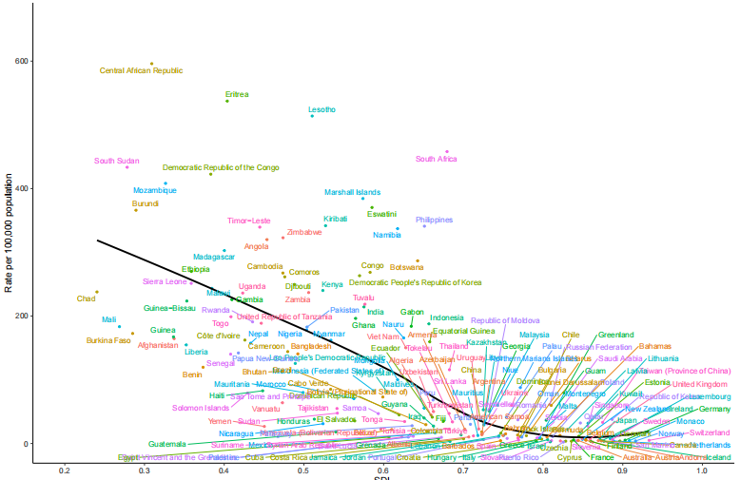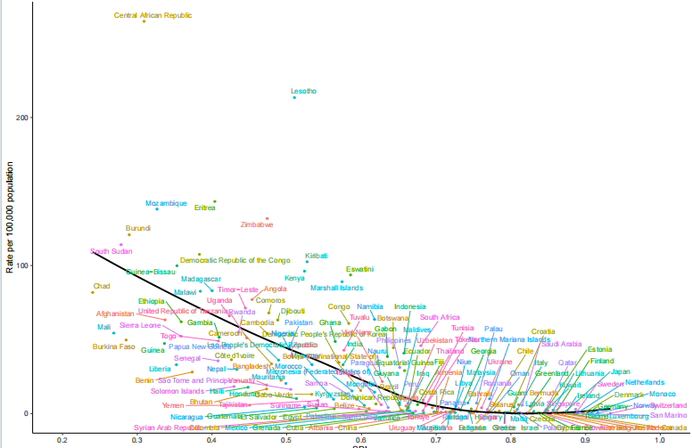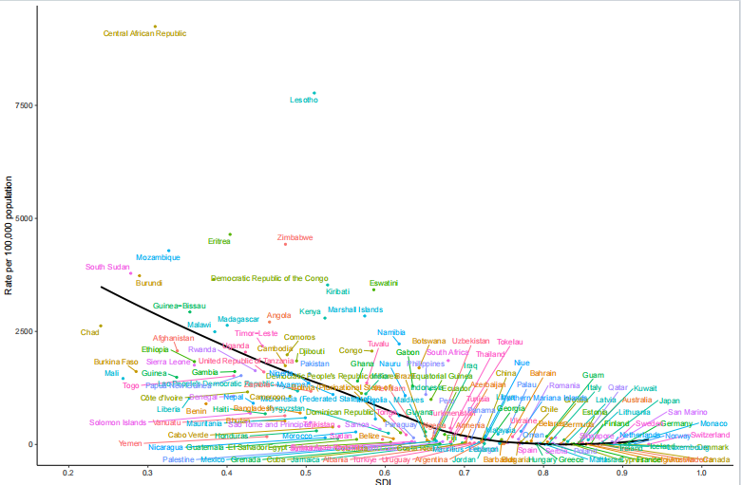

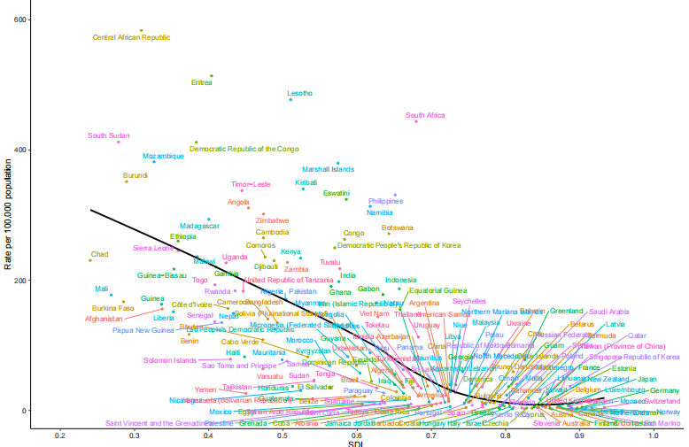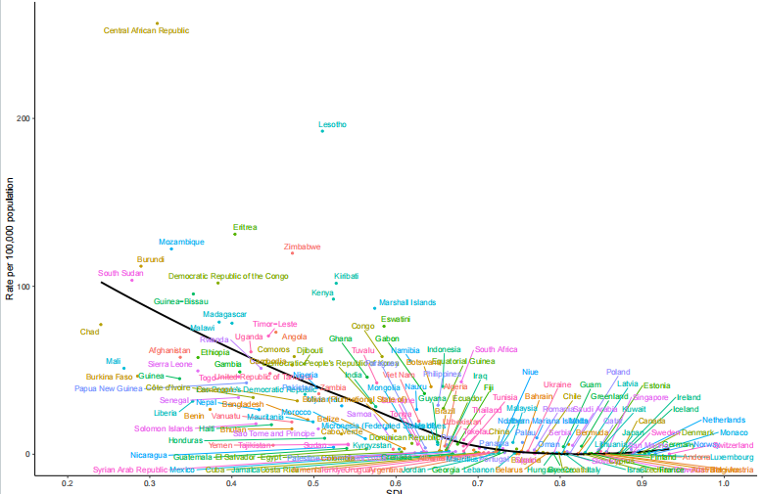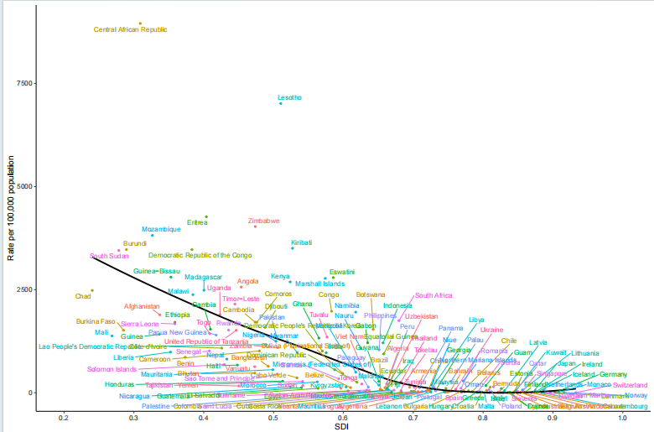

Figure S1: The association between the sociodemographic index (SDI) and the age-standardized incidence rate, death rate, and DALY rate of tuberculosis (TB) and drug-susceptible tuberculosis (DS-TB) with the sociodemographic index (SDI) across 204 countries and regions in 2021 year (A: Incidence rate of TB. B: Death rate of TB. C: DALY rate of TB. D: Incidence rate of DS-TB. E: Death rate of DS-TB. F: DALY rate of DS-TB).

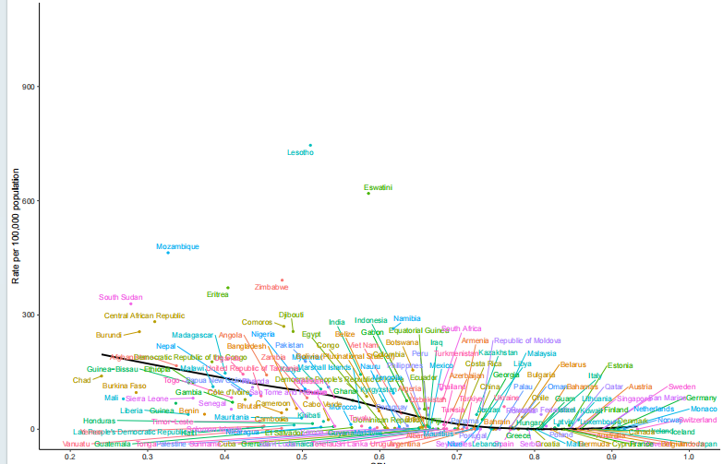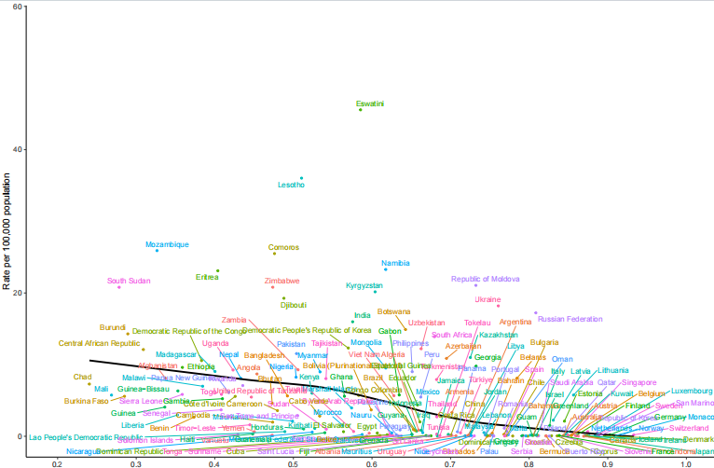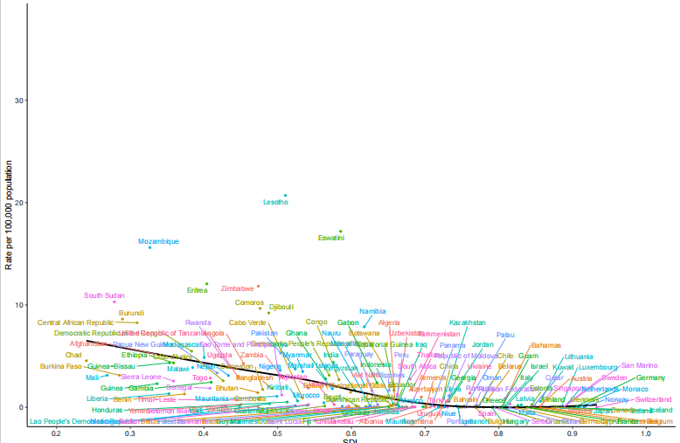

Figure S2: The association between the sociodemographic index (SDI) and the age-standardized incidence rate, death rate, and DALY rate of multidrug-resistant tuberculosis (MDR-TB) across 204 countries and regions in 2021 year(G: Incidence rate of MDR-TB. H: Death rate of MDR-TB. I: DALY rate of MDR-TB).）

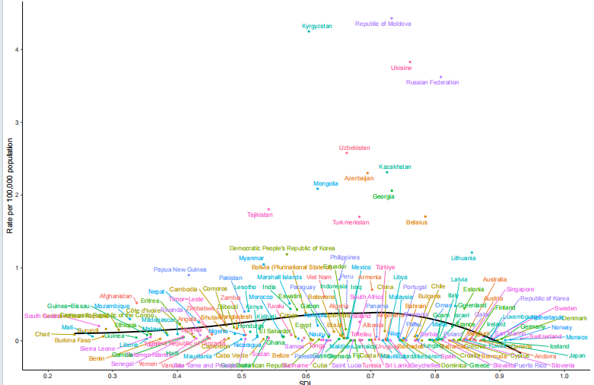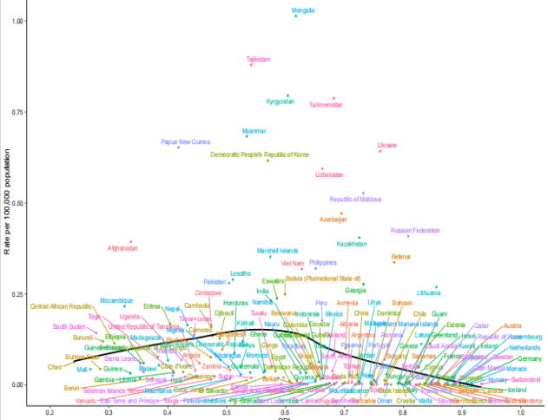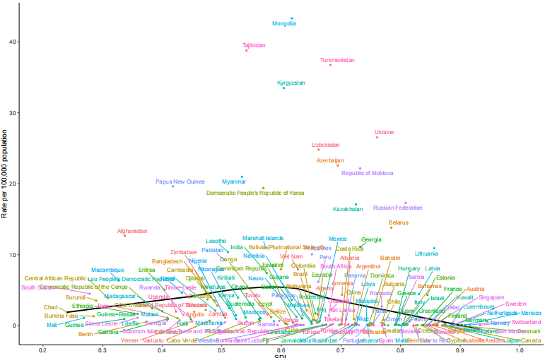

Figure S3: The association between the sociodemographic index (SDI) and the age-standardized incidence rate, death rate, and DALY rate of extensively drug-resistant tuberculosis (XDR-TB) across 204 countries and regions in 2021 year(J: Incidence rate of MDR-TB. K: Death rate of MDR-TB. L: DALY rate of MDR-TB).

