Supplementary figures
Figure S1. NEK9 is downregulated and positively correlated with USP19 in pancreatic cancer. (A and B) Representative IHC staining and quantification of NEK9 expression in compared clinical samples. (C) The mRNA expression of NEK9 in compared clinical samples. (D) Western blot analysis of NEK9 expression in six pancreatic cell lines. (E) Correlation between USP19 and NEK9 protein expression in compared clinical samples. (F) Kaplan-Meier analysis for pancreatic cancer patients from published database. (G) CCK-8 assay, (H) EdU assay, (I) Colony formation assay, (J) Flow cytometric analysis, (K and L) Transwell assay and (M) Wound healing assay of MiaPaca-2 and CFPAC-1 cells transfected as indicated. *p<0.05, **p<0.01, ***p<0.001.

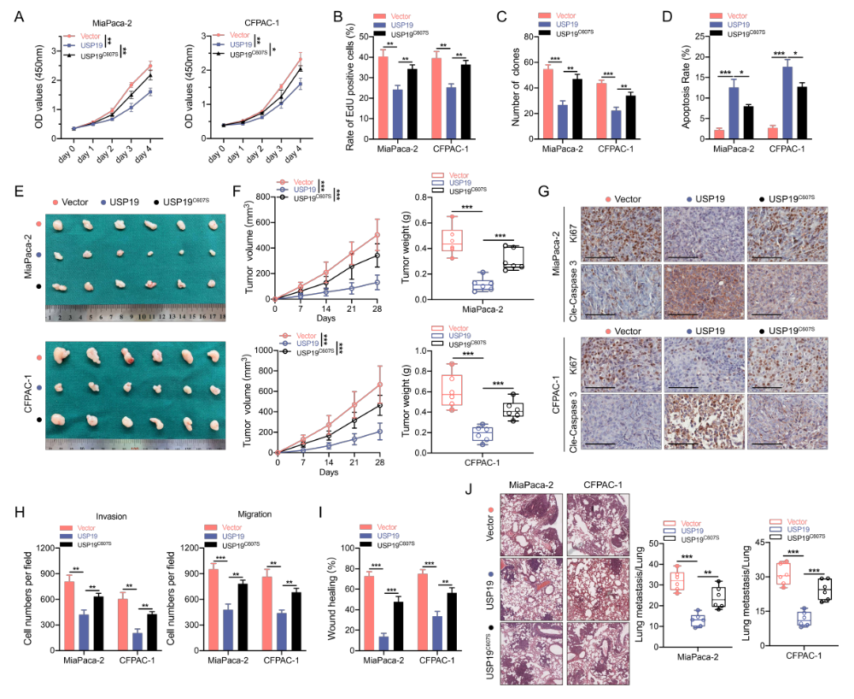
Figure S2. Catalytically inactive mutant USP19^{C607S} abolished its inhibitory effects on pancreatic cancer. (A)CCK-8 assays, (B) EdU assays, (C) colony formation assays and (D) apoptosis assays were conducted in MiaPaca-2 and CFPAC-1 cells as indicated. (E and F) Representative images of tumors and quantification of tumor volumes and tumor weights in nude mice bearing MiaPaca-2 and CFPAC-1 cells in indicated groups. (G) IHC staining of Ki67 and cleaved caspase 3 of tumor sections in indicated groups. Scale bar, 100μm. (H) Transwell invasion assays and (I) wound healing assays were performed in MiaPaca-2 and CFPAC-1 cells as indicated. (J) H&E staining and quantification of pulmonary metastatic nodules in indicated groups. Scale bar, 500μm. *p<0.05, **p<0.01, ***p<0.001.

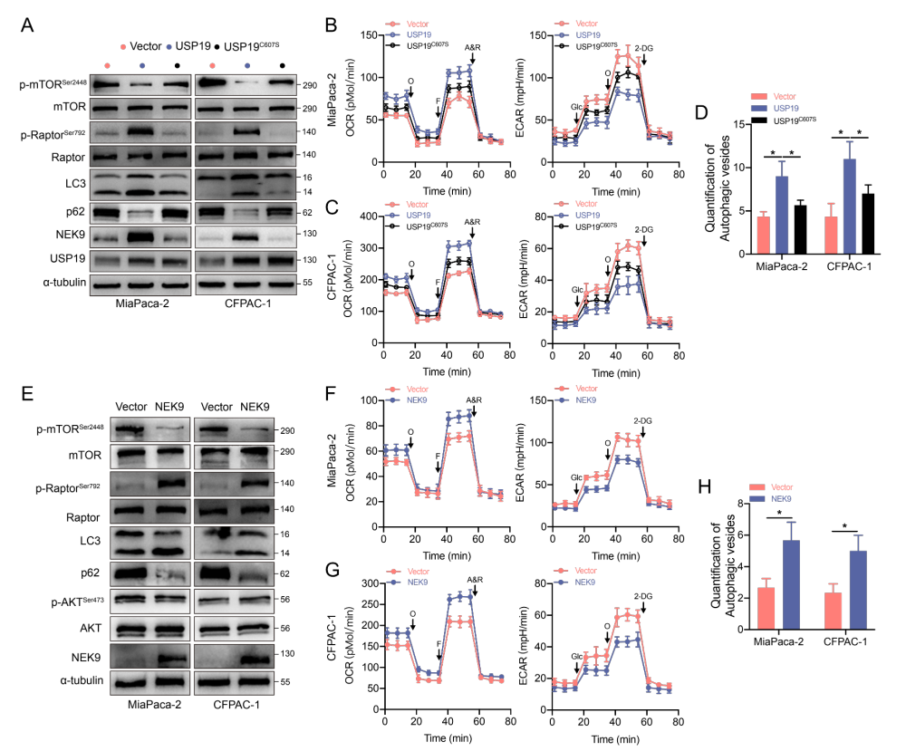
Figure S3. USP19/NEK9 axis inhibited Warburg effect and activated autophagy pathway in pancreatic cancer. (A) Western blot analysis of mTOR signaling, LC3 and p62 protein levels in MiaPaca-2 and CFPAC-1 cells transfected with USP19 or USP19^{C607S}. (B and C) Detection and quantification of ECAR and OCR in MiaPaca-2 and CFPAC-1 cells as indicated. (D) TEM was applied to determine the autophagic microstructure in MiaPaca-2 and CFPAC-1 cells as indicated. (E) Western blot analysis of mTOR signaling, LC3 and p62 protein levels in MiaPaca-2 and CFPAC-1 cells transfected with NEK9. (F and G) Detection and quantification of ECAR and OCR in MiaPaca-2 and CFPAC-1 cells as indicated. (H) TEM was applied to determine the autophagic microstructure of transfected MiaPaca-2 and CFPAC-1 cells as indicated. *p<0.05.

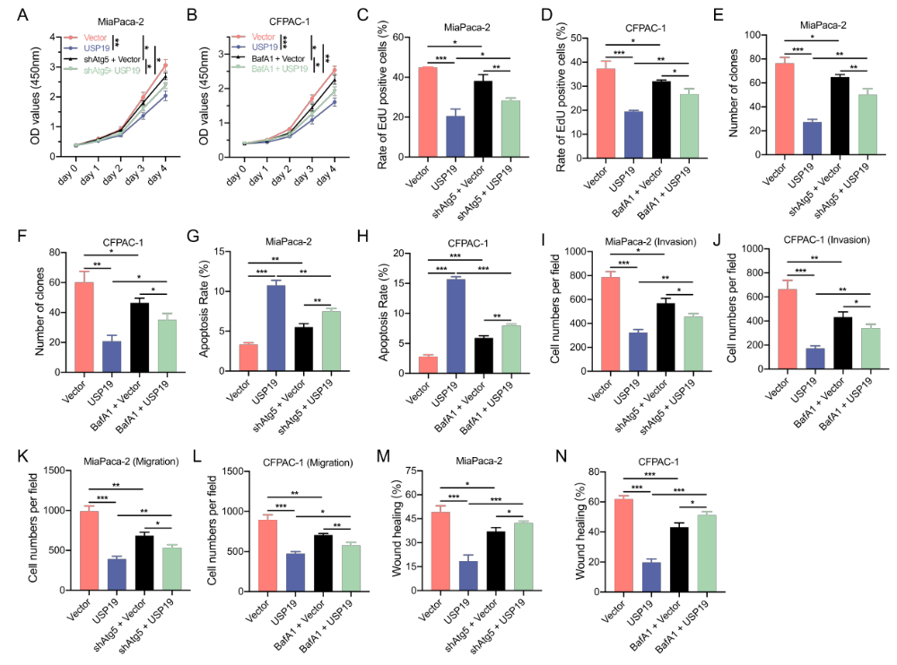
Figure S4. Inhibition of autophagy by Atg5 knockdown or inhibitor BafA1 (50nM) abolished the tumor-inhibitory role of USP19 in pancreatic cancer cells. (A-G) A series of functional experiments including CCK-8 assays, EdU assays, colony formation assays, apoptosis assays, transwell invasion assays and wound healing assays were performed to confirm the role of autophagy in MiaPaca-2 and CFPAC-1 cells transfected with USP19. *p<0.05, **p<0.01, ***p<0.001.

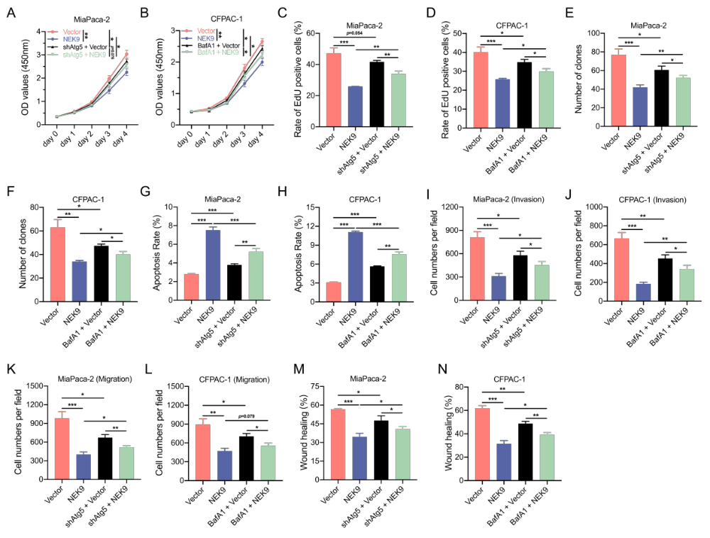
Figure S5. Inhibition of autophagy by knockdown or inhibitor BafA1 (50nM) abolished the tumor-inhibitory role of NEK9 in pancreatic cancer cells. (A-G) A series of functional experiments including CCK-8 assays, EdU assays, colony formation assays, apoptosis assays, transwell invasion assays and wound healing assays were performed to confirm the role of autophagy in MiaPaca-2 and CFPAC-1 cells transfected with NEK9. *p<0.05, **p<0.01, ***p<0.001.

