Indigofera tinctoria leaf powder as a promising additive to improve indigo fermentation prepared with sukumo (composted Polygonum tinctorium leaves)

Helena de Fátima Silva Lopes • Zhihao Tu • Hisako Sumi • Isao Yumoto*

Helena de Fátima Silva Lopes • Zhihao Tu • Isao Yumoto
Bioproduction Research Institute, National Institute of Advanced Industrial Science and Technology (AIST), Tsukisamu-Higashi, Toyohira-ku, Sapporo 062-8517, Japan

Helena de Fátima Silva Lopes • Isao Yumoto
Laboratory of Environmental Microbiology, Graduate School of Agriculture, Hokkaido University, Kita-ku, Sapporo 060-8589, Japan

Hisako Sumi
North-Indigo Textile Arts Studio 2-3-9, Matsugae, Otaru 047-1470, Japan

Isao Yumoto (Corresponding author) E-mail: i.yumoto@aist.go.jp
Bioproduction Research Institute, National Institute of Advanced Industrial Science and Technology (AIST), Tsukisamu-Higashi, Toyohira-ku, Sapporo 062-8517, Japan

SUPPLEMENTARY MATERIAL

Supplementary Table 1. Changes in bacterial count (CFU) of Indigofera tinctoria leaf powder (LP) and sukumo in wood ash extract
LP | Dilution with physiological saline (cell count in original sample) | Exposure to wood ash extract at 26 °C for 30 min
Bacterial count in 0.5 g/5 mL suspension (CFU/ mL physiological saline or wood ash extract) | 5.3 × 10⁵ | 3.4 × 10⁵
Expected bacterial count in fermentation fluid (CFU/mL) | 5.8 × 10³ | 3.7 × 10³
Change from original count | 100% | 64%
Sukumo | Dilution with physiological saline (cell count in original sample) | Exposed to wood ash extract at 55 °C for 30 min
Bacterial count in 0.5 g/5 mL suspension (CFU/ mL physiological saline or wood ash extract) | 4.6 × 10⁵ | 4.9 × 10⁵
Expected bacterial count in fermentation fluid (CFU/ mL) | 3.9 × 10⁵ | 4.1 × 10⁵
Change from original count | 100% | 105%

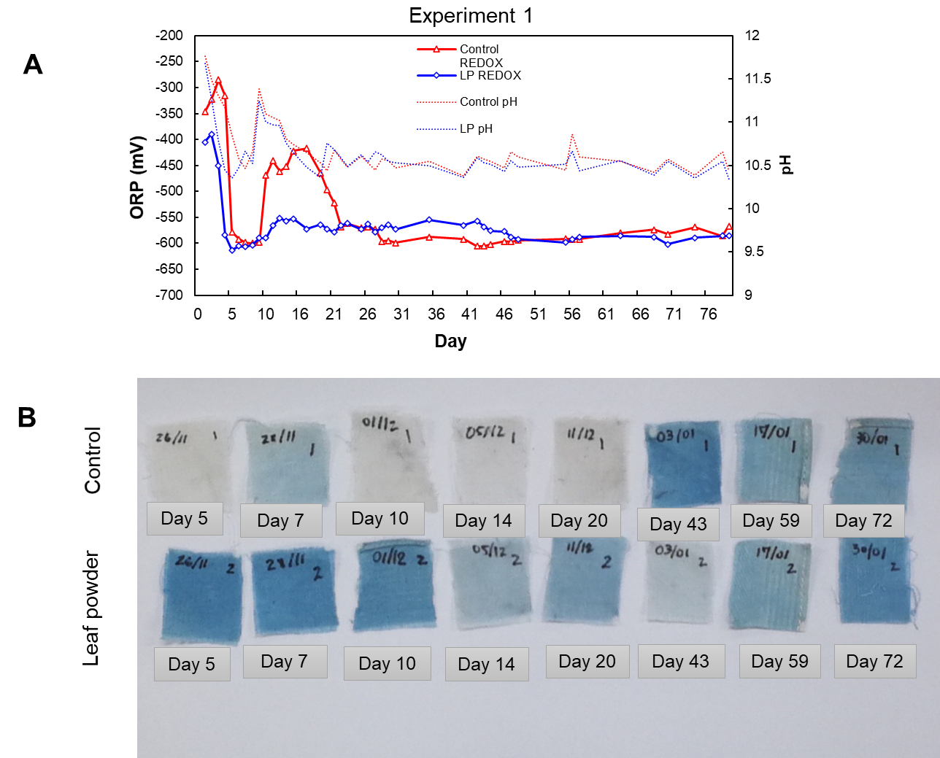
Supplementary Fig. S1. Changes in redox potential (ORP) and pH from day 1 to day 70 (A) and dyeing results from day 5 to day 72 of Experiment 1 with (LP) and without (control) Indigofera tinctoria leaf powder.

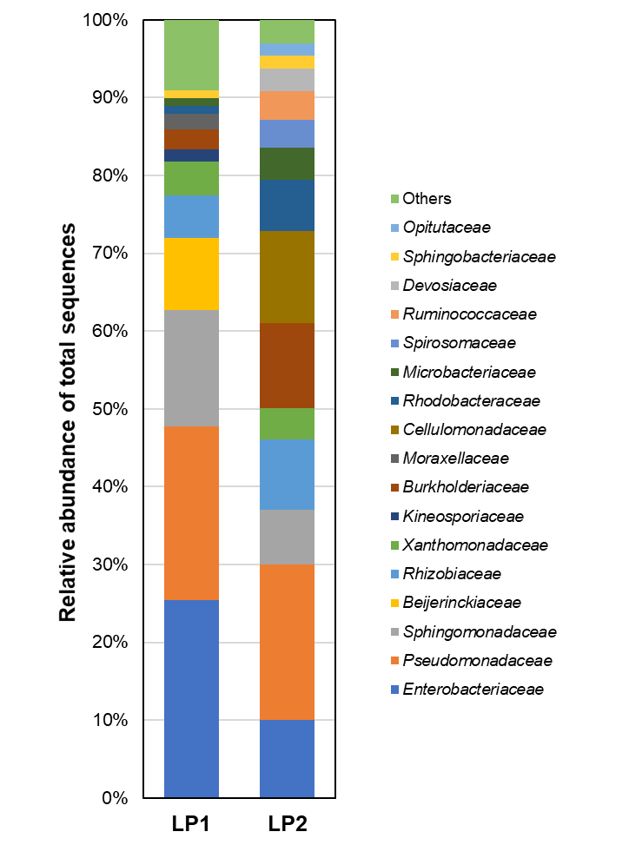
Supplementary Fig. S2. Relative abundance (%) of bacterial constituents based on 16S rRNA analysis (≥2.0% in sample) in leaf powders 1 (LP1) and 2 (LP2).

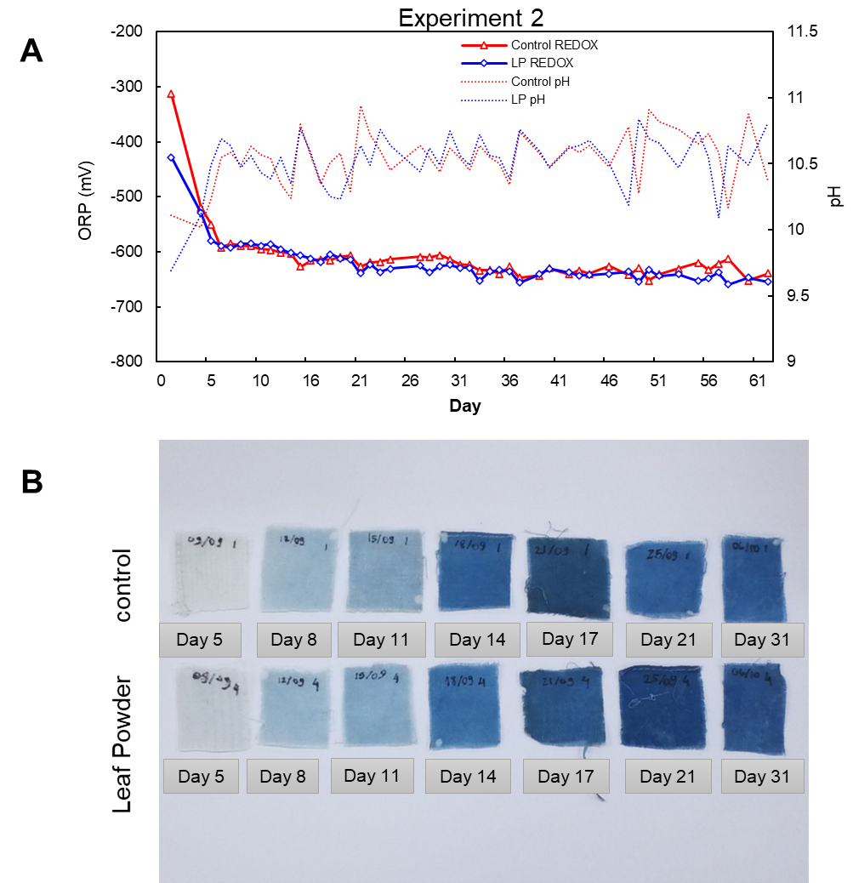
Supplementary Fig. S3. Changes in redox potential (ORP) and pH from day 1 to day 62 (A) and dyeing results from day 5 to day 31 of Experiment 2 with (LP) and without (control) Indigofera tinctoria leaf powder.
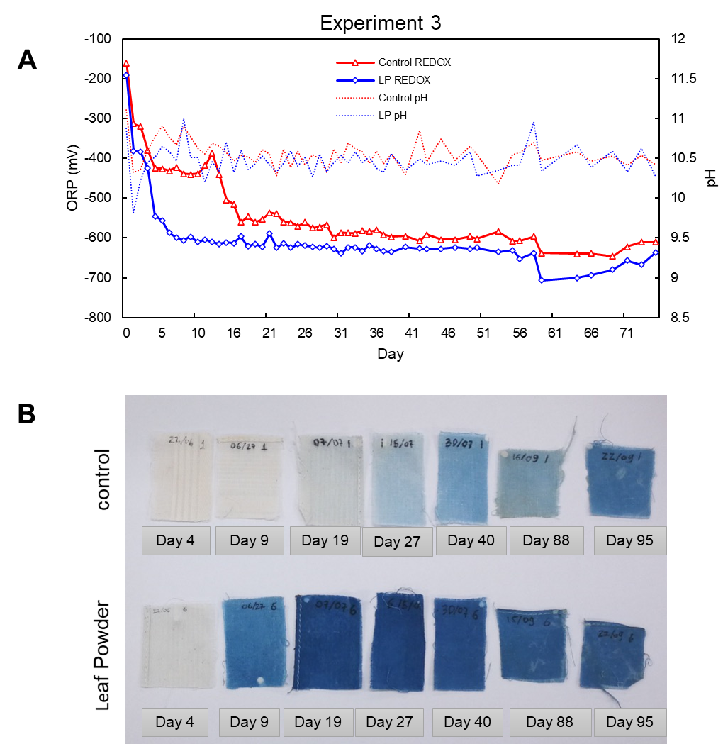
Supplementary Fig. S4. Changes in redox potential (ORP) and pH from day 1 to day 75 (A) and dyeing results from day 4 to day 95 of Experiment 3 with (LP) and without (control) Indigofera tinctoria leaf powder.
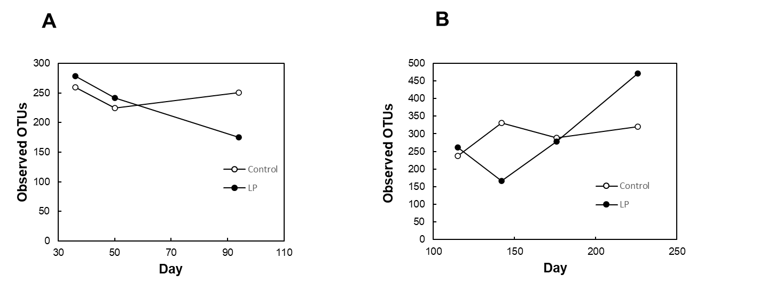

Supplementary Fig. S5. Changes in observed OTUs at 18512 sample depth varying with sukumo fermentation period in Experiment 2 (A) and Experiment 3 (B) indigo fermentation batches with (LP) and without (control) Indigofera tinctoria leaf powder. Analysis was performed using Divisive Amplicon Algorithm (DADA2) and depended on the fermentation period.

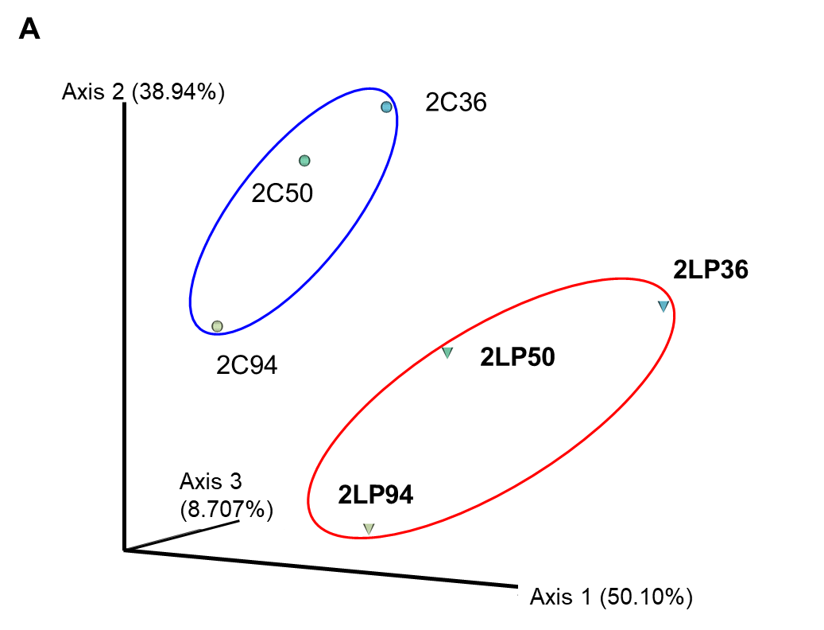
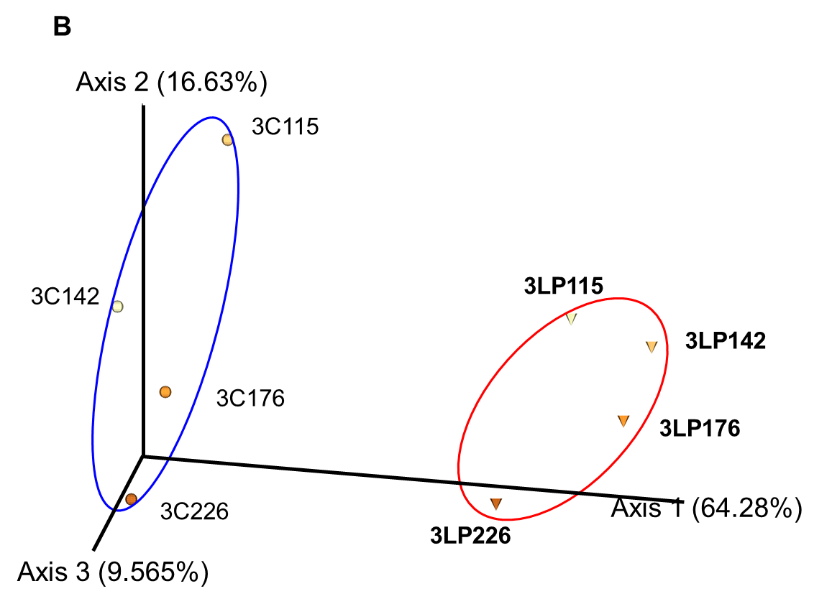

Supplementary Fig. S6. Principal coordinate analysis (PCoA) using Bray-Curtis dissimilarity matrix on Experiment 2 (A) and Experiment 3 (B). Triangles and circles indicate samples with (LP) and without (control) Indigofera tinctoria leaf powder, respectively.

