APPENDICE A

- Data

Table A.1. Datas and Sources.
Data | Source
Contaminated areas | CETESB (2020)
Hydrography | ANA (2017)
Boundary of the Upper Tietê basin | SIGRH (2020)
Municipal and state boundaries | IBGE (2020)
Digital Elevation Model | EMPLASA (2010)
Wells | DAEE / SIAGAS (2020)
Hydrogeological units | DAEE / IPT / IG/ CPRM (2005)
Social vulnerability | GEOSEADE (2010)

- Hydraulic Conductivity

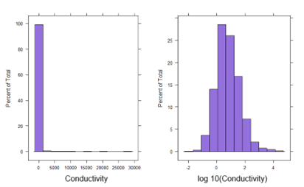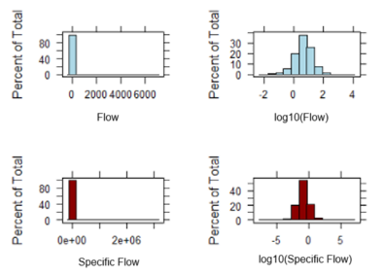

Figure A-1. Histograms of Hydraulic Conductivity, Flow and Specific Flow and its respective ln transformation.

Table A-2. Correlation of Flow and Specific Flow with Conductivity.
Variable | Correlation with Conductivity | P-value
Flow | 0,747 | 2,2e⁻¹⁶
Specific Flow | 0,704 | 2,2e⁻¹⁶

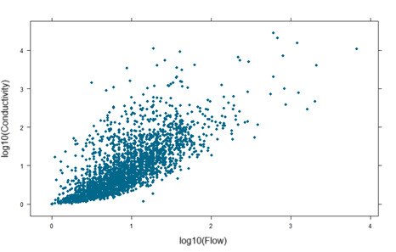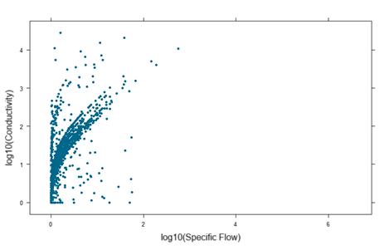
Figure A-2. Correlation of Flow and Specific Flow with Conductivity.
  - São Paulo Aquifer
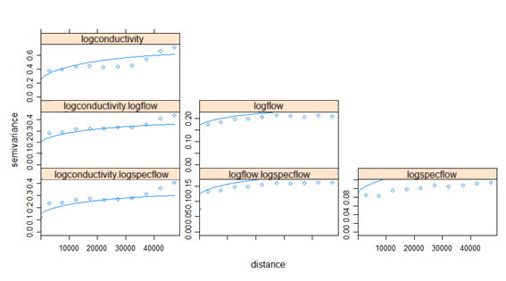
Figure A-3. Variogram of Hydraulic Conductivity for São Paulo Aquifer.

  - Precambrian Aquifer

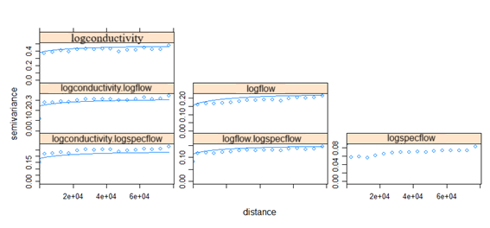
Figure A-4. Variogram of Hydraulic Conductivity for PreCambrian Aquifer.

- Thickness
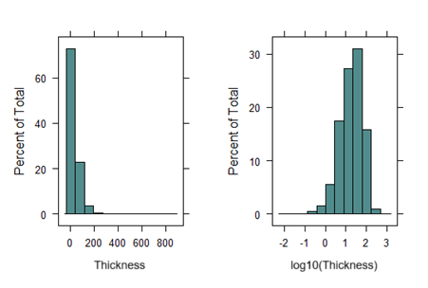
Figure A-5. Histogram of Thickness and its respective ln transformation.
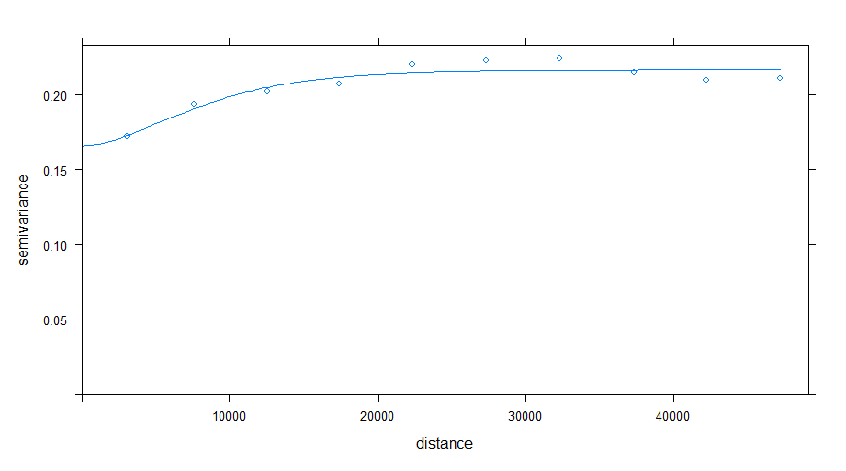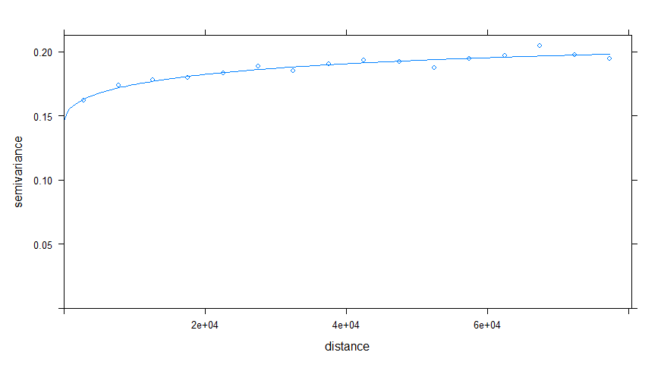
Figure A-6. Variogram of Thickness for São Paulo and PreCambrian Aquifers.

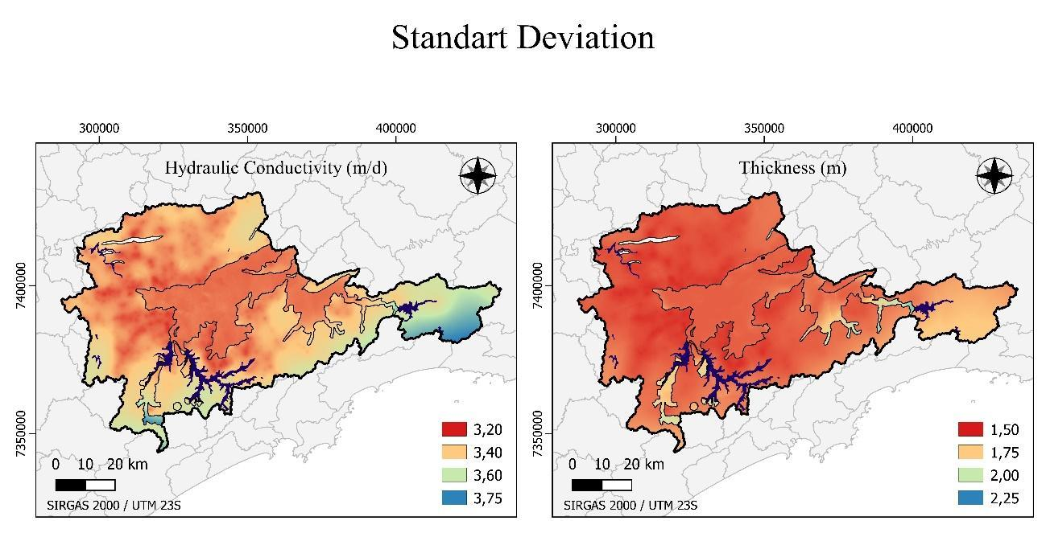
Figure A-7. Standard deviation maps for hydraulic conductivity and thickness krigings.

- Safety perimeters

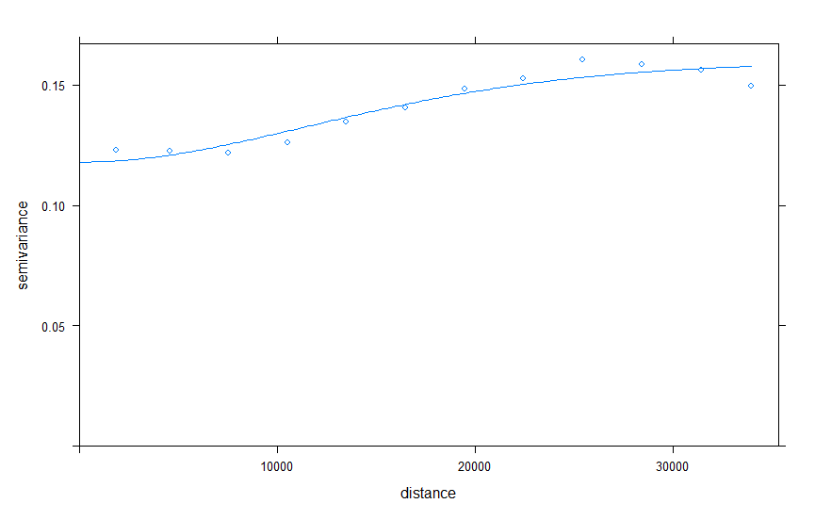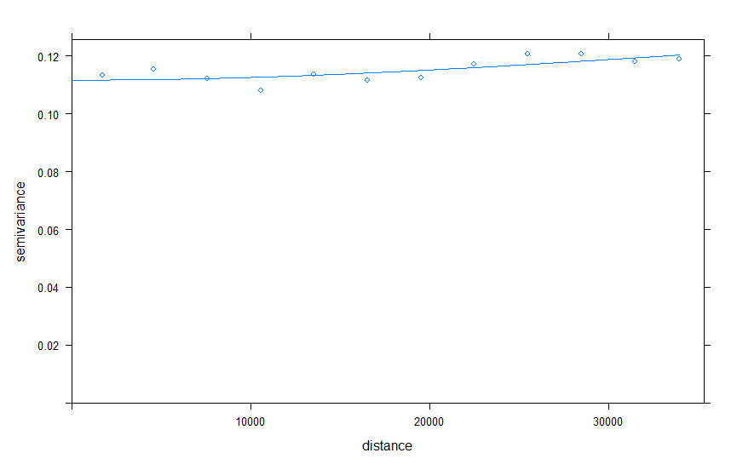
Figure A-8. Variogram of Ordinary Kriging Flow for São Paulo and PreCambrian Aquifers.

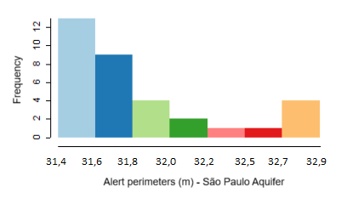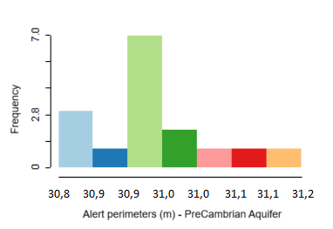
Figure A-9. Histogram for alert perimeters.

- Social vulnerability
In order to complement the social vulnerability data in regions where there is no classification and there is income information, an ordinal regression was performed.

Table A-3. Ordinal Regression for Social Vulnerability.
logit(P) | [Y<=1]  Lower | Y<=2  Very Low | Y<=3  Low | Y<=4  Medium | Y<=5  High | Y=6  Higher
Intercept | -12.909 | -4.406 | -3.028 | -1.744 | -0.481 | > -0.481
Exp(Intercept) | 0.000002 | 0.012 | 0.048 | 0.175 | 0.618 | > 0.618
Transition limit in R$ | 2183.16 | 626.54 | 496.77 | 290.82 | 222.84 | < 222.84

Somers's Delta 0.754 [confidence interval of 95%: 0.75-0.76].

The estimated results were unified with the data already available by SEADE, using it only where no values. In this way, Map A-10 was obtained. Of the 1,204 missing census tracts, 343 were filled in, with the remainder, 861, being areas that had no income value. They were visually explored on satellite images, reaching the conclusion that they correspond to unoccupied areas with native vegetation, therefore they received a “zero” vulnerability level for this analysis, since they do not have exposed people. However, it is understood that they can be areas of ecological value and that their contamination can impact the ecosystem services provided, since many of them are areas of protection of springs. This dimension of relevance for water supply was captured by the “exposure” dimension in the risk analysis, by including the density of water concessions.
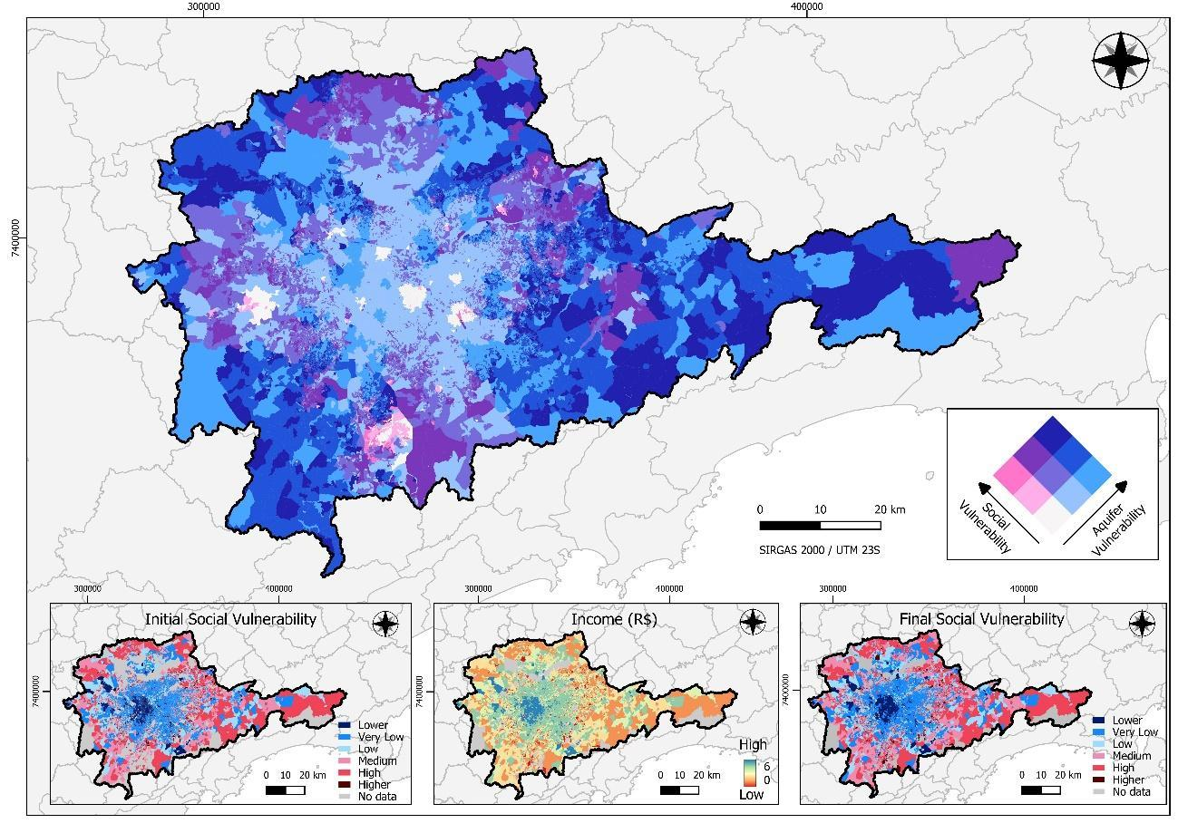
Figure A-10. Vulnerability maps for vulnerability.

APPENDICE B

Aquifer Vulnerability Index
Variables
library(sp)
library(gstat)
library(sf)
library(raster)
library(readr)
library(geoR)
require("lattice")

#####################################################################

#Data
pocos <- read_delim("Pocos_Finais.csv",
delim = ";", escape_double = FALSE, trim_ws = TRUE)
View(pocos)

#Important Note: For the dissertation the wells were separated into 2 different .csv files
#To carry out the specific analysis of each aquifer, just import the aquifers separately in two scripts.

#####################################################################

# Correction for valid values
pocoscondutividade<-subset(pocos, !is.na(pocos$CondutividadeMDIA))
pocoscondutividade<-subset(pocoscondutividade, pocoscondutividade$CondutividadeMDIA != 0)
min(pocoscondutividade$CondutividadeMDIA)
pocoscondutividade$logcondutividade<-log10(pocoscondutividade$CondutividadeMDIA+1)
#coordinates(pocoscondutividade) <- ~ X + Y
pocoscondutividade<-st_as_sf(pocoscondutividade,coords=c(1,2))

pocosvazao<-subset(pocos, !is.na( pocos$TesteVazao))
pocosvazao <- subset(pocosvazao, pocosvazao$TesteVazao != 0)
min(pocosvazao$TesteVazao)
pocosvazao$logvazao<-log10(pocosvazao$TesteVazao+1)
#coordinates(pocosvazao) <- ~ X + Y
pocosvazao<-st_as_sf(pocosvazao,coords=c(1,2))

pocosvazaoe<-subset(pocos, !is.na( pocos$VazaoEspecFinal))
pocosvazaoe <- subset(pocosvazaoe, pocosvazaoe$VazaoEspecFinal != 0)
min(pocosvazaoe$VazaoEspecFinal)
pocosvazaoe$logvazaoe<-log10(pocosvazaoe$VazaoEspecFinal+1)
#coordinates(pocosvazaoe) <- ~ X + Y
pocosvazaoe<-st_as_sf(pocosvazaoe,coords=c(1,2))

pocosn<-subset(pocos, !is.na(pocos$TesteNivelEstat))
pocosn<-subset(pocosn, pocosn$TesteNivelEstat != 0)
min(pocosn$TesteNivelEstat)
pocosn$logpocosn<-log10(pocosn$TesteNivelEstat+1)
#coordinates(pocosn) <- ~ X + Y
pocosn<-st_as_sf(pocosn,coords=c(1,2))

#####################################################################

#Histogram

h1 <- histogram(~ CondutividadeMDIA , pocoscondutividade, xlab="Condutividade", col="mediumpurple", nint=12)
h2 <- histogram(~ log10(CondutividadeMDIA), pocoscondutividade, xlab="log10(Condutividade)", col="mediumpurple", nint=12)
print(h1, split = c(1,1,2,1), more=T)
print(h2, split = c(2,1,2,1), more=F)

h1 <- histogram(~ TesteNivelEstat , pocosn, xlab="Nível Estático", col="mediumpurple", nint=12)
h2 <- histogram(~ log10(TesteNivelEstat), pocosn, xlab="log10(Nível Estático)", col="mediumpurple", nint=12)
print(h1, split = c(1,1,2,1), more=T)
print(h2, split = c(2,1,2,1), more=F)

h3 <- histogram(~ TesteVazao, pocosvazao, xlab="Vaz?o", col="lightblue", nint=12)
h4 <- histogram(~ log10(TesteVazao), pocosvazao, xlab="log10(Vaz?o)", col="lightblue", nint=12)
print(h3, split = c(1,1,2,1), more=T)
print(h4, split = c(2,1,2,1), more=F)

#####################################################################

#Variogram
#plot(v.logcondutividade.c <- variogram(logcondutividade ~ 1, data=pocoscondutividade, cutoff=150000, cloud=T))
plot(v.logcondutividade <- variogram(logcondutividade ~ 1, data=pocoscondutividade, cutoff=150000, width=5000), pl=F)

# remove duplicate wells
pocoscondutividade_sp<-as(pocoscondutividade,"Spatial")
pocos_geodata <- as.geodata(pocoscondutividade_sp[,"logcondutividade"])
duplicados<-dup.coords(pocos_geodata)
duplicados
pocoscondutividade<-pocoscondutividade[-c(1196,1469,1361,2552),] #apagando pontos duplicados com valor igual
pocoscondutividade_sp<-as(pocoscondutividade,"Spatial")
pocos_geodata <- as.geodata(pocoscondutividade_sp[,"logcondutividade"])
duplicados<-dup.coords(pocos_geodata)
duplicados
pocos_geodata_jitter<-jitterDupCoords(pocos_geodata,max=5)
duplicados<-dup.coords(pocos_geodata_jitter)

Hydraulic Conductivity
Ordinary Kriging
#variogram
variograma_geor <- variog(pocos_geodata_jitter)
plot(variograma_geor)
#dev.new()
#eyefit_geor <- eyefit(variograma_geor)
pocoscondutividade_jitter<-as.data.frame(pocos_geodata_jitter)
names(pocoscondutividade_jitter)[names(pocoscondutividade_jitter)=="data"]<-"logcondutividade"
pocoscondutividade<-st_as_sf(pocoscondutividade_jitter,coords=c(1,2))

v.logcondutividade <- variogram(logcondutividade ~ 1, data=pocoscondutividade, cutoff=150000, width=5000)
plot(v.logcondutividade)

#Matern Model
(m.logcondutividade_mat <- fit.variogram(v.logcondutividade, fit.method=6, vgm("Mat"), fit.kappa = TRUE))
plot(v.logcondutividade, pl=F, model=m.logcondutividade_mat)
attr(m.logcondutividade_mat, "SSErr")

#Exponencial Model
(m.logcondutividade_exc <- fit.variogram(v.logcondutividade,fit.method=6, vgm("Exc")))
plot(v.logcondutividade, pl=F, model=m.logcondutividade_exc)
attr(m.logcondutividade_exc, "SSErr")

#####################################################################

# Test to optimize local kriging
erro_medio_quadrado <- function(peso) {
gs<-gstat(formula=logcondutividade~1, locations=pocoscondutividade, model=m.logcondutividade_mat,nmax=peso)
cv <- gstat.cv(gs)
sqrt(mean(na.omit(cv$residual^2)))}
peso_otimo <- optimize(f=erro_medio_quadrado, interval=c(25,40)) # demora um pouco
peso_otimo$minimum #melhor valor para nmax foi 27
peso_otimo$objective

#Cross validation
cv_mat<-krige.cv(logcondutividade ~ 1,locations=pocoscondutividade,m.logcondutividade_mat,nmax=27)
mean(cv_mat$residual^2)
sqrt(mean(cv_mat$residual^2))
1-(var(na.omit(cv_mat$residual))/var(pocoscondutividade$logcondutividade))

cv_exc<-krige.cv(logcondutividade ~ 1,locations=pocoscondutividade,m.logcondutividade_exc,nmax=27)
mean(na.omit(cv_exc$residual^2))

#####################################################################

# Key variable interpolation - ordinary kriging
modelo_raster<-raster(pocoscondutividade, res=100)
modelo_grid<-as(modelo_raster,"SpatialPixels")
pocoscondutividade_sp<-as(pocoscondutividade,"Spatial")
k.o <- krige(formula=logcondutividade~1, locations=pocoscondutividade_sp,newdata=modelo_grid, model=m.logcondutividade_mat,nmax=27)
dev.off()
plot(k.o["var1.pred"])
plot(k.o["var1.var"])
dev.off()
k.o_predicted<-10^(raster(k.o["var1.pred"])) # converting from logarithm to original value
plot(k.o_predicted)
k.o_std<-10^(sqrt(raster(k.o["var1.var"]))) # converting from logarithm variance to standard deviation in the original value
plot(k.o_std)
raster::writeRaster(k.o_std,"k.o_std.tif")
raster::writeRaster(k.o_predicted,"kopredicted.tif")

CoKriging - Flow
# Correlation chart

pocos$logvazao<-log10(pocos$TesteVazao+1)
pocos$logcondutividade<-log10(pocos$CondutividadeMDIA+1)
xyplot(logcondutividade ~ logvazao, data=pocos, pch=20, cex=1.2, col="deepskyblue4", ylab="log10(Condutividade)", xlab="log10(Vazao)")

with(pocos, cor(logvazao, logcondutividade, use = "complete"))

#####################################################################
# remove duplicate wells
pocosvazao_sp<-as(pocosvazao,"Spatial")
pocos_geodata <- as.geodata(pocosvazao_sp[,"logvazao"])
duplicados<-dup.coords(pocos_geodata)
duplicados
pocosvazao<-pocosvazao[-c(8068,8070,8071,3781,933,1153,2740,7068,2129,4485,1349,3879,3676,6872,7813,2993,2994,1092,6161,2114,5488,3763,370,5553,1529,8083,8084,3465,3690,3446,990,5565,8044,7137,5766),] # deleting duplicate points with equal value
pocosvazao_sp<-as(pocosvazao,"Spatial")
pocos_geodata <- as.geodata(pocosvazao_sp[,"logvazao"])
duplicados<-dup.coords(pocos_geodata)
duplicados
pocos_geodata_jitter<-jitterDupCoords(pocos_geodata,max=5)
duplicados<-dup.coords(pocos_geodata_jitter)
duplicados

#####################################################################

#variogram
variograma_geor <- variog(pocos_geodata_jitter)
plot(variograma_geor)
#dev.new()
#eyefit_geor <- eyefit(variograma_geor)
pocosvazao_jitter<-as.data.frame(pocos_geodata_jitter)
names(pocosvazao_jitter)[names(pocosvazao_jitter)=="data"]<-"logvazao"
pocosvazao<-st_as_sf(pocosvazao_jitter,coords=c(1,2))

v.logvazao <- variogram(logvazao ~ 1, pocosvazao, cutoff=150000,width=5000)
plot(v.logvazao, pl=F)

#Matern Model
(m.logvazao_mat <- fit.variogram(v.logvazao, fit.method=6, vgm("Mat"), fit.kappa = TRUE))
plot(v.logvazao, pl=F, model=m.logvazao_mat)
attr(m.logvazao_mat, "SSErr")

#build a data structure for the co-regionalization model
#Fit the models to direct and cross variograms simultaneously
(g <- gstat(NULL, id = "logcondutividade", form = logcondutividade ~ 1, data=pocoscondutividade_sp))
pocosvazao_sp<-as(pocosvazao,"Spatial")
(g <- gstat(g, id = "logvazao", form = logvazao ~ 1, data=pocosvazao_sp))
# cross variogram
v.cross <- variogram(g,cutoff=150000,width=5000)
plot(v.cross, pl=F)

# variogram model - adjusted
(g <- gstat(g, id = "logcondutividade", model = m.logcondutividade_mat, fill.all=T,nmax=27))
g$data$logcondutividade$nmax<-27
g$data$logvazao$nmax<-27
(g <- fit.lmc(v.cross, g, fit.method=6, correct.diagonal=1.01))

#####################################################################

# interpolation – cokriging
coko <- predict(g,newdata=modelo_grid,debug.level=-1)
coko$logcondutividade.pred
dev.off()
plot(coko["logcondutividade.pred"])
plot(coko["logcondutividade.var"])
dev.off()
coko_predicted<-10^(raster(coko["logcondutividade.pred"]))
plot(coko_predicted)
coko_std<-10^(sqrt(raster(coko["logcondutividade.var"])))
plot(coko_std)
raster::writeRaster(coko_predicted,"coko_predicted.tif")
raster::writeRaster(coko_std,"coko_std.tif")

#####################################################################

# cross validation
cv.c <- gstat.cv(g,verbose=TRUE)
str(cv.c)
summary(cv.c$residual)
sqrt(mean(cv.c$residual^2))
mean(cv.c$residual)
mean(cv.c$residual^2/cv.c$logcondutividade.var)
1-(var(cv.c$residual)/var(cv.c$observed))

CoKriging – Specific Flow
# Correlation chart
pocos$logvazaoe<-log10(pocos$VazaoEspecFinal+1)
pocos$logcondutividade<-log10(pocos$CondutividadeMDIA+1)
xyplot(logcondutividade ~ logvazaoe, data=pocos, pch=20, cex=1, col="deepskyblue4", ylab="log10(Condutividade)", xlab="log10(Vazao especifica)")
with(pocos, cor(logvazaoe, logcondutividade, use = "complete"))

#####################################################################

# remove duplicate wells
pocosvazaoe_sp<-as(pocosvazaoe,"Spatial")
pocos_geodata <- as.geodata(pocosvazaoe_sp[,"logvazaoe"])
duplicados<-dup.coords(pocos_geodata)
duplicados
pocosvazaoe<-pocosvazaoe[-c(825, 1036, 2503, 6167, 4999, 4082, 1217, 3544, 3369, 5995,2741, 1769, 976, 5452, 1931, 1778, 3383, 3141, 877, 6229, 5117 ),] #deleting duplicate points with equal value
pocosvazaoe_sp<-as(pocosvazaoe,"Spatial")
pocos_geodata <- as.geodata(pocosvazaoe_sp[,"logvazaoe"])
duplicados<-dup.coords(pocos_geodata)
duplicados
pocos_geodata_jitter<-jitterDupCoords(pocos_geodata,max=5)
duplicados<-dup.coords(pocos_geodata_jitter)
duplicados

#####################################################################

#variogram
variograma_geor <- variog(pocos_geodata_jitter)
plot(variograma_geor)
#dev.new()
#eyefit_geor <- eyefit(variograma_geor)
pocosvazao_jitter<-as.data.frame(pocos_geodata_jitter)
names(pocosvazao_jitter)[names(pocosvazao_jitter)=="data"]<-"logvazaoe"
pocosvazaoe<-st_as_sf(pocosvazao_jitter,coords=c(1,2))

v.logvazaoe <- variogram(logvazaoe ~ 1, pocosvazaoe, cutoff=150000,width=5000)
plot(v.logvazaoe, pl=F)

# Matern Model
(m.logvazaoe_mat <- fit.variogram(v.logvazaoe, fit.method=6, vgm("Mat"), fit.kappa = TRUE))
plot(v.logvazaoe, pl=F, model=m.logvazaoe_mat)
attr(m.logvazaoe_mat, "SSErr")

#build a data structure for the co-regionalization model
#Fit the models to direct and cross variograms simultaneously
(g <- gstat(NULL, id = "logcondutividade", form = logcondutividade ~ 1, data=pocoscondutividade_sp))
pocosvazaoe_sp<-as(pocosvazaoe,"Spatial")
(g <- gstat(g, id = "logvazaoe", form = logvazaoe ~ 1, data=pocosvazaoe_sp))

# cross variogram
v.cross <- variogram(g,cutoff=150000,width=5000)
plot(v.cross, pl=F)

# variogram model - adjusted
(g <- gstat(g, id = "logcondutividade", model = m.logcondutividade_mat, fill.all=T,nmax=27))
g$data$logcondutividade$nmax<-27
g$data$logvazaoe$nmax<-27
(g <- fit.lmc(v.cross, g, fit.method=6, correct.diagonal=1.01))
plot(variogram(g,cutoff=150000,width=5000), model=g$model)

#####################################################################

# interpolation - cokriging
coko2 <- predict(g,newdata=modelo_grid,debug.level=-1)
coko2$logcondutividade.pred
dev.off()
plot(coko2["logcondutividade.pred"])
plot(coko2["logcondutividade.var"])
dev.off()
coko2_predicted<-10^(raster(coko2["logcondutividade.pred"]))
plot(coko2_predicted)
coko2_std<-10^(sqrt(raster(coko2["logcondutividade.var"])))
plot(coko2_std)
raster::writeRaster(coko2_predicted,"coko2_predicted.tif")
raster::writeRaster(coko2_std,"coko2_std.tif")

#####################################################################

# cross validation
cv.c <- gstat.cv(g,verbose=TRUE)
str(cv.c)
summary(cv.c$residual)
sqrt(mean(cv.c$residual^2))
mean(cv.c$residual)
mean(cv.c$residual^2/cv.c$logcondutividade.var)
1-(var(cv.c$residual)/var(cv.c$observed))

CoKriging – Flow and Specific Flow
#build a data structure for the co-regionalization model
#Fit the models to direct and cross variograms simultaneously
(g <- gstat(NULL, id = "logcondutividade", form = logcondutividade ~ 1, data=pocoscondutividade_sp))
pocosvazao_sp<-as(pocosvazao,"Spatial")
(g <- gstat(g, id = "logvazao", form = logvazao ~ 1, data=pocosvazao_sp))
(g <- gstat(g, id = "logvazaoe", form = logvazaoe ~ 1, data=pocosvazaoe_sp))

# cross variogram
v.cross <- variogram(g,cutoff=150000,width=5000)
plot(v.cross, pl=F)

# variogram model - adjusted
(g <- gstat(g, id = "logcondutividade", model = m.logcondutividade_mat, fill.all=T,nmax=27))
g$data$logcondutividade$nmax<-27
g$data$logvazao$nmax<-27
g$data$logvazaoe$nmax<-27
(g <- fit.lmc(v.cross, g, fit.method=6, correct.diagonal=1.01))
plot(variogram(g,cutoff=150000,width=5000), model=g$model)

#####################################################################

# interpolation - cokriging
coko3 <- predict(g,newdata=modelo_grid,debug.level=-1)
coko3$logcondutividade.pred
dev.off()
plot(coko3["logcondutividade.pred"])
plot(coko3["logcondutividade.var"])
dev.off()
coko3_predicted<-10^(raster(coko3["logcondutividade.pred"]))
plot(coko3_predicted)
coko3_std<-10^(sqrt(raster(coko3["logcondutividade.var"])))
plot(coko3_std)
raster::writeRaster(coko3_predicted,"coko3_predicted.tif")
raster::writeRaster(coko3_std,"coko3_std.tif")

#####################################################################

# cross validation
cv.c <- gstat.cv(g,verbose=TRUE)
str(cv.c)
summary(cv.c$residual)
sqrt(mean(cv.c$residual^2))
mean(cv.c$residual)
mean(cv.c$residual^2/cv.c$logcondutividade.var)
1-(var(cv.c$residual)/var(cv.c$observed))

Thickness
Ordinary Kriging
# Variogram
#plot(v.logpocosn.c <- variogram(logpocosn ~ 1, data=pocosn, cutoff=40000, cloud=T))

plot(v.logpocosn <- variogram(logpocosn ~ 1, data=pocosn, cutoff=40000, width=5000), pl=F)

#####################################################################

# remove duplicate wells
pocosn_sp<-as(pocosn,"Spatial")
pocos_geodata <- as.geodata(pocosn_sp[,"logpocosn"])
duplicados<-dup.coords(pocos_geodata)
duplicados
pocosn<-pocosn[-c(3468, 831, 1040, 2501, 6196, 5008,4086, 1219, 1472, 3540,3363, 6023, 6757, 2738, 1766, 7043, 7046, 7047, 7057, 7034, 7049, 979, 5464, 1929, 1775, 3450, 1388, 6932, 3377, 3134, 882, 6913, 6261, 6982, 6983, 6984, 6985, 6993, 6994, 6974, 6975, 6874, 6875, 5078, 5175, 5106, 6902,7013, 7003),] #apagando pontos duplicados com valor igual
pocosn_sp<-as(pocosn,"Spatial")
pocos_geodata <- as.geodata(pocosn_sp[,"logpocosn"])
duplicados<-dup.coords(pocos_geodata)
duplicados
pocos_geodata_jitter<-jitterDupCoords(pocos_geodata,max=5)
duplicados<-dup.coords(pocos_geodata_jitter)

#####################################################################

#variogram
variograma_geor <- variog(pocos_geodata_jitter)
plot(variograma_geor)
#dev.new()
#eyefit_geor <- eyefit(variograma_geor)
pocosn_jitter<-as.data.frame(pocos_geodata_jitter)
names(pocosn_jitter)[names(pocosn_jitter)=="data"]<-"logpocosn"
pocosn<-st_as_sf(pocosn_jitter,coords=c(1,2))

v.logpocosn <- variogram(logpocosn ~ 1, data=pocosn, cutoff=40000, width=5000)
plot(v.logpocosn)

#Matern
(m.logpocosn_mat <- fit.variogram(v.logpocosn, fit.method=6, vgm("Mat"), fit.kappa = TRUE))
plot(v.logpocosn, pl=F, model=m.logpocosn_mat)
attr(m.logpocosn_mat, "SSErr")

# Exponencial
(m.logpocosn_exc <- fit.variogram(v.logpocosn,fit.method=6, vgm("Exc")))
plot(v.logpocosn, pl=F, model=m.logpocosn_exc)
attr(m.logpocosn_exc, "SSErr")

#test to optimize local kriging
erro_medio_quadrado <- function(peso) {
gs<-gstat(formula=logpocosn~1, locations=pocosn, model=m.logpocosn_mat,nmax=peso)
cv <- gstat.cv(gs)
sqrt(mean(na.omit(cv$residual^2)))}
peso_otimo <- optimize(f=erro_medio_quadrado, interval=c(25,40))
peso_otimo$minimum #melhor valor para nmax foi 28
peso_otimo$objective

#####################################################################

# cross validation
cv_mat<-krige.cv(logpocosn ~ 1,locations=pocosn,m.logpocosn_mat,nmax=28)
mean(cv_mat$residual^2)
1-(var(na.omit(cv_mat$residual))/var(pocosn$logpocosn))
cv_exc<-krige.cv(logpocosn ~ 1,locations=pocosn,m.logpocosn_exc,nmax=28)
mean(na.omit(cv_exc$residual^2))

#####################################################################

# Key variable interpolation - ordinary kriging

modelo_raster<-raster(pocosn, res=100)
modelo_grid<-as(modelo_raster,"SpatialPixels")
pocosn_sp<-as(pocosn,"Spatial")
k.o <- krige(formula=logpocosn~1, locations=pocosn_sp,newdata=modelo_grid, model=m.logpocosn_mat,nmax=27)
dev.off()
plot(k.o["var1.pred"])
plot(k.o["var1.var"])
dev.off()
k.o_predicted<-10^(raster(k.o["var1.pred"])) #converting from logarithm to original valueplot(k.o_predicted)
k.o_std<-10^(sqrt(raster(k.o["var1.var"]))) # converting from logarithm variance to standard deviation in the original value
plot(k.o_std)
raster::writeRaster(k.o_std,"k.o_std.tif")
raster::writeRaster(k.o_predicted,"kopredicted.tif")

Flow
Indicative Kriging
library(sp)
library(gstat)
library(sf)
library(raster)
library(readr)
library(geoR)
require("lattice")
library(dismo)
library(stars)
library(fields)
library(rcompanion)
library(bestNormalize)
library(automap)

#####################################################################

pocos <- read_csv("PreCambriano.csv")
View(PreCambriano)

#####################################################################

#Correction for valid values
pocosvazao<-subset(pocos, !is.na( pocos$TesteVazao))
pocosvazao <- subset(pocosvazao, pocosvazao$TesteVazao != 0)
#coordinates(pocosvazao) <- ~ X + Y
pocosvazao<-st_as_sf(pocosvazao,coords=c(1,2))

# remove duplicate wells
pocos_sp<-as(pocosvazao,"Spatial")
pocos_geodata <- as.geodata(pocos_sp[,"TesteVazao"])
duplicados<-dup.coords(pocos_geodata)
duplicados
pocosvazao<-pocosvazao[-c(2995, 2996, 2997,331, 81, 98, 221, 692, 164, 412, 114, 2565, 1414, 1762, 1852, 1335, 2492, 1161, 2782, 2420, 3879, 3729, 4042, 3712, 3713, 3208, 3197, 3365 ),]
pocos_sp<-as(pocosvazao,"Spatial")
pocos_geodata <- as.geodata(pocos_sp[,"TesteVazao"])
duplicados<-dup.coords(pocos_geodata)
duplicados
pocos_geodata_jitter<-jitterDupCoords(pocos_geodata,max=5)
duplicados<-dup.coords(pocos_geodata_jitter)

#####################################################################

#variogram
variograma_geor <- variog(pocos_geodata_jitter)
plot(variograma_geor)

##variable normalization
pocosvazao_jitter<-as.data.frame(pocos_geodata_jitter)
names(pocosvazao_jitter)[names(pocosvazao_jitter)=="data"]<-"TesteVazao"
pocosvazao<-st_as_sf(pocosvazao_jitter,coords=c(1,2))
plotNormalHistogram(pocosvazao$TesteVazao)
modelo_normal <- bestNormalize(pocosvazao$TesteVazao)
modelo_normal
plotNormalHistogram(modelo_normal$x.t)
pocosvazao$vazao_n <- modelo_normal$x.t

#Variogram

vazao_15 <- predict(modelo_normal, newdata=15)
v.vazao_n <- variogram(I(vazao_n>vazao_15)~1, data=pocosvazao, cutoff=35000, width=3000)
plot(v.vazao_n)

#Matern
(m.vazao_n_mat <- fit.variogram(v.vazao_n, fit.method=6, vgm("Ste"), fit.kappa = TRUE))
plot(v.vazao_n, pl=F, model=m.vazao_n_mat)
attr(m.vazao_n_mat, "SSErr")

#####################################################################

#test to optimize local kriging
erro_medio_quadrado <- function(peso) {
gs<-gstat(formula=I(vazao_n>vazao_15)~1, locations=pocosvazao, model=m.vazao_n_mat, nmax=peso)
cv <- gstat.cv(gs)
sqrt(mean(na.omit(cv$residual^2)))}

peso_otimo <- optimize(f=erro_medio_quadrado, interval=c(25,40))
peso_otimo$minimum #nmax = 34
peso_otimo$objective #0,34

#####################################################################

#Cross validation (replace 15 with 20 for Aquifer Sao Paulo)
cv_mat<-krige.cv(I(vazao_n>vazao_15)~1,locations=pocosvazao,m.vazao_n_mat,nmax=34)
mean(cv_mat$residual^2)
1-(var(na.omit(cv_mat$residual))/var(pocosvazao$vazao_n))

#####################################################################

#indicative kriging - PC Aquifer #Outflow greater than 15m2/h (replace 15 for 20 for Sao Paulo Aquifer)

modelo_raster<-raster(pocosvazao, res=100)
modelo_grid<-as(modelo_raster,"SpatialPixels")
pocosvazao_sp<-as(pocosvazao,"Spatial")
krigagem_indicadora <- krige(formula=I(vazao_n>vazao_15)~1, locations=pocosvazao_sp, model=m.vazao_n_mat, nmax=34, newdata=modelo_grid)
plot(krigagem_indicadora["var1.pred"])
plot(krigagem_indicadora["var1.var"])
dev.off()

Risk
Ordinal Regression – Social Vulnerability
library(ordinalNet)
library(DescTools)
library ("vctrs")
library(readr)
options(scipen = 999) #para mostrar mais casas decimais

#####################################################################

#Data
Ordinaldf <- read_delim("vulnerabilidade2.csv",
delim = ";", escape_double = FALSE, na = "NA",
trim_ws = TRUE)
View(Ordinaldf)

#####################################################################

Ordinaldf$vulnerabilidade_nivel<- factor(Ordinaldf$vulnerabilidade_nivel,
levels = c(1,2,3,4,5,6),
labels = c("Baixissima vulnerabilidade", "Vulnerabilidade muito baixa", "vulnerabilidade baixa", "vulnerabilidade media", "vulnerabilidade alta", "vulnerabilidade muito alta")) #label ordinal var
Ordinaldf<-na.omit(Ordinaldf) # remove lines with vulnerability = Zero

#####################################################################

fit1 <- ordinalNet(x=as.matrix(Ordinaldf$renda), y=Ordinaldf$vulnerabilidade_nivel, family="cumulative", link="logit")
summary(fit1)
coef(fit1, matrix=TRUE)
exp(coef(fit1, matrix=TRUE))
predicted_same<-predict(fit1, type="class")
View(as.data.frame(predicted_same))
SomersDelta(x=predicted_same,y=Ordinaldf$vulnerabilidade_nivel,conf.level = 0.95)

#####################################################################

#predict

vulnerability_all<-read_delim("vulnerabilidade2.csv")
View(vulnerability_all)
vulnerability_prediction<-vulnerability_all[vulnerability_all$renda!=0,] # remove linhas com Renda = Zero, porque não é um valor confiável
#vulnerability_prediction$vulnerabilidade_nivel<- factor(vulnerability_prediction$vulnerabilidade_nivel,
# levels = c(1,2,3,4,5,6),
#labels = c("Baixissima vulnerabilidade", "Vulnerabilidade muito baixa", "vulnerabilidade baixa", "vulnerabilidade media", "vulnerabilidade alta", "vulnerabilidade muito alta")) #label ordinal var
View(vulnerability_prediction)
predicted_new<-predict(fit1,newx = as.matrix(vulnerability_prediction$renda), type="class")
View(as.data.frame(predicted_new))
vulnerability_prediction<-cbind(vulnerability_prediction,predicted_new)
View(vulnerability_prediction)
write.csv(vulnerability_prediction,"vulnerability_prediction.csv")

#####################################################################

# join data
vulnerability_with_prediction<-merge(vulnerability_all,vulnerability_prediction[,c(1,5)],by="fid",all.x=TRUE)
vulnerability_with_prediction$predicted_new[is.na(vulnerability_with_prediction$predicted_new)]<-0
vulnerability_with_prediction$vulnerabilidade_nivel[is.na(vulnerability_with_prediction$vulnerabilidade_nivel)]<-0
vulnerability_with_prediction$vulnerabilidade_nivel[vulnerability_with_prediction$vulnerabilidade_nivel==0]<-vulnerability_with_prediction$predicted_new[vulnerability_with_prediction$vulnerabilidade_nivel==0]
View(vulnerability_with_prediction)

write.csv(vulnerability_prediction,"vulnerability_with_prediction.csv")

Kernel – Contaminated Areas
update.packages(ask=FALSE)
install.packages("raster")
install.packages("sf")
install.packages("rgdal")
install.packages("spatstat")
install.packages("maptools")
install.packages("tmap")
install.packages("rgeos")
install.packages("sp")
library(raster)
library(sf)
library(spatstat)
library(maptools)
library(sp)

getwd()

#####################################################################

#Data
areascont <- st_read("areascontaminadas_altotiete.gpkg")
plot(st_geometry(areascont), pch=20, cex=0.4, col=2)

areascont<-st_as_sf(areascont,coords=c(1,2))
areascont
areascont<-st_cast(areascont,to="POINT")
areascont
areascont<-st_transform(areascont,crs=31983)

areascont_xy <- st_coordinates(areascont)
areas_nivel_sp <- as(areascont, "Spatial")
areas_nivel_ppp <- as(areas_nivel_sp,"ppp")
View(areas_nivel_ppp)

#areascont_xy <- st_coordinates(areascont)
#View(areascont_xy)

#View(areascont)
#areas_nivel<-areascont[,"nivel"] #para tirar as areas sem informacoes
#View(areas_nivel)
#areas_nivel_xy <- st_coordinates(areas_nivel)
#nivel <- areas_nivel$nivel #transformar em vetor
#View(nivel)
#areas_nivel_sp <- as(areas_nivel, "Spatial")
#areas_nivel_ppp <- as(areas_nivel_sp,"ppp")
#View(areas_nivel_ppp)

#####################################################################

raio_otimo <- bw.ppl(areas_nivel_ppp)
raio_otimo
dev.new()
plot(raio_otimo) #grafico da validação cruzada

modelo_raster<-raster(areascont, res=20)
modelo_grid<-as(modelo_raster,"SpatialPixels")

areas_kernel <- density(areas_nivel_ppp, sigma = raio_otimo, se=TRUE, newdata=modelo_grid)
areas_kernel
plot(areas_kernel$estimate) # kernel map
plot(areas_kernel$SE) # uncertainty map

areas_kernel$estimate_sgdf <- as(areas_kernel$estimate, "SpatialGridDataFrame")
areas_kernel$estimate_raster <- raster(areas_kernel$estimate_sgdf)
plot(areas_kernel$estimate_raster)
writeRaster(areas_kernel$estimate_raster,"kernel_areascontaminadasv2_predict.tif")

areas_kernel$SE_sgdf <- as(areas_kernel$SE, "SpatialGridDataFrame")
areas_kernel$SE_raster <- raster(areas_kernel$SE_sgdf)
plot(areas_kernel$SE_raster)
writeRaster(areas_kernel$SE_raster,"kernel_areascontaminadas_se.tif")

Kernel – Exposure
library(raster)
library(sf)
library(spatstat)
library(maptools)
library(sp)

getwd()

#####################################################################

# Data
pocos <- st_read("outorgas_duplicadas.gpkg")
plot(st_geometry(pocos), pch=20, cex=0.4, col=4)

pocos<-st_as_sf(pocos,coords=c(1,2))
pocos #multipoints
pocos<-st_cast(pocos,to="POINT")
pocos # pontos
pocos<-st_transform(pocos,crs=31983)

bacia<-st_read("06_Bacia_Alto_Tiete.shp")
crs(bacia)
bacia<-st_transform(bacia, crs=31983)
plot(st_geometry(bacia))

pocos_xy <- st_coordinates(pocos)
View(pocos_xy)

###################################################################

pocos<-pocos[,"vazao"]
pocos_sp <- as(pocos, "Spatial")
pocos_sp
pocos_ppp <- as(pocos_sp,"ppp")
pocos_ppp
View(pocos_ppp)
pocos_ppp_unmark <- unmark(pocos_ppp) #mostrar os pocos sem atributos
plot(pocos_ppp_unmark)
bacia_sp<-as(bacia,"Spatial")
bacia_owin<-as(bacia_sp,"owin")
plot(bacia_owin)

#####################################################################

b<-bw.smoothppp(pocos_ppp, hmin=0.1, hmax=5000)
b
plot(b)
pocos_densidade_vazao <- Smooth.ppp(pocos_ppp,sigma=b,eps=30)
gc()
plot(pocos_densidade_vazao)
outorga <- as(pocos_densidade_vazao, "SpatialGridDataFrame")
outorga_raster <- raster(outorga)
plot(outorga_raster)
writeRaster(outorga_raster,"outorga_kernel_10_25.tif")

