Supplemental material: Gauging the threat of invasive species to UNESCO World Heritage Sites relative to other anthropogenic threats.

Table S1: The number (N -out of a possible 229 WHSs), average (AVE), standard deviation (SD) and standard error (SE) of threat assessments. Significant differences in scores among threats are indicated by Sig.group from a Tukey’s post hoc test (P < 0.05).

Threat | N | AVE |  | SD | SE | Sig.group
Invasive.species | 104 |  | 3.63 | 1.05 | 0.10 | A
Pollution | 106 |  | 3.58 | 1.04 | 0.10 | AB
Land.Use.Change | 123 |  | 3.56 | 1.29 | 0.12 | ABC
Hunting | 105 |  | 3.53 | 1.18 | 0.11 | ABC
Climate.change | 152 |  | 3.49 | 0.92 | 0.07 | ABC
Disease | 37 |  | 3.35 | 1.03 | 0.17 | ABCD
Fire | 68 |  | 3.34 | 0.96 | 0.12 | BCDE
Logging | 81 |  | 3.27 | 1.25 | 0.14 | CDE
Poverty | 48 |  | 3.19 | 1.12 | 0.16 | DE
Mining | 72 |  | 3.17 | 1.11 | 0.13 | DE
Tourism | 158 |  | 3.06 | 1.23 | 0.10 | DE
Population.density | 100 |  | 3.00 | 1.21 | 0.12 | E

Table S2: The comparison between our invasive species threat score determined by literature review against the UNESCO/IUCN scores (from: Shackleton et al. 2020). X-square value = 40.017, df = 20, p-value = 0.00497. ⇑ and ⇓ indicate cells that are significantly over- and under-represented, respectively.

Current score | UNESCO/IUCN threat score
Current score | Very low | Low | High | Very high | Data deficient
1 | 0 | 0 | 1 | 0 | 3
2 | 1 | 2 | 1 | 1 | 3
3 | 0 | 8⇑ | 3 | 2 | 22
4 | 0 | 5 | 13⇑ | 2 | 12⇓
5 | 1 | 2 | 7 | 4 | 11
NA | 1 | 9⇓ | 20 | 8 | 87⇑

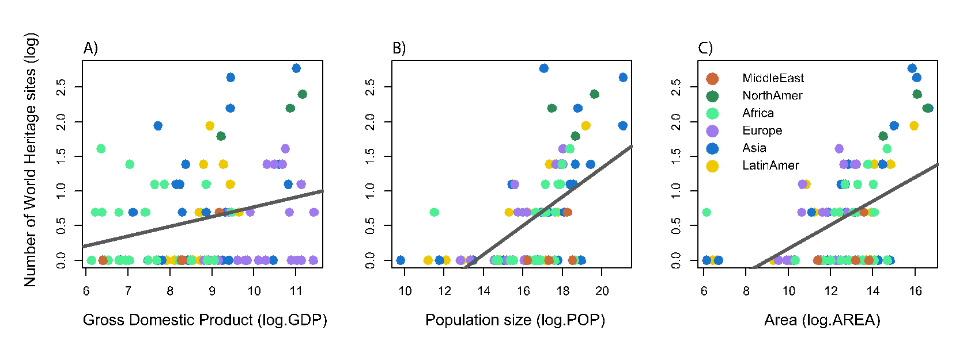
Fig. S1: The relationships between the number of WHSs and national-level predictors: A) GDP, B) human population size, and C) geographic area. The solid lines indicate significant relationships (P < 0.05), and the coloured circles represent different regions of the world.

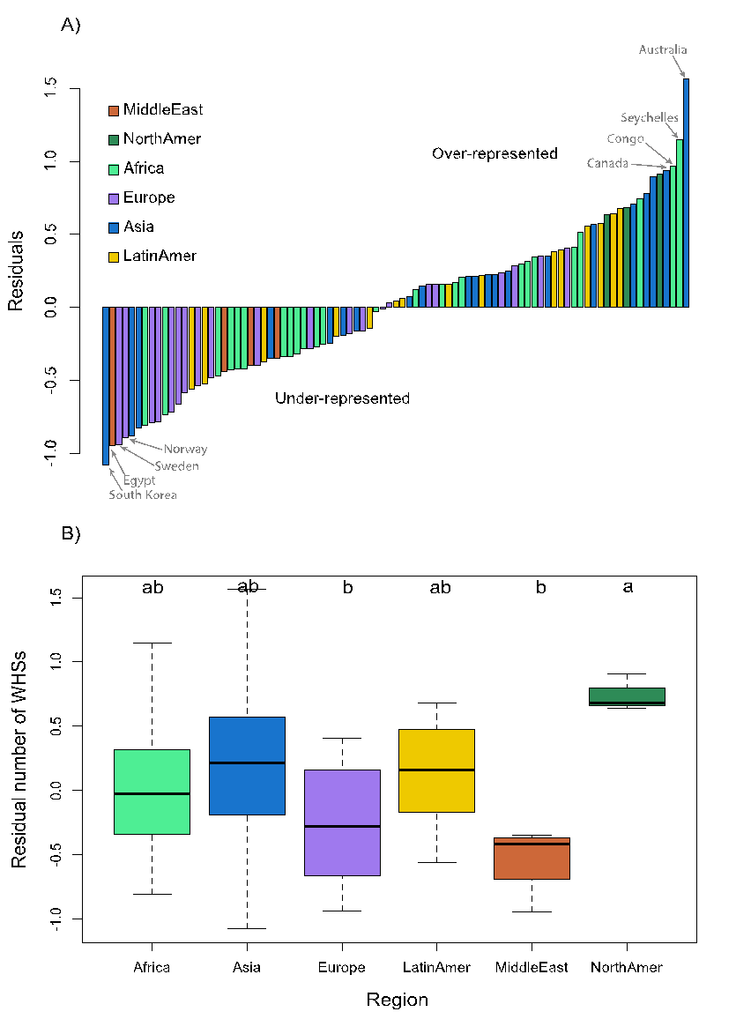
Fig. S2: Assessment of over- and under-representation of the number of WHSs in different regions globally. This assessment uses the residuals from a model predicting the number of WHSs from national GDP, population size, and area.

Fig. S3: The distribution of the number of articles for each World Heritage Site (A) and the number of WHSs scored for each threat (B).

Fig. S4: The geographical distribution of number of articles found for each world heritage site that assesses a threat.
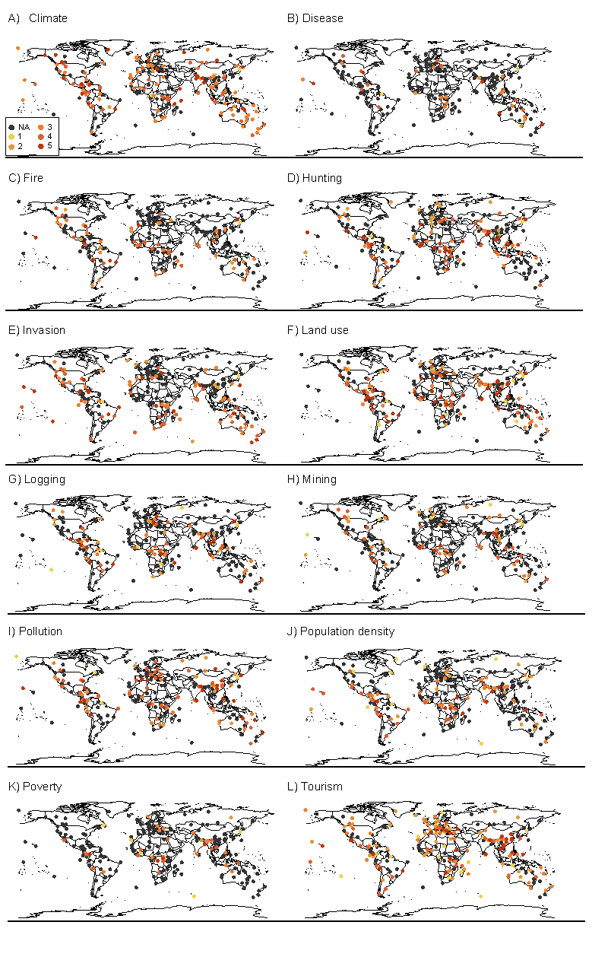
Fig. S5: Global distributions of the threat statuses for all twelve threats assessed in this analysis.

Fig. S6: Average impact scores for each impact category. A) With NAs omitted, and average based on scored records. B) NAs set to 1, assumes that only threats impacting WHSs were scored and so NAs actually reflect low impact.

