Supplementary Information

Operando Neutron Imaging-guided Gradient Design of Li-ion Solid Conductor for Extremely High Mass-loading Cathodes
Tongtai Ji¹, Yuxuan Zhang², James Torres², Jean-Christophe Bilheux², Jiwei Wang¹, Hongli Zhu^{1,} *
¹Department of Mechanical and Industrial Engineering, Northeastern University, 360 Huntington Avenue, Boston, Massachusetts 02115, United States
²Neutron Scattering Division, Oak Ridge National Laboratory, Oak Ridge, Tennessee 37831, USA.

*: Corresponding author: h.zhu@neu.edu

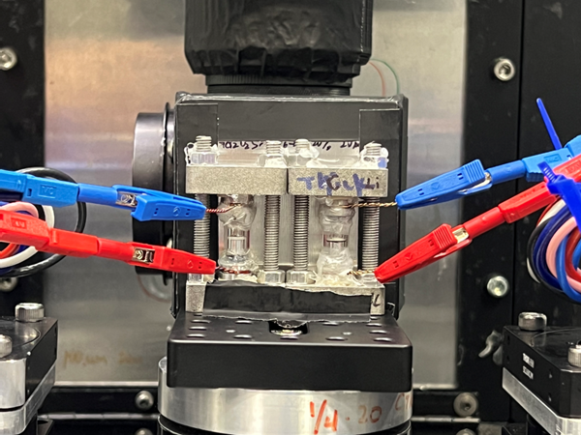
(Front view)
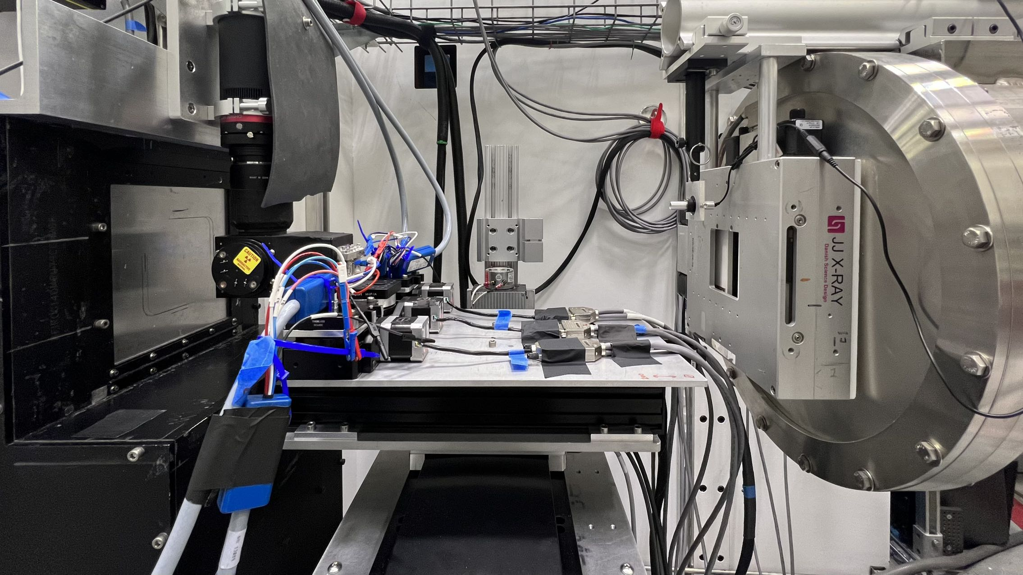
(Side view)
Supplementary Figure 1. Pictures of the setup of the Operando neutron imaging on Multimodal Advanced Radiography Station (MARS), HFIR beamline CG-1D, at Oak Ridge National Laboratory

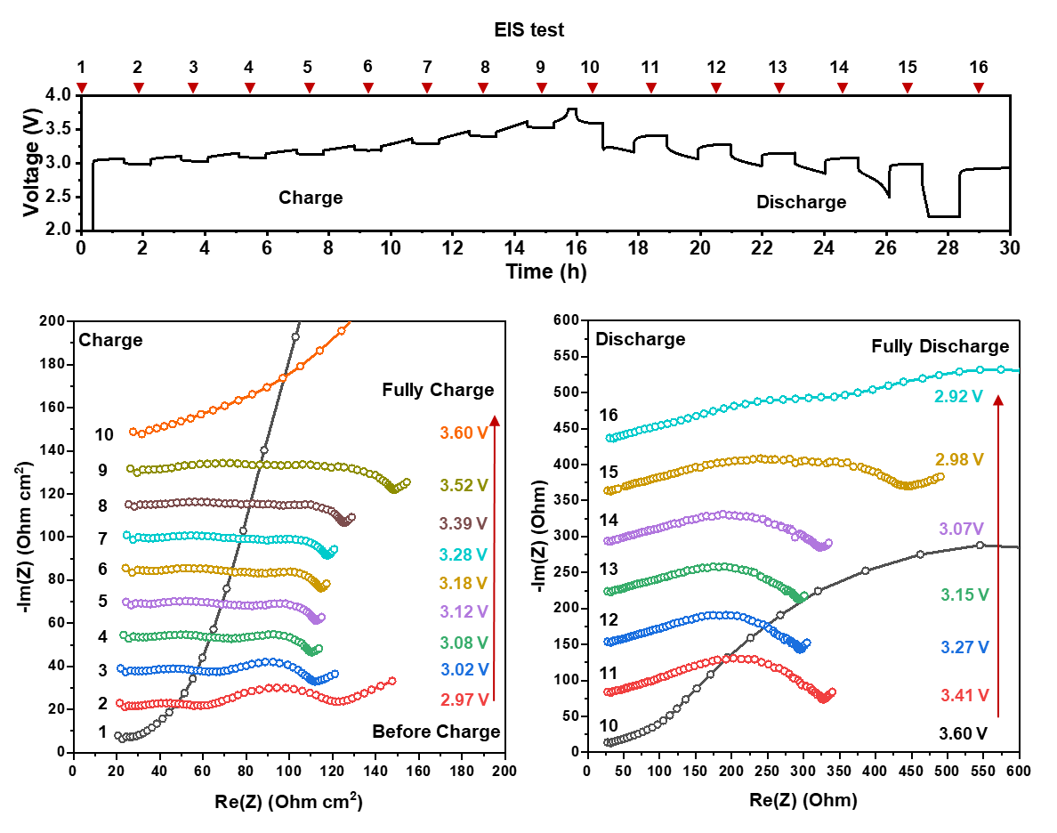
Supplementary Figure 2. Charge and discharge profile for the Operando neutron imaging cell with thick cathode (33.3mg/cm²), and the Operando electrochemical impedance spectroscopies (EISs) collected during cycling.

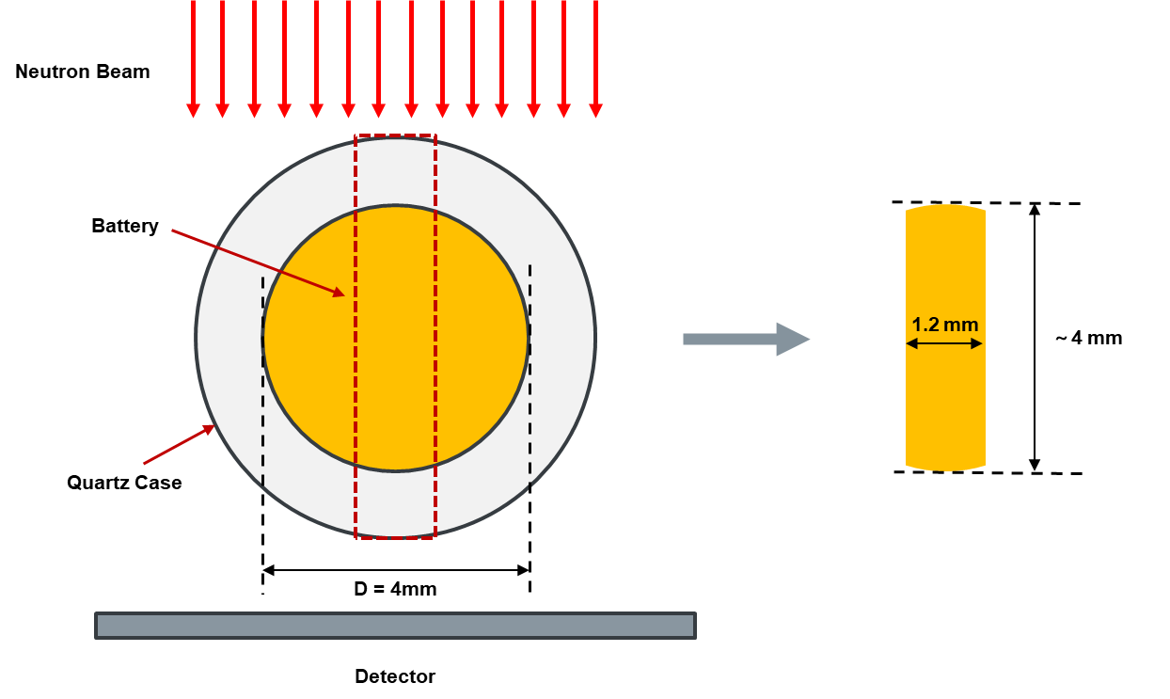
Supplementary Figure 3. Schematic of the sampling area for the neutron imaging analysis

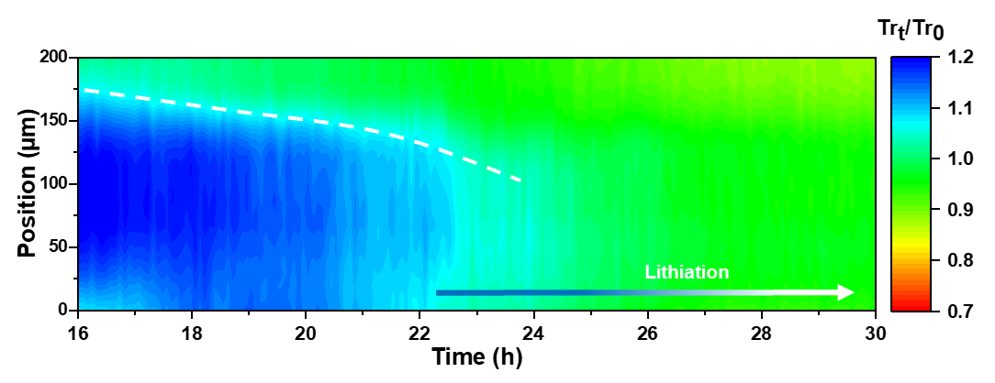

Supplementary Figure 4. Zoomed-in neutron transmission change (Tr_{t}/Tr₀) for the thick cathode layer during discharge process.

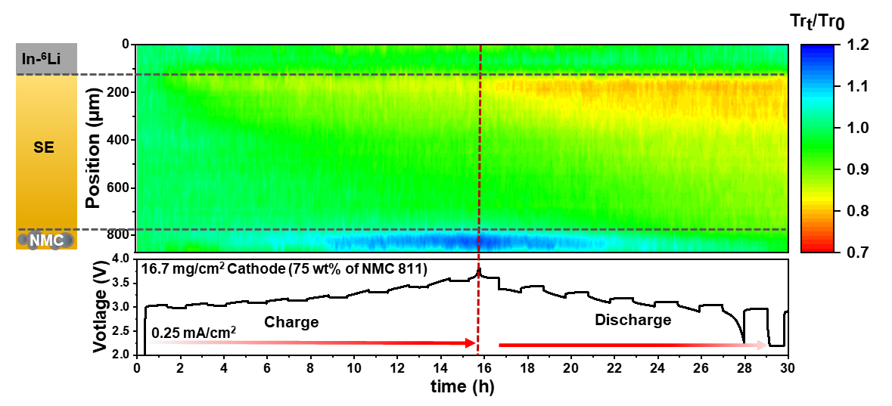
Supplementary Figure 5. The average neutron transmission change ratio (Tr_{t}/Tr₀) of the Operando neutron imaging cell with 16.7mg/cm² cathode as a function of time and the corresponding charge/discharge curve

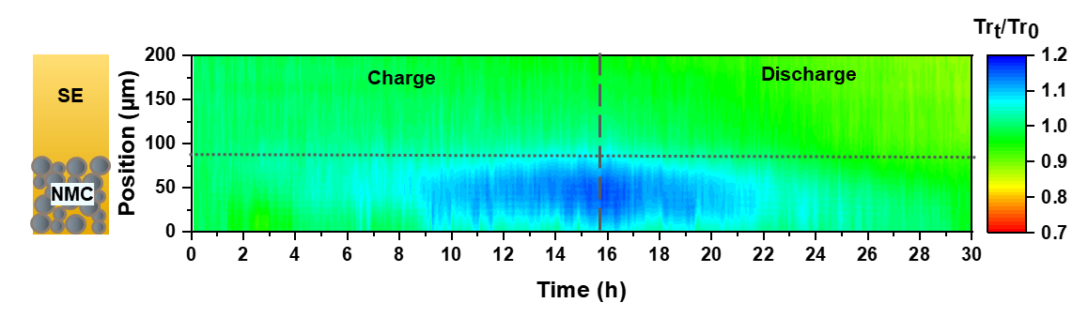
Supplementary Figure 6. Zoomed-in neutron transmission change (Tr_{t}/Tr₀) for the thin cathode layer during charge and discharge process.

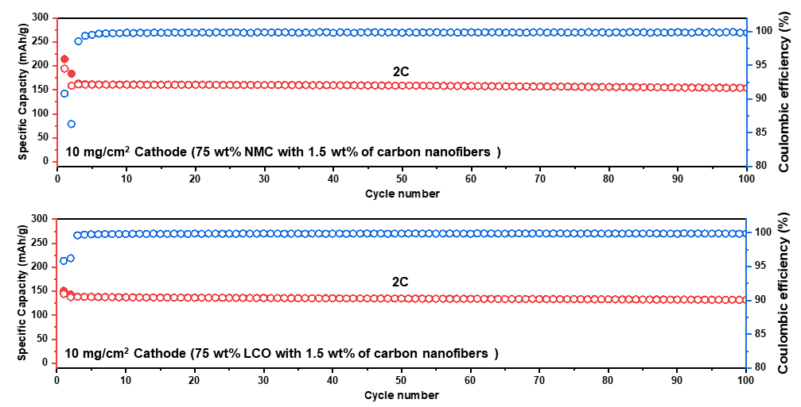
Supplementary Figure 7. Cycling stability of the composite cathode with the carbon nanofibers, the cells were initialized at C/10 for the first cycle and then cycled at 2C.

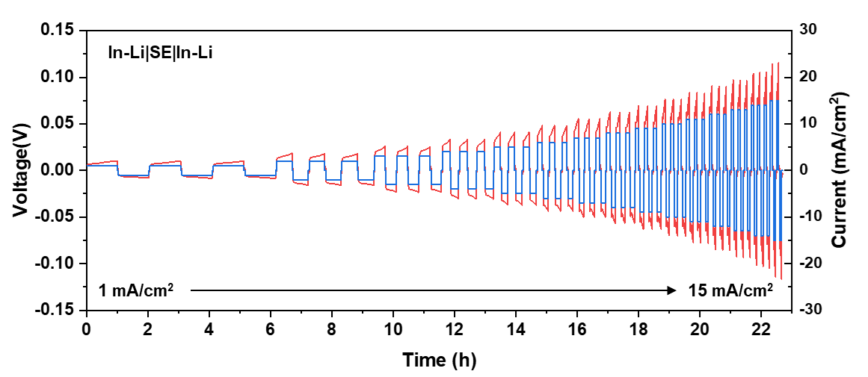
Supplementary Figure 8. Critical current density (CCD) test for the In-Li anode

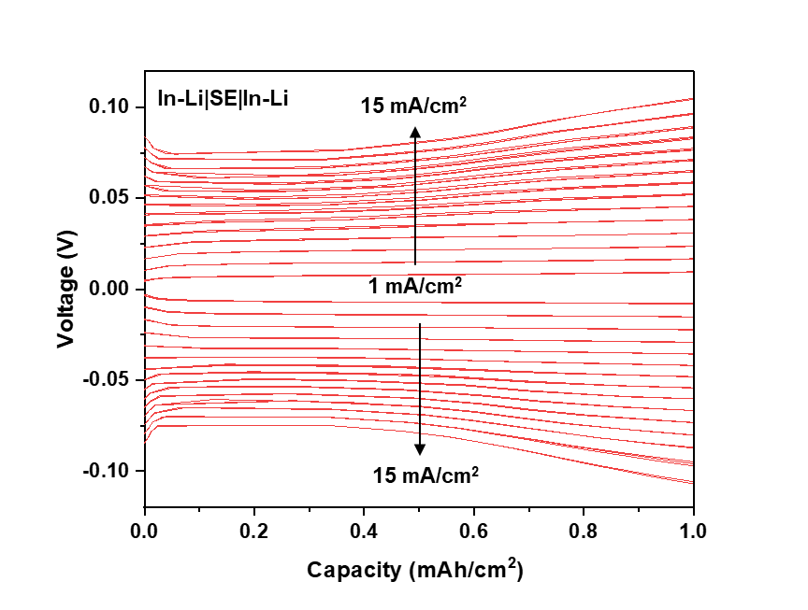
Supplementary Figure 9. Voltage profile of the CCD test for the In-Li anode

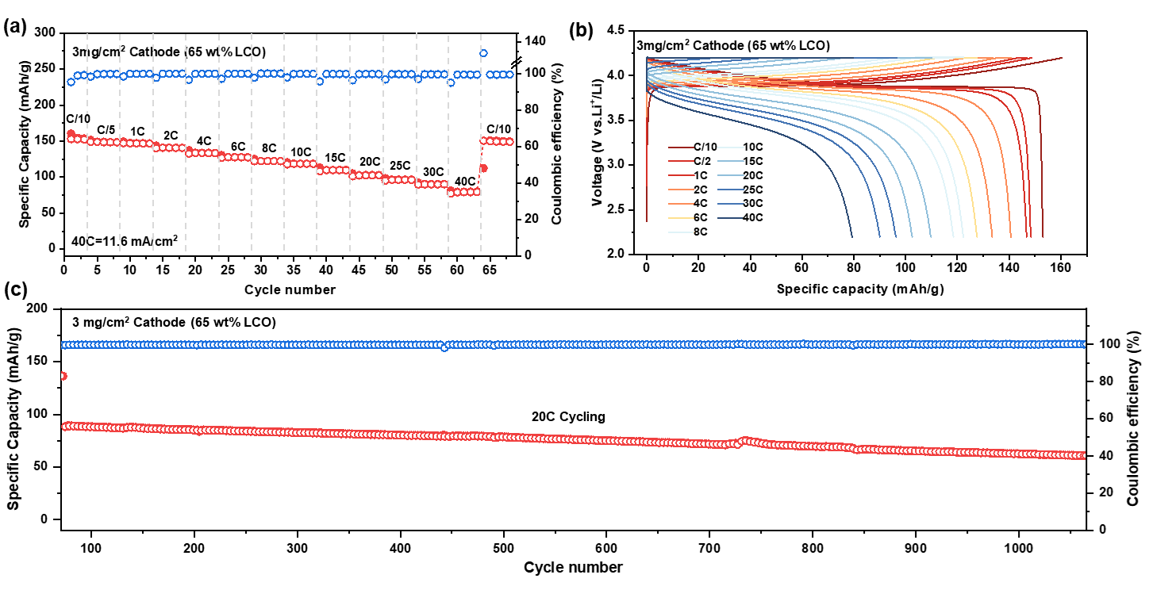
Supplementary Figure 10. Rate and cycling performance of thin LCO cathode (3 mg/cm² with 65 wt% of LCO).
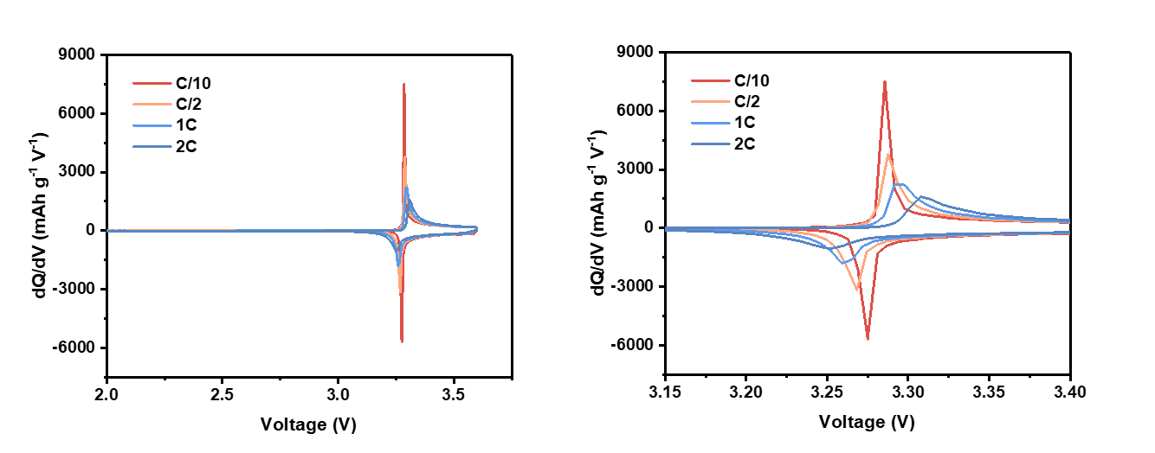
Supplementary Figure 11. (left) dQ/dV curves of the ASSBs with 3 mg/cm² LCO cathode from C/10 to 2C and (right) zoom-in dQ/dV curves.

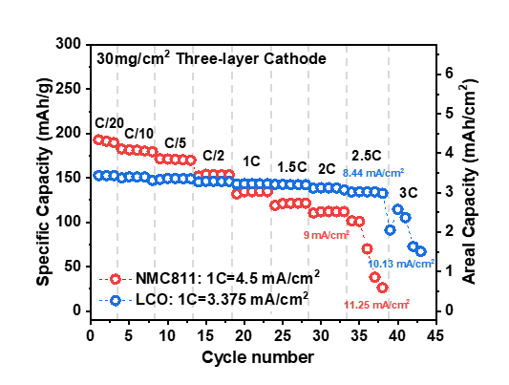
Supplementary Figure 12. The rate performance of ASSBs with the 30 mg/cm² three-layer cathode to the cell fail.
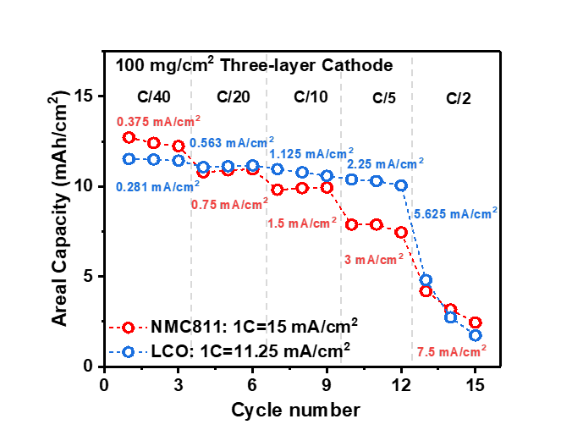
Supplementary Figure 13. The rate performance of ASSBs with the 100 mg/cm² three-layer cathode to the cell fail.

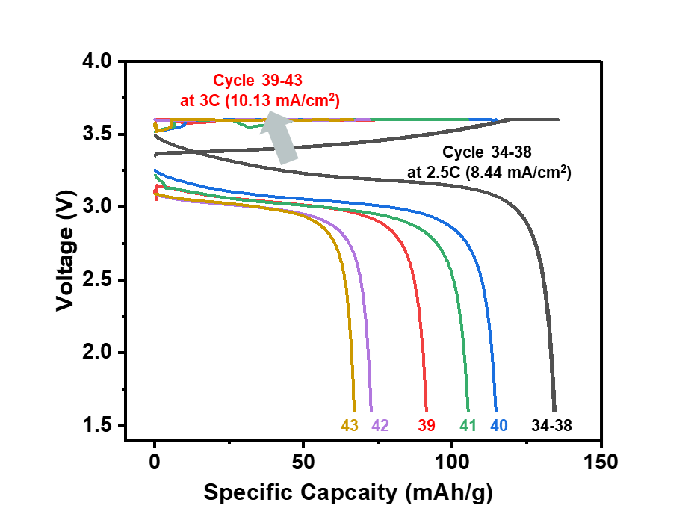
Supplementary Figure 14. Charge/discharge profiles from cycle 34 to 43 of the battery with 30 mg/cm² three-layer LCO cathode.
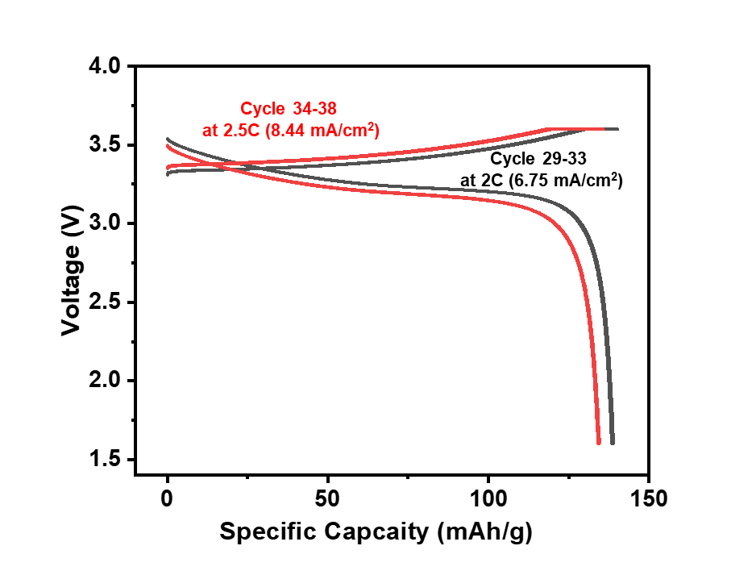
Supplementary Figure 15. Charge/discharge profiles from cycle 29 to 34 of the battery with 30 mg/cm² three-layer LCO cathode.

Supplementary Table 1. Neutron attenuation coefficients for nature Li, Li isotopes, and other materials
Material | Neutron attenuation coefficient, Σ [cm⁻¹]*
Nature Li | 4.6964
⁶Li | 33.5047
⁷Li | 0.0543
In | 10.3944
Li_{5.4}PS_{4.4}Cl_{1.6} ** | 2.4385
⁶Li_{5.4}PS_{4.4}Cl_{1.6} | 27.4019
LiNi_{0.8}Mn_{0.1}Co_{0.1}O₂** | 2.8689
Li_{0.5}Ni_{0.8}Mn_{0.1}Co_{0.1}O₂** | 1.8688
*All values are for cold neutrons at a wavelength of 2.53 Å
** Li element is nature Li

Supplementary Equation 1. Calculation of tortuosity of the composite cathode¹
$${τ_{i}}^{2}=\frac{σ_{i,eff}}{σ_{i,0}}∅_{i}$$
Where τ_{i} is the tortuosity factor, σ_{i,eff} is the effective conductivity, σ_{i,0} is the bulk conductivity, and ϕ_{i} the volume fraction.

Reference
1 Minnmann, P., Quillman, L., Burkhardt, S., Richter, F. H. & Janek, J. Editors’ choice—quantifying the impact of charge transport bottlenecks in composite cathodes of all-solid-state batteries. Journal of The Electrochemical Society 168, 040537 (2021).

