SUPPLEMENTARY MATERIALS
Antibodies measurement

Anti-SARS-CoV-2 specific IgG antibodies directed against the S1 domain of the Spike protein and against RBD of the original strain were assessed using the QuantiVac ELISA kit from Euroimmun® (Lubeck, Germany). Neutralizing antibodies against the D614 Wuhan-related [BetaCoV/France/IDF0372/2020] SARS-CoV-2 viral strain were assessed with a microneutralization test as previously described (31). The test uses clinical strains of SARS-CoV-2 (100 TCID50/well), TMPRSS2-expressing VeroE6 cells and relies on cytopathic effect (CPE) detection at 5 days post-infection. It is a VNT100 (100% of wells lysed in duplicate format). The test is automated in a NSB3 laboratory for all dilution and dispensing steps and for CPE reading. Dilutions tested were 20, 40, 80, 160, 320, 640 and 1280. The range was extended if a titer of 1280 was observed in the first instance.

Supplementary figure 1. Distribution of the anti-Spike IgG, RBD IgG, and neutralizing antibodies according to the specific populations in participants from the ANRS0001S COV-POPART cohort
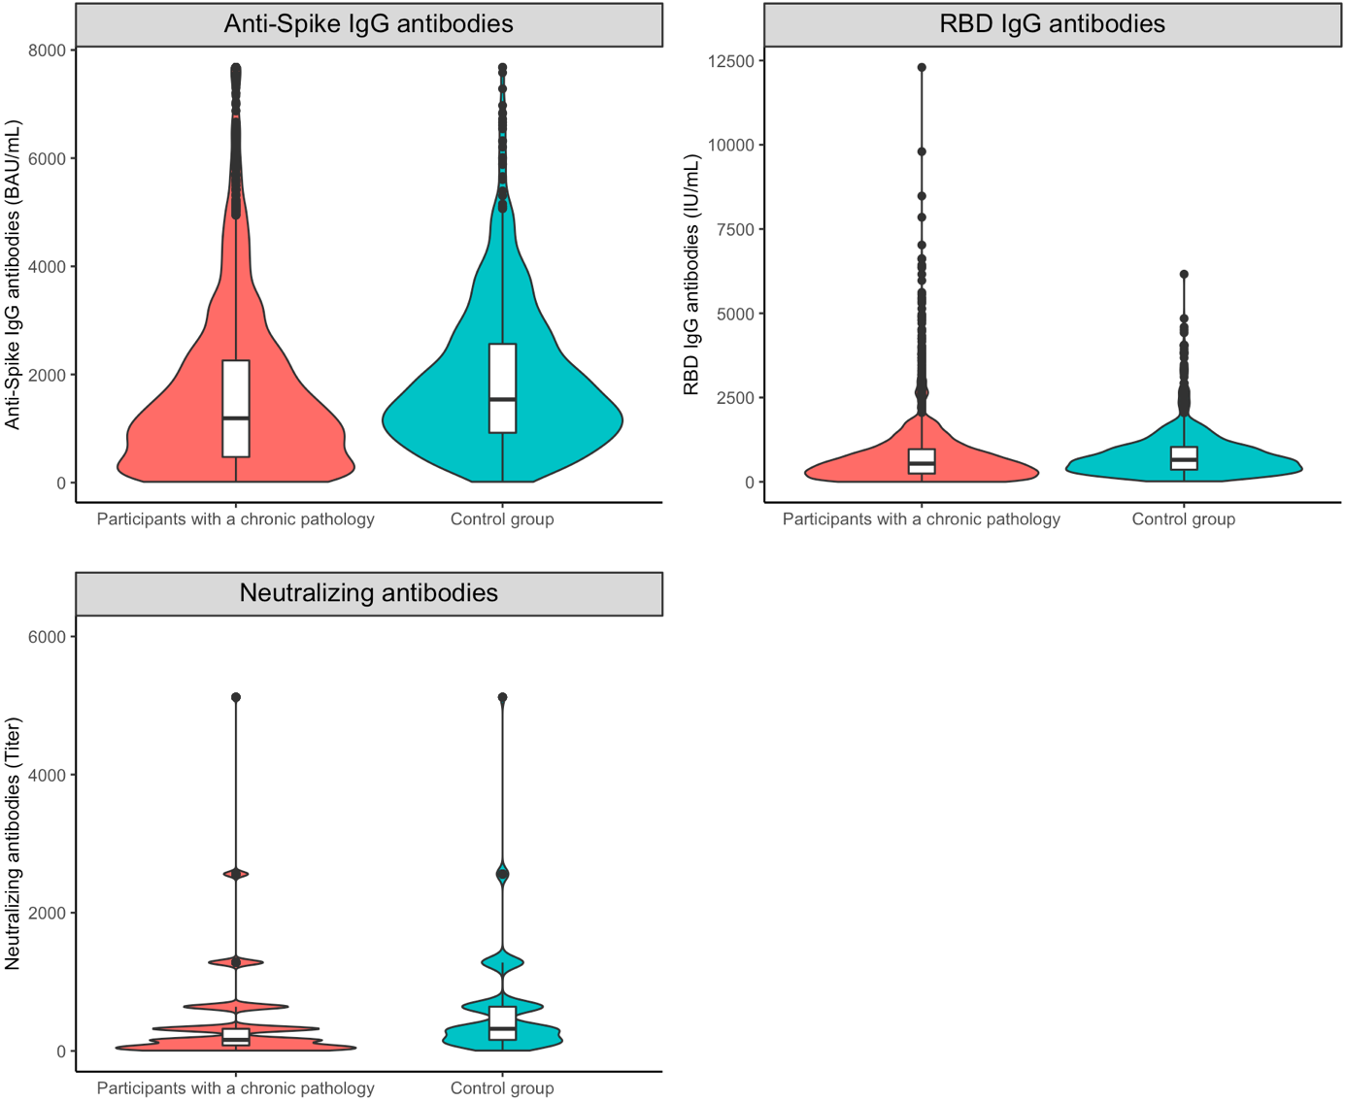
Supplementary Figure 2. Cumulative incidences of SARS-CoV-2 infection from one month after the primary vaccine course in participants of the ANRS0001S COV-POPART cohort study.
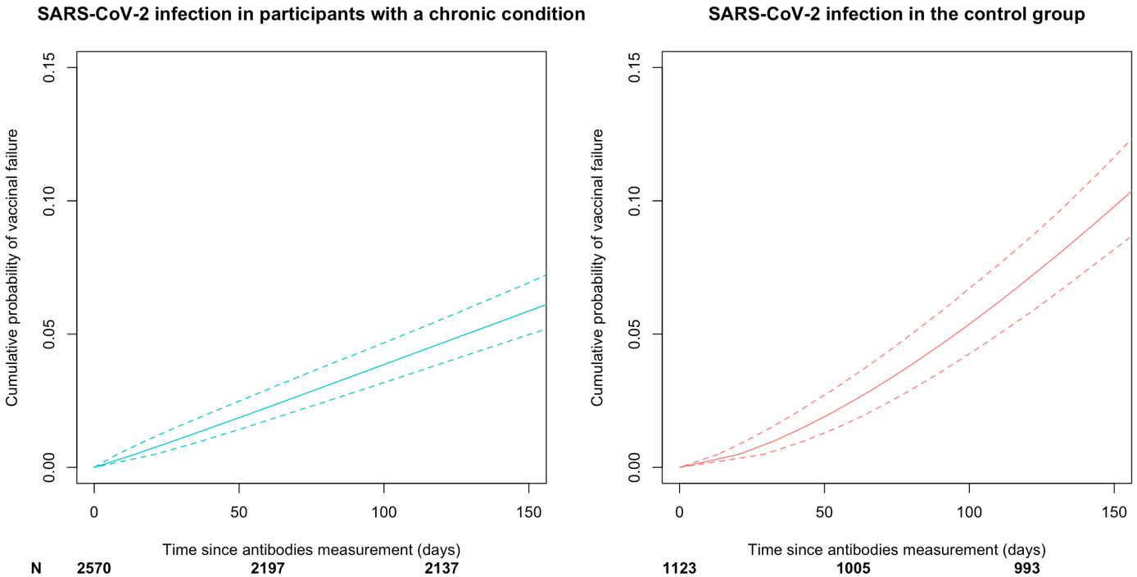
Control group: participants not from specific populations

Supplementary table 1. Description of anti-Spike IgG, anti-RBD IgG and neutralizing antibody responses at one month after the primary vaccine course anti-SARS-CoV-2 vaccine in participants of the ANRS0001S COV-POPART cohort study.
 | Specific populations |  | Control group
Antibodies | N | Frequency [CI] or  Geometric mean [CI] | N | Frequency [CI] or  Geometric mean [CI]
Anti-Spike (BAU/mL) | 2569 |  | 1123
% responders |  | 93.0 [91.9; 94.0] |  | 99.8 [99.4; 100.0]
Quantification |  | 836.8 [789.7; 886.7] |  | 1415.7 [1347.4; 1487.4]
Anti-RBD IgG (IU/mL) | 2570 |  | 1123
% responders |  | 91.7 [90.5; 92.7] |  | 99.3 [98.6; 99.7]
Quantification |  | 354.2 [330.8; 379.2] |  | 585.2 [555.8; 616.2]
Neutralisation (fold dilution) | 2565 |  | 1123
% responders |  | 89.9 [88.6 ; 91.0] |  | 99.5 [98.8 ; 99.8]
Quantification |  | 139.4 [130.9; 148.5] |  | 317.1 [297.5; 337.9]
Control group: participants not from specific populations

Supplementary table 2. Cumulative probabilities of SARS-CoV-2 infection at 5 months after the antibody measurement one month after the primary vaccine course scheme according to the populations included in the ARNS0001S COV-POPART cohort study.
Population | Number of infections | Median follow-up (in months) | Cumulative probability [95% CI]
Specific populations | 143 | 4.6 [3.4; 5.6] | 6.0 [5.0; 7.0]
Obese or diabetic | 71 | 4.6 [3.5; 5.7] | 7.4 [5.9; 9.4]
Obese non-diabetic | 56 | 5.0 [3.7; 5.9] | 7.5 [5.7; 9.6]
HIV | 32 | 4.8 [2.9; 5.2] | 4.5 [3.0 ; 6.8]
Diabetic | 25 | 4.4 [2.6; 5.3] | 6.9 [4.4; 10.9]
MS or NMOSD | 19 | 4.4 [3.7; 5.8] | 5.4 [3.1; 8.6]
CIR | 15 | 4.6 [3.9; 5.9] | 7.6 [4.1; 12.2]
Inflammatory diseases | 11 | 4.6 [2.9; 5.6] | 8.2 [4.0; 14.4]
Solid organs transplanted | 5 | 3.0 [2.8; 3.0] | 15.4 [4.5; 51.8]
AHSCT | 4 | 0.1 [0.1; 2.1] | 8.4 [0.0; 33.5]
Cancer | 5 | 3.5 [1.8; 3.9] | -
CKD | 4 | 4.8 [4.5; 4.9] | 22.3 [3.1; 100.0]
Hypogammaglobulinemia | 1 | - | 22.9 [7.0; 91.1]
Others specific population* | 46 | 4.6 [3.0; 5.5] | 6.3 [4.7; 8.5]
Control group | 114 | 4.5 [3.7; 5.1] | 10.1 [8.3; 11.9]
< 65 years | 111 | 4.5 [3.7; 5.1] | 11.8 [9.7; 13.9]
≥ 65 years | 3 | 5.4 [4.8; 5.4] | 4.8 [0.4; 44.6]
* Specific population non-obese or diabetic or HIV
HIV: Human Immunodeficiency virus, MS or NMOSD: multiple sclerosis or neuromyelitis optica spectrum disorder, AHSCT: autologous hematopoietic stem cell transplant, CKD: chronic kidney disease
Control group: participants not from specific populations
Supplementary table 3. Association between baseline factors and SARS-CoV-2 infection after the primary vaccine course in participants of the ANRS0001S COV-POPART cohort
 | Specific populations |  | Control group
 | Univariable | Multivariable | Univariable | Multivariable
Characteristics | HR [95% CI] | HR* [95% CI] | HR [95% CI] | HR* [95% CI]
Anti-Spike IgG (BAU/mL) 264 vs 15** | 0.6 [0.2; 1.1] | 0.5 [0.1; 1.0] | 0.7 [0.4; 1.0] | 0.4 [0.0; 0.8]
Age (/10 years) | 0.8 [0.7; 0.9] | 0.8 [0.7; 0.9] | 0.8 [0.7; 0.9] | 0.7 [0.6; 0.8]
Sex
Men | ref | ref | ref | ref
Women | 0.7 [0.5; 1.1] | 0.7 [0.5; 1.0] | 0.8 [0.5; 1.1] | 0.7 [0.5; 1.0]
Body mass index (/5 kg/m²) | 1.1 [0.9; 1.2] | 1.1 [1.0; 1.3] | 1.1 [0.8; 1.6] | 1.3 [0.9; 1.7]
Number of doses
2 | ref | ref | - | -
3 | 2.0 [1.0; 4.1] | 1.4 [0.7; 2.9] | - | -
* Cox proportional hazards model adjusted on the anti-Spike IgG antibody value and for all variables in the column for multivariable
** Hazard ratio for anti-Spike IgG antibody level was estimated to compare participants with a value of 264 BAU/mL versus 15 BAU/mL because natural cubic splines were used for the estimation of the effect of antibody values on the risk of SARS-CoV-2 infection
Control group: participants not from specific populations

Supplementary table 4. Association between baseline factors and SARS-CoV-2 infection defined by antigenic test and RT-PCR after the primo-vaccination in participants of the ANRS0001S COV-POPART cohort
 | Specific populations |  | Control group
 | Univariable | Multivariable | Univariable | Multivariable
Characteristics | HR [95% CI] | HR* [95% CI] | HR [95% CI] | HR* [95% CI]
Anti-Spike IgG (BAU/mL) 264 vs 15** | 0.4 [0.0; 1.5] | 0.8 [0.2; 1.3] | 1.3 [0.9; 1.6] | 0.5 [0.1; 0.9]
Age (/10 years) | 1.1 [0.9; 1.8] | 0.7 [0.6; 0.8] | 0.7 [0.6; 0.8] | 0.6 [0.6; 0.8]
Sex
Men | ref | ref | ref | ref
Women | 0.5 [0.4; 0.8] | 0.6 [0.4; 0.9] | 0.7 [0.5; 1.0] | 0.6 [0.4; 1.0]
BMI (/5 kg/m²) | 1.2 [1.0; 1.3] | 1.2 [1.0; 1.3] | 1.0 [0.7; 1.3] | 1.2 [0.8; 1.6]
Number of doses
2 | ref | ref | - | -
3 | 2.3 [1.3; 4.2] | 2.8 [1.4; 5.6] | - | -
* Adjusted on the anti-Spike IgG antibody value and for all variables in the column for multivariable
** Hazard ratio for anti-Spike IgG antibody was estimated to compare participants with a value of 264 BAU/mL versus 15 BAU/mL because natural cubic splines were used for the estimation of the effect of antibody values on the risk of SARS-CoV-2 infection
BMI: Body mass index
Control group: participants not from specific population

Supplementary table 5. Area under receiving operating characteristic (AUROC) of the antibody value for the prediction of SARS-CoV-2 infection defined by antigenic test and RT-PCR at five months after baseline in participants from the ANRS0001S COV-POPART cohort
 | Specific populations |  | Control group
Antibodies | Univariable | Multivariable* | Univariable | Multivariable**
Anti-Spike IgG (BAU/mL) | 38.9 | 71.0 | 40.8 | 71.1
Anti-RBD IgG (IU/mL) | 40.2 | 70.1 | 47.5 | 67.8
Neutralizing antibodies (fold dilution) | 41.1 | 66.7 | 45.6 | 68.8
Model without antibody | - | 68.3 | - | 69.9
AUROC are corrected for optimism using 1000 bootstrap samples
* Adjusted on age, sex, BMI, number of doses and number of comorbidities
** Adjusted on age, sex and BMI
Control group: participants not from specific population

Supplementary table 6. AUROCs of the antibody value for the prediction of SARS-CoV-2 infection at five months after baseline according to the specific populations in participants from the ANRS0001S COV-POPART cohort
 | Specific populations receiving 2 doses during the primary vaccine course |  | Diabetic or obese |  | HIV |  | Participants from other specific populations
Antibodies | Uni | Multi | Uni | Multi | Uni | Multi | Uni | Multi
Anti-Spike IgG (BAU/mL) | 71.1 | 74.7 | 81.5 | 78.0 | 63.4 | 62.6 | 72.9 | 75.7
Anti-RBD IgG (IU/mL) | 72.1 | 75.6 | 78.7 | 77.5 | 60.4 | 62.0 | 74.6 | 78.3
Neutralizing (fold dilution) | 69.2 | 72.8 | 75.9 | 76.0 | 60.6 | 59.0 | 68.2 | 71.9
Model without antibody | - | 71.5 | - | 77.1 | - | 59.5 | - | 74.3
HIV: human immunodeficiency virus

