SUPPLEMENTARY INFORMATION
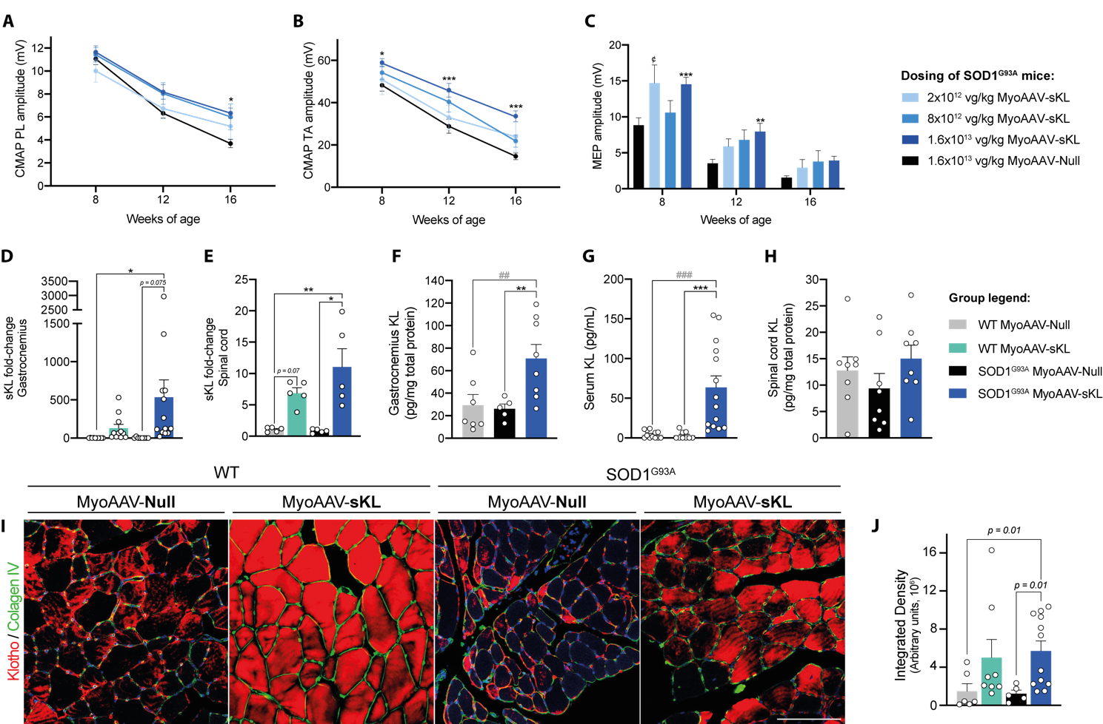
Figure S1. Secreted Klotho is overexpressed in skeletal muscles and preserves neuromuscular function in a dose-dependent manner. (A, B) CMAP amplitude of the PL (A) and TA (B) muscles in three treated groups with escalated doses of MyoAAV-Des-sKL: 2x10¹², 8x10¹², or 1.6x10¹³ vg/kg. Two-way ANOVA with Tukey comparisons (n = 5, 9 and 16 SOD1 sKL, respectively, and 24 SOD1 Null). (C) MEP amplitude of the TA muscle comparing the administered doses. MyoAAV vectors efficiently transduced and increased Klotho mRNA (D) and protein (F) levels in gastrocnemius and in TA muscles as evidenced by immunohistochemistry (I, J). A slight increase in mRNA expression was detected in the spinal cord (E), but translated to no significant differences in protein levels (H). (G) Muscle overexpression and secretion of sKL increased serum concentration in SOD1^{G93A} sKL-treated mice. One or two-way ANOVA followed by Tukey’s post hoc test, *p£ 0.05, **p£ 0.01, ***p£ 0.001 (n = 5-14, specified in each graph). Comparisons are SOD1 sKL vs. SOD1 Null (*) or vs. WT Null (#), WT vs. SOD1 Null ($), and SOD1 sKL 2x10¹² vg/kg vs. SOD1 Null (¢). Data plotted as mean ± SEM.
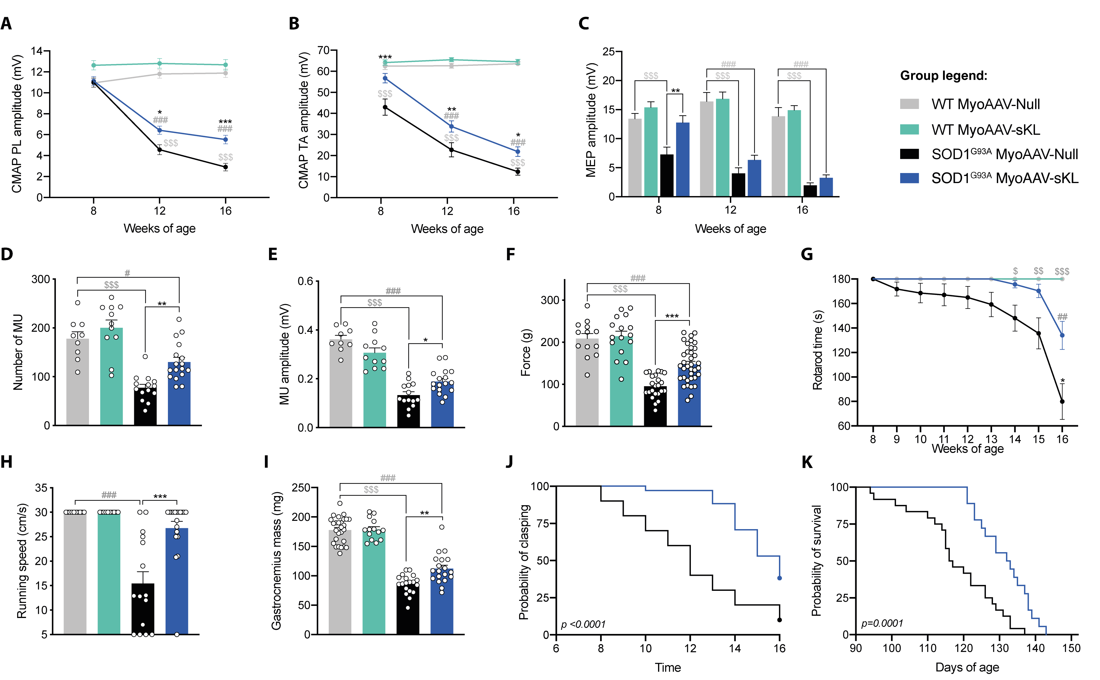
Figure S2. MyoAAV-mediated muscle overexpression of sKL preserves neuromuscular function in SOD1^{G93A} male mice. (A, B) CMAP amplitude of the PL (A) and TA muscles (B) in male SOD1^{G93A} mice treated with MyoAAV vectors at the dose of 1.6x10¹³ vg/kg compared to null-treated mice and WT mice. (C) Average maximum MEP amplitudes recorded in the TA muscle (n = 17 WT Null, 22 WT sKL, 17 SOD1 Null, 27 SOD1 sKL). Electrophysiological MUNE (D) and SMUA (E) for the TA muscle (n = 9 WT Null, 11 WT sKL, 14 SOD1 Null, 17 SOD1 sKL). Grip strength (F), rotarod performance (G), and treadmill running speed (H) were improved in sKL-treated SOD1^{G93A} male mice (n = 13-19 WT Null, 15-22 WT sKL, 15-27 SOD1 Null and 19-39 SOD1 sKL). (I) The gastrocnemius weight was preserved at 16 weeks of age. Two-way ANOVA followed by Tukey’s post hoc analysis for all comparisons: *p£ 0.05, **p£ 0.01, ***p£ 0.001; SOD1 sKL vs. SOD1 Null (*) or vs. WT Null (#), WT vs. SOD1 Null ($), and SOD1 sKL 2x10¹² vg/kg vs. SOD1 Null (¢). Data plotted as mean ± SEM. (J) Overexpression of sKL delayed the appearance of the clasping response (n = 20 SOD1 Null, 35 SOD1 sKL) and significantly prolonged survival curves (K) in SOD1^{G93A} males (n = 24 SOD1 Null, 18 SOD1 sKL). Log-rank (Mantel-Cox) test was conducted for comparisons.

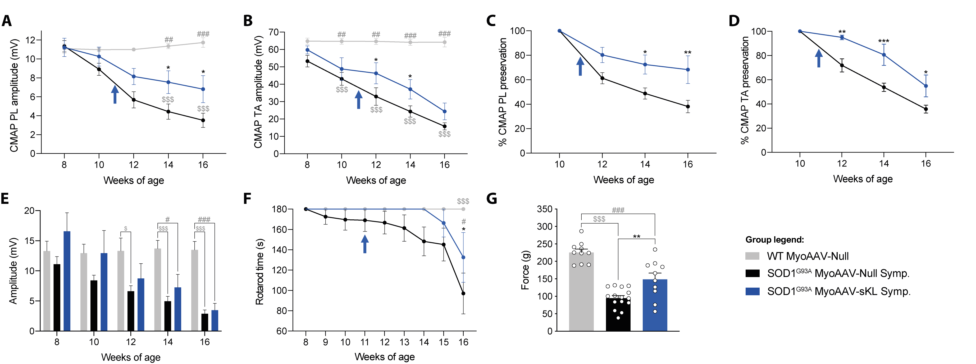
Figure S3. MyoAAV-Des-sKL administered at the symptomatic stage decelerates the progression of motor and neuromuscular deficits in male SOD1^{G93A} mice. (A, B) CMAP amplitude of PL (A) and TA muscles (B). (C, D) CMAP expressed as the percentage relative to values recorded the week preceding the treatment. (E) MEP amplitude of the TA muscle. Arrows indicate the time point of vectors administration. (F) Treated-SOD1^{G93A} male mice showed enhanced motor performance in the rotarod test. Two-way ANOVA followed by Tukey’s test (n = 7 WT Null, 11 SOD1 Null, 9 SOD1 sKL). (G) Preservation in the grip strength was observed for sKL-treated SOD1^{G93A} male mice at 16 weeks of age. Two-way ANOVA followed by Tukey’s multiple comparisons: *p£ 0.05, **p£ 0.01, ***p£ 0.001, SOD1 sKL vs. SOD1 Null (*) or vs. WT Null (#), and WT Null vs. SOD1 Null ($). Data represented as mean ± SEM.

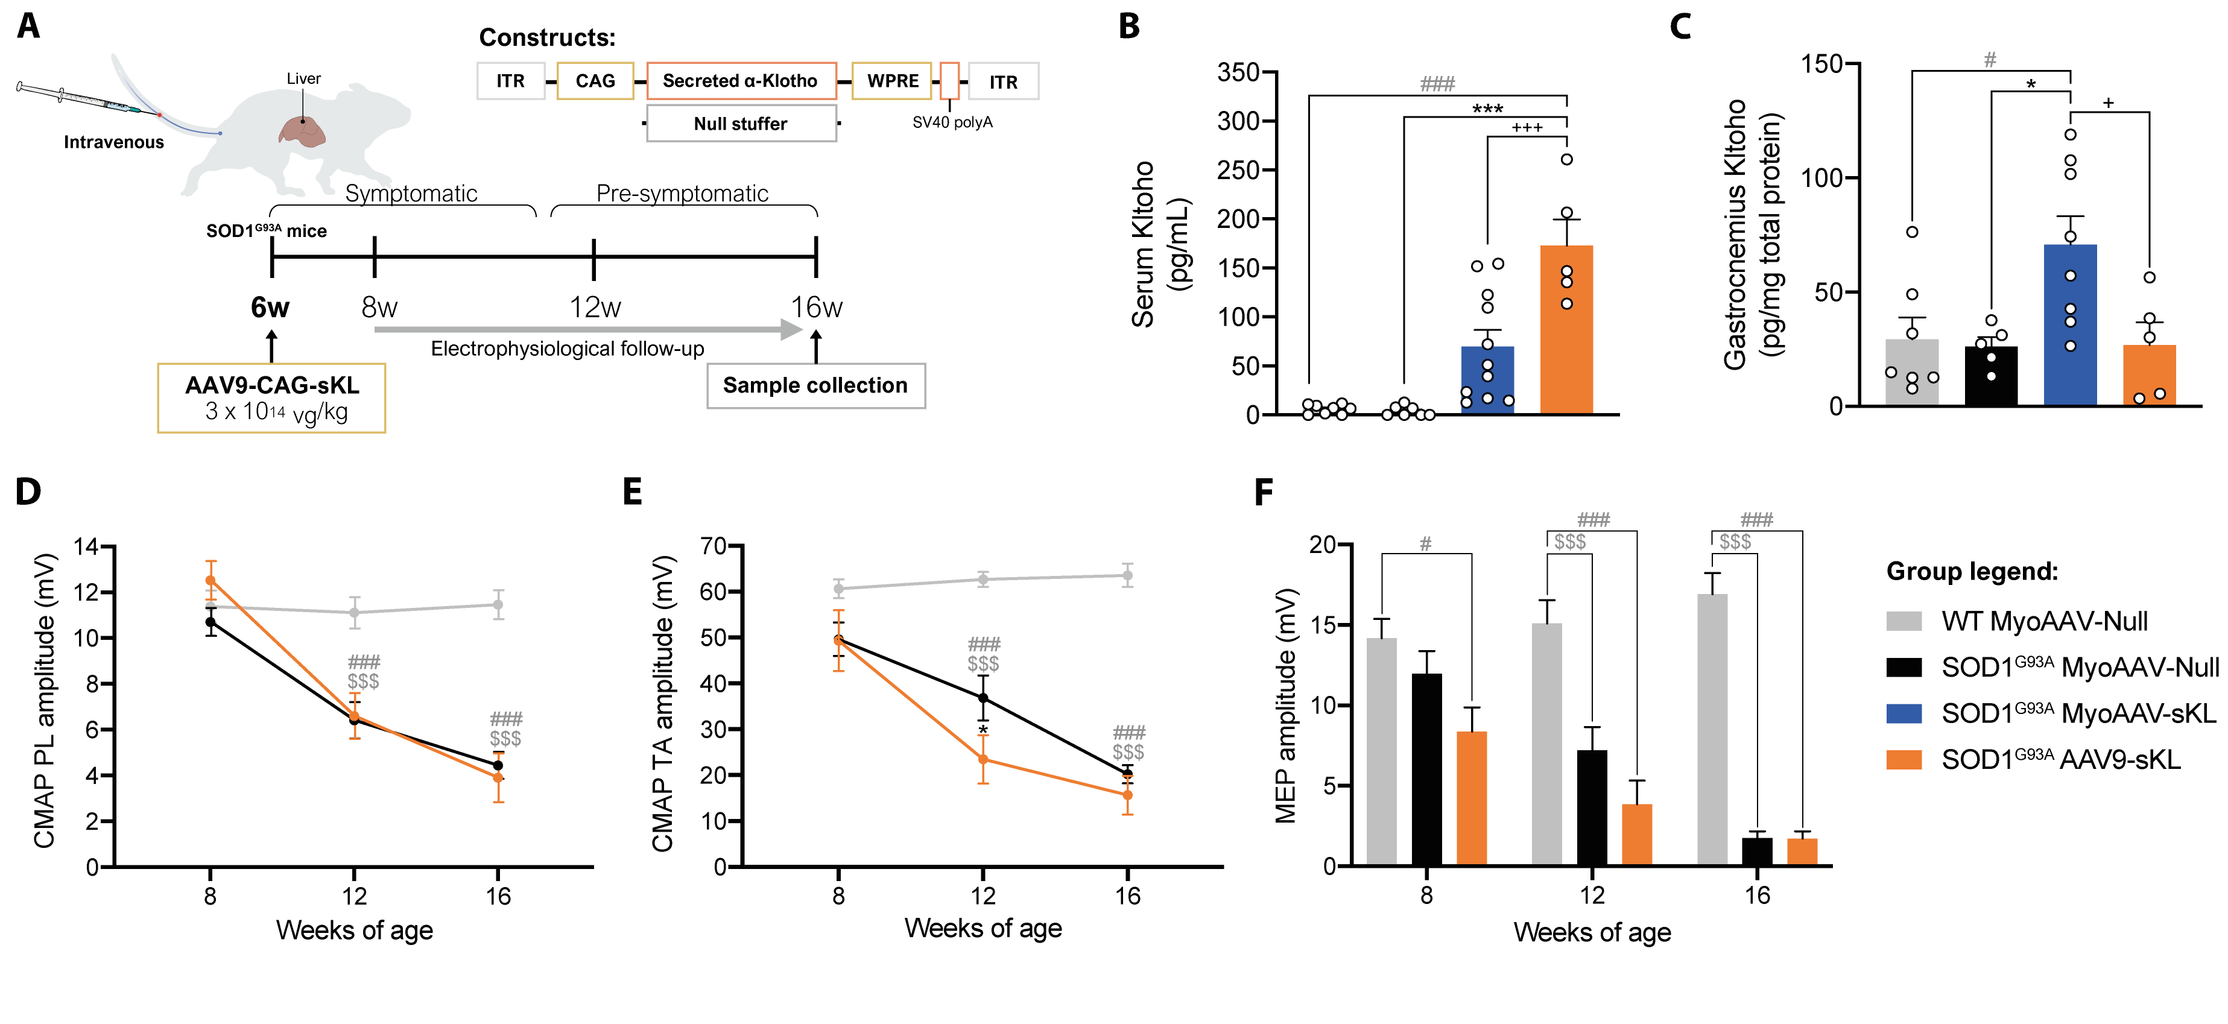Figure S4. High circulating sKL levels do not preserve neuromuscular function in SOD1^{G93A} female mice. (A) Proof-of-concept study for inducing high liver overexpression and blood levels of sKL. (B) Serum and (C) gastrocnemius muscle sKL concentration in MyoAAV- and AAV9-treated animals (n = 7-8 WT Null, 12 SOD1 Null, 8-11 SOD1 MyoAAV-sKL, 5 SOD1 AAV9-sKL). CMAP amplitude of PL (D) and TA muscles (E), and (F) MEP amplitudes of the TA muscle in AAV9-CAG-sKL-injected SOD1^{G93A} mice and controls. Two-way ANOVA with Tukey’s post-hoc test, *p£ 0.05, **p£ 0.01, ***p£ 0.001. Comparisons are SOD1 sKL vs. SOD1 Null (*) or vs. WT Null (#), WT Null vs. SOD1 Null ($) and SOD1 AAV9-sKL vs. SOD1 MyoAAV-sKL (+), n = 9 WT Null, 12 SOD1 Null, and 6 SOD1 AAV9-sKL. Data is shown as mean ± SEM.

Table S1. Number of differentially expressed genes in the gastrocnemius muscle of sKL- and Null-treated WT and SOD1^{G93A} mice for the different contrasts. (p_{adj} < 0.1; |Shrunken FC| > 2).
Contrast | Downregulated DEG | Upregulated DEG
SOD1 sKL_SOD1 Null | 82 | 37
SOD1 Null_WT Null | 272 | 449
SOD1 sKL_WT sKL | 31 | 157
WT sKL_WT Null | 20 | 24
Inter (4 groups) | 17 | 23

Table S2. Number of neutral proteins and proteins significantly over- or underabundant in the gastrocnemius muscle of sKL- and Null-treated WT and SOD1^{G93A} mice in each contrast. (p_{adj} < 0.05; neutral = -1.5 < FC < 1.5, up = FC > 1.5, down = FC < 1.5).
Contrast | Down | Neutral | Up
SOD1 sKL_SOD1 Null | 73 | 3084 | 107
SOD1 Null_WT Null | 157 | 2726 | 360
SOD1 Null_WT sKL | 175 | 2680 | 389
SOD1 sKL_WT Null | 0 | 3078 | 9
SOD1 sKL_WT sKL | 1 | 3064 | 11
WT sKL_WT Null | 0 | 2947 | 0

