Figure S1. The landscape of CRMs and genes on the chromosomes, in sliding windows of ${10}^{6}$ bp with a step size of ${10}^{5}$ bp along the chromosomes and in TADs and non-TADs in the mouse genome. A. Heatmap of correlations among genome sizes, numbers of CRMs and genes on chromosomes, and total lengths of CRMs and genes on chromosomes. B. Manhattan plot of the normalized lengths of CRMs in sliding windows along the chromosomes. C. Manhattan plot of the normalized numbers of CRMs in sliding windows along the chromosomes. D. Manhattan plot of the normalized lengths of genes in sliding windows along the chromosomes. E. Manhattan plot of the normalized numbers of genes in sliding windows along the chromosomes. F. Percentages of the genome length, and numbers of CRMs and genes, covered by TADs. G. Correlation between the numbers of CRMs and the numbers of genes within TADs. H. Correlation between the numbers of CRMs and the numbers of genes within non-TAD regions.

Figure S2. Lengths and Numbers of CRMs and genes in sliding windows of ${10}^{7}$ bp with a step size of ${10}^{6}$ bp along the chromosomes of the human genome. A. Manhattan plot of the normalized lengths of CRMs in sliding windows along the chromosomes. B. Manhattan plot of the normalized numbers of CRMs in sliding windows along the chromosomes. C. Manhattan plot of the normalized lengths of genes in sliding windows along the chromosomes. D. Manhattan plot of the normalized numbers of genes in sliding window along the chromosomes.

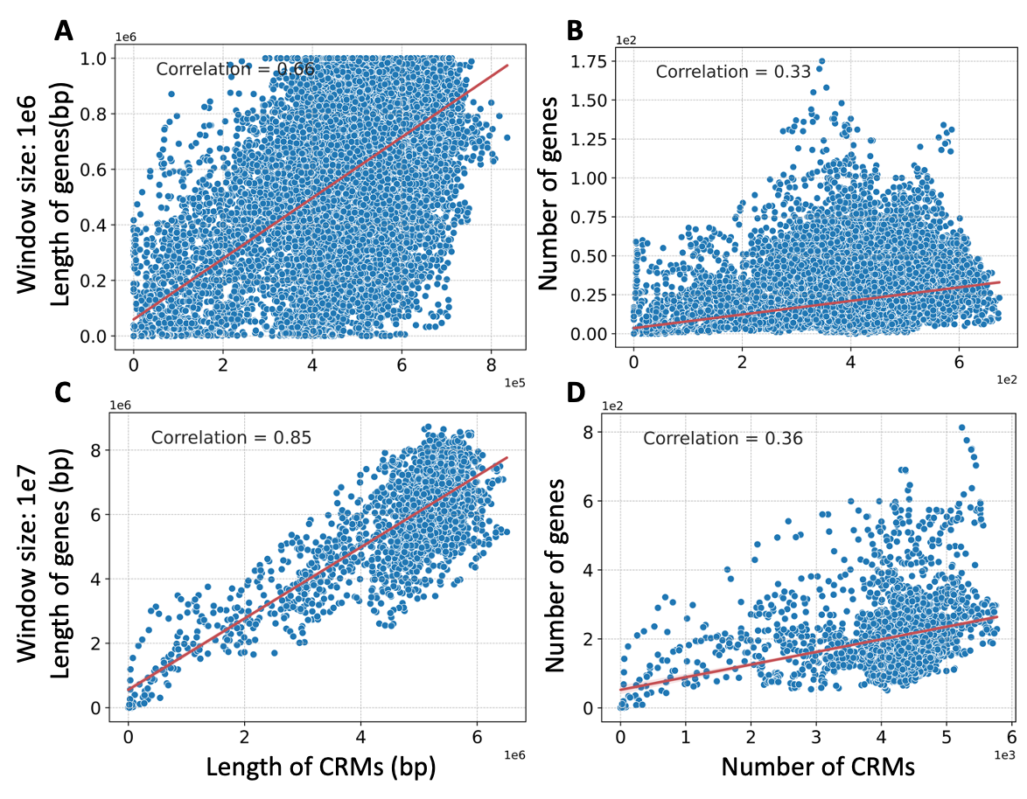

Figure S3. Relationships between the lengths or numbers of CRMs and those of genes in sliding windows in the human genome. A. Relationship between the lengths of CRMs and those of genes in sliding windows of ${10}^{6}$ bp. B. Relationship between the numbers of CRMs and those of genes in sliding windows of ${10}^{6}$ bp. C. Relationship between the lengths of CRMs and those of genes in sliding windows of ${10}^{7}$ bp. D. Relationship between the numbers of CRMs and those of genes in sliding windows of ${10}^{7}$ bp.

Figure S4. Lengths and Numbers of CRMs and genes in sliding windows of ${10}^{7}$ bp with a step size of ${10}^{6}$ bp along the chromosomes of the mouse genome. A. Manhattan plot of the normalized lengths of CRMs in sliding windows along the chromosomes. B. Manhattan plot of the normalized numbers of CRMs in sliding windows along the chromosomes. C. Manhattan plot of the normalized lengths of genes in sliding windows along the chromosomes. D. Manhattan plot of the normalized numbers of genes in sliding window along the chromosomes.

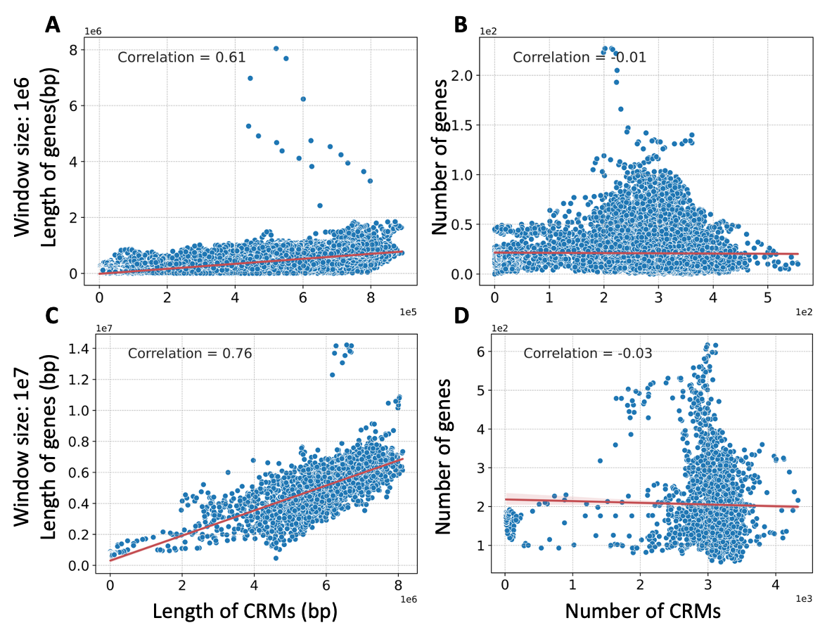
Figure S5. Relationships between the lengths or numbers of CRMs and those of genes in sliding windows in the mouse genome. A. Relationship between the lengths of CRMs and those of genes in sliding windows of ${10}^{6}$ bp. B. Relationship between the numbers of CRMs and those of genes in sliding windows of ${10}^{6}$ bp. C. Relationship between the lengths of CRMs and those of genes in sliding windows of ${10}^{7}$ bp. D. Relationship between the numbers of CRMs and those of genes in sliding windows of ${10}^{7}$ bp.

Figure S6. Classification of FANTOM promoters and enhancers, VISTA enhancers and our CRMs based on whether or not they overlap TSSs in the mouse genome. A. Comparison of percentages of the CPC and CPL categories in FANTOM promoters and enhancers, VISTA enhancers and our CRMs. B. Boxplots of the lengths of the CPC and CPL categories in FANTOM promoters and enhancers, VISTA enhancers and our CRMs. C. CRM (chr10:105839767-105844033) is classified as the CPC category, containing a FANTOM CPC promoter (a core promoter of gene Ccdc59: chr10: 105841454-105841512) and a FANTOM CPC promoters (a core promoter of gene Ccdc59: chr10: 105841323-105841372) plus other regulatory elements. D. CRM (chr8:123477104-123479225) is classified as the CPC category, containing a FANTOM CPL promoters (a proximal promoter of gene Afg3l1: chr8:123477849-123477856), two FANTOM CPC promoters (core promoters of gene Afg3l1: chr8:123477859-123477904, chr8:123477934-123477945), and a downstream promoter element of gene Afg3l1: chr8:123478144-123478181 and a FANTOM CPL enhancer (chr8:123478955-123479296) plus other regulatory elements. E. CRM (chrX:73473538-73482090) located upstream of gene Bgn is classified as the CPL category, containing two FANTOM CPL enhancers (chrX:73476667-73476958 and chrX:73480499-73480597) plus other regulatory elements. F. CRM (chr1:133185552-133186431) located upstream of gene Plekha6 is classified as the CPL category, overlapping a VISTA CPL enhancer (chr1:133185980-133189493).
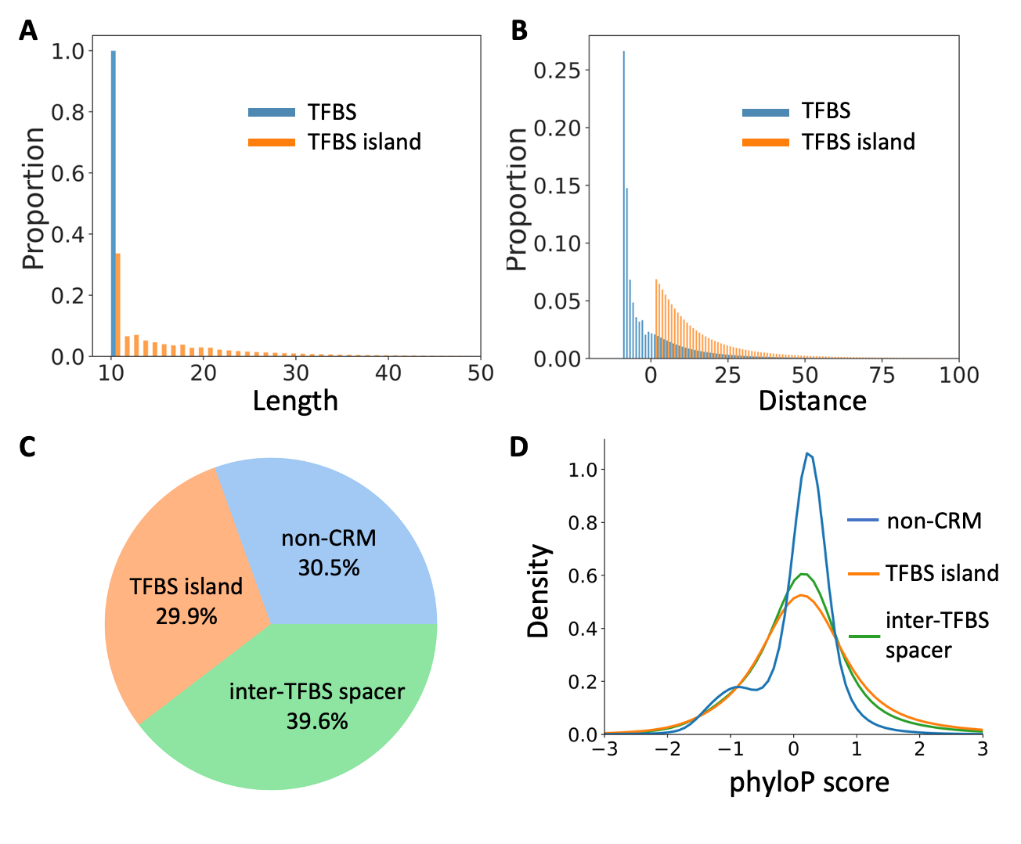
Figure S7. Properties of putative TFBSs and inter-TFBS islands in the predicted CRMs in the mouse genome. A. Distribution of the lengths of putative TFBSs and TFBS islands in the predicted CRMs (only the length region from 10 to 50 bp is shown). B. Distribution of the distance between adjacent of putative TFBSs and TFBS islands in the predicted CRMs (only the distance region from -20 to 100 bp is shown). D. Coverage of putative TFBS islands, inter-TFBS spacers and non-CRMs in the genomic regions from which we were able to predict CRMs and constituent TFBSs. E. Distribution of phyloP scores of TFBS islands, inter-TFBS spacers in the predicted CRMs in comparison with that of the non-CRMCs (only the score region from -3 to 3 is shown).

Figure S8. Boxplots of LINSIGHT scores of non-CRMs, TFBS islands and inter-TFBS spacers in the human genome.

