Supplementary Material

Supplementary Figure
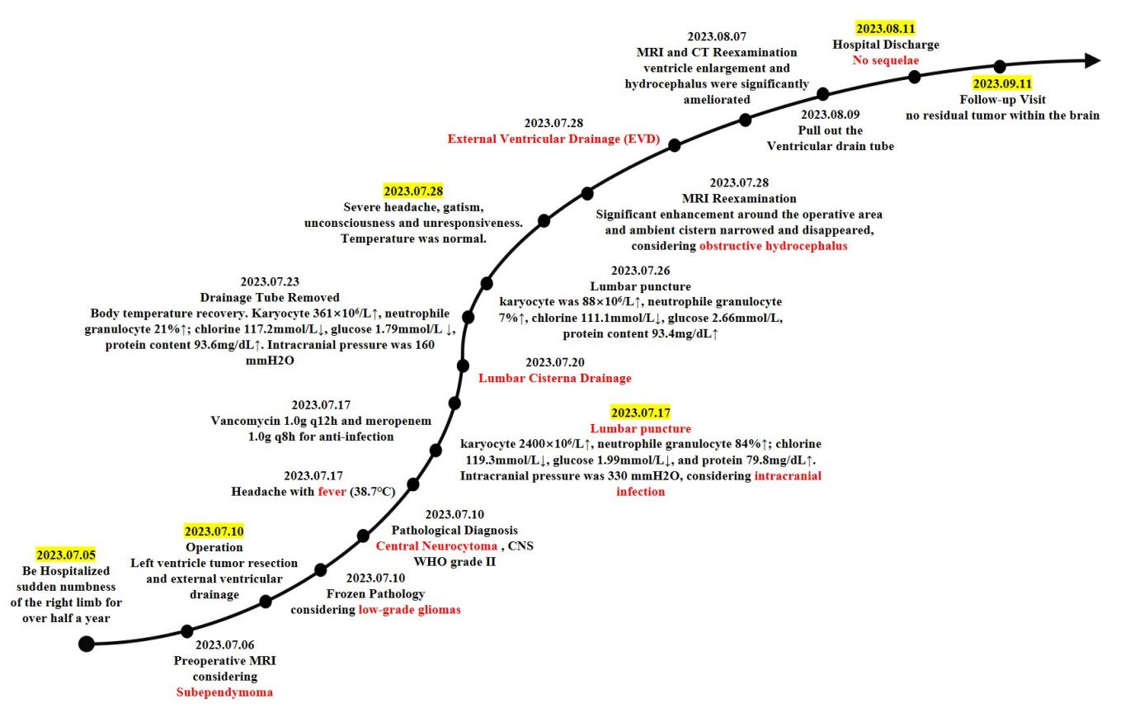
Supplementary Figure 1. Changes in the patient's treatment and condition during hospitalization

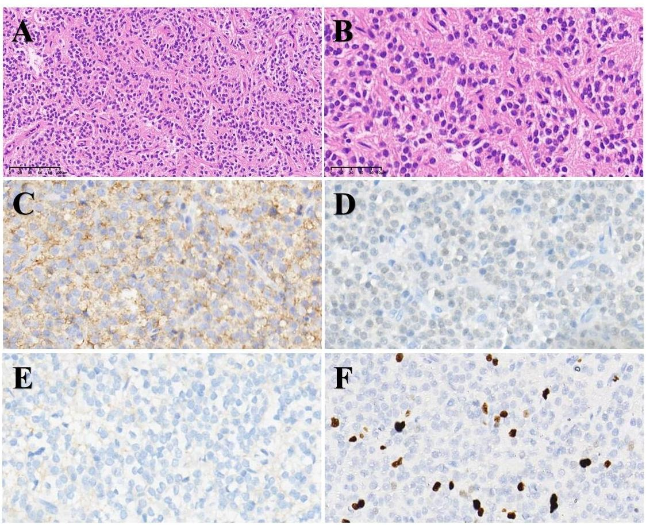
Supplementary Figure 2. H&E staining at magnifications 20× (A) and 40× (B) demonstrated small round cell neuroepithelial tumor (left ventricle) rich in cells with dense blood vessels, predisposing to low-grade glioma and not excluding CN or ependymoma. Immunohistochemical staining at magnifications 40× were positive for Syn (C), NeuN (D), L1CAM (E), and Ki-67 (F). The Ki-67 proliferation fraction was from 5% to 10%.

