Supplementary Material

Title: Transcriptome of Tomato (Solanum lycopersicum) Reveals Impacts of Rhizosphere Microbiomes on Host Interactions

Authors: Garcia, J.¹, Moravek, M.¹, Fish, T.², Thannhauser, T.², Fei, Z.³, Sparks, J.P.⁴, Giovannoni, J.^{2,3}, & Kao-Kniffin, J.^{1*}

Affiliations:
¹School of Integrative Plant Science, Cornell University, Ithaca, NY, USA 14850
²USDA Robert W. Holley Center for Agriculture & Health, Ithaca, NY, USA 14850
³Boyce Thompson Institute, Ithaca, NY, USA 14850
⁴Department of Ecology & Evolutionary Biology, Cornell University, Ithaca, NY, USA 1485

*Corresponding Author:
Jenny Kao-Kniffin, 135 Plant Science Building, Cornell University, Ithaca, NY 14853, E-mail: jtk57@cornell.edu, Phone: (607) 255-8886, Fax: (607) 255-0599

Table S1 Eigenvalues corresponding to the Principle coordinates analysis (PCoA) comparing rhizosphere bacterial communities in the vermicompost (V), sterile vermicompost (SV), and control (C) treatments at harvest.

 | Eigenvalue
PCoA1 | 0.509019
PCoA2 | 0.261369
PCoA3 | 0.196658
PCoA4 | 0.144189
PCoA5 | 0.12401
PCoA6 | 0.102135
PCoA7 | 0.087407
PCoA8 | 0.073198
PCoA9 | 0.05788
PCoA10 | 0.051044
PCoA11 | 0.047443
PCoA12 | 0.036686
PCoA13 | 0.034798
PCoA14 | 0.026375
PCoA15 | -1.09E-17

Table S2 Eigenvalues corresponding to the Principle coordinates analysis (PCoA) comparing rhizosphere fungal communities in the vermicompost (V), sterile vermicompost (SV), and control (C) treatments at harvest.
 | Eigenvalue
PCoA1 | 1.829003
PCoA2 | 0.839663
PCoA3 | 0.431334
PCoA4 | 0.424781
PCoA5 | 0.278533
PCoA6 | 0.175531
PCoA7 | 0.137931
PCoA8 | 0.096265
PCoA9 | 0.081978
PCoA10 | 0.042197
PCoA11 | 0.022552
PCoA12 | 0.01458
PCoA13 | 1.56E-16
PCoA14 | -0.0014
PCoA15 | -0.0119

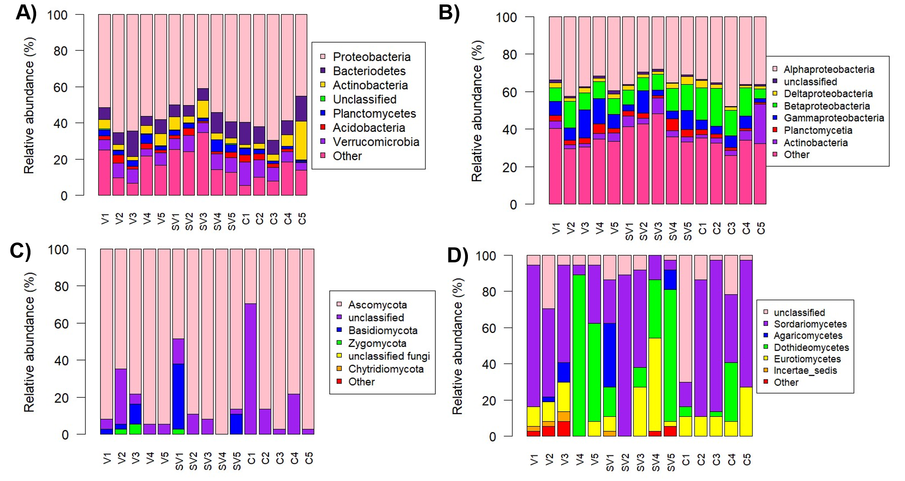
Fig. S1 A) Stacked bar plot displaying relative abundances of the seven most abundant bacterial phyla in each individual sample. B) Stacked bar plot displaying relative abundances of the seven most abundant bacterial classes in each individual sample. C) Stacked bar plot displaying relative abundances of the seven most abundant fungal phyla in each individual sample. D) Stacked bar plot displaying relative abundances of the seven most abundant fungal classes in each individual sample. Each treatment had n=5 replicates.

