Appendix figures and tables
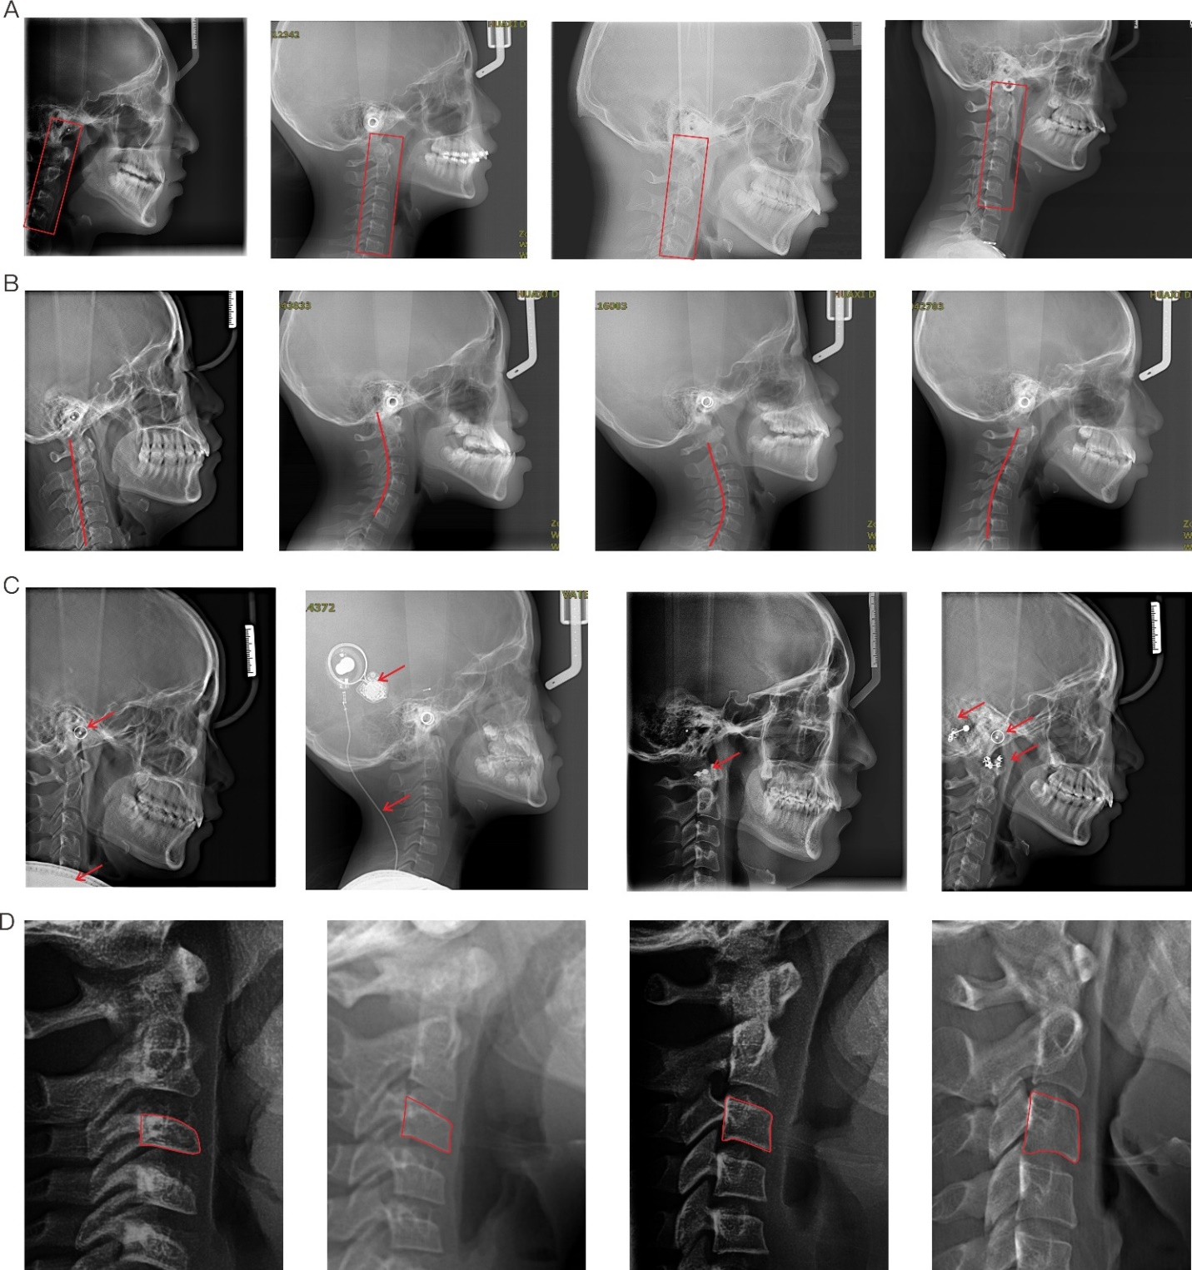
Appendix Figure 1. Examples of various conditions that could compromise the accuracy of automatic landmark localization on cervical vertebrae. (A) Divergence on the location of cervical vertebrae between distinct images. (B) Various directions, alignment and curvature of cervical vertebrae. (C) Interference of underlying and surrounding structures. (D) Morphological variation of cervical vertebrae.

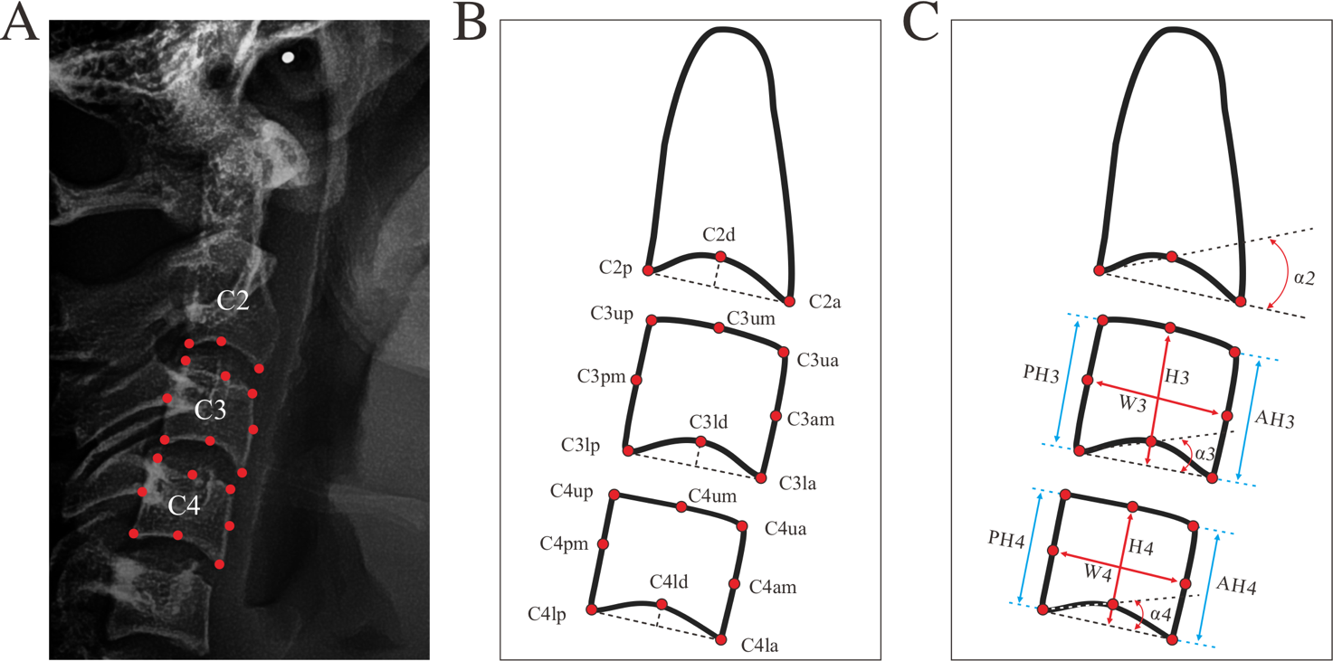
Appendix Figure 2. Landmarks and measurements for QCVM analysis. (A) Landmarks for C2, C3 and C4 in cropped cephalogram, marked in red. (B) Landmark location and definition; (B) Measurements for QCVM analysis.

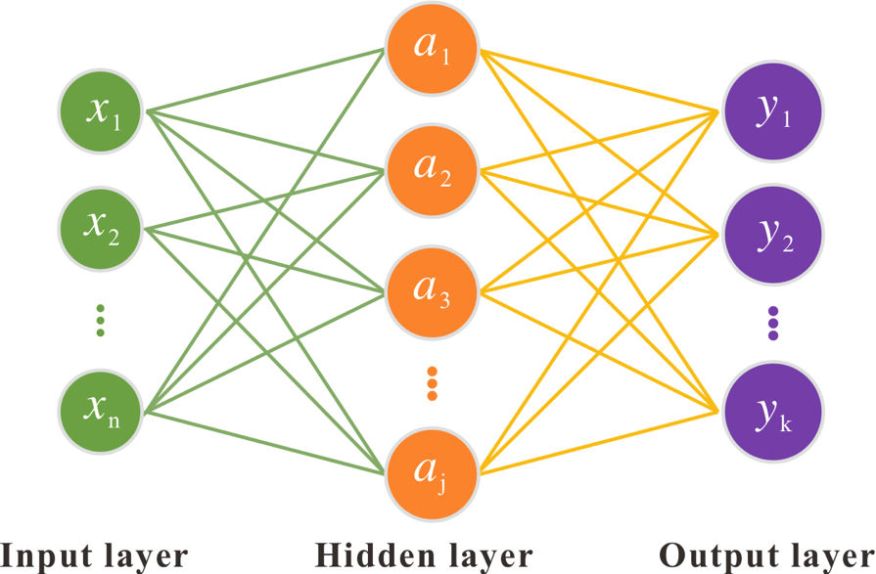
Appendix Figure 3. The architecture of full-connection used in this study. The input is the measurements as illustrated in Figure 2C and supplementary table 2 (α2, α3, α4, AH3, AH4, PH3, PH4, W3, W4, H3, H4, H3/W3, H4/W4, AH3/PH3, AH4/PH4), and the output is the classification of CS1~6.

No. | Landmarks | Definition
1 | C2p | The most posterior point of C2 on the lower border
2 | C2a | The most anterior point of C2 on the lower border
3 | C2d | The deepest point of the concavity at the lower border of C2
4 | C3lp | The most posterior point of C3 on the lower border
5 | C3pm | The middle point of C3 on the posterior border
6 | C3up | The most posterior point of C3 on the upper border
7 | C3um | The middle point of C3 on the upper border
8 | C3ua | The most anterior point of C3 on the upper border
9 | C3am | The middle point of C3 on the anterior border
10 | C3la | The most anterior point of C3 on the lower border
11 | C3ld | The deepest point of the concavity at the lower border of C3
12 | C4lp | The most posterior point of C4 on the lower border
13 | C4pm | The middle point of C4 on the posterior border
14 | C4up | The most posterior point of C4 on the upper border
15 | C4um | The middle point of C4 on the upper border
16 | C4ua | The most anterior point of C4 on the upper border
17 | C4am | The middle point of C4 on the anterior border
18 | C4la | The most anterior point of C4 on the lower border
19 | C4ld | The deepest point of the concavity at the lower border of C4
Appendix Table 1. The landmarks and definition for QCVM analysis.

Measurements | Description
α2 | Antero-superior angle of C2d–C2p connection to C2p–C2a connection
α3 | Antero-superior angle of C3ld–C3lp connection to C3lp–C3la connection
α4 | Antero-superior angle of C4ld–C4lp connection to C4lp–C4la connection
W3 | Distance of C3am-C3pm connection
W4 | Distance of C4am-C4pm connection
H3 | Distance from C3um to the middle point of C3lp-C3la connection
H4 | Distance from C4um to the middle point of C4lp-C4la connection
H3/W3 | The distance ratio of H3 to W3
H4/W4 | The distance ratio of H4 to W4
AH3 | Vertical distance of C3ua to the connection of C3lp and C3la
AH4 | Vertical distance of C4ua to the connection of C4lp and C4la
PH3 | Vertical distance of C3up to the connection of C3lp and C3la
PH4 | Vertical distance of C4up to the connection of C4lp and C4la
AH3/PH3 | The distance ratio of AH3 to PH3
AH4/PH4 | The distance ratio of AH4 to PH4
Appendix Table 2. QCVM Measurements description

Landmarks | Distance error (mm)
Landmarks | CVnet |  | Manual
 | Median | Mean±SD | Median | Mean±SD
C2p | 0.59 | 0.64±0.35* | 0.43 | 0.48±0.30*
C2a | 0.77 | 0.81±0.49* | 0.45 | 0.53±0.41*
C2d | 0.64 | 0.68±0.39* | 0.45 | 0.55±0.38*
C3lp | 0.52 | 0.59±1.02* | 0.43 | 0.55±1.04*
C3pm | 0.53 | 0.62±1.04* | 0.49 | 0.61±1.04*
C3up | 1.07 | 1.20±1.15 | 0.91 | 1.07±1.14
C3um | 0.69 | 0.81±1.18* | 0.63 | 0.76±1.19*
C3ua | 0.50 | 0.64±1.17* | 0.43 | 0.59±1.16*
C3am | 0.54 | 0.68±1.16* | 0.53 | 0.66±1.17*
C3la | 0.39 | 0.54±1.18* | 0.37 | 0.48±1.19*
C3ld | 0.43 | 0.55±1.06* | 0.39 | 0.51±1.06*
C4lp | 0.47 | 0.61±1.04* | 0.44 | 0.59±1.03*
C4pm | 0.59 | 0.70±1.02* | 0.55 | 0.67±1.02*
C4up | 1.24 | 1.30±1.06 | 0.92 | 1.05±1.09
C4um | 0.79 | 0.87±1.04 | 0.67 | 0.79±1.12
C4ua | 0.43 | 0.57±1.07* | 0.40 | 0.52±1.09*
C4am | 0.53 | 0.61±1.08* | 0.42 | 0.53±1.12*
C4la | 0.45 | 0.54±1.09* | 0.38 | 0.48±1.09*
C4ld | 0.44 | 0.55±1.08* | 0.37 | 0.49±1.11*
*P<0.05 when compared Manual to the CVnet model.
Appendix Table 3. Quantitative localization results of 19 vertebra landmarks.

CVM Stage | Train dataset | Test dataset | True Classification | False Classification | Classification Accuracy
CS1 | 345 | 40 | 33 | 7 | 82.50%
CS2 | 343 | 40 | 31 | 9 | 77.50%
CS3 | 289 | 30 | 10 | 20 | 33.33%
CS4 | 275 | 30 | 19 | 11 | 63.33%
CS5 | 290 | 30 | 19 | 11 | 63.33%
CS6 | 348 | 40 | 34 | 6 | 85.00%
Total | 1890 | 210 | 146 | 64 | 69.52%
Appendix Table 4 Data distribution and CVnet prediction accuracy in CS1~6.

