Supporting Information
Identification key genes involved in lignin and flavonoid accumulation during Tilia tuan seed maturation.
Lei Liu ^{1,2}, Cui Long^{1,2}, Xuri Hao ^{1,2}, Rui Zhang ^{1,2}, Chenqi Li ^{1,2}, Yuepeng Song ^{1,2§}
¹National Engineering Laboratory for Tree Breeding, College of Biological Sciences and Technology, Beijing Forestry University, No. 35, Qinghua East Road, Beijing 100083, P. R. China
²Key Laboratory of Genetics and Breeding in Forest Trees and Ornamental Plants, College of Biological Sciences and Technology, Beijing Forestry University, No. 35, Qinghua East Road, Beijing 100083, P. R. China

E-mail addresses: Yuepeng Song, Yuepengsong@bjfu.edu.cn; Lei Liu, liuleibjfu@bjfu.edu.cn; Cui Long, longcui@bjfu.edu.cn; Xuri Hao, haoxuri@bjfu.edu.cn; Rui Zhang, ZhangRui0823@bjfu.edu.cn; Chenqi Li, cqli1998@bjfu.edu.cn.

§Author for correspondence:
Yuepeng Song, Phone: +86-10-62336007; Fax: +86-10-62336164; Email: Yuepengsong@bjfu.edu.cn
Supplemental Figures
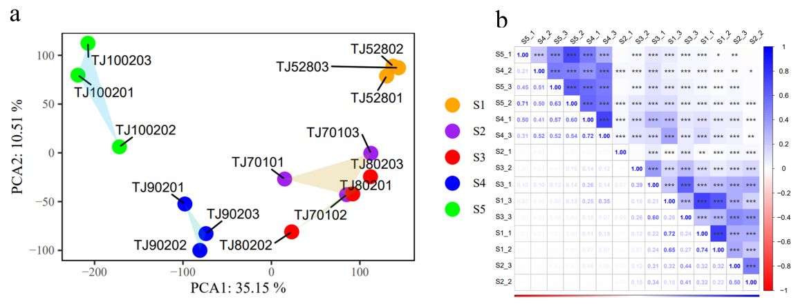
Fig. S1 (a) Principal component analysis (PCA) of transcriptomic data from 5 developmental stages of T.tuan. (b) Sample correlation analysis of transcriptomic data from 5 developmental stages of T.tuan.
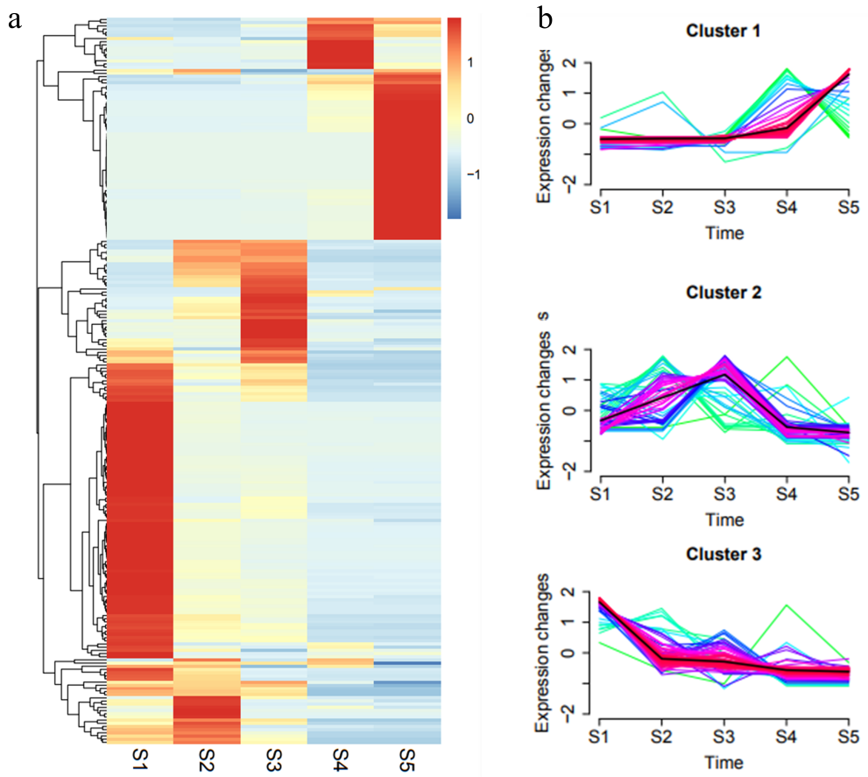
Fig. S2 Expression dynamics of the lignin biosynthesis pathway genes in T. tuan seeds growing. (a) Hierarchical clustering tree of lignin biosynthesis pathway genes. Genes highly expression were highlighted in red whereas genes low expressed were highlighted in blue. Z-scores of data were standardized to −2 to 2. (b) Expression profiles of all lignin biosynthesis pathway genes by Mfuzz clustering analysis. All pathway genes were classified into three clusters based on their FPKM using the Mfuzz R package.
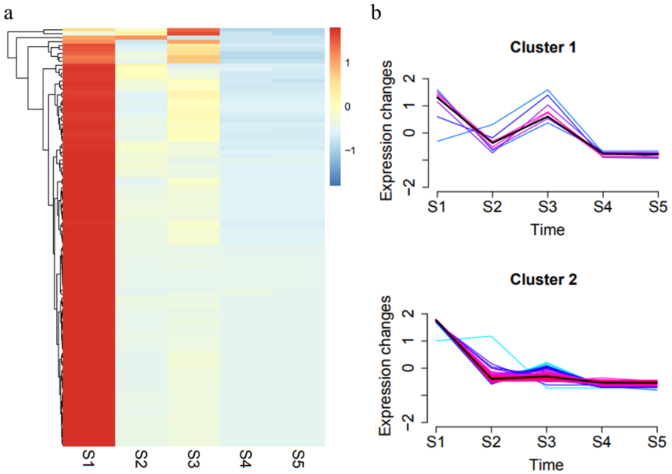
Fig. S3 Expression dynamics of the flavonoid biosynthesis pathway genes in T. tuan seeds growing. (a) Hierarchical clustering tree of flavonoid biosynthesis pathway genes. Genes highly expression were highlighted in red whereas genes low expressed were highlighted in blue. Z-scores of data were standardized to −2 to 2. (b) Expression profiles of all flavonoid biosynthesis pathway genes by Mfuzz clustering analysis. All pathway genes were classified into two clusters based on their FPKM using the Mfuzz R package.
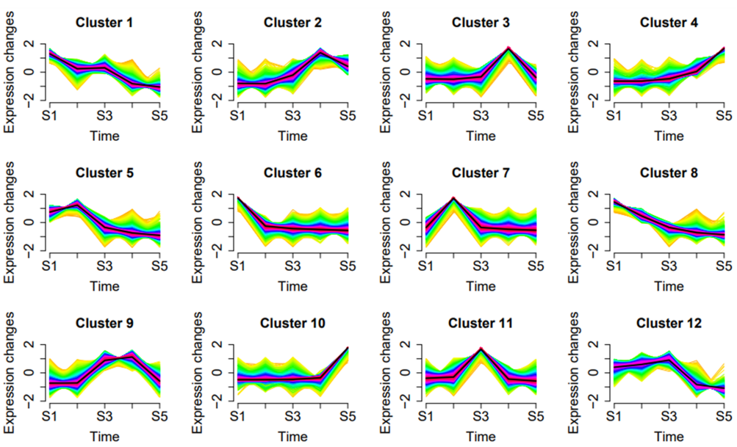
Fig. S4 Temporal expression patterns of all genes in the five development stages of the T. tuan seeds. All genes were classified into twelve clusters based on their expression patterns using the Mfuzz R package.
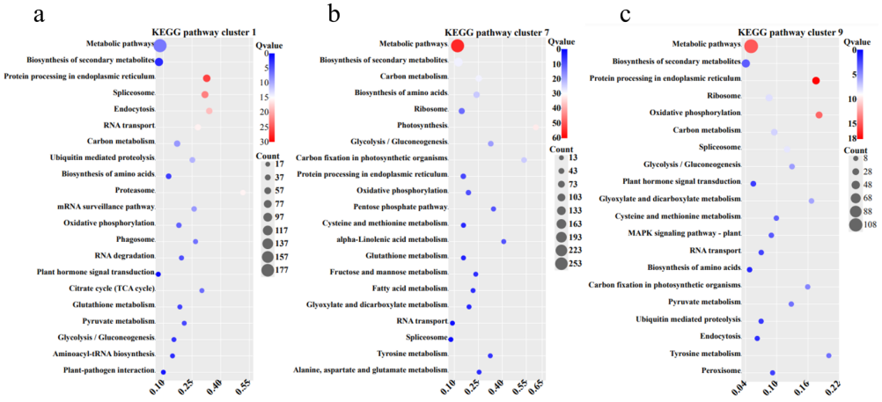
Fig. S5 Distribution of enriched KEGG pathways for various genes expression patterns during the seeds development. KEGG pathways involved in the biosynthesis of metabolites of cluster 2 (a), cluster 9 (b) and cluster 11 (c). Each circle represents a KEGG pathway.
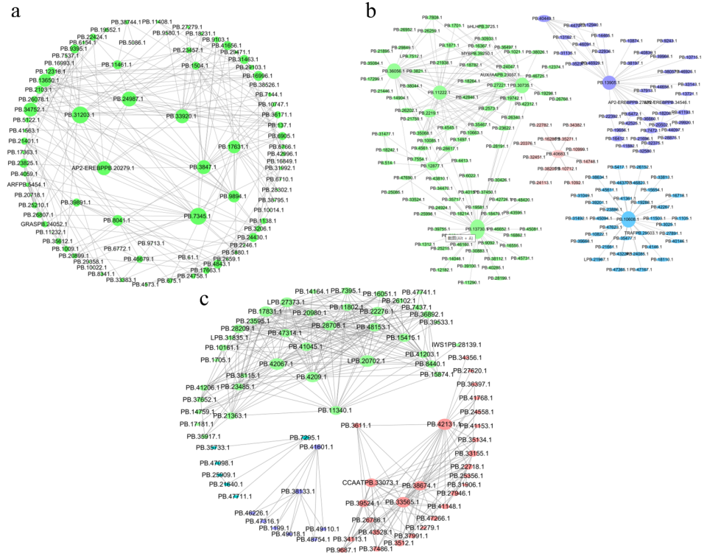
Fig. S6 The correlation networks of genes in the tan (a), brown (b) and black (c) modules, in which only edges with weight above a threshold of 0.626, 0.599 and 0.599 are displayed, respectively. Different colours indicate different network modules.
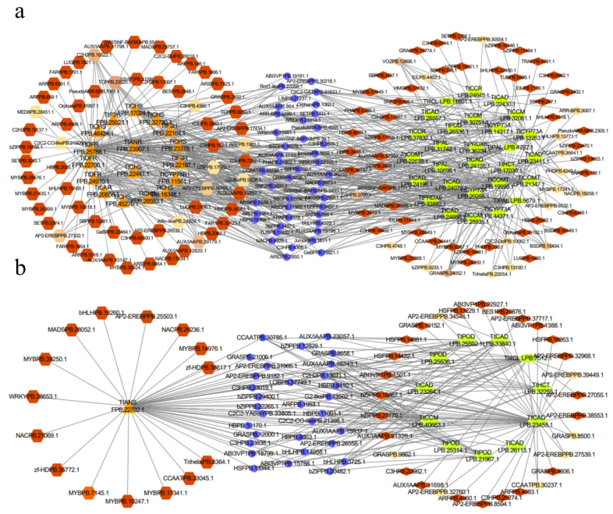
Fig. S7 The correlation networks of genes in the tan (a) and brown (b) modules, in which only edges with weight above a threshold of 0.35 are displayed. The triangle and ellipse represent structural genes involved in flavonoids and lignin biosynthesis during fruit development and ripening, respectively. Diamonds and regular hexagon with different colors represents different families of transcription factors identified in the same module whose transcripts are correlated with expression of structural genes. The circular represents that transcription factors related to flavonoid and lignin structural genes.
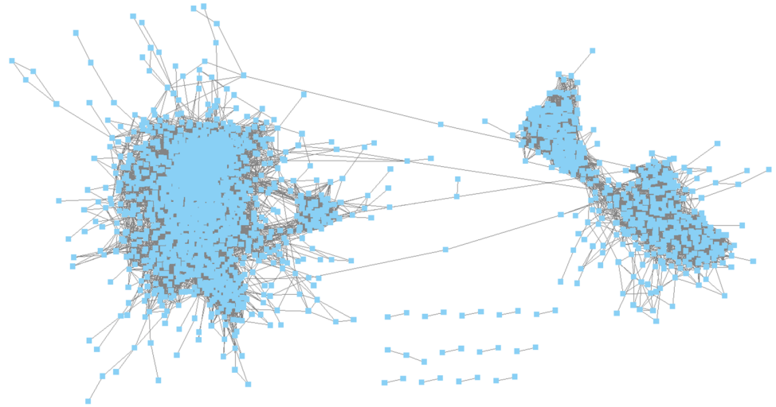
Fig. S8 TF-structural gene co-expression networks (2331 nodes and 245502 edges). Each blue node and grey edge in the GCNs represent a TF/structural gene and a co-expression relationship, respectively. The GCNs are visualized using the Cytoscape tool (http://cytoscape.org).
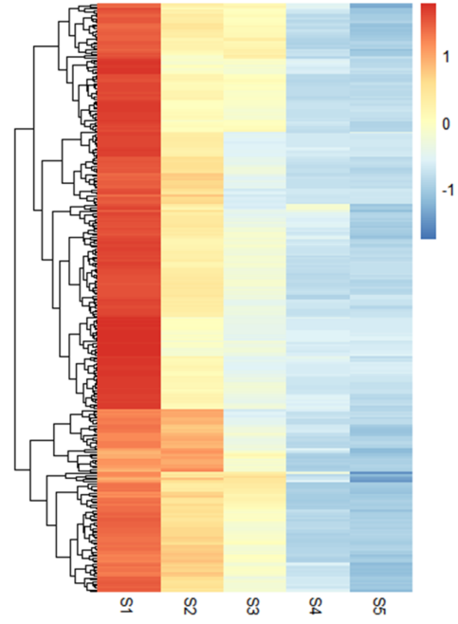
Fig. S9 Expression levels of all members of the subnetwork constructed based on genes co-expressed with TtWRKY15 are shown. Low to high expressions is shown by an adjustment of variety from blue to red. Z-scores of data were standardized to −2 to 2.

