Table 1: Demographics of the professional respondents

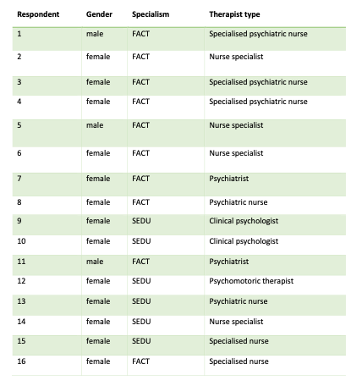

Table 2: Demographics of the client respondents

