Supplementary material 3.
Histograms of the distribution of Montgomery-Åsberg Depression rating Scale – scores (MADRS) and scores on self-perceived readiness to change gambling behavior at baseline.
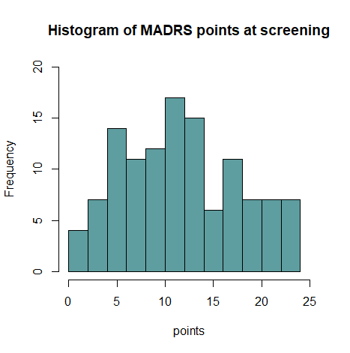
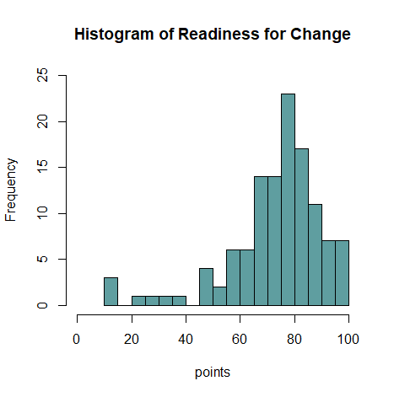
Supplementary Material 3. Comparison between game types.
Response variable | Effect | Compared groups | Test statistic (week 12) | p-value (week 12)
G-SAS | Gametype | Lotteries/Betting | 1.271 | 0.568
 |  | Lotteries/Slots | 1.876 | 0.228
 |  | Lotteries/Online | 0.763 | 0.865
 |  | Betting/Slots | 0.415 | 0.975
 |  | Betting/Online | 0.804 | 0.846
 |  | Slots/Online | 1.766 | 0.278

Comparison between the differences between game types on the scores on the Gambling Symptom Assessment Scale (GSAS) as the explanatory variable. Game types are the participants self-reported primary game type.

