Targeted Gene-Hormone Therapy of Colorectal Cancer with Guanylin Expressing Nano-system: In Silico and In Vitro Study
Pouria Samadi, Fatemeh Rahbarizadeh², Fatemeh Nouri³, Meysam Soleimani³, Rezvan Najafi , Akram Jalali ^{4 *}
Research Center for Molecular Medicine, Hamadan University of Medical Sciences, Hamadan, Iran
² Department of Medical Biotechnology, Faculty of Medical Sciences, Tarbiat Modares University, Tehran, Iran
³ Department of Pharmaceutical Biotechnology, School of Pharmacy, Hamadan University of Medical Sciences, Hamadan, Iran
⁴ Student Research Committee, Hamadan University of Medical Sciences, Hamadan, Iran
* Correspondence to Akram Jalali, Research Center for Molecular Medicine, Hamadan University of Medical Sciences, Hamadan, Iran. Email: akram.jalali59@gmail.com

Supplementary Figures:

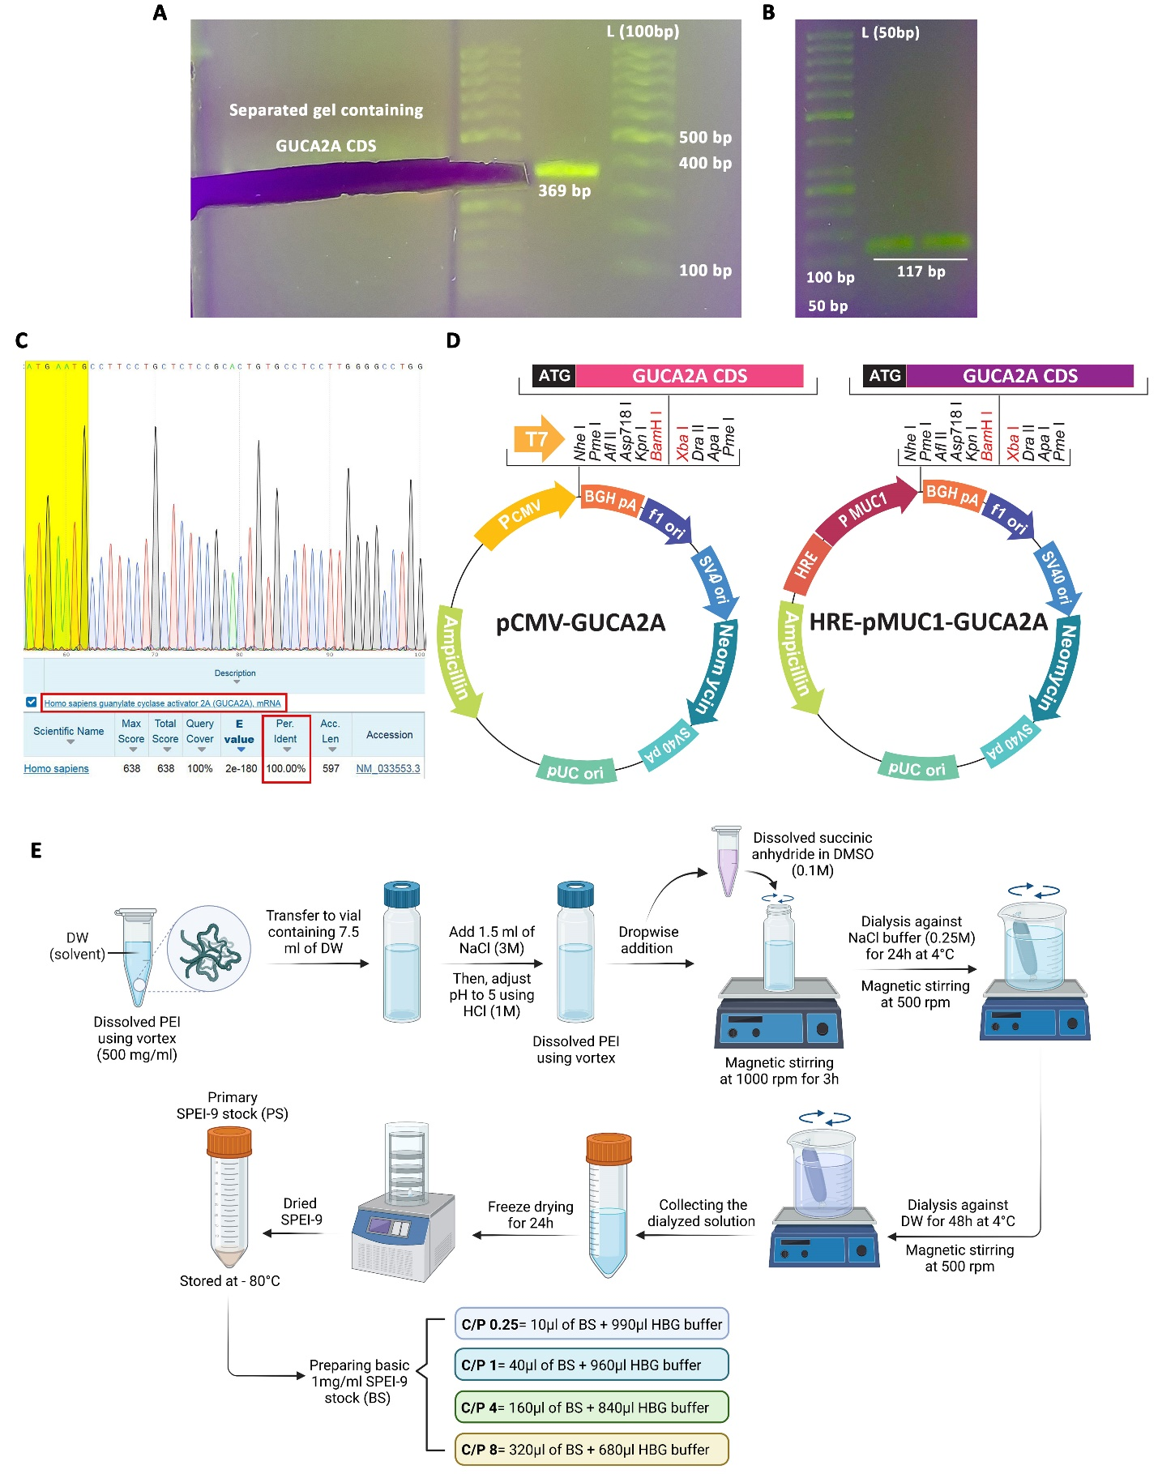
Supplementary Figure S1. Construction of the guanylin-expressing nano-system. A) Amplification and gel extraction of GUCA2A coding sequence (CDS). B) Colony PCR validation of the constructed pCMV-GUCA2A and HRE-pMUC1-GUCA2A vectors. C) Final validation of the constructed vectors through Sanger sequencing. D) Schematic diagram of the constructed pCMV-GUCA2A and HRE-pMUC1-GUCA2A vectors. E) Schematic representation of the various steps involved in the synthesis of the SPEI-9 nanocarrier. This schematic is created with BioRender.

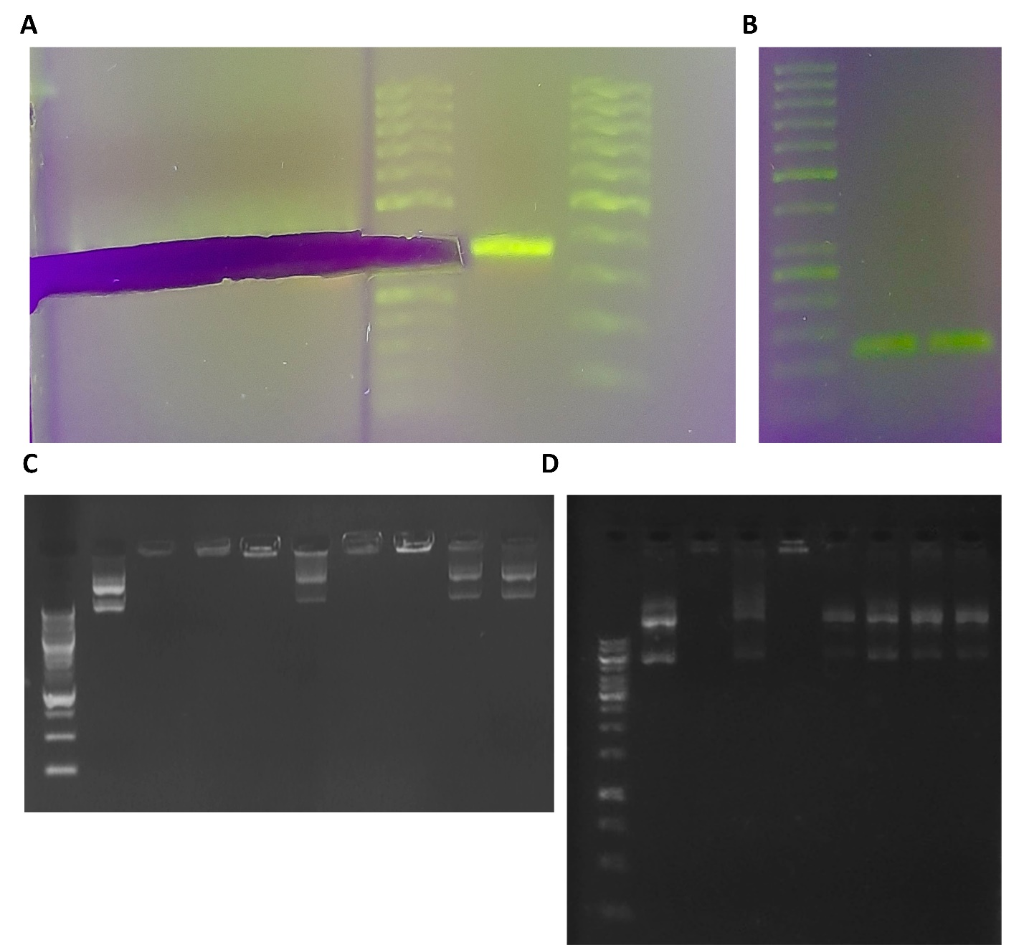
Supplementary Figure S2. Raw images of gel electrophoresis for: A) Amplification and gel extraction of GUCA2A coding sequence (CDS). B) Colony PCR validation of the constructed pCMV-GUCA2A and HRE-pMUC1-GUCA2A vectors. C) Evaluation of the loading efficiency of synthesized SPEI-9 and PEI. D) Assessment of vector protection against degradation by DNase I loaded in SPEI-9.

