Table 1 Optimization of reaction conditionsª
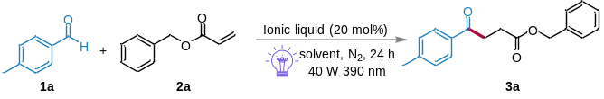
Entry | Ionic liquid | Solvent | Yield (%)^{b}
1 | IL-1 | DCM | 78
2 | IL-1 | DCE | 65
3 | IL-1 | CH₃CN | 23
4 | IL-1 | EtOAc | 56
5 | IL-1 | acetone | 33
6 | IL-1 | PhCl | 59
7 | IL-2 | DCM | 61
8 | IL-3 | DCM | 47
9 | IL-4 | DCM | 51
10 | IL-5 | DCM | 55
11 | IL-6 | DCM | N.D.
12 | IL-7 | DCM | trace
13 | IL-8 | DCM | 19
14 | IL-9 | DCM | trace
15^{c} | IL-1 | DCM | 37
16^{d} | IL-1 | DCM | 58
17 | ---- | DCM | N.D.
18e | IL-1 | DCM | N.D.
ªReaction conditions: 1a (0.6 mmol), 2a (0.2 mmol), ionic liquid (20 mol%), solvent (2 mL), 40 W purple Kessil LED lamp (390 nm), under N₂ atmosphere for 24 h. N.D. = not detection. ^{b}Isolated yields were given. ^{c}10 W purple Kessil LED lamp (390 nm). ^{d}20 W purple Kessil LED lamp (390 nm). ^{e}In dark
Table 2 Substrate scope of aldehydesª
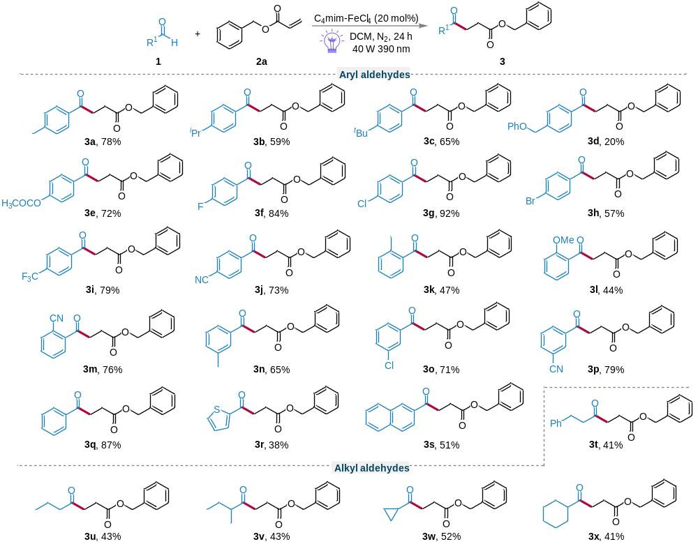
ªReaction conditions: 1 (0.6 mmol), 2a (0.2 mmol), and C₄mim-FeCl₄ (20 mol%) in DCM (2 mL) with the irradiation of purple LED under N₂ atmosphere for 24 h. Isolated yields were given.
Table 3 Substrate scope of alkenesª
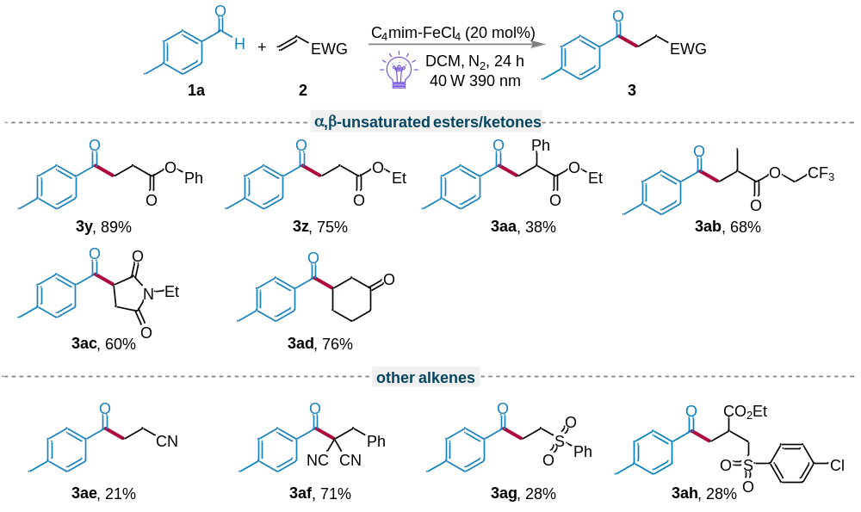
ªReaction conditions: 1a (0.6 mmol), 2 (0.2 mmol), and C₄mim-FeCl₄ (20 mol%) in DCM (2 mL) with the irradiation of purple LED under N₂ atmosphere for 24 h. Isolated yields were given.

