SUPPLEMENTARY MATERIAL

Table S1. Cross tabulation for the electronic Frailty Index (eFI) and the Charlson Comorbidity Index (CCI).
 |  |  | eFI
 |  | Fit | Mild | Moderate | Severe | Sum
CCI | <1 | 14,924 | 11,613 | 6,356 | 1,948 | 34,841
 | 1-10' | 7,151 | 12,823 | 8,717 | 3,151 | 31,842
 | >10 | 6,631 | 13,888 | 13,160 | 6,826 | 40,505
 | Sum | 28,706 | 38,324 | 28,233 | 11,925 | 107,188

Table S2. Cross tabulation for the Charlson Comorbidity Index (CCI) and the Hospital Frailty Risk Score (HFRS).
 |  |  | HFRS
 |  | Low | Intermediate | High | Sum
CCI | <1 | 18,397 | 11,684 | 4,760 | 34,841
 | 1-10' | 14,566 | 12,505 | 4,771 | 31,842
 | >10 | 8,584 | 18,792 | 13,129 | 40,505
 | Sum | 41,547 | 42,981 | 22,660 | 107,188

Table S3. Cross tabulation for the electronic Frailty Index (eFI) and the Hospital Frailty Risk Score (HFRS).
 |  |  | HFRS
 |  | Low | Intermediate | High | Sum
 | Fit | 17,507 | 8,950 | 2,249 | 28,706
eFI | Mild | 15,267 | 16,232 | 6,825 | 38,324
 | Moderate | 6,948 | 12,821 | 8,464 | 28,233
 | Severe | 1,825 | 4,978 | 5,122 | 11,925
 | Sum | 41,547 | 42,981 | 22,660 | 107,188

Table S4. Chi-squared tests for independence and Cramer’s V for association strength between the Charlson Comorbidity Index (CCI), electronic Frailty Index (eFI) and Hospital Frailty Risk Score (HFRS).
 |  | Chi-squared tests
Comorbidity indices |  | test statistic | df | p-value | Cramer's V
CCI | eFI | 9135.7 | 6 | <0.001 | 0.206
CCI | HFRS | 10106 | 4 | <0.001 | 0.217
eFI | HFRS | 13979 | 6 | <0.001 | 0.255

Figure S1. Mortality rates for patients in different HFRS categories admitted to hospital with a Pneumonia or Flu diagnosis between 2010 and 2018, stratified by patients who were admitted to an Intensive Care Unit
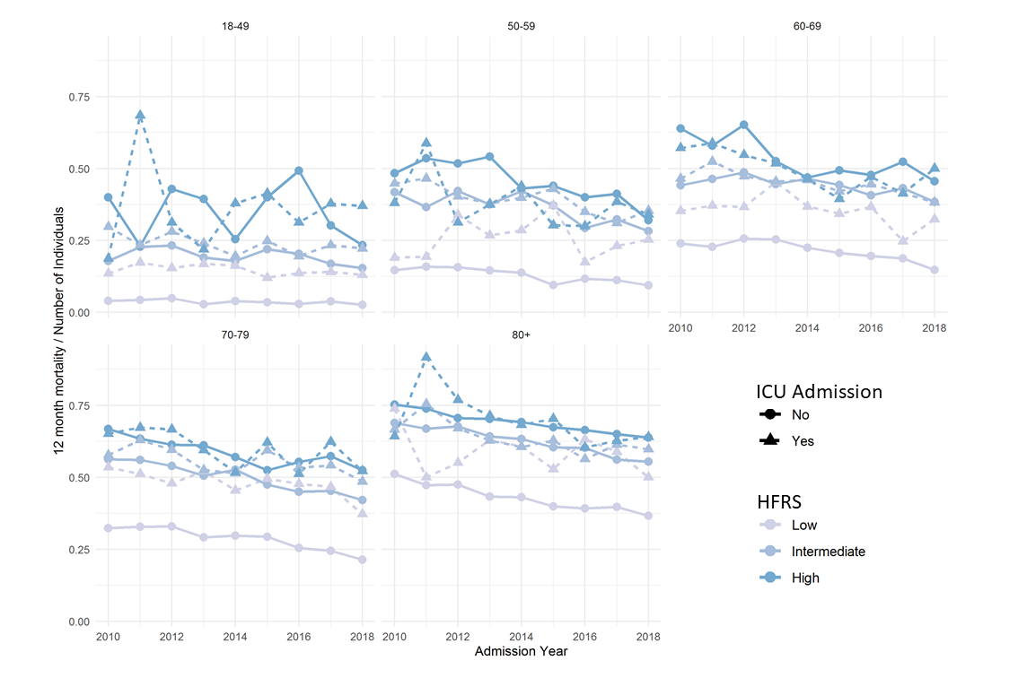
HFRS: Hospital Frailty Risk Score; ICU: Intensive Care Unit

Figure S2. Mortality rates for patients in different CCI categories admitted to hospital with a Pneumonia or Flu diagnosis between 2010 and 2018, stratified by patients who were admitted to an Intensive Care Unit
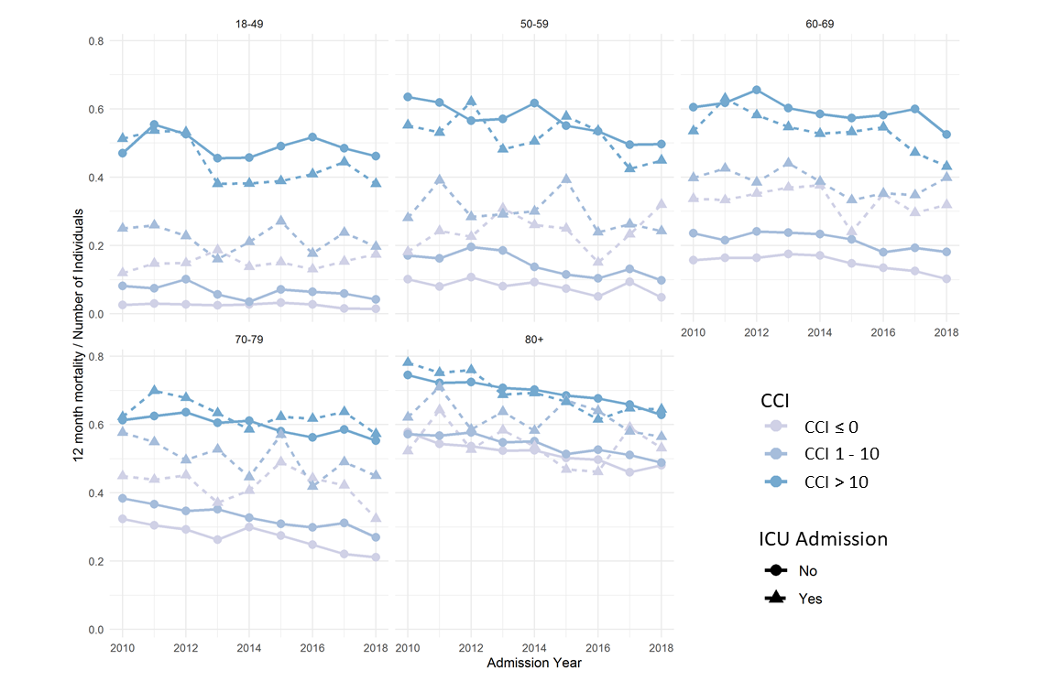
CCI: Charlson Comorbidity Index; ICU: Intensive Care Unit

Figure S3. Mortality rates for patients in different eFI categories admitted to hospital with a Pneumonia or Flu diagnosis between 2010 and 2018, stratified by patients who were admitted to an Intensive Care Unit
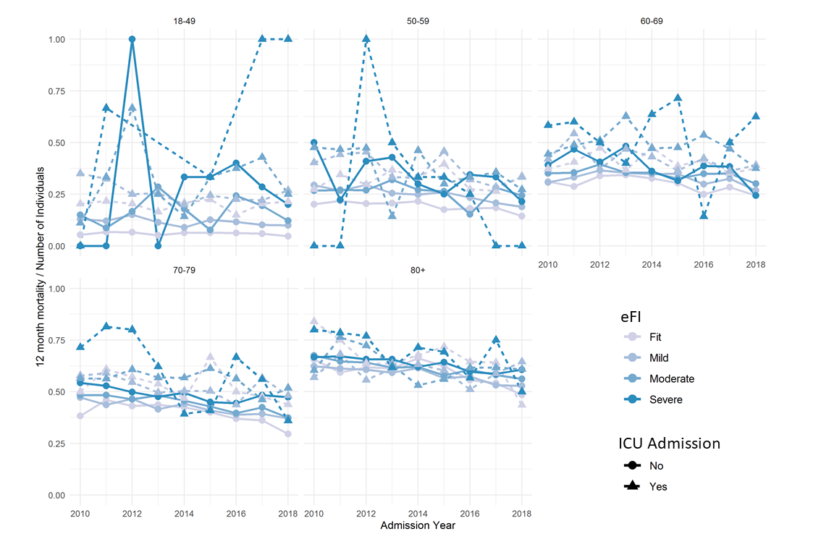
eFI: electronic Frailty Index; ICU: Intensive Care Unit

