SUPPLEMENTAL INFORMATION
Figures Legends for S1-S7
Supplemental figure S1
Figure S1. Comparative transcriptome analyses across vertebrates unveiled a natural feature of inner ears from species with high regenerative capacity. (A) Differences in ABR thresholds for drug-injected X. laevis recorded at 500-4000 Hz. (T represents the phase of administration, R represents the recovery phase). (B) Venn plots showing the commonly expressed genes between chicken and mouse. Most of the known deafness genes (226) from the human deafness gene database were present in the 12605 common expressed genes between Xenopus and mouse. (C) Differential expression patterns and hierarchical clustering of common genes among mouse, chicken, and Xenopus. The heatmap on the right lists the representative genes that are critical for inner ear development or hair cell regeneration, labelled in red. The GO functional analysis indicates a significant enrichment of inner ear development, proliferation and regeneration-related terms for group1, which exhibits high gene expression levels in Xenopus and low levels in mouse and chicken. In contrast, the group4 exhibited low expression levels in Xenopus and chicken but high levels in mouse. Negative regulation of proliferation, autophagy, and death-related terms were significantly enriched in this group.

Supplemental figure S2
Figure S2. The single cell atlas of Xenopus inner ear and its comparison with mouse. Heatmaps in (A) and (B) display the relative expression levels of the top three differentially expressed genes (y-axis) from each cluster (x-axis) of mouse and Xenopus. UMAP plots of Fxyd2 and Kcnk2 genes are presented in (C).

Supplemental figure S3-1
Figure S3-1. The comparison of the inner ear cell atlas across species highlights the neuronal type III cells as one of the most conserved types. (A) Overlapping of inner ear cell atlas between Xenopus whole inner ear and AP-BP part, with different samples indicated by colors. (B) UMAP analysis and overlapping of the inner ear cell atlas between Xenopus inner ear and mouse cochlea, with different species indicated by colors. (C) The Sankey plot illustrates the degree of conservation or similarity between inner ear cell types in mouse and Xenopus. The top 6 similarity coefficients are labelled. Gray and thin lines indicate very low or almost no significant similarity between the cell types. (D) UMAP plots demonstrated the integration of the Xenopus (AP-BP) and mouse cell atlas. The merged cell atlas was subclustered into 26 cell types. (E) UMAP analysis and overlapping of inner ear neurons cells between Xenopus and mouse inner ear.

Supplemental figure S3-2
Figure S3-2. The comparison of the inner ear cell atlas across species highlights the neuronal type III cells as one of the most conserved types. Characterization of ganglion neuron subtypes. (A) Validation of neuronal type III cells by immunostaining with marker Tuj1 and RNA in situ detection with Nefh genes in mouse cochlea. (B) Conserved expression of nefh gene expression in Xenopus inner ear ganglion. (C) The UMAP painting of differentially expressed genes of mouse type I SGN, which is exactly consistent with previous studies and validates our snRNA-seq quality. Scale bar equals to 100 µm.

Supplemental figure S4
Figure S4. Characterization of hair cells in Xenopus inner ear (AP-BP) revealed their high conservation in vertebrates. (A) Specific and conserved expression of canonical hair cell markers in Xenopus AP-BP. The expression of loxhd1, otof, lmod2, sh2d4b, and srrm3 genes clearly identified the auditory hair cells from other inner ear cell types. (B) RNA in situ detection and confirmation of otof gene expression in BP, cristae and saccule in Xenopus. (C) Immunostaining with myo7a antibody and RNA in situ detection of loxhd1 mRNA in Xenopus AP hair cells. All scale bar equals to 100 µm.

Supplemental figure S5-1
Figure S5-1. Characterization of hair cell subtypes in the whole inner ear of Xenopus. (A) Two cell clusters were identified as hair cells using canonical markers. (B) Differential expressed genes for the two hair cell clusters in Xenopus whole inner ear. (C) Exaction and sub-clustering of Xenopus inner ear hair cell. Five hair cell subtypes were identified. (D) The top10 differentially expressed genes for each hair cell subtype. (E) Specific differential expressed gene markers for each hair cell subtype. (F) UMAP plots painting of the hair cell marker genes for each subtype.

Supplemental figure S5-2
Figure S5-2. Expression of hair cell marker genes in Xenopus inner ear. (A) RNA in situ detection of hair cell marker genes gata2 (A), ush2a (B), dclk3 (C), and calb2 (D) in Xenopus inner ear. These genes specifically expressed in the hair cells of AP (A, B, C and D) and cristae (D, bottom). calb2 gene also shows strong expression in inner ear ganglion neurons (F, as indicated by the dashed white cycle). Scale car equals to 100 µm.

Supplemental figure S6
Figure S6. Cross-species comparative analyses of auditory hair cells confirmed that the OHCs are newly evolved hair cell subtypes existing exclusively in mammals. The expression patterns of IHC marker gene (Slc17a8) and OHC marker (Ikzf2) in UMAP plots from mouse (A), Xenopus (B), chicken (C), merged hair cells of mouse/Xenopus (D), and merged hair cells of mouse/Xenopus/chicken (E). (F) and (G) UMAP showing overlay of auditory hair cells between Xenopus and chicken. (H) and (I) UMAP showing overlay of auditory hair cells between mouse and chicken.

Supplemental figure S7
Figure S7. Characterization and evolution of auditory hair cells across vertebrate. (A) Transcriptomic features of all auditory hair cell subtypes in mouse, Xenopus and chicken. The top differentially expressed genes between mouse IHC and OHC (IHC/OHC DEGs) were used to plot the expression heatmap across species. The expression levels are indicated by a color gradient from blue to red, with blue and orange font used to highlight the top mouse OHC and IHC DEGs on the right. (B) Expression patterns of IHC/OHC DEGs in Tbx2- or Slc26a5-positive hair cell groups in mouse and Xenopus. (C) A perfect genomic collinearity of Otof and nearby gene loci and genome browser visualization of H3K27ac ChIP-seq data in Xenopus and mouse inner ear. The enrichment of H3K27ac indicates the transcriptional activities and regulatory program in Otof gene locus in two species.

Table S1. Primers for RNA in situ.
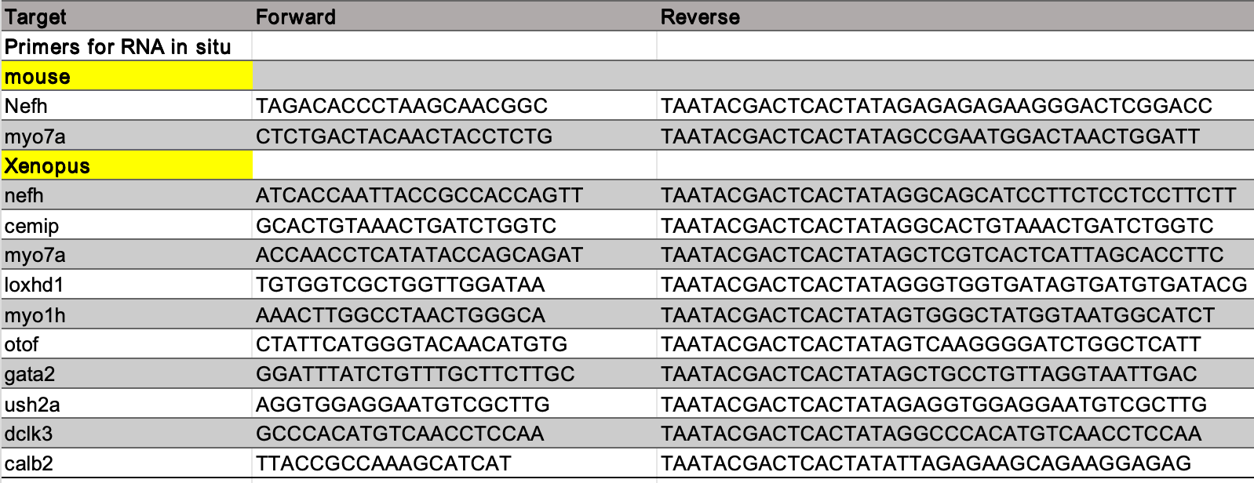

Dataset Legends
Dataset S1. Gene count matrix on multiple datasets. The table shows the statistics of all the gene read numbers from Xenopus, chicken, and mouse inner ear RNA-seq data.

Dataset S2. Differential gene expression between Xenopus, chicken, and mouse inner ears. Pairwise display of co-expressed differential genes between species.

Dataset S3. Differentially expressed genes between mouse inner hair cell (IHC) and outer hair cell (OHC).

