S2 Appendix: Linear Fit Scatter Plot Graphs

S2.1 Appendix: Linear Fit Scatter Plot Graphs of the African Countries
Source: Author’s Compilation Based on Secondary Data.

S2.2 Appendix: Linear Fit Scatter Plot Graphs of the African Countries
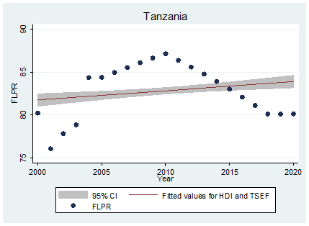
Source: Author’s Compilation Based on Secondary Data.

S2.3 Appendix: Linear Fit Scatter Plot Graphs of the Asian Countries
Source: Author’s Compilation Based on Secondary Data.

S2.4 Appendix: Linear Fit Scatter Plot Graphs of the Asian Countries
Source: Author’s Compilation Based on Secondary Data.
S2.5 Appendix: Linear Fit Scatter Plot Graphs of the Asian Countries
Source: Author’s Compilation Based on Secondary Data.

S2.6 Appendix: Linear Fit Scatter Plot Graphs of the European Countries
Source: Author’s Compilation Based on Secondary Data.

S2.7 Appendix: Linear Fit Scatter Plot Graphs of the European Countries
Source: Author’s Compilation Based on Secondary Data.

S2.8 Appendix: Linear Fit Scatter Plot Graphs of the European Countries
Source: Author’s Compilation Based on Secondary Data.

S2.9 Appendix: Linear Fit Scatter Plot Graphs of the European Countries
Source: Author’s Compilation Based on Secondary Data.

S2.10 Appendix: Linear Fit Scatter Plot Graphs of the North American Countries
Source: Author’s Compilation Based on Secondary Data.

S2.11Appendix: Linear Fit Scatter Plot Graphs of the South American Countries
Source: Author’s Compilation Based on Secondary Data.

