Supplementary data 1. Methods
Bone marrow harvesting
With the patient in the prone position, the posterior superior iliac spine puncture point was selected, and the skin around the puncture point was disinfected and covered with a disinfecting hole towel. A 16 - or 18-gauge needle was chosen, the fixator of the bone marrow aspirate was fixed to a length of 1.5 cm and the syringe was checked for air leakage. Local intradermal, subcutaneous, and periosteal anesthesia was done with 2% lidocaine. After confirming the efficacy of anesthesia, the puncture operator fixed the puncture site at the left thumb and suggestive finger, and the right hand held the bone marrow aspiration needle inserted perpendicularly to the bone surface, and when the tip of the puncture needle touched a hard bone, the puncture needle was rotated left and right along the long axis of the body of the puncture needle and advanced, slowly into the bone. When it is felt that the puncture resistance has disappeared, and the puncture needle has become fixed within the bone, it indicates that the puncture needle has entered the marrow cavity. The needle core was pulled out and placed inside a sterile disc; After receiving a 20 mL syringe with heparin containing NS, aspirate with appropriate force, and aspirate 50 mL of bone marrow fluid. Bone marrow fluid was aspirated, the needle core was reinserted, the needle was pulled out, and sterile gauze was applied to the needle hole, and after pressing for 1 to 2 min, the local iodophor was disinfected, replaced the sterile gauze cover, and the adhesive cloth was pressurized and fixed.

Isolation of BM-MSCs, passage, and surface antigen detection
- Dissociate cells into a single cell suspension by treating adherent cells with a sufficient volume of 0.25% Trypsin-EDTA to submerge cells in the T75 flask. Incubate at 37 C for 2 min. A double volume of complete medium was added to terminate digestion. Incubate the plate at 37º C for 5 min, and wash with 5–10 mL of 1×PBS to collect cell suspension into a conical centrifuge tube. Centrifuge at 300 g for 5 min; aspirate the supernatant.
- Resuspend the pellet in 1 mL 1×PBS and add 0.4% Trypan Blue solution to determine cell count and viability. Resuspend the cell pellet with cold Stain Buffer to a final concentration of 1×10⁷ cells/mL. Distribute 100µL aliquots of the cell suspension (10⁶ cells) to either tube. Add antibodies to cells and incubate for 20 min on ice, protected from light.
- Wash the cells two times with 1mL volumes of 1×PBS. Centrifuge cells at 300 g for 5 min.
- Resuspend the cell pellet in 500µL volumes of 1×PBS.
- The cells were incubated with anti-human CD34, PerCP anti-human CD45, PE/Cy7 anti-human CD73, FITC anti-human CD90, and PE anti-CD105 (Endoglin) flow antibodies before analyzing stained cell samples by flow cytometry.

Supplementary data 2 - Results
Figure S1.
A. Cell growth status 24 hours after primary isolation. B. Cell growth state after six days of continuous culture. C. Cell growth state before the first passage. D. Growth status of the fourth passage BM-MSC cells. The cell morphology was examined and counted under eyepiece 10x, objective lens 5x, resolution: A-C: 1024x768, D: 2592x1944, Scale bar: 50 µm

Figure S2.
The ultrasound images of endometrial basal layer blood flow before and after treatment in all cases are shown in the figure below
Patient No | Before treatment | After 3 infusions of BMSCs / after treatment
1 | 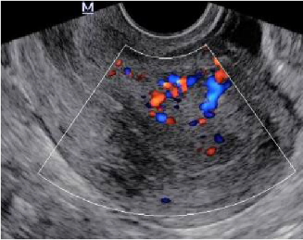 | 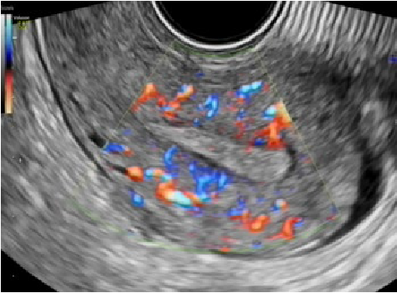
2 | 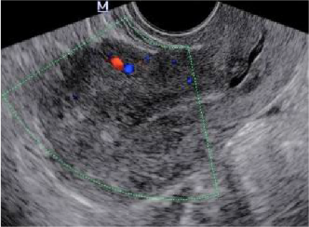 | 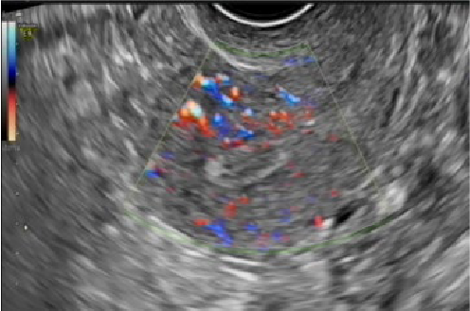
3 | 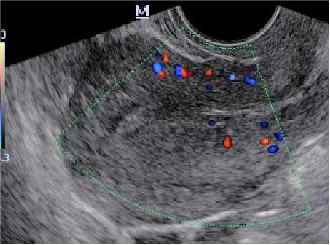 | 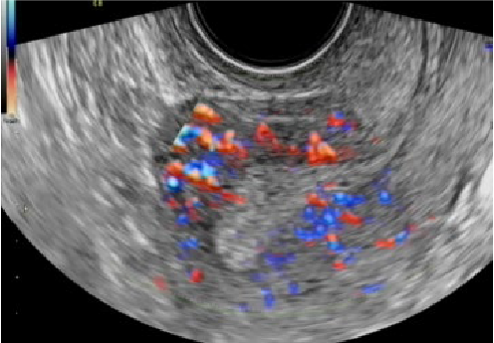
4 | 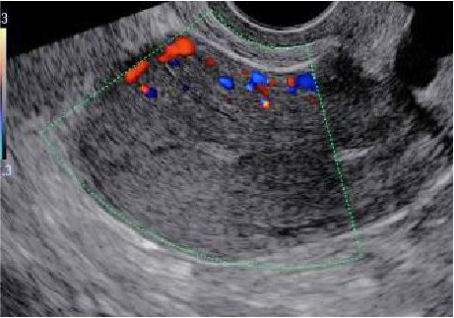 | 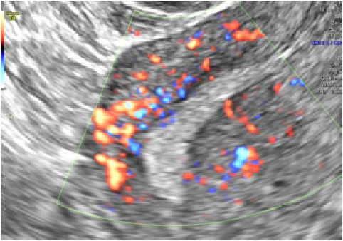
5 | 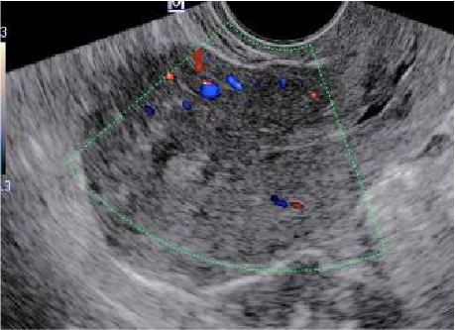 | 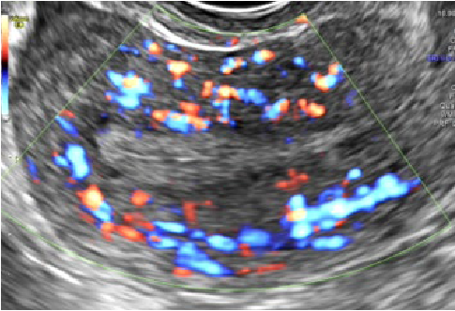
6 | 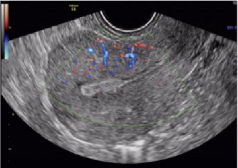 | 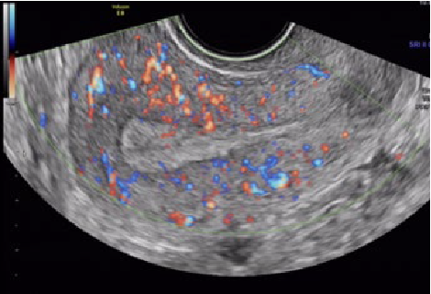
7 | 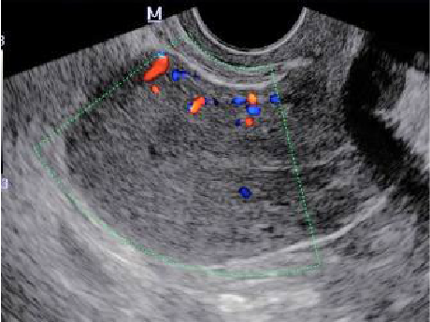 | 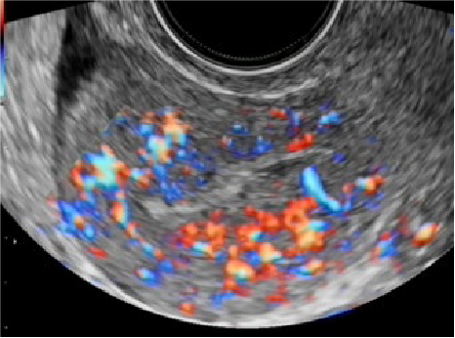

Figure S3.
Hysteroscopy before, after blunt separation, and before BM-MSCs perfusion.
A.
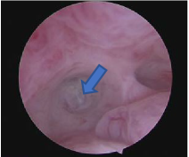
Preoperative hysteroscopy showed adhesion and atresia of the internal cervix.
B.
Hysteroscopy before operation, showed that the uterine cavity was narrow. After the blunt separation of the adhesion of the cervical internal mouth, the adhesion was seen on both sides of the uterine cavity but the uterine horn area, and the fallopian tube opening were not visible.
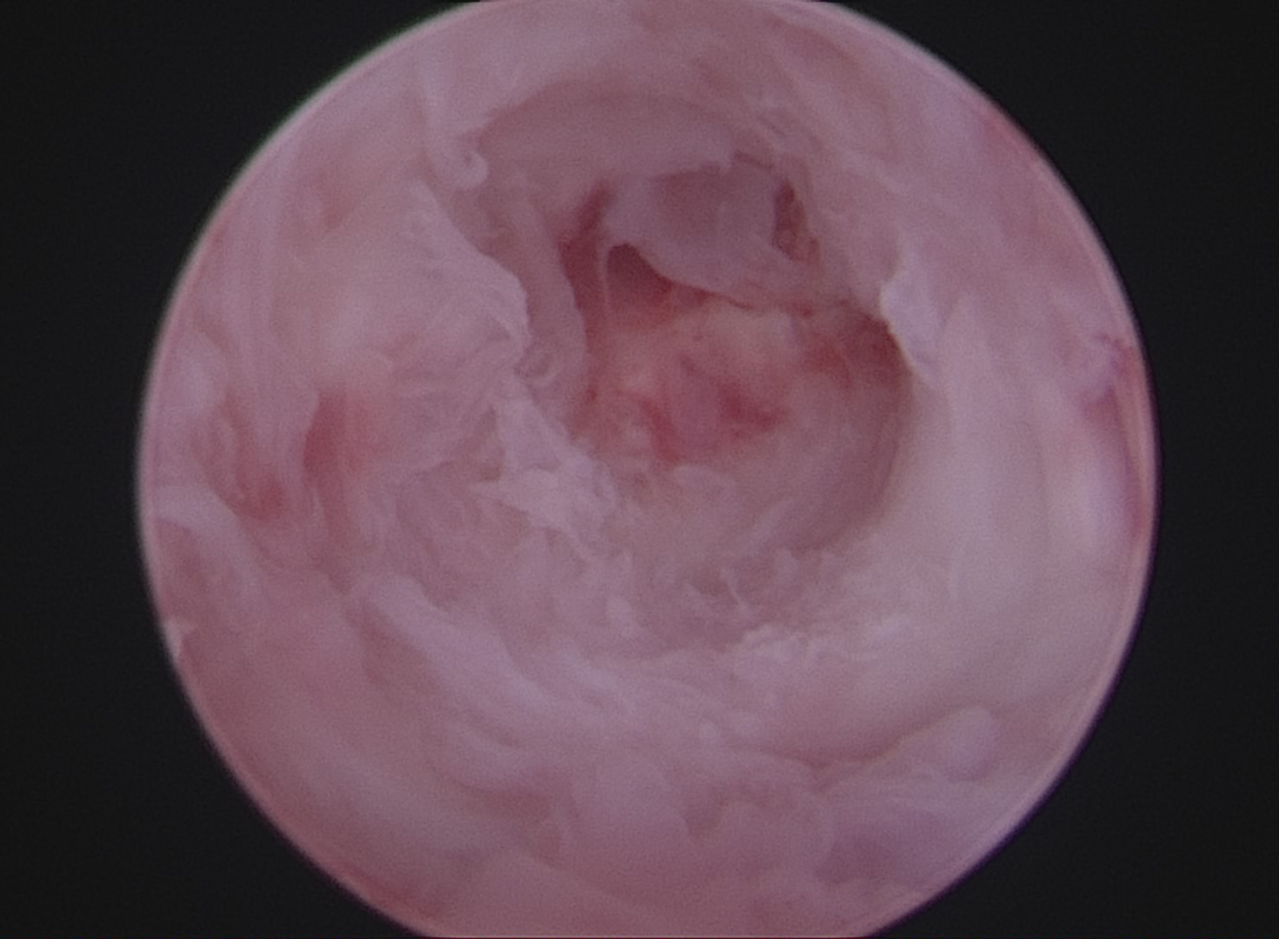
C.
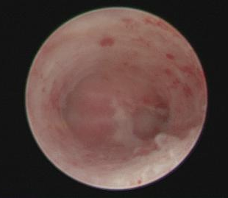
After the separation of intrauterine adhesions before BMSCs perfusion, the uterine cavity was generally restored to normal. However, there were scars on the surface of the uterine wall and no obvious sign of endometrium.

