Table 3 Base case(s) simulation, adopted by DIALux evo (Source: Author)
Variable / Case Study | (a) | (b) | (c)
Variable / Case Study | Gypsum Engraving | Textile Weaving | Pottery Making
Room Photo | 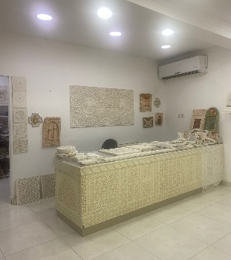 | 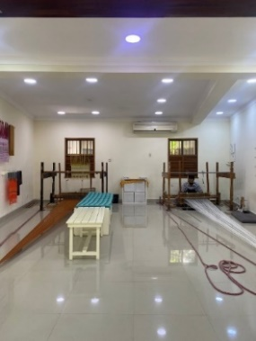 | 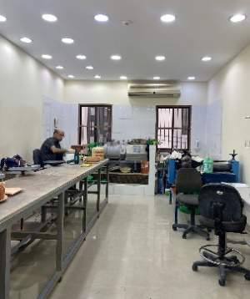
Geometry  (existing lighting layout) & No. of luminaires | 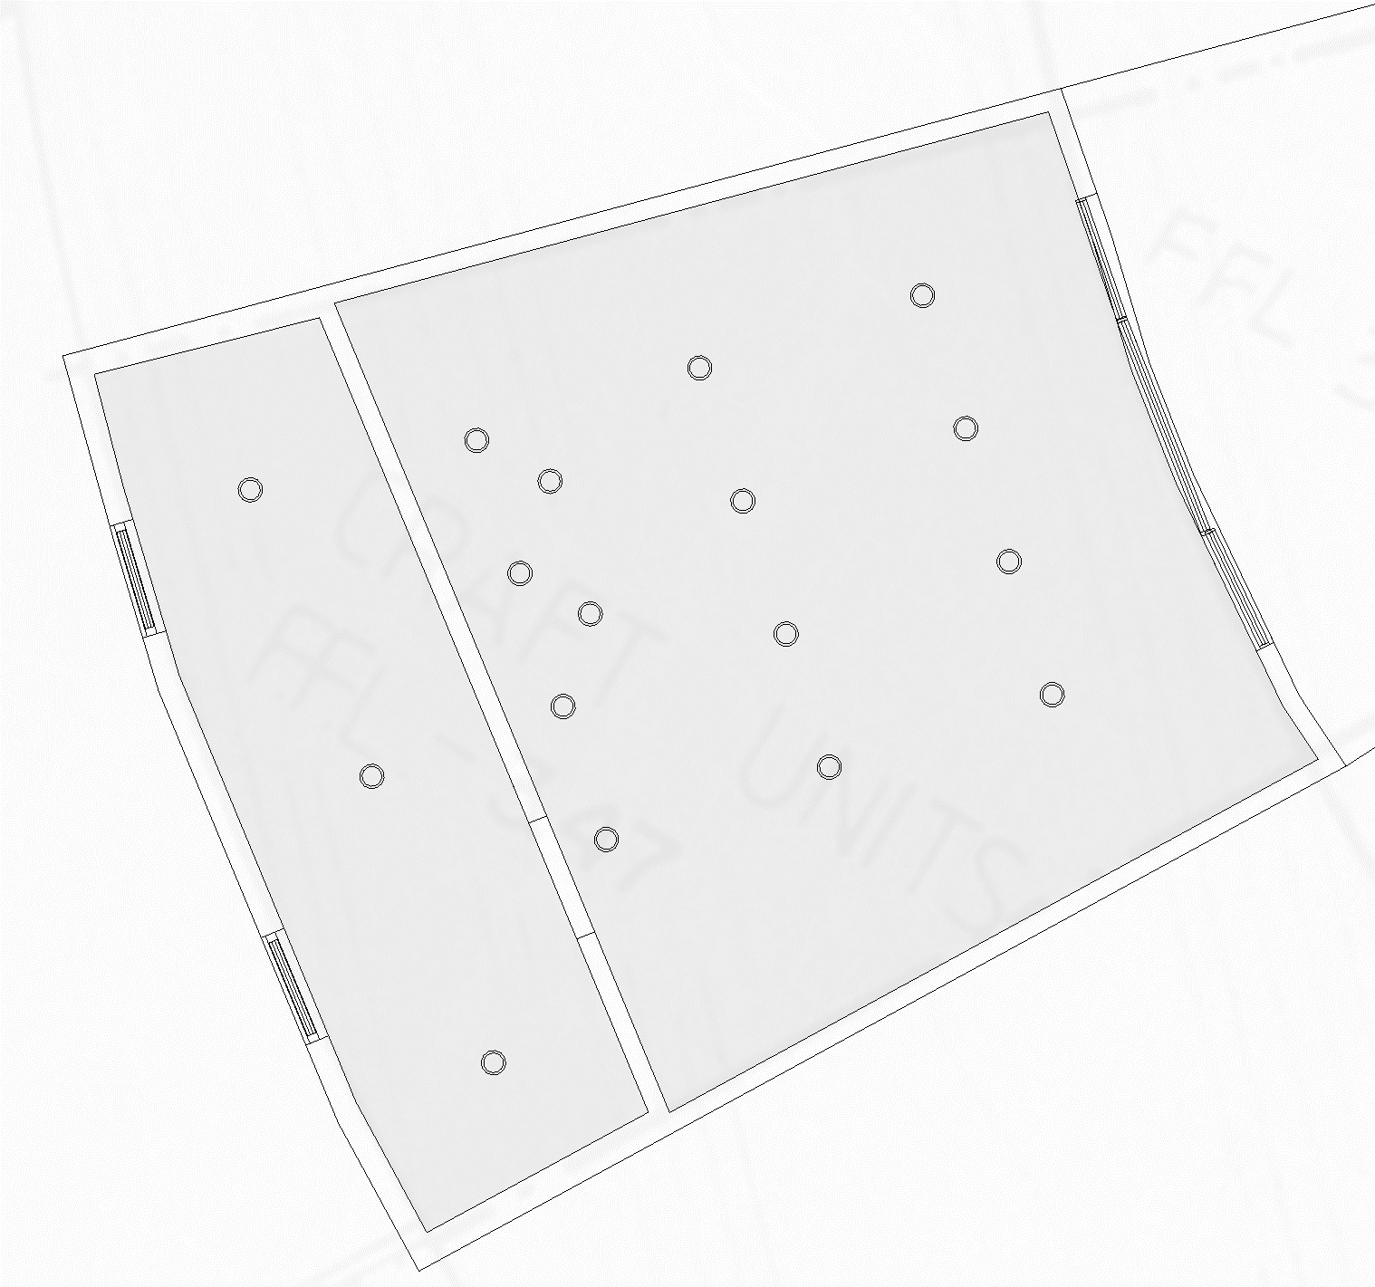 | 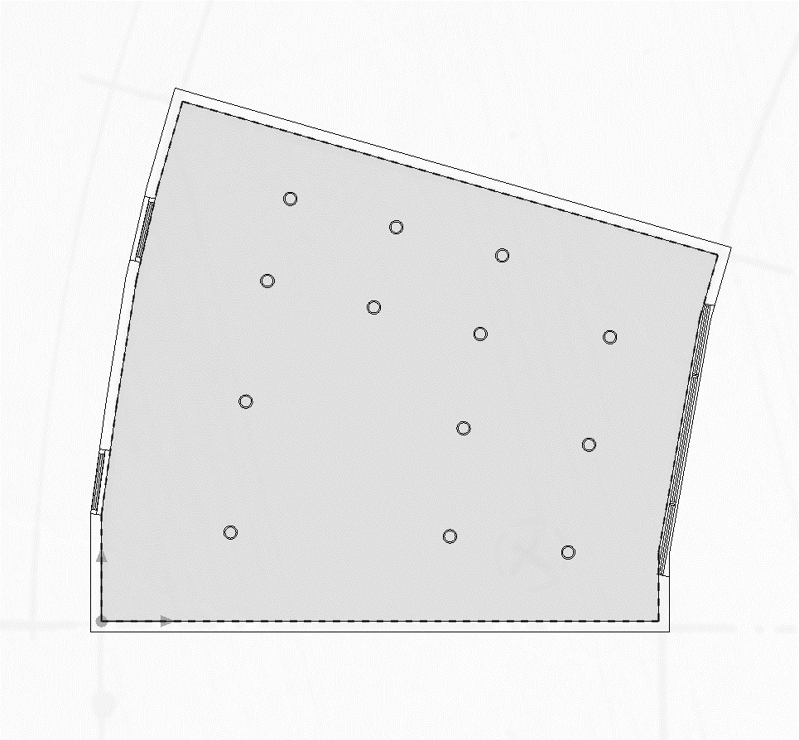 | 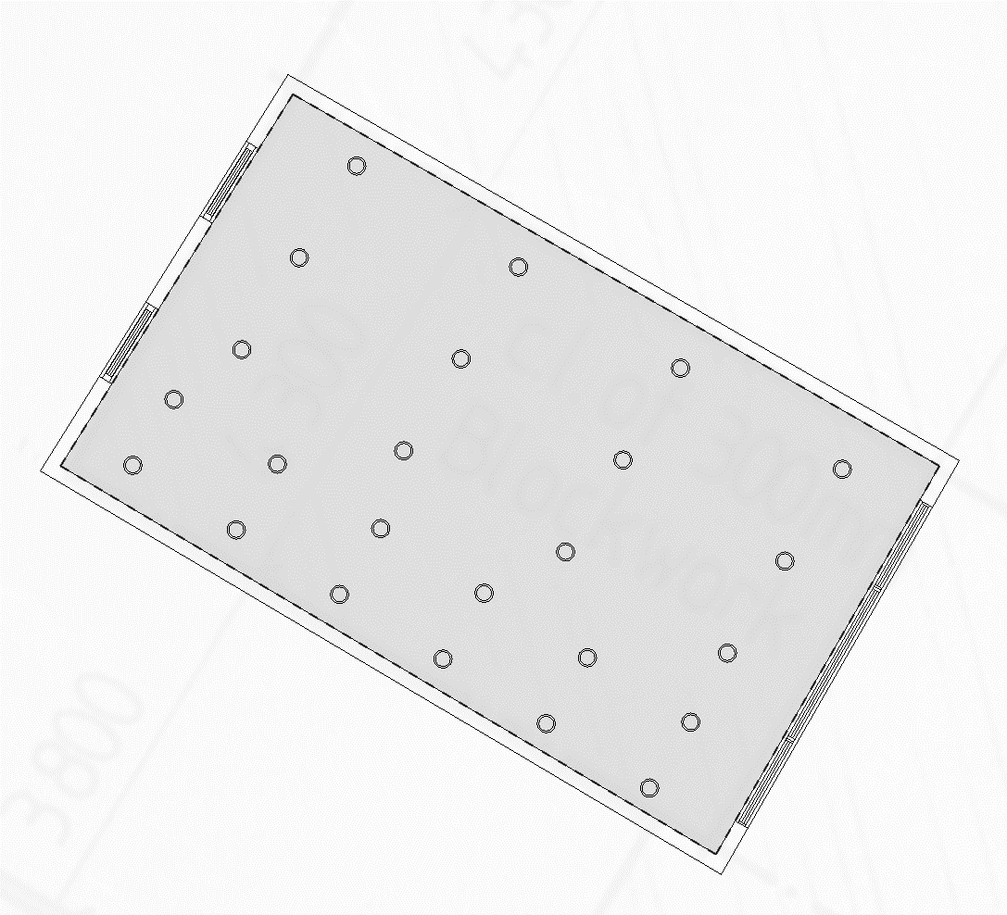
Geometry  (existing lighting layout) & No. of luminaires | 14 pcs - main zone  3 pcs - store | 13 pcs | 24 pcs
Area (m²) | 34 m² | 48 m² | 35 m²
Height (m) | 3 m | 3 m | 3 m
WWR (%) | 13.8% | 13.8% | 14.2%
ADF | 2.8% | 3.1% | 1.8%
Daylight Effective Area (Min / Max) | 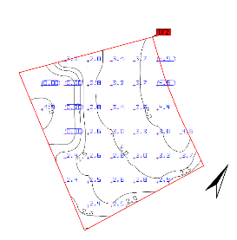  Min 0.0%  Max 4.9% | 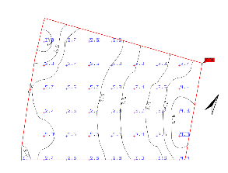  Min 2.53%  Max 4.78% | 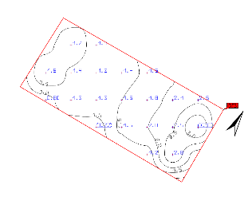  Min 0.76%  Max 3.41%

