Supplementary Information

From planning to implementation: a multi-stakeholder partnership for managing plant invasions in tropical island ecosystems

Mathieu Rouget¹ (✉); Pauline Fenouillas¹ (✉); Emilie Cazal²; Margot Caubit²; Cédric Ajaguin Soleyen¹; Eve Balard³; Antoine Becker-Scarpitta¹; Laurent Calichiama⁴; Gael Karczewski²; Christophe Lavergne⁵; Benoît Lequette²; Léa Marie⁶; Guillaume Payet²; Nicolas Payet⁷; Frédéric Picot⁵; Dominique Strasberg⁸; Julien Triolo⁶; Vincent Turquet⁷; Jean-Philippe Delorme².

¹UMR PVBMT, CIRAD, Saint Pierre, La Réunion ; ²Parc national de La Réunion, La Plaine des Palmistes, La Réunion ; ³DEAL, Saint-Denis, La Réunion ; ⁵SPL-EDDEN, Saint-Pierre, La Réunion ;⁴SPL-Edden, Saint-Pierre, La Réunion ; ⁵CBNM, Saint-Leu, La Réunion ; ⁶ ONF Réunion, Saint-Denis, La Réunion ; ⁷ Département de La Réunion, Saint-Denis, La Réunion ; ⁸UMR PVBMT, Université de La Réunion, Saint-Denis, La Réunion

E-mail : mathieu.rouget@cirad.fr / pauline.fenouillas@cirad.fr

Supplementary S1: Rapid assessment method for invasion degree
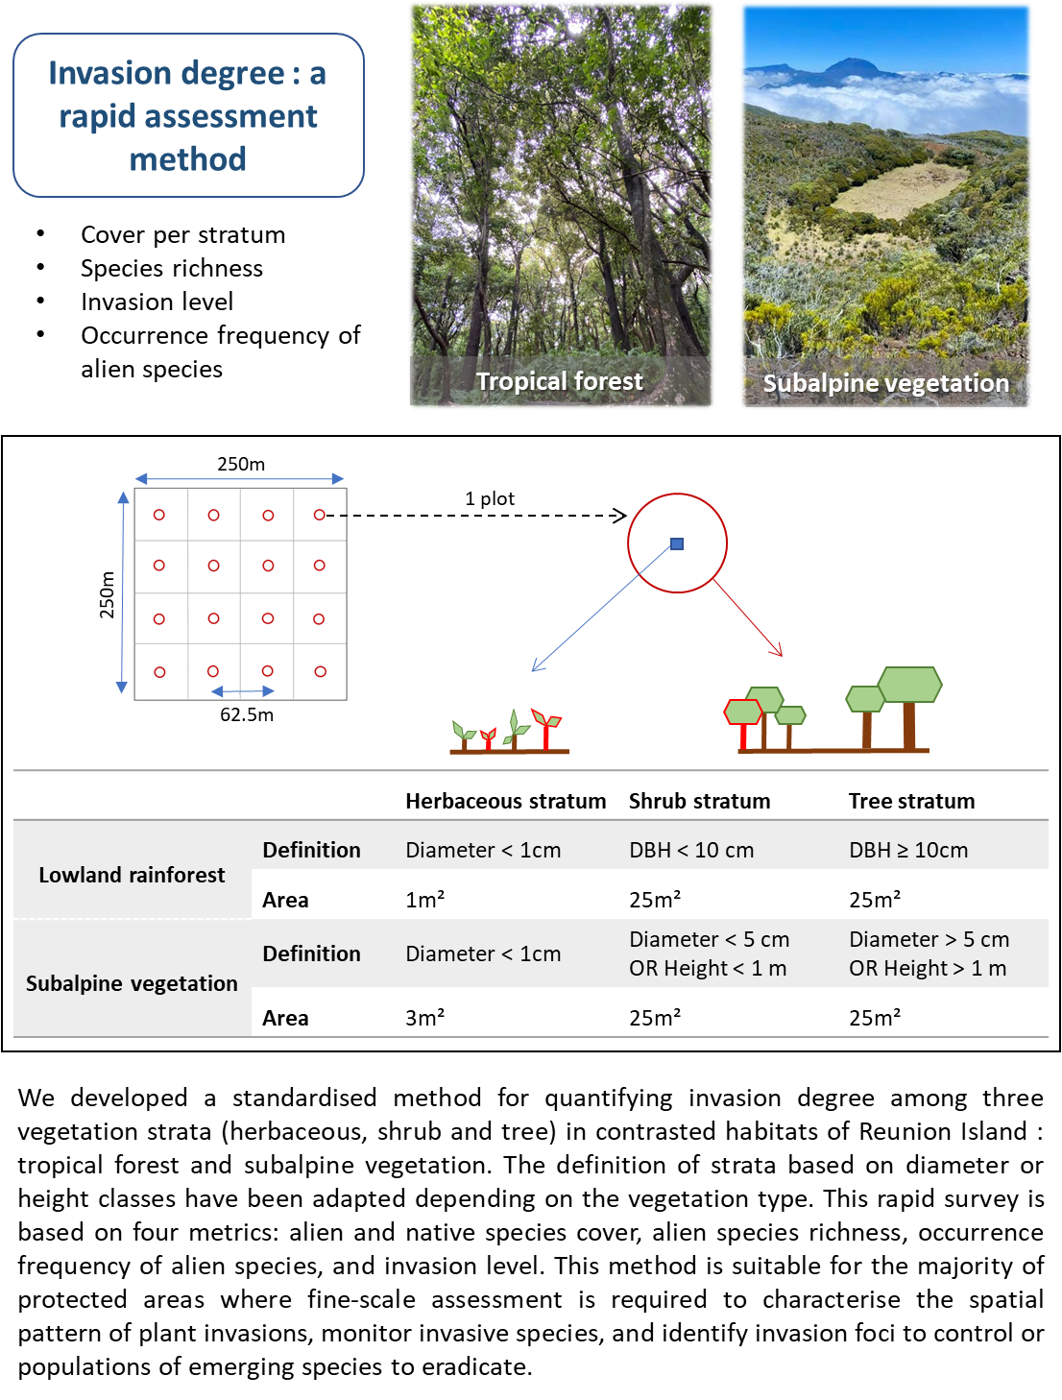

Supplementary S2: Plaine des Fougères site
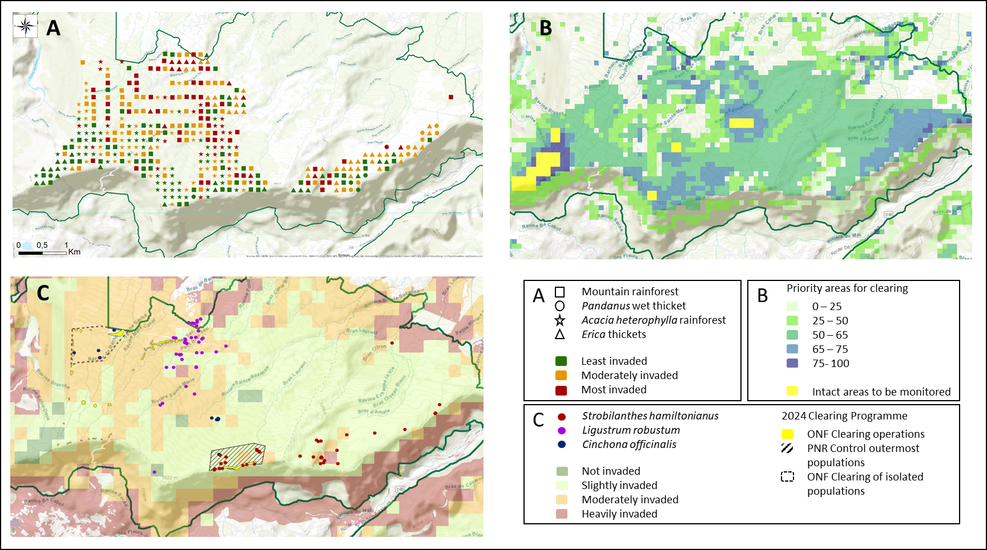
A) invasion degree, B) priority areas and C) proposed interventions (including emerging species)

