Supplementary figures
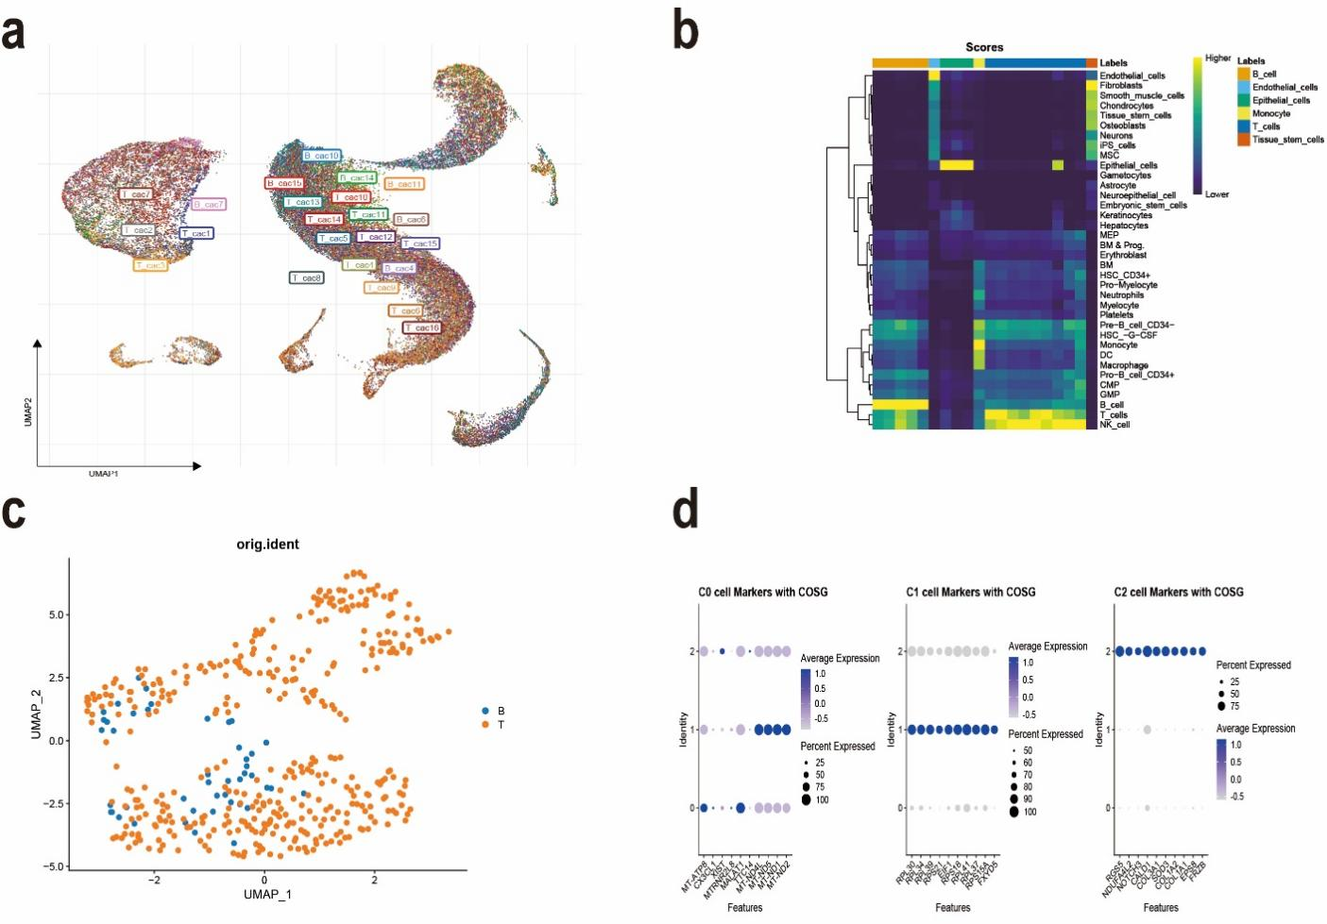
Figure S1 Analysis of endothelial cell clusters in colorectal cancer single-cell samples. a The batch effect between the 23 samples was well removed.b The cells were successfully divided into 6 clusters by singleR package, which were labeled as epithelial cells, monocytes, endothelial cells, T cells, B cells and tissue stem cells.c Carcinoma and paracancerous distribution of three endothelial cell subsets.d Marker genes for various endothelial cell subsets.

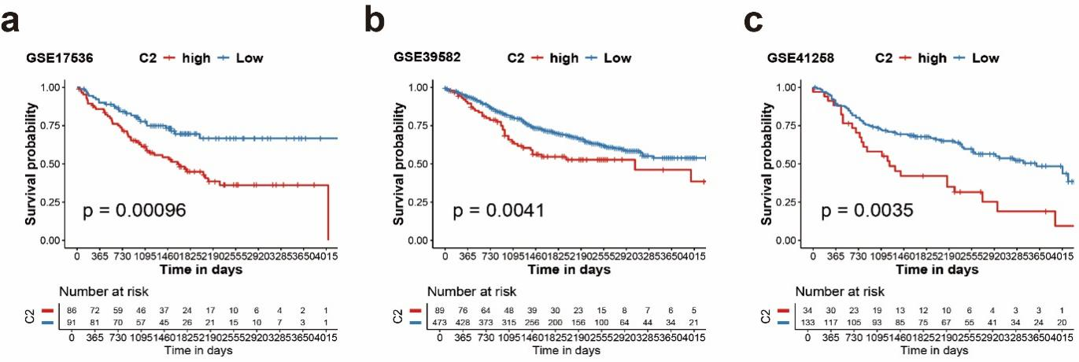
Figure S2 The survival significance of the C2 subset was verified in other CRC public databases.a GSE17536.b GSE39582.c GSE41258.

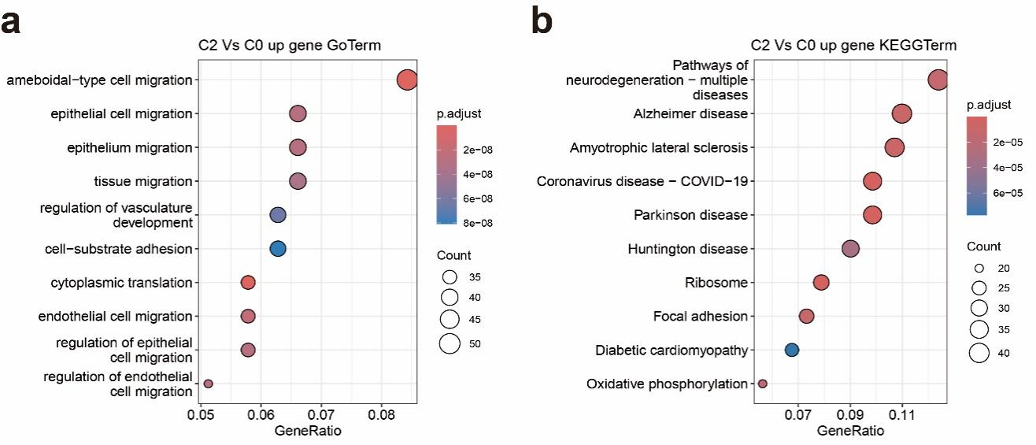
Figure S3 GO and KEGG analyses were performed for differentially upregulated genes in the C2 subset relative to the C0 subpopulation.a,b Pathways related to endothelial cell adhesion and migration are significantly enriched in the C2 subset.

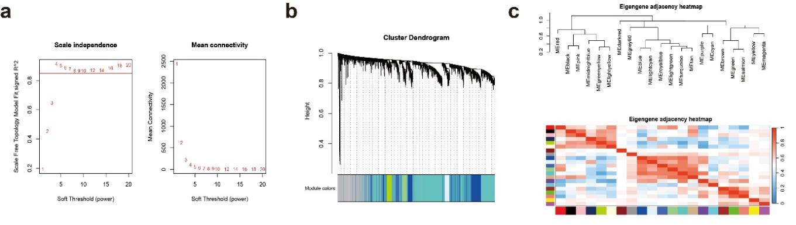
Figure S4 Co-expression network generated using WGCNA.a Determination of soft-thresholding
power in the WGCNA.b The cluster dendrogram of the genes with median absolute deviation in
the top 25%. Each branch in the figure represents one gene, and every color below represents one
co-expression module.c Explore correlations between modules that have low coefficients in all
regions except for the high diagonal coefficient.

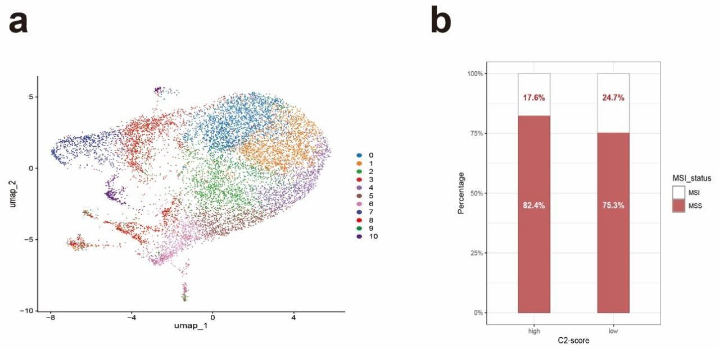
Figure S5 a The endothelial cell dimensionality reduction cluster was divided into 11 clusters.b In the TCGA database, the proportion of patients with MSI is higher in people with high C2 endothelial subgroup scores.

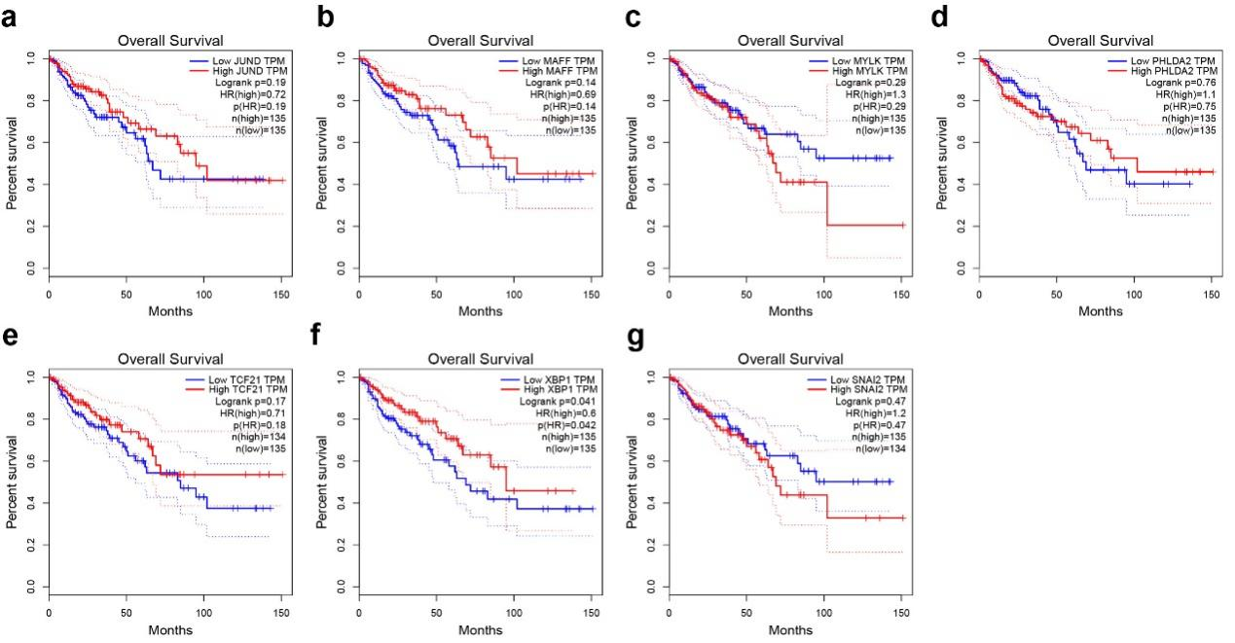
Figure S6 The survival significance of 7 transcription factor genes in the CRC cohort was obtained from the GEPIA database.a JUND.b MAFF.c MYLK.d PHLDA2.e TCF21.f XBP1.g SNAI2.

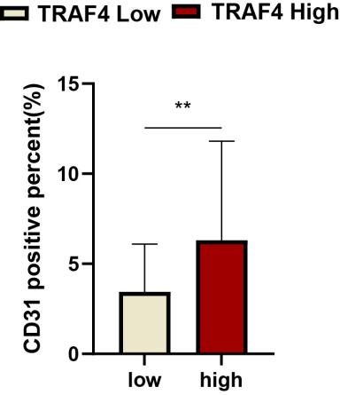
Figure S7 Samples with a high percentage of TRAF4 positivity showed a higher percentage of CD31 positivity.

