Supplemental Data

Supplemental Figure 1
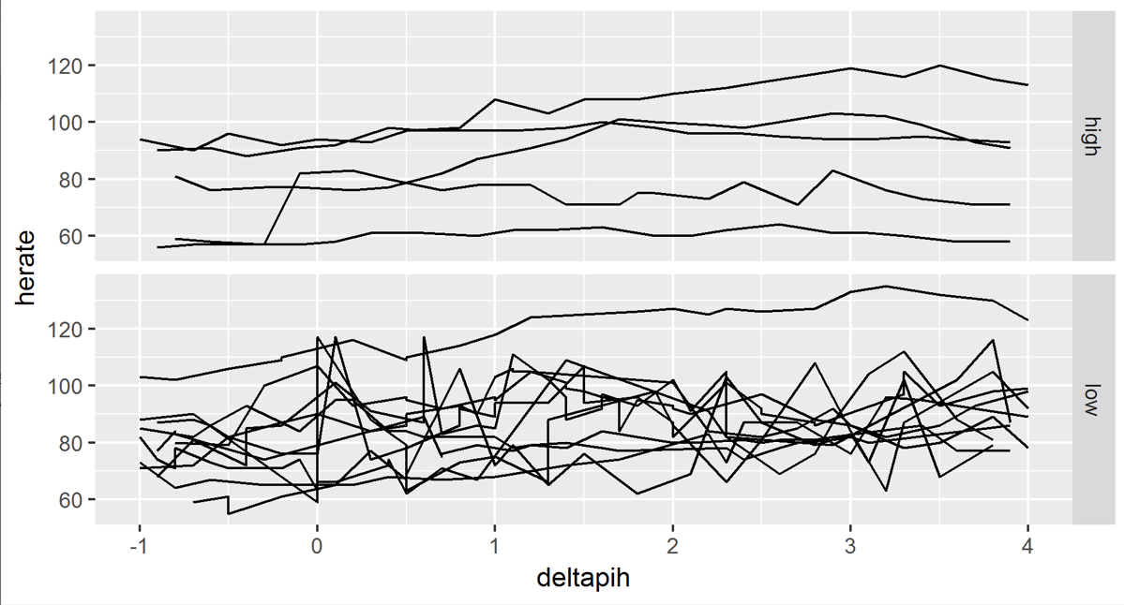

Legend:
Figure S1: HR comparison between high and low dose dose ELI: No overall change in HR during either high dose or dose ELI. Hours shown are from 1 hour before ELI (-1) to 4 hours after the start of ELI infusion.

Figure S2: Cerebral microdialysis values of extracellular pyruvate during the high dose ELI (top) and low dose ELI (bottom)
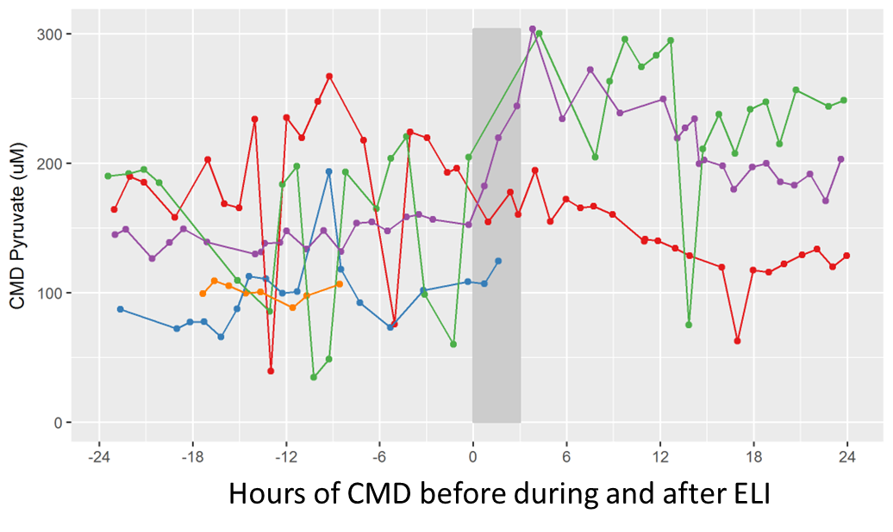
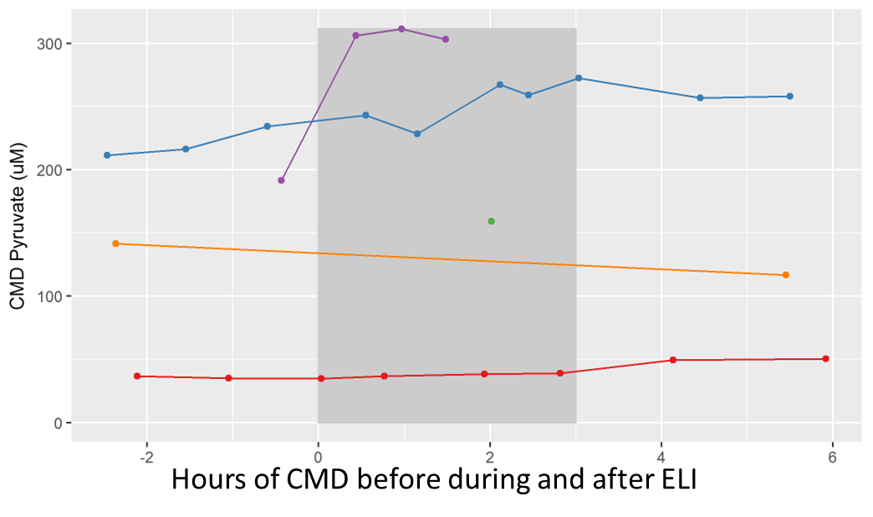
Legend:
Figure S2”: Hourly values of cerebral microdialysis (CMD) pyruvate before, during and after the high dose ELI, n=5 subjects (top) and low dose ELI, n=5 subjects (bottom). No significant change in CMD pyruvate were noted.

