Supplementary Information for
Spin freezing induced giant exchange bias in a doped Hund’s metal
S. J. Li¹, D. Zhao¹, J. Li¹, B. L. Kang¹, M. Shan¹, Y. B. Zhou¹, X. Y. Li¹, T. Wu^{1,2,3,4,5*} and X. H. Chen^{1,2,3,4,5*}
¹Hefei National Research Center for Physical Sciences at the Microscale, University of Science and Technology of China, Hefei, Anhui 230026, China
²CAS Key Laboratory of Strongly-coupled Quantum Matter Physics, Department of Physics, University of Science and Technology of China, Hefei, Anhui 230026, China
³CAS Center for Excellence in Superconducting Electronics (CENSE), Shanghai 200050, China
⁴Collaborative Innovation Center of Advanced Microstructures, Nanjing University, Nanjing 210093, China
⁵Hefei National Laboratory, University of Science and Technology of China, Hefei 230088, China

*Corresponding author. Email: wutao@ustc.edu.cn (T. Wu); chenxh@ustc.edu.cn (X. H. Chen)

Outline:
Part $A.$ Evolutions of different parameters obtained in the thermoremanent magnetization (TRM) measurements
S1. Evolutions of relaxation time ($t_{r}$) and elongation exponent ($n$) obtained in the TRM measurements.
S2. Evolutions of $M_{0}$ and $∆M$ obtained in the TRM measurements, similar to that of $H_{EB}$ and $H_{C}$ respectively.
Part $B$. Characterizations of EB effect in Cr-doped CsFe₂As₂ from the magnetoresistance measurements.
S3. Characterizations of EB effect in Cr-doped (x = 0.06) CsFe₂As₂ from the magnetization and magnetoresistance measurements.
S4. Definition of the parameter $δ_{max}$ in the magnetoresistance measurements.
S5. Characterizations of EB effect in Cr-doped (x = 0.10) CsFe₂As₂ from the magnetization and magnetoresistance measurements.
S6. Systematic magnetoresistance measurements performed on Cr-doped (x = 0.06) CsFe₂As₂.
S7. Systematic magnetoresistance measurements performed on Cr-doped (x = 0.10) CsFe₂As₂.
S8. Evolutions of the parameter $δ_{max}$ in the magnetoresistance measurements performed on Cr-doped CsFe₂As₂.
S9. Training effect in Cr-doped (x = 0.10) CsFe₂As₂ evidenced from the repeated magnetoresistance measurements.
Part $C$. Results of the magnetization and magnetoresistance measurements in the pristine and Co-doped CsFe₂As₂.
S10. Absence of EB effect in the pristine CsFe₂As₂ evidenced from the magnetization and magnetoresistance measurements.
S11. Absence of EB effect in Co-doped (x = 0.07) CsFe₂As₂ evidenced from the magnetization measurements.
S12. Absence of EB effect in Co-doped (x = 0.11) CsFe₂As₂ evidenced from the magnetization measurements.
Part $D$. Research of EB effect in two inhomogeneous systems, perovskite material and Heusler alloy.
S13. Collected data of the exchange bias field ($H_{EB}$) and coercive field ($H_{C}$) in two inhomogeneous EB systems, perovskite material and Heusler alloy.
Part $A.$ Evolutions of different parameters obtained in the thermoremanent magnetization (TRM) measurements
S1. Evolutions of relaxation time ($t_{r}$) and elongation exponent ($n$) obtained in the TRM measurements.
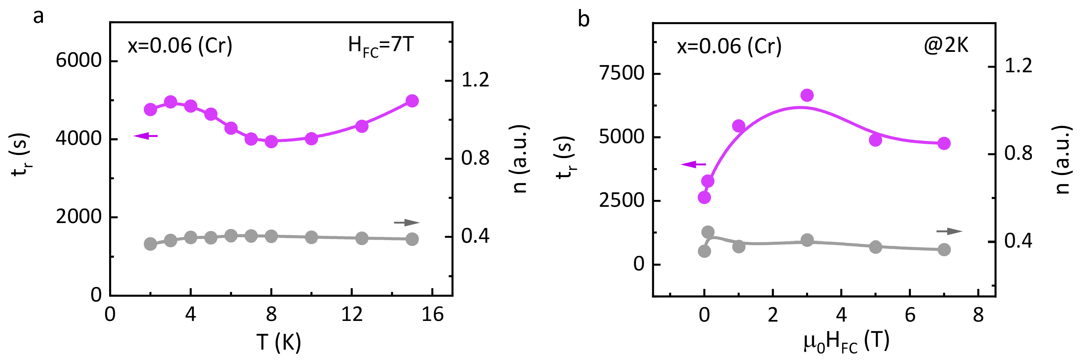
Fig. S1 | Evolutions of the relaxation time ($t_{r}$) and elongation exponent ($n$) in the TRM measurements performed on Cr-doped (x = 0.06) CsFe₂As₂. (a): Temperature-dependent relaxation time $t_{r}$ (the purple dots) and elongation exponent $n$ (the gray dots). (b): Cooling-field-dependent relaxation time $t_{r}$ (the purple dots) and elongation exponent $n$ (the gray dots). To be mentioned, the data taken at temperatures higher than $T_{f}$ are not shown here, since they could not be fitted well via the stretched exponential function.
S2. Evolutions of $M_{0}$ and $∆M$ obtained in the TRM measurements, similar to that of $H_{EB}$ and $H_{C}$ respectively.
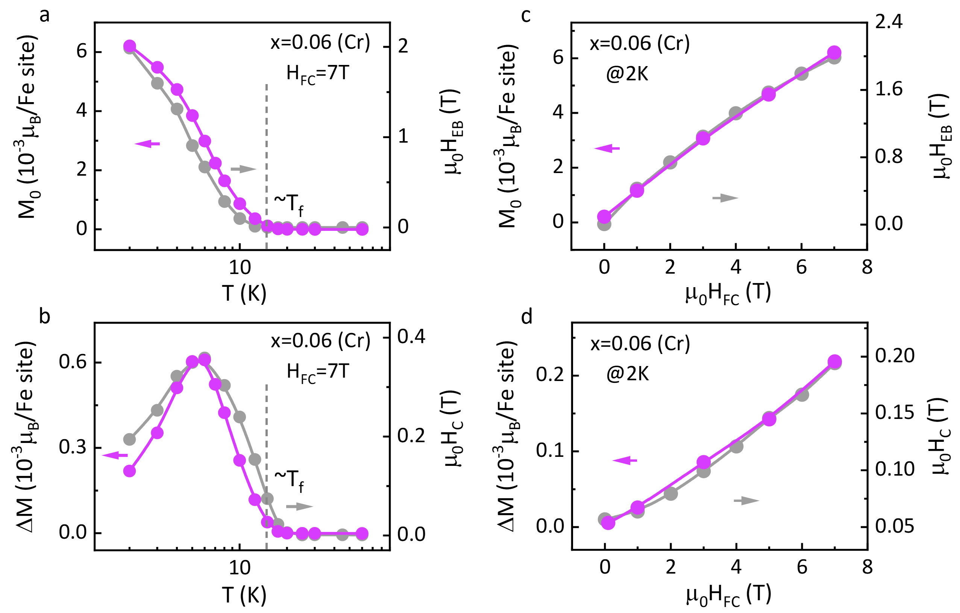
Fig. S2 | Evolutions of the initial magnetization ($M_{0}$) and magnetization reduction ($ΔM$) in the TRM measurements performed on Cr-doped (x = 0.06) CsFe₂As₂. (a), (b): Temperature-dependent $M_{0}$ and $ΔM$ (the purple dots) respectively, obtained from the stretched exponential fitting to the TRM relaxation curves taken at different temperatures with $H_{FC}=7 T$. The gray dots in panel a or b represent the temperature-dependent exchange bias field $H_{EB}$ or coercive field $H_{C}$, the same as the data in Figs. 4a or 4b in the main text. The gray dashed line in panel a or b marks the spin-freezing temperature $T_{f}$, around which $M_{0}$ starts to be nonzero. (c), (d): Cooling-field-dependent $M_{0}$ and $ΔM$ (the purple dots), obtained from the stretched exponential fitting to the TRM relaxation curves taken at 2 K with different cooling fields. The gray dots in panel c or d represent the cooling-field-dependent exchange bias field $H_{EB}$ or coercive field $H_{C}$, the same as the data in Figs. 4c or 4d in the main text. The solid lines in panels a-d are guiding for the eyes.
By comparison, the obtained initial magnetization ($M_{0}$) shows the similar temperature-dependence to that of $H_{EB}$ in Cr-doped (x = 0.06) CsFe₂As₂: $M_{0}$ starts to be nonzero and increase with decreasing temperature below the spin-freezing temperature ($T_{f}\sim$14 K, $H_{FC}=$ 7 T) as shown in Fig. S2a. Meanwhile, $M_{0}$ shows an increasing tendency with $H_{FC}$ from 0 to 7 T at 2 K, similar to $H_{EB}$ as shown in Fig. S2c. In addition, the magnetization reduction ($ΔM$) displays the similar temperature-dependence to that of $H_{C}$ in Cr-doped (x = 0.06) CsFe₂As₂: $ΔM$ starts to be nonzero and increase with decreasing temperature below the characteristic temperature, which is above $T_{f}$; Around 6 K, it reaches the maximum value and starts to decrease upon further cooling (Fig. S2b). Meanwhile, $ΔM$ shows a monotonic increase with increasing $H_{FC}$ from 0 to 7 T at 2 K, similar to $H_{C}$ as shown in Fig. S2d.
Here, the initial magnetization $M_{0}$ refers to the net magnetization at the zero time when the cooling field are removed after waiting for an hour at the target temperature. When the target temperature is above $T_{f}$, the net magnetization is almost zero due to the disordered arrangement of the spin moments in the spin-glass state. Below $T_{f}$, the net magnetization starts to be nonzero as the spin moments are frozen in Cr-doped (x = 0.06) CsFe₂As₂. With decreasing temperature, the net magnetization would increase due to the weakening of thermal fluctuations and the increase in magnetic anisotropy. Accompanied with that, the interfacial pinning effect would enhance, resulting in the increase in $H_{EB}$ as described in the main text. At 2 K, with increasing $H_{FC}$, spin moments in the FM regions and the SG matrix would be aligned more in the direction of cooling field. Besides, the number and size of the FM regions induced by the Cr dopants would increase at the expense of the SG matrix, bringing about the increase in $M_{0}$. Accompanied with that, the increase in the number of pinning FM/SG boundaries and the enhanced pinning effect would lead to the increase in $H_{EB}$ as described in the main text. Hence, $M_{0}$ shows the similar temperature and cooling-field-dependence to that of $H_{EB}$, as shown in Figs. S2a and S2c.
As for the magnetization reduction $ΔM$, it refers to the difference between $M_{0}$ and $M_{∞}$ ($ΔM=M_{0}-M_{∞}$, $M_{0}$ is the initial magnetization at zero time with $H_{FC}=$ 7 T and $M_{∞}$ is the magnetization at infinite time after removing the cooling field). In other words, it is related to the change of spin configuration in the relaxation process. If the spin configuration changes a lot, the magnetization reduction would be large, and vice versa. As we know, the magnetic coercivity $M_{C}$ is also related to the change of spin configuration between the maximum and zero magnetization in the hysteresis loop measurements. If the spin configuration changes a lot, the magnetic coercivity $M_{C}$ would be large, and vice versa. In such case, the magnetization reduction $ΔM$ would show the similar evolutions to that of $M_{C}$. As described in Methods, $M_{C}$ shows the good liner dependence on $H_{C}$ as shown in the inset of Extended Data Figs. 10b and 10d. Therefore, $ΔM$ finally shows the similar temperature and cooling-field dependence to that of $H_{C}$ as shown in Figs. S2b and S2d. These results strongly confirm the exchange bias effect is closely related to the spin-freezing state in Cr-doped Hund’s metal CsFe₂As₂.
Part $B.$ Characterizations of EB effect in Cr-doped CsFe₂As₂ from the magnetoresistance measurements.
S3. Characterizations of EB effect in Cr-doped (x = 0.06) CsFe₂As₂ from the magnetization and magnetoresistance measurements.
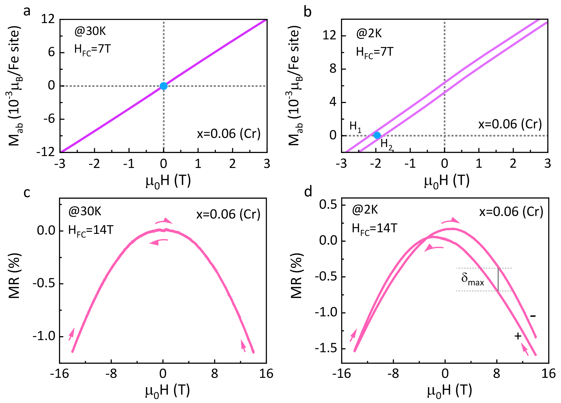
Figure S3 | Evidences for EB effect in Cr-doped (x = 0.06) CsFe₂As₂ from the magnetization and magnetoresistance measurements. (a): Linear magnetization versus field line taken at 30 K after the sample is cooled from above $T_{f}$ with $H_{FC}=$ 7 T. (b): Magnetization versus field (MH) curves taken at 2 K after the sample is cooled from above $T_{f}$ with a cooling field of 7 T ($H_{FC}=$ 7 T). $H_{1}$, $H_{2}$ marks the left and right intercepts of each loop on the zero-magnetization axis. The blue dot in panels a and b marks the center of each MH curve on the field-axis. The path of field scanning is 7 T $→ -$7 T $→$ 7 T ($H_{FS}=$ 7 T). For clarity, we only present the low-field magnetic susceptibilities. To be mentioned, the data is the same as that shown in Fig. 2a in the main text. (c): Magnetoresistance (MR) versus field curves taken at 30 K after the sample is cooled from above $T_{f}$ with $H_{FC}=$14 T, $H_{FS}=$14 T. (d): Magnetoresistance (MR) versus field curves taken at 2 K after the sample is cooled from above $T_{f}$ with $H_{FC}=$14 T, $H_{FS}=$14 T. The symbol “$+$” represents the path of field scanning is 14 T $→$ $-$14 T (as indicated by the arrows) and the corresponding curve is marked as ${MR}_{+}$; the symbol “$-$” represents the path of field scanning is $-$14 T $→$ 14 T (as indicated by the arrows) and the corresponding curve is marked as ${MR}_{-}$. Here, $δ_{max}$is the parameter to characterize the strength of EB effect in the magnetoresistance measurements, whose definition is described in detail in the following Fig. S4. Notably, the magnetic field is in-plane and parallel to the direction of the current in the magnetoresistance measurements.
As shown in Fig. S3a, the magnetization of Cr-doped (x = 0.06) CsFe₂As₂ is linearly dependent on the magnetic field when the sample is cooled to 30 K (higher than $T_{f}$) with a cooling field of 7 T ($H_{FC}=$ 7 T). With temperature decreasing to 2 K (lower than $T_{f}$), an evident magnetic hysteresis loop appears and its center is shifted to the negative field as marked by the blue dot in Fig. S3b. As described in the main text, such shifts should be attributed to the exchange bias (EB) effect. Simultaneously, evident signals for the EB effect are also detected in the magnetoresistance measurements. As shown in Fig. S3d, there is an apparent difference between the ${MR}_{-}$ and ${MR}_{+}$ curve at 2 K in Cr-doped (x = 0.06) CsFe₂As₂, corresponding to the shifted MH loop in Fig. S3b. With temperature increasing to 30 K, higher than $T_{f}$, the difference disappears as the ${MR}_{-}$ and ${MR}_{+}$ curve coincides with each other (Fig. S3c), corresponding to the linear MH line across the origin (Fig. S3a). In order to quantitatively express the relative difference between the two curves, we define a parameter as $δ= {(ρ_{{MR}_{-}}-ρ_{{MR}_{+}})}/{(ρ_{{MR}_{-}})}*100$ and further define its maximum value as $δ_{max}=Max\left\{\left.δ\right\}\right.$ (Fig. S4) to characterize the strength of EB effect in the magnetoresistance measurements.
S4. Definition of the parameter $δ_{max}$ in the magnetoresistance measurements.
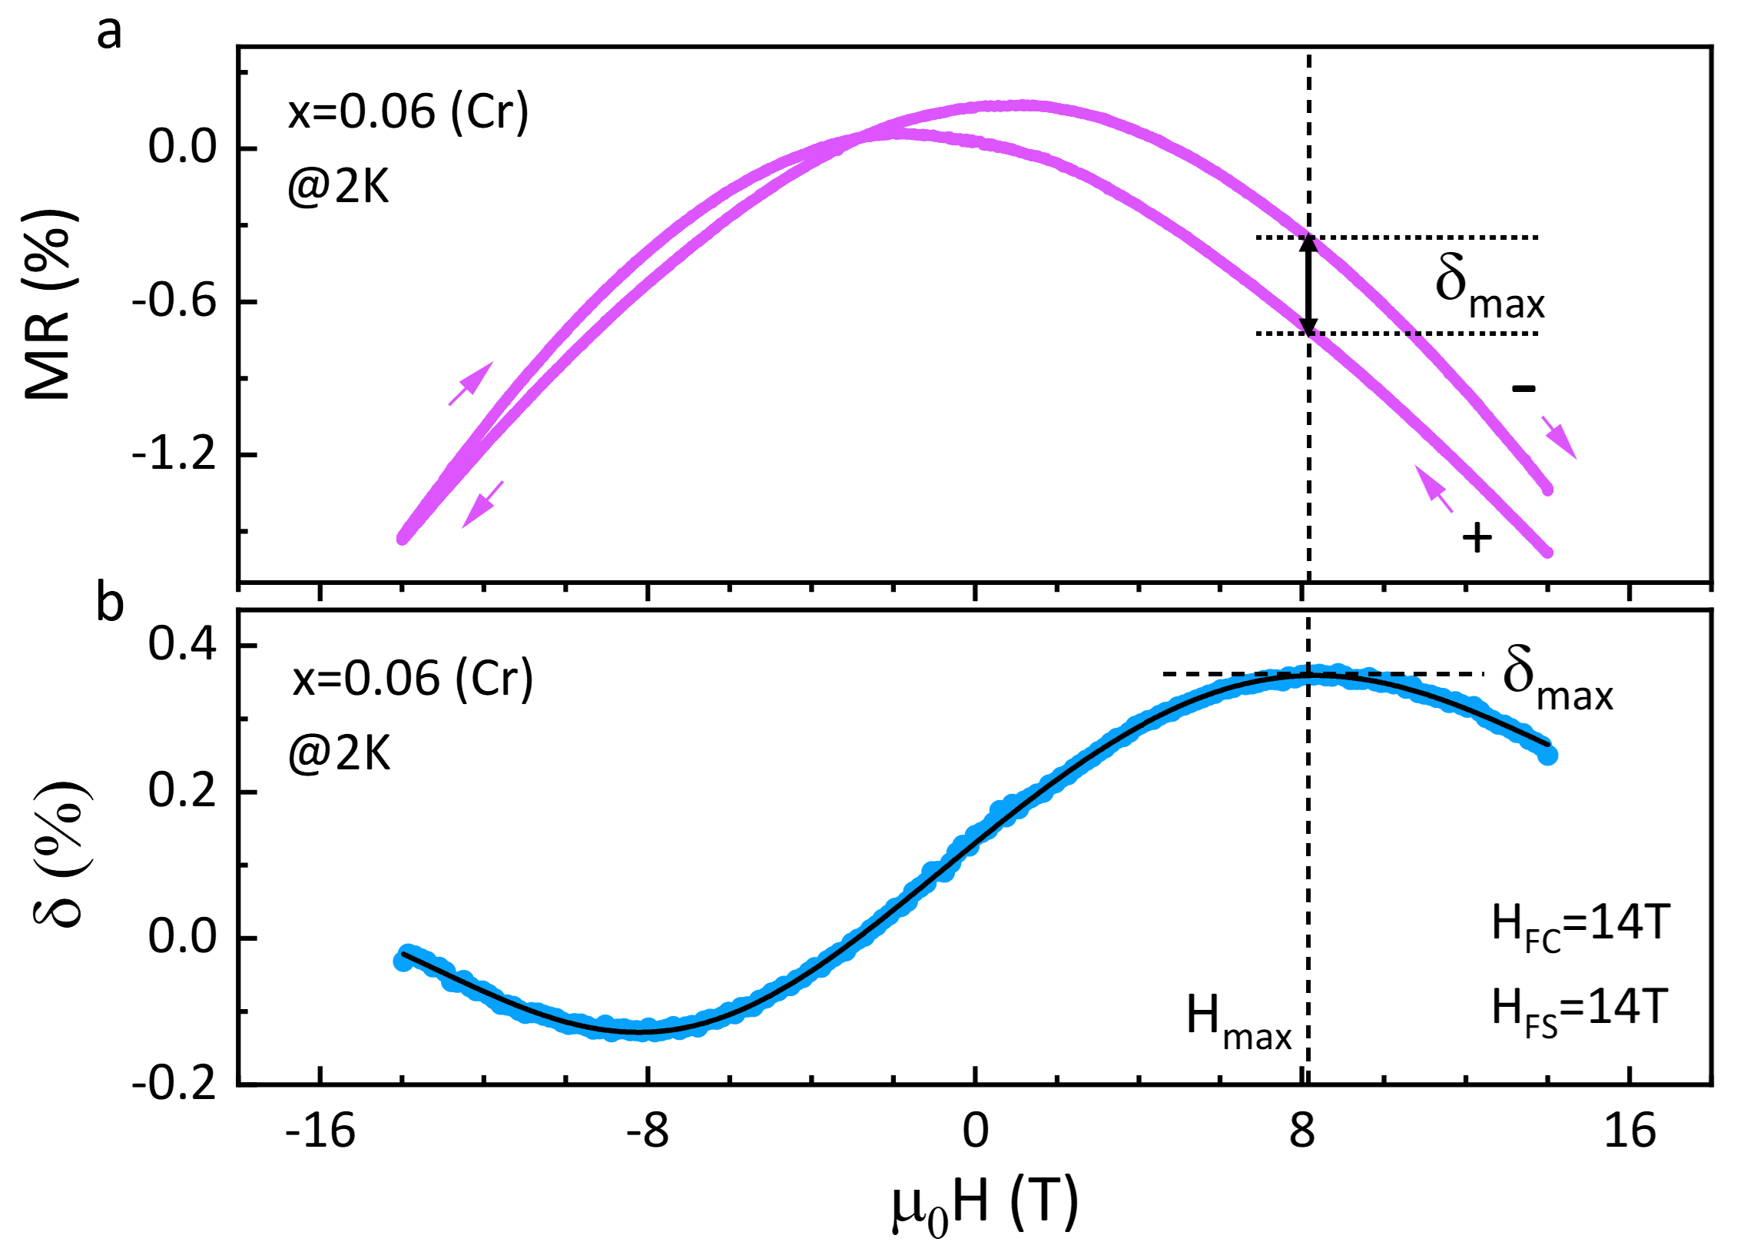
Figure S4 | Definition of parameters $δ$ and $δ_{max}$ in the magnetoresistance measurements. (a): Magnetoresistance versus field (MR) curve taken at 2 K after Cr-doped (x = 0.06) CsFe₂As₂ is cooled from above $T_{f}$ with $H_{FC}=$ 14 T, $H_{FS}=$14 T. The symbol “$+$” and “$-$” represents the magnetic field scanning direction in the magnetoresistance measurements, the same as that in Fig. S3d. (b): Field-dependent $δ$ at 2 K, which is defined as the relative magnetoresistance difference between ${MR}_{+}$ curve and ${MR}_{-}$ curve, $δ= {(ρ_{{MR}_{-}}-ρ_{{MR}_{+}})}/{(ρ_{{MR}_{-}})}*100$. Furthermore, we define the parameter $δ_{max}$as $δ_{max}=Max\left\{δ\right\}$ to characterize the strength of EB effect in the magnetoresistance measurements. According to the Gaussian bimodal fitting (the solid black line), we could obtain the maximum value $δ_{max}$. The dashed vertical line in panels a and b marks the filed $H_{max}$ at which $δ$ reaches its maximum value.
S5. Characterizations of EB effect in Cr-doped (x = 0.10) CsFe₂As₂ from the magnetization and magnetoresistance measurements.
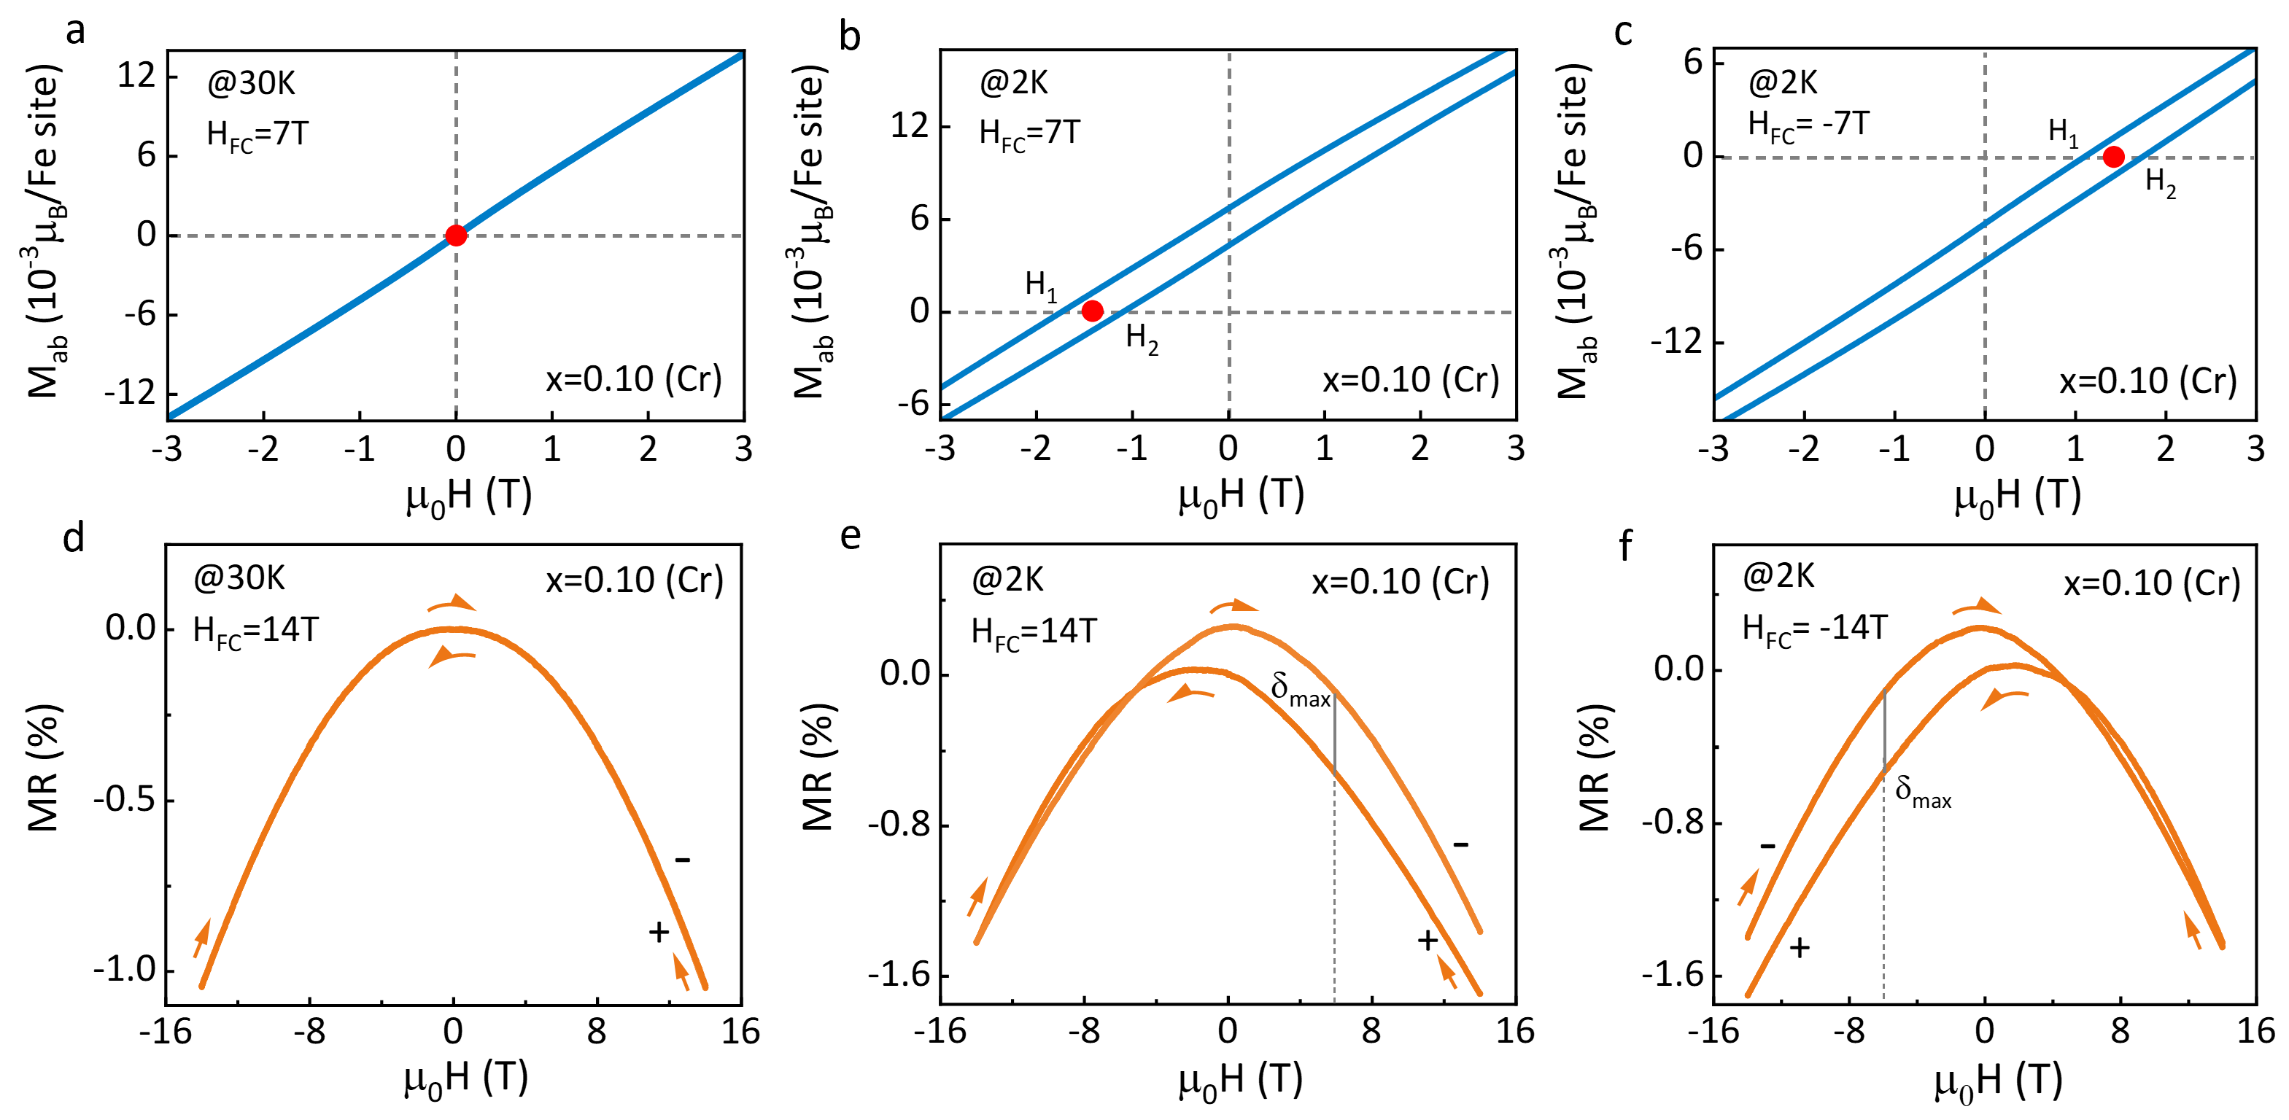
Figure S5 | Evidences for EB effect in Cr-doped (x = 0.10) CsFe₂As₂ from the magnetization and magnetoresistance measurements. (a): Linear magnetization versus field line taken at 30 K after the sample is cooled from above $T_{f}$ with $H_{FC}=$ 7 T, $H_{FS}=$ 7 T. (b), (c): Magnetization versus field (MH) curves taken at 2 K after the sample is cooled from above $T_{f}$ with a cooling field of 7 T ($H_{FC}=$ 7 T) and $-$7 T ($H_{FC}=$ $-$7 T), respectively. $H_{1}$ ($H_{2}$) marks the left (right) intercept of each loop on the zero-magnetization axis. The red dot in panels a-c marks the center of each MH curve on the field-axis. The path of field scanning is 7 T $→ -$7 T $→$ 7 T ($H_{FS}=$ 7 T). For clarity, we only present the low-field magnetic susceptibilities. Notably, the data is the same as that shown in Figs. 2c and 2d in the main text. (d): Magnetoresistance (MR) versus field curves taken at 30 K after the sample is cooled from above $T_{f}$ with $H_{FC}=$14 T, $H_{FS}=$14 T. (e), (f): Magnetoresistance (MR) versus field curves taken at 2 K after the sample is cooled from above $T_{f}$ with a cooling field of 14 T ($H_{FC}=$ 14 T) and $-$14 T ($H_{FC}=$ $-$14 T), respectively. In panels d-f, the symbol “$+$”, “$-$” and $δ_{max}$are the same as that described in Fig. S3d.
As shown in Fig. S5a, the magnetization of Cr-doped (x = 0.10) CsFe₂As₂ is linearly dependent on the magnetic field when the sample is cooled to 30 K with a cooling field of 7 T ($H_{FC}=$ 7 T). With temperature decreasing to 2 K, an evident magnetic hysteresis loop appears and its center is shifted to the negative field with $H_{FC}=$ 7 T, as marked by the red dot in Fig. S5b. When the cooling field becomes $-$7 T ($H_{FC}=$ $-$7 T), the loop center is shifted to the positive field, which is almost opposite to that with $H_{FC}=$ 7 T as shown in Fig. S5c. Simultaneously, the parameter $δ_{max}$in the magnetoresistance measurements appears at the almost opposite filed with $H_{FC}=$ 14 T and $H_{FC}=$ $-$14 T (Figs. S5e and S5f), corresponding to the symmetric loop shift in the magnetization measurements. When the temperature increases to 30 K, higher than $T_{f}$, the ${MR}_{-}$ curve coincides with the ${MR}_{+}$curve in the whole field sweeping range (Fig. S5d), corresponding to that linear MH line shown in Fig. S5a. Such cooling-field dependent magnetization and magnetoresistance results further indicate the presence of the EB effect in Cr-doped CsFe₂As₂ [1-3].
S6. Systematic magnetoresistance measurements performed on Cr-doped (x = 0.06) CsFe₂As₂.
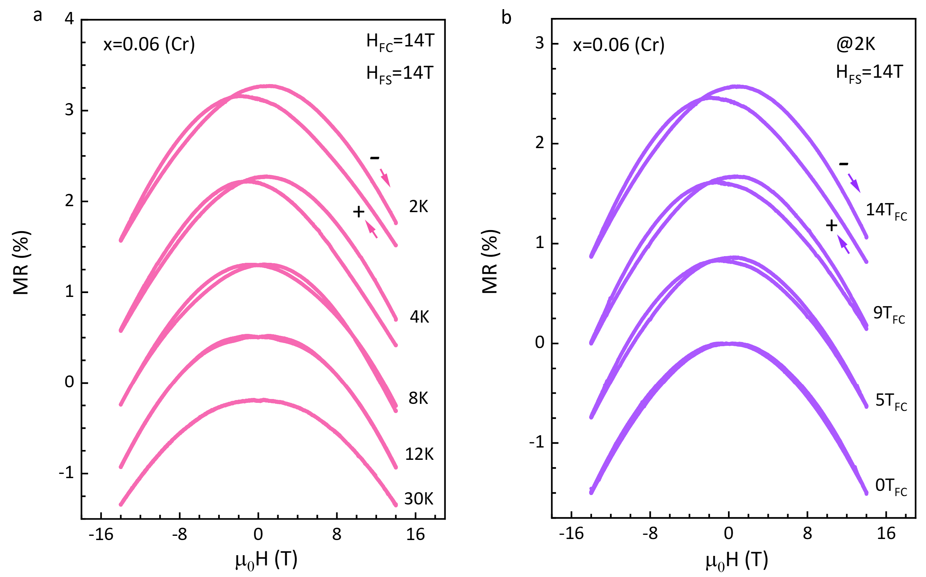
Figure S6 | Magnetoresistance versus field measurements performed on Cr-doped (x = 0.06) CsFe₂As₂. (a): Magnetoresistance versus field (MR) curve taken at various temperatures after the sample is cooled from above $T_{f}$ with a cooling field of 14 T ($H_{FC}=$ 14 T). (b): Magnetoresistance versus field (MR) curve taken at 2 K after the sample is cooled from above $T_{f}$ with different cooling fields. Here, the magnetic field is in-plane and parallel to the direction of the current. For clarity, the MR curves have been shifted along the y-axis in panels a and b. From these measurements, the obtained parameter $δ_{max}$ has been plotted in the following Fig. S8.
S7. Systematic magnetoresistance measurements performed on Cr-doped (x = 0.10) CsFe₂As₂.
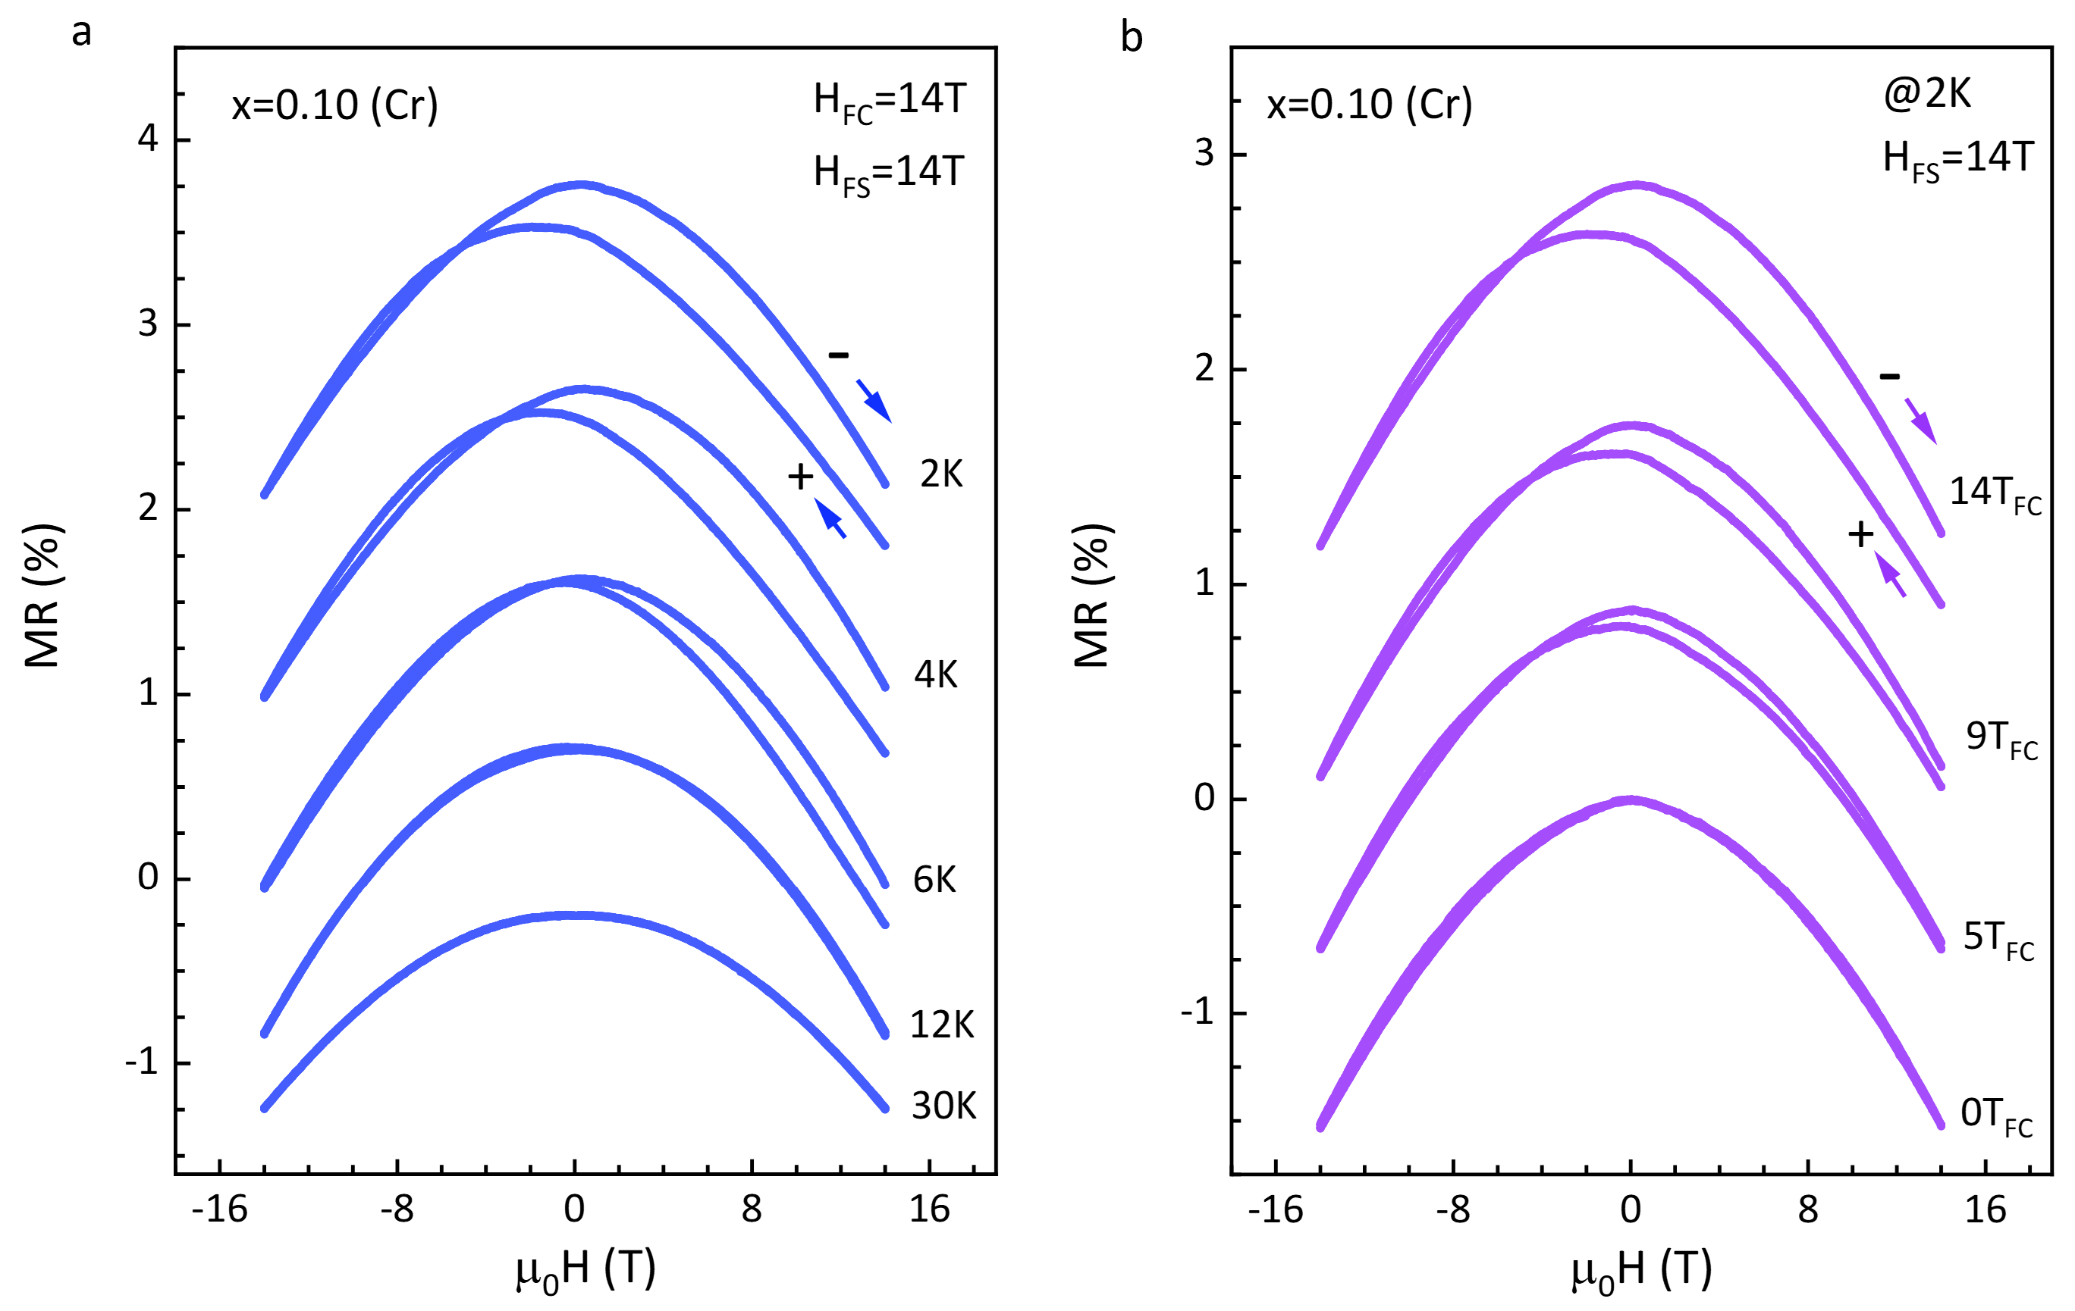
Figure S7 | Magnetoresistance versus field measurements performed on Cr-doped (x = 0.10) CsFe₂As₂. (a): Magnetoresistance versus field (MR) curve taken at various temperatures after the sample is cooled from above $T_{f}$ with a cooling field of 14 T ($H_{FC}=$ 14 T). (b): Magnetoresistance versus field (MR) curve taken at 2 K after the sample is cooled from above $T_{f}$ with different cooling fields. Here, the magnetic field is in-plane and parallel to the direction of the current. For clarity, the MR curves have been shifted along the y-axis in panels a and b. From these measurements, the obtained parameter $δ_{max}$ has been plotted in the following Fig. S8.
S8. Evolutions of the parameter $δ_{max}$ in the magnetoresistance measurements performed on Cr-doped CsFe₂As₂.
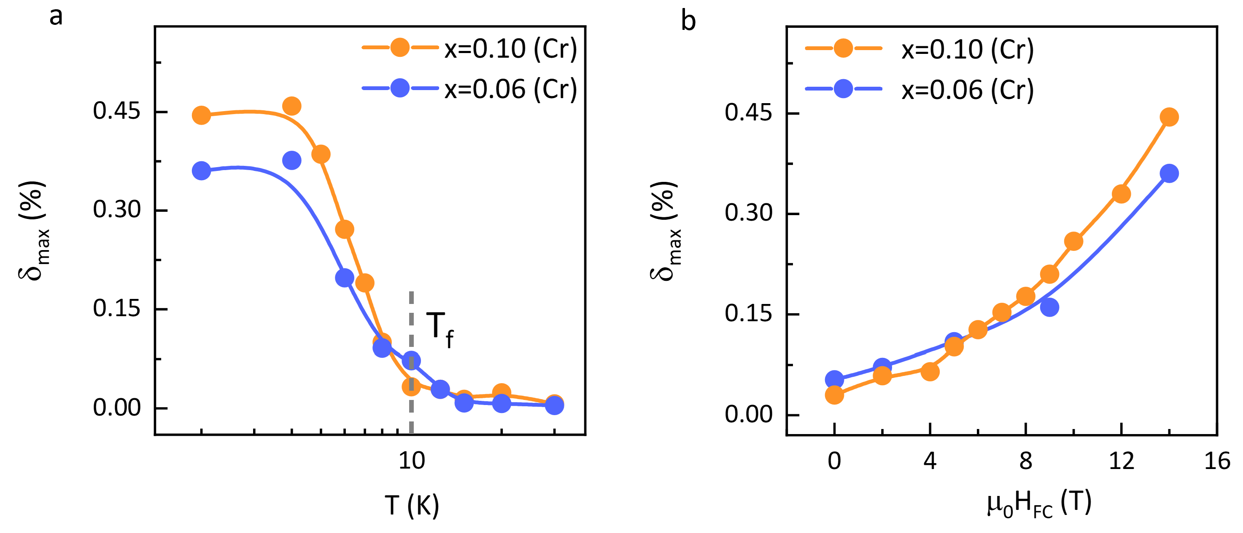
Figure S8 | Evolutions of the parameter $δ_{max}$ in the magnetoresistance measurements performed on Cr-doped CsFe₂As₂ (x = 0.06 (blue dots) and x = 0.10 (yellow dots)). (a): Temperature dependence of $δ_{max}$. The dashed line marks the spin-freezing temperature with the cooling field of 14 T (${ H}_{FC}=$14 T), around which $δ_{max}$ starts to be nonzero. (b): Cooling-field dependence of $δ_{max}$ at 2 K. The solid lines are guiding for the eyes.
To further investigate the evolutions of EB effect, we performed the systematic magnetoresistance measurements on Cr-doped (x = 0.06) and (x = 0.10) CsFe₂As₂. In Figs. S6 and S7, we present several representative MR curves measured at different conditions. From these measurements, we could obtain the temperature-dependent and cooling-field-dependent $δ_{max}$. As shown in Fig. S8a, $δ_{max}$ starts to be nonzero and increase with decreasing temperature around $T_{f }$, which is estimated to be 10 K with $H_{FC}=$ 14 T according to the extrapolation of AT line shown in Fig. 1b in the main text or in the inset of Extended Data Fig. 2b. Near 4 K, it tends to be saturated. In addition, it presents a monotonic increase with increasing $H_{FC}$ ($0≤H_{FC}≤$ 14 T) at 2 K as shown in Fig. S8b.
In view of spin-dependent scattering mechanism [4], such evolutions of $δ_{max}$ could be interpreted naturally, in which the relative difference of longitudinal magnetoresistance mainly depends on the change of spin configuration. Above $T_{f}$, the spin configuration is reversible on the two curves and thus $δ_{max}$ is almost zero. Below $T_{f}$, the spin configuration on ${MR}_{-}$ curve is different from that on ${MR}_{+}$ curve due to the shifts of loop center. With the increase of loop shifts, the difference of spin configurations between the two curves would become more prominent. Besides, the increase of coercivity would also enhance the difference of spin configuration between the two curves. Therefore, the parameter $δ_{max}$ would increase with the increase in $H_{EB}$ and $H_{C}$, and vice versa. In such case, it is reasonable that $δ_{max}$ starts to increase below $T_{f}$ and then shows a plateau-like behavior around 4 K (Fig. S8a), where $H_{EB}$ and $H_{C}$ start to display the opposite trend with further decreasing temperature in Cr-doped CsFe₂As₂ (Figs. 4a and 4b in the main text). Likewise, $δ_{max}$ increases with increasing $H_{FC}$ at 2 K (Fig. S8b) under the influence of both $H_{EB}$ and $H_{C}$ (Figs. 4c and 4d in the main text). To be mentioned, $H_{EB}$ starts to decrease around 9 T in Cr-doped (x = 0.10) CsFe₂As₂ (Fig. 4e in the main text), while, $H_{C}$ continues to increase until 14 T (Fig. 4f in the main text). Because the increase in $H_{C}$ is obviously larger than the decrease in $H_{EB}$, $δ_{max}$ still shows a monotonic increasing trend with $H_{FC}$ ($0≤H_{FC}≤$ 14 T) in Cr-doped (x = 0.10) CsFe₂As₂.
These consistent temperature-dependent and cooling-field-dependent results in the magnetoresistance and magnetization measurements validate that $δ_{max}$ indeed could be regarded as the parameter to characteristic the strength of EB effect in Cr-doped CsFe₂As₂. By the way, we could not define the explicit $H_{EB}$or $H_{C}$ in the magnetoresistance measurements like in the case of MnF₂/Fe bilayers [3], since the change of magnetoresistance in Cr-doped (x = 0.06) CsFe₂As₂ is very tiny and thus no sharp peak could be detected around the coercive field.
S9. Training effect in Cr-doped (x = 0.10) CsFe₂As₂ evidenced from the repeated magnetoresistance measurements.
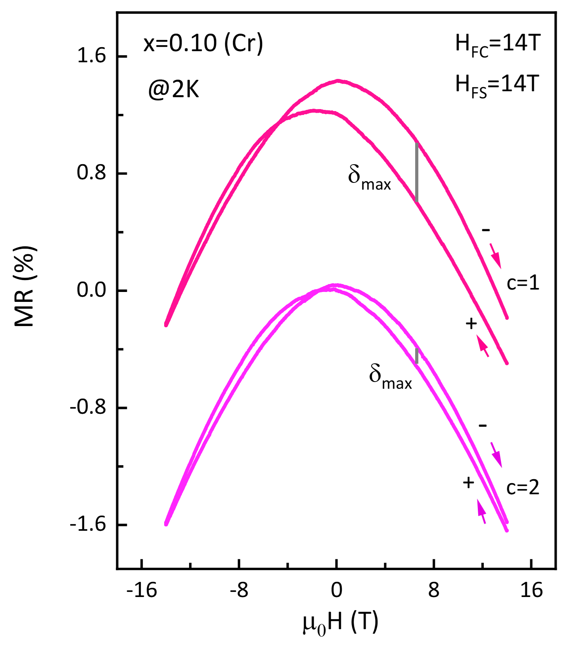
Fig. S9 | Training effect in Cr-doped (x = 0.10) CsFe₂As₂ evidenced from the repeated magnetoresistance measurements. Magnetoresistance versus field (MR) curves taken at 2 K after the sample is cooled from above $T_{f}$ with $H_{FC}=14 T$. The symbol “$+$”, “$-$” and $δ_{max}$ represents the same meaning as described in Fig. S3d. The symbol “$c$” represents the number of field cycles in the continuous magnetoresistance measurements. The path of filed scanning is 14 T $→$ –14 T $→$ 14 T ($c$ = 1) $→$ –14 T $→$ 14 T ($c$ = 2). Notably, the magnetic field is in-plane and parallel to the direction of the current. For clarity, the MR curves with $c$ = 1 have been shifted along the y-axis.
Training effect (TE) is a powerful method to confirm the EB effect is an intrinsic behavior rather than an artifact of the minor loop [1,2,5]. As shown in Extended Data Fig. 9, an evident asymmetric training effect has been observed in Cr-doped (x = 0.10) CsFe₂As₂ from the continuous magnetization measurements, further excluding the possibility of minor loops. Here, similar training effect has also been detected in the repeated magnetoresistance measurements of Cr-doped (x = 0.10) CsFe₂As₂. As shown in Fig. S9, the parameter $δ_{max}$ in the second field cycle ($c$ = 2) is obviously smaller than that in the first field cycle ($c$ = 1), corresponding to the decrease in $H_{EB}$ and $H_{C}$ with $n$ in the continuous magnetization measurements since $δ_{max}$ would decrease with the decrease in $H_{EB}$ and $H_{C}$ as described in the above S8.
Part $C$. Results of the magnetization and magnetoresistance measurements in the pristine and Co-doped CsFe₂As₂.
S10. Absence of EB effect in the pristine CsFe₂As₂ evidenced from the magnetization and magnetoresistance measurements.
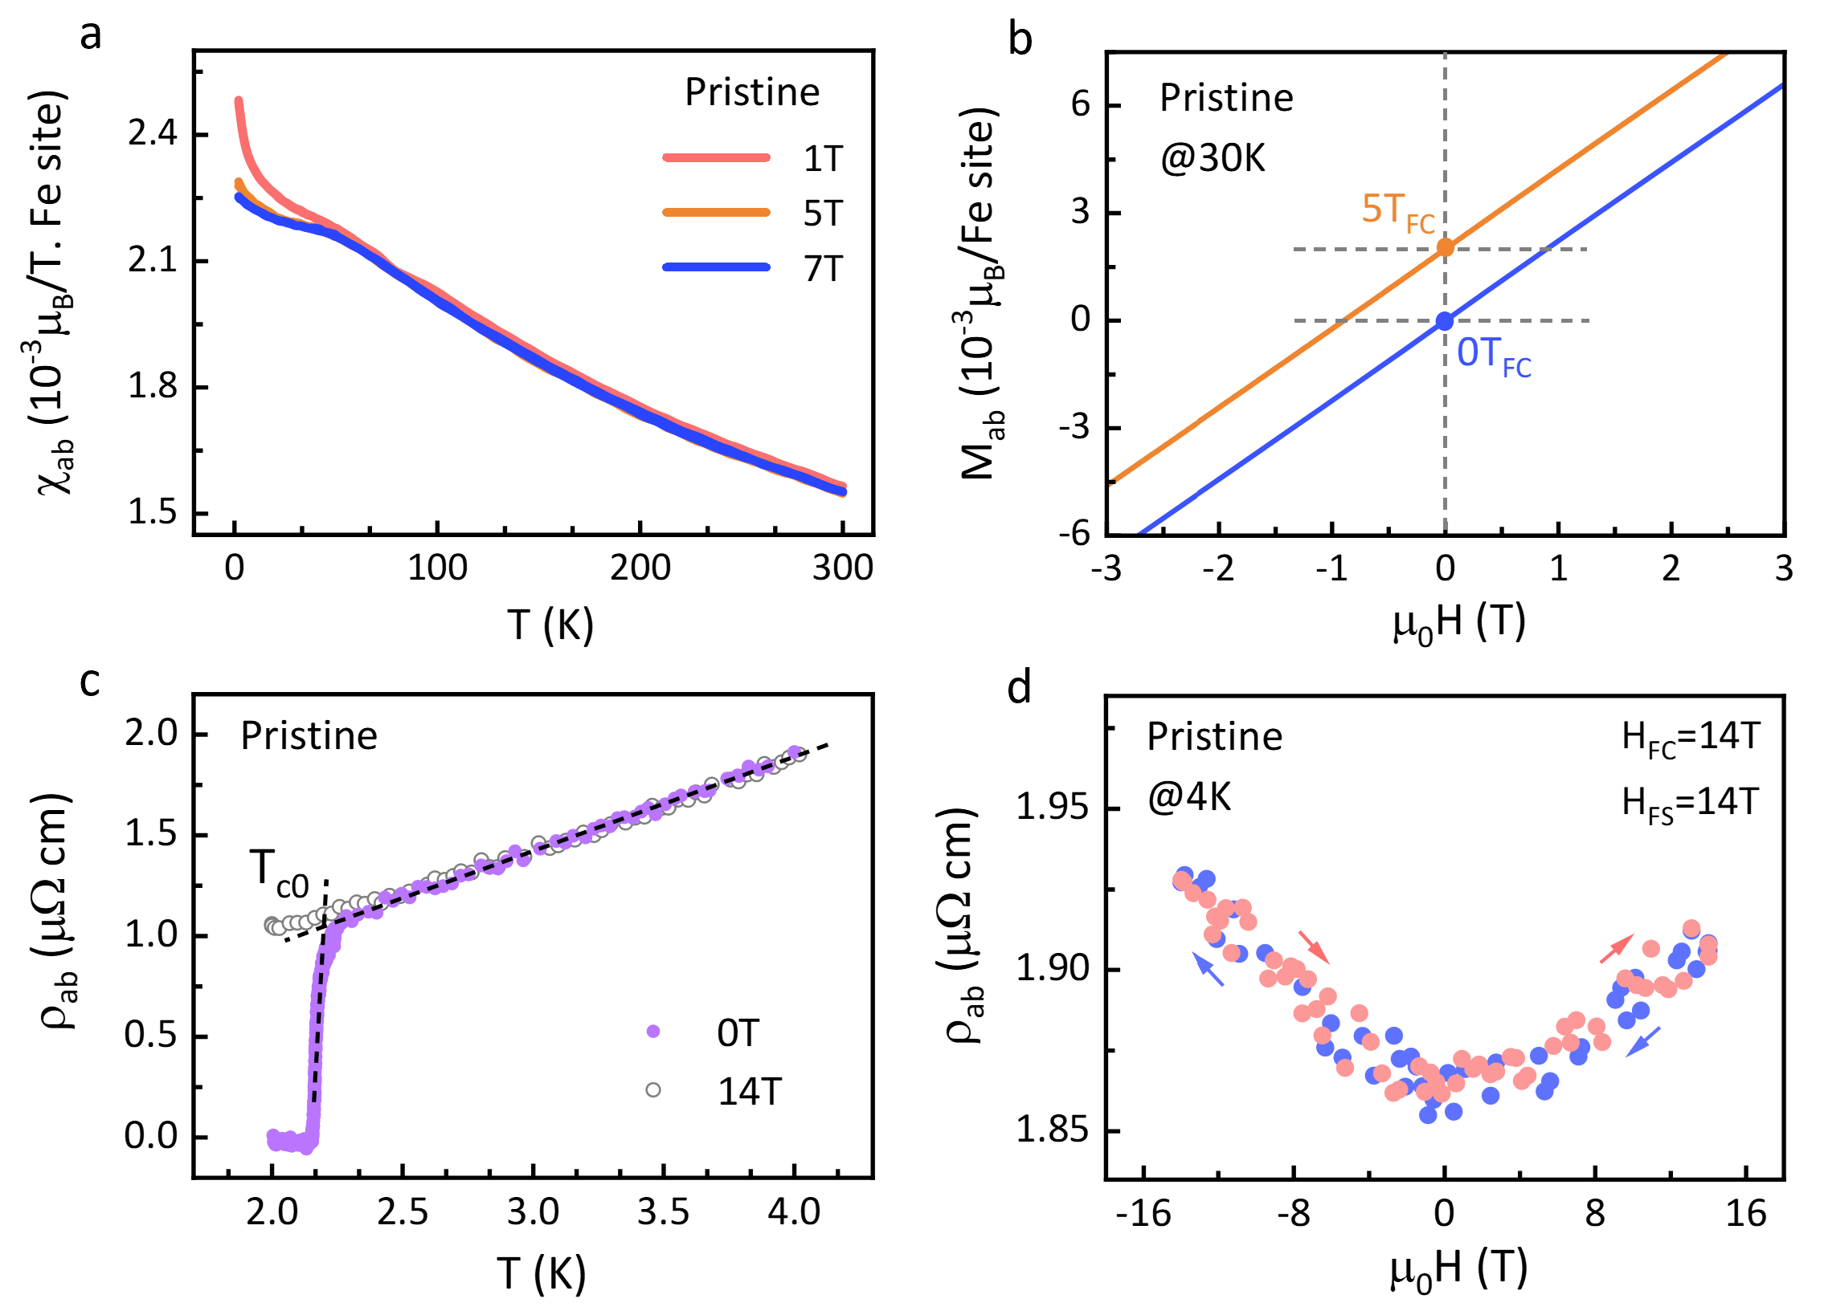
Fig. S10 | Magnetization and magnetoresistance measurements performed on the pristine CsFe₂As₂. (a): Temperature-dependent in-plane magnetic susceptibilities $χ_{ab}$ of the pristine CsFe₂As₂, measured under both field cooling (FC) and zero-field (ZFC) cooling modes with the applied field of 1, 5 and 7 T. (b): In-plane magnetization versus field (MH) lines taken at 30 K when the sample is cooled with the field of 0 T (the blue line) and 5 T (the yellow line). For comparison, the line with $H_{FC}=$5 T is shifted along the y-axis since it is totally overlapped with the line with $H_{FC}=0 T$. The path of field scanning is 7 T $→$ $-$7 T $→$ 7 T ($H_{FS}=$ 7 T) in the magnetization measurements. Here, we only present the low-field MH line for clarity. (c): Low-temperature in-plane resistivities $ρ_{ab}$in the pristine CsFe₂As₂, measured with the applied field of 0 T (the solid purple dots) and 14 T (the hollow gray dots). The black dashed lines are two tentative T-linear trends to extract the onset superconducting transition temperature $T_{c0} \sim$2.2 K, consistent with that previously reported [6]. Here, the magnetic field is out-of-plane and perpendicular to the direction of the current. (d): Magnetoresistance versus field curve taken at 4 K after the sample is cooled with a field of 14 T ($H_{FC}=$ 14 T). The path of field scanning is 14 T $→$ $-$14 T $→$ 14 T ($H_{FS}=$ 14 T), as indicated by the arrows. Here, the magnetic field is in-plane and parallel to the direction of the current. By the way, the data are kind of scattered due to the tiny magnetoresistance in the pristine CsFe₂As₂.
S11. Absence of EB effect in Co-doped (x = 0.07) CsFe₂As₂ evidenced from the magnetization measurements.
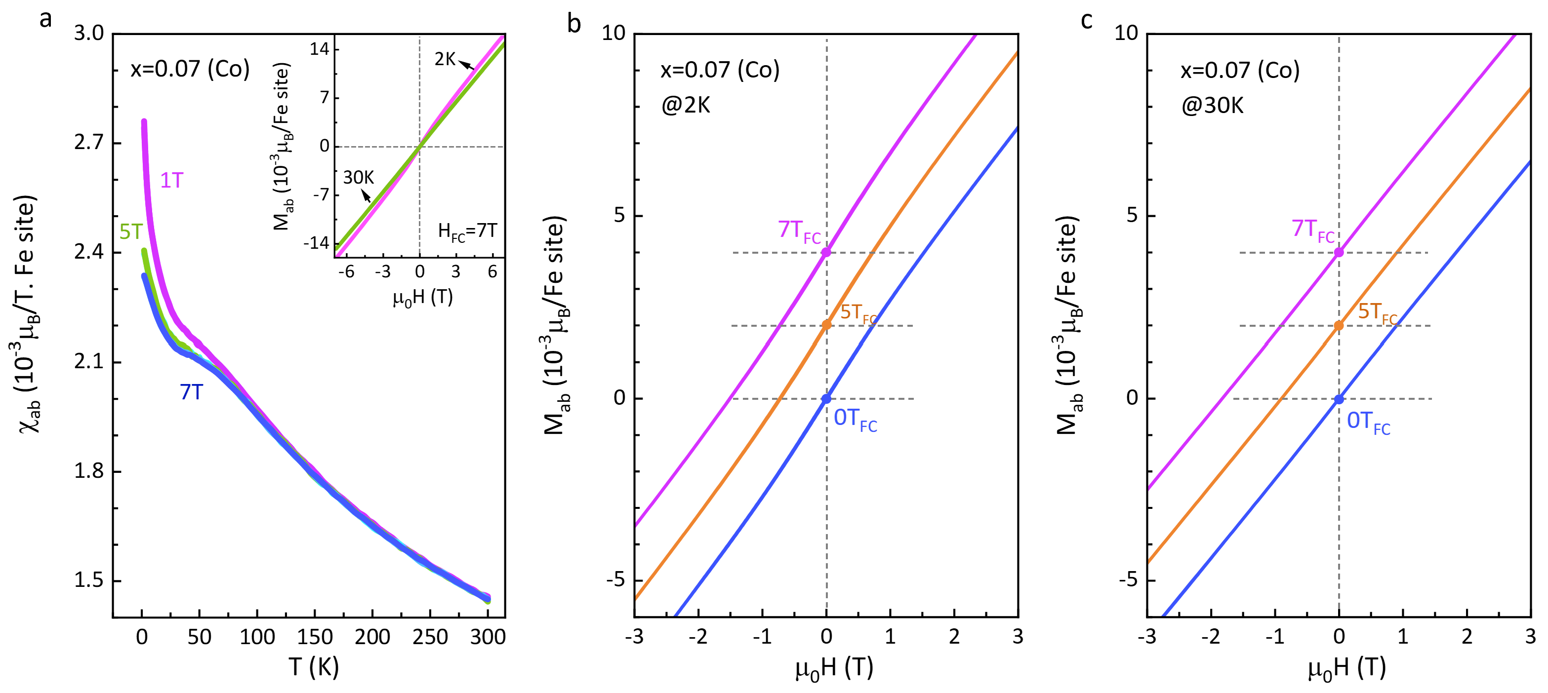
Fig. S11 | Magnetization measurements performed on Co-doped (x = 0.07) CsFe₂As₂. (a): Temperature-dependent in-plane magnetic susceptibilities $χ_{ab}$, measured under both field cooling (FC) and zero-field (ZFC) cooling modes with the applied field of 1, 5 and 7 T. Inset are the magnetization versus field (MH) lines taken at 2 K and 30 K after the sample is cooled with a field of 7 T ($H_{FC}=$ 7 T). The enlarged images are displayed in panels b and c. (b), (c): Low-field in-plane magnetization versus field (MH) lines measured with different cooling fields, taken at 2 K and 30 K respectively. For comparison, the lines with $H_{FC}>0 T$ in panels b and c are shifted along the y-axis since they are totally overlapped with the line with $H_{FC}=0 T$.
S12. Absence of EB effect in Co-doped (x = 0.11) CsFe₂As₂ evidenced from the magnetization measurements.
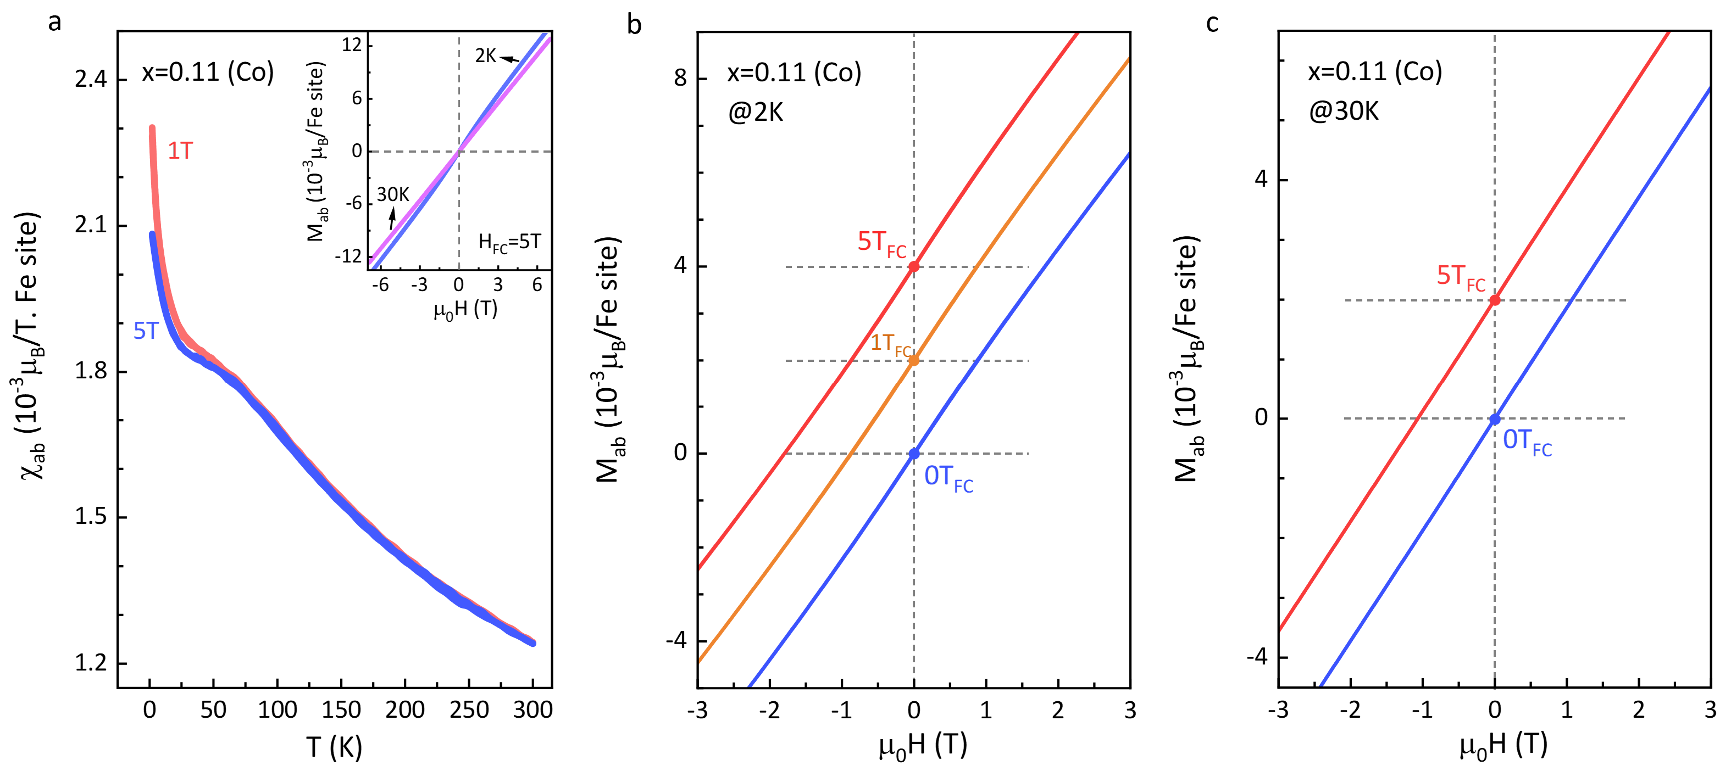
Fig. S12 | Magnetization measurements performed on Co-doped (x = 0.11) CsFe₂As₂. (a): Temperature-dependent in-plane magnetic susceptibilities $χ_{ab}$, measured under both field cooling (FC) and zero-field (ZFC) cooling modes with the applied field of 1 and 5 T. Inset are the magnetization versus field (MH) lines taken at 2 K and 30 K after the sample is cooled with a field of 5 T ($H_{FC}=$ 5 T). The enlarged images are displayed in panels b and c. (b), (c): Low-field in-plane magnetization versus field (MH) lines with different cooling fields, taken at 2 K and 30 K respectively. For comparison, the lines with $H_{FC}>0 T$ in panels b and c are shifted along the y-axis since they are totally overlapped with the line with $H_{FC}=0 T$.
As shown in Figs. S10a, S11a and S12a, the in-plane magnetic susceptibilities $χ_{ab}$ show the typical paramagnetic behaviors with decreasing temperature and could be normalized well under different applied fields except at low temperatures, where the behavior of $χ_{ab}$ could be influenced by the impurity effect. Besides, the FC curve completely coincides with the ZFC curve and the magnetization versus field (MH) curve is always a straight line crossing the origin whether at 2 K or 30 K in the pristine or Co-doped (x = 0.07 and x= 0.11) CsFe₂As₂ (Figs. S10b, S11b, S11c, S12b and S12c). Different from that in Cr-doped CsFe₂As₂, such results indicate the absence of spin-glass state in the pristine and Co-doped (x = 0.07 and x= 0.11) CsFe₂As₂, consistent with that reported in our earlier work [7].
Moreover, the MH lines with different cooling fields are totally overlapped with each other whether measured at 2 K or 30 K (Figs. S10b, S11b, S11c, S12b and S12c), indicating the cooling-field-history has no effect on the MH behaviors in the pristine or Co-doped (x = 0.07 and x= 0.11) CsFe₂As₂. In addition, the magnitude of the applied field does not have any influence on the resistivity behavior in the pristine CsFe₂As₂ as seen from the almost same $ρ_{ab}$ in the normal state with the applied field of 0 T and 14 T (Fig. S10c). Meanwhile, there is almost no difference between the field-decreasing and field-increasing curve at 4 K (Fig. S10d), indicating the field-sweeping history has no effect on the magnetoresistance behavior in the normal state of the pristine CsFe₂As₂. By comparison with that in Cr-doped CsFe₂As₂, such behaviors of $χ_{ab}$ and $ρ_{ab}$ suggest the absence of EB effect in the pristine and Co-doped (x = 0.07 and x= 0.11) CsFe₂As₂, which should be attributed to the absence of spin-glass state at low temperatures.
Part D. Research of EB effect in two inhomogeneous systems, perovskite material and Heusler alloy.
S13. Collected data of the exchange bias field ($H_{EB}$) and coercive field ($H_{C}$) in two inhomogeneous EB systems, perovskite material and Heusler alloy.
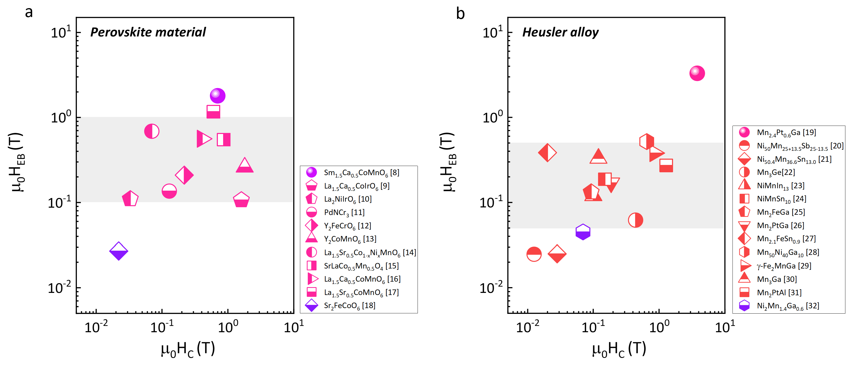
Fig. S13 | Collected data of $H_{EB}$ and $H_{C}$ in two inhomogeneous EB systems, perovskite material (a) and Heusler alloy (b). The dark purple ball in panel a represents Sm_{1.5}Ca_{0.5}CoMnO₆ with the largest bias field of 1.8 T in perovskite material. The pink ball in panel b represents Mn_{2.4}Pt_{0.6}Ga with the largest bias field of 3.3 T in Heusler alloy. The purple dots in panels a and b are on behalf of Sr₂FeCoO₆ and Ni₂Mn_{1.4}Ga_{0.6} respectively with the much smaller bias field, classified into the spin-glass system exhibiting EB effect. The four data have been plotted in Fig. 5g in the main text for comparison.
A number of experiments have been explored in the inhomogeneous materials, helpful to investigate the role of disorder and frustration played in EB systems. Here, we mainly research the perovskite material and Heusler alloy, whose characteristic parameters $H_{EB}$ and $H_{C}$ are shown in Fig. S13. It is clear that most of $H_{EB}$ are on the order of 0.1 T and only a few could reach the order of several Tesla whether in perovskite material or Heusler alloy, where the interfacial exchange coupling between FM clusters (SG, SSG (super spin glass)) and AFM (FIM (ferrimagnet), SG) matrix are thought to bring about the EB effect [8-32]. These complex magnetic phases result from the frustration of competing interactions induced mainly by the structural distortion and antisite disorder effect. Among them, Mn_{2.4}Pt_{0.6}Ga presents the largest $H_{EB}$ of 3.3 T (the pink ball in Fig. S13b), where the exchange interactions between the almost compensated AFM host and the small FM clusters play a vital role [19]. In addition, $H_{EB}$ could reach 1.8 T at 5 K in Sm_{1.5}Ca_{0.5}CoMnO₆ (the dark purple ball in Fig. S13a), which has been thought to be the consequence of interfacial effect between the AFM core and the SSG matrix [8]. However, the smaller $H_{EB}$ is on the order of 0.01 T in double perovskite Sr₂FeCoO₆ (the purple bottom-filled diamond in Fig. S13a) and NiMn-based alloy Ni₂Mn_{1.4}Ga_{0.6} (the purple bottom-filled hexagon in Fig. S13b), where the coexistence of FM region and SG matrix without long-range magnetic orders gives rise to the EB effect [18,32]. That is to say, the SG state or SG interface plays an essential role in controlling EB effect in Ni₂Mn_{1.4}Ga_{0.6} and Sr₂FeCoO₆, which could be classified as spin-glass systems exhibiting EB effect as shown in Fig. 5g in the main text.

References
- Nogués, J. & Schuller, I. K. Exchange bias. J. Magn. Magn. Mater. 192: 203-232 (1999).
- Sahoo, R. C., Takeuchi, Y., Ohtomo, A. et al. Exchange bias and spin glass states driven by antisite disorder in the double perovskite compound LaSrCoFeO₆. Phys. Rev. B 100: 214436 (2019).
- Leighton, C., Song, M., Nogués, J. et al. Using magnetoresistance to probe reversal asymmetry in exchange biased bilayers. J. Appl. Phys. 88: 344-347 (2000).
- Diény, B. Giant magnetoresistance in spin-valve multilayers. J. Magn. Magn. Mater. 136: 335-359 (1994).
- Binek, C. Training of the exchange-bias effect: A simple analytic approach. Phys. Rev. B 70: 014421 (2004).
- Wang, A. F., Pan, B. Y., Luo, X. G. et al. Calorimetric study of single-crystal CsFe₂As₂. Phys. Rev. B 87: 214509 (2013).
- Li, S. J., Zhao, D., Wang, S. et al. Emergent spin-glass state in the doped Hund's metal CsFe₂As₂. Phys. Rev. B 107: 115144 (2023).
- Giri, S. K., Sahoo, R. C., Dasgupta, P. et al. Giant spontaneous exchange bias effect in Sm_{1.5}Ca_{0.5}CoMnO₆ perovskite. J. Phys. D 49: 165002 (2016).
- Coutrim, L. T., Bittar, E. M., Stavale, F. et al. Compensation temperatures and exchange bias in La_{1.5}Ca_{0.5}CoIrO₆. Phys. Rev. B 93: 174406 (2016).
- Rao, T. D., Marik, S., Singh, D. et al. Observation of exchange bias effect in La₂NiIrO₆. J. Alloy. Compd. 705: 849-852 (2017).
- Lin, S., Shao, D. F., Lin, J. C. et al. Spin-glass behavior and zero-field-cooled exchange bias in a Cr-based antiperovskite compound PdNCr₃. J. Mater. Chem. C 3: 5683-5696 (2015).
- Patra, K. P. & Ravi, S. Sign reversal of both spontaneous and conventional exchange bias in nanoparticles of Y₂FeCrO₆ double perovskite. J. Appl. Phys. 132 (2022).
- Nair, H. S., Chatterji, T. & Strydom, A. M. Antisite disorder-induced exchange bias effect in multiferroic Y₂CoMnO₆. Appl. Phys. Lett. 106 (2015).
- Zhang, H., Wang, S., Chen, W. et al. The exchange bias effect and Griffiths phase in La_{1.5}Sr_{0.5}Co_{1-x}Ni_{x}MnO₆: The impact of the divalent Ni. Curr. Appl. Phys. 53: 65 (2023).
- Das, R. R., Parida, P., Bera, A. K. et al. Giant exchange bias in the single-layered Ruddlesden-Popper perovskite SrLaCo_{0.5}Mn_{0.5}O₄. Phys. Rev. B 98: 184417 (2018).
- Sahoo, R. C., Paladhi, D., Dasgupta, P. et al. Antisite-disorder driven large exchange bias effect in phase separated La_{1.5}Ca_{0.5}CoMnO₆ double perovskite. J. Magn. Magn. Mater. 428: 86-91 (2017).
- Krishna Murthy, J. & Venimadhav, A. Giant zero field cooled spontaneous exchange bias effect in phase separated La_{1.5}Sr_{0.5}CoMnO₆. Appl. Phys. Lett. 103 (2013).
- Pradheesh, R., Nair, H. S., Sankaranarayanan, V. et al. Exchange bias and memory effect in double perovskite Sr₂FeCoO₆. Appl. Phys. Lett. 101 (2012).
- Nayak, A. K., Nicklas, M., Chadov, S. et al. Design of compensated ferrimagnetic Heusler alloys for giant tunable exchange bias. Nature Mater. 14: 679-684 (2015).
- Khan, M., Dubenko, I., Stadler, S. et al. Exchange bias behavior in Ni–Mn–Sb Heusler alloys. Appl. Phys. Lett. 91 (2007).
- Çakır, A., Acet, M. & Farle, M. Exchange bias caused by field-induced spin reconfiguration in Ni-Mn-Sn. Phys. Rev. B 93: 094411 (2016).
- Qian, J. F., Nayak, A. K. & Kreiner, G. et al. Exchange bias up to room temperature in antiferromagnetic hexagonal Mn₃Ge. J. Phys. D. Appl. Phys. 47: 305001 (2014).
- Wang, B. M., Liu, Y., Ren, P. et al. Large exchange bias after zero-field cooling from an unmagnetized state. Phys. Rev. Lett. 106: 077203 (2011).
- Wang, B. M., Liu, Y., Xia, B. et al. Large exchange bias obtainable through zero-field cooling from an unmagnetized state in Ni-Mn-Sn alloys. J. Appl. Phys. 111 (2012).
- Liu, Z. H., Zhang, Y. J., Zhang, H. G. et al. Giant exchange bias in Mn₂FeGa with hexagonal structure. Appl. Phys. Lett. 109 (2016).
- Nayak, A. K., Nicklas, M., Chadov, S. et al. Large zero-field cooled exchange-bias in bulk Mn₂PtGa. Phys. Rev. Lett. 110: 127204 (2013).
- Zhang, Q., Liu, Z. & Ma, X. Magnetic transition and the associated exchange bias, transport properties in Mn_{2.1}FeSn_{0.9} alloy. J. Phys. D. Appl. Phys. 54: 505001 (2021).
- Zhang, Y., Li, J., Tian, F. et al. Spin cluster size dependence of exchange bias effect in Mn₅₀Ni₄₀Ga₁₀ Heusler alloys. Intermetallics 107: 10-14 (2019).
- Tang, X. D., Wang, W. H., Zhu, W. et al. Giant exchange bias based on magnetic transition in γ-Fe₂MnGa melt-spun ribbons. Appl. Phys. Lett. 97 (2010).
- Song, L., Ding, B., Li, H. et al. Observation of large exchange bias above room temperature in antiferromagnetic hexagonal Mn₃Ga. J. Magn. Magn. Mater. 536: 168109 (2021).
- Patel, A. K., Samatham, S. S., Lukoyanov, A. V. et al. Nearly compensated ferrimagnetic behavior and giant exchange bias of hexagonal Mn₂PtAl: experimental and theoretical studies. Phys. Chem. Chem. Phys. 24: 29539 (2022).
- Han, Z. D., Qian, B., Wang, D. H. et al. Magnetic phase separation and exchange bias in off-stoichiometric Ni-Mn-Ga alloys. Appl. Phys. Lett. 103: 172403 (2013).

