SUPPLEMENTARY INFORMATION
Nonlinear Memristive Computational Spectrometer
Xin Li^{1,2,3}, Jie Wang¹, Feilong Yu¹, Jin Chen¹, Guanhai Li^{1,3,4,5*}, Xiaoshuang Chen^{1,3,4,5}, Wei Lu^{1,2,3,4,5}
¹State Key Laboratory of Infrared Physics, Shanghai Institute of Technical Physics, Chinese Academy of Sciences, 500 Yu-Tian Road, Shanghai, 200083, China
²School of Physical Science and Technology, ShanghaiTech University, Shanghai 201210, China
³University of Chinese Academy of Science, No. 19A Yuquan Road, Beijing 100049, China
⁴Hangzhou Institute for Advanced Study, University of Chinese Academy of Sciences, No.1 Sub-Lane Xiangshan, Hangzhou, 310024, China
⁵Shanghai Research Center for Quantum Sciences, 99 Xiupu Road, Shanghai, 201315, China
*xschen@mail.sitp.ac.cn; ghli0120@mail.sitp.ac.cn

Table of contents
Note 1. Calculation of band structure and electrical transport properties of p-i-n WSe₂.
Fig. S2. Transfer curves for different doping types of WSe₂.
Fig. S3. Comparison of Energy Band Modulation: Gate-Control vs. Ion Migration.
Fig. S4: Differential charge density analysis of Pd-doped WSe₂.
Fig. S5. TCAD Simulation of Nonlinear Photonic Memristor Dynamics.
Fig. S6. Exploration of Energy Band Evolution and Memristive Characteristics.
Fig. S7. Diverse Photocurrent Responses across Wavelengths for Spectral 1 to Spectrum 5.
Fig. S8. Diverse Photocurrent Responses across Wavelengths for Spectral 6 to Spectrum 10.
Fig. S9. Measured spectral power for Spectrum 1 to Spectrum 10.
Fig. S10. Partial Dynamic Nonlinear Response of the Memristor Across Power, Voltage, and Wavelengths.
Fig. S11. Nonlinear response of memristor under 631nm irradiation in various states.
Fig. S12. Process for Altered Memristive Behavior in PIN Devices.
Fig. S13. Photocurrent and Dark Current Response in Non-Memristive Devices under Monochromatic Light.
Fig. S14. Output Characteristic Curves of Non-Memristor under Voltage Scanning.
Fig. S15. Dark Current Behavior in Non-Memristor Devices Across Various States.
Fig. S16. Responsivity Comparison Between Memristor and Non-Memristor Devices.
Fig. S17. Spectrometer Measurement Optical Setup.
Fig. S18. Spectral Reconstruction via Nonlinear Neural Networks.
Fig. S19. Dark current repeatability in the memristor.
Fig. S20. Photocurrent repeatability in the memristor.
Fig. S21. Response in the visible band.
Fig. S22. Reconstructed versus actual spectra for 400nm-800nm.
Table S1. Performance comparison of reported computational spectrometers and ours.

Supplementary Note 1. Calculation of band structure and electrical transport properties of p-i-n WSe_{2.}

The values of carrier concentration versus Fermi energy level and carrier mobility are calculated by the following equations.
For nondegenerate n-type semiconductor (𝐸_{𝐶} − 𝐸_{𝐹} > 2𝑘_{𝐵𝑇})
$$N_{n}=N_{c}exp⁡(-\frac{E_{c}-E_{v}}{k_{B}T})$$
For degenerate n-type semiconductor (𝐸_{𝐶} − 𝐸_{𝐹} ≤ 2𝑘_{𝐵𝑇})
$$N_{n}=N_{c}\frac{2}{\sqrt{π}}F_{1/2}⁡(-\frac{E_{c}-E_{v}}{k_{B}T})$$
$N_{c}=2×{(\frac{m_{e}^{*}k_{B}T}{2πћ^{2}})}^{\frac{3}{2}}={K(\frac{m_{e}^{*}}{m_{0}})}^{\frac{3}{2}}$ ( K=2.5094E19) is the conduction band equivalent density of states, $k_{B}$ is the Boltzmann constant, $T$ is the temperature,$m_{e}^{*}$ is the electron effective mass¹, and $F_{1/2}$ is the Fermi integral function. Mobility is calculated as²$μ=\frac{I_{ds}L}{V_{ds}n_{2D}}$. Finally, the electron mobility and hole mobility were calculated as 13 cm²V⁻¹s⁻¹ and 1 cm²V⁻¹s⁻¹, respectively³.
The basic transport model of WSe₂ is
$$∇^{2}φ=-\frac{q}{ε}(N+p-n)$$
Here $φ$ is the potential, $N$ is the net doping concentration, $p$ is the electron concentration, and $n$ is the hole concentration.
$$\frac{∂n}{∂t}=\frac{1}{q}∇∙\vec{J_{n}}+(G-R)$$
Eq. 4 implies the electron continuity, where G and R denote the carrier production rate and the complex rate, respectively.
$$\frac{∂p}{∂t}=-\frac{1}{q}∇∙\vec{J_{p}}+(G-R)$$
Eq. 5 is the hole continuity equation, where G and R denote the carrier production rate and the complex rate, respectively.
$$\vec{J_{n}}=qD_{n}∇n-nqμ_{e}∇φ$$
Eq. 6 is the electron current transport equation, including diffusion and drift currents.
$$\vec{J_{p}}=-qD_{p}∇p-pqμ_{p}∇φ$$
Eq. 7 is the hole current transport equation, including diffusion and drift currents.
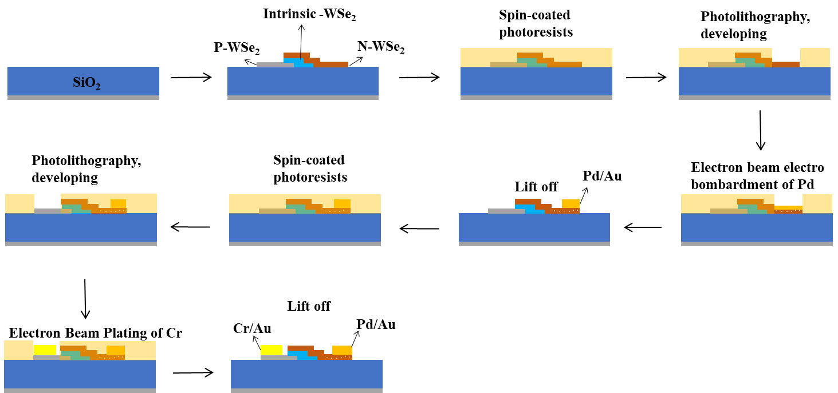
Fig. S1. Stepwise Fabrication of the Nonlinear Micro-Spectrometer. This figure outlines the meticulous process used to create the device, starting with the mechanical exfoliation of WSe₂ flakes from bulk crystals. These flakes are then transferred onto a SiO₂/Si substrate to form a PIN structure. A photoresist layer is applied to the WSe₂ surface before defining the anode pattern via laser direct writing lithography. High-speed Pd deposition (30 nm) follows, utilizing an electron beam evaporator to establish the anode. The process continues with the detachment of the anode end, and the creation of the drain end involves spin-coating another layer of photoresist, additional lithography, and a final detachment step, culminating in a device with Cr/Au (5nm/25nm) serving as the cathode.

Fig. S2. Transfer curves for different doping types of WSe₂. (a) P-doped WSe₂ (Nb-doped), (b) intrinsic WSe₂, (c) N-doped WSe₂ (Re-doped). where the insets are schematic diagrams of the corresponding field effect transistors of the devices, respectively. It can be seen that the type of transport of the carriers of the three materials is well demonstrated by the transfer curves.

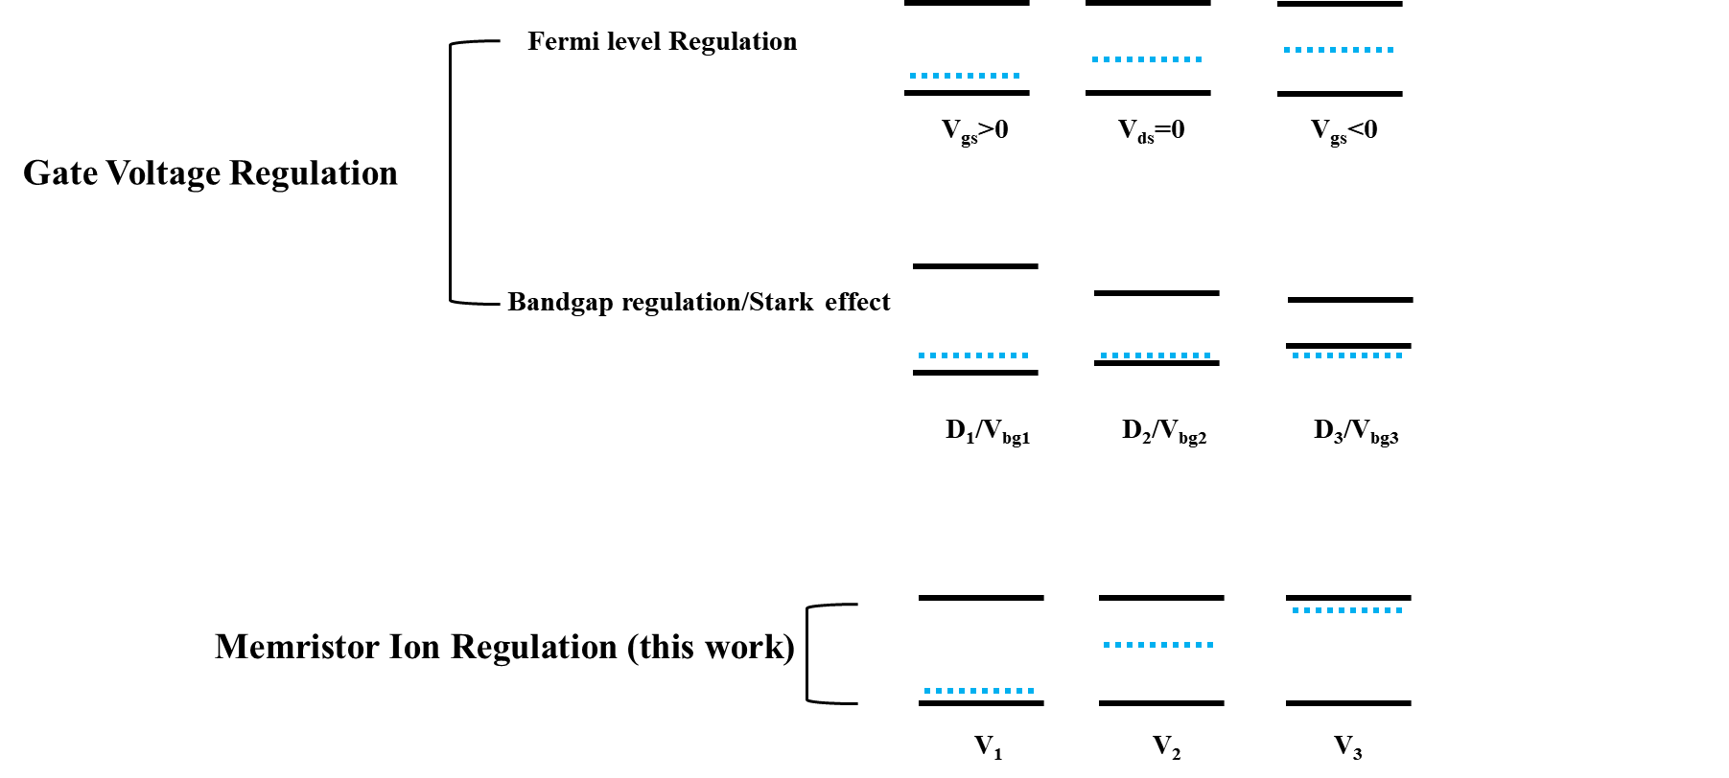
Fig. S3: Comparison of Energy Band Modulation: Gate-Control vs. Ion Migration. This figure contrasts the traditional gate voltage modulation of energy bands, which is typically limited to Fermi level modulation in unipolar materials and bandgap width modulation (or Stark effect), with the advanced technique of ion migration. Gate-controlled modulation is constrained in its ability to adjust the Fermi level and can only alter the bandgap width within a specific range. In contrast, the innovative approach of amnesia tuning through ion scanning significantly extends the modulation capacity, enabling dramatic adjustments to the material's Fermi level.

Fig. S4: Differential charge density analysis of Pd-doped WSe₂. Since the radius of Pd atom is closer to the radius of Se atom, usually Pd forms a substitutional impurity of Se [1]. Based on the first nature principle, the differential charge density of the model is calculated. As shown in the figure, the charge density around Pd is significantly reduced, implying that in this structural species Pd exists in the form of electron donor, which transforms WSe₂ to n-doped. Moreover, when Pd is bonded to W, two electron-losing metal atoms, its Coulomb repulsion is strong and the binding energy is lowered, implying that only a small driving force is needed to release Pd from bonding.

Fig. S5: TCAD Simulation of Nonlinear Photonic Memristor Dynamics. (a) Illustrates the space charge region's evolution in TCAD simulations, transitioning from highly doped P (-40V pulsing) to highly doped N (40V pulsing), depicted from left to right. (b) Shows the pin band diagram's evolution in the P layer, moving from a highly doped P state to a highly doped N state with voltage pulsing. (c) Depicts the distribution of the built-in electric field within the pin structure as it transitions from P to N doping states. (d) Visualizes the spatial charge concentration distribution within the pin structure, highlighting the significant modulation from P to N doping states due to voltage pulsing.

Fig. S6: Exploration of Energy Band Evolution and Memristive Characteristics. (a) Displays an SEM image of the photonic memristor, highlighting its resistive switching properties. (b) Shows the distribution of Pd ions across channels 1, 2, 3, and 4 (referenced in (a)) after undergoing preprocessing with voltage pulsing at 40V, 20V, -20V, and -40V to establish resistive switching. (c) Details the elemental composition within channels 1(i), 2(ii), 3(iii), and 4(iv) following 20V pulsing, emphasizing the memristor's resistive switching attributes. (d) Presents an SEM image of a device lacking resistive switching characteristics for comparison. (e) Illustrates the distribution of Pd ions in channels 1, 2, 3, and 4 (as shown in (d)) without resistive switching characteristics, post voltage pulsing at varied levels. (f) Explores the elemental composition within channels 1(i), 2(ii), 3(iii), and 4(iv) of the non-switching device, post 20V pulsing, highlighting differences in material composition and ion distribution in the absence of resistive switching features.

Fig. S7: Diverse Photocurrent Responses across Wavelengths for Spectral 1 to Spectrum 5. This figure showcases photocurrent datasets from Spectrum 1 to Spectrum 5, capturing the device's response to back-and-forth voltage scanning at 40V across different wavelengths, specifically from 630nm to 640nm with a half-width of 2nm. The lower panels offer an expanded view of specific regions, highlighted by red boxes in the upper panels, providing detailed insights into the photocurrent variations and demonstrating the device's sensitivity and resolution capabilities at these narrowly defined wavelength intervals.
Fig. S8. Photocurrent datasets for different wavelengths in Spectrum 6 to Spectrum 10. This figure presents the device's response to voltage scanning (40V, back-and-forth) over different wavelengths, spanning 630nm to 640nm with a 2nm half-width. Enhanced views of select areas, marked by red boxes in the upper panels, are displayed in the lower panels, offering detailed examination of photocurrent fluctuations and showcasing the device's acute wavelength resolution and sensitivity within this narrow wavelength range.

Fig. S9. Measured spectral power for Spectrum 1 to Spectrum 10. This figure displays the measured spectral powers for Spectrum 1 through Spectrum 10, with each curve representing the spectral power of the white source post-monochromatic filtering. These measurements reveal the differential power distribution across the spectra, providing insights into the filtering efficacy and spectral characteristics of the device under varying light conditions.
Fig. S10: Partial Dynamic Nonlinear Response of the Memristor Across Power, Voltage, and Wavelengths. This figure illustrates the memristor's nonlinear response as a function of varying parameters such as power, voltage, and wavelengths. Changes in voltage alter the device's responsivity due to dynamic shifts in the energy band structure. Increased power introduces a delay in the internal migration of Pd ions, significantly affecting the device's responsivity. This visualization underscores the intricate relationship between electrical input and the memristor's photonic output, highlighting its complex internal mechanisms.

Fig. S11. Nonlinear response of memristor to 631nm light at different powers in various states. State 1: -40 V, State 2: 10 V, State 3: 20 V, State 4: 30 V, and State 5: 40 V pulsing.

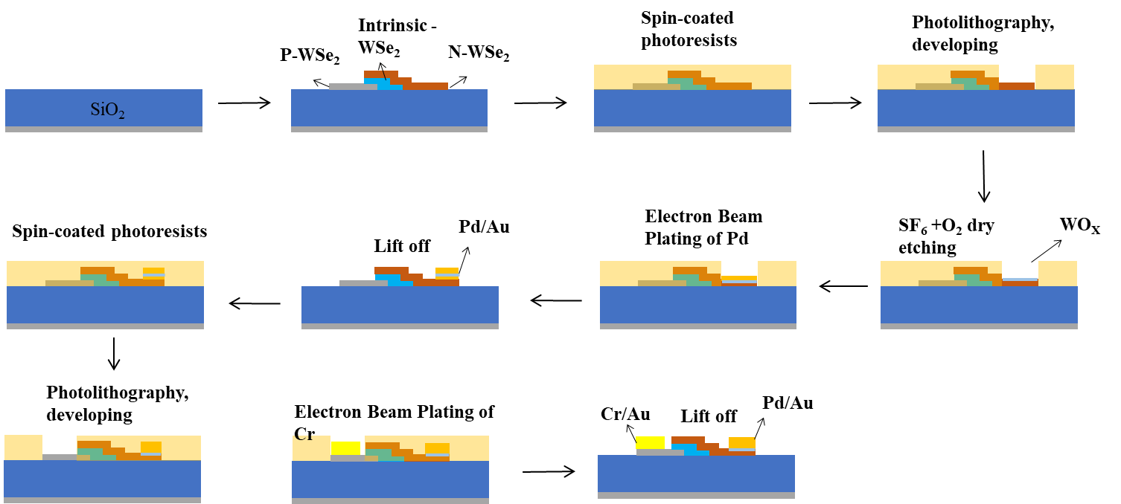
Fig. S12: Process for Altered Memristive Behavior in PIN Devices. This figure outlines the modified fabrication steps designed to suppress memristive behavior in the PIN device. Starting with the mechanical exfoliation of WSe₂ flakes onto a SiO₂/Si substrate, the process includes coating with photoresist and defining the anode pattern via laser lithography. The exposed regions are etched using SF₆ and O₂ gases at 150 W to prepare for electrode formation. Subsequently, Pd is deposited at a low speed to form the anode, followed by detachment. The cathode end is similarly created using spin-coating, lithography, and detachment, finishing with Cr/Au deposition (5nm/25nm), aiming for a structure without inherent memristive characteristics.

Fig. S13: Photocurrent and Dark Current Response in Non-Memristive Devices under Monochromatic Light. This figure presents the photocurrent and dark current behavior of non-memristor devices stimulated with 631nm (a), 635nm (b), and 640nm (c) monochromatic light. It is observed that these devices exhibit robust pn junction characteristics, with photocurrents increasing almost linearly in response to rising optical power. This linear increase in photocurrent, alongside a corresponding rise in photo-generated electromotive force, underscores the distinct electrical behavior of non-memristive devices under varying light conditions.

Fig. S14: Output Characteristic Curves of Non-Memristor under Voltage Scanning. This figure illustrates the output characteristic curves of a non-memristor device as the voltage is scanned from -40V to +40V. Unlike memristive counterparts, this device exhibits no memristive effects, serving as a stark contrast for intuitive comparison. The absence of memristive behavior is attributed to the lack of Pd ion implantation, preventing the dynamic modulation of the energy band and highlighting the critical role of ion migration in memristive functionality.

Fig. S15: Dark Current Behavior in Non-Memristor Devices Across Various States. This figure examines the dark current characteristics of non-memristor devices, highlighting that their low-voltage polarity characteristics cannot be modulated in the same manner as memristors. Moreover, these devices lack the non-volatile nature inherent to memristors, emphasizing a significant distinction in their electrical behavior and memory retention capabilities.

Fig. S16: Responsivity Comparison Between Memristor and Non-Memristor Devices. This figure contrasts the responsivity of memristor and non-memristor devices under optical stimuli of 631nm (a), 635nm (b), and 640nm (c) across different states (State 1: -40V, State 2: 10V, State 3: 20V, State 4: 30V, and State 5: 40V pulsing). The comparison delineates the distinctive response behaviors, highlighting the memristor's advanced functionality and the non-memristor's static response under identical conditions.

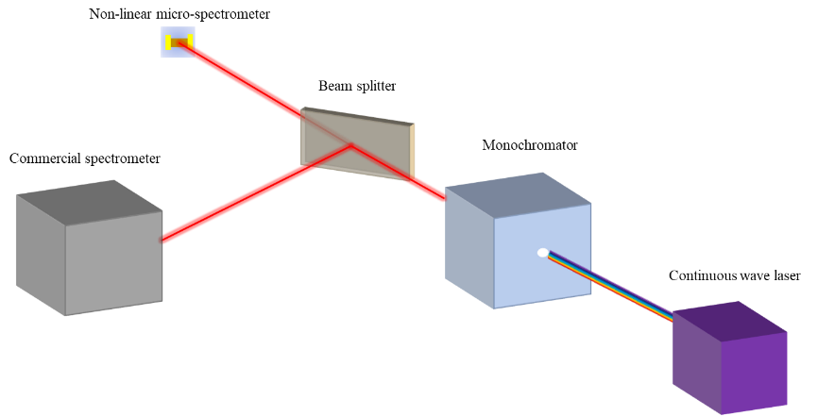
Fig. S17: Spectrometer Measurement Optical Setup. This figure presents a schematic of the optical setup utilized for reconstructing unknown spectra using our single-junction photonic memristor. A white light source emits a continuous spectrum, processed by a monochromator to yield monochromatic, narrow-bandwidth light. This light is then split; one path directs light towards the nonlinear memristor for analysis, while another path leads some light to a commercial spectrometer for reference measurements, illustrating the comprehensive approach to spectral data collection and analysis.

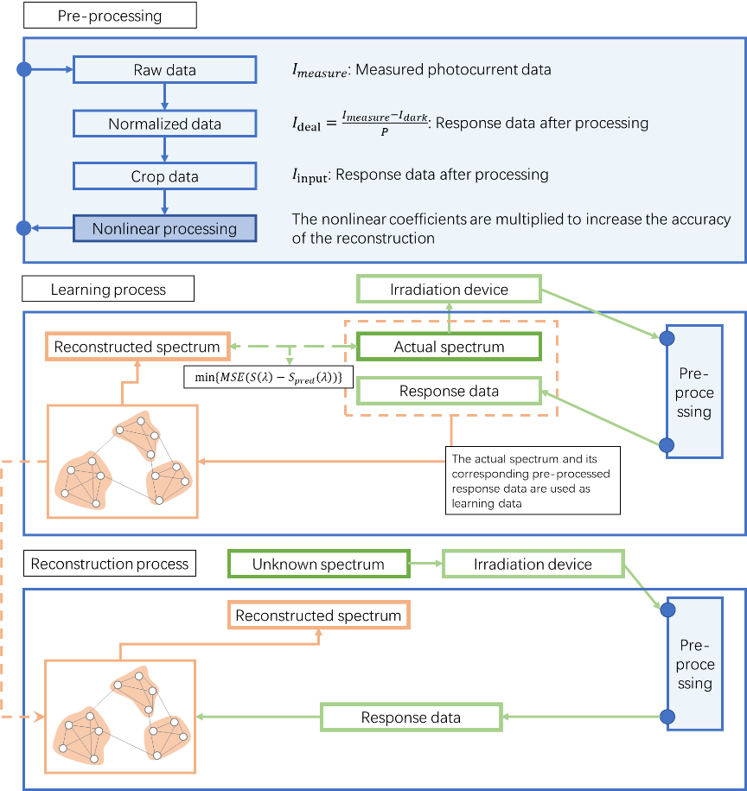
Fig. S18: Spectral Reconstruction via Nonlinear Neural Networks. This figure outlines the spectral reconstruction process using nonlinear neural networks, tailored to accommodate the device's nonlinearity which renders traditional methods ineffective. It details the initial data preprocessing to derive usable optical response data, followed by the neural network's training phase aimed at minimizing the mean squared error (MSE) between the reconstructed and actual spectra, with Adam chosen as the optimizer. As training progresses, the learning rate decreases. The final step involves using the trained network to predict unknown spectra, incorporating nonlinear processing for varying power levels or complex spectral incidences, thus enhancing the network's adaptability to diverse spectral inputs.

Fig. S19: Dark Current Repeatability in the Memristor. This figure displays the outcomes of scanning the memristor's dark current 20 times, demonstrating high repeatability. Such consistency is crucial for the accuracy of spectral prediction, underscoring the device's reliability and the predictability of its performance in spectral analysis tasks.

Fig. S20. Photocurrent repeatability in the memristor. This figure highlights the results from three consecutive photocurrent scans under identical conditions, showcasing negligible differences between the trials. The near-overlapping results under the same experimental setup affirm the memristor's operational consistency. This repeatability is crucial, indicating that the device's testing variance falls well below its accuracy threshold, thereby validating the reliability of the memristor for precise spectral analysis applications.

Fig. S21. Response in the visible band. (a) IT of the device under 405 nm laser irradiation at different power. (b) IT of the device under 520 nm laser irradiation at different power. (c) IT of the device under 830 nm laser irradiation at different power.

Fig. S22. Reconstructed versus actual spectra for 400nm-800nm. We reconstructed the 400-800 nm spectra based on this algorithm, and it can be seen that the reconstructed spectra are basically consistent with the input spectra.

Table S1: Performance comparison of reported computational spectrometers and ours.

Reference | Physics or method (material or device) | Structure or  requirement | Footprint | Spectral  resolution | Spectral  range (nm) | wavelength accuracy
(4) | Nanowire bandgap gradation (single CdS_{x}Se_{1−x} nanowire) | Detector array | 75×0.5 μm² | ~10nm | 500-630 | /
(5) | Bandgap tuned by Stark effect (black phosphorus channel) | Single detector @80K | 16×9 μm² | ~90nm | 2000-9000 | /
(6) | Tunable quantum efficiency (superconducting nanowire) | Single detector @1.65K | 6×6 μm² | ~6nm | 660-1900 | /
(7) | Tunable interlayer excited state transition (ReS₂/Au/WSe₂ vdW heterostructure) | Single detector @80K | 6×4 μm² | ~20nm | 1150-1470 | /
(8) | Tunable interlayer transport (MoS₂/WSe₂ vdW heterojunction) | Single detector under  ambient conditions | 22×8 μm² | ~3nm | 405-845 | 0.36nm
(9) | Tunable interlayer transport (MoS₂/BP vdW heterojunction) | Single detector @300K | 30×20 μm² | ~2nm | 1700-3600 | /
(10) | Tunable interlayer transport (SnS₂/ReSe₂ vdW heterojunction) | Single detector @300K | 22×10 μm² | ~5nm | 400-800 | /
This work | Our memristive energy band regulation (P-I-N WSe₂ vdW heterojunction) | Single detector @300K | 4×9 μm² | ~2nm | 400-800 | 0.18nm

References
1 Liu, E. et al. Signatures of moiré trions in WSe₂/MoSe₂ heterobilayers. Nature 594, 46-50 (2021).
2 Chen, Y. et al. Unipolar barrier photodetectors based on van der Waals heterostructures. Nature. Electronics 4, 357-363 (2021).
3 Wang, Z. et al. The ambipolar transport behavior of WSe₂ transistors and its analogue circuits. NPG Asia Materials 10, 703-712 (2018).
4. Yang, Z. et al. Single-nanowire spectrometers. Science 365, 1017-1020 (2019).
5. Yuan, S. et al. A wavelength-scale black phosphorus spectrometer. Nat. Photonics 15, 601-607 (2021).
6. Kong, L. et al. Single-detector spectrometer using a superconducting nanowire. Nano Lett. 21, 9625-9632 (2021).
7. Deng, W. et al. Electrically tunable two-dimensional heterojunctions for miniaturized near-infrared spectrometers. Nat. Commun. 13, 4627 (2022).
8. Hoon, H. Y. et al. Miniaturized spectrometers with a tunable van der Waals junction. Science 378, 296-299 (2022).
9. Uddin, M. G. et al. Broadband miniaturized spectrometers with a van der Waals tunnel diode. Nature Communications 15, 571 (2024).
10. Wu, G. et al. Miniaturized spectrometer with intrinsic long-term image memory. Nature Communications 15, 676 (2024).

