Supplementary Information (SI)

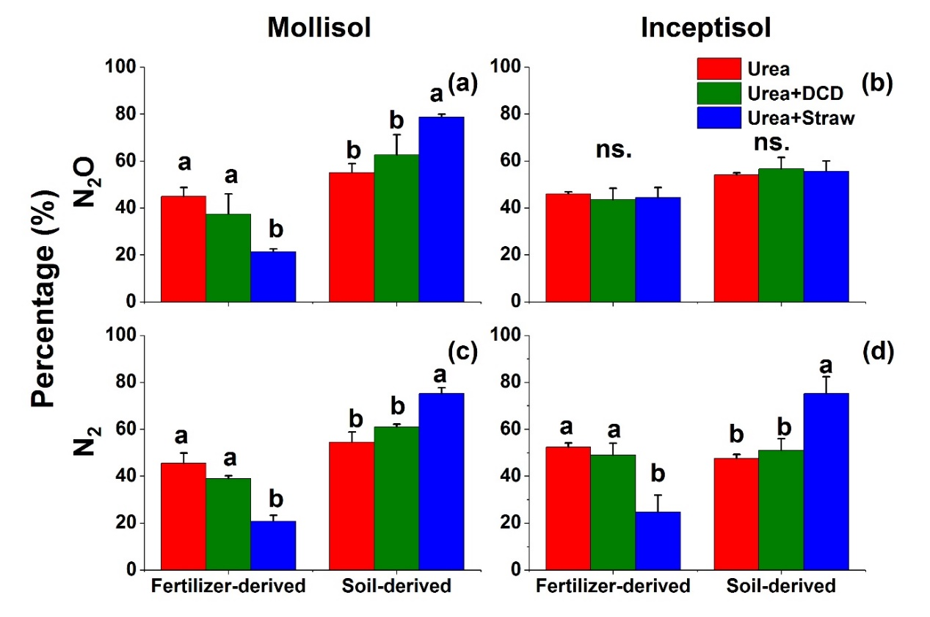
Fig. 1S Percentages of Fertilizer-derived and soil-derived cumulative N₂O and N₂ emissions in the two soils. Error bars show the standard error of the means (n = 4). Different letters indicate significant differences in soil-derived N₂ or N₂O emissions at p < 0.05 among the Urea, Urea+DCD and Urea+Straw treatments. “ns.” indicates not significant.

