Supplementary Information

Colorimetric Identification of Colorless Acid Vapors using a Metal-Organic Framework-Based Sensor

Wonhyeong Jang, Hyejin Yoo, Dongjun Shin, Seokjin Noh, and Jin Yeong Kim*

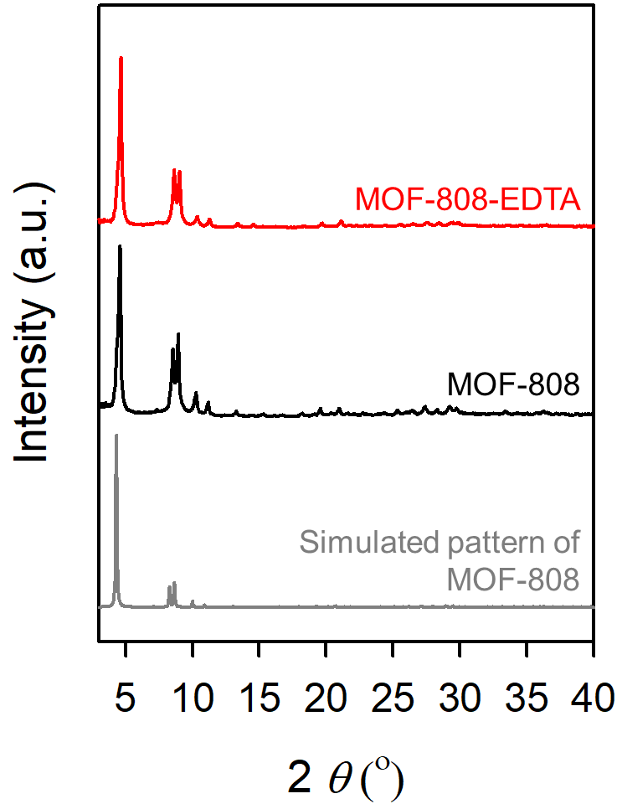
Supplementary Figure 1. XRPD patterns of MOF-808 (black) and MOF-808-EDTA (red) with simulated XRPD pattern of MOF-808 (gray).
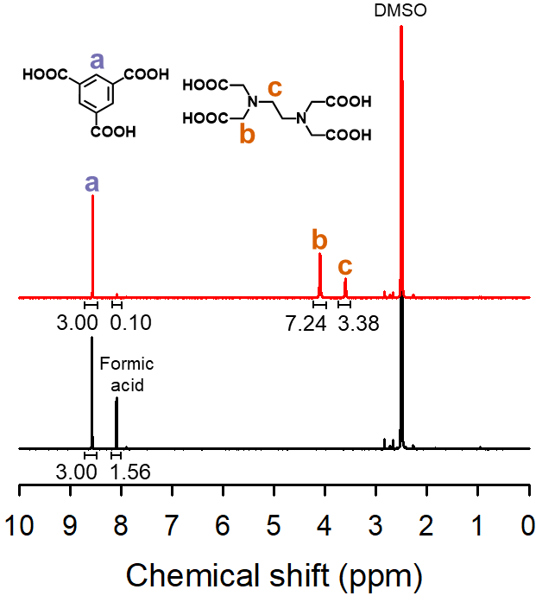
Supplementary Figure 2. ¹H NMR spectra of MOF-808 (black) and MOF-808-EDTA (red) in D₂SO₄/DMSO-d₆ solution.

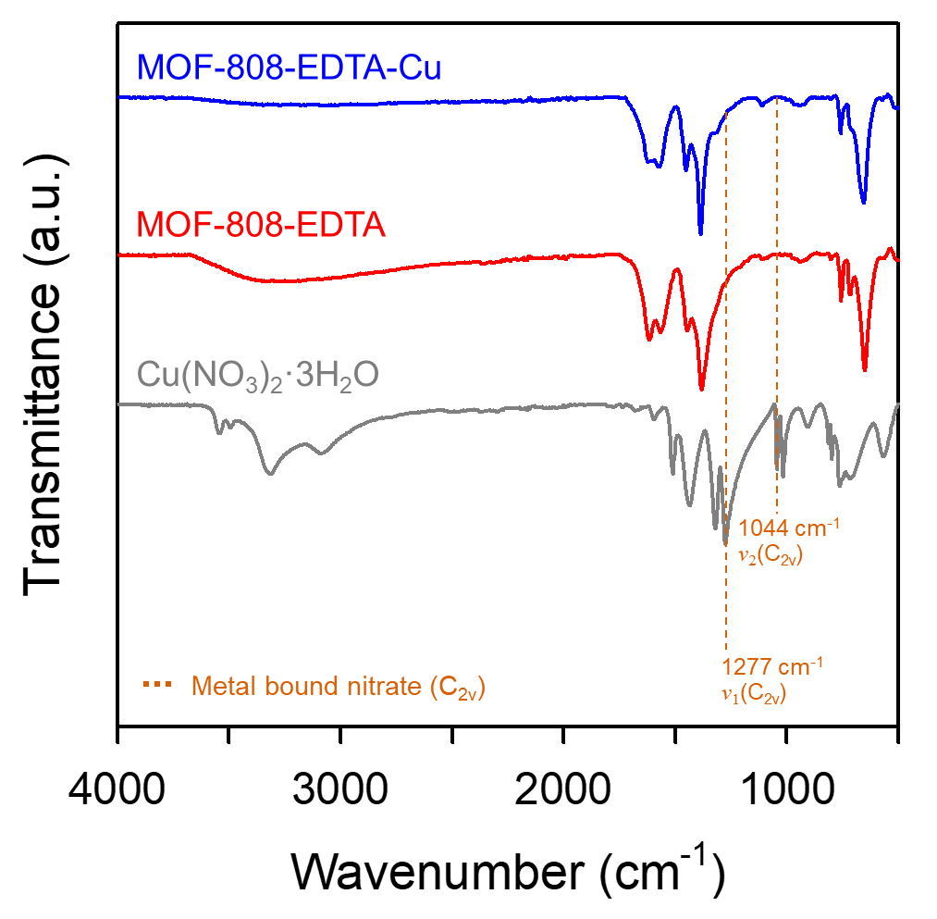
Supplementary Figure 3. FT-IR spectra of MOF-808-EDTA-Cu (blue), MOF-808-EDTA (red), and Cu(NO₃)₂$∙$3H₂O (gray).

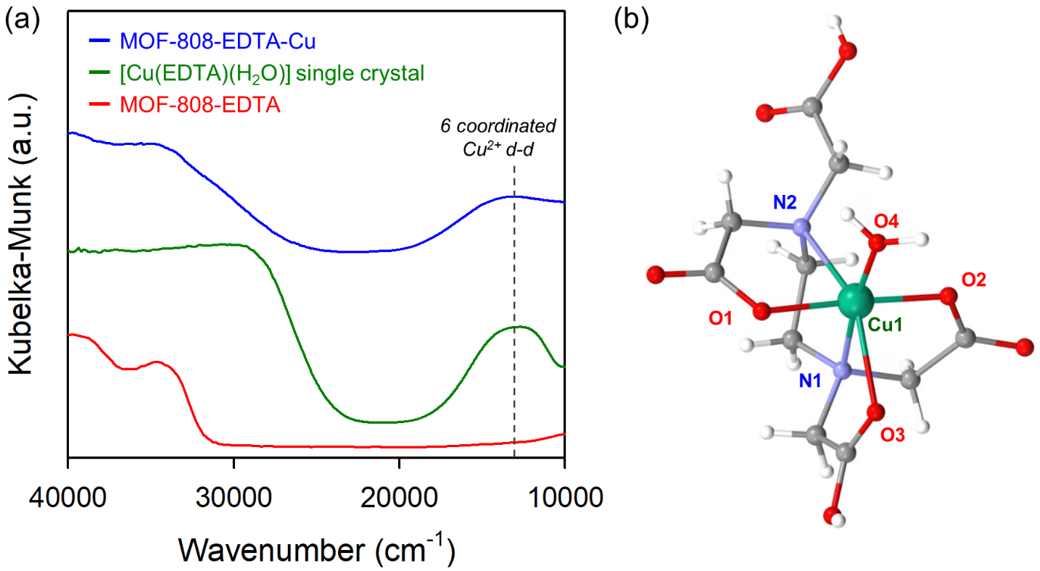
Supplementary Figure 4. (a) Diffuse reflectance UV-vis-NIR spectra of MOF-808-EDTA-Cu (blue), [Cu(EDTA)(H₂O)] single crystal (green), and MOF-808-EDTA (red). For MOF-808-EDTA-Cu (blue) and [Cu(EDTA)(H₂O)] single crystal (green), the peak appeared at ca. 13140 cm⁻¹ is corresponding to d-d transition of an octahedral six-coordinated of Cu ion. (b) Crystal structure of [Cu(EDTA)(H₂O)] with six-coordinated geometry of Cu as a ball-and-stick model¹.

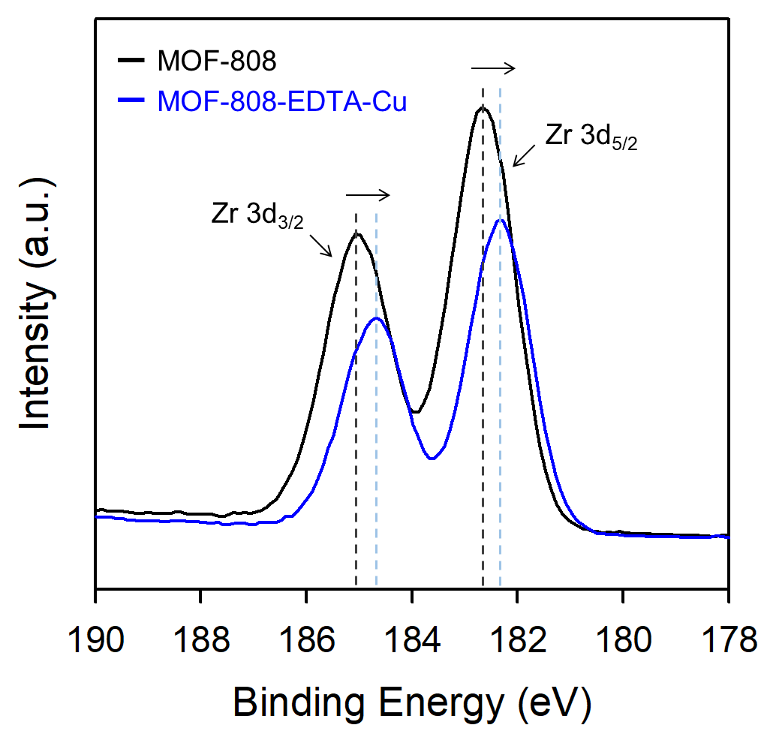
Supplementary Figure 5. Zr 3d XPS spectra of MOF-808 (black) and MOF-808-EDTA-Cu (blue).

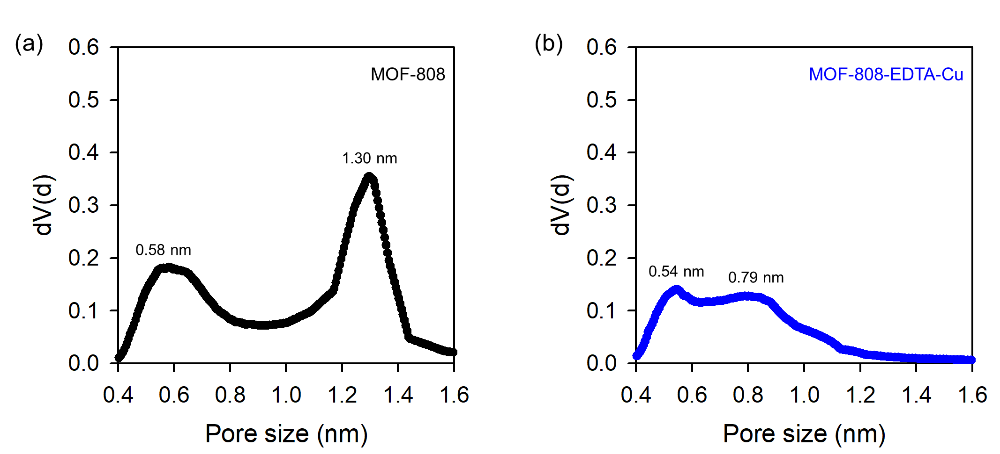
Supplementary Figure 6. Pore size distribution graphs of (a) MOF-808 (black) and (b) MOF-808-EDTA-Cu (blue).

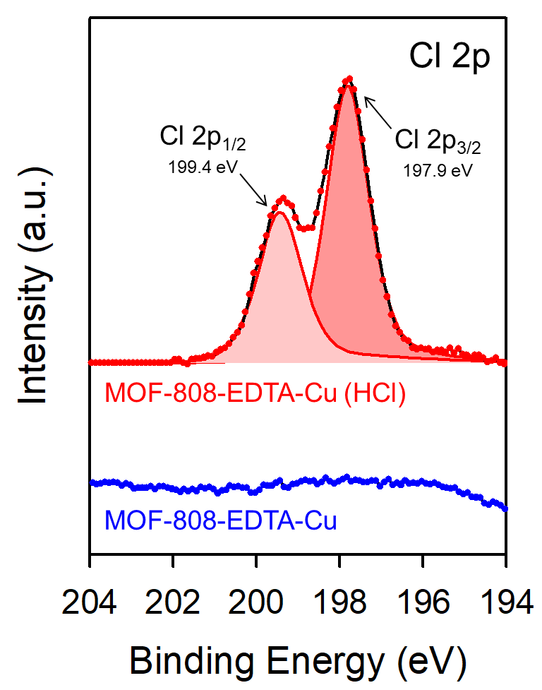
Supplementary Figure 7. Cl 2p XPS spectra of MOF-808-EDTA-Cu (HCl) (red dot) and MOF-808-EDTA-Cu (blue dot).

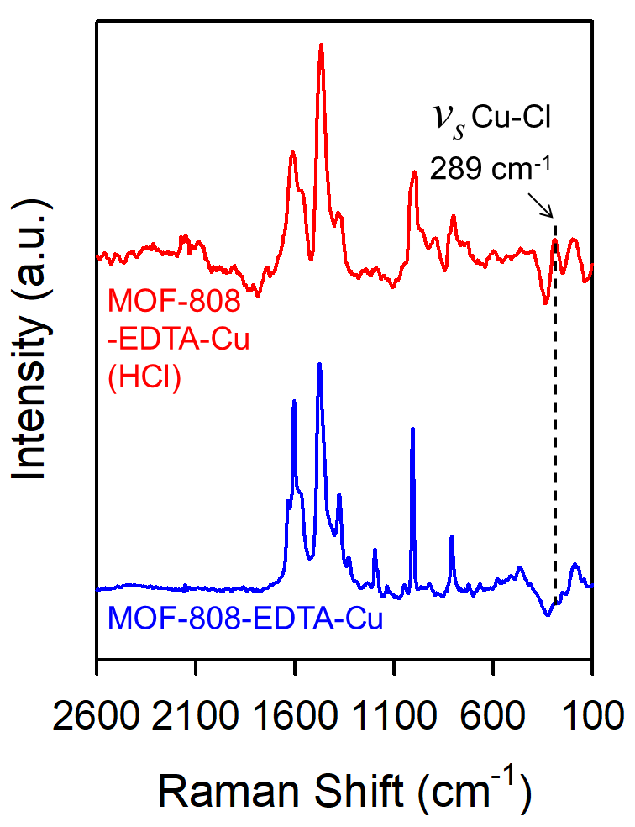
Supplementary Figure 8. Raman spectra of MOF-808-EDTA-Cu (HCl) (red) and MOF-808-EDTA-Cu (blue). For MOF-808-EDTA-Cu (HCl) (red), the peak appeared at 289 cm⁻¹ is identical to the Raman stretching of Cu-Cl, which is formed with incorporated Cl to Cu²⁺ ion.

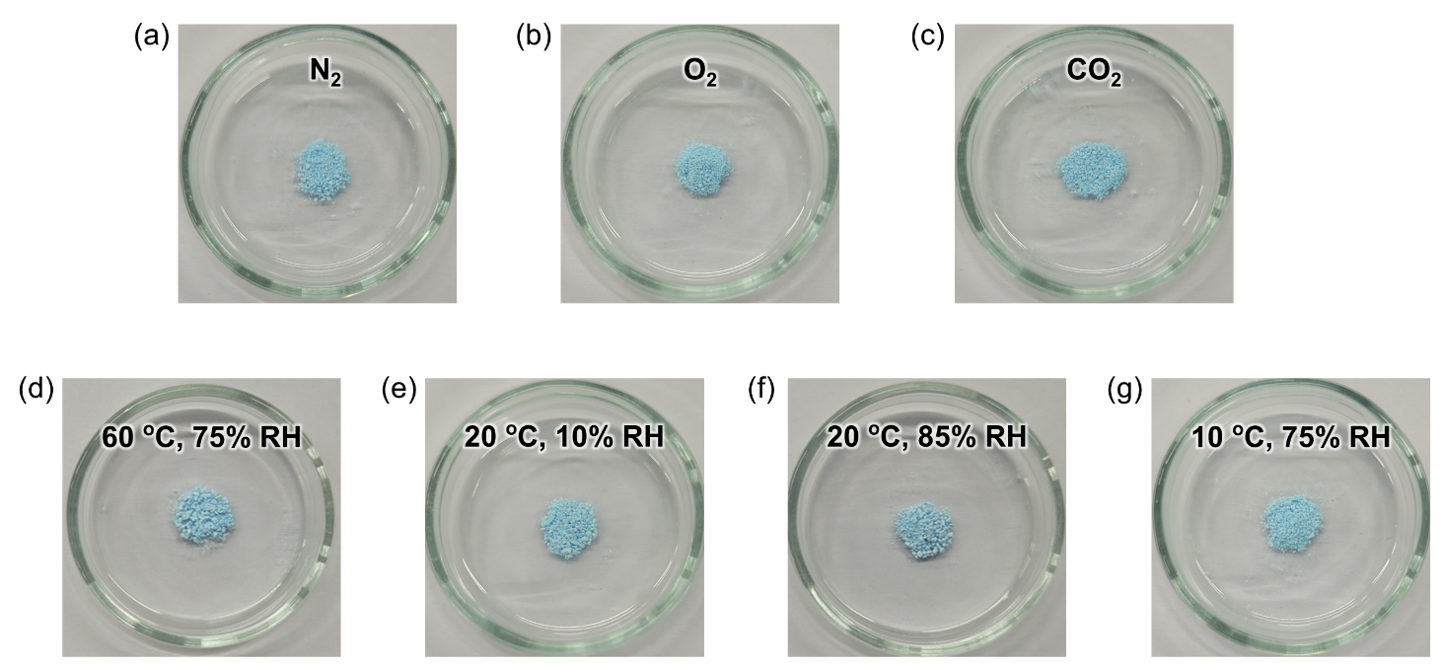
Supplementary Figure 9. Photographs of MOF-808-EDTA-Cu exposed to (a) N₂ gas, (b) O₂ gas, (c) CO₂ gas, (d) 60 ℃, 75% relative humidity air, (e) 20 ℃, 10% relative humidity air, (f) 20 ℃, 85% relative humidity air, (g) 10 ℃, 75% relative humidity air for 30 min.

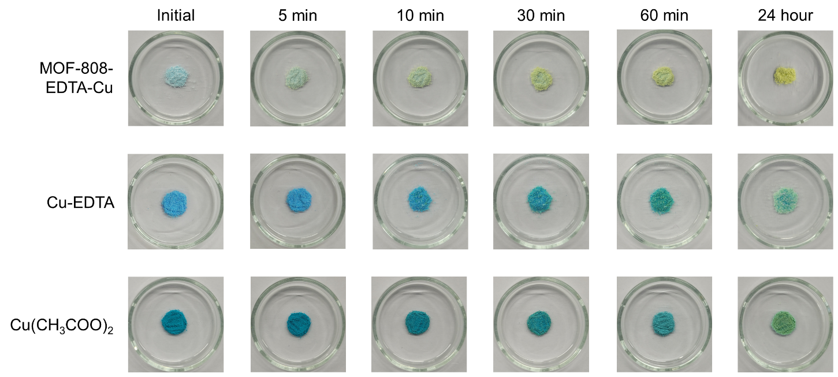
Supplementary Figure 10. Photographs of MOF-808-EDTA-Cu, Cu-EDTA, and Cu(CH₃COO)₂ for the colorimetric response by exposure to 120 ppm HCl vapor for 5 min, 10 min, 30 min, 60 min, and 24 hours.

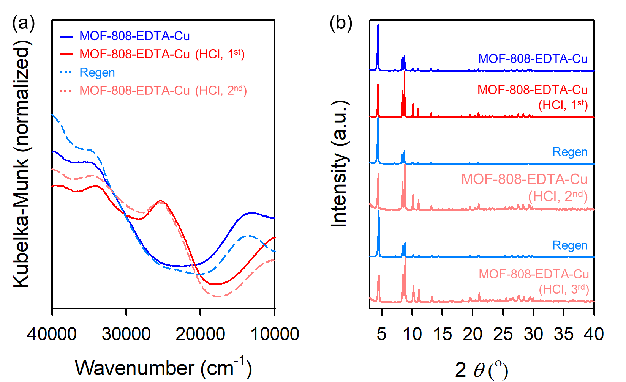
Supplementary Figure 11. (a) Diffuse reflectance UV-vis-NIR spectra of MOF-808-EDTA-Cu, 1st HCl exposed MOF-808-EDTA-Cu, regenerated MOF-808-EDTA-Cu, and 2nd HCl exposed MOF-808-EDTA-Cu. (b) XRPD patterns of MOF-808-EDTA-Cu at each stage during three cycles of alternating exposure to HCl vapor and water.

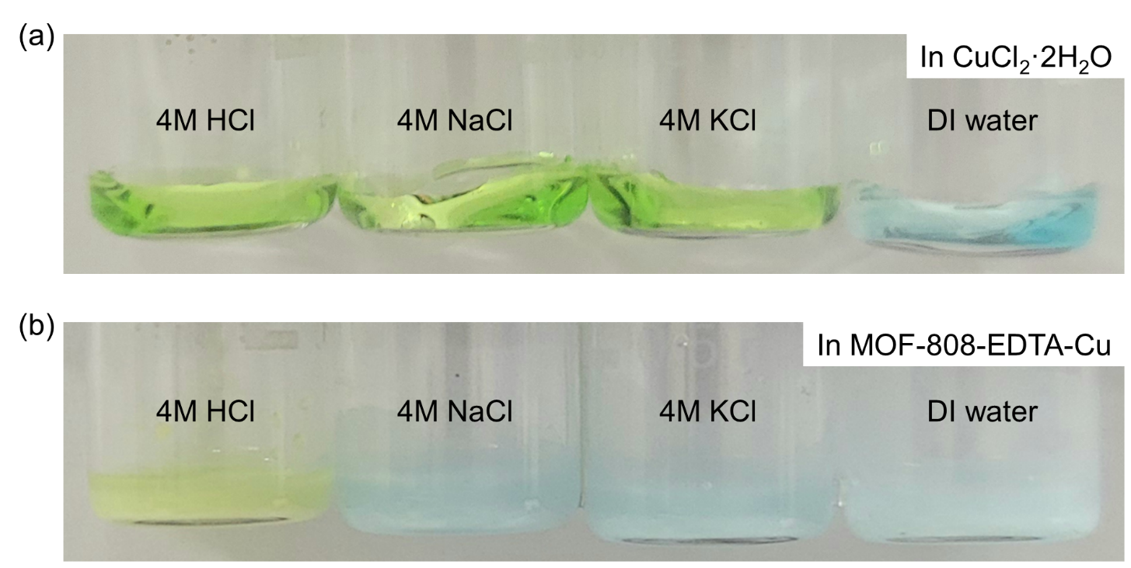
Supplementary Figure 12. Photographs of (a) CuCl₂·2H₂O, (b) MOF-808-EDTA-Cu in 4M HCl, NaCl, KCl solution and DI water.

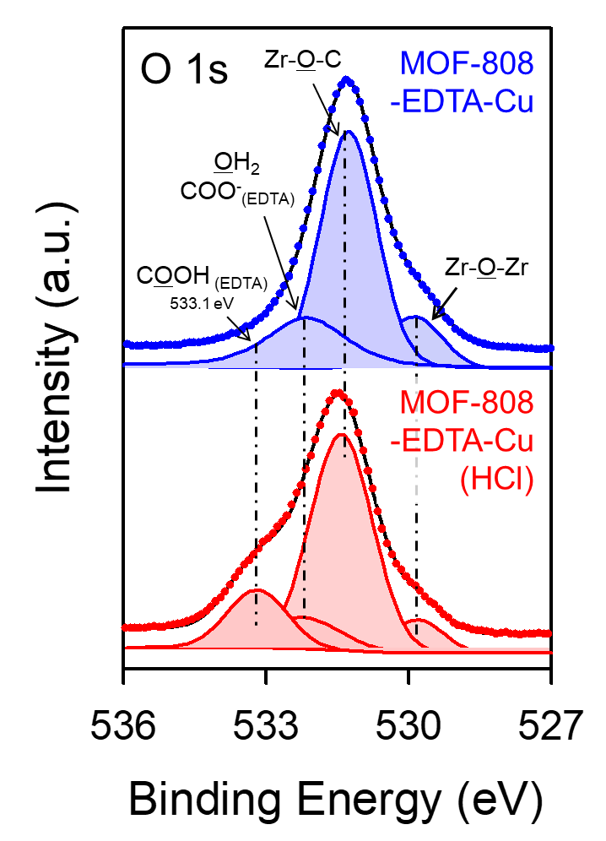
Supplementary Figure 13. O 1s XPS spectra of MOF-808-EDTA-Cu (blue) and MOF-808-EDTA­Cu (HCl) (red).

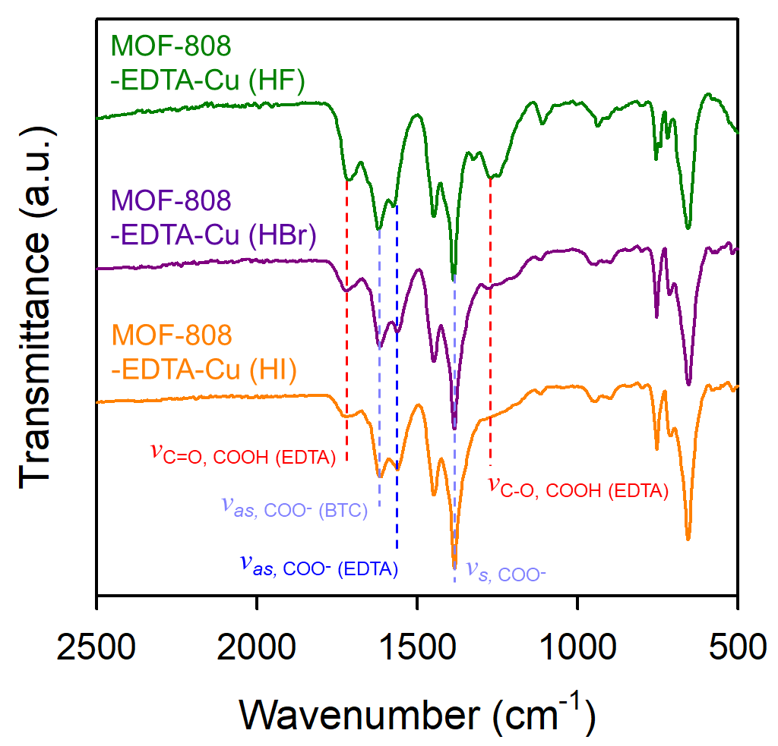
Supplementary Figure 14. FT-IR spectra of MOF-808-EDTA-Cu (HF) (dark green), MOF-808-EDTA-Cu (HBr) (dark purple) and MOF-808-EDTA-Cu (HI) (orange).

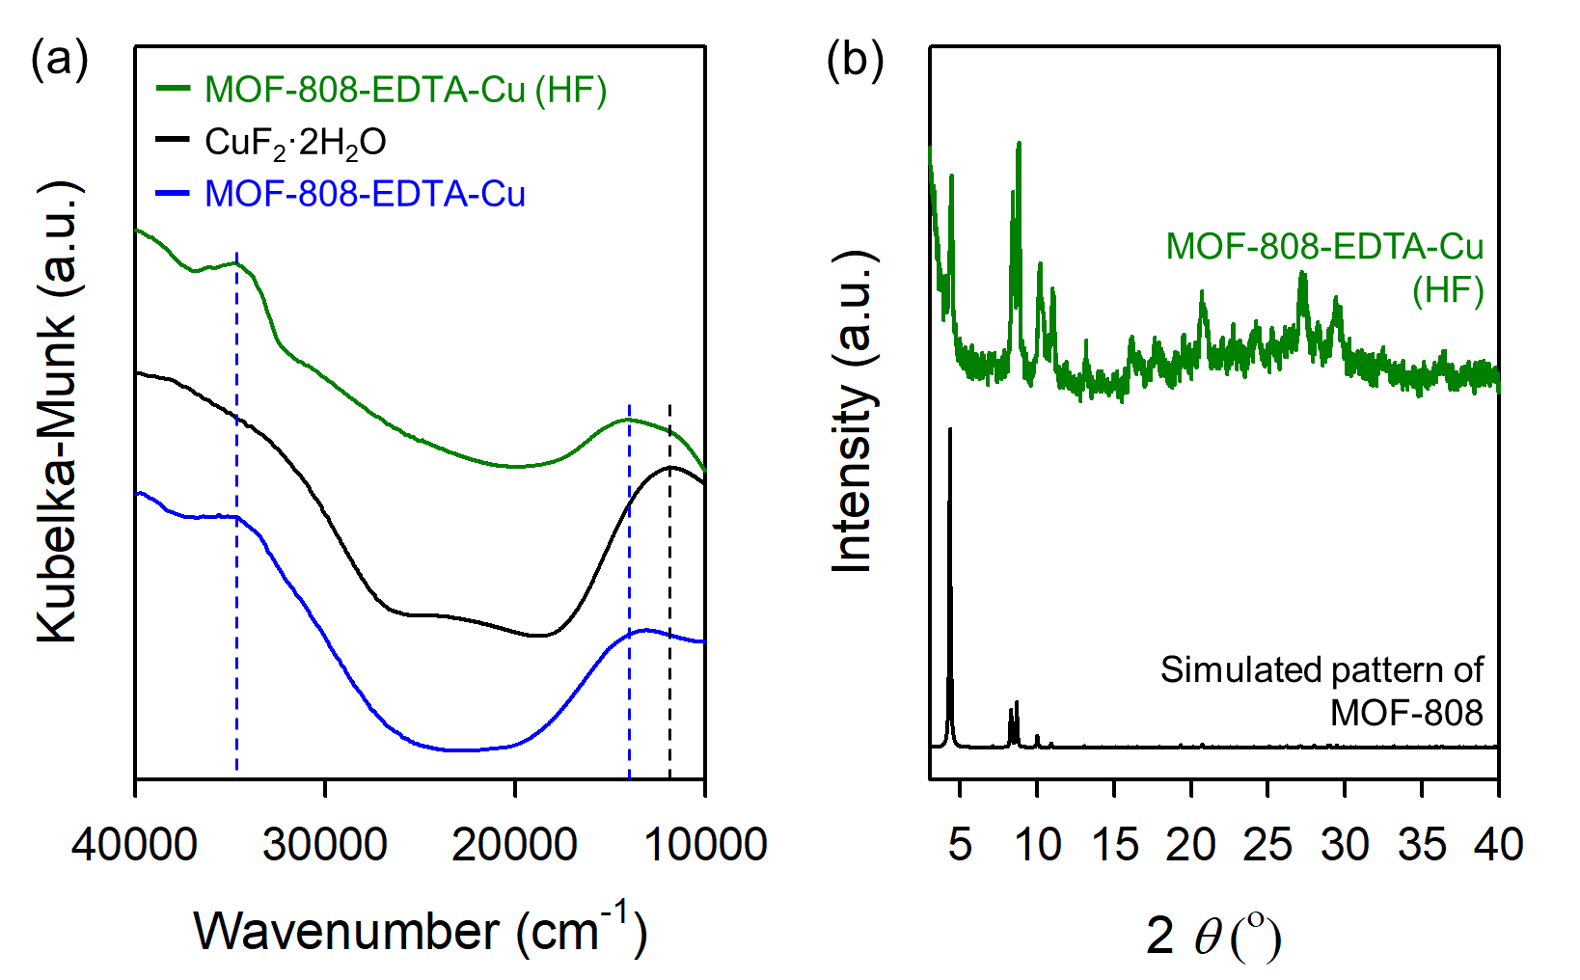
Supplementary Figure 15. (a) Diffuse reflectance UV-vis-NIR spectra of MOF-808-EDTA-Cu (HF) (dark green), CuF₂·2H₂O (black), and MOF-808-EDTA-Cu (blue). (b) XRPD patterns of MOF-808-EDTA-Cu (HF) (dark green) with simulated XRPD pattern of MOF-808 (black).
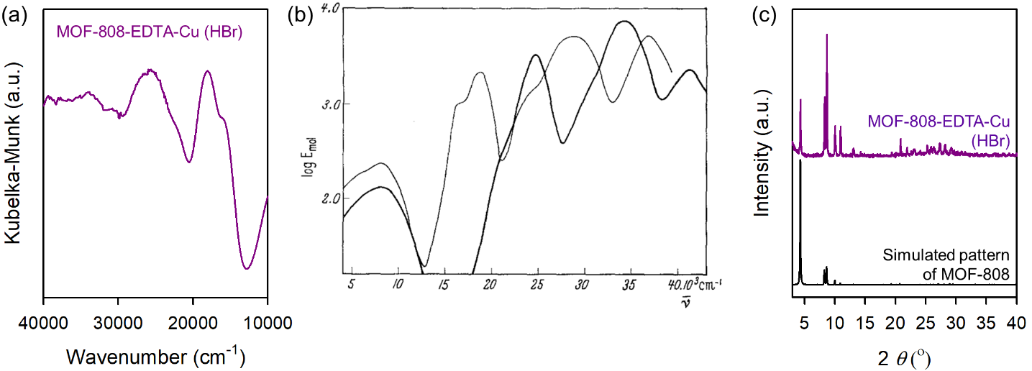
Supplementary Figure 16. (a) Diffuse reflectance UV-vis-NIR spectra of and MOF-808-EDTA-Cu (HBr), (b) Molar absorption spectra of [CuCl₄]²⁻ (thick line) and [CuBr₄]²⁻ (thin line). Reprinted with permission from ref 2. Copyright 1963 Springer Nature. (c) XRPD patterns MOF-808-EDTA-Cu (HBr) (dark purple) with simulated XRPD pattern of MOF-808 (black).

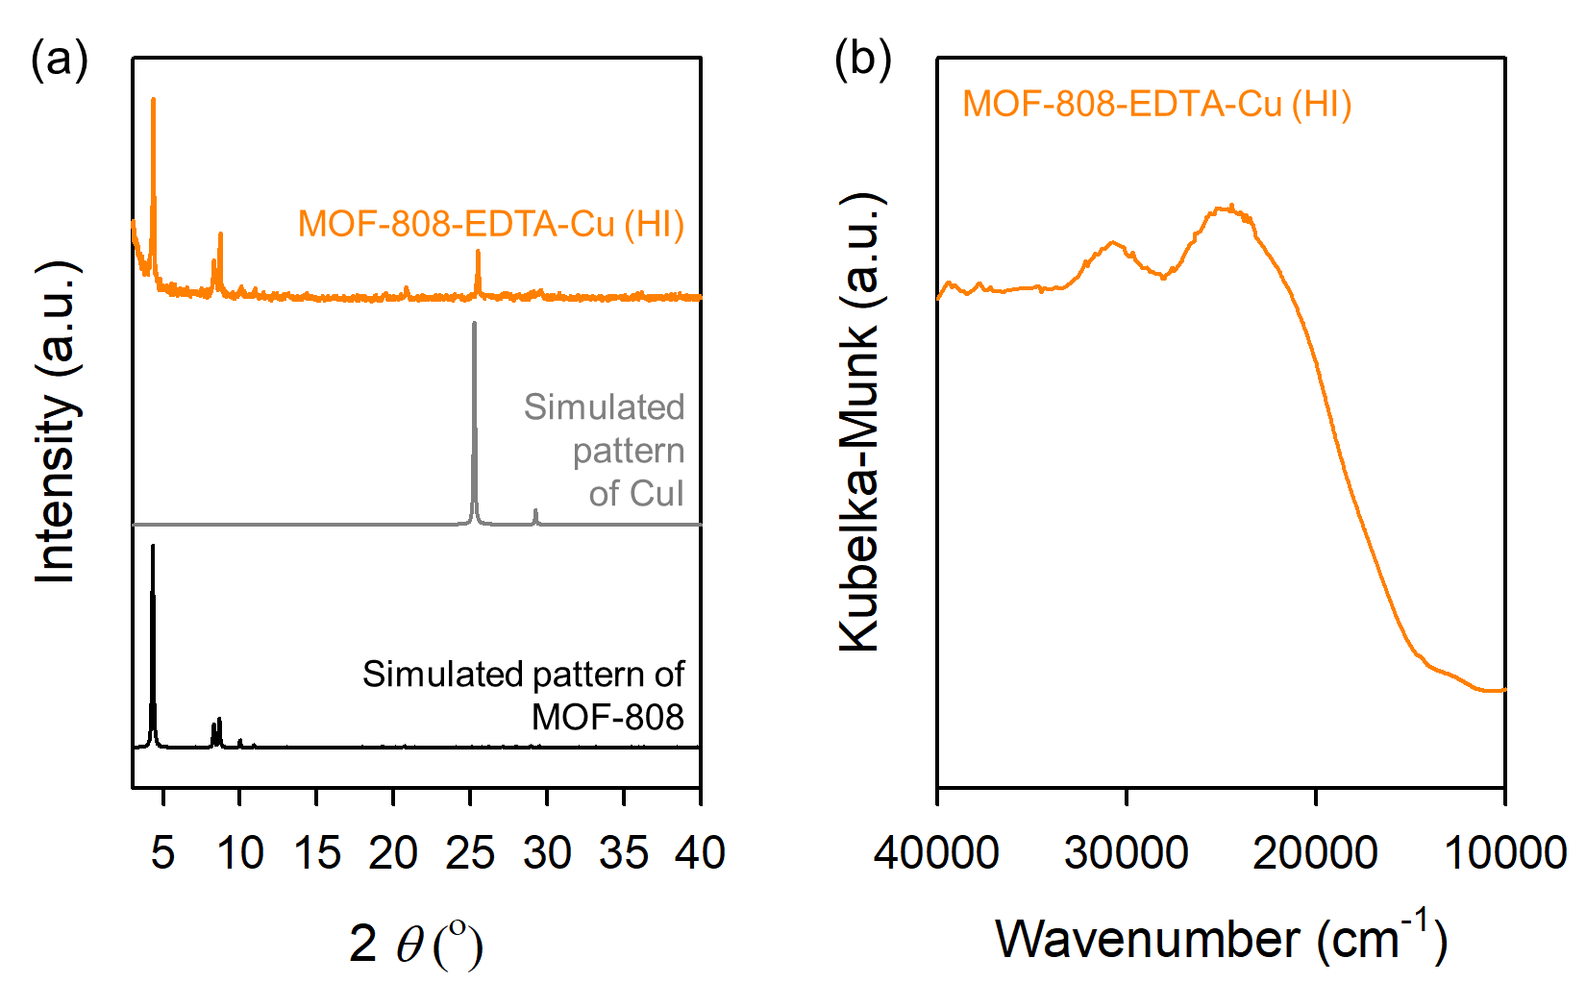
Supplementary Figure 17. (a) XRPD patterns of MOF-808-EDTA-Cu (HI) (orange) with simulated XRPD patterns of CuI (gray) and MOF-808 (black), (b) Diffuse reflectance UV-vis-NIR spectra of MOF-808-EDTA-Cu (HI) (orange).

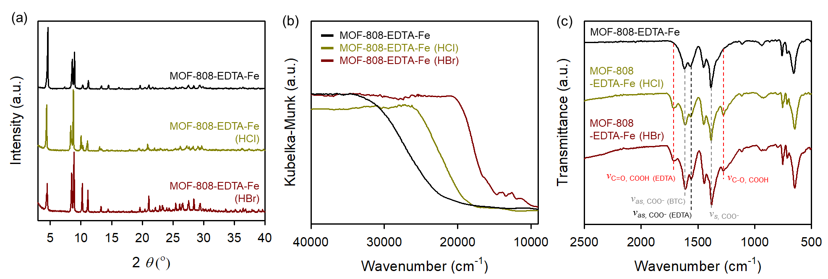
Supplementary Figure 18. (a) PXRD patterns of MOF-808-EDTA-Fe (black), MOF-808-EDTA-Fe (HCl) (dark yellow), and MOF-808-EDTA-Fe (HBr) (brown), (b) Diffuse reflectance UV-vis-NIR spectra of MOF-808-EDTA-Fe (black), MOF-808-EDTA-Fe (HCl) (dark yellow), and MOF-808-EDTA-Fe (HBr) (brown), (c) FT-IR spectra of MOF-808-EDTA-Fe (black), MOF-808-EDTA-Fe (HCl) (dark yellow), and MOF-808-EDTA-Fe (HBr) (brown).

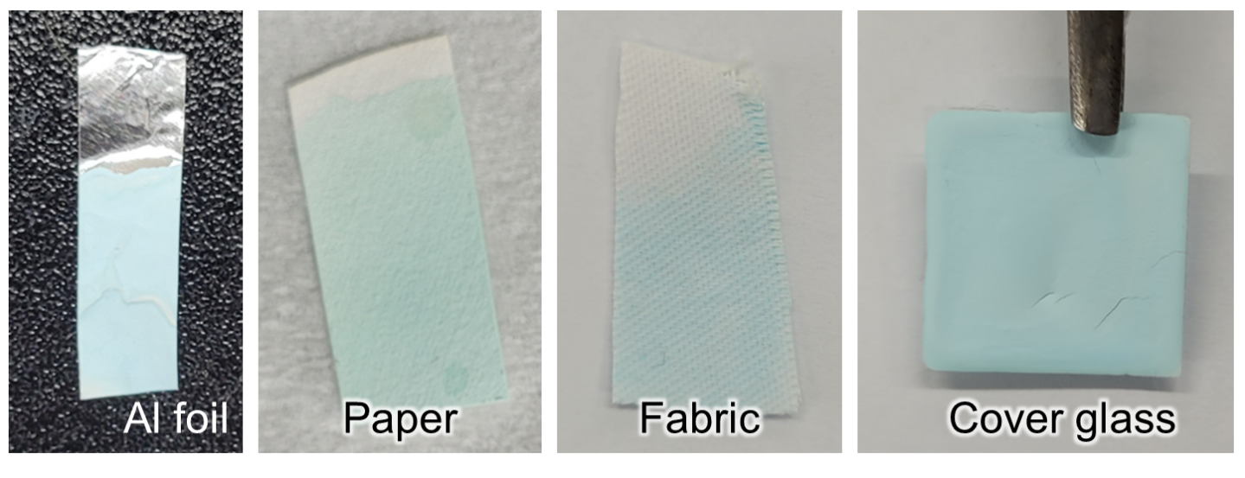
Supplementary Figure 19. Photographs of MOF-808-EDTA-Cu ink applied to various substrates.

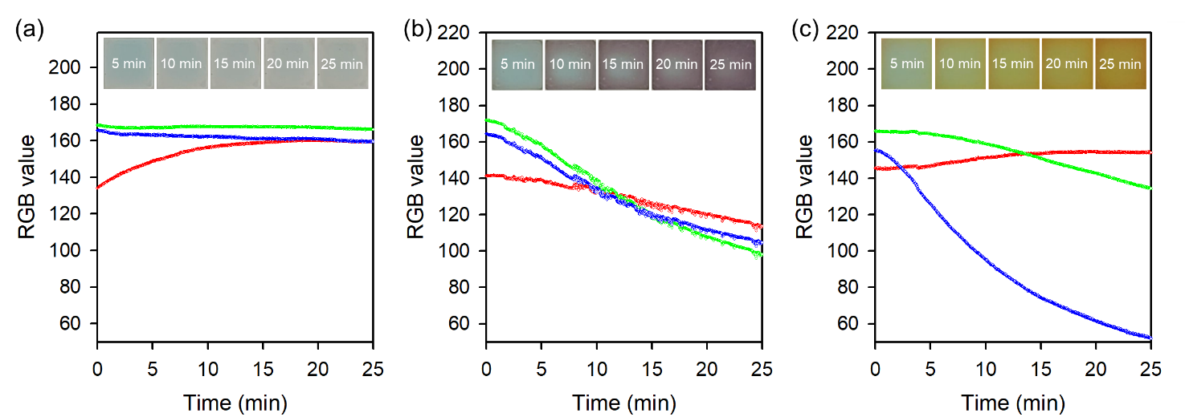
Supplementary Figure 20. Time-dependent RGB curves of MOF-808-EDTA-Cu portable sensors exposed to (a) HF, (b) HBr, and (c) HI vapor. (Inset) Photographs of MOF-808-EDTA-Cu portable sensors under acid vapor exposures.

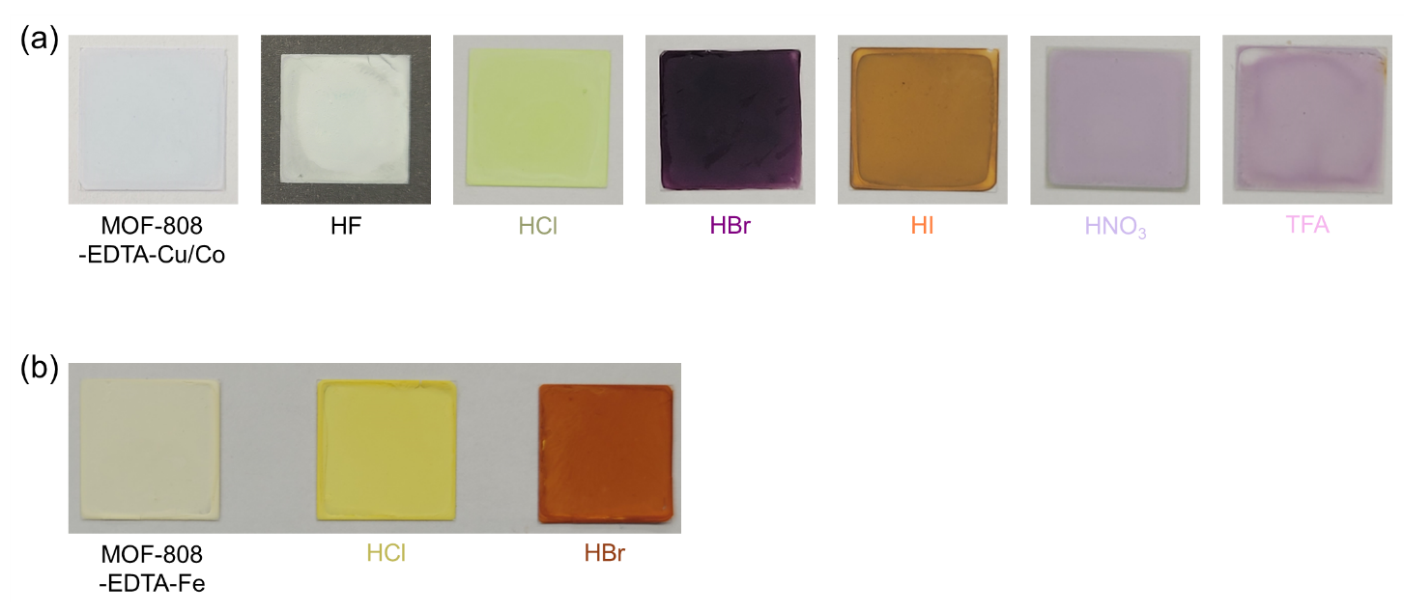
Supplementary Figure 21. (a) Color change of MOF-808-EDTA-Cu/Co portable sensor for identifying hydrofluoric acid, hydrochloric acid, hydrobromic acid, hydroiodic acid, nitric acid, and trifluoroacetic acid vapor, (b) Color change of MOF-808-EDTA-Fe portable sensor for identifying hydrochloric acid, and hydrobromic acid vapor.

References for supplementary information

- Yu, K. et. al. A low-cost commercial Cu (ii)–EDTA complex for electrocatalytic water oxidation in neutral aqueous solution. Chem. Commun. 58, 12835-12838 (2022).
- Furlani, C. & Morpurgo, G. Properties and electronic structure of tetrahalogenocuprate (II)-complexes. Theor. Chim. Acta 1, 102-115 (1963).

