Description of cusp wear coefficient
Cusp wear at the premolar-molar boundary was quantified and accounted for to prevent later shape analyses from being affected. Cusp wear quantification was based on methods previously developed to quantify the age of primates based on percent of dentine exposure (PDE; Formula C1 and Figure C1; Galbany et al. 2011). This method outlined dentine exposure occurring on cheek teeth and recorded it as a proportion of total area. In my thesis, this methodology was used to quantify cusp wear on both the p4 and m1 of each specimen. PDE was calculated for the p4 and m1 as dentine area over the entire occlusal area expressed as a percentage (see Formula 1).
$$Percent of dentine exposure \left(PDE;\%\right)= \frac{Area of dentine exposed from occlusal view}{Area of entire tooth from occlusal view} X 100$$
Formula S3. Percent of dentine exposure formula used by Galbany et al. 2011 to quantify the relationship between age and dental wear in Amboseli baboons. The same formula was used in my study to quantify cusp wear in ungulate taxa of interest.

A preliminary subset of ungulates from the University of Calgary collections was used to determine threshold PDE values as standards. Specimens were selected to represent a broad sample of ungulates that had cusp structure unobscured by cusp wear. This allowed for a generalized and conservative estimate of the maximum amount of cusp wear permissible before cusp structures would be worn away. PDE values were calculated for both the p4 and m1 of standard specimens; the resulting PDE values

became the maximum PDE thresholds for inclusion in my analyses. Molar wear did not obstruct cusp structure until 40 % PDE for the most worn standard. The p4 threshold was determined to be 35% PDE for the most worn standard. Both the p4 and m1 PDE thresholds were set at 35 % for all specimens to allow for conservative exclusion of potential cusp wear artifacts.
PDE measurements were taken in Fiji v. 2.0.0. If the calculated PDE for the p4 and m1 were both lower than the threshold, the specimen was included in the following analyses. If there were multiple specimens of a species that passed PDE, the specimen with the lowest PDE was selected as a representative.
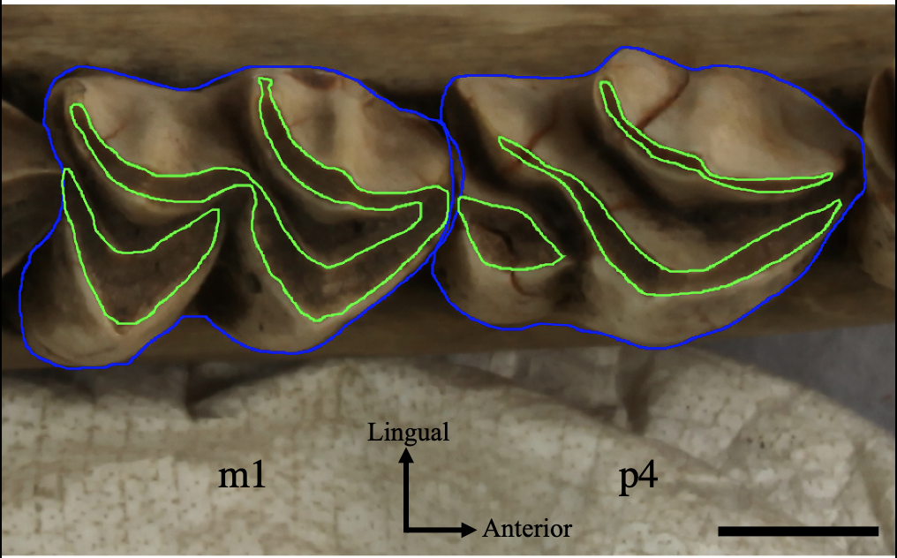
Figure S3. Cusp wear coefficient scheme applied to an Alces alces specimen (UAM ES 44204). Blue line indicates overall cheek tooth area while green line encloses area of dentine exposure. Scale bar represents 1 cm. Abbreviations; p4, lower fourth premolar. m1, lower first molar.

Literature cited:
Galbany, J., Dotras, L., Alberts, S. C., & Pérez-Pérez, A. (2011). Tooth size variation related to age in Amboseli baboons. Folia Primatologica, 81(6), 348-359.

