SUPPLEMENTARY TABLE

Supplementary Table S1. CABMR Patient Baseline Characteristics.
Age | Gender | Race | Transplant
27 | F | African-American | Kidney
37 | M | African-American | Heart
37 | M | African-American | Heart
46 | M | Caucasian | Kidney
55 | M | African-American | Heart
56 | M | African-American | Kidney
61 | F | African-American | Kidney
73 | F | Caucasian | Heart

SUPPLEMENTARY FIGURES
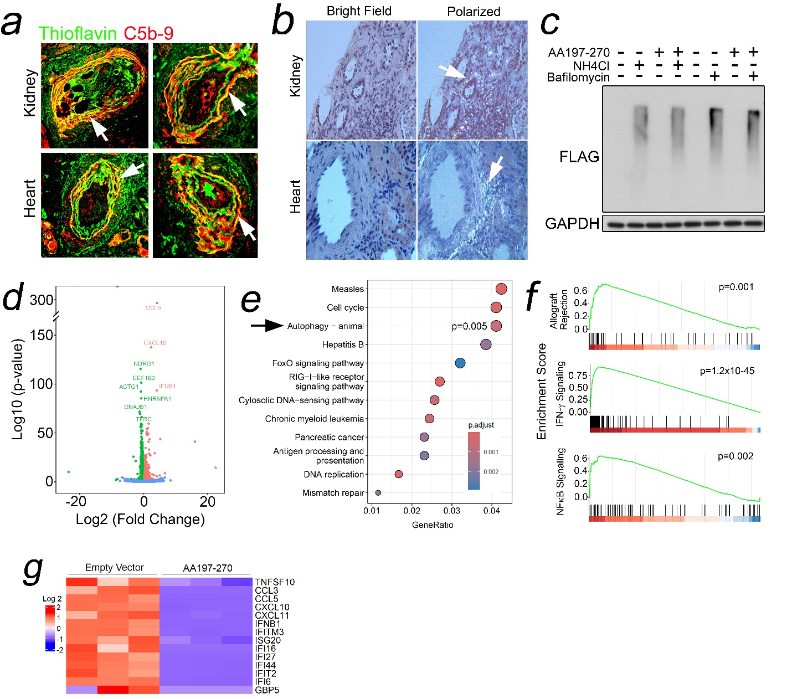
Supplementary Figure 1. Human kidney and heart biopsies with CABMR were analyzed for thioflavin staining by I.F. (a, n=8) and Congo Red staining via polarized light microscopy (b). HEK293 cells pre-treated with NH₄Cl or bafilomycin prior to transfection with AA197-270 (c). AA197-270 cells were analyzed by RNA seq (d-g). n=3 transfectants were analyzed (c-g).

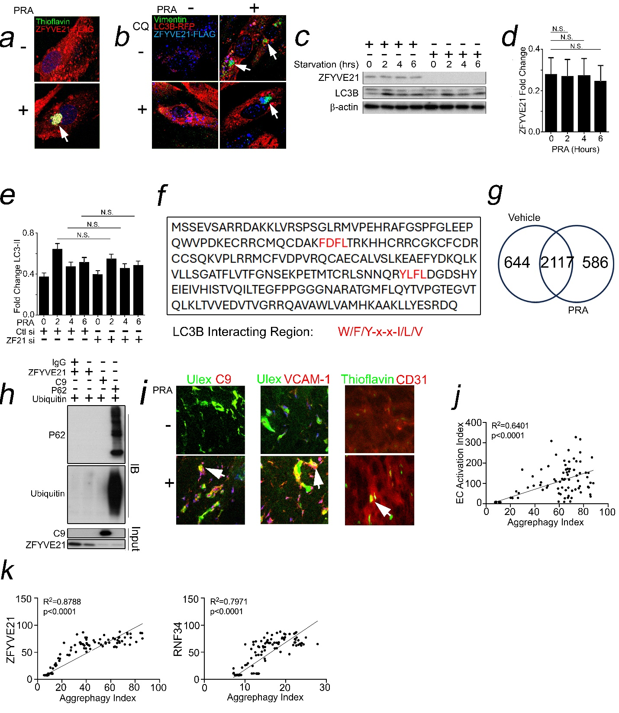
Supplementary Figure 2. HUVECs were treated with PRA for 2 hours prior to I.F. staining (a). HUVECs were transfected with LC3B-RFP and ZFYVE21-FLAG and analyzed by I.F. following 2 hours of PRA treatment (b). HUVECs were serum starved for the times indicated prior to Western blot analysis (c-e). Human ZFYVE21 protein sequence contains two LC3B interacting regions (f). ZFYVE21-GFP HUVECs were treated with PRA for 2 hours prior to GFP bead pulldowns and LC-MS/MS (g). K48 Ub-WT-HA was incubated with ZFYVE21, C9, and P62 proteins as indicated for 4 hours at 4°C prior to HA pulldowns and Western blot analysis (h). HUVECs embedded in collagen-fibronectin gels and implanted in SCID/beige mice for 3 weeks prior to intravenous injection with 200μL neat PRA sera and gel harvest 24 hours later (i, n=3 per group). Public transcriptomes were analyzed for correlations using Pearson’s r (j,k).

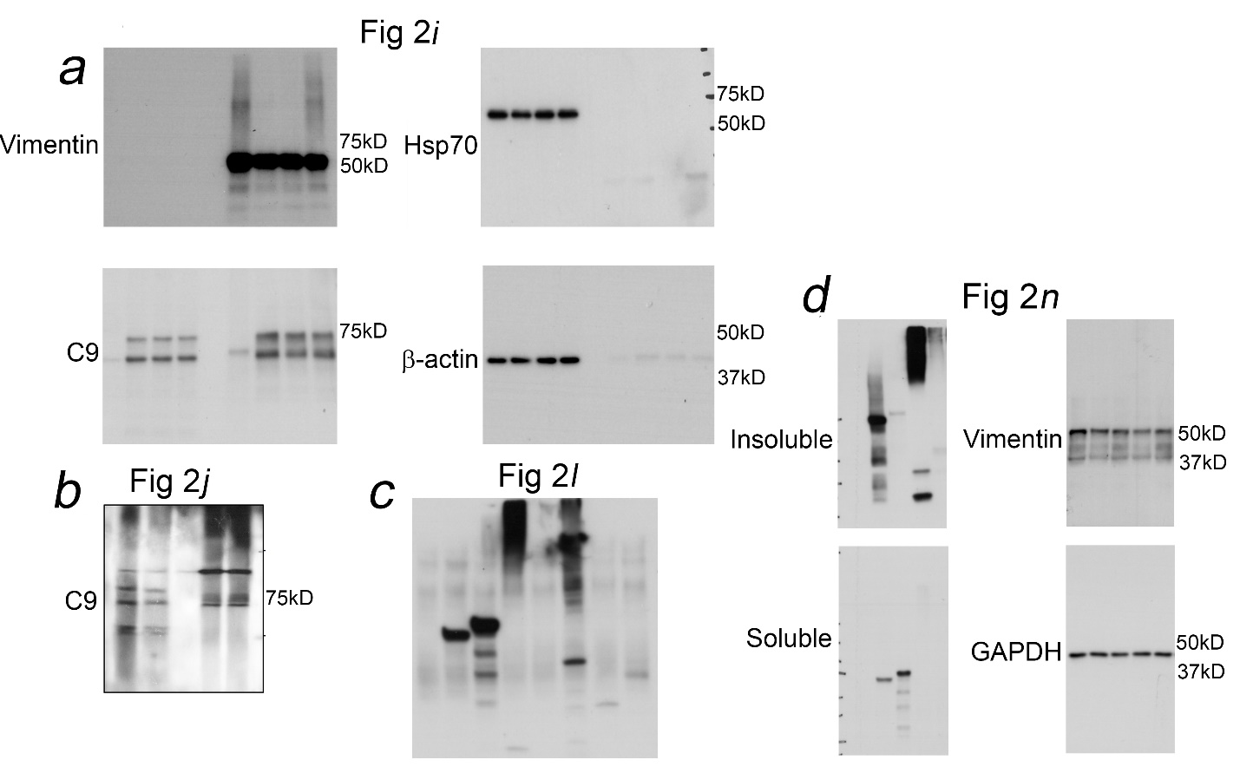
Supplementary Figure 3. Western Blot Films for Main Figure 2. Original uncropped films corresponding to Western blots in main Figure 2 in the manuscript.

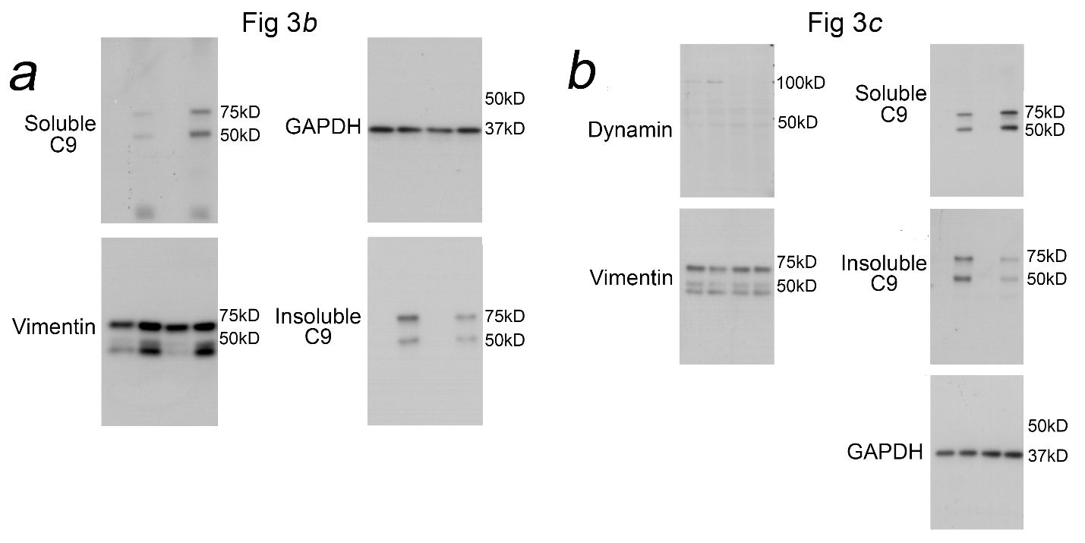

Supplementary Figure 4. Western Blot Films for Main Figure 3. Original uncropped films corresponding to Western blots in main Figure 3 in the manuscript.

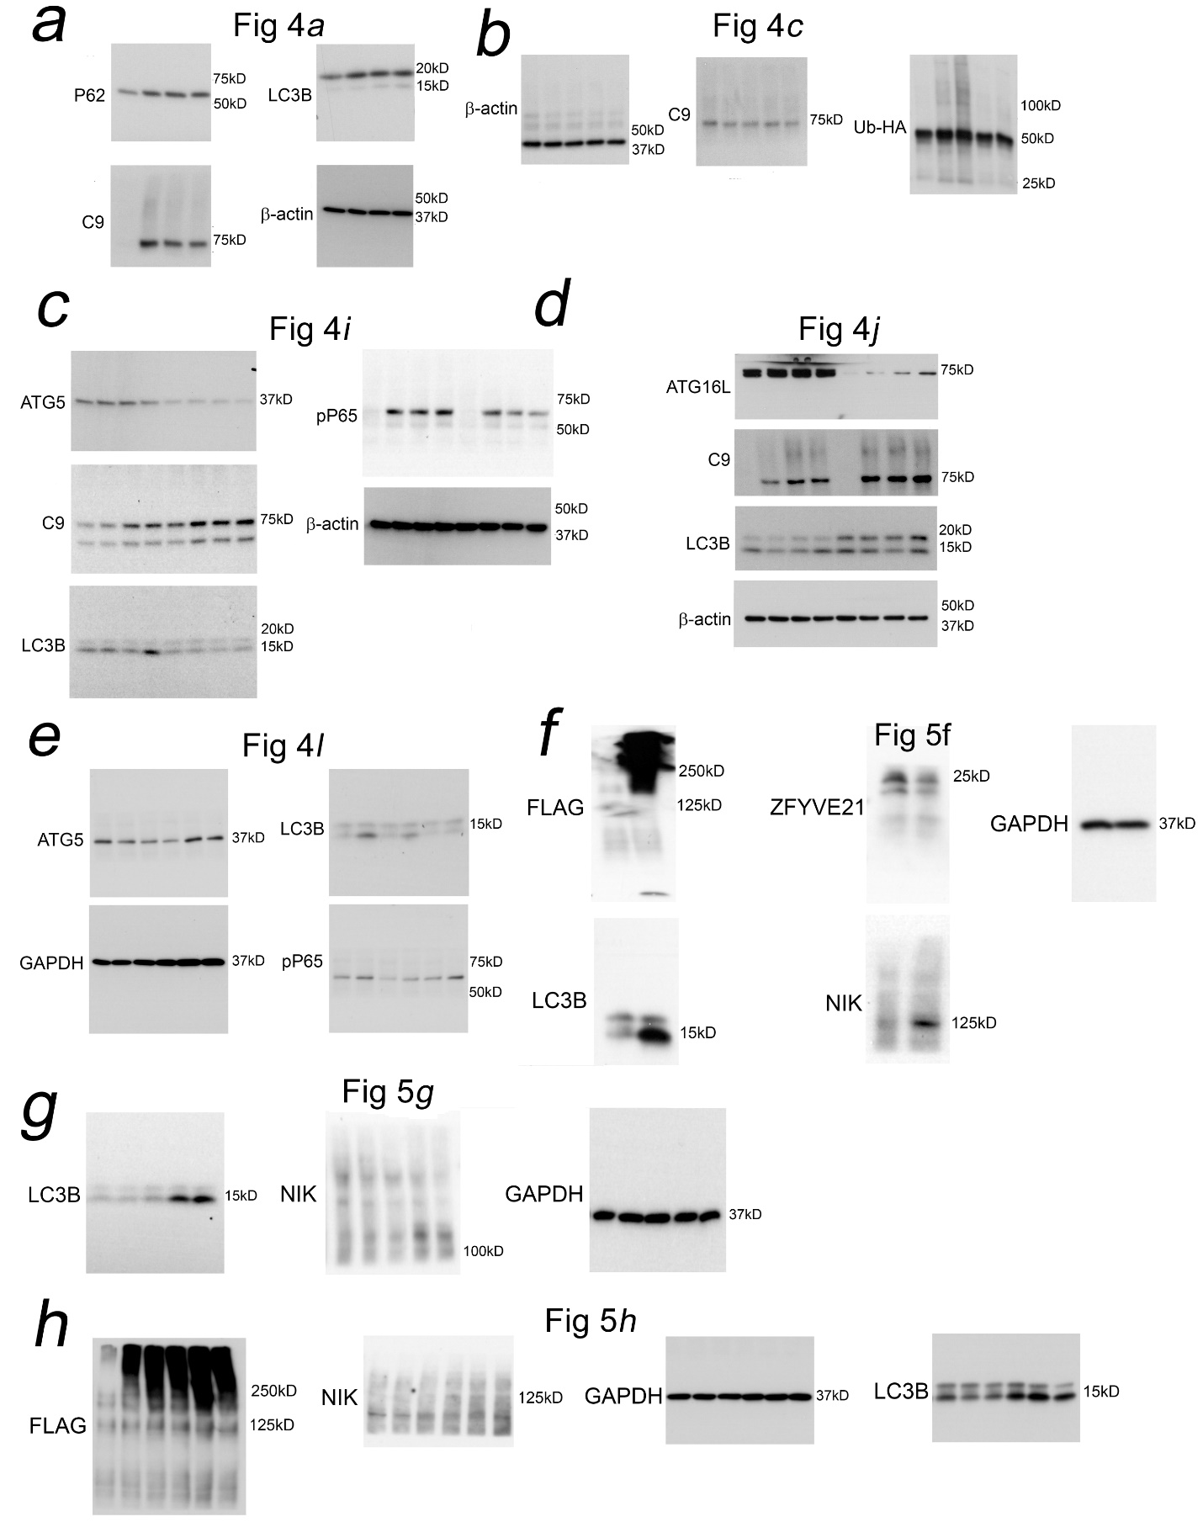
Supplementary Figure 5. Western Blot Films for Main Figure 4 and Main Figure 5. Original uncropped films corresponding to Western blots in main Figure 4 in the manuscript.
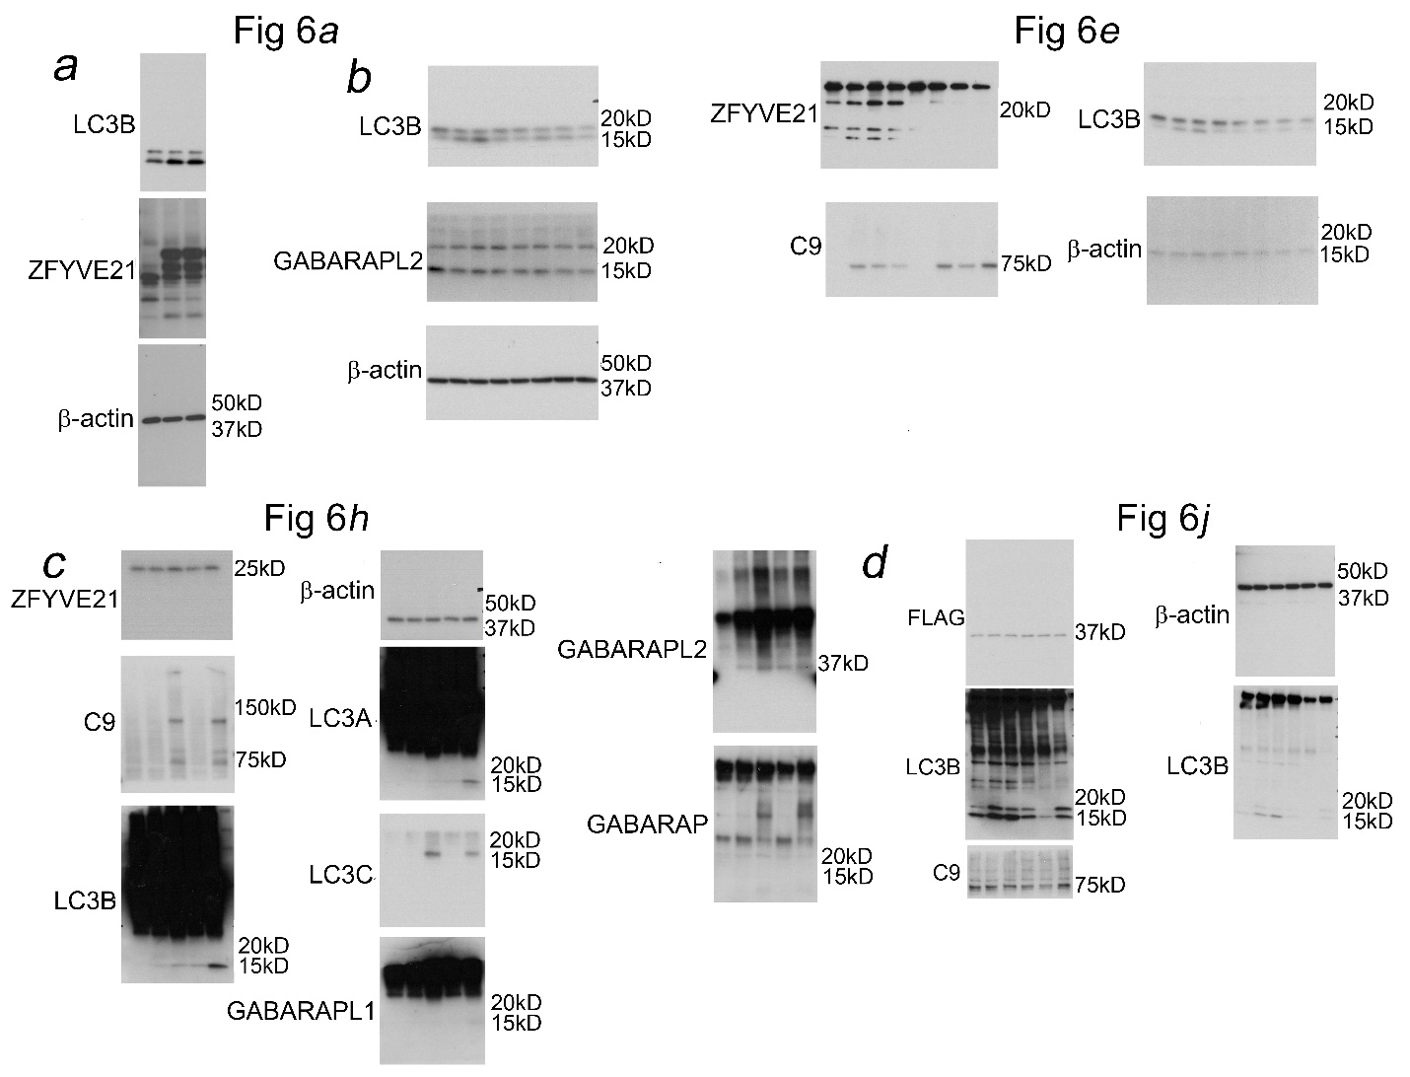
Supplementary Figure 6. Original uncropped films corresponding to Western blots in main Figure 6 in the manuscript.

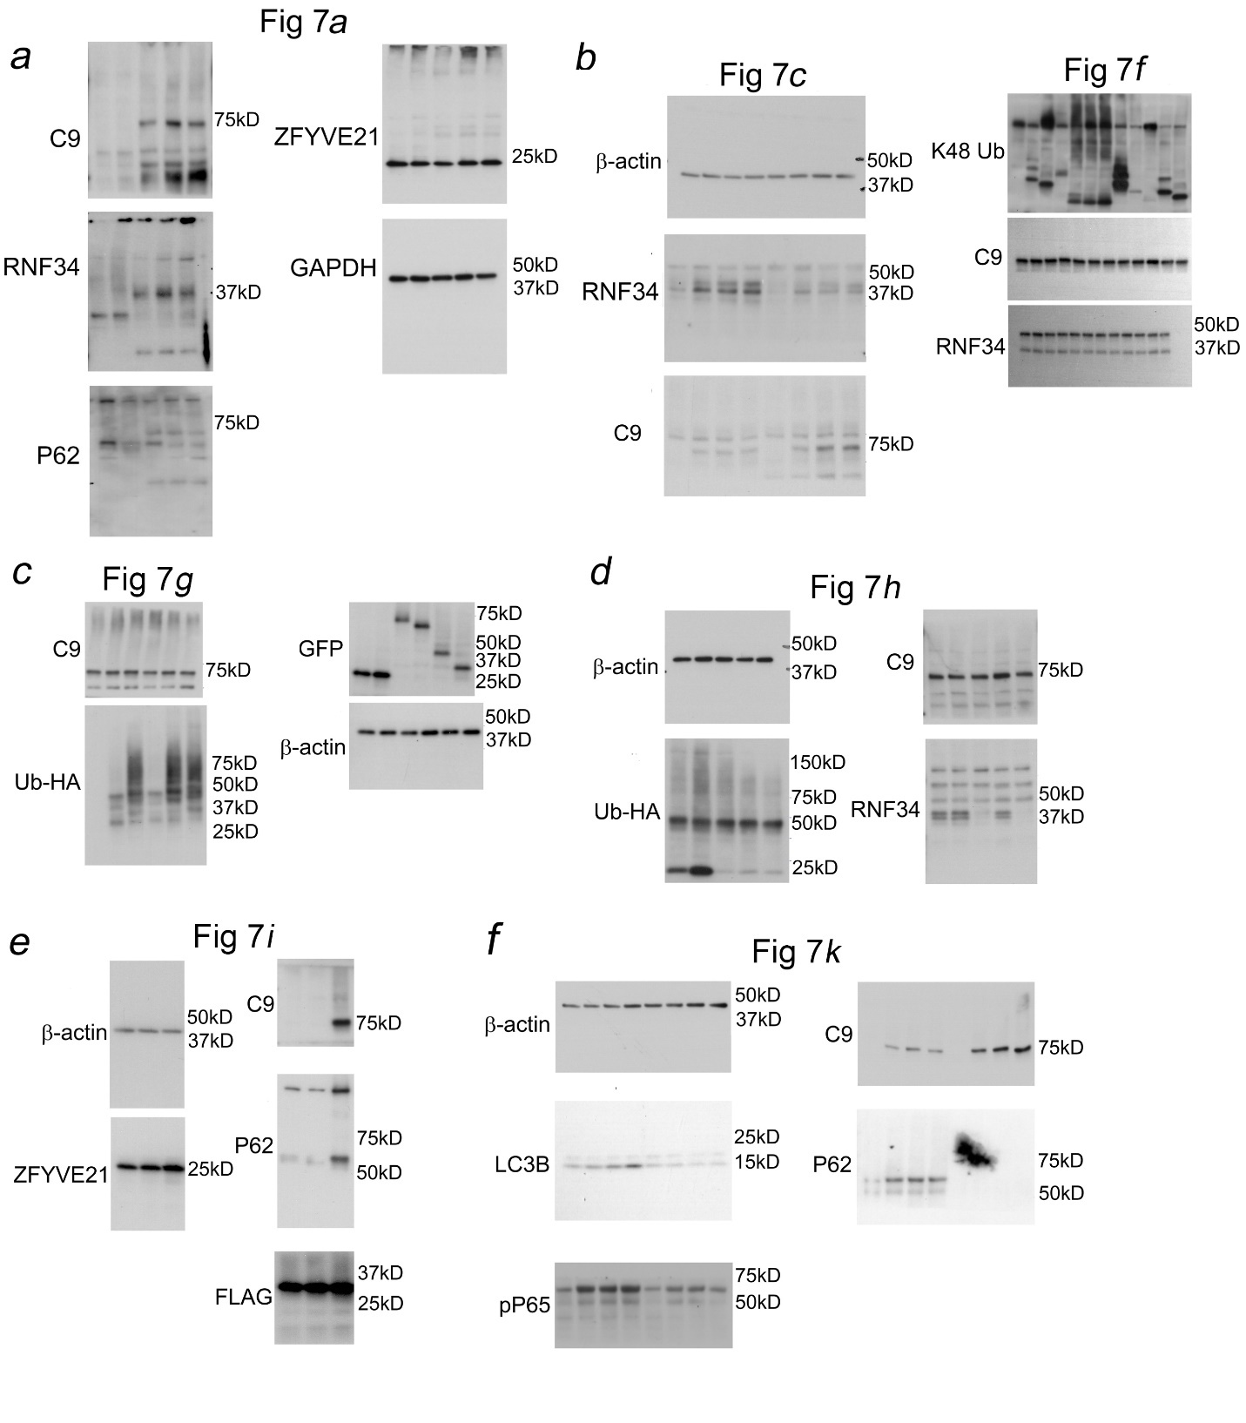
Supplementary Figure 7. Original uncropped films corresponding to Western blots in main Figure 7 in the manuscript.

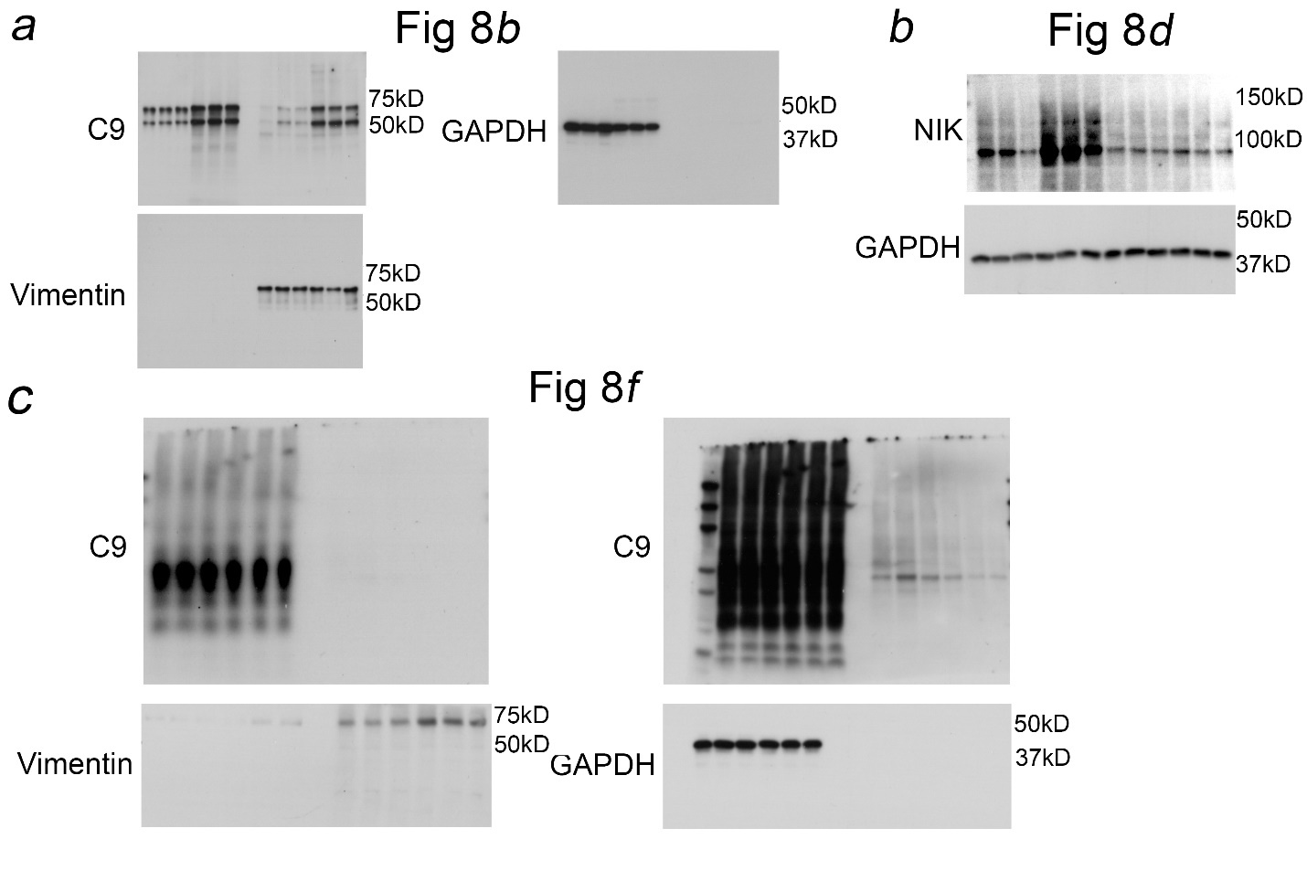
Supplementary Figure 8. Original uncropped films corresponding to Western blots in main Figure 8 in the manuscript.

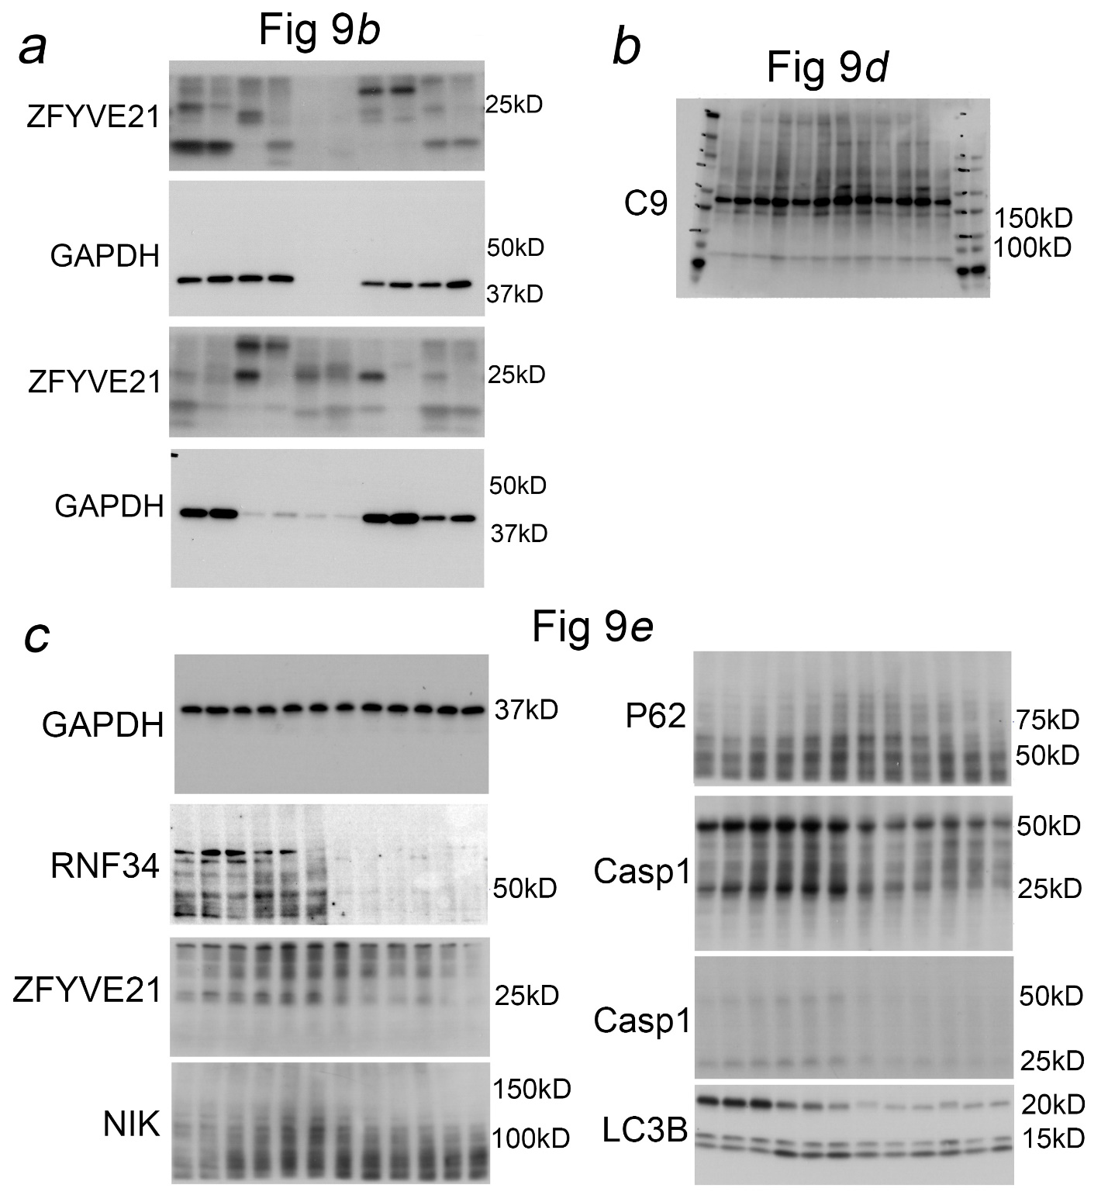
Supplementary Figure 9. Original uncropped films corresponding to Western blots in main Figure 9 in the manuscript.

