Supporting information

Metabolomic Profiling of COVID-19 Using Serum and Urine Samples in Intensive Care and Medical Ward Cohorts

Ana Isabel Tristán,^{a,}‡ Cristina Jiménez-Luna,^{b,}‡ Ana Cristina Abreu,ª Francisco Manuel Arrabal-Campos,^{c} Ana del Mar Salmerón,ª Firma Isabel Rodríguez,^{d} Manuel Ángel Rodríguez Maresca,^{d} Antonio Bernardino García,^{d} Consolación Melguizo,^{b} José Carlos Prados^{b,}*, Ignacio Fernández.^{a,}*

ª Department of Chemistry and Physics, Research Centre CIAIMBITAL, University of Almería, Ctra. Sacramento, s/n, 04120, Almería (Spain)
^{b} Biomedical Research Center, University of Granada, Biosanitary Institute of Granada (IBS), Av. Del Conocimiento s/n, 18014, Granada (Spain)
^{c} Department of Engineering, CeiA3, University of Almería, Ctra. Sacramento, s/n, 04120, Almería (Spain)
^{d} Torrecárdenas University Hospital, Almería (Spain)

‡ These authors have contributed equally

* Corresponding authors: jcprados@ugr.es and ifernan@ual.es

Index
Figure S1. Representative ¹H RMN spectra of urine and serum sample with the assignments.
Table S1. Clinical signs and symptoms on admission, and initial laboratory findings of patients with COVID-19 admitted to medical ward and ICU, and healthy controls.
Table S2. Association between hospital and ICU times with clinical parameters in COVID-19 patients.
Table S3. Metabolite assignment in serum sample extracts by ¹H NMR and diagnostic signals.
Table S4. Metabolite assignment in urine sample extracts by ¹H NMR and diagnostic signals.
Figure S2. Statistical validation of the corresponding OPLS-DA model from serum samples by permutation analysis (100 times).
Figure S3. Statistical validation of the corresponding OPLS-DA model from urine samples by permutation analysis (100 times).
Table S5. Metabolic routes significantly disturbed by COVID-19 disease, according to the "Pathway analysis".
Table S6. Data of p-value derived from the correlation analysis between clinical features and serum metabolite levels in COVID-19 patients (medical ward and ICU).
Table S7: Data of p-value derived from the correlation analysis between clinical features and serum metabolite levels in COVID-19 patients admitted to medical ward.
Table S8: Data of p-value derived from the correlation analysis between clinical features and serum metabolite levels in COVID-19 patients admitted to ICU.
Figure S4. Receiver operating characteristic (ROC) curves of metabolite biomarker panels.
Figure S5. Area Under the Receiver Operating Characteristic Curve and cumulative number of true positive instances against the cumulative number of instances in the data set classification model compared to a random or ideal classifier.
Table S9. Statistical Results of the Multi-Output Regression Model.
Table S10. Confusion matrix depicting the results of our SVM model with highest accuracy.

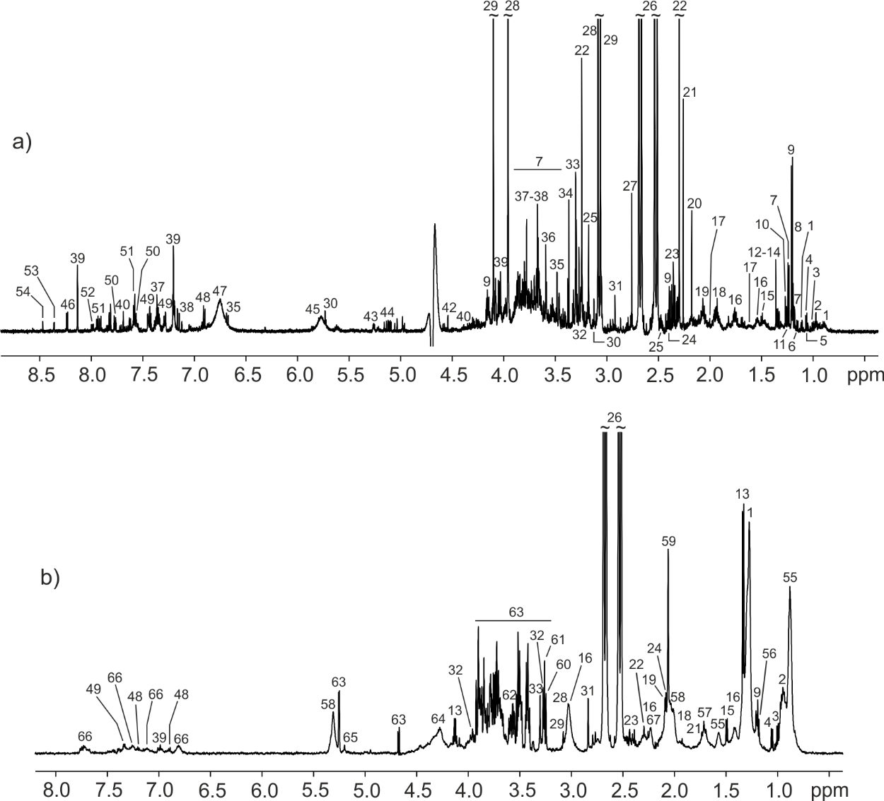
Figure S1. Representative ¹H RMN spectra of A) urine sample and B) serum sample. Assignments for urine: 1-3-methyloxovalerate; 2-Leucine; 3-Isoleucine; 4-Valine; 5-3-hydroxiisobutyrate; 6-Isopropanol; 7-Fucose; 8-Methylmalonate; 9-3-hydroxybutyrate; 10-Threonine; 11-3-hydroxyisovalerate; 12-2-phenylpropionate; 13-Lactate; 14-2-hydroxyisobutyrate; 15-Alanine; 16-Lysine; 17-Arginine; 18-Acetate; 19-Glutamate; 20-Methionine; 21-Acetone; 22-Acetoacetate; 23-Succinate; 24-Glutamine; 25-Carnitine; 26-Citrate: 27-Dimethylamine (DMA); 28-Creatine; 29-Creatinine; 30-Cis-aconitate; 31-Trimethylamine (TMA); 32-Betaine; 33-TMAO (Trimethylamine-N-oxide); 34-Methanol; 35-4-hydroxyphenylacetate; 36-Glycine; 37-N-phenylacetilglycine; 38-3-methylhistidine; 39-Histidine; 40-Pseudouridine; 41-Trigonelline; 42-Arabinose; 43-Glucuronate; 44-Unk_1; 45-Urea; 46-Hipoxantine; 47-Unk_2; 48-Tyrosine; 49-Phenylalanine; 50-3-indoxylsulphate; 51-Hippurate; 52-Unk_3; 53-Unk_4; 54-Formate. Unknown metabolites (an overall of four) are labelled as “Unk”. Assignments for serum: 2-Leucine/FA Ω-3; 3-Isoleucine; 4-Valine; 5-Fatty acids (FA); 9-3-hydroxybutyrate; 13-Lactate; 15-Alanine; 16-Lysine; 18-Acetate; 19-Glutamate; 21-Acetone; 22-Acetoacetate; 23-Succinate; 24-Glutamine; 26-Citrate; 28-Creatine; 29-Creatinine; 31-Trimethylamine; 32-Betaine; 33-TMAO; 39-Histidine; 48-Tyrosine; 49-Phenylalanine; 55-Ethanol; 57-Citrulline; 58-UFA; 59-N-acetylglycoproteins (NAG); 60-Choline; 61-PC/GPC; 62-Glycerol; 63-Glucose; 64-TAG; 65-Mannose; 66-Tryptophan; 67-Proline.

Table S1. Clinical signs and symptoms on admission, and initial laboratory findings of patients with COVID-19 admitted to medical ward and ICU, and healthy controls.
Variable | Medical ward (n=46) | ICU (n=34) | Total (n=80) | Healthy controls (n=32) | p-value
Clinical signs and symptoms on admission
Dyspnoea |  |  |  |  | 0.028*
No, n (%) | 13 (28.89) | 3 (8.82) | 16 (20.25)
Yes, n (%) | 32 (71.11) | 31 (91.18) | 63 (79.75)
Oxygen saturation |  |  |  |  | 0.002**
Normal,ª n (%) | 16 (53.33) | 5 (15.62) | 21 (33.87)
Mild hypoxia,^{b} n (%) | 8 (26.67) | 6 (18.75) | 14 (22.58)
Moderate hypoxia,^{c} n (%) | 2 (6.67) | 8 (25.00) | 10 (16.13)
Severe hypoxia,^{d} n (%) | 4 (13.33) | 13 (40.62) | 17 (27.42)
Pneumonia |  |  |  |  | 0.016 *
No, n (%) | 16 (35.56) | 4 (11.76) | 20 (25.32)
Yes, n (%) | 29 (64.44) | 30 (88.24) | 59 (74.68)
Initial laboratory findings: biochemistry
LDH |  |  |  |  | 0.013*
Normal level, n (%) | 23 (51.11) | 8 (23.53) | 31 (39.24)
High level, n (%) | 22 (48.89) | 26 (76.47) | 48 (60.76)
Ferritin |  |  |  |  | 0.173
Normal level, n (%) | 14 (31.11) | 6 (17.65) | 20 (25.32)
High level, n (%) | 31 (68.89) | 28 (82.35) | 59 (74.68)
C-reactive protein |  |  |  |  | 0.103
Normal level, n (%) | 9 (20.00) | 2 (5.88) | 11 (13.92)
High level, n (%) | 36 (80.00) | 32 (94.12) | 68 (86.08)
IL-6 |  |  |  |  | 0.342
Normal level, n (%) | 15 (33.33) | 8 (23.53) | 23 (29.11)
High level, n (%) | 30 (66.67) | 26 (76.47) | 56 (70.89)
Transaminases
Normal level, n (%) | 36 (80.00) | 0 | 36 (80.00)
High level, n (%) | 9 (20.00) | 0 | 9 (20.00)
Initial laboratory findings: blood count
Leukocytes |  |  |  |  | 0.097
Normal level, n (%) | 40 (93.02) | 27 (79.41) | 67 (87.01)
High level, n (%) | 3 (6.98) | 7 (20.59) | 10 (12.99)
Neutrophils |  |  |  |  | 0.073
Normal level, n (%) | 41 (91.11) | 26 (76.47) | 67 (84.81)
High level, n (%) | 4 (8.89) | 8 (23.53) | 12 (15.19)
Lymphocytes |  |  |  |  | <0.001***
Normal level, n (%) | 28 (62.22) | 7 (20.59) | 35 (44.30)
Low level, n (%) | 17 (37.78) | 27 (79.41) | 44 (55.70)
Initial laboratory findings: clotting
Fibrinogen |  |  |  |  | 0.025*
Normal level, n (%) | 26 (57.78) | 11 (32.35) | 37 (46.84)
High level, n (%) | 19 (42.22) | 23 (67.65) | 42 (53.16)
D-dimer |  |  |  |  | 0.401
Normal level, n (%) | 13 (28.89) | 7 (20.59) | 20 (25.32)
High level, n (%) | 32 (71.11) | 27 (79.41) | 59 (74.68)
LDH: lactate dehydrogenase; IL-6: interleukin 6. ª Normal oxygen saturation was considered at a 95-100% level. ^{b} Mild hypoxia considered at a 91-94% level. ^{c} Moderate hypoxia was considered at an 86-90% level. ^{d} Severe hypoxia was considered at a level < 86%. * p < 0.05, ** p < 0.01, *** p < 0.001.

Table S2. Association between hospital and ICU times with clinical parameters.
 | Medical ward (n=46) |  |  | ICU (n=34) |  |  | COVID-19 patients (n=80) |  |  | ICU (n=34)
Variables | n | Mean days in hospital (SD) | p-value | n | Mean days in hospital (SD) | p-value | n | Mean days in hospital (SD) | p-value | n | Mean days in ICU (SD) | p-value
Cardiovascular risk comorbidities
Hypertension |  |  | 0.015* |  |  | 0.88 |  |  | 0.26 |  |  | 0.247
No | 21 | 16.84 (22.72) |  | 18 | 43.17 (24.85) |  | 39 | 29.65 (26.98) |  | 18 | 26.94 (18.30)
Yes | 25 | 27.38 (30.57) |  | 16 | 44.50 (26.21) |  | 41 | 34.23 (29.80) |  | 16 | 32.63 (19.52)
Obesity or overweight |  |  | 0.203 |  |  | 0.472 |  |  | 0.06 |  |  | 0.416
No | 40 | 22.21 (28.11) |  | 24 | 42.04 (25.24) |  | 64 | 29.89 (28.54) |  | 24 | 31.50 (20.29)
Yes | 6 | 26.60 (25.71) |  | 10 | 48.00 (25.64) |  | 16 | 40.87 (26.84) |  | 10 | 25.10 (14.63)
Dyslipidemia |  |  | 0.193 |  |  | 0.245 |  |  | 0.009** |  |  | 0.252
No | 37 | 18.85 (22.76) |  | 19 | 38.58 (21.83) |  | 56 | 25.92 (24.18) |  | 19 | 26.63 (17.79)
Yes | 9 | 37.33 (39.42) |  | 15 | 50.40 (28.13) |  | 24 | 45.50 (32.62) |  | 15 | 33.40 (20.01)
Diabetes |  |  | 0.943 |  |  | 0.077 |  |  | 0.437 |  |  | 0.745
No | 35 | 23.33 (29.47) |  | 26 | 40.50 (25.90) |  | 61 | 30.90 (29.02) |  | 26 | 29.35 (19.32)
Yes | 11 | 20.70 (21.36) |  | 8 | 54.50 (20.20) |  | 19 | 35.72 (26.61) |  | 8 | 30.50 (18.31)
Presence ≥ 1 cardiovascular risk factors^{A} |  |  | 0.022* |  |  | 0.226 |  |  | 0.055 |  |  | 0.249
No | 13 | 14.25 (18.63) |  | 9 | 35.00 (21.13) |  | 22 | 23.14 (21.91) |  | 9 | 25.11 (20.05)
Yes | 33 | 26.00 (29.97) |  | 25 | 46.96 (26.06) |  | 58 | 35.35 (29.95) |  | 25 | 31.24 (18.51)
Initial laboratory findings: biochemistry
LDH | 23 |  | 0.808 |  |  | 0.454 |  |  | 0.076 |  |  | 0.21
Normal level | 22 | 21.41 (25.49) |  | 8 | 37.88 (21.68) |  | 31 | 25.80 (25.27) |  | 8 | 22.25 (16.83)
High level |  | 24.10 (30.20) |  | 26 | 45.62 (26.20) |  | 48 | 36.00 (29.78) |  | 26 | 31.88 (19.11)
Ferritin |  |  | 0.023* |  |  | 0.03* |  |  | 0.002** |  |  | 0.021*
Normal level | 14 | 10.25 (7.89) |  | 6 | 25.83 (13.11) |  | 20 | 15.44 (12.16) |  | 6 | 16.17 (8.61)
High level | 31 | 27.55 (30.92) |  | 28 | 47.64 (25.54) |  | 59 | 37.08 (30.01) |  | 28 | 32.50 (19.24)
C-reactive protein | 9 |  | 0.302 |  |  | 0.143 |  |  | 0.057 |  |  | 0.048*
Normal level | 36 | 19.75 (24.50) |  | 2 | 20.00 (14.14) |  | 11 | 19.80 (22.11) |  | 2 | 11.00 (1.41)
High level |  | 23.40 (28.53) |  | 32 | 45.28 (25.03) |  | 68 | 33.85 (28.89) |  | 32 | 30.78 (18.79)
IL-6 |  |  | 0.745 |  |  | 0.776 |  |  | 0.897 |  |  | 0.823
Normal level | 15 | 25.36 (29.83) |  | 8 | 48.88 (30.18) |  | 23 | 33.91 (31.44) |  | 8 | 32.38 (23.56)
High level | 30 | 21.45 (26.89) |  | 26 | 42.23 (23.81) |  | 56 | 31.27 (27.33) |  | 26 | 28.77 (17.57)
Initial laboratory findings: blood count
Leukocytes |  |  | 0.209 |  |  | 0.125 |  |  | 0.345 |  |  | 0.055
Normal level | 40 | 23.92 (29.01) |  | 27 | 40.78 (24.83) |  | 67 | 30.92 (28.41) |  | 27 | 26.81 (18.18)
High level | 3 | 7.00 (1.00) |  | 7 | 55.43 (24.48) |  | 10 | 40.90 (30.77) |  | 7 | 40.43 (18.54)
Neutrophils |  |  | 0.181 |  |  | 0.161 |  |  | 0.275 |  |  | 0.149
Normal level | 41 | 23.90 (28.27) |  | 26 | 40.85 (25.32) |  | 67 | 30.58 (28.21) |  | 26 | 27.31 (18.35)
High level | 4 | 7.00 (1.00) |  | 8 | 53.38 (23.40) |  | 12 | 40.73 (29.20) |  | 8 | 37.13 (19.54)
Lymphocytes |  |  | 0.94 |  |  | 0.064 |  |  | 0.015* |  |  | 0.061
Normal level | 28 | 25.85 (33.12) |  | 7 | 28.86 (13.47) |  | 35 | 26.47 (29.98) |  | 7 | 19.00 (12.83)
Low level | 17 | 17.44 (13.48) |  | 27 | 47.67 (26.14) |  | 44 | 36.42 (26.58) |  | 27 | 32.37 (19.32)
Initial laboratory findings: clotting
Fibrinogen |  |  | 0.863 |  |  | 0.834 |  |  | 0.173 |  |  | 0.782
Normal level | 26 | 24.12 (29.68) |  | 11 | 42.45 (30.07) |  | 37 | 29.72 (30.59) |  | 11 | 32.54 (22.32)
High level | 19 | 20.78 (25.08) |  | 23 | 44.43 (23.11) |  | 42 | 34.05 (26.50) |  | 23 | 28.22 (17.27)
D-dimer |  |  | 0.489 |  |  | 0.949 |  |  | 0.293 |  |  | 0.765
Normal level | 13 | 17.00 (19.43) |  | 7 | 41.71 (19.30) |  | 20 | 26.11 (22.47) |  | 7 | 31.43 (17.18)
High level | 32 | 24.94 (30.15) |  | 27 | 44.33 (26.71) |  | 59 | 33.97 (29.98) |  | 27 | 29.15 (19.50)
LDH: lactate dehydrogenase; IL-6: interleukin 6. ^{A} Cardiovascular risk factors including hypertension, obesity/overweight, dyslipidemia, and diabetes. SD: standard deviation. * p < 0.05, ** p < 0.01, *** p < 0.001.

Table S3. Metabolite assignment in serum sample extracts by ¹H NMR and diagnostic signals.
Metabolites |  | Chemical shift (δ_{H}, ppm) and J (Hz)
Amino acids
1 | Valine | 1.00 (d, J = 7.2 Hz), 1.05 (d, J = 7.2 Hz)
2 | Isoleucine | 0.95 (t), 1.02 (d, J = 7.2 Hz), 1.31 (m)
3 | Leucine | 0.97 (d), 0.98 (d), 1.72 (m)
4 | Lysine | 1.42 (m), 1.74 (m), 1.91 (m), 2.71 (m), 3.02 (m), 3.73 (m)
5 | Alanine | 1.49 (d, J = 7.4 Hz), 3.80 (m)
6 | Proline | 2.07 (m), 2.47 (m)
7 | Glutamate | 2.10 (m), 2.37 (m)
8 | Glutamine | 2.15 (m), 2.47 (m)
9 | Tyrosine | 6.89 (m), 7.20 (m)
10 | Phenylalanine | 7.33 (m), 7.38 (m), 7.43 (m)
11 | Histidine | 7.06 (s), 7.76 (s)
12 | Tryptophan | 6.80 (m), 6.99 (m), 7.25 (s), 7.69 (m), 7.74 (m)
13 | Creatine | 3.06 (d), 3.92 (s)
14 | Citrulline | 1.72 (m), 1.92 (m), 3.06 (m)
Organic acids
15 | 3-Hydroxybutyrate | 1.22 (d, J = 6.57 Hz), 2.38 (m)
16 | Acetate | 1.93 (s)
17 | Lactate | 1.34 (d, J = 7.0 Hz), 4.13 (q, J = 7.0 Hz)
18 | Succinate | 2.39 (s)
19 | Citrate | 2.53 (d, J = 15.8 Hz), 2.67 (d, J = 15.8 Hz)
Sugars
20 | Glucose | 3.26 (dd), 4.68 (d, J = 8.1 Hz), 5.25 (d, J = 3.9 Hz)
21 | Mannose | 4.89 (d), 5.20 (d)
Others
22 | Ethanol | 1.19 (t, J = 7.10 Hz), 3.67 (m)
23 | N-acetylglycoproteins | 2.06 (s)
24 | Acetone | 2.25 (s)
25 | Acetoacetate | 2.29 (s)
26 | TMA | 2.84 (s)
27 | Creatinine | 3.08 (d), 4.08 (s)
28 | Choline | 3.23 (s)
29 | Glycerophosphocholine | 3.27 (s)
30 | Betaine | 3.29 (s), 3.96 (s)
31 | TMAO | 3.31 (s)
32 | Glycerol | 3.59 (dd), 3.67 (dd, J = 11.7, 4.3 Hz) y 3.90 (m)
33 | TAG | 4.31 (m)
34 | Fatty acids | 0.89 (–CH3), 0.96 (n3) 1.24-1.32 (–(CH2)n–), 1.57 (–CH2–CH2–COOR), 2.03 (–CH2–CH=CH–, UFA), 2.23 (–CH2–COOR), 2.76 (=CH–CH2–CH=, PUFA), 5.30 (–CH=CH–, UFA)*
Abbreviations: s = singlet, d = doublet, t = triplet, dd = doublet of doublets, m = multiplet, q = quadruplet, PUFA - polyunsaturated fatty acids, UFA - unsaturated fatty acids.

Table S4. Metabolite assignment in urine sample extracts by ¹H NMR and diagnostic signals.
Metabolites |  | Chemical shift (δ_{H}, ppm) and J (Hz)
Amino acids
1 | Valine | 0.99 (d, J = 7.2 Hz), 1.04 (d, J = 7.2 Hz)
2 | Isoleucine | 0.94 (t), 1.00 (d, J = 7.2 Hz), 1.31 (m)
3 | Leucine | 0.95 (d), 0.96 (d), 1.72 (m)
4 | Threonine | 1.23 (d)
5 | Lysine | 1.46 (m), 1.52 (m), 1.74 (m), 1.90 (m), 3.05 (m)
6 | Alanine | 1.48 (d, J = 7.4 Hz)
7 | Arginine | 1.67 (m), 1.74 (m), 1.92 (m), 3.27 (t)
8 | Glutamate | 2.05 (m), 2.30 (m)
9 | Glutamine | 2.05 (m), 2.13 (m), 2.43 (m)
10 | Tyrosine | 6.89 (m), 7.19 (m)
11 | Phenylalanine | 7.32 (m), 7.37 (m), 7.42 (m)
12 | Creatine | 3.04 (s), 3.94 (s)
13 | Trigonelline | 4.52 (s), 8.93 (m) 9.00 (m), 9.30 (s)
14 | Glycine | 3.57 (s)
15 | Histidine | 3.22 (dd), 3.30 (dd), 4.02 (dd), 7.19 (s), 8.12 (d)
Organic acids
16 | Acetate | 1.91 (s)
17 | Lactate | 1.33 (d, J = 7.0 Hz), 4.13 (q, J = 7.0 Hz)
18 | Succinate | 2.34 (s)
19 | Citrate | 2.50 (d, J = 15.8 Hz), 2.66 (d, J = 15.8 Hz)
20 | Formate | 8.45 (s)
Sugars
21 | Fucose | 1.16 (d), 1.22 (d), 4.57 (d), 5.25 (d)
22 | Arabinose | 4.54 (d), 5.24 (d)
Others
23 | 3-methyl-2-oxovalerate | 0.89 (t), 1.09 (d)
24 | 3-hydroxyisobutyrate | 1.05 (d)
25 | Isopropanol | 1.13 (d)
26 | Methylmalonate | 1.18 (d)
27 | 3-hydroxybutyrate | 1.19 (d), 2.31 (dd), 2.37 (dd), 4.14 (m)
28 | 3-hydroxyisovalerate | 1.25 (s)
29 | 2-phenylpropionate | 1.32 (d), 7.29 (m), 7.35 (m), 7.38 (m)
30 | 2-hydroxyisobutyrate | 1.34 (s)
31 | Acetone | 2.24 (s)
32 | Methionine | 2.16 (s), 2.63 (m)
33 | Carnitine | 2.46 (m), 3.16 (s), 3.41 (m)
34 | DMA | 2.74 (s)
35 | TMA | 2.90 (s)
36 | Acetoacetate | 2.28 (s), 3.23 (s)
37 | Creatinine | 3.07 (s), 4.08 (s)
38 | Cis-aconitate | 3.11 (d), 5.71 (m)
39 | 3-methylhistidine | 3.69 (s), 7.10 (s), 7.92 (s)
40 | Pseudouridine | 4.14 (t), 4.28 (t), 7.67 (d)
41 | 4-hydroxyphenylacetate | 3.46 (s), 6.66 (m), 7.18 (m)
42 | 3-indoxylsulphate | 7.20 (m), 7.27 (m), 7.36 (s), 7.51 (m), 7.70 (m)
43 | Hippurate | 7.56 (m), 7.61 (m), 7.80 (m)
44 | Betaine | 3.25 (s), 3.95 (s)
45 | TMAO | 3.28 (s)
46 | Methanol | 3.35 (s)
47 | N-phenylacetylglycine | 3.66 (s), 3.74 (d), 7.35 (m), 7.42 (m)
48 | Hipoxantine | 8.21 (s), 8.22 (s)
49 | Urea | 5.75 (bs)
50 | Glucuronate | 5.21 (d)
Abbreviations: s = singlet, d = doublet, t = triplet, dd = doublet of doublets, m = multiplet, q = quadruplet, bs = broad signal, PUFA - polyunsaturated fatty acids, UFA - unsaturated fatty acids.

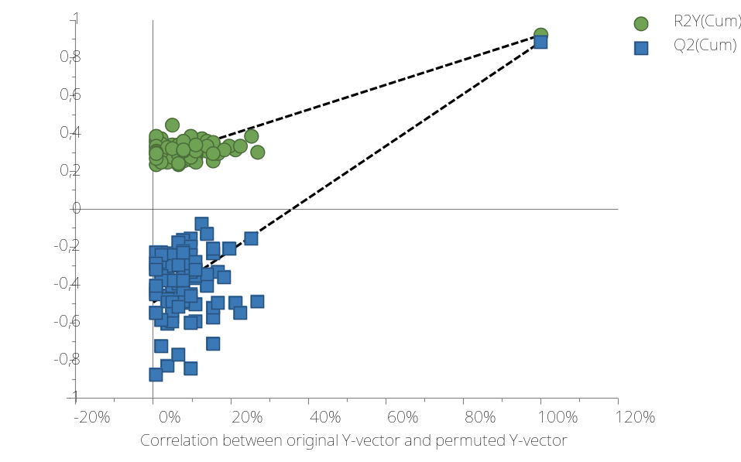
Figure S2. Statistical validation of the corresponding OPLS-DA model from serum samples by permutation analysis (100 times).

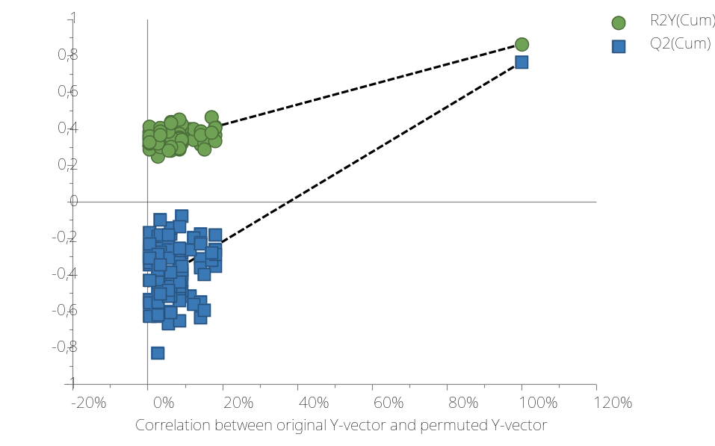
Figure S3. Statistical validation of the corresponding OPLS-DA model from urine samples by permutation analysis (100 times).

Table S5. Metabolic routes significantly disturbed by COVID-19 disease, according to the "Pathway analysis". The statistical analysis values displayed are the followings: Number of matching metabolites, p-value, Holm and FDR p-values and impact index.
 | Metabolic Pathway Name | Metabolites Hits | p | p-Holm | p-FDR | Impact Index
1 | Phenylalanine, tyrosine and tryptophan biosynthesis | 2/4 | 1.79×10⁻⁴ | 0.01 | 7.51×10⁻³ | 1.00
2 | Phenylalanine metabolism | 2/10 | 1.32×10⁻³ | > 0.05 | 0.04 | 0.36
3 | Glycerolipid metabolism | 2/16 | 3.45×10⁻³ | > 0.05 | > 0.05 | 0.25
4 | Arginine and proline metabolism | 2/38 | 0.02 | > 0.05 | > 0.05 | 0.10
Abbreviations: FDR – false discovery rate

Table S6. Data of p-value derived from the correlation analysis between clinical features and serum metabolite levels in COVID-19 patients (medical ward and ICU).
Metabolite | Hypertension | Obesity or  overweight | Dyslipidemia | Diabetes | LDH | Ferritin | C-reactive protein | IL6 | Leukocytes | Neutrophils | Lymphocytes | Fibrinogen | D-dimer
FA except n3 | 0,031* | 0,021* | 0,344 | 0,858 | 0,956 | 0,179 | 0,256 | 0,757 | 0,336 | 0,859 | 0,411 | 0,008* | 0,7
Valine | 0,197 | 0,012* | 0,614 | 0,867 | 0,996 | 0,351 | 0,49 | 0,935 | 0,135 | 0,463 | 0,27 | 0,23 | 0,955
Isoleucine | 0,138 | 0,026* | 0,645 | 0,742 | 0,645 | 0,241 | 0,472 | 0,97 | 0,154 | 0,463 | 0,594 | 0,407 | 0,955
FA n3 | 0,033* | 0*** | 0,287 | 0,699 | 0,206 | 0,223 | 0,455 | 0,732 | 0,256 | 0,826 | 0,948 | 0,133 | 0,892
Ethanol | 0*** | 0,179 | 0,485 | 0,895 | 0,221 | 0,548 | 0,87 | 0,875 | 0,339 | 0,675 | 0,383 | 0,313 | 0,275
3-HB | 0*** | 0,276 | 0,203 | 0,436 | 0,765 | 0,246 | 0,438 | 0,79 | 0,755 | 0,782 | 0,925 | 0,652 | 0,725
Lactate | 0,051 | 0,063 | 0,254 | 0,499 | 0,789 | 0,447 | 0,555 | 0,668 | 0,283 | 0,429 | 0,762 | 0,318 | 0,265
Lysine | 0,047* | 0,018* | 0,128 | 0,657 | 0,742 | 0,973 | 0,96 | 0,884 | 0,175 | 0,227 | 0,854 | 0,901 | 0,548
Alanine | 0,107 | 0,036* | 0,236 | 0,632 | 0,375 | 0,34 | 0,446 | 0,431 | 0,236 | 0,526 | 0,877 | 0,318 | 0,901
UFA | 0,033* | 0,044* | 0,52 | 0,568 | 0,891 | 0,084 | 0,275 | 0,644 | 0,541 | 0,837 | 0,54 | 0,037 | 0,427
NAG | 0,016* | 0,011* | 0,344 | 0,522 | 0,289 | 0,214 | 0,728 | 0,456 | 0,431 | 0,815 | 0,925 | 0,211 | 0,964
Citrate | 0,041* | 0,045* | 0,164 | 0,383 | 0,184 | 0,937 | 0,654 | 0,774 | 0,264 | 0,96 | 0,428 | 0,542 | 0,376
TMA | 0,009** | 0,228 | 0,637 | 0,64 | 0,106 | 0,919 | 0,517 | 0,961 | 0,326 | 0,994 | 0,228 | 0,61 | 0,482
Acetone | 0,011* | 0,022* | 0,277 | 0,931 | 0,689 | 0,062 | 0,472 | 0,765 | 0,32 | 0,938 | 0,534 | 0,276 | 0,357
Acetoacetate | 0,002** | 0,021* | 0,12 | 0,657 | 0,844 | 0,246 | 0,365 | 0,79 | 0,152 | 0,613 | 0,594 | 0,925 | 0,751
Proline | 0,021* | 0,003** | 0,328 | 0,463 | 0,138 | 0,219 | 0,837 | 0,97 | 0,241 | 0,859 | 0,587 | 0,267 | 0,838
Glutamine | 0,031* | 0,214 | 0,344 | 0,352 | 0,15 | 0,683 | 0,322 | 0,782 | 0,222 | 0,815 | 0,11 | 0,732 | 0,964
Creatine | 0,012* | 0,002** | 0,548 | 0,235 | 0,624 | 0,08 | 0,343 | 0,554 | 0,513 | 0,848 | 0,925 | 0,338 | 0,692
Creatinine | 0,021* | 0,144 | 0,898 | 0,804 | 0,313 | 0,786 | 0,35 | 0,732 | 0,901 | 0,803 | 0,416 | 0,338 | 0,295
TMAO | 0,343 | 0,238 | 0,192 | 0,986 | 0,043* | 0,533 | 0,11 | 0,561 | 0,76 | 0,904 | 0,47 | 0,318 | 0,295
Glycerol | 0,003** | 0,007** | 0,254 | 0,751 | 0,494 | 0,692 | 0,624 | 0,233 | 0,825 | 0,288 | 0,909 | 0,589 | 0,982
Glucose | 0,007** | 0,037* | 0,974 | 0,284 | 0,66 | 0,312 | 0,262 | 0,824 | 0,668 | 0,336 | 0,534 | 0,808 | 0,533
PUFA | 0,016* | 0,134 | 0,254 | 0,813 | 0,899 | 0,223 | 0,389 | 0,961 | 0,873 | 0,771 | 0,547 | 0,104 | 0,454
Mannose | 0,059 | 0,033* | 0,814 | 0,529 | 0,781 | 0,265 | 0,25 | 0,629 | 0,989 | 0,574 | 0,476 | 0,155 | 0,246
Tryptophan | 0,17 | 0,004** | 0,35 | 0,632 | 0,123 | 0,937 | 0,413 | 0,47 | 0,58 | 0,837 | 0,964 | 0,076 | 0,503
Tyrosine | 0,09 | 0*** | 0,676 | 0,47 | 0,444 | 0,246 | 0,222 | 0,866 | 0,141 | 0,545 | 0,694 | 0,152 | 0,83
Phenylalanine | 0,215 | 0,009** | 0,715 | 0,449 | 0,534 | 0,626 | 0,397 | 0,978 | 0,461 | 0,848 | 0,948 | 0,338 | 0,725
Choline | 0,001** | 0,576 | 0,408 | 0,235 | 0,781 | 0,65 | 0,421 | 0,644 | 0,966 | 0,915 | 0,636 | 0,396 | 0,734
PC & GPC | 0,055 | 0,023* | 0,459 | 0,485 | 0,758 | 0,946 | 0,76 | 0,832 | 0,614 | 0,654 | 0,452 | 0,024* | 0,105
Betaine | 0,018* | 0,692 | 0,485 | 0,813 | 0,008 | 0,812 | 0,079 | 0,591 | 0,679 | 0,517 | 0,188 | 0,385 | 0,179
Acetate | 0,1 | 0,001** | 0,764 | 0,858 | 0,184 | 0,334 | 0,564 | 0,987 | 0,174 | 0,654 | 0,925 | 0,522 | 0,768
TAG | 0,06 | 0,004** | 0,527 | 0,436 | 0,118 | 0,518 | 0,508 | 0,841 | 0,35 | 0,983 | 0,694 | 0,033* | 0,803
Spearman's correlation coefficient was used for the analysis. Abbreviations: FA: fatty acids; UFA: Unsaturated Fatty-Acid; NAG: N-Acetylglutamate; TMA: trimethylamine; TMAO: Trimethylamine N-oxide; PUFA: Polyunsaturated fatty acids; PC: Phosphocholine; GPC: Glycerophosphocholine; TAG: Triacylglycerol; 3-HB: 3-hydroxybutyrate. * p < 0.05, ** p < 0.01, *** p < 0.001.

Table S7. Data of p-value derived from the correlation analysis between clinical features and serum metabolite levels in COVID-19 patients admitted to medical ward.
Metabolite | Hypertension | Obesity or overweight | Dyslipidemia | Diabetes | LDH | Ferritin | C-reactive protein | IL6 | Leukocytes | Neutrophils | Lymphocytes | Fibrinogen | D-dimer
FA except n3 | 0,196 | 0,14 | 0,978 | 0,482 | 0,823 | 0,332 | 0,385 | 0,705 | 0,516 | 0,53 | 0,489 | 0,055 | 0,505
Valine | 0,152 | 0,161 | 0,401 | 0,755 | 0,893 | 0,197 | 0,655 | 0,317 | 0,568 | 0,365 | 0,177 | 0,572 | 0,459
Isoleucine | 0,146 | 0,131 | 0,195 | 0,795 | 0,655 | 0,172 | 0,52 | 0,379 | 0,565 | 0,409 | 0,489 | 0,892 | 0,429
FA n3 | 0,06 | 0,006** | 0,52 | 0,348 | 0,242 | 0,13 | 0,286 | 0,569 | 0,393 | 0,53 | 0,945 | 0,428 | 0,401
Ethanol | 0,001** | 0,131 | 0,845 | 0,856 | 0,271 | 0,37 | 0,956 | 0,602 | 0,509 | 0,875 | 0,596 | 0,541 | 0,099
3-HB | 0,018* | 0,023* | 0,978 | 0,678 | 0,488 | 0,234 | 0,675 | 0,653 | 0,981 | 0,479 | 0,474 | 0,964 | 0,675
Lactate | 0,054 | 0,433 | 0,933 | 0,532 | 0,335 | 0,332 | 0,978 | 0,447 | 0,994 | 0,344 | 0,393 | 0,946 | 0,254
Lysine | 0,043* | 0,373 | 0,802 | 0,678 | 0,207 | 0,53 | 0,889 | 0,329 | 0,885 | 0,504 | 0,17 | 0,619 | 0,287
Alanine | 0,054 | 0,197 | 0,433 | 0,697 | 0,183 | 0,124 | 0,37 | 0,406 | 0,524 | 0,504 | 0,836 | 0,769 | 0,429
UFA | 0,268 | 0,238 | 0,911 | 0,795 | 0,929 | 0,215 | 0,484 | 0,67 | 0,783 | 0,252 | 0,695 | 0,194 | 0,537
NAG | 0,01* | 0,019* | 0,823 | 0,39 | 0,323 | 0,224 | 0,615 | 0,943 | 0,71 | 0,344 | 0,628 | 0,752 | 0,554
Citrate | 0,096 | 0,021* | 0,956 | 0,716 | 0,191 | 0,345 | 0,911 | 0,758 | 0,542 | 0,53 | 0,534 | 0,483 | 0,98
TMA | 0,006** | 0,284 | 0,78 | 0,835 | 0,155 | 0,682 | 0,401 | 0,306 | 0,922 | 0,479 | 0,149 | 0,296 | 0,205
Acetone | 0,146 | 0,083 | 0,759 | 0,64 | 0,982 | 0,112 | 0,845 | 0,925 | 0,729 | 0,324 | 0,836 | 0,468 | 0,49
Acetoacetate | 0,046* | 0,01* | 0,889 | 0,532 | 0,531 | 0,143 | 0,385 | 0,406 | 0,413 | 0,666 | 0,872 | 0,526 | 0,64
Proline | 0,018* | 0,005** | 0,759 | 0,334 | 0,207 | 0,165 | 0,596 | 0,887 | 0,599 | 0,53 | 0,446 | 0,786 | 0,622
Glutamine | 0,041* | 0,317 | 0,802 | 0,775 | 0,281 | 0,357 | 0,37 | 0,406 | 0,91 | 0,386 | 0,112 | 0,497 | 0,622
Creatine | 0,002** | 0,131 | 0,845 | 0,361 | 0,46 | 0,055 | 0,185 | 0,067 | 0,803 | 0,103 | 0,432 | 0,964 | 0,554
Creatinine | 0,041* | 0,354 | 0,15 | 0,716 | 0,474 | 0,904 | 0,417 | 0,165 | 0,377 | 0,287 | 0,73 | 0,839 | 0,521
TMAO | 0,893 | 0,522 | 0,802 | 0,716 | 0,516 | 0,682 | 0,083 | 0,295 | 0,722 | 0,814 | 0,89 | 0,455 | 0,883
Glycerol | 0,001** | 0,006** | 0,717 | 0,736 | 0,312 | 0,309 | 0,502 | 0,74 | 0,826 | 0,165 | 0,662 | 0,857 | 0,622
Glucose | 0,043* | 0,059 | 0,596 | 0,404 | 0,789 | 0,345 | 0,539 | 0,506 | 0,55 | 0,205 | 0,596 | 0,839 | 0,334
PUFA | 0,159 | 0,197 | 0,867 | 0,659 | 0,858 | 0,425 | 0,696 | 0,67 | 0,895 | 0,431 | 0,662 | 0,178 | 0,334
Mannose | 0,188 | 0,161 | 0,596 | 0,876 | 0,911 | 0,425 | 0,502 | 0,981 | 0,833 | 0,191 | 0,549 | 0,483 | 0,554
Tryptophan | 0,188 | 0,002** | 0,675 | 0,239 | 0,302 | 0,629 | 0,094 | 0,925 | 0,165 | 0,754 | 0,836 | 0,15 | 0,693
Tyrosine | 0,018* | 0,006** | 0,355 | 0,228 | 0,407 | 0,244 | 0,107 | 0,831 | 0,278 | 0,504 | 0,908 | 0,635 | 0,373
Phenylalanine | 0,133 | 0,035* | 0,596 | 0,228 | 0,531 | 0,172 | 0,15 | 0,962 | 0,802 | 0,61 | 0,908 | 0,556 | 0,459
Choline | 0,041* | 0,943 | 0,956 | 0,06 | 0,841 | 0,546 | 0,205 | 0,317 | 0,122 | 0,178 | 0,446 | 0,455 | 0,675
PC & GPC | 0,106 | 0,499 | 0,45 | 0,736 | 0,37 | 0,562 | 0,823 | 0,419 | 0,319 | 0,178 | 0,343 | 0,296 | 0,163
Betaine | 0,028* | 0,887 | 0,355 | 0,114 | 0,108 | 0,885 | 0,069 | 0,181 | 0,26 | 0,165 | 0,308 | 0,089 | 0,205
Acetate | 0,043* | 0,015* | 0,615 | 0,876 | 0,065 | 0,234 | 0,45 | 0,636 | 0,722 | 0,252 | 0,596 | 0,982 | 0,844
TAG | 0,106 | 0,002** | 0,557 | 0,209 | 0,251 | 0,439 | 0,249 | 0,962 | 0,107 | 0,814 | 0,89 | 0,125 | 0,675
Spearman's correlation coefficient was used for the analysis. Abbreviations: FA: fatty acids; UFA: Unsaturated Fatty-Acid; NAG: N-Acetylglutamate; TMA: trimethylamine; TMAO: Trimethylamine N-oxide; PUFA: Polyunsaturated fatty acids; PC: Phosphocholine; GPC: Glycerophosphocholine; TAG: Triacylglycerol; 3-HB: 3-hydroxybutyrate. * p < 0.05, ** p < 0.01, *** p < 0.001.

Table S8. Data of p-value derived from the correlation analysis between clinical features and serum metabolite levels in COVID-19 patients admitted to ICU.
Metabolite | Hypertension | Obesity or overweight | Dyslipidemia | Diabetes | LDH | Ferritin | C-reactive protein | IL6 | Leukocytes | Neutrophils | Lymphocytes | Fibrinogen | D-dimer
FA except n3 | 0,06 | 0,139 | 0,254 | 0,321 | 0,681 | 0,29 | 0,555 | 0,342 | 0,681 | 0,667 | 0,863 | 0,06 | 0,796
Valine | 0,86 | 0,021* | 0,105 | 0,712 | 0,967 | 0,715 | 0,768 | 0,321 | 0,103 | 0,041* | 0,931 | 0,275 | 0,341
Isoleucine | 0,622 | 0,085 | 0,02* | 0,342 | 0,806 | 0,927 | 0,883 | 0,246 | 0,093 | 0,041* | 0,966 | 0,242 | 0,298
FA n3 | 0,416 | 0,014* | 0,016* | 0,565 | 0,806 | 0,927 | 0,555 | 0,837 | 0,522 | 0,363 | 0,863 | 0,101 | 0,125
Ethanol | 0,153 | 0,335 | 0,041* | 0,651 | 0,837 | 0,927 | 0,459 | 0,565 | 0,436 | 0,341 | 0,863 | 0,213 | 0,731
3-HB | 0,003 | 0,759 | 0,076 | 0,51 | 0,651 | 0,784 | 0,374 | 0,434 | 0,648 | 0,698 | 0,546 | 0,477 | 0,966
Lactate | 0,321 | 0,15 | 0,254 | 0,837 | 0,321 | 0,891 | 0,335 | 0,183 | 0,165 | 0,125 | 0,463 | 0,348 | 0,863
Lysine | 0,573 | 0,044* | 0,131 | 0,967 | 0,321 | 0,213 | 0,883 | 0,458 | 0,103 | 0,057 | 0,341 | 0,654 | 0,605
Alanine | 0,622 | 0,119 | 0,025* | 0,806 | 0,806 | 0,891 | 0,825 | 0,774 | 0,359 | 0,24 | 0,546 | 0,242 | 0,605
UFA | 0,071 | 0,187 | 0,547 | 0,197 | 0,837 | 0,196 | 0,264 | 0,213 | 0,681 | 0,667 | 1 | 0,11 | 0,605
NAG | 0,597 | 0,101 | 0,064 | 0,87 | 0,935 | 0,436 | 1 | 0,197 | 0,409 | 0,49 | 0,259 | 0,03* | 0,463
Citrate | 0,304 | 0,129 | 0,011* | 0,537 | 0,967 | 0,29 | 0,605 | 0,837 | 0,312 | 0,437 | 0,605 | 0,477 | 0,298
TMA | 0,396 | 0,262 | 0,097 | 0,837 | 1 | 0,891 | 0,459 | 0,07 | 0,165 | 0,341 | 0,411 | 0,329 | 0,731
Acetone | 0,042* | 0,23 | 0,151 | 0,537 | 0,458 | 0,409 | 0,298 | 0,565 | 0,464 | 0,518 | 0,796 | 0,601 | 0,698
Acetoacetate | 0,023* | 0,514 | 0,011* | 0,87 | 0,458 | 0,82 | 0,768 | 0,484 | 0,196 | 0,191 | 0,278 | 0,454 | 0,863
Proline | 0,525 | 0,013* | 0,034* | 0,743 | 0,87 | 0,552 | 0,768 | 0,51 | 0,249 | 0,24 | 0,387 | 0,041* | 0,363
Glutamine | 0,24 | 0,129 | 0,041* | 0,458 | 0,774 | 0,82 | 0,825 | 0,246 | 0,038* | 0,125 | 0,546 | 0,601 | 0,83
Creatine | 0,972 | 0,002** | 0,141 | 0,565 | 0,837 | 0,964 | 0,768 | 0,133 | 0,269 | 0,207 | 0,223 | 0,129 | 0,931
Creatinine | 0,376 | 0,129 | 0,131 | 0,967 | 0,935 | 1 | 0,941 | 0,282 | 0,436 | 0,387 | 0,931 | 0,055 | 0,463
TMAO | 0,304 | 0,73 | 0,009** | 0,902 | 0,085 | 0,715 | 0,825 | 0,593 | 0,715 | 0,796 | 0,796 | 0,173 | 0,24
Glycerol | 0,321 | 0,15 | 0,141 | 0,935 | 0,743 | 0,522 | 0,883 | 0,156 | 0,891 | 0,763 | 0,363 | 0,199 | 0,575
Glucose | 0,071 | 0,28 | 0,777 | 0,537 | 0,902 | 0,964 | 0,415 | 0,743 | 0,964 | 0,796 | 0,897 | 0,911 | 0,731
PUFA | 0,055 | 0,442 | 0,185 | 0,837 | 0,837 | 0,384 | 0,374 | 0,458 | 0,891 | 0,796 | 0,966 | 0,55 | 0,731
Mannose | 0,163 | 0,187 | 0,751 | 0,197 | 0,837 | 0,522 | 0,298 | 0,434 | 0,964 | 0,897 | 0,698 | 0,368 | 0,298
Tryptophan | 0,673 | 0,201 | 0,037* | 0,321 | 0,282 | 0,584 | 0,058 | 0,229 | 0,436 | 0,667 | 0,763 | 0,227 | 0,051
Tyrosine | 0,944 | 0,007** | 0,173 | 0,593 | 0,743 | 0,855 | 0,335 | 0,593 | 0,269 | 0,114 | 0,796 | 0,079 | 0,387
Phenylalanine | 0,916 | 0,065 | 0,211 | 0,774 | 0,87 | 0,335 | 0,605 | 0,967 | 0,436 | 0,437 | 0,796 | 0,329 | 0,176
Choline | 0,004** | 0,335 | 0,105 | 0,712 | 0,565 | 0,891 | 0,298 | 0,434 | 0,114 | 0,162 | 0,575 | 0,709 | 0,863
PC & GPC | 0,304 | 0,016 | 0,076 | 0,593 | 0,622 | 0,648 | 0,712 | 0,156 | 0,927 | 0,698 | 0,897 | 0,017* | 0,437
Betaine | 0,271 | 0,201 | 0,394 | 0,342 | 0,169 | 0,927 | 0,712 | 0,301 | 0,493 | 0,49 | 0,546 | 0,242 | 0,83
Acetate | 0,944 | 0,006** | 0,239 | 0,681 | 0,712 | 0,855 | 0,883 | 0,622 | 0,138 | 0,114 | 0,207 | 0,275 | 0,863
TAG | 0,339 | 0,101 | 0,059 | 0,565 | 0,409 | 0,964 | 0,335 | 0,774 | 0,855 | 0,931 | 0,931 | 0,066* | 0,278
Spearman's correlation coefficient was used for the analysis. Abbreviations: FA: fatty acids; UFA: Unsaturated Fatty-Acid; NAG: N-Acetylglutamate; TMA: trimethylamine; TMAO: Trimethylamine N-oxide; PUFA: Polyunsaturated fatty acids; PC: Phosphocholine; GPC: Glycerophosphocholine; TAG: Triacylglycerol; 3-HB: 3-hydroxybutyrate. * p < 0.05, ** p < 0.01, *** p < 0.001.

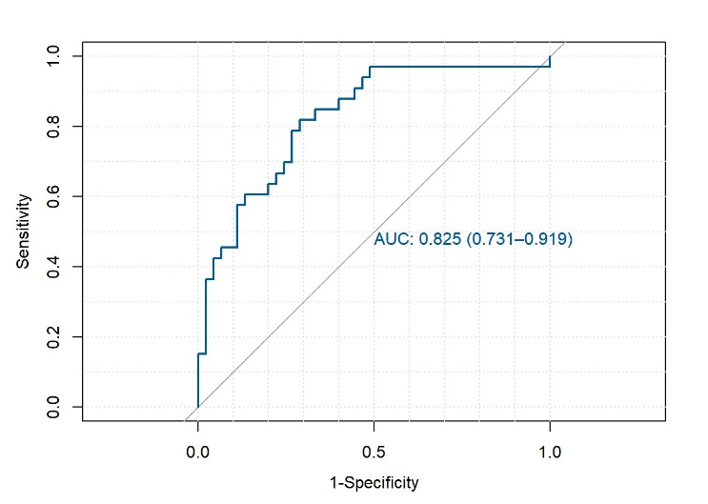
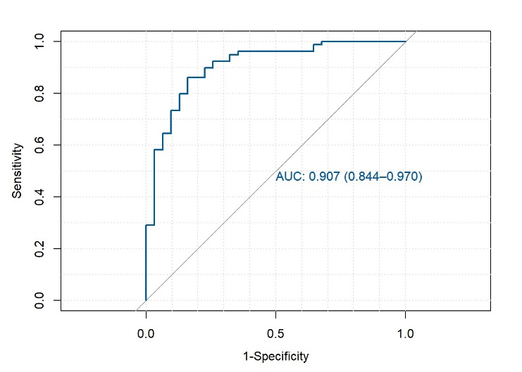
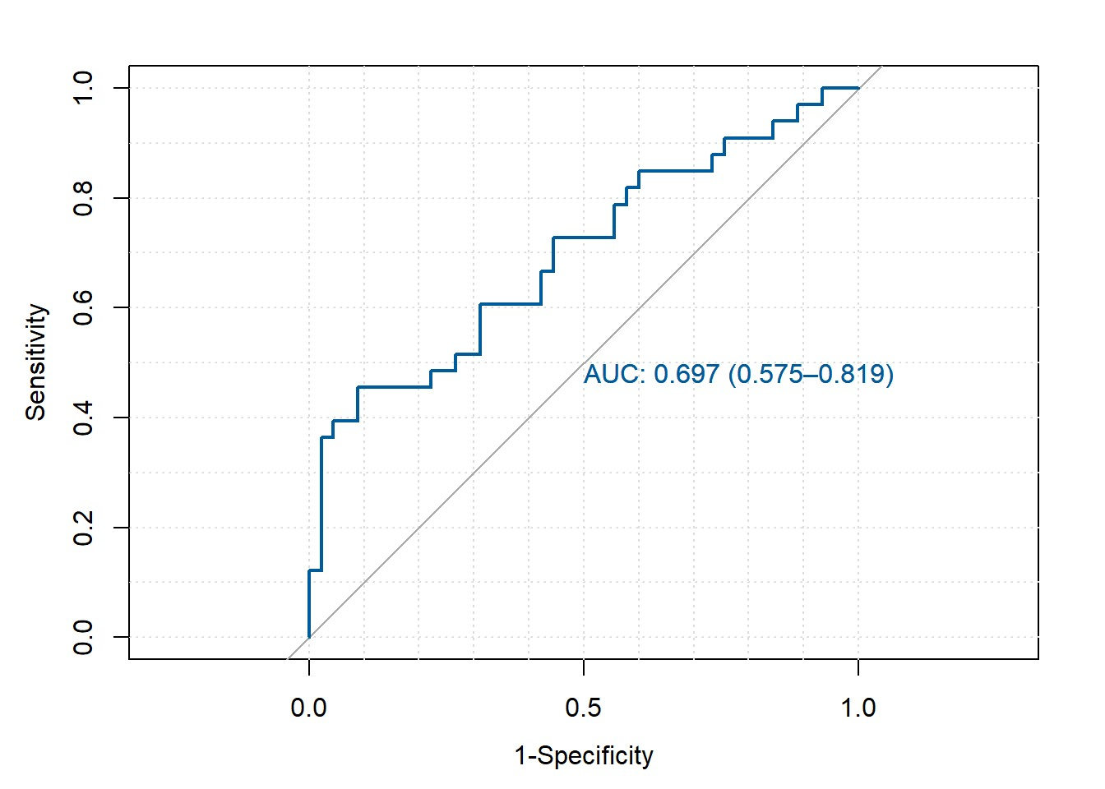
Figure S4. Receiver operating characteristic (ROC) curves of metabolite biomarker panels. A) Metabolite-based panel discriminating COVID-19 patients from healthy controls (panel: isoleucine, TMAO and glucose). B) Metabolite-based panel discriminating MW patients from ICU patients (panel: ethanol, TMAO, tyrosine and betaine). C) Biomarker panel based on the metabolites: ethanol, TMAO, tyrosine and betaine, together with the clinical variables obesity/overweight, dyslipidemia, and lymphocyte count. Confidence interval 95%. AUC: area under the curve.
C
A
B

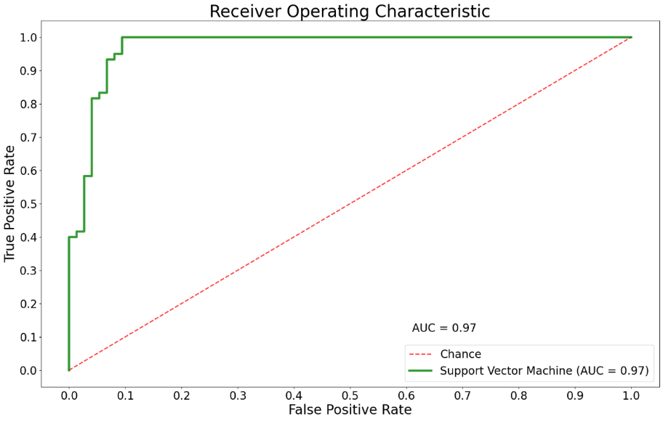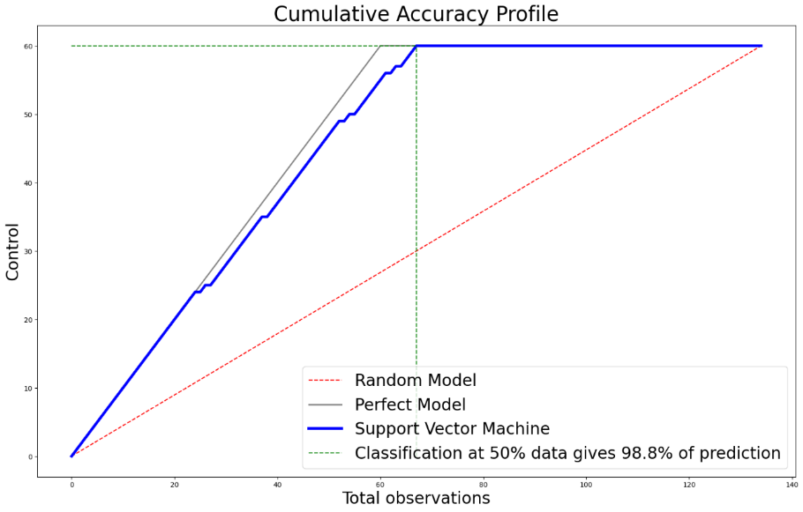
A
B
Figure S5. A) Area Under the Receiver Operating Characteristic Curve (AUC); B) Cumulative number of true positive instances against the cumulative number of instances in the data set classification model compared to a random (dotted line) or ideal classifier (grey line).

Table S9. Statistical Results of the Multi-Output Regression Model.
R² | Adj. R² | F-statistic | Prob(F-stat) | Log-Likelihood | AIC | BIC
0.997 | 0.949 | 38.25 | 0.0025 | 193.93 | -183.86 | 88.76

Table S10. Confusion matrix depicting the results of our SVM model with highest accuracy.
 | Prediction positive | Prediction negative
Real positive | 70 | 4
Real negative | 1 | 59

